Lesson 26
Objective: Add a pair of two-digit numbers when the ones digits have a sum greater than 10.

Suggested Lesson Structure
 Application Problem (5 minutes)
 Fluency Practice (10 minutes)
 Concept Development (35 minutes)
 Student Debrief (10 minutes)
Total Time (60 minutes)
Application Problem (5 minutes)
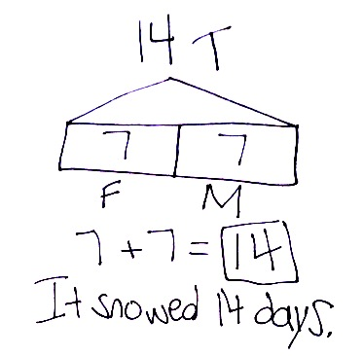
It snowed 7 days in February and the same number of days in March. How many days did it snow in those 2 months? Use the RDW process to solve the problem.
Extension: It snowed 3 days in January. How many days did it snow in all 3 months? How many more days did it snow in February than in January?
Note: Today’s problem gives students the chance to work with equal parts. Some students may struggle when only one number is given. Circulate and notice which students are reading and making sense of the problem. Students who are struggling may need more support, as they read through the problem, to draw as they go.
Fluency Practice (10 minutes)
- Sprint Targeting Core Fluency: Missing Addends for Sums of Ten(s) 1.OA.6 (10 minutes)
Sprint Targeting Core Fluency: Missing Addends for Sums of Ten(s) (10 minutes)
Materials: (S) Missing Addends for Sums of Ten(s) Sprint (Lesson 25 Sprint Core Fluency)
Note: Students complete the same Sprint from the prior day’s lesson as an opportunity to build confidence as they work to master the core fluency of the grade level and to extend this thinking to larger numbers. Between Sprints, engage the students in jumping jacks or running in place as they count from 40 to 80. This keeps their math minds going and builds confidence for the second Sprint.
Concept Development (35 minutes)
Materials: (T) 5 ten-sticks (3 red and 2 yellow) (S) 4 ten-sticks from math toolkit, personal white board
Students gather at the meeting area with their partners and materials in a semicircle formation.
T: (Write 19 + 15 on the chart and show with 19 red and 15 yellow linking cubes.) Partner A, make 19 with your cubes. Partner B, make 15 with yours.
S: (Show cubes in a ten-stick and some ones to match their addend.)
T: Let’s add on the tens first to solve.
T/S: (Move the yellow ten-stick next to the red ten-stick.)
T: 19 and 10 is…?
S: 29.
T: What do we still have to add?
S: 5.
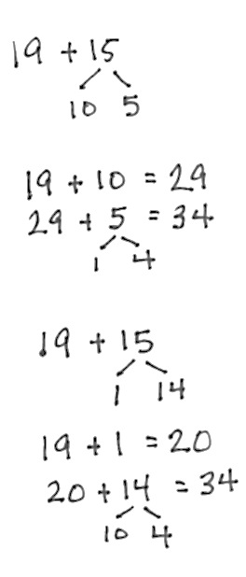
T: Add 5 to 29. (Wait as students use their cubes to solve.)
T: How did you add 5 to 29?
S: I can keep on counting. Twenty niiiine, 30, 31, 32, 33, 34. 29 needs 1 more to make 30, so I got 1 from 5. That gave us 30 and 4. That’s 34. 9 needs 1 more to make 10. 2 tens and 1 ten is 3 tens. Now, we have 3 tens plus 4 ones. That’s 34.
T: Let’s draw a number bond that shows exactly how we solved 19 + 15. We are starting with 19. Why did we break apart 15 into 10 and 5?
S: We added on the ten first, so we took out 10 from 15. 5 is the other part of 15.
T: So, our first number sentence is…?

NOTES ON
MULTIPLE MEANS
OF ENGAGEMENT:
Some students may need extra time to solidify their understanding of the adding on the ten strategy. Give them another sequence of problems for further practice rather than introducing a new strategy.

S: 19 + 10 = 29.
T: (Record.) Next? (Write 29 + 5 = .) How can we record what we did to add 5?
S: Break apart 5 into 1 and 4. We needed the 1 to make the next ten.
T: (Write the number bond.) 29 + 1 is…?
S: 30.
T: 30 + 4 is…?
S: 34.
T: (Complete the number sentence.)
Repeat the process following the suggested sequence, releasing students to work independently, in pairs, or small groups, as possible: 19 + 16, 19 + 18, 18 + 17, 17 + 15, 16 + 16, and 15 + 18.
Chart the problems with their number bonds and two number sentences, listing them vertically. During the next component of the lesson, these solutions will be juxtaposed to solutions completing the ten first.
T: Let’s look at 19 + 15 again. Partner A, make 19 with your cubes. Partner B, make 15. (Show 19 and 15 with cubes.) Before, we broke 15 into 10 and 5 because adding on the tens is easy. What’s another strategy we know that uses ten?
S: Make the next ten!
T: Yes! Use your cubes to make the next ten and solve 19 + 15.
S: 19 needs 1 more to make 20, so we took 1 from 15 to make 20. That gave us 3 tens and 4 ones. That’s 34. 19 plus 1 is 20.
20 plus 14 is 30 and 4. That’s 34. (As students describe, make a number bond below the number sentence showing 15 broken apart into 1 and 14.)
T: 19 needs how many more to make the next ten? (Point to 19 cubes.)
S: 1 more.
T: (Take away 1 cube from the 5 in 15 and place with 19 cubes.) How many tens did we make from 19?
S: 2 tens.
T: We still need to add 14. 20 + 14 is…?
S: 34.
T: How did we break apart 15 this time? Why? (Point to how the yellow cubes are decomposed.)
S: We broke it into 1 and 14. We took 1 from 15 because 19 needs 1 more to make the next ten. When we took away 1, there was still 14 left from the 15.
T: Work with your partner and write the two number sentences that show how we made the next ten first to solve.
S: (Write 19 + 1 = 20 and 20 + 14 = 34.)
Repeat the process, modeling with cubes and number bonds using the same sequence from above and chart the number bonds and two number sentences.
T: (Point to the chart.) Look at the two ways we solved the same addition problem. What do you notice about the difference in how we broke apart one of the addends?
S: When we want to add on the tens first, we always break apart the number to 10 and some ones. But when we want to make the next ten, we break apart the addend to get out the number we need, and then add the rest. If we start with 19, we take out a 1 from the other addend because 19 and 1 makes 20. If we start with 18, we take out a 2 from the other addend because 18 + 2 = 20.
Problem Set (10 minutes)
Students should do their personal best to complete the Problem Set within the allotted 10 minutes. For some classes, it may be appropriate to modify the assignment by specifying which problems they work on first. Some problems do not specify a method for solving.
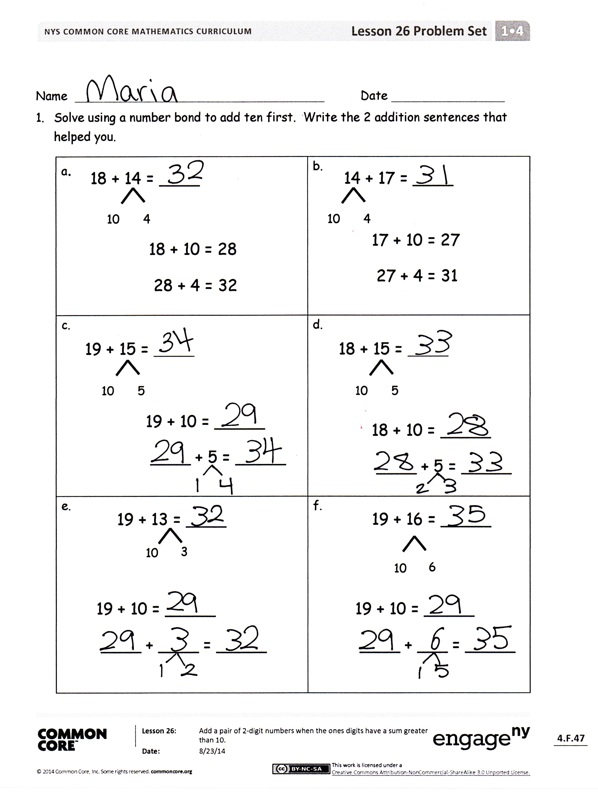
Student Debrief (10 minutes)
Lesson Objective: Add a pair of two-digit numbers when the ones digits have a sum greater than 10.
The Student Debrief is intended to invite reflection and active processing of the total lesson experience.
Invite students to review their solutions for the Problem Set. They should check work by comparing answers with a partner before going over answers as a class. Look for misconceptions or misunderstandings that can be addressed in the Debrief. Guide students in a conversation to debrief the Problem Set and process the lesson.
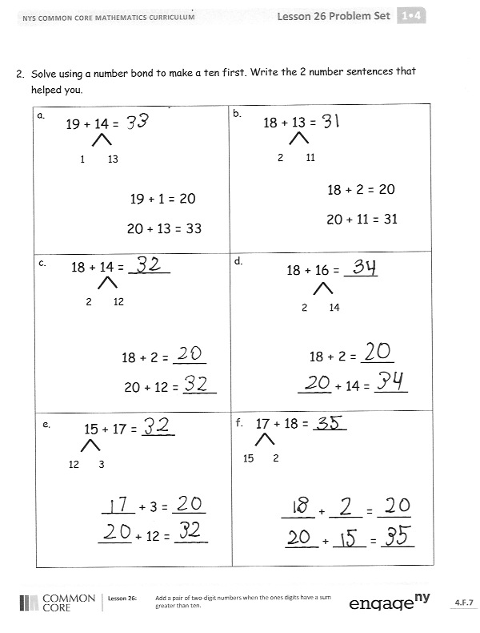
Any combination of the questions below may be used to lead the discussion.
- How are Problems 1(a) and 1(b) related? How can solving 1(a) help you solve 1(b)?
- Which strategy is easier for you to use when you add? Adding on the ten first or making the next ten first? Explain why it’s easier for you.
- Using what we learned today, try solving
49 + 11. Which strategy did you use?
- Look at the Application Problem from today and yesterday. How are they similar? How are they different?
Exit Ticket (3 minutes)
After the Student Debrief, instruct students to complete the Exit Ticket. A review of their work will help with assessing students’ understanding of the concepts that were presented in today’s lesson and planning more effectively for future lessons. The questions may be read aloud to the students.

Name Date
- Solve using a number bond to add ten first. Write the 2 addition sentences that helped you.
a.  18 + 14 = ____  10  4  18 + 10 = 28  28 + 4 = 32 | b.  17 + 10 = 27  27 + 4 = 31  10  4  14 + 17 = ____
c.  19 + 15 = ____  10  5  19 + 10 = _____  ____ + 5 = _____ | d.  18 + 10 = _____  ____ + 5 = _____  10  5  18 + 15 = ____
e.  19 + 13 = ____  10  3  19 + 10 = _____  ____ + ____ = _____ | f.  19 + 16 = _____  10  6  19 + 10 = _____  ____ + ___ = _____

- Solve using a number bond to make a ten first. Write the 2 number sentences that helped you.
a.  19 + 14 = _____  1  13  19 + 1 = 20  20 + 13 = 33 | b.  18 + 13 = _____  2  11  18 + 2 = 20  20 + 11 = 31
c.  18 + 2 = ____  20 + 12 = ____  2  12  18 + 14 = _____ | d.  18 + 16 = ____  2  14  18 + 2 = ____  ____ + 14 = ____  17 + 18 = ____
e.  15 + 17 = ____  12  3  ____ + 3 = ____  ____ + 12 = ____ | f.  15  2  ____ + ____ = ____  ____ + ____ = ____

Name Date

- Solve using number bonds to add ten first. Write the 2 number sentences that helped you.

a.  15 + 19 = ____  ____ + ____ = ____  ____ + ____ = ____ | b.  ____ + ____ = ____  ____ + ____ = ____  19 + 17 = ____

- Solve using number bonds to make a ten. Write the 2 number sentences that helped you.
a.  15 + 19 = ____  ____ + ____ = ____  ____ + ____ = ____ | b.  ____ + ____ = ____  ____ + ____ = ____  19 + 17 = ____

Name Date
- Solve using a number bond to add ten first. Write the 2 addition sentences that helped you.
a.  18 + 13 = ____  10  3  18 + 10 = 28  28 + 3 = 31 | b.  19 + 10 = 29  29 + 3 = 32  13 + 19 = ____  10  3
c.  17 + 15 = ____  10  5  17 + 10 = _____  ____ + 5 = _____ | d.  17 + 10 = _____  ____ + 6 = _____  10  6  17 + 16 = ____
e.  17 + 14 = ____  10  4  17 + 10 = _____  ____ + ____ = _____ | f.  19 + 17 = _____  10  7  19 + 10 = _____  ____ + ___ = _____

- Solve using a number bond to make a ten first. Write the 2 number sentences that helped you.
a.  19 + 13 = _____  1  12  19 + 1 = 20  20 + 12 = 32 | b.  19 + 14 = _____  1  13  19 + 1 = 20  20 + 13 = 33
c.  18 + 2 = ____  20 + 13 = ____  2  13  18 + 15 = _____ | d.  18 + 17 = ____  2  15  18 + 2 = ____  ____ + 15 = ____  19 + 19 = ____
e.  18 + 19 = ____  ____ + 1 = ____  ____ + 17 = ____  1  17 | f.  18  1  ____ + ____ = ____  ____ + ____ = ____

