|  |
| --- |
|  |

Lesson 1: Graphs of Piecewise Linear Functions

Student Outcomes

* Students define appropriate quantities from a situation (a “graphing story”), choose and interpret the scale and the origin for the graph, and graph the piecewise linear function described in the video. They understand the relationship between physical measurements and their representation on a graph.

Classwork

**Exploratory Challenge (20 minutes)**

Show the first minutes of the video below, telling the class that our goal will simply be to describe in words the motion of the man. (Note: Be sure to stop the video at 1:08 because after that the answers to the graphing questions are given.)

Elevation vs. Time # [<http://www.mrmeyer.com/graphingstories1/graphingstories2.mov>. This is the second video under “Download Options” at the site <http://blog.mrmeyer.com/?p=213> called “Elevation vs. Time #.”]

After viewing the video, have students share out loud their ideas on describing the motion. Some might speak in terms of speed, distance traveled over time, or change of elevation. All approaches are valid. Help students begin to shape their ideas with precise language.

**MP.1**

Direct the class to focus on the change of elevation of the man over time and begin to put into words specific details linking elevation with time.

* How high do you think he was at the top of the stairs? How did you estimate that elevation?
* Were there intervals of time when his elevation wasn’t changing? Was he still moving?
* Did his elevation ever increase? When?

Help students discern statements relevant to the chosen variable of elevation.

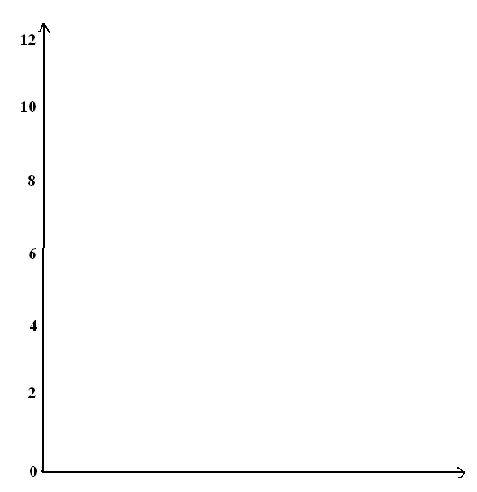If students do not naturally do so, suggest representing this information on a graph. As per the discussion that follows, display a set of axes on the board with vertical axis labeled in units relevant to the elevation.

Ask these types of questions:

* How should we label the vertical axis? What unit of measurement should we choose (feet or meters)?
* How should we label the horizontal axis? What unit of measurement should we choose?
* Should we measure the man’s elevation to his feet or to his head on the graph?
* The man starts at the top of the stairs. Where would that be located on the graph?
* Show me with your hand what the general shape of the graph should look like.

Give time for students to draw the graph of the story (alone or in pairs). Lead a discussion through the issues of formalizing the diagram: The labels and units of the axes, a title for the graph, the meaning of a point plotted on the graph, a method for finding points to plot on the graph, and so on.

**MP.6**

**MP.3**

Note: The graph shown at the end of the video is incorrect! The man starts at “ feet above the ground,” which is clearly false. You might ask students, “Can you find the error made in the video?”

**Example 1 (15 minutes)**

Present the following graph and question.

Example 1

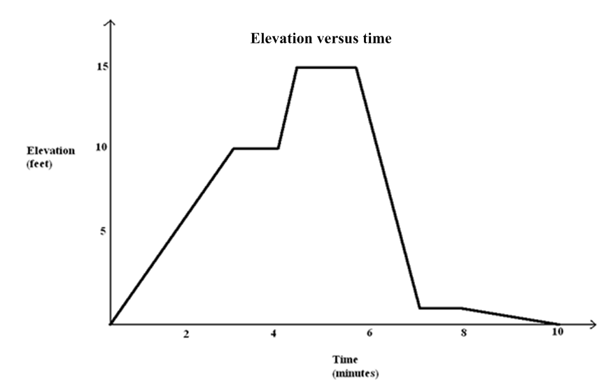Here is an elevation-versus-time graph of a person’s motion. Can we describe what the person might have been doing?

Have students discuss this question in pairs or in small groups. It will take some imagination to create a context that matches the shape of the graph, and there will likely be debate.

Additional questions to ask:

* What is happening in the story when the graph is increasing, decreasing, constant over time?
  + *Answers will vary depending on the story: a person is “walking up a hill,” etc.*
* What does it mean for one part of the graph to be steeper than another?
  + *The person is climbing or descending faster than in the other part.*
* How does the slope of each line segment relate to the context of the person’s elevation?
  + *The slope gives the average change in elevation per minute.*
* Is it reasonable that a person moving up and down a vertical ladder could have produced this elevation versus time graph?
  + *It is unlikely because the speed is too slow: feet per minute. If the same graph had units in seconds then it would be reasonable.*
* Is it possible for someone walking on a hill to produce this elevation versus time graph and return to her starting point at the -minute mark? If it is, describe what the hill might look like.
  + *Yes, the hill could have a long path with a gentle slope that would zigzag back up to the top and then a shorter, slightly steeper path back down to the beginning position.*
* What was the average rate of change of the person’s elevation between time minutes and time minutes?
  + *ft/min, or ft/min.*

These types of questions help students understand that the graph represents only elevation, not speed or horizontal distance from the starting point. This is an important observation.

Closing (5 minutes)

Ask the following:

* How would you describe the graph of Example 1 to a friend?
* What type of equation(s) would be required to create this graph?

Introduce the following definition to your students and discuss briefly. (We will return to this definition later in the year.)

Piecewise-Defined Linear Function: Given non-overlapping intervals on the real number line, a *(real) piecewise linear function* is a function from the union of the intervals on the real number line that is defined by (possibly different) linear functions on each interval.

Point out that all graphs we studied today are graphs of piecewise linear functions. Remind students (see Standard 8.F.A.3) that the graphs of linear functions are straight lines, and show how each segment in one of the graphs studied today is part of a straight line as in:



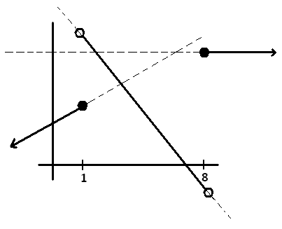

or

Also show students the intervals on which each linear function is defined. One may wish to point out there might be ambiguity as to whether or not the endpoints of a given interval belong to that interval. For example, in the first diagram we could argue that three linear functions are defined on the intervals ,, and , or perhaps on the intervals , and instead. (Warning: Your students have not been formally introduced to interval notation.) There is no ambiguity in the second example. This point about the interval endpoints is subtle and is not an issue to focus on in a concerted way in this particular lesson.

Exit Ticket (5 minutes)

Name ___________________________________________________ Date____________________

Lesson 1: Graphs of Piecewise Linear Functions

Exit Ticket

The graph in the Exploratory Challenge is made by combining pieces of nine linear functions (it is a piecewise linear function).  Each linear function is defined over an interval of time, represented on the horizontal axis. List those nine time intervals.

Exit Ticket Sample Solutions

Students may describe the intervals in words. Do not worry about the endpoints of the intervals in this lesson.

The graph in the Exploratory Challenge is made by combining pieces of nine linear functions (it is a piecewise linear function).  Each linear function is defined over an interval of time, represented on the horizontal axis. List those nine time intervals.

Between and seconds;

Between and seconds;

Between and seconds;

Between and seconds;

Between and seconds;

Between and seconds;

Between and seconds;

Between and seconds;

And seconds onwards.

Problem Set Sample Solutions

1. Watch the video, “Elevation vs. Time #” (below).   
     
   <http://www.mrmeyer.com/graphingstories1/graphingstories3.mov>. (This is the third video under “Download Options” at the site <http://blog.mrmeyer.com/?p=213> called “Elevation vs. Time #.”)  
     
   It shows a man climbing down a ladder that is feet high. At time seconds, his shoes are at feet above the floor, and at time seconds, his shoes are at feet. From time seconds to the second mark, he drinks some water on the step feet off the ground. After drinking the water, he takes seconds to descend to the ground and then he walks into the kitchen. The video ends at the second mark.
   1. Draw your own graph for this graphing story. Use straight line segments in your graph to model the elevation of the man over different time intervals. Label your -axis and -axis appropriately, and give a title for your graph*.*

*[See video for one example of a graph of this story.]*

* 1. Your picture is an example of a graph of a piecewise linear function. Each linear function is defined over an interval of time, represented on the horizontal axis. List those time intervals.

*The intervals are , , , and , with the understanding that the inclusions of the endpoints may vary. Students may use any notation they want to describe the intervals.*

* 1. In your graph in part (a), what does a horizontal line segment represent in the graphing story?

It is a period of time when he is neither going up nor down.

* 1. If you measured from the top of the man’s head instead (he is feet tall), how would your graph change?

*The whole graph would be shifted up feet.*

* 1. Suppose the ladder descends into the basement of the apartment. The top of the ladder is at ground level ( feet) and the base of the ladder is feet below ground level. How would your graph change in observing the man following the same motion descending the ladder?

The whole graph would be shifted downwards feet.

* 1. What is his average rate of descent between time seconds and time seconds? What was his average rate of descent between time seconds and time seconds? Over which interval does he descend faster? Describe how your graph in part (a) can also be used to find the interval during which he is descending fastest.

His average rate of descent between and seconds was ft/sec.

His average rate of descent between and seconds wasft/sec.

He was descending faster from to seconds.

The interval during which he is descending the fastest corresponds to the line segment with the steepest negative slope.

1. Create an elevation-versus-time graphing story for the following graph:



Answers will vary. A story such as the following fits the graph:

A swimmer climbs a ladder to a waterslide, sits for two seconds at the top of the slide, and then slides down the slide into water. She stays steady at the same position underwater for two seconds before rising to the surface.

Teachers should also accept other contexts, e.g., interpreting “ elevation” as the height of a deck feet above ground.

1. Draw an elevation-versus-time graphing story of your own, and then create a story for it.

Answers will vary. Do not be too critical of their graphs and stories.