Lesson 22: Average Rate of Change

Classwork
Exercise
The height of a container in the shape of a circular cone is $7.5$ft., and the radius of its base is $3$ ft., as shown. What is the total volume of the cone?
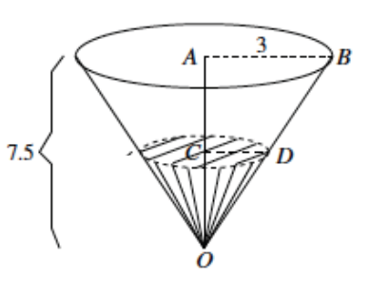

Time in minutes | Water level in feet
 | $$1$$
 | $$2$$
 | $$3$$
 | $$4$$
 | $$5$$
 | $$6$$
 | $$7$$
 | $$7.5$$

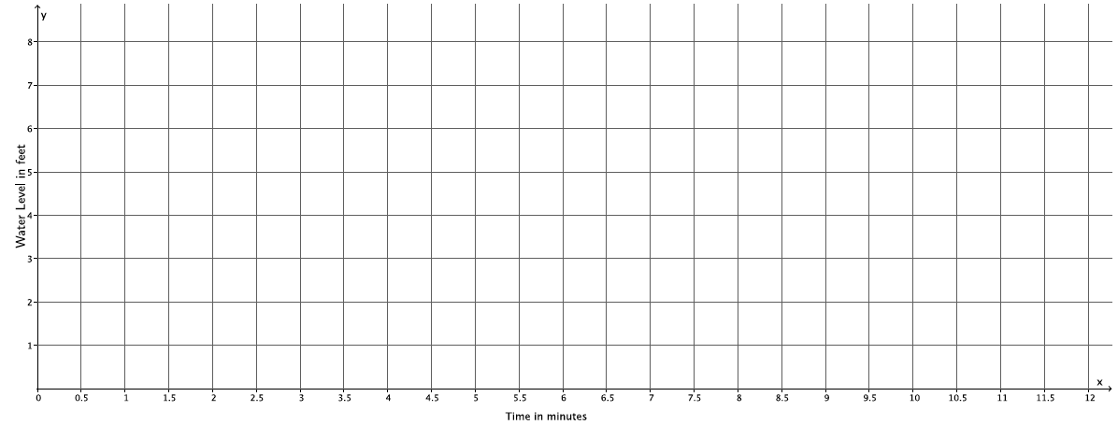

Problem Set

- Complete the table below for more intervals of water levels of the cone discussed in class. Then graph the data on a coordinate plane.
Time in minutes | Water level in feet
 | $$1$$
 | $$1.5$$
 | $$2$$
 | $$2.5$$
 | $$3$$
 | $$3.5$$
 | $$4$$
 | $$4.5$$
 | $$5$$
 | $$5.5$$
 | $$6$$
 | $$6.5$$
 | $$7$$
 | $$7.5$$
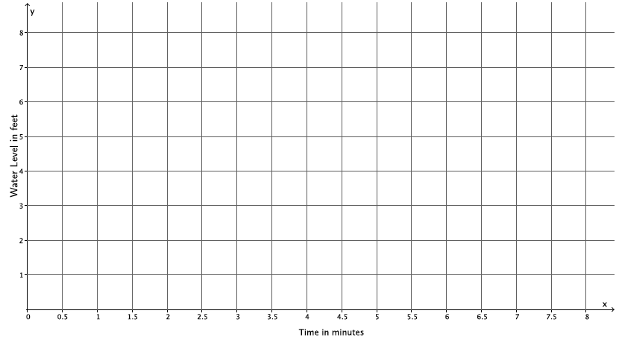
- Complete the table below and graph the data on a coordinate plane. Compare the graphs from Problems 1 and 2. What do you notice? If you could write a rule to describe the function of the rate of change of the water level of the cone, what might the rule include?
$$x$$ | $$\sqrt{x}$$
$$1$$
$$4$$
$$9$$
$$16$$
$$25$$
$$36$$
$$49$$
$$64$$
$$81$$
$$100$$

- Describe, intuitively, the rate of change of the water level if the container being filled were a cylinder. Would we get the same results as with the cone? Why or why not? Sketch a graph of what filling the cylinder might look like, and explain how the graph relates to your answer.
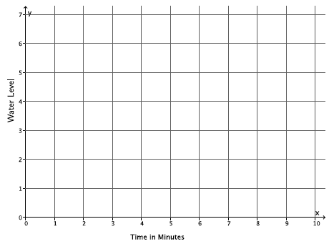

- Describe, intuitively, the rate of change if the container being filled were a sphere. Would we get the same results as with the cone? Why or why not?

