Lesson 22: Average Rate of Change

Student Outcomes
- Students know how to compute the average rate of change in the height of water level when water is poured into a conical container at a constant rate.

Lesson Notes
This lesson focuses on solving one challenging problem that highlights the mathematical practice of making sense of and persevering in solving problems. As students work through the problem, they will reach an important conclusion about constant rate and average rate of change. They will learn that given a circumstance where a cone is being filled at a constant rate (the rate at which water is being poured into the cone is constant), the actual rate of change at which the solid is filling up is not constant, hence the “average rate of change”. Throughout the problem students have to apply many of the concepts learned throughout the year, namely, concepts related to the volume of solids, similarity, constant rate, and rate of change.
MP.1
The Opening requires a demonstration of the filling of a cone with sand or some other substance.

Classwork
Opening (5 minutes)
Teachers will do a demonstration for students pouring sand (or water, rice, etc.) into an inverted circular cone at a constant rate. Students are asked to describe, intuitively, the rate at which the cone is being filled. Specifically, students should be asked to imagine the cone as two halves, an upper half and a lower half. Which half would fill faster and why? Teachers can contrast this with a demonstration of water filling a cylinder.
Students should be able to state that the narrower part of the cone is filled more quickly than the wider part of the cone. For this reason, it can be concluded that the rate of change of the volume of cone is not constant and an average rate must be computed. However, the rate of change of the volume of the cylinder is constant because at each increment of the height, the size of the cylinder is exactly the same which means that the volume increases at a constant rate.
If it is not possible to do a demonstration, a video of a cone being filled can be found at the following location: http://www.youtube.com/watch?v=VEEfHJHMQS8.

Discussion (30 minutes)
Exercise
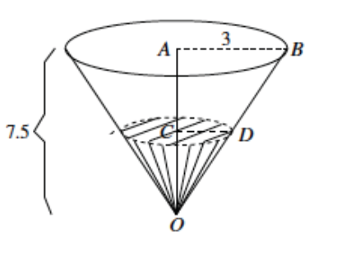
The height of a container in the shape of a circular cone is $7.5$ ft. and the radius of its base is $3$ft., as shown. What is the total volume of the cone?

The volume of the cone is
$$V=\frac{1}{3}π3^{2}\left(7.5\right) \\ =22.5π$$

- If we knew the rate at which the cone was being filled with water, how could we use that information to determine how long it would take to fill the cone?
  - We could take the total volume and divide it by the rate to determine how long it would take to fill.
- Water flows into the container (in its inverted position) at a constant rate of $6$ ft³ per minute. Approximately when will the container be filled?
Provide students time to work in pairs on the problem. Have students share their work and their reasoning about the problem.
  - Since the container is being filled at a constant rate then the volume must be divided by the rate at which it is being filled (using $3.14$ for $π$ and rounding to the hundredths place):
$$\frac{22.5π}{6}≈11.78 min$$
It will take almost $12$ minutes to fill the cone at a rate of $6$ ft³ per minute.
- Now we want to show that even though the water filling the cone flows at a constant rate, the rate of change of the volume in the cone is not constant. For example, if we wanted to know how many minutes it would take for the level in the cone to reach $1$ft., then we would have to first determine the volume of the cone when the height is 1 ft. Do we have enough information to do that?
  - Yes, we will need to first determine the radius of the cone when the height is $1$ft.
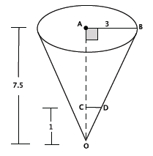
- What equation can we use to determine the radius when the height is 1 ft.? Explain how your equation represents the situation.
  - If we let $|CD|$ represent the radius of the cone when the height is $1$ ft., then
$$\frac{3}{\left|CD\right|}=\frac{7.5}{1}$$
The number $3$ represents the radius of the original cone. The $7.5$ represents the height of the original cone, and the $1$ represents the height of the cone we are trying to solve for.
- Use your equation to determine the radius of the cone when the height is $1$ ft.
  - The radius when the height is $1$ ft. is
$$3=7.5\left|CD\right| \\ \frac{3}{7.5}=\left|CD\right| \\ 0.4=\left|CD\right|$$
- Now determine the volume of the cone when the height is $1$ ft.
  - Then we can find the volume of the cone with a height of $1$ft.:
$$V=\frac{1}{3}π{\left(0.4\right)}^{2}\left(1\right) \\ =\frac{0.16}{3}π$$
Now we can divide the volume by the rate at which the cone is being filled to determine how many minutes it would take to fill a cone with a height of$1$ft.:
$$\frac{0.16}{3}π≈0.167$$
$$\frac{0.167}{6}≈0.028$$
It would take about $0.028$ minutes to fill a cone with a height $of 1$ ft.
- Calculate the number of minutes it would take to fill the cone at $1$ft. intervals. Organize your data in the table below.
Provide students time to work on completing the table. They should replicate the work above by first finding the radius of the cone at the given heights, then using the radius to determine the volume of the cone, and then the time it would take to fill a cone of that volume at the given constant rate. Once most students have finished, continue with the discussion below.

Time in minutes | Water level in feet
$$0.028$$ | $$1$$
$$0.22$$ | $$2$$
$$0.75$$ | $$3$$
$$1.78$$ | $$4$$
$$3.49$$ | $$5$$
$$6.03$$ | $$6$$
$$9.57$$ | $$7$$
$$11.78$$ | $$7.5$$
- We know that the sand (rice, water, etc.) being poured into the cone is poured at a constant rate, but is the level of the substance in the cone rising at a constant rate? Provide evidence to support your answer.
MP.3
Provide students time to construct an argument based on the data collected to show that the substance in the cone is not rising at a constant rate. Have students share their reasoning with the class. Students should be able to show that the rate of change (slope) between any two data points is not the same using calculations like $\frac{2-1}{0.22-0.028}=\frac{1}{0.192}=5.2$and $\frac{7-6}{9.57-6.03 }=\frac{1}{3.54}=0.28$or by graphing the data and showing that it is not linear.
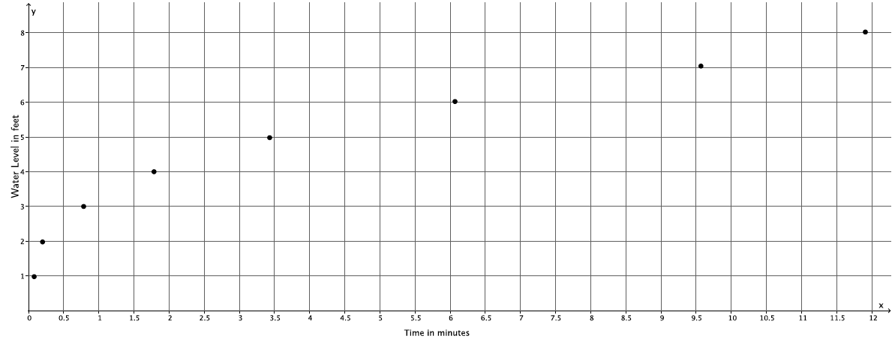

Close the discussion by reminding students of the demonstration at the Opening of the lesson. Ask students if the math supported their conjectures about average rate of change of the water level of the cone.

Closing (5 minutes)
Consider asking students to write a summary of what they learned. Prompt them to include a comparison of how filling a cone is different from filling a cylinder. Another option is to have a whole class discussion where you ask students how to interpret this information in a real-world context. For example, if they were filling a cylindrical container and a conical container with the same radius and height, which would fill first? Or the example, would the rate of change of the volume be different if we were emptying the cone as opposed to filling it? Would the rate of change in the water level be different if we were emptying the cone as opposed to filling it? How so? What might that look like on a graph?
Summarize, or ask students to summarize, the main points from the lesson:
- We know intuitively that the narrower part of a cone will fill up faster than the wider part of a cone.
- By comparing the time it takes for a cone to be filled to a certain water level, we can determine that the rate of filling the cone is not constant.

Exit Ticket (5 minutes)
Name Date
Lesson 22: Average Rate of Change

Exit Ticket

- A container in the shape of a square base pyramid has a height of$5$ ft. and a base length of $5$ft., as shown. Water flows into the container (in its inverted position) at a constant rate of $4$ ft³ per minute. Calculate the number of minutes it would take to fill the cone at $1$ ft. intervals. Organize your data in the table below.
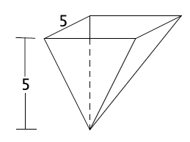
Water level in feet | Area of base in feet² | Volume in feet³ | Time in minutes
$$1$$
$$2$$
$$3$$
$$4$$
$$5$$

  - How long will it take to fill up the container?

  - Show that the water level is not rising at a constant rate. Explain.

Exit Ticket Sample Solutions

- A container in the shape of a square base pyramid has a height of$5$ ft. and a base length of $5$ ft., as shown. Water flows into the container (in its inverted position) at a constant rate of $4$ft³ per minute. Calculate the number of minutes it would take to fill the cone at $1$ ft. intervals. Organize your data in the table below.
Water level in feet | Area of base in feet² | Volume in feet³ | Time in minutes
$$1$$ | $$1$$ | $$\frac{1}{3}$$ | $$0.08$$
$$2$$ | $$4$$ | $$\frac{8}{3}$$ | $$0.67$$
$$3$$ | $$9$$ | $$\frac{27}{3}=9$$ | $$2.25$$
$$4$$ | $$16$$ | $$\frac{64}{3}$$ | $$5.33$$
$$5$$ | $$25$$ | $$\frac{125}{3}$$ | $$10.42$$

  - How long will it take to fill up the container?
It will take approximately $11$ minutes to fill up the container.

  - Show that the water level is not rising at a constant rate. Explain.
$$\frac{2-1}{0.67-0.08}=\frac{1}{0.59}≈1.69$$

$$\frac{5-4}{10.42-5.33}=\frac{1}{5.09}≈0.2$$
The rate at which the water level is rising in the container is not the same for the first foot and the last foot. Furthermore, the rate at which the water is rising in the first foot is higher than the rate at which the water is rises in the last foot.

Problem Set Sample Solutions

- Complete the table below for more intervals of water levels of the cone discussed in class. Then graph the data on a coordinate plane.
Time in minutes | Water level in feet
$$0.028$$ | $$1$$
$$0.09$$ | $$1.5$$
$$0.22$$ | $$2$$
$$0.44$$ | $$2.5$$
$$0.75$$ | $$3$$
$$1.2$$ | $$3.5$$
$$1.78$$ | $$4$$
$$2.54$$ | $$4.5$$
$$3.49$$ | $$5$$
$$4.64$$ | $$5.5$$
$$6.03$$ | $$6$$
$$7.67$$ | $$6.5$$
$$9.57$$ | $$7$$
$$11.78$$ | $$7.5$$

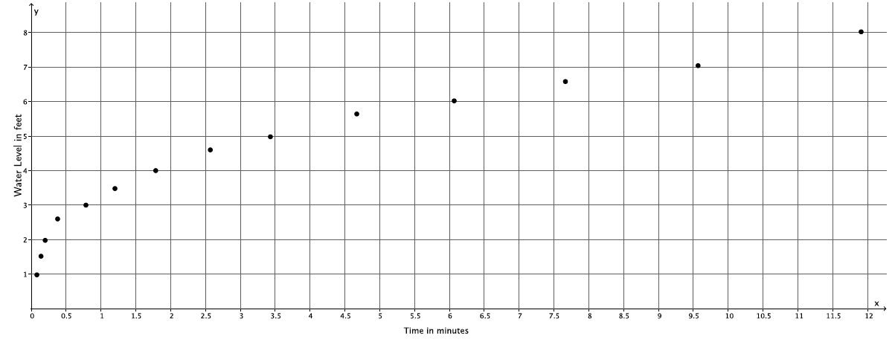
Water level in feet
Time in minutes

- Complete the table below and graph the data on a coordinate plane. Compare the graphs from Problems 1 and 2. What do you notice? If you could write a rule to describe the function of the rate of change of the water level of the cone, what might the rule include?
$$x$$ | $$\sqrt{x}$$
$$1$$ | $$1$$
$$4$$ | $$2$$
$$9$$ | $$3$$
$$16$$ | $$4$$
$$25$$ | $$5$$
$$36$$ | $$6$$
$$49$$ | $$7$$
$$64$$ | $$8$$
$$81$$ | $$9$$
$$100$$ | $$10$$
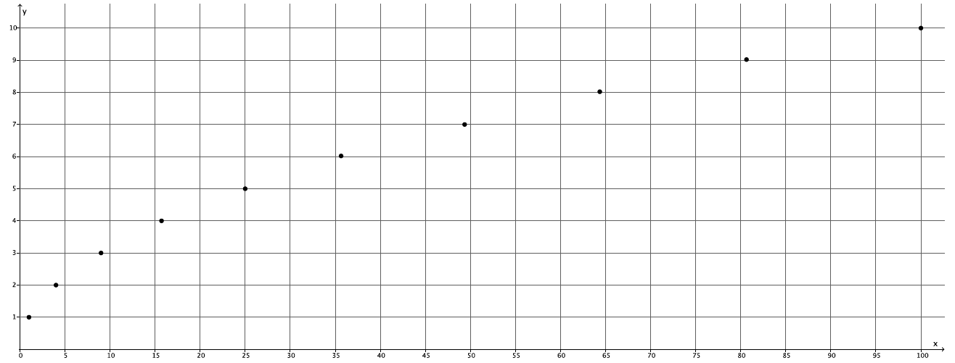

The graphs are similar in shape. The rule that describes the function for the rate of change likely includes a square root. Since the graphs of functions are the graphs of certain equations where their inputs and outputs are points on a coordinate plane, it makes sense that the rule that would produce such a curve would be a graph of some kind of square root.

- Describe, intuitively, the rate of change of the water level if the container being filled were a cylinder. Would we get the same results as with the cone? Why or why not? Sketch a graph of what filling the cylinder might look like, and explain how the graph relates to your answer.
If the container being filled were a cylinder, we would see a constant rate of change in the water level because there is no narrow or wide part like there is with a cone. Therefore, we would not see the same results as we did with the cone. The rate of change would be the same over any time interval for any given height of the cylinder. The following graph demonstrates this. If a cylinder were being filled at a constant rate, the graph would be linear as shown because the water that would flow into the cylinder would be filling up the same sized solid throughout.

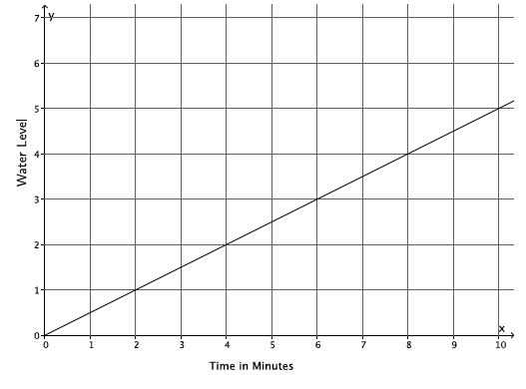

- Describe, intuitively, the rate of change if the container being filled were a sphere. Would we get the same results as with the cone? Why or why not?
The rate of change in the water level would not be constant if the container being filled were a sphere. The water level would rise quickly at first, then slow down, then rise quickly again because of the narrower parts of the sphere at the top and the bottom and the wider parts of the sphere around the middle. We would not get the same results as we saw with the cone, but the results would be similar in that the rate of change is non-linear.

