Lesson 25
Objective: Add a pair of two-digit numbers when the ones digits have a sum less than or equal to 10.

Suggested Lesson Structure
 Application Problem (5 minutes)
 Fluency Practice (16 minutes)
 Concept Development (29 minutes)
 Student Debrief (10 minutes)
Total Time (60 minutes)
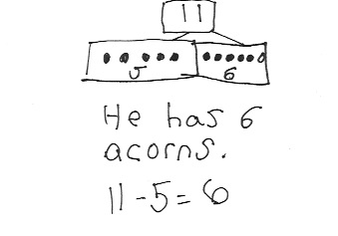
Application Problem (5 minutes)
A chipmunk hides 11 acorns under a tree. Later, he gives 5 of the acorns to his friend. How many acorns does the chipmunk have? Use the RDW process to solve the problem.
Extension: A squirrel has double the number of acorns the chipmunk had to begin with. How many acorns does the squirrel have?
Note: Today’s problem challenges students to pay attention to the differences in a story problem. During the Debrief, students compare yesterday’s Application Problem with today’s, analyzing the parts and the whole or total in each problem.
Fluency Practice (16 minutes)
- Get to 10 or 20 1.OA.6 (4 minutes)
- Sprint Targeting Core Fluency: Missing Addends for Sums of Ten(s) 1.OA.6 (10 minutes)
- Take Out 1 or 2 1.OA.5 (2 minutes)
Get to 10 or 20 (4 minutes)
Materials: (S) 1 dime and 10 pennies
Note: This fluency activity uses dimes and pennies as abstract representations of tens and ones to help students become familiar with coins, while simultaneously providing practice with missing addends to ten(s).

For the first two minutes:
- Lay out 0–10 pennies in 5-group formation and ask students to identify the amount shown
(e.g., 9 ones).
- Ask for the addition sentence to get to 10 (e.g., 9 ones + 1 one = 10 ones).
For the next two minutes:
- Repeat Steps 1 and 2. Then, add a dime and ask students to identify the amount shown (e.g., 1 ten 9 ones = 19 or 9 cents + 10 cents = 19 cents) and a new addition sentence (e.g., 19 cents + 1 cent = 20 cents).
Vary the unit terminology throughout the activity (ones, pennies, cents, tens, dimes).
Sprint Targeting Core Fluency: Missing Addends for Sums of Ten(s) (10 minutes)
Materials: (S) Missing Addends for Sums of Ten(s) Sprint
Note: The first two quadrants of this Sprint focus on partners to 10, which reviews the core fluency standard and prepares students for today’s lesson. The third and fourth quadrants relate partners to 10 to corresponding partners to 20. This adds excitement to the grade-level fluency goals as students see how these equations relate to larger numbers.
Take Out 1 or 2 (2 minutes)
Note: This anticipatory fluency exercise practices taking out 1 or 2 from two-digit numbers to prepare students to use this skill when adding 2 two-digit numbers in upcoming lessons.
Choose numbers between 0 and 10, and follow the paradigm below.
T: Take out 1 from each number. 6. (Signal.)
S: 1 and 5.
Continue with other numbers within 10. Then, start again at 6.
T: 6.
S: 1 and 5.
T: 16.
S: 1 and 15.
T: 26.
S: 1 and 25.
T: 36.
S: 1 and 35.
After students take out 1 for a minute, start again and take out 2.

Concept Development (29 minutes)
Materials: (T) 5 ten-sticks (4 red and 1 yellow) (S) 4 ten-sticks from math toolkit, personal white board
Students gather in the meeting area with their materials in a semicircle formation.
The first 10 minutes of Lesson 25’s Concept Development can be used to solidify the learning that has occurred in Lesson 24. Three sets of problems have been provided for students who are ready to extend their double-digit addition skills. The teaching sequence from Lesson 24 may be used to guide instruction. Students should be encouraged to use their cubes, quick ten drawing, or the number bond to solve their problems. Note that Problems 10–12 involve numbers greater than 40. Encourage students to use place value language to describe and compare strategies for solving. Ask questions such as, “What is another way this can be solved? Why did you choose your method?”
NOTES ON
MULTIPLE MEANS
OF ACTION AND EXPRESSION:
More advanced students may choose to show how they solved some problems using the arrow way. This shows that these students are thinking more abstractly while adding two-digit numbers.

Problems 1–4 Problems 5–8 Problems 9–12
15 + 12 24 + 13 37 + 22
15 + 13 26 + 13 46 + 23
15 + 15 27 + 13 46 + 24
16 + 14 12 + 28 53 + 17

After 10 minutes of practice, proceed with the following:
T: (Write 17 + 13.) How could we solve this?
S: 17 + 10 = 27. 27 + 3 = 30. (While students describe, show the number bond and write two number sentences.)
T: Great job! So far, we have been practicing to add the tens first as an easy way to add two-digit numbers. What if I wanted to add my tens at the end? How else might we start?
S: We can add the ones first. 17 + 3 is 20, and then 20 + 10 is 30.
(While students describe, use the number bond and number sentences as shown.)
T: Great strategies! Earlier today, we were adding on tens first. This time, we can add the ones first. Let’s try some more!

Repeat the process following the suggested sequence: 18 + 12, 28 + 12, 18 + 22, 16 + 23, 16 + 24, and 21 + 19. Students may choose to continue practicing adding on the tens first as in the previous exercise. Alternatively, they may start with trying to add the ones using the number bond or the arrow way, and explain their choice.
MP.5
NOTES ON
MULTIPLE MEANS
OF ACTION AND EXPRESSION:
Encourage students to explain their thinking about adding or subtracting tens. Students may learn as much from each other’s reasoning as from the lesson. The teacher will learn more about their level of thinking and ability to express that thinking.
Problem Set (10 minutes)
Students should do their personal best to complete the Problem Set within the allotted 10 minutes. For some classes, it may be appropriate to modify the assignment by specifying which problems they work on first.
Student Debrief (10 minutes)
Lesson Objective: Add a pair of two-digit numbers when the ones digits have a sum less than or equal to 10.
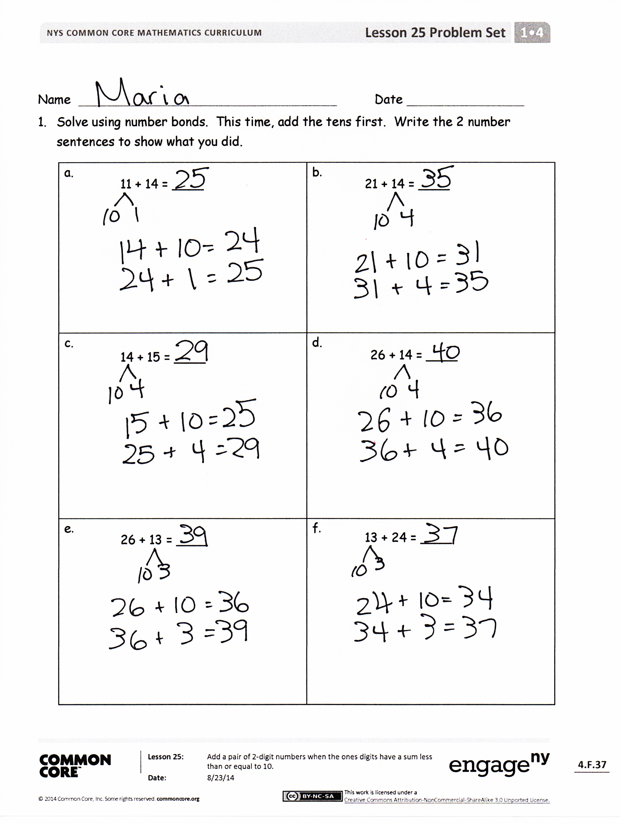
The Student Debrief is intended to invite reflection and active processing of the total lesson experience.
Invite students to review their solutions for the Problem Set. They should check work by comparing answers with a partner before going over answers as a class. Look for misconceptions or misunderstandings that can be addressed in the Debrief. Guide students in a conversation to debrief the Problem Set and process the lesson.
Any combination of the questions below may be used to lead the discussion.
- Look at Problem 1(c) and 1(d). Why can’t we use the strategy to get to the next ten in 1(c) while we can in 1(d)?
- In Problem 2(g), which addend did you start with? Why?
- Share your strategy for solving 2(h) with your partner. How are your strategies similar or different?
- Look at Problem 2(h). How might a number bond look different for using the adding the ten strategy compared to the adding the ones strategy?
- Look at Problem 2(c). How can you use the arrow way to show the different ways to solve this problem?

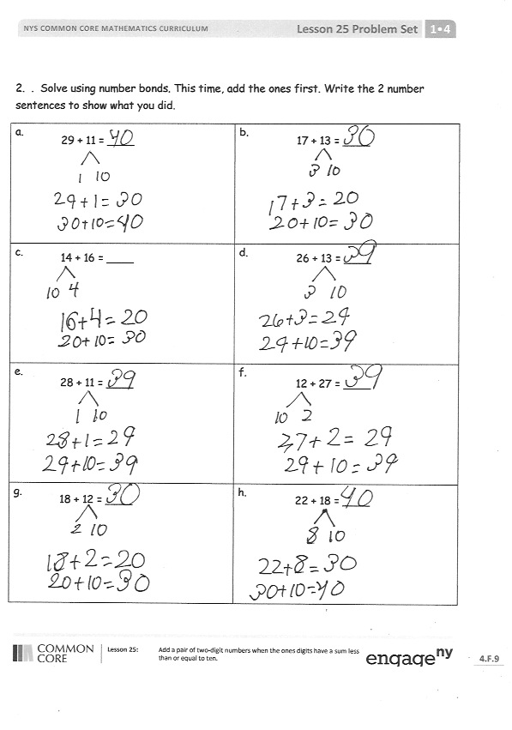
- How is the adding the ten strategy similar and different compared to the adding the ones strategy? How does that show in your number bonds and the two number sentences that follow the number bond?
- How did the Application Problem connect to today’s lesson?
Exit Ticket (3 minutes)
After the Student Debrief, instruct students to complete the Exit Ticket. A review of their work will help with assessing students’ understanding of the concepts that were presented in today’s lesson and planning more effectively for future lessons. The questions may be read aloud to the students.

Name Date
Number Correct:
A
*Write the missing number.
1 | 5 + ☐ = 10 |  | 16 | 9 + ☐ = 10
2 | 9 + ☐ = 10 |  | 17 | 19 + ☐ = 20
3 | 10 + ☐ = 10 |  | 18 | 5 + ☐ = 10
4 | 0 + ☐ = 10 |  | 19 | 15 + ☐ = 20
5 | 8 + ☐ = 10 |  | 20 | 1 + ☐ = 10
6 | 7 + ☐ = 10 |  | 21 | 11 + ☐ = 20
7 | 6 + ☐ = 10 |  | 22 | 3 + ☐ = 10
8 | 4 + ☐ = 10 |  | 23 | 13 + ☐ = 20
9 | 3 + ☐ = 10 |  | 24 | 4 + ☐ = 10
10 | ☐ + 7 = 10 |  | 25 | 14 + ☐ = 20
11 | 2 + ☐ = 10 |  | 26 | 16 + ☐ = 20
12 | ☐ + 8 = 10 |  | 27 | 2 + ☐ = 10
13 | 1 + ☐ = 10 |  | 28 | 12 + ☐ = 20
14 | ☐ + 2 = 10 |  | 29 | 18 + ☐ = 20
15 | ☐ + 3 = 10 |  | 30 | 11 + ☐ = 20
Name Date
Number Correct:
B
*Write the missing number.
1 | 10 + ☐ = 10 |  | 16 | 5 + ☐ = 10
2 | 0 + ☐ = 10 |  | 17 | 15 + ☐ = 20
3 | 9 + ☐ = 10 |  | 18 | 9 + ☐ = 10
4 | 5 + ☐ = 10 |  | 19 | 19 + ☐ = 20
5 | 6 + ☐ = 10 |  | 20 | 8 + ☐ = 10
6 | 7 + ☐ = 10 |  | 21 | 18 + ☐ = 20
7 | 8 + ☐ = 10 |  | 22 | 2 + ☐ = 10
8 | 2 + ☐ = 10 |  | 23 | 12 + ☐ = 20
9 | 3 + ☐ = 10 |  | 24 | 3 + ☐ = 10
10 | ☐ + 7 = 10 |  | 25 | 13 + ☐ = 20
11 | 2 + ☐ = 10 |  | 26 | 17 + ☐ = 20
12 | ☐ + 8 = 10 |  | 27 | 4 + ☐ = 10
13 | 1 + ☐ = 10 |  | 28 | 16 + ☐ = 20
14 | ☐ + 9 = 10 |  | 29 | 18 + ☐ = 20
15 | ☐ + 2 = 10 |  | 30 | 12 + ☐ = 40

Name Date
- Solve using number bonds. This time, add the tens first. Write the 2 number sentences to show what you did.
a.  11 + 14 = ____  21 + 14 = ____  14 + 15 = ____  26 + 13 = ____  26 + 14 = ____  13 + 24 = ____ | b.
c. | d.
e. | f.

- Solve using number bonds. This time, add the ones first. Write the 2 number sentences to show what you did.
a.  29 + 11 = ____ | b.  17 + 13 = ____
c.  14 + 16 = ____ | d.  26 + 13 = ____
e.  28 + 11 = ____ | f.  12 + 27 = ____
g.  18 + 12 = ____ | h.  22 + 18 = ____

Name Date
Solve using number bonds. Write the 2 number sentences to record what you did.
a.  12 + 27 = ______ | b.  21 + 19 = ______

Name Date
- Solve using number bonds. This time, add the tens first. Write the 2 number sentences to show what you did.
a.  12 + 14 = ____  14 + 21 = ____  15 + 14 = ____  23 + 16 = ____  25 + 14 = ____  16 + 24 = ____ | b.
c. | d.
e. | f.

a.  27 + 10 = ____ | b.  27 + 13 = ____
c.  13 + 26 = ____ | d.  26 + 14 = ____
e.  12 + 18 = ____ | f.  18 + 21 = ____
g.  19 + 11 = ____ | h.  21 + 19 = ____
- Solve using number bonds. This time, add the ones first. Write the 2 number sentences to show what you did.

