Lesson 21: Volume of Composite Solids

Classwork
Exercises 1–4
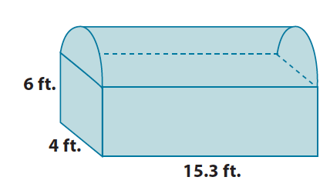
- a. Write an expression that can be used to find the volume of the chest shown below. Explain what each part of
your expression represents.

  - What is the approximate volume of the chest shown below? Use $3.14$ for $π$. Round your final answer to the tenths place.

- a. Write an expression that can be used to find the volume of the figure shown below. Explain what each part of
your expression represents.
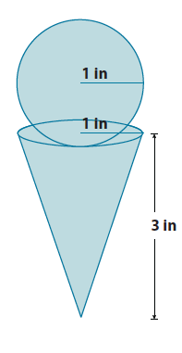

  - Assuming every part of the cone can be filled with ice cream, what is the exact and approximate volume of the cone and scoop? (Recall that exact answers are left in terms of $π$ and approximate answers use $3.14$ for $π$). Round your approximate answer to the hundredths place.

- a. Write an expression that can be used to find the volume of the figure shown below. Explain what each part of
your expression represents.
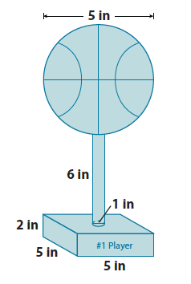

  - Every part of the trophy shown below is made out of silver. How much silver is used to produce one trophy? Give an exact and approximate answer rounded to the hundredths place.

- Use the diagram of scoops below to answer parts (a) and (b).
  - Order the scoops from least to greatest in terms of their volumes. Each scoop is measured in inches.
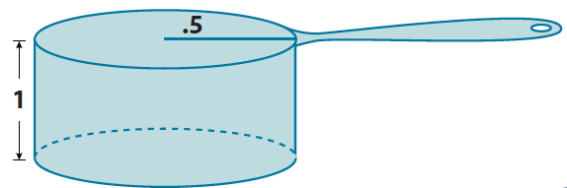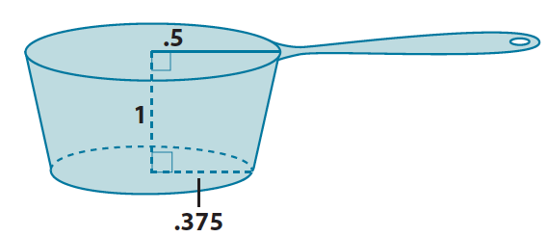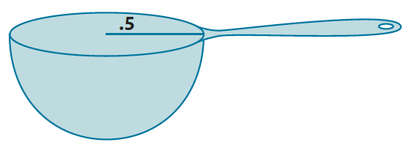

  - How many of each scoop would be needed to add a half-cup of sugar to a cupcake mixture? (One-half cup is approximately $7$in³.) Round your answer to a whole number of scoops.

Lesson Summary
Composite solids are figures that are comprised of more than one solid. Volumes of composites solids can be added as long as no parts of the solids overlap. That is, they touch only at their boundaries.
Problem Set

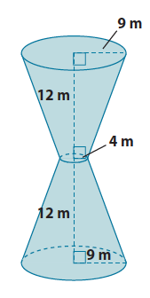
- What volume of sand would be required to completely fill up the hourglass shown below? Note: 12m is the height of the truncated cone, not the lateral length of the cone.

- a. Write an expression that can be used to find the volume of the prism with the pyramid portion removed.
Explain what each part of your expression represents.
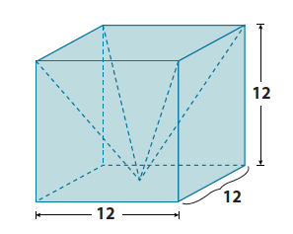

  - What is the volume of the prism shown above with the pyramid portion removed?

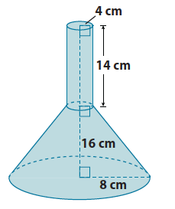
- a. Write an expression that can be used to find the volume of the funnel shown below. Explain what each part of
your expression represents.

  - Determine the exact volume of the funnel shown above.
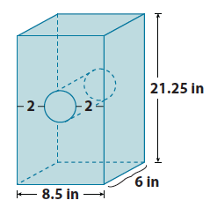
- What is the approximate volume of the rectangular prism with a cylindrical hole shown below? Use $3.14$ for $π.$ Round your answer to the tenths place.

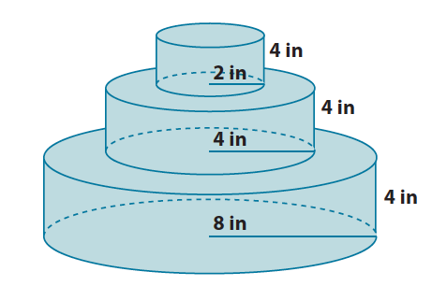
- A layered cake is being made to celebrate the end of the school year. What is the exact total volume of the cake shown below?

