Lesson 21: Volume of Composite Solids

Student Outcomes
- Students know how to determine the volume of a figure composed of combinations of cylinders, cones, and spheres.

Classwork
Exploratory Challenge/Exercises 1–4 (20 minutes)
A fact that students should know is that volumes can be added as long as the solids touch only on the boundaries of their figures. That is, there cannot be any overlapping sections. This is a key understanding that students should be able to figure out with the first exercise. Then allow them to work independently or in pairs to determine the volumes of composite solids in Exercises 1–4. All of the exercises include MP.1, where students persevere with some challenging problems and compare solution methods, and MP.2, where students explain how the structure of their expressions relate to the diagrams from which they were created.
Exercises 1–4
- a. Write an expression that can be used to find the volume of the chest shown below. Explain what each part of
your expression represents.
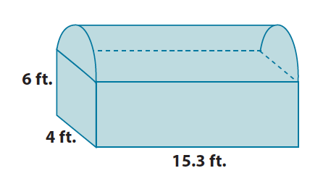
$$\left(4×15.3×6\right)+\frac{1}{2}\left(π2^{2}\left(15.3\right)\right)$$
The expression$\left(4×15.3×6\right)$represents the volume of the prism, and $\frac{1}{2}\left(π2^{2}\left(15.3\right)\right)$ is the volume of the half cylinder on top of the chest. Adding the volumes together will give the total volume of the chest.

  - What is the approximate volume of the chest shown below? Use $3.14$for $π$. Round your final answer to the tenths place.
The rectangular prism at the bottom has the following volume:  $$V=4×15.3×6 \\ =367.2$$ | The half-cylinder top has the following volume:  $$V=\frac{1}{2}\left(π2^{2}\left(15.3\right)\right) \\ =\frac{1}{2}\left(61.2π\right) \\ =30.6π \\ =96.084$$
The total volume of the chest shown is $367.2+96.084=463.284 ≈463.3$ ft ³.

Once students have finished the first exercise, ask them what they noticed about the total volume of the chest and what they noticed about the boundaries of each figure that comprised the shape of the chest. These questions illustrate the key understanding that volume is additive as long as the solids touch only at the boundaries and do not overlap.
- a. Write an expression that can be used to find the volume of the figure shown below. Explain what each part
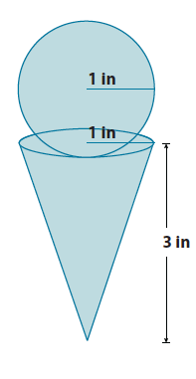
of your expression represents.
$$\frac{4}{3}π1^{3}+\frac{1}{3}π1^{2}\left(3\right)$$
The expression $\frac{4}{3}π1^{3}$ represents the volume of the sphere and $\frac{1}{3}π1^{2}\left(3\right)$ represents the volume of the cone. The sum of those two expressions gives the total volume of the figure.

  - Assuming every part of the cone can be filled with ice cream, what is the exact and approximate volume of the cone and scoop? (Recall that exact answers are left in terms of $π$ and approximate answers use $3.14$ for $π$). Round your approximate answer to the hundredths place.
The volume of the scoop is  $$V=\frac{4}{3}π1^{3} \\ =\frac{4}{3}π \\ ≈4.19$$ | The volume of the cone is  $$V=\frac{1}{3}π1^{2}\left(3\right) \\ =π \\ ≈3.14$$
The total volume of the cone and scoop is approximately $4.19+3.14=7.33$in³. The exact volume of the cone and scoop is $\frac{4}{3}π+π=\frac{7}{3}π$in³.

- a. Write an expression that can be used to find the volume of the figure shown below. Explain what each part
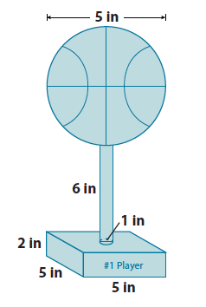
of your expression represents.
$$\left(5×5×2\right)+π{\left(\frac{1}{2}\right)}^{2}\left(6\right)+\frac{4}{3}π{\left(2.5\right)}^{3}$$
The expression $\left(5×5×2\right)$ represents the volume of the rectangular base, $π{\left(\frac{1}{2}\right)}^{2}\left(6\right)$ represents the volume of the cylinder, and $\frac{4}{3}π{\left(2.5\right)}^{3}$ is the volume of the sphere on top. The sum of the separate volumes gives the total volume of the figure.

  - Every part of the trophy shown is made out of silver. How much silver is used to produce one trophy? Give an exact and approximate answer rounded to the hundredths place.
The volume of the rectangular base is  $$V=5×5×2 \\ =50$$ | The volume of the cylinder holding up the basketball is  $$V=π{\left(\frac{1}{2}\right)}^{2}\left(6\right) \\ =\frac{1}{4}π\left(6\right) \\ =\frac{3}{2}π \\ ≈4.71$$ | The volume of the basketball is  $$V=\frac{4}{3}π{\left(2.5\right)}^{3} \\ =\frac{4}{3}π\left(15.625\right) \\ =\frac{62.5}{3}π \\ ≈65.42$$
The approximate total volume of silver needed to make the trophy is $50+4.71+65.42=120.13$in³. The exact volume of the trophy is $50+\frac{3}{2}π+\frac{62.5}{3}π=50+\left(\frac{3}{2}+\frac{62.5}{3}\right)π=50+\frac{134}{6}π=50+\frac{67}{3}π$ in³.
- Use the diagram of scoops below to answer parts (a) and (b).
  - Order the scoops from least to greatest in terms of their volumes. Each scoop is measured in inches.
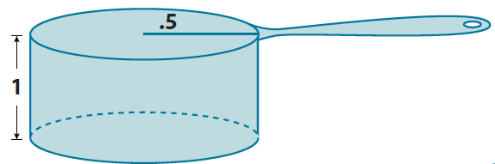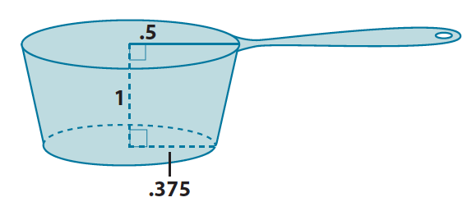
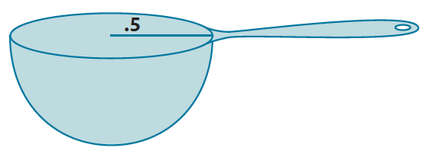
The volume of the cylindrical scoop is  $$V=π{\left(\frac{1}{2}\right)}^{2}\left(1\right) \\ =\frac{1}{4}π i{n.}^{3}$$ | The volume of the spherical scoop is  $$V=\frac{1}{2}\left(\frac{4}{3}π{\left(\frac{1}{2}\right)}^{3}\right) \\ =\frac{1}{2}\left(\frac{4}{3}π\left(\frac{1}{8}\right)\right) \\ =\frac{4}{48}π \\ =\frac{1}{12}π i{n.}^{3}$$ | The volume of the truncated cone scoop is  Let $x$ represent the height of the portion of the cone that was removed.  $$\frac{0.5}{0.375}=\frac{x+1}{x} \\ 0.5x=0.375\left(x+1\right) \\ 0.5x=0.375x+0.375 \\ 0.125x=0.375 \\ x=3$$
The volume of the small cone is  $$V=\frac{1}{3}π{\left(0.375\right)}^{2}\left(3\right) \\ =\frac{9}{64}π i{n.}^{3}$$ | The volume of the large cone is  $$V=\frac{1}{3}π{\left(0.5\right)}^{2}\left(4\right) \\ =\frac{1}{3}π i{n.}^{3}$$ | The volume of the truncated cone is  $$\frac{1}{3}π-\frac{9}{64}π=\left(\frac{1}{3}-\frac{9}{64}\right)π \\ =\frac{64-27}{192}π \\ =\frac{37}{192}π i{n.}^{3}$$
The three scoops have volumes of $\frac{1}{4}π$in³, $\frac{1}{12}π$in³, and $\frac{37}{192}π$in³. In order from least to greatest, they are $\frac{1}{12}π$in³, $\frac{37}{192}π$in³, and $\frac{1}{4}π$ in³. Then the spherical scoop is the smallest, followed by the truncated cone scoop, and lastly the cylindrical scoop.

  - How many of each scoop would be needed to add a half-cup of sugar to a cupcake mixture? (One-half cup is approximately $7$in³.) Round your answer to a whole number of scoops.
The cylindrical scoop is $\frac{1}{4}π$ in³, which is approximately $0.785$in³. Let $x$ be the number of scoops needed to fill one-half cup.
$$0.785x=7 \\ x=\frac{7}{0.785} \\ =8.9171… \\ ≈9$$
It would take about $9$ scoops of the cylindrical cup to fill one-half cup.
The spherical scoop is $\frac{1}{12}π$in³, which is approximately $0.262$in³. Let $x$ be the number of scoops needed to fill one-half cup.
$$0.262x=7 \\ x=\frac{7}{0.262} \\ =26.71755… \\ ≈27$$
It would take about $27$ scoops of the cylindrical cup to fill one-half cup.
The truncated cone scoop is $\frac{37}{192}π$in³, which is approximately $0.605$in³. Let $x$ be the number of scoops needed to fill one-half cup.
$$0.605x=7 \\ x=\frac{7}{0.605} \\ =11.57024… \\ ≈12$$
It would take about $12$ scoops of the cylindrical cup to fill one-half cup.

Discussion (15 minutes)
Ask students how they were able to determine the volume of each of the composite solids in Exercises 1–4. Select a student (or pair) to share their work with the class. Tell students that they should explain their process using the vocabulary related to the concepts needed to solve the problem. Encourage other students to critique the reasoning of their classmates and hold them all accountable for the precision of their language. The following questions could be used to highlight MP.1 and MP.2:
- Is it possible to determine the volume of the solid in one step? Explain why or why not.
- What simpler problems were needed in order to determine the answer to the complex problem?
- How did your method of solving differ from the one shown?
- What did you need to do in order to determine the volume of the composite solids?
- What symbols or variables were used in your calculations, and how did you use them?
- What factors might account for minor differences in solutions?
- What expressions were used to represent the figures they model?

Closing (5 minutes)
Summarize, or ask students to summarize the main points from the lesson:
- As long as no parts of solids overlap, we can add their volumes together.
- We know how to use the formulas for cones, cylinders, spheres, and truncated cones to determine the volume of a composite solid.
Lesson Summary
Composite solids are figures that are comprised of more than one solid. Volumes of composites solids can be added as long as no parts of the solids overlap. That is, they touch only at their boundaries.

Exit Ticket (5 minutes)
Name Date
Lesson 21: Volume of Composite Solids

Exit Ticket

Andrew bought a new pencil like the one shown below on the left. He used the pencil every day in his math class for a week, and now his pencil looks like the one shown below on the right. How much of the pencil, in terms of volume, did he use?
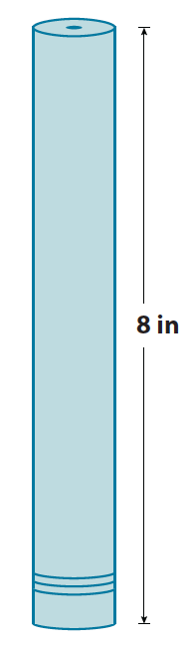
Note: Figures not drawn to scale.

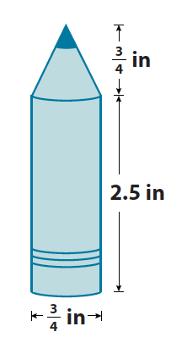
Exit Ticket Sample Solutions

Andrew bought a new pencil like the one shown below on the left. He used the pencil every day in his math class for a week, and now his pencil looks like the one shown below on the right. How much of the pencil, in terms of volume, did he use?
$$V=π(0.375)^{2}8 \\ V=1.125π$$
Volume of the pencil at the beginning of the week was $1.125π$in³.
$$V= π(0.375)^{2}2.5 \\ V=0.3515π$$
The volume of the cylindrical part of the pencil is $0.3515π$ in³.
$$V=\frac{1}{3}π(0.375)^{2}(0.75) \\ V=\frac{0.1054}{3}π \\ V=0.0351π$$
The volume of the cone part of the pencil is $0.0351π$ in ³.
$$0.3515π+0.0351π=\left(0.3515+0.0351\right)π=0.3866π.$$
The total volume of the pencil after a week is $0.3866π$in³.
$$1.125π-0.3866π=\left(1.125-0.3866\right)π=0.7384π.$$
In one week, Andrew used $0.7384π$ in³ of the pencil’s total volume.

Problem Set Sample Solutions

- What volume of sand would be required to completely fill up the hourglass shown below? Note: 12m is the height of the truncated cone, not the lateral length of the cone.
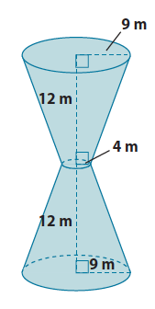
Let $x$ represent the height of the portion of the cone that has been removed.
$$\frac{4}{9}=\frac{x}{x+12} \\ 4\left(x+12\right)=9x \\ 4x+48=9x \\ 48=5x \\ \frac{48}{5}=x \\ 9.6=x$$
The volume of the removed cone is  $$V=\frac{1}{3}π4^{2}\left(9.6\right) \\ =\frac{153.6}{3}π$$ | The volume of the cone is  $$V=\frac{1}{3}π9^{2}\left(21.6\right) \\ =\frac{1,749.6}{3}π$$

The volume of one truncated cone is
$$\frac{1,749.6}{3}π-\frac{153.6}{3}π=\left(\frac{1,749.6}{3}-\frac{153.6}{3}\right)π \\ =\frac{1,596}{3}π \\ =532 π$$
The volume of sand needed to fill the hourglass is $1,064π$ m³.
- a. Write an expression that can be used to find the volume of the prism with the pyramid portion removed.
Explain what each part of your expression represents.
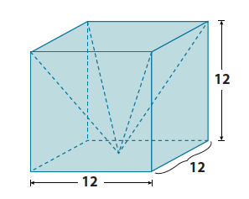
$$12^{3}-\frac{1}{3}\left(12^{3}\right)$$
The expression $12^{3}$ is the volume of the cube and $\frac{1}{3}\left(12^{3}\right)$ is the volume of the pyramid. Since the pyramid’s volume is being removed from the cube, then we subtract the volume of the pyramid from the cube.

  - What is the volume of the prism shown above with the pyramid portion removed?
The volume of the prism is  $$V=12^{3} \\ =1,728$$ | The volume of the pyramid is  $$V=\frac{1}{3}\left(1,728\right) \\ =576$$
The volume of the prism with the pyramid removed is $1,152$units³.

- a. Write an expression that can be used to find the volume of the funnel shown below. Explain what each part
of your expression represents.
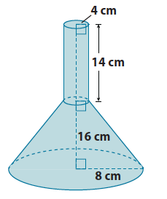
$$π4^{2}\left(14\right)+\left(\frac{1}{3}π8^{2}\left(x+16\right)-\frac{1}{3}π4^{2}\left(x\right)\right)$$
The expression $π4^{2}\left(14\right)$ represents the volume of the cylinder. The expression $\left(\frac{1}{3}π8^{2}\left(x+16\right)-\frac{1}{3}π4^{2}\left(x\right)\right)$ represents the volume of the truncated cone. The $x$ represents the unknown height of the smaller cone. When the volume of the cylinder is added to the volume of the truncated cone, then we will have the volume of the funnel shown.

  - Determine the exact volume of the funnel shown above.
The volume of the cylinder is
$$V=π4^{2}\left(14\right) \\ =224π$$
Let $x$ be the height of the cone that has been removed.
$$\frac{4}{8}=\frac{x}{x+16} \\ 4\left(x+16\right)=8x \\ 4x+64=8x \\ 64=4x \\ 16=x$$
The volume of the small cone is  $$V=\frac{1}{3}π4^{2}\left(16\right) \\ =\frac{256}{3}π$$ | The volume of the large cone is  $$V=\frac{1}{3}π8^{2}\left(32\right) \\ =\frac{2,048}{3}π$$
The volume of the truncated cone is
$$\frac{2,048}{3}π-\frac{256}{3}π=\left(\frac{2,048}{3}-\frac{256}{3}\right)π \\ =\frac{1,792}{3}π$$
The volume of the funnel is $224π+\frac{1,792}{3}π=821\frac{1}{3}π$cm³.

- What is the approximate volume of the rectangular prism with a cylindrical hole shown below? Use $3.14$ for $π$. Round your answer to the tenths place.
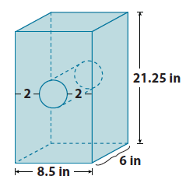
The volume of the prism is
$$V=8.5(6)(21.25) \\ =1,083.75$$
The volume of the cylinder is
$$V=π{\left(2.25\right)}^{2}\left(6\right) \\ =30.375π \\ ≈95.3775$$
The volume of the prism with the cylindrical hole is
$1,083.75-95.3775=988.3725≈988.4$in³.

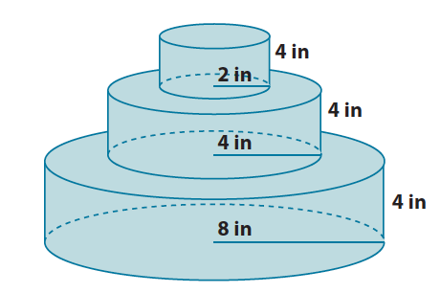
- A layered cake is being made to celebrate the end of the school year. What is the exact total volume of the cake shown below?
The bottom layer’s volume is  $$V=8^{2}π\left(4\right) \\ =256π$$ | The middle layer’s volume is  $$V=4^{2}π\left(4\right) \\ =64π$$ | The top layer’s volume is  $$V=2^{2}π\left(4\right) \\ =16π$$

The total volume of the cake is
$256π+64π+16π=\left(256+64+16\right)π=336π$in³

