Lesson 24
Objective: Add a pair of two-digit numbers when the ones digits have a sum less than or equal to 10.

Suggested Lesson Structure
 Application Problem (5 minutes)
 Fluency Practice (14 minutes)
 Concept Development (31 minutes)
 Student Debrief (10 minutes)
Total Time (60 minutes)
Application Problem (5 minutes)
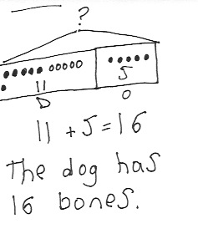A dog hides 11 bones behind his doghouse. Later, his owner gives him 5 more bones. How many bones does the dog have now? Use the RDW process to share your thinking as you solve the problem.
Extension: All the bones are brown or white. The same number of bones are brown as white. How many brown bones does the dog have?
Note: This problem reviews the add to with result unknown problem type so that students can focus on the drawing and labeling of the tape diagram. In the extension, students are challenged to consider the relationship between the two parts. Keep at least one student work sample to use as a comparison during Lesson 25’s Debrief.
Fluency Practice (14 minutes)
- Grade 1 Core Fluency Differentiated Practice Sets 1.OA.6 (5 minutes)
- Number Bond Addition and Subtraction 1.OA.6 (4 minutes)
- Count by 10 or 1 with Dimes and Pennies 1.NBT.5, 1.MD.3 (3 minutes)
- Add Tens 1.NBT.4 (2 minutes)
Grade 1 Core Fluency Differentiated Practice Sets (5 minutes)
Materials: (S) Core Fluency Practice Sets (Lesson 23 Core Fluency Practice Sets)
Note: This activity assesses students’ progress toward mastery of the required addition fluency for first graders. Give Practice Set B to students who correctly answered all questions on Practice Set A in the previous lesson. All other students should try to improve their scores on Practice Set A.
Students complete as many problems as they can in 90 seconds. Assign a counting pattern and start number for early finishers, or tell them to practice make ten addition or subtraction on the back of their papers. Collect and correct any Practice Set completed within the allotted time.
Number Bond Addition and Subtraction (4 minutes)
Materials: (S) Personal white board, die per pair of students
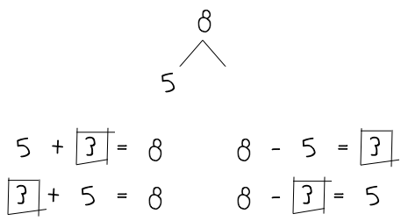
Note: This fluency activity addresses Grade 1’s core fluency requirement and strengthens understanding of the relationship between addition and subtraction.
Repeat the activity from Lesson 21. Today, assign partners of equal ability and an appropriate range of numbers for each pair. Allow partners to choose a number for their whole and roll the die to determine one of the parts. Both students write two addition and two subtraction sentences with a box for the missing number in each equation and solve for the missing number. They then exchange personal white boards and check each other’s work.
Count by 10 or 1 with Dimes and Pennies (3 minutes)
Materials: (T) 10 dimes and 10 pennies
Note: This fluency activity uses dimes and pennies as abstract representations of tens and ones to help students become familiar with coins, while simultaneously providing practice with counting forward and back by 10 or 1.
- Minute 1: Place and take away dimes in a 5-group formation as students count along by 10.
- Minute 2: Begin with 2 pennies. Ask how many ones there are. Instruct students to start at 2 and add and subtract 10 as you place and take away dimes.
- Minute 3: Begin with 2 dimes. Ask how many tens there are. Instruct students to begin at 20 and add and subtract 1 as you place and take away pennies.
Add Tens (2 minutes)
Materials: (T) 100-bead Rekenrek
Note: Reviewing how to add multiples of 10 enables students to utilize their understanding of place value to add 2 two-digit numbers in today’s lesson.
T: (Show 14 on the Rekenrek.) Add 10.
S: 14 + 10 = 24.
T: Add 20.
S 14 + 20 = 34.
Repeat, displaying other teen numbers and instructing students to add 10 and 20. If students find it challenging to mentally add 20, scaffold by asking them to add 2 tens and modeling with the Rekenrek before asking them to add 20.
Concept Development (31 minutes)
Materials: (T) 5 ten-sticks (3 red and 2 yellow), chart paper (S) 4 ten-sticks from math toolkit, personal white board

NOTES ON
MULTIPLE MEANS
OF EXPRESSION:
At this stage of development, students will typically start in the highest place, in this case, the tens place. This is an acceptable strategy for addition at any level. Starting with the ones place only makes the standard algorithm easier and is not necessary until students are adding larger numbers with regrouping in multiple places.
Students gather in the meeting area with their partners and materials.
T: (Write 24 + 13.) Partner A, show 24 with your cubes. Partner B, show 13 with your cubes.
S: (Show 24 or 13 with cubes.)
T: Combine your cubes to show the easiest way to find the total.
S: (Add cubes.)
T: How did you add 24 and 13?
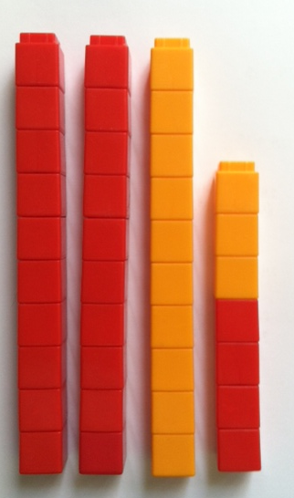
S: We put the tens together, and the ones together.
We put 2 tens and 1 ten together. We put 4 ones and 3 ones together. We have 3 ten-sticks and 7 ones. We made 37.
T: I love the way you combined the tens with tens and ones with ones together. 2 tens and 1 ten is…?
S: 3 tens.
T: 4 ones and 3 ones is…?
S: 7 ones.
T: 3 tens 7 ones is…?
S: 37.
T: 24 + 13 is…?
S: 37.
T: (Complete the number sentence. Then, show 24 using red cubes.) You are experts at working with tens. You know how to add tens to any number just like we practiced during fluency today. Let’s use that skill to add 24 and 13. Let’s add 10 from 13 to 24 first.
NOTES ON
MULTIPLE MEANS
OF ENGAGEMENT:
Appropriate scaffolds help all students feel successful. Some students may get the tens and ones confused when adding. Students may use place value charts to write the numbers in that they are adding to help them move toward visualizing. Using their ten-sticks and ones cubes will also help these students eventually move from concrete to abstract.

T: (Place the ten-stick next to 2 ten-sticks.) 1 ten more than 2 tens 4 is…?
S: 3 tens 4.
T: What do I need to still add?
S: 3 ones.
T: (Place 3 yellow cubes on top of 4 red cubes.) 34 and 3 is…?
S: 37.
T: We just used our expertise on tens by adding 1 ten to 24 first.
T: Let’s use a number bond to do the same thing. How did we break apart 13?
S: 10 and 3.
T: (Draw the number bond.) What did we do first? (Point to the number bond.)
S: Add 10. (Write 24 + 10.)
T: 24 + 10 is…?
S: 34.
T: Next? (Point to the number bond.)
S: Add 3.
T: 34 + 3 is…?
S: 37.
T: Now, you write the two addition sentences to show how we added 1 ten first.
S: (Write 24 + 10 = 34 and 34 + 3 = 37.)
T: Let’s try a new problem. (Write 24 + 16.) Partner A, make 24 with your linking cubes. Partner B, make 16. (Wait.) What part of 16 did we add first when we added 24 + 13?
S: 10.
T: Add 10 to 24. What is the result?
S: (Lay down a ten-stick next to 2 ten-sticks.) 34.
T: What more do we have to add?
S: 6.
T: How much do you have altogether?
S: 40.
T: Show us what you did.
S: We made another ten-stick with 4 and 6. Now, we have 4
ten-sticks. That’s 40. 4 ones and 6 ones is 10 ones. 3 tens and 10 ones is the same as 40. That’s what we did yesterday!
T: Make a number bond and write two number sentences to record how you solved 24 + 16. We started with 24. Let’s break apart 16 into…?
S: 10 and 6. (Break apart 16 into 10 and 6.) If needed, have students represent their process of adding 24 and 16 in quick ten drawings, talking through the steps with their partners. Ask students to also write two addition sentences to record their steps.
NOTES ON
MULTIPLE MEANS
OF ENGAGEMENT:
Remember to provide challenging extensions for students working above grade level. Give them one two-digit number and the sum. Have students find the mystery two-digit addend.

Repeat the process following the suggested sequence: 22 + 14, 23 + 16, 23 + 17, 19 + 21, 22 + 18, and 12 + 28 (start with 28, the bigger addend, then add 10 and 2).
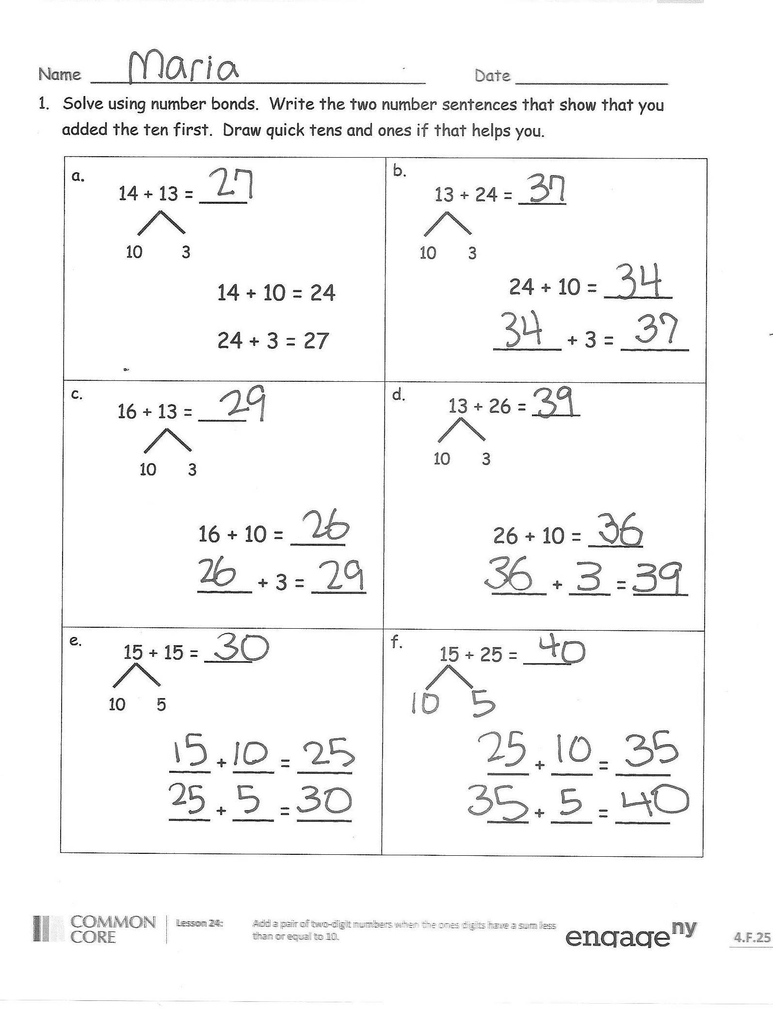
Problem Set (10 minutes)
Students should do their personal best to complete the Problem Set within the allotted 10 minutes. For some classes, it may be appropriate to modify the assignment by specifying which problems they work on first. Some problems do not specify a method for solving. Students should solve these problems using the RDW approach used for Application Problems.
Student Debrief (10 minutes)
Lesson Objective: Add a pair of two-digit numbers when the ones digits have a sum less than or equal to 10.
The Student Debrief is intended to invite reflection and active processing of the total lesson experience.
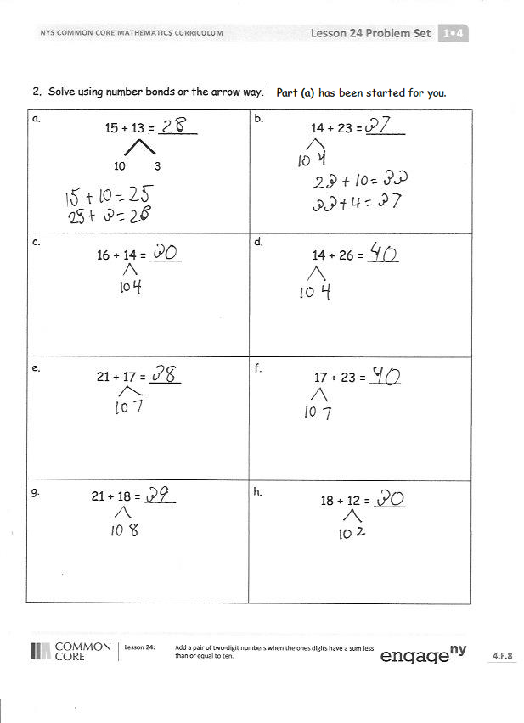
Invite students to review their solutions for the Problem Set. They should check work by comparing answers with a partner before going over answers as a class. Look for misconceptions or misunderstandings that can be addressed in the Debrief. Guide students in a conversation to debrief the Problem Set and process the lesson. Any combination of the questions below may be used to lead the discussion.
- How did you solve Problem 1(d)? Which addend did you start with and why?
- How can setting up for Problem 1(e) help you solve Problem 1(f)?
- How can setting up for Problem 2(e) help you solve Problem 2(f)?
- What new strategy did we use to add 2 two-digit addends?
- How did the Application Problem connect to today’s lesson?
Exit Ticket (3 minutes)
After the Student Debrief, instruct students to complete the Exit Ticket. A review of their work will help with assessing students’ understanding of the concepts that were presented in today’s lesson and planning more effectively for future lessons. The questions may be read aloud to the students.
Name Date
- Solve using number bonds. Write the two number sentences that show that you added the ten first. Draw quick tens and ones if that helps you.
a.  14 + 13 = ____  10  3  10  14 + 10 = 24  24 + 3 = 27 | b.  13 + 24 = ____  10  3  24 + 10 = _____  _____ + 3 = _____
c.  16 + 13 = ____  10  3  16 + 10 = ____  ____ + 3 = ____ | d.  10  3  13 + 26 = ____  26 + 10 = ____  ____ + ___ = ____
e.  15 + 15 = ____  10  5  ___ + ___ = ____  ___ + ___ = ____ | f.  ___ + ___ = ____  ___ + ___ = ____  15 + 25 = ____
- Solve using number bonds or the arrow way. Part (a) has been started for you.
a.  10  3 | b.  14 + 23 = ____
c.  16 + 14 = ____ | d.  14 + 26 = ____
e.  21 + 17 = ____ | f.  17 + 23 = ____
g.  21 + 18 = ____ | h.  18 + 12 = ____

Name Date
Solve using number bonds. Write the two number sentences that show that you added the ten first.
13 + 26 = _____  1.  ____ + ____ = ____  ____ + ____ = ____ | 19 + 21 = _____  2.  ____ + ____ = ____  ____ + ____ = ____

Name Date
- Solve using number bonds. Write the two number sentences that show that you added the ten first. Draw quick tens and ones if that helps you.
a.  13 + 16 = ____  3  10  16 + 10 = 26  26 + 3 = 29 | b.  16 + 23 = ____  10  6  23 + 10 = _____  _____ + 6 = _____
c.  16 + 14 = ____  10  4  16 + 10 = ____  ____ + 4 = ____ | d.  14 + 26 = ____  10  4  26 + 10 = ____  ____ + ___ = ____
e.  17 + 13 = ____  10  3  ___ + ___ = ____  ___ + ___ = ____ | f.  ___ + ___ = ____  ___ + ___ = ____  27 + 13 = ____
- Solve using number bonds. Part (a) has been started for you.
a.  14 + 13 = ____  15 + 13 = ____  10  3  ___ + ___ = ____  ___ + ___ = ____ | b.  24 + 14 = _____  ___ + ___ = ____  ___ + ___ = ____
c.  15 + 14 = ____ | d.  24 + 15 = ____
e.  22 + 17 = ____ | f.  27 + 12 = ____
g.  18 + 12 = ____ | h.  28 + 12 = ____

