Lesson 20: Truncated Cones

Classwork
Opening Exercise 1
- Examine the bucket below. It has a height of $9$ inches and a radius at the top of the bucket of$4$ inches.

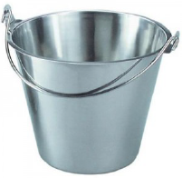

  - Describe the shape of the bucket. What is it similar to?

  - Estimate the volume of the bucket.

Example 1
Determine the volume of the truncated cone shown below.
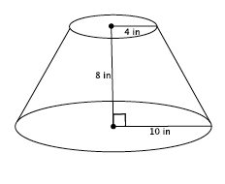
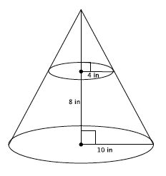

Exercises 2–6
- Find the volume of the truncated cone.
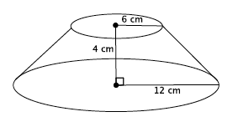
  - Write a proportion that will allow you to determine the height of the cone that has been removed. Explain what all parts of the proportion represent.

  - Solve your proportion to determine the height of the cone that has been removed.

  - Write an expression that can be used to determine the volume of the truncated cone. Explain what each part of the expression represents.

  - Calculate the volume of the truncated cone.

- Find the volume of the truncated cone.
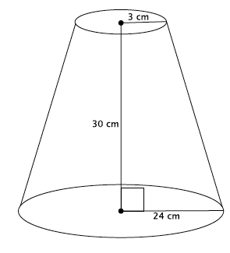

- Find the volume of the truncated pyramid with a square base.
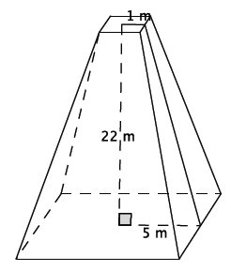
  - Write a proportion that will allow you to determine the height of the cone that has been removed. Explain what all parts of the proportion represent.

  - Solve your proportion to determine the height of the pyramid that has been removed.

  - Write an expression that can be used to determine the volume of the truncated pyramid. Explain what each part of the expression represents.

  - Calculate the volume of the truncated pyramid.

- A pastry bag is a tool used to decorate cakes and cupcakes. Pastry bags take the form of a truncated cone when filled with icing. What is the volume of a pastry bag with a height of $6$ inches, large radius of $2$ inches, and small radius of $0.5$ inches?

- Explain in your own words what a truncated cone is and how to determine its volume.

Lesson Summary
A truncated cone or pyramid is a solid figure that is obtained by removing the top portion above a plane parallel to the base. Shown below on the left is a truncated cone. A truncated cone with the top portion still attached is shown below on the right.
Truncated cone: | Truncated cone with top portion attached:
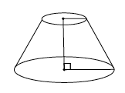 | 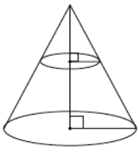
To determine the volume of a truncated cone, you must first determine the height of the portion of the cone that has been removed using ratios that represent the corresponding sides of the right triangles. Next, determine the volume of the portion of the cone that has been removed and the volume of the truncated cone with the top portion attached. Finally, subtract the volume of the cone that represents the portion that has been removed from the complete cone. The difference represents the volume of the truncated cone.
Pictorially,
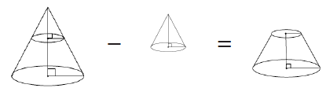
Problem Set

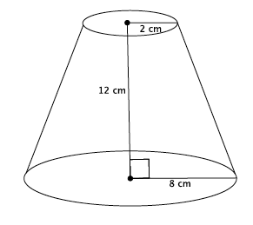
- Find the volume of the truncated cone.
  - Write a proportion that will allow you to determine the height of the cone that has been removed. Explain what all parts of the proportion represent.
  - Solve your proportion to determine the height of the cone that has been removed.
  - Show a fact about the volume of the truncated cone using an expression. Explain what each part of the expression represents.
  - Calculate the volume of the truncated cone.
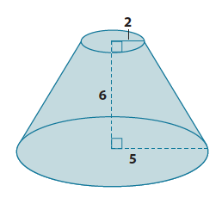
- Find the volume of the truncated cone.

- Find the volume of the truncated pyramid with a square base.
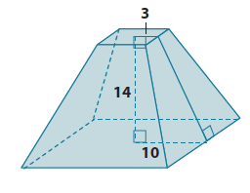
- Find the volume of the truncated pyramid with a square base. Note: $3$ mm is the distance from the center to the edge of the square at the top of the figure.
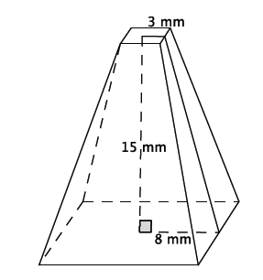

- Find the volume of the truncated pyramid with a square base. Note: $0.5$ cm is the distance from the center to the edge of the square at the top of the figure.

- Explain how to find the volume of a truncated cone.
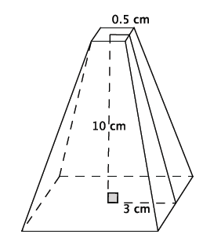

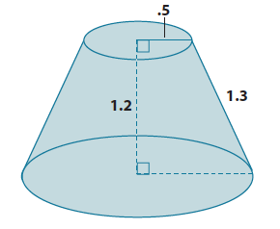
- Challenge: Find the volume of the truncated cone.

