Lesson 20: Truncated Cones

Student Outcomes
- Students know that truncated cones and pyramids are solids obtained by removing the top portion above a plane parallel to the base.
- Students find the volume of truncated cones.

Lesson Notes
Finding the volume of a truncated cone is not explicitly stated as part of the eighth grade standards; however, finding the volume of a truncated cone combines two major skills learned in this grade, specifically, understanding similar triangles and their properties and calculating the volume of a cone. This topic is included because it provides an application of seemingly unrelated concepts. Furthermore, it allows students to see how learning one concept, similar triangles and their properties, can be applied to three-dimensional figures. Teaching this concept also reinforces students’ understanding of similar triangles and how to determine unknown lengths of similar triangles.

Classwork
Opening Exercise (5 minutes)
Opening Exercise
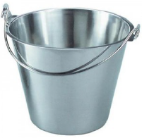
- Examine the bucket below. It has a height of $9$ inches and a radius at the top of the bucket of$4$ inches.

  - Describe the shape of the bucket. What is it similar to?
  - Estimate the volume of the bucket.

Discussion (10 minutes)
Before beginning the discussion, have students share their thoughts about the Opening Exercise. Students will likely say that the bucket is cone-shaped but not a cone or that it is cylinder-shaped but tapered. Any estimate between $48π$ in³ (the volume of a cone with the given dimensions) and $144π$ in³ (the volume of a cylinder with the given dimensions) is reasonable. Then continue with the discussion below.
- When the top, narrower portion of a cone is removed, specifically so that the base of the portion that is removed is parallel to the existing base, the resulting shape is what we call a truncated cone.
Here we have a cone:
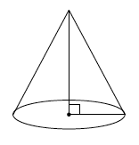
Here we have a truncated cone:
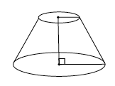
What is the shape of the portion that has been removed?
  - The portion of the figure that has been removed will look like a cone. It will be a cone that is smaller than the original.
- Here is the cone and the part that has been removed together in one drawing.
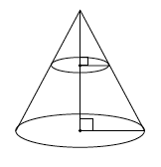
Do you think the right triangles shown in the diagram are similar? Explain how you know.
Provide students time to discuss in groups the answer to the question. Then have students share their reasoning as to why the triangles are similar.
  - Yes, the triangles are similar. Mark the top of the cone point $O.$ Then a dilation from $O$ by scale factor $r$ would map one triangle onto another. We also know that the triangles are similar because of the AA criterion. Each triangle has a right angle and they have a common angle at the top of the cone (from the center of dilation).
- What does that mean about the lengths of the legs and the hypotenuse of each right triangle?
  - It means that the corresponding side lengths will be equal in ratio.
- We will use all of these facts to help us determine the volume of a truncated cone.

Example 1 (10 minutes)
- Our goal is to determine the volume of the truncated cone shown below. Discuss in your groups how we might be able to do that.
Example 1
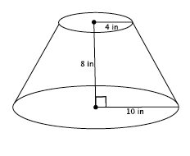
Determine the volume of the truncated cone shown below.
MP.1

Provide students time to discuss in groups a strategy for finding the volume of the truncated cone. Use the discussion questions below to guide their thinking as needed.
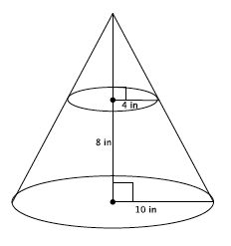
- Since we know that the original cone and the portion that has been removed to make this truncated cone are similar, let’s begin by drawing in the missing portion.
- We know the formula to find the volume of a cone. Is there enough information in the new diagram for us to find the volume? Explain.
  - No, there’s not enough information. We’d have to know the height of the cone and at this point we only know the height of the truncated cone, $8$ inches.
- Recall our conversation about the similar right triangles. We can use what we know about similarity to determine the height of the cone with the following proportion. What does each part of the proportion represent in the diagram?
MP.2
$$\frac{4}{10}=\frac{x}{x+8}$$
  - The $4$ is the radius of the small cone. The $10$ is the radius of the large cone. The $x$ represents the height of the small cone. The expression $x+8$ represents the height of the large cone.
- Work in your groups to determine the height of the small cone.
  - Since the triangles are similar, we will let $x$ represent the height of the cone that has been removed. Then
$$4\left(x+8\right)=10x \\ 4x+32=10x \\ 32=6x \\ \frac{32}{6}=x \\ 5.\overline{3}=x$$
- Now that we know the height of the cone that has been removed, we also know the total height of the cone. How might we use these pieces of information to determine the volume of the truncated cone?
  - We can find the volume of the large cone, find the volume of the small cone that was removed, and then subtract the volumes. What will be left is the volume of the truncated cone.
- Write an expression that represents the volume of the truncated cone. Use approximations for the heights since both are infinite decimals. Be prepared to explain what each part of the expression represents in the situation.
  - The volume of the truncated cone is given by the expression
$$\frac{1}{3}π{10}^{2}\left(13.3\right)-\frac{1}{3}π4^{2}\left(5.3\right)$$
where $\frac{1}{3}π{10}^{2}\left(13.3\right)$ is the volume of the large cone and $\frac{1}{3}π4^{2}\left(5.3\right)$ is the volume of the smaller cone. The difference in the volumes will be the volume of the truncated cone.
- Determine the volume of the truncated cone. Use the approximate value of the number $5.\overline{3}$ when you compute the volumes.
  - The volume of the small cone is
$$V=\frac{1}{3}π4^{2}\left(5.3\right) \\ =\frac{1}{3}π84.8 \\ =\frac{84.8}{3}π$$
The volume of the large cone is
$$V=\frac{1}{3}π{10}^{2}\left(13.3\right) \\ =\frac{1,330}{3}π$$
The volume of the truncated cone is
$$\frac{1,330}{3}π-\frac{84.8}{3}π=\left(\frac{1,330}{3}-\frac{84.8}{3}\right)π \\ =\frac{1,245.2}{3}π$$
The volume of the truncated cone is $\frac{1,245.2}{3}π$in³.
- Write an equivalent expression for the volume of a truncated cone that shows the volume is $\frac{1}{3}$ of the difference between two cylinders. Explain how your expression shows this.
MP.2
  - The expression $\frac{1}{3}π{10}^{2}\left(13.3\right)-\frac{1}{3}π4^{2}\left(5.3\right)$ can be written as $\frac{1}{3}\left(π{10}^{2}\left(13.3\right)-π4^{2}\left(5.3\right)\right)$, where $π{10}^{2}\left(13.3\right)$is the volume of the larger cylinder, and $π4^{2}\left(5.3\right)$ is the volume of the smaller cylinder. One-third of the difference is the volume of a truncated cone with the same base and height measurements as the cylinders.

Exercises 2–6 (10 minutes)
Students work in pairs or small groups to complete Exercises 2–6.
Exercises 2–6
- Find the volume of the truncated cone.
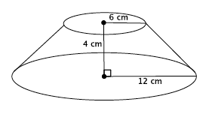
  - Write a proportion that will allow you to determine the height of the cone that has been removed. Explain what all parts of the proportion represent.
$$\frac{6}{12}=\frac{x}{x+4}$$
Let $x$ represent the height of the small cone. Then $x+4$ is the height of the large cone (with the removed part included). The $6$ represents the base radius of the removed cone, and the $12$ is the base radius of the large cone.

  - Solve your proportion to determine the height of the cone that has been removed.
$$6\left(x+4\right)=12x \\ 6x+24=12x \\ 24=6x \\ 4=x$$

  - Write an expression that can be used to determine the volume of the truncated cone. Explain what each part of the expression represents.
$$\frac{1}{3}π12^{2}\left(8\right)-\frac{1}{3}π6^{2}\left(4\right)$$
The expression $\frac{1}{3}π12^{2}\left(8\right)$ is the volume of the large cone, and $\frac{1}{3}π6^{2}\left(4\right)$ is the volume of the small cone. The difference of the volumes gives the volume of the truncated cone.
  - Calculate the volume of the truncated cone.
The volume of the small cone is  $$V=\frac{1}{3}π6^{2}\left(4\right) \\ =\frac{144}{3}π$$ | The volume of the large cone is  $$V=\frac{1}{3}π12^{2}\left(8\right) \\ =\frac{1,152}{3}π$$
The volume of the truncated cone is:
$$\frac{1,152}{3}π-\frac{144}{3}π=\left(\frac{1,152}{3}-\frac{144}{3}\right)π \\ =\frac{1,008}{3}π=336π$$
The volume of the truncated cone is $336π$cm³.

- Find the volume of the truncated cone.
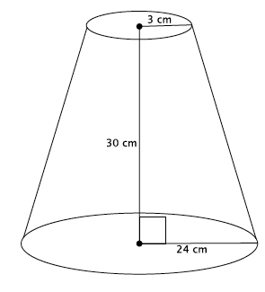
Let $x$ represent the height of the small cone.
$$\frac{3}{24}=\frac{x}{x+30} \\ 3x+90=24x \\ 90=21x \\ \frac{30}{7}=x \\ 4.3≈x$$
The volume of the small cone is  $$V=\frac{1}{3}π3^{2}\left(4.3\right) \\ =\frac{38.7}{3}π$$ | The volume of the large cone is  $$V=\frac{1}{3}π{24}^{2}\left(34.3\right) \\ =\frac{19,756.8}{3}π$$
The volume of the truncated cone is
$$\frac{19756.8}{3}π-\frac{38.7}{3}π=\left(\frac{19,756.8}{3}-\frac{38.7}{3}\right)π \\ =\frac{19,718.1}{3}π$$
The volume of the truncated cone is $\frac{19,718.1}{3}π$ cm³.
- Find the volume of the truncated pyramid with a square base.
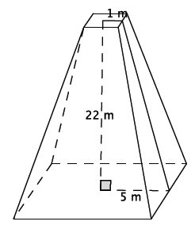

  - Write a proportion that will allow you to determine the height of the cone that has been removed. Explain what all parts of the proportion represent.
$$\frac{1}{5}=\frac{x}{x+22}$$
Let $x$ represent the height of the small pyramid. Then $x+22$ is the height of the large pyramid. The $1$ represents half of the length of the base of the small pyramid, and the $5$ represents half of the length of the base of the large pyramid.

  - Solve your proportion to determine the height of the pyramid that has been removed.
$$x+22=5x \\ 22=4x \\ 5.5=x$$

  - Write an expression that can be used to determine the volume of the truncated pyramid. Explain what each part of the expression represents.
$$\frac{1}{3}\left(100\right)27.5-\frac{1}{3}\left(4\right)5.5$$
The expression$\frac{1}{3}\left(100\right)27.5$ is the volume of the large pyramid, and $\frac{1}{3}\left(4\right)5.5$ is the volume of the small pyramid. The difference of the volumes gives the volume of the truncated pyramid.

  - Calculate the volume of the truncated pyramid.
The volume of the small pyramid is  $$V=\frac{1}{3}\left(4\right)5.5 \\ =\frac{22}{3}$$ | The volume of the large pyramid is  $$V=\frac{1}{3}\left(100\right)27.5 \\ =\frac{2,750}{3}$$ | The volume of the truncated pyramid is  $$\frac{2,750}{3}-\frac{22}{3}=\frac{2,728}{3}$$
The volume of the truncated pyramid is $\frac{2,728}{3}$m³.

- A pastry bag is a tool used to decorate cakes and cupcakes. Pastry bags take the form of a truncated cone when filled with icing. What is the volume of a pastry bag with a height of $6$ inches, large radius of $2$ inches, and small radius of $0.5$ inches?
Let $x$ represent the height of the small cone.
$$\frac{x}{x+6}=\frac{0.5}{2} \\ 2x= 0.5\left(x+6\right) \\ 2x=\frac{1}{2}x+3 \\ \frac{3}{2}x=3 \\ x=2$$
The volume of the small cone is  $$V=\frac{1}{3}π{\left(\frac{1}{2}\right)}^{2}\left(2\right) \\ =\frac{1}{6}π$$ | The volume of the large cone is  $$V=\frac{1}{3}π2^{2}\left(8\right) \\ =\frac{32}{3}π$$ | The volume of the truncated cone is  $$\frac{32}{3}π-\frac{1}{6}π=\left(\frac{32}{3}-\frac{1}{6}\right)π \\ =\frac{63}{6}π=\frac{21}{2}π$$
The volume of the pastry bag is $\frac{21}{2}π$in³ when filled.

- Explain in your own words what a truncated cone is and how to determine its volume.
A truncated cone is a cone with a portion of the top cut off. The base of the portion that is cut off needs to be parallel to the base of the original cone. Since the portion that is cut off is in the shape of a cone, then to find the volume of a truncated cone, you must find the volume of the cone (without any portion cut off), find the volume of the cone that is cut off, and then find the difference between the two volumes. That difference is the volume of the truncated cone.

Closing (5 minutes)
Summarize, or ask students to summarize, the main points from the lesson:
- A truncated cone or pyramid is a solid figure that is obtained by removing the top portion above a plane parallel to the base.
- Information about similar triangles can provide the information we need to determine the volume of a truncated figure.
- To find the volume of a truncated cone first find the volume of the part of the cone that was removed, then the total volume of the cone. Finally, subtract the removed cone’s volume from the total cone’s volume. What is leftover is the volume of the truncated cone.

Lesson Summary
A truncated cone or pyramid is a solid figure that is obtained by removing the top portion above a plane parallel to the base. Shown below on the left is a truncated cone. A truncated cone with the top portion still attached is shown below on the right.
Truncated cone: | Truncated cone with top portion attached:
 | 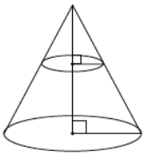
To determine the volume of a truncated cone, you must first determine the height of the portion of the cone that has been removed using ratios that represent the corresponding sides of the right triangles. Next, determine the volume of the portion of the cone that has been removed and the volume of the truncated cone with the top portion attached. Finally, subtract the volume of the cone that represents the portion that has been removed from the complete cone. The difference represents the volume of the truncated cone.
Pictorially,
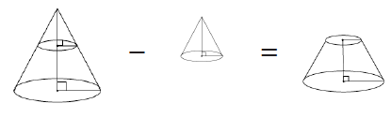

Exit Ticket (5 minutes)

Name Date
Lesson 20: Truncated Cones

Exit Ticket

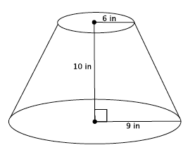
Find the volume of the truncated cone.

  - Write a proportion that will allow you to determine the height of the cone that has been removed. Explain what all parts of the proportion represent.

  - Solve your proportion to determine the height of the cone that has been removed.

  - Write an expression that can be used to determine the volume of the truncated cone. Explain what each part of the expression represents.

  - Calculate the volume of the truncated cone.

Exit Ticket Sample Solutions

Find the volume of the truncated cone.

  - Write a proportion that will allow you to determine the height of the cone that has been removed. Explain what all parts of the proportion represent.
$$\frac{6}{9}=\frac{x}{x+10}$$
Let $x$ represent the height of the small cone. Then $x+10$ is the height of the large cone. Then $6$ is the base radius of the small cone, and the $9$ is the base radius of the large cone.

  - Solve your proportion to determine the height of the cone that has been removed.
$$6\left(x+10\right)=9x \\ 6x+60=9x \\ 60=3x \\ 20=x$$

  - Write an expression that can be used to determine the volume of the truncated cone. Explain what each part of the expression represents.
$$\frac{1}{3}π9^{2}\left(30\right)-\frac{1}{3}π6^{2}\left(20\right)$$
The expression $\frac{1}{3}π9^{2}\left(30\right)$ represents the volume of the large cone, and $\frac{1}{3}π6^{2}\left(20\right)$ is the volume of the small cone. The difference in volumes represents the volume of the truncated cone.

  - Calculate the volume of the truncated cone.
The volume of the small cone is  $$V=\frac{1}{3}π6^{2}\left(20\right) \\ =\frac{720}{3}π$$ | The volume of the large cone is  $$V=\frac{1}{3}π9^{2}\left(30\right) \\ =\frac{2,430}{3}π$$ | The volume of the truncated cone is  $$\frac{2,430}{3}π-\frac{720}{3}π=\left(\frac{2,430}{3}-\frac{720}{3}\right)π \\ =\frac{1,710}{3}π \\ =570π$$
The volume of the truncated cone is $570π$ in ³.

Problem Set Sample Solutions
Students use what they know about similar triangles to determine the volume of truncated cones.

- Find the volume of the truncated cone.
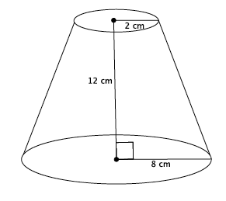
  - Write a proportion that will allow you to determine the height of the cone that has been removed. Explain what all parts of the proportion represent.
$$\frac{2}{8}=\frac{x}{x+12}$$
Let $x$ represent the height of the small cone. Then $x+12$ is the height of the large cone. The $2$ represents the base radius of the small cone, and the $8$ represents the base radius of the large cone.

  - Solve your proportion to determine the height of the cone that has been removed.
$$2\left(x+12\right)=8x \\ 2x+24=8x \\ 24=6x \\ 4=x$$

  - Show a fact about the volume of the truncated cone using an expression. Explain what each part of the expression represents.
$$\frac{1}{3}π8^{2}\left(16\right)-\frac{1}{3}π2^{2}\left(4\right)$$
The expression $\frac{1}{3}π8^{2}\left(16\right)$ represents the volume of the large cone, and $\frac{1}{3}π2^{2}\left(4\right)$ is the volume of the small cone. The difference in volumes gives the volume of the truncated cone.

  - Calculate the volume of the truncated cone.
The volume of the small cone is  $$V=\frac{1}{3}π2^{2}\left(4\right) \\ =\frac{16}{3}π$$ | The volume of the large cone is  $$V=\frac{1}{3}π8^{2}\left(16\right) \\ =\frac{1,024}{3}π$$ | The volume of the truncated cone is  $$\frac{1,024}{3}π-\frac{16}{3}π=\left(\frac{1,024}{3}-\frac{16}{3}\right)π \\ =\frac{1,008}{3}π \\ =336π$$
The volume of the truncated cone is $336π$cm³.

- Find the volume of the truncated cone.
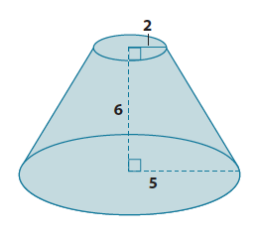
Let $x$ represent the height of the small cone.
$$\frac{2}{5}=\frac{x}{x+6} \\ 2\left(x+6\right)=5x \\ 2x+12=5x \\ 12=3x \\ 4=x$$
The volume of the small cone is  $$V=\frac{1}{3}π2^{2}\left(4\right) \\ =\frac{16}{3}π$$ | The volume of the large cone is  $$V=\frac{1}{3}π5^{2}\left(10\right) \\ =\frac{250}{3}π$$ | The volume of the truncated cone is  $$\frac{250}{3}π-\frac{16}{3}π=\left(\frac{250}{3}-\frac{16}{3}\right)π \\ =\frac{234}{3}π \\ =78π$$
The volume of the truncated cone is $78π$ units³.

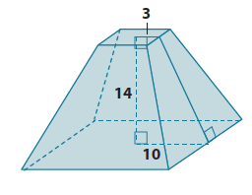
- Find the volume of the truncated pyramid with a square base.
Let $x$ represent the height of the small pyramid.
$$\frac{3}{10}=\frac{x}{x+14} \\ 3\left(x+14\right)=10x \\ 3x+42=10x \\ 42=7x \\ 6=x$$
The volume of the small pyramid is  $$V=\frac{1}{3}\left(36\right)\left(6\right) \\ =\frac{216}{3}$$ | The volume of the large pyramid is  $$V=\frac{1}{3}\left(400\right)\left(20\right) \\ =\frac{8,000}{3}$$ | The volume of the truncated pyramid is  $$\frac{8,000}{3}-\frac{216}{3}=\frac{7,784}{3}$$
The volume of the truncated pyramid is $\frac{7,784}{3}$units³$.$

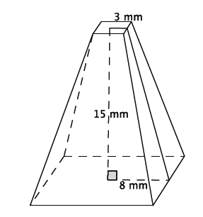
- Find the volume of the truncated pyramid with a square base. Note: $3$ mm is the distance from the center to the edge of the square at the top of the figure.
Let $x$ represent the height of the small pyramid.
$$\frac{3}{8}=\frac{x}{x+15} \\ 3\left(x+15\right)=8x \\ 3x+45=8x \\ 45=5x \\ 9=x$$
The volume of the small pyramid is  $$V=\frac{1}{3}\left(36\right)\left(9\right) \\ =108$$ | The volume of the large pyramid is  $$V=\frac{1}{3}\left(256\right)\left(24\right) \\ =2,048$$ | The volume of the truncated pyramid is  $$2,048-108=1,940$$
The volume of the truncated pyramid is $1,940$ mm³.

- Find the volume of the truncated pyramid with a square base. Note: $0.5$ cm is the distance from the center to the edge of the square at the top of the figure.
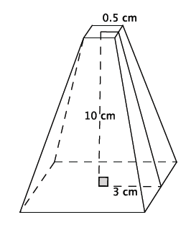
Let $x$ represent the height of the small pyramid.
$$\frac{0.5}{3}=\frac{x}{x+10} \\ \frac{1}{2}\left(x+10\right)=3x \\ \frac{1}{2}x+5=3x \\ 5=\frac{5}{2}x \\ 2=x$$
The volume of the small pyramid is  $$V=\frac{1}{3}\left(1\right)\left(2\right) \\ =\frac{2}{3}$$ | The volume of the large pyramid is  $$V=\frac{1}{3}\left(36\right)\left(12\right) \\ =\frac{432}{3}$$ | The volume of the truncated pyramid is  $$\frac{432}{3}-\frac{2}{3}=\frac{430}{3}$$
The volume of the truncated pyramid is $\frac{430}{3}$ cm³.

- Explain how to find the volume of a truncated cone.
The first thing you have to do is use the ratios of corresponding sides of similar triangles to determine the height of the cone that was removed to make the truncated cone. Once you know the height of that cone, you can determine its volume. Then you can find the height of the cone (the truncated cone and the portion that was removed). Once you know both volumes you can subtract the smaller volume from the larger volume. The difference is the volume of the truncated cone.

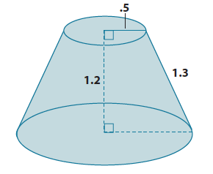
- Challenge: Find the volume of the truncated cone.
Since the height of the truncated cone is $1.2$ units, we can drop a perpendicular line from the top of the cone to the bottom of the cone so that we have a right triangle with a leg length of $1.2$ units and a hypotenuse of $1.3$ units. Then by the Pythagorean Theorem, if $b$ is the length of the leg of the right triangle, then
$$1.2^{2}+b^{2}=1.3^{2} \\ 1.44+b^{2}=1.69 \\ b^{2}=0.25 \\ b=0.5$$
The part of the radius of the bottom base found by the Pythagorean Theorem is $0.5$. When we add the length of the upper radius (because if you translate along the height of the truncated cone then it is equal to the remaining part of the lower base), then the radius of the lower base is $1$.
Let $x$ represent the height of the small cone:
$$\frac{0.5}{1}=\frac{x}{x+1.2} \\ \frac{1}{2}\left(x+1.2\right)=x \\ \frac{1}{2}x+0.6=x \\ 0.6=\frac{1}{2}x \\ 1.2=x$$
The volume of the small cone  $$V=\frac{1}{3}π\left(0.5^{2}\right)\left(1.2\right) \\ =\frac{0.3}{3}π$$ | The volume of the large cone is  $$V=\frac{1}{3}π\left(1^{2}\right)\left(2.4\right) \\ =\frac{2.4}{3}π$$ | The volume of the truncated cone is  $$\frac{2.4}{3}π-\frac{0.3}{3}π=\left(\frac{2.4}{3}-\frac{0.3}{3}\right)π \\ =\frac{2.1}{3}π \\ =0.7π$$
The volume of the truncated cone is $0.7π$ units³.

