Lesson 23
Objective: Interpret two-digit numbers as tens and ones, including cases with more than 9 ones.

Suggested Lesson Structure
 Application Problem (5 minutes)
 Fluency Practice (10 minutes)
 Concept Development (35 minutes)
 Student Debrief (10 minutes)
Total Time (60 minutes)
Application Problem (5 minutes)
Kim picks up 10 loose pencils and puts them in a cup. Ben has 1 package of 10 pencils that he adds to the cup. How many pencils are now in the cup? Use the RDW process to solve the problem.
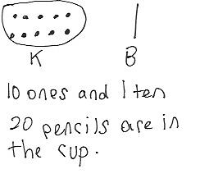
Note: This problem bridges the objectives from Lesson 19 through to today’s lesson. During the Debrief, students complete a place value chart to match the story and reinterpret the number 20 in several ways. As in Topic D, throughout Topic F the Application Problem starts the lesson so fluency activities flow into the Concept Development.
Fluency Practice (10 minutes)
- Grade 1 Core Fluency Differentiated Practice Sets 1.OA.6 (5 minutes)
- Count by 10 with Dimes 1.NBT.5, 1.MD.3 (2 minutes)
- Tens and Ones 1.NBT.4 (3 minutes)
Grade 1 Core Fluency Differentiated Practice Sets (5 minutes)
Materials: (S) Core Fluency Practice Sets
Note: Throughout Topic F and for the remainder of the year, each day’s fluency activity includes an opportunity for review and mastery of the sums and differences with totals through 10 by means of the Core Fluency Practice Sets or Sprints. Five options are provided in this lesson for the Core Fluency Practice Set, with Sheet A being the simplest addition fluency of the grade and Sheet E being the most complex. Start all students on Sheet A. Keeping a record of student progress is suggested to move students to more complex sheets as they are ready.
Students complete as many problems as they can in 90 seconds. Reaching 100% accuracy and completion is recommended before moving students to the next level. Collect any Practice Sheet that has been completed within the 90 seconds and check the answers. The next time Core Fluency Practice Sets are used, students who have successfully completed their set today can be provided with the next level.
For early finishers, assign a counting pattern and start number. Celebrate improvement, as well as advancement. Students should be encouraged to compete with themselves rather than their peers. Interview students on practice strategies. Notify caring adults of each student’s progress.
Count by 10 with Dimes (2 minutes)
Materials: (T) 10 dimes
Note: This fluency activity strengthens students’ ability to recognize a dime and identify its value, while providing practice with counting forward and back by 10.
Lay out and take away dimes in 5-group formation as students count by 10 both the regular way and the Say Ten Way.
Tens and Ones (3 minutes)
Materials: (T) 100-bead Rekenrek
Note: This fluency activity reviews how to decompose two-digit numbers into tens and ones with the Rekenrek, so students can see alternate decompositions in today’s lesson.
T: (Show a 16 on the Rekenrek). How many tens do you see?
S: 1 ten.
T: How many ones?
S: 6 ones.
T: Say the number the Say Ten Way.
S: Ten 6.
T: Good. 1 ten plus 6 ones is…?
S: 16.
T: 16 + 10 is…?
S: 26.
Slide over the next row and repeat for 26, and then 36. Continue with the following suggested sequence: 15, 25, 35, 45, 55, 65, 75; 17, 27, 37, 57, 97. Then, follow the same script, but ask students to subtract 10 instead of add 10, using the following suggested sequence: 39, 29, 19, 9; 51, 41, 31, etc.

Concept Development (35 minutes)
Materials: (T) Chart paper, place value chart (Lesson 2 Template 2) (optional) (S) Personal white board,
ten-sticks from math toolkit
Have students gather in the meeting area in a semicircle formation.
T: (Ask three student volunteers to come to the front.) Show us 3 tens using your magic counting sticks.
S: (Each student shows clasped hands.)
T: How many tens do you see?
S: 3 tens.
T: How many loose ones do you see?
S: 0 ones.
T: What is the value of 3 tens?
S: 30.
T: (Write 30 = 3 tens, and fill in the place value chart. Continue to chart student responses as they make other combinations of 30 using tens and ones.)
T: (Ask one student to unclasp her hands.) How many tens do you see?
S: 2 tens.
T: How many loose ones do you see?
S: 10 ones.
T: Do we still have 30? Explain how you know.
S: Yes! We didn’t add anything or take anything away. 1 ten became 10 ones, but they are the same amount. They have the same value.

NOTES ON
MULTIPLE MEANS
OF REPRESENTATION:
Careful selection of pairs for collaborative work is essential to achieving expected outcomes. This lesson will work well with heterogeneous groupings of students. Pair one student who possesses a clear understanding of the concept with another student who might need more practice with tens and ones. Pair an English language learner with another student who expresses his reasoning especially well.

T: How is 30 made here? (Chart the students’ answers.)
S: With 2 tens and 10 ones.
Repeat the process and ask the remaining students to unbundle their tens one at a time to show 1 ten 20 ones and, finally, 30 ones.
T: Let’s look at the chart. The number 30 can be represented in many different ways. 30 can be
made of…?
S: 3 tens, 2 tens 10 ones, 1 ten 20 ones, or 30 ones!
T: Get together with your partner and another pair of students. Show as many tens as you can using your magic counting sticks. (Allow time for group work.)
T: What is the largest amount of tens you can make?
S: 4 tens.
T: What is 4 tens?
S: 40.
T: Show more ways to make 40, and record them on your personal white board.
S: We made 3 tens 10 ones. 2 tens 20 ones. 1 ten 30 ones. 40 ones.
T: (Ask four volunteers to come to the front.) Show 37 using your magic counting sticks with as many tens as possible.
S: (Show 3 tens 7 ones.)
T: (Tap the third student on the shoulder.) If Student 3 unbundles his ten, how many tens and ones will we have?
S: 2 tens 17 ones.
T: Let’s check. Student 3, unbundle your magic counting sticks! Were we correct? Are there 2 tens and 17 ones?
S: Yes!
T: Explain to your partner how 2 tens 17 ones is the same as 37.
MP.7
S: 17 ones is the same as 1 ten and 7 ones. 2 tens and 1 ten is 3 tens. 7 more ones is 37.
T: Show 37 as 3 tens 7 ones again. If only 1 student shows 1 ten, how many ones will there be to make 37? 37 is the same as 1 ten and how many ones?
S: 1 ten 27 ones.
T: How did you know?
S: (Point to each student with unclasped hands.) 10, 20, 7 is 27. 2 students will have to unbundle their sticks, so that’s 20. 20 ones and 7 ones is 27 ones.
T: Let’s check. Student 1, keep your hands clasped. The other students with tens, unbundle and show 10 ones. (Wait.) 37 is the same as how many tens and how many ones?
S: 1 ten 27 ones.
Repeat the process, showing 0 tens 37 ones.
Have students work in pairs using linking cubes or working in groups of four using magic counting sticks to make all combinations of tens and ones to make 13, 23, 27, 34, and 38.
Next, write a number in the tens and ones place using the place value chart template (see image below), and ask students to determine the total value:
T: (Write 1 ten 15 ones on a place value chart.) What is the value of 1 ten 15 ones? You may use your cubes or work with your classmates and their magic counting sticks to show your thinking.
S: 10 plus 15 is 25. 1 ten is 10 ones. 10 ones and 15 ones is 25 ones. 15 ones is the same as 1 ten 5 ones. Add another 1 ten, and I have 2 tens 5 ones; that’s 25.
T: So, the value of 1 ten 15 ones is…?
S: 25.
Repeat the process with the following sequence:
- 1 ten 15 ones, 25 ones
- 3 tens 5 ones, 2 tens 15 ones, 1 ten 25 ones
- 31 ones, 2 ten 11 ones, 1 ten 21 ones, 3 tens 1 one
- 2 ten 16 ones, 3 tens 6 ones
- 1 ten 29 ones, 3 tens 9 ones
NOTES ON
MULTIPLE MEANS
OF REPRESENTATION:
As students complete the Problem Set, allow those who need more concrete practice to use their ten-sticks and ones cubes. Some students may not be able to visualize ones as tens especially when completing Problem 4. Support these students by having them lay out the numbers as they are matching. Their path to abstract thinking may be a little longer than those of other students.

Students may work in pairs and use their linking cubes or in groups of 4 using fingers to solve while others visualize every 10 ones as 1 ten.
Problem Set (10 minutes)
Students should do their personal best to complete the Problem Set within the allotted 10 minutes. For some classes, it may be appropriate to modify the assignment by specifying which problems they work on first.
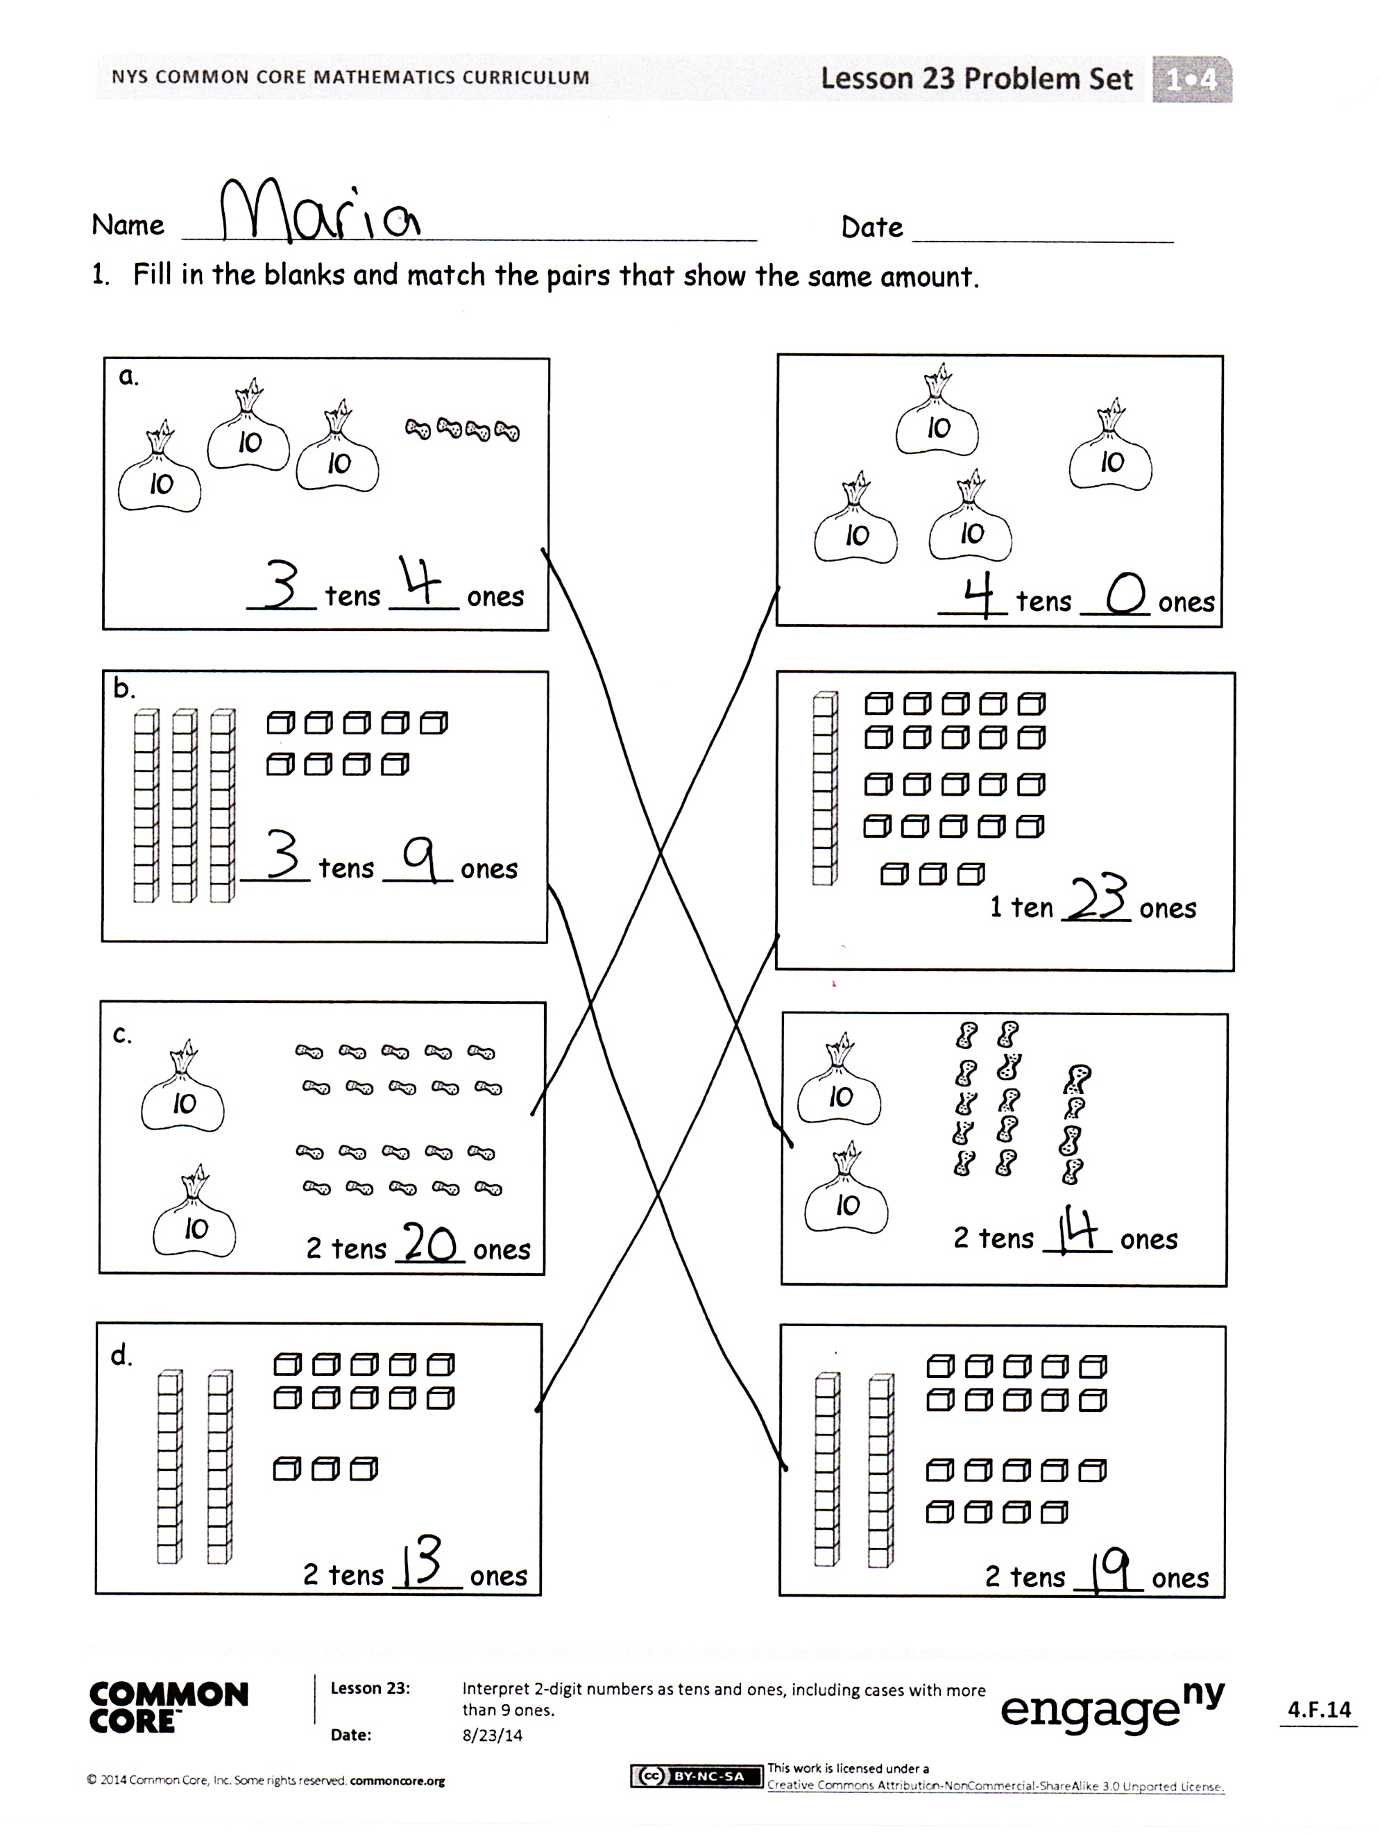
Student Debrief (10 minutes)
Lesson Objective: Interpret two-digit numbers as tens and ones, including cases with more than 9 ones.
The Student Debrief is intended to invite reflection and active processing of the total lesson experience.
Invite students to review their solutions for the Problem Set. They should check work by comparing answers with a partner before going over answers as a class. Look for misconceptions or misunderstandings that can be addressed in the Debrief. Guide students in a conversation to debrief the Problem Set and process the lesson.
Any combination of the questions below may be used to lead the discussion.
- How did you solve Problem 4? Explain your thinking.
- Look at Problem 1(d). A student says 2 tens 13 ones can be written as 213. How can you help this student understand why this is not correct?
- Look at Problem 2. Circle the place value charts that have two digits in the ones place. What do you notice?
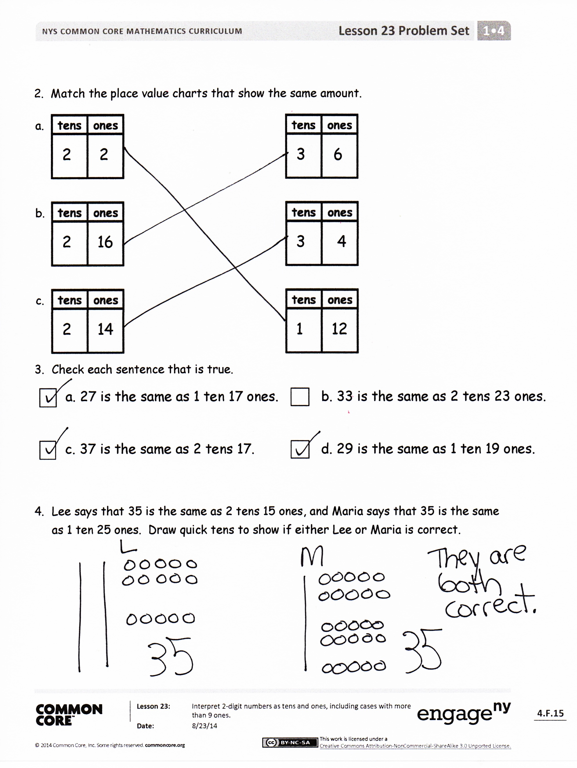
- Look at Problem 3. Circle the statement that is not true. Write down as many combinations of tens and ones as you can to make the statement true.
- How can using Say Ten counting help you find your combinations of tens and ones?
- How did the Application Problem connect to today’s lesson? How could we write the total number of pencils in the place value chart? What other combinations of tens and ones can we use to make this number?
Exit Ticket (3 minutes)
After the Student Debrief, instruct students to complete the Exit Ticket. A review of their work will help with assessing students’ understanding of the concepts that were presented in today’s lesson and planning more effectively for future lessons. The questions may be read aloud to the students.

Name Date
My Addition Practice
1. | 6 + 0 = ___ | 11. | 7 + 1 = ___ | 21. | 5 + 3 = ___
2. | 0 + 6 = ___ | 12. | ___ = 1 + 7 | 22. | ___ = 5 + 4
3. | 5 + 1 = ___ | 13. | 3 + 3 = ___ | 23. | 6 + 4 = ___
4. | 1 + 5 = ___ | 14. | 3 + 4 = ___ | 24. | 4 + 6 = ___
5. | 6 + 1 = ___ | 15. | ___ = 3 + 5 | 25. | ___ = 4 + 4
6. | 1 + 6 = ___ | 16. | 6 + 3 = ___ | 26. | 3 + 4 = ___
7. | 6 + 2 = ___ | 17. | 7 + 3 = ___ | 27. | 5 + 5 = ___
8. | 5 + 2 = ___ | 18. | ___ = 7 + 2 | 28. | ___ = 4 + 5
9. | 2 + 5 = ___ | 19. | 2 + 7 = ___ | 29. | 3 + 7 = ___
10. | 2 + 4 = ___ | 20. | 2 + 8 = ___ | 30. | ___ = 3 + 6
Today, I finished _____ problems.
I solved _____ problems correctly.

Name Date
My Missing Addend Practice
1. | 6 + ___ = 6 | 11. | 3 + ___ = 6 | 21. | 4 + ___ = 7
2. | 0 + ___ = 6 | 12. | 4 + ___ = 8 | 22. | 7 = 3 + ___
3. | 5 + ___ = 6 | 13. | 10 = 5 + ___ | 23. | 2 + ___ = 7
4. | 4 + ___ = 6 | 14. | 5 + ___ = 9 | 24. | 2 + ___ = 8
5. | 0 + ___ = 7 | 15. | 5 + ___ = 7 | 25. | 9 = 2 + ___
6. | 6 + ___ = 7 | 16. | 8 = 5 + ___ | 26. | 2 + ___ = 10
7. | 1 + ___ = 7 | 17. | 5 + ___ = 9 | 27. | 10 = 3 + ___
8. | 7 + ___ = 8 | 18. | 8 + ___ = 10 | 28. | 3 + ___ = 9
9. | 1 + ___ = 8 | 19. | 7 + ___ = 10 | 29. | 4 + ___ = 9
10. | 6 + ___ = 8 | 20. | 10 = 6 + ___ | 30. | 10 = 4 + ___
Today, I finished _____ problems.
I solved _____ problems correctly.

Name Date
My Related Addition and Subtraction Practice
1. | 5 + ___ = 6 | 11. | 7 + ___ = 10 | 21. | 4 + ___ = 8
2. | 1 + ___ = 6 | 12. | 10 – 7 = ___ | 22. | 8 – 4 = ___
3. | 6 - 1 = ___ | 13. | 5 + ___ = 7 | 23. | 4 + ___ = 7
4. | 9 + ___ = 10 | 14. | 7 – 5 = ___ | 24. | 7 – 4 = ___
5. | 1 + ___ = 10 | 15. | 5 + ___ = 8 | 25. | 5 + ___ = 9
6. | 10 – 9 = ___ | 16. | 8 – 5 = ___ | 26. | 9 – 5 = ___
7. | 5 + ___ = 10 | 17. | 4 + ___ = 6 | 27. | 6 + ___ = 9
8. | 10 – 5 = ___ | 18. | 6 – 4 = ___ | 28. | 9 – 6 = ___
9. | 8 + ___ = 10 | 19. | 3 + ___ = 6 | 29. | 4 + ___ = 7
10. | 10 – 8 = ___ | 20. | 6 – 3 = ___ | 30. | 7 – 4 = ___
Today, I finished _____ problems.
I solved _____ problems correctly.

Name Date
My Subtraction Practice
1. | 6 - 0 = ___ | 11. | 6 - 3 = ___ | 21. | 8 - 4 = ___
2. | 6 - 1 = ___ | 12. | 7 - 3 = ___ | 22. | 8 - 3 = ___
3. | 7 - 1 = ___ | 13. | 9 – 3 = ___ | 23. | 8 - 5 = ___
4. | 8 - 1 = ___ | 14. | 10 - 8 = ___ | 24. | 9 - 5 = ___
5. | 6 - 2 = ___ | 15. | 10 - 6 = ___ | 25. | 9 - 4 = ___
6. | 7 - 2 = ___ | 16. | 10 – 4 = ___ | 26. | 7 - 3 = ___
7. | 9 - 2 = ___ | 17. | 10 - 5 = ___ | 27. | 10 - 7 = ___
8. | 10 - 10 = ___ | 18. | 7 – 6 = ___ | 28. | 9 - 7 = ___
9. | 10 - 9 = ___ | 19. | 7 - 5 = ___ | 29. | 9 - 6 = ___
10. | 10 - 7 = ___ | 20. | 6 - 4 = ___ | 30. | 8 - 6 = ___

Today, I finished _____ problems.
I solved _____ problems correctly.

Name Date
My Mixed Practice
1. | 4 + 2 = ___ | 11. | 2 + ___ = 6 | 21. | 8 - 5 = ___
2. | 2 + ___ = 6 | 12. | 6 - 2 = ___ | 22. | 3 + ___ = 8
3. | 6 = 3 + ___ | 13. | 6 - 4 = ___ | 23. | 8 = ___ + 5
4. | 2 + 5 = ___ | 14. | 5 + ___ = 7 | 24. | ___ + 2 = 9
5. | 7 = 5 + ___ | 15. | 7 - 5 = ___ | 25. | 9 = ___ + 7
6. | 4 + 3 = ___ | 16. | 7 - 4 = ___ | 26. | 9 – 2 = ___
7. | 7 = ___ + 4 | 17. | 7 - 3 = ___ | 27. | 9 - 7 = ___
8. | 8 = ___ + 4 | 18. | 8 = 6 + ___ | 28. | 9 - 6 = ___
9. | 4 + 5 = ___ | 19. | 8 - 2 = ___ | 29. | 9 = ___ + 4
10. | 9 = ___ + 4 | 20. | 8 – 6 = ___ | 30. | 9 - 6 = ___
Today, I finished _____ problems.
I solved _____ problems correctly.

Name Date
- Fill in the blanks and match the pairs that show the same amount.
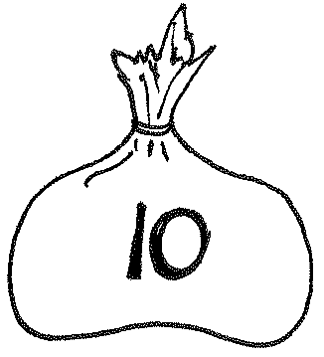
a.

____ tens ____ ones
____ tens ____ ones

b.

____ tens ____ ones
1 ten ____ ones
2. Match the place value charts that show the same amount.
2 tens ____ ones
2 tens ____ ones
2 tens ____ ones
2 tens ____ ones
c.
d.
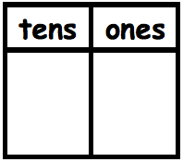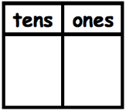
3
6
b.
2
14
a.
2
2
c.
2
16

3
4

1
12

- Check each sentence that is true.
□ a. 27 is the same as 1 ten 17 ones. □ b. 33 is the same as 2 tens 23 ones.

□ c. 37 is the same as 2 tens 17 ones. □ d. 29 is the same as 1 ten 19 ones.

- Lee says that 35 is the same as 2 tens 15 ones, and Maria says that 35 is the same as 1 ten 25 ones. Draw quick tens to show if either Lee or Maria is correct.

Name Date
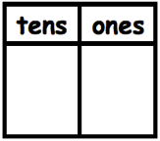Match the place value charts that show the same amount.
2
8
3
6
2
12
a.
2
16

b.
1
18

c.
3
2

Tamra says that 24 is the same as 1 ten 14 ones, and Willie says that 24 is the same as 2 tens 14 ones. Draw quick tens to show if Tamra or Willie is correct.

Name Date
- Fill in the blanks and match the pairs that show the same amount.
a.
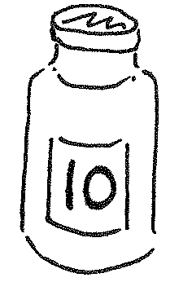

____ tens ____ ones
2 tens ____ ones

b.

2. Match the place value charts that show the same amount.
1 ten ____ ones
c.
1 ten ____ ones
____ tens ____ ones
____ tens ____ ones
____ tens ____ ones
d.
2 tens ____ ones
23
14
33
86
22
1816
a.
b.

12
1616

c.
02
2114
62
21

- Check each sentence that is true.
□ a. 35 is the same as 1 ten 25 ones. □ b. 28 is the same as 1 ten 18 ones.

□ c. 36 is the same as 2 tens 16 ones. □ d. 39 is the same as 2 tens 29 ones.

- Emi says that 37 is the same as 1 ten 27 ones, and Ben says that 37 is the same as 2 tens 7 ones. Draw quick tens to show if Emi or Ben is correct.

