Lesson 19: Cones and Spheres

Classwork
Opening Exercises 1–2
Note: Figures not drawn to scale.
- Determine the volume for each figure below.
  - Write an expression that shows volume in terms of the area of the base, $B$, and the height of the figure. Explain the meaning of the expression, and then use it to determine the volume of the figure.
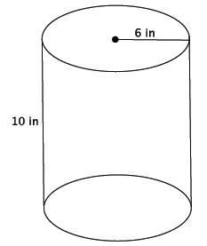

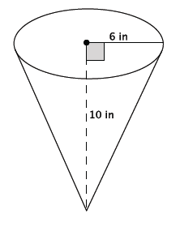
  - Write an expression that shows volume in terms of the area of the base, $B$, and the height of the figure. Explain the meaning of the expression, and then use it to determine the volume of the figure.

- a. Write an expression that shows volume in terms of the area of the base, $B$, and the height of the figure.
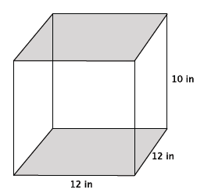
Explain the meaning of the expression, and then use it to determine the volume of the figure.

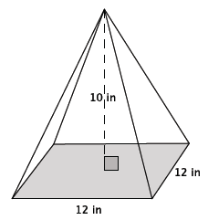
  - The volume of the pyramid shown below is $480$ in³. What do you think the formula to find the volume of a pyramid is? Explain your reasoning.

Example 1
State as many facts as you can about a cone.
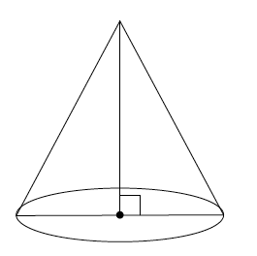

Exercises 3–10
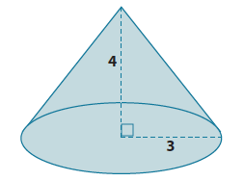
- What is the lateral length of the cone shown below?

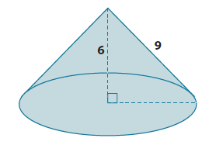
- Determine the exact volume of the cone shown below.

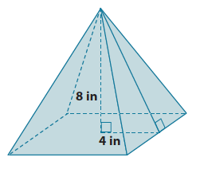
- What is the lateral length (slant height) of the pyramid shown below? Give an exact square root answer and an approximate answer rounded to the tenths place.

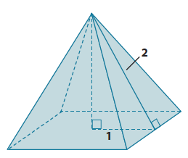
- Determine the volume of the pyramid shown below. Give an exact answer using a square root.

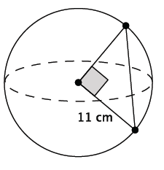
- What is the length of the chord of the sphere shown below? Give an exact answer using a square root.

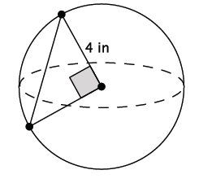
- What is the length of the chord of the sphere shown below? Give an exact answer using a square root.

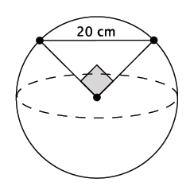
- What is the volume of the sphere shown below? Give an exact answer using a square root.

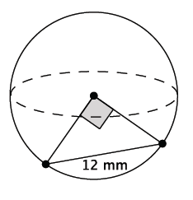
- What is the volume of the sphere shown below? Give an exact answer using a square root.

Lesson Summary
The volume formula for a right square pyramid is $V=\frac{1}{3}Bh$, where $B$ is the area of the square base.
The lateral length of a cone, sometimes referred to as the slant height, is the side $s$, shown in the diagram below.
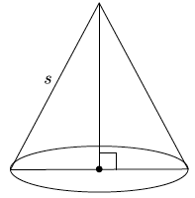
Given the lateral length and the length of the radius, the Pythagorean Theorem can be used to determine the height of the cone.
Let $O$ be the center of a circle, and let $P$ and $Q$ be two points on the circle. Then $PQ$ is called a chord of the circle.
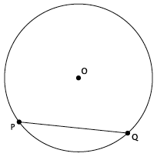
The segments $OP$ and $OQ$ are equal in length because both represent the radius of the circle. If the angle formed by $POQ$ is a right angle, then the Pythagorean Theorem can be used to determine the length of the radius when given the length of the chord; or the length of the chord can be determined if given the length of the radius.

Problem Set

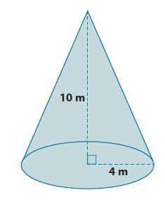
- What is the lateral length of the cone shown below? Give an approximate answer rounded to the tenths place.
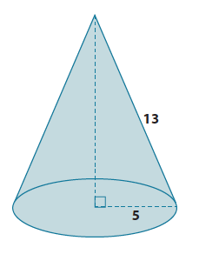
- What is the volume of the cone shown below? Give an exact answer.

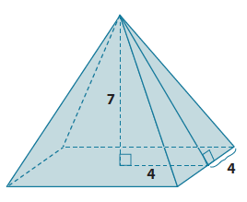
- Determine the volume and surface area of the pyramid shown below. Give exact answers.

- Alejandra computed the volume of the cone shown below as $64π$cm². Her work is shown below. Is she correct? If not, explain what she did wrong and calculate the correct volume of the cone. Give an exact answer.
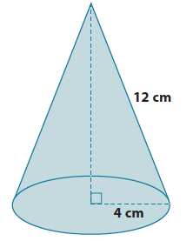
$$V=\frac{1}{3}π\left(4^{2}\right)\left(12\right)$$
$$=\frac{16\left(12\right)π}{3} \\ =64π \\ =64π cm^{3}$$

- What is the length of the chord of the sphere shown below? Give an exact answer using a square root.
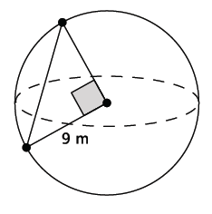

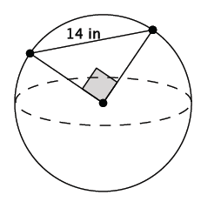
- What is the volume of the sphere shown below? Give an exact answer using a square root.

