Lesson 19: Cones and Spheres

Student Outcomes
- Students use the Pythagorean Theorem to determine an unknown dimension of a cone or a sphere.
- Students know that a pyramid is a special type of cone with triangular faces and a rectangular base.
- Students know how to use the lateral length of a cone and the length of a chord of a sphere to solve problems related to volume.

Classwork
Opening Exercises 1–2 (5 minutes)
Students complete Exercises 1–2 individually. The purpose of these exercises is for students to perform computations that may help them see how a pyramid’s volume can be seen as analogous to a cone’s volume. Their response to part (b) of Exercise 2 is the starting point of the discussion that follows.
Opening Exercises
Note: Figures not drawn to scale.
Scaffolding:
Printable nets, located at the end of the lesson, can be used to create 3-D models for this Opening Exercise.
- Determine the volume for each figure below.
  - Write an expression that shows volume in terms of the area of the base, $B$, and the height of the figure. Explain the meaning of the expression, and then use it to determine the volume of the figure.

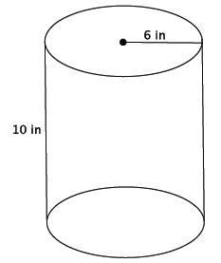
$$V=Bh$$
The expression $V=Bh$ means that the volume of the cylinder is found by multiplying the area of the base by the height. The base is a circle whose area can be found by squaring the radius,$6$, and then multiplying by $π$. The volume is found by multiplying that area by the height of $10$.
$$V=π6^{2}\left(10\right) \\ =360π$$
The volume of the cylinder is $360π$in³.

  - Write an expression that shows volume in terms of the area of the base, $B$, and the height of the figure. Explain the meaning of the expression, and then use it to determine the volume of the figure.
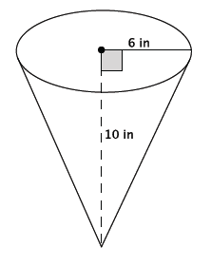
$V=\frac{1}{3}Bh$
The expression $V=\frac{1}{3}Bh$ means that the volume of the cone is found by multiplying the area of the base by the height, then taking one-third of that product. The base is a circle whose area can be found by squaring the radius, $6$, and then multiplying by $π$. The volume is found by multiplying that area by the height of $10$ and then taking one-third of that product. $$V=\frac{1}{3}π6^{2}\left(10\right) \\ =\frac{360}{3}π \\ =120 π$$
The volume of the cone is $120π$in³.

- a. Write an expression that shows volume in terms of the area of the base, $B$, and the height of the figure.
Explain the meaning of the expression, and then use it to determine the volume of the figure.
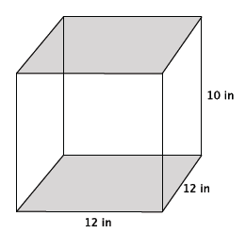
$$V=Bh$$
The expression $V=Bh$ means that the volume of the prism is found by multiplying the area of the base by the height. The base is a square whose area can be found by multiplying $12×12$. The volume is found by multiplying that area, $144$, by the height of $10$.
$$V=12\left(12\right)\left(10\right) \\ =1,440$$
The volume of the prism is $1,440$ in³.
MP.7
&
MP.8

  - The volume of the pyramid shown below is $480$in³. What do you think the formula to find the volume of a pyramid is? Explain your reasoning.
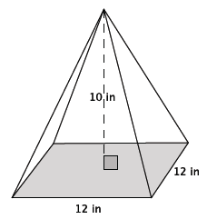
Since $480=\frac{1,440}{3}$, the formula to find the volume of a pyramid is likely $\frac{1}{3}Bh$, where $B$ is the area of the base. This is similar to the volume of a cone compared to the volume of a cylinder with the same base and height. The volume of a pyramid is $\frac{1}{3}$ of the volume of the rectangular prism with the same base and height.

Discussion (5 minutes)
- What do you think the formula to find the volume of a pyramid is? Explain.
Ask students to share their response to part (b) of Exercise 2. If students do not see the connection between cones and cylinders to pyramids and prisms, then use the discussion points below.
- A pyramid is similar to a cone, but a pyramid has a square base and faces that are shaped like triangles.
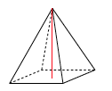
- The relationship between a cone and cylinder is similar for pyramids and prisms. How are the volumes of cones and cylinders related?
  - A cone is one-third the volume of a cylinder with the same base and height.
- In general we say that the volume of a cylinder is $V=Bh$, where $B$ is the area of the base. Then the volume of a cone is $V=\frac{1}{3}Bh$, again where $B$ is the area of the base.
- How do you think the volumes of pyramids and rectangular prisms are related?
  - The volume of a pyramid is one-third the volume of a rectangular prism with the same base and height.
- In general, the volume of a rectangular prism is $V=Bh$, where $B$ is the area of the base. Then the volume of a pyramid is $V=\frac{1}{3}Bh$, again where $B$ is the area of the base.

Example 1
Example 1
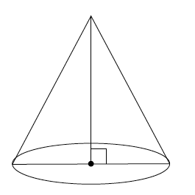
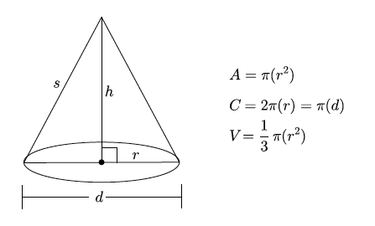
State as many facts as you can about a cone.

Provide students with a minute or two to discuss as many facts as they can about a circular cone. When they are finished discussing, have students share their facts with the class. As they identify parts of the cone and facts about the cone, label the drawing above. Students should be able to state or identify the following: radius, diameter, height, base, area of a circle is $A=πr^{2}$, circumference is $C=2πr=2d$, and the volume of a cone is $V=\frac{1}{3}Bh$, where $B$ is the area of the base.
- What part of the cone have we not identified?
  - The slanted part of the cone.
- The slanted part of the cone is known as the lateral length, which is also referred to as the slant height. We denote the lateral length of a cone by $s$.
Label the lateral length of the cone with $s$ on the drawing above.
- Now that we know about the lateral length of a cone, we can begin using it in our work.

Exercises 3–6 (9 minutes)
Students work in pairs to complete Exercises 3–6. Students may need assistance determining the dimensions of the base of a pyramid. Let students reason through it first, offering guidance if necessary. Consider allowing students the use of a calculator or leaving their answers as square roots, but not approximated unless asked, so as not to distract from the goal of the lesson. As needed, continue to remind students that we need only consider the positive square root of a number when our context involves length.
Exercises
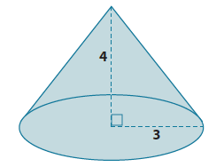
- What is the lateral length of the cone shown below?
Let $c$ be the lateral length
$$3^{2}+4^{2}=c^{2} \\ 9+16=c^{2} \\ 25=c^{2} \\ \sqrt{25}=\sqrt{c^{2}} \\ 5=c$$
The lateral length of the cone is $5$ units.

- Determine the exact volume of the cone shown below.
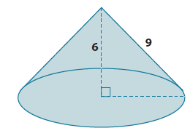
Let $r$ be the radius of the base.
$$6^{2}+r^{2}=9^{2} \\ 36+r^{2}=81 \\ r^{2}=45$$
The area of the base is $45π$.
$$V=\frac{1}{3}Bh \\ V=\frac{1}{3}45π\left(6\right) \\ V=90π$$
The volume of the cone is $90π$ units³.
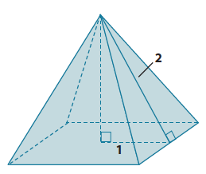
- What is the lateral length (slant height) of the pyramid shown below? Give an exact square root answer and an approximate answer rounded to the tenths place.
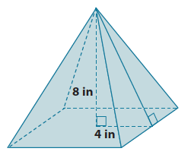
Let $c$ represent the lateral length of the pyramid.
$$4^{2}+8^{2}=c^{2} \\ 16+64=c^{2} \\ 80=c^{2} \\ \sqrt{80}=\sqrt{c^{2}} \\ \sqrt{80}=c$$The number $\sqrt{80}$is between $8$and $9$. In the sequence of tenths, it is between $8.9$ and $9.0$. Since $80$ is closer to $8.9^{2}$ than $9^{2}$, then the approximate lateral length is $8.9$ inches.

- Determine the volume of the pyramid shown below. Give an exact answer using a square root.
Let $h$ be the height of the pyramid.
$$1^{2}+h^{2}=2^{2} \\ 1+h^{2}=4 \\ h^{2}=3 \\ \sqrt{h^{2}}=\sqrt{3} \\ h=\sqrt{3}$$
The area of the base is $4$ units².
$$V=\frac{1}{3}\left(4\right)\left(\sqrt{3}\right) \\ =\frac{4\sqrt{3}}{3}$$
The volume of the pyramid is $\frac{4\sqrt{3}}{3}$units³.

Discussion (7 minutes)
- Let $O$ be the center of a circle, and let $P$ and $Q$ be two points on the circle. Then $PQ$ is called a chord of the circle.
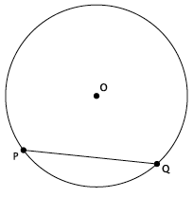

- What do you notice about the lengths $|OP|$ and $\left|OQ\right|$?
  - Both lengths are equal to the radius, $r$, of the circle which means they are equal in length to each other.
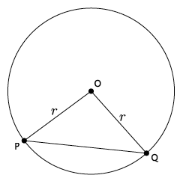
- Will lengths $|OP|$ and $\left|OQ\right|$always be equal to $r$, no matter where the chord is drawn?
Provide students time to place points $P$ and $Q$ around the circle to get an idea that no matter where the endpoints of the chord are placed, the length from the center of the circle to each of those points is always equal to $r.$ The reason is based on the definition of a chord. Points $P$ and $Q$ must lie on the circle in order for $PQ$ to be identified as a chord.
- When the angle $∠POQ$ is a right angle, we can use Pythagorean Theorem to determine the length of the chord given the length of the radius; or if we know the length of the chord, we can determine the length of the radius.
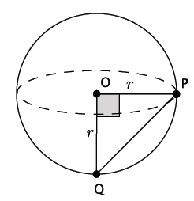
- Similarly, when points $P$ and $Q$ are on the surface of a sphere the segment that connects them is called a chord.
- Just like with circles, if the angle formed by $POQ$ is a right angle, then we can use the Pythagorean Theorem to find the length of the chord if we are given the length of the radius; or given the length of the chord, we can determine the radius of the sphere.

Exercises 7–10 (9 minutes)
Students work in pairs to complete Exercises 7–10. Consider allowing students to use their calculators or to leave their answers as square roots (simplified square roots if that lesson was used with students) but not approximated so as not to distract from the goal of the lesson.

- What is the length of the chord of the sphere shown below? Give an exact answer using a square root.
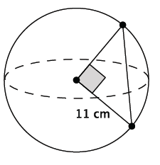
Let $c$ represent the length of the chord.
$$11^{2}+11^{2}=c^{2} \\ 121+121=c^{2} \\ 242=c^{2} \\ \sqrt{242}=\sqrt{c^{2}} \\ \sqrt{11^{2}×2}=c \\ 11\sqrt{2}=c$$
The length of the chord is $\sqrt{242}=11\sqrt{2}$ cm.

- What is the length of the chord of the sphere shown below? Give an exact answer using a square root.
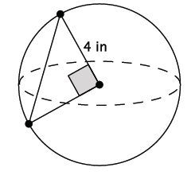
Let $c$ represent the length of the chord.
$$4^{2}+4^{2}=c^{2} \\ 16+16=c^{2} \\ 32=c^{2} \\ \sqrt{32}=\sqrt{c^{2}} \\ \sqrt{4^{2}×2}=c \\ 4\sqrt{2}=c$$
The length of the chord is $\sqrt{32}=4\sqrt{2}$ in.

- What is the volume of the sphere shown below? Give an exact answer using a square root.
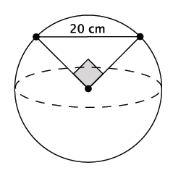
Let $r$ represent the radius of the sphere.
$$r^{2}+r^{2}=20^{2} \\ 2r^{2}=400 \\ r^{2}=200 \\ \sqrt{r^{2}}=\sqrt{200} \\ r=\sqrt{200} \\ r=\sqrt{10^{2}×2} \\ r=10\sqrt{2}$$ | $$V=\frac{4}{3}πr^{3} \\ =\frac{4}{3}π{\left(10\sqrt{2}\right)}^{3} \\ =\frac{4}{3}π10^{3}{\left(\sqrt{2}\right)}^{3} \\ =\frac{4}{3}π1,000\left(\sqrt{8}\right) \\ =\frac{4}{3}π1,000\left(\sqrt{2^{2}×2}\right) \\ =\frac{4}{3}π1,000\left(2\right)\left(\sqrt{2}\right) \\ =\frac{8,000\sqrt{2}}{3}π$$

The volume of the sphere is $\frac{4}{3}π{(\sqrt{200})}^{3}=\frac{8,000\sqrt{2}}{3}π$cm³.

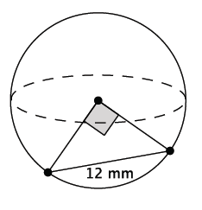
- What is the volume of the sphere shown below? Give an exact answer using a square root.
Let $r$ represent the radius of the sphere.
$$r^{2}+r^{2}=12^{2} \\ 2r^{2}=144 \\ r^{2}=72 \\ \sqrt{r^{2}}=\sqrt{72} \\ r=\sqrt{6^{2}×2} \\ r=6\sqrt{2}$$ | $$V=\frac{4}{3}πr^{3} \\ =\frac{4}{3}π{\left(6\sqrt{2}\right)}^{3} \\ =\frac{4}{3}π6^{3}{\left(\sqrt{2}\right)}^{3} \\ =\frac{4}{3}π216\left(\sqrt{8}\right) \\ =\frac{4}{3}π216\left(\sqrt{2^{2}×2}\right) \\ =\frac{4}{3}π216\left(2\right)\left(\sqrt{2}\right) \\ =\frac{1728\sqrt{2}}{3}π \\ =576 π\sqrt{2}$$
The volume of the sphere is $576 π\sqrt{2}$mm³.

Closing (5 minutes)
Summarize, or ask students to summarize, the main points from the lesson:
- The volume formulas for cones and cylinders are similar to those of pyramids and rectangular prisms.
- The formula to determine the volume of a pyramid is $\frac{1}{3}Bh$, where $B$ is the area of the base. This is similar to the formula to determine the volume of cone.
- The segment formed by two points on a circle is called a chord.
- We know how to apply the Pythagorean Theorem to cones and spheres to determine volume.

Lesson Summary
The volume formula for a right square pyramid is $V=\frac{1}{3}Bh$, where $B$ is the area of the square base.
The lateral length of a cone, sometimes referred to as the slant height, is the side $s$, shown in the diagram below.
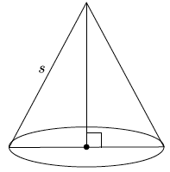
Given the lateral length and the length of the radius, the Pythagorean Theorem can be used to determine the height of the cone.
Let $O$ be the center of a circle, and let $P$ and $Q$ be two points on the circle. Then $PQ$ is called a chord of the circle.
The segments $OP$ and $OQ$ are equal in length because both represent the radius of the circle. If the angle formed by $POQ$ is a right angle, then the Pythagorean Theorem can be used to determine the length of the radius when given the length of the chord; or the length of the chord can be determined if given the length of the radius.

Exit Ticket (5 minutes)
Name Date
Lesson 19: Cones and Spheres

Exit Ticket

Which has the larger volume? Give an approximate answer rounded to the tenths place.

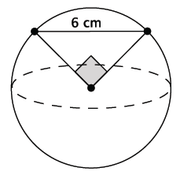
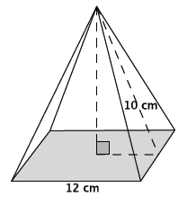

Exit Ticket Sample Solutions

Which has the larger volume? Give an approximate answer rounded to the tenths place.
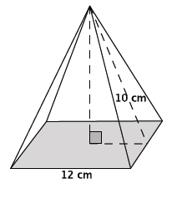
Let $h$ represent the height of the square cone.  $$h^{2}+6^{2}={10}^{2} \\ h^{2}+36=100 \\ h^{2}=64 \\ h=8$$ | $$V=\frac{1}{3}\left({12}^{2}\right)8 \\ V=\frac{1}{3}\left(144\right)8 \\ V=384$$
The volume of the square pyramid is $384$cm³.

Let $r$represent the radius of the sphere.  $$r^{2}+r^{2}=6^{2} \\ 2r^{2}=36 \\ r^{2}=18 \\ \sqrt{r^{2}}=\sqrt{18} \\ r=\sqrt{3^{2}×2} \\ r=3\sqrt{2}$$ | $$V=\frac{4}{3}πr^{3} \\ =\frac{4}{3}π{\left(3\sqrt{2}\right)}^{3} \\ =\frac{4}{3}π3^{3}{\left(\sqrt{2}\right)}^{3} \\ =\frac{4}{3}π27\left(\sqrt{8}\right) \\ =\frac{4}{3}π27\left(\sqrt{2^{2}×2}\right) \\ =\frac{4}{3}π27\left(2\right)\left(\sqrt{2}\right) \\ =72π\sqrt{2}$$
The volume of the sphere is $72π\sqrt{2}$ cm³.
The number $\sqrt{2}$is between $1$ and $2$. In the sequence of tenths, it is between $1.4$ and $1.5$. Since $2$ is closer to $1.4^{2}$ than $1.5^{2}$, then the number is approximately $1.4.$
We know from previous lessons, we can estimate $π=3.1$.
Then the approximate volume of the sphere is
$$V=72\left(1.4\right)3.1 \\ V=312.48$$
Therefore, the volume of the square cone is greater.

Problem Set Sample Solutions
Students use the Pythagorean Theorem to solve mathematical problems in three dimensions.

- What is the lateral length of the cone shown below? Give an approximate answer rounded to the tenths place.
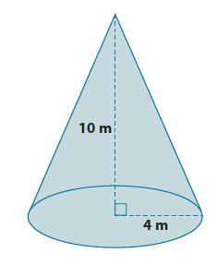
Let $c$ be the lateral length
$${10}^{2}+4^{2}=c^{2} \\ 100+16=c^{2} \\ 116=c^{2} \\ \sqrt{116}=\sqrt{c^{2}} \\ \sqrt{116}=c$$
The number $\sqrt{116}$is between $10$ and $11$. In the sequence of tenths, it is between $10.7$ and $10.8$. Since $116$ is closer to $10.8^{2}$than $10.7^{2}$ then the approximate value of the number is $10.8.$

The lateral length of the cone is approximately $10.8$ m.

- What is the volume of the cone shown below? Give an exact answer.
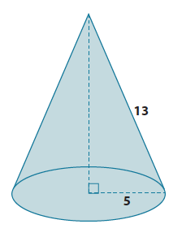
Let $h$ represent the height of a cone.
$$5^{2}+h^{2}=13^{2} \\ 25+h^{2}=169 \\ h^{2}=144 \\ \sqrt{h^{2}}=\sqrt{144} \\ h=12$$
The height of the cone is $12$ units.
$$V=\frac{1}{3}π 25\left(12\right) \\ =100π$$
The volume of the cone is $100π$ units³.

- Determine the volume and surface area of the pyramid shown below. Give exact answers.
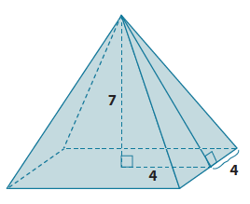
$$V=\frac{1}{3}\left(64\right)\left(7\right) \\ =\frac{448}{3}$$
The volume of the pyramid is $\frac{448}{3}$ units³.
Let $c$ represent the lateral length.
$$7^{2}+4^{2}=c^{2} \\ 49+16=c^{1} \\ 65=c^{2} \\ \sqrt{65}=\sqrt{c^{2}} \\ \sqrt{65}=c$$
The base area is $64$ units², and the four faces are each $\frac{8\sqrt{65}}{2}=4$√65, so the total area of the faces is $4×4\sqrt{65}=16\sqrt{65}$. The surface area is $64+16\sqrt{65}$ units².
- Alejandra computed the volume of the cone shown below as $64π$cm². Her work is shown below. Is she correct? If not, explain what she did wrong and calculate the correct volume of the cone. Give an exact answer.
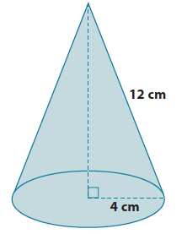
$$V=\frac{1}{3}π\left(4^{2}\right)\left(12\right)$$
$$=\frac{16\left(12\right)π}{3} \\ =64π \\ =64π cm^{3}$$
Alejandra’s work is incorrect. She used the lateral length instead of the height of the cone to compute volume.
Let $h$ represent the height.  $$4^{2}+h^{2}=12^{2} \\ 16+h^{2}=144 \\ h^{2}=128 \\ \sqrt{h^{2}}=\sqrt{128} \\ h=\sqrt{128} \\ h=\sqrt{8^{2}×2} \\ h=8\sqrt{2}$$ | $$V=\frac{1}{3}π4^{2}\left(8\sqrt{2}\right) \\ V=\frac{1}{3}π128\sqrt{2} \\ V=\frac{128\sqrt{2}}{3}π$$
The volume of the cone is$\frac{128\sqrt{2}}{3}π$ cm³.

- What is the length of the chord of the sphere shown below? Give an exact answer using a square root.
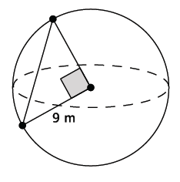
Let $c$ represent the length of the chord.
$$9^{2}+9^{2}=c^{2} \\ 81+81=c^{2} \\ 162=c^{2} \\ \sqrt{162 }=\sqrt{c^{2}} \\ \sqrt{162}=c \\ \sqrt{9^{2}×2}=c \\ 9\sqrt{2}=c$$
The length of the chord is $\sqrt{162}=9\sqrt{2}$ m.

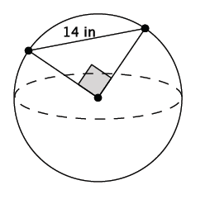
- What is the volume of the sphere shown below? Give an exact answer using a square root.
Let $r$ represent the radius.  $$r^{2}+r^{2}=14^{2} \\ 2r^{2}=196 \\ r^{2}=98 \\ \sqrt{r^{2}}=\sqrt{98} \\ r=\sqrt{7^{2}×2} \\ r=7\sqrt{2}$$ | $$V=\frac{4}{3}πr^{3} \\ =\frac{4}{3}π{\left(7\sqrt{2}\right)}^{3} \\ =\frac{4}{3}π343\left(\sqrt{8}\right) \\ =\frac{4}{3}π343\left(2\sqrt{2}\right) \\ =\frac{2,744\sqrt{2}}{3}π$$
The volume of the sphere is $\frac{4}{3}π{\left(\sqrt{98}\right)}^{3}=\frac{2,744\sqrt{2}}{3}π$in³.

