Lesson 18: Applications of the Pythagorean Theorem

Classwork
Exercises 1–5
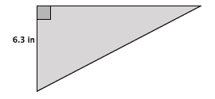
- The area of the right triangle shown below is $26.46$in². What is the perimeter of the right triangle? Round your answer to the tenths place.

- The diagram below is a representation of a soccer goal.
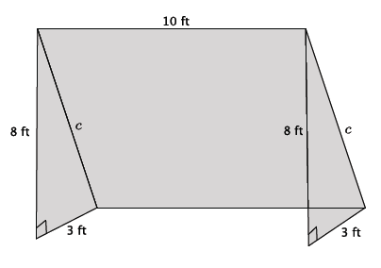

  - Determine the length of the bar, $c$, that would be needed to provide structure to the goal. Round your answer to the tenths place.

  - How much netting (in square feet) is needed to cover the entire goal?

- The typical ratio of length to width that is used to produce televisions is $4:3.$
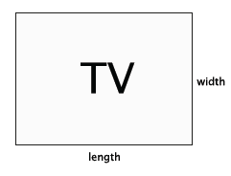
  - A TV with those exact measurements would be quite small, so generally the size of the television is enlarged by multiplying each number in the ratio by some factor of $x$. For example, a reasonably sized television might have dimensions of $4×5:3×5,$ where the original ratio $4:3$ was enlarged by a scale factor of $5$. The size of a television is described in inches, such as a $60$” TV, for example. That measurement actually refers to the diagonal length of the TV (distance from an upper corner to the opposite lower corner). What measurement would be applied to a television that was produced using the ratio of $4×5:3×5$?

  - A $42$” TV was just given to your family. What are the length and width measurements of the TV?

  - Check that the dimensions you got in part (b) are correct using the Pythagorean Theorem.

  - The table that your TV currently rests on is $30$” in length. Will the new TV fit on the table? Explain.

- Determine the distance between the following pairs of points. Round your answer to the tenths place. Use graph paper if necessary.
  - $\left(7, 4\right)$ and $\left(-3, -2\right)$

  - $(-5, 2)$ and $(3, 6)$

  - Challenge: $(x_{1}, y_{1})$ and $\left(x_{2}, y_{2}\right)$. Explain your answer.

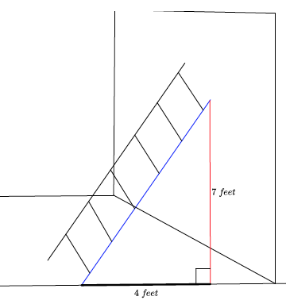
- What length of ladder will be needed to reach a height of $7$feet along the wall when the base of the ladder is $4$ feet from the wall? Round your answer to the tenths place.

Problem Set

- A $70$” TV is advertised on sale at a local store. What are the length and width of the television?

- There are two paths that one can use to go from Sarah’s house to James’ house. One way is to take C Street, and the other way requires you to use A Street and B Street. How much shorter is the direct path along C Street?
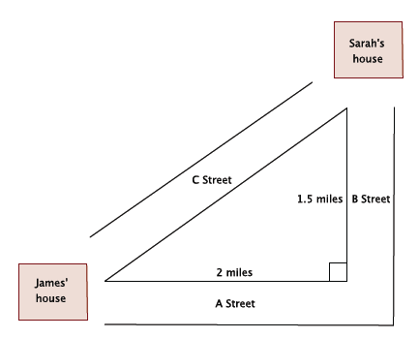

- An isosceles right triangle refers to a right triangle with equal leg lengths, $s$, as shown below.
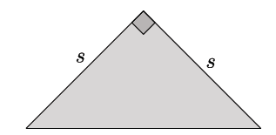

What is the length of the hypotenuse of an isosceles right triangle with a leg length of $9$ cm? Write an exact answer using a square root and an approximate answer rounded to the tenths place.

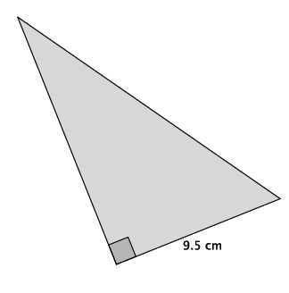
- The area of the right triangle shown at right is $66.5$cm².
  - What is the height of the triangle?
  - What is the perimeter of the right triangle? Round your answer to the tenths place.

- What is the distance between points $(1, 9)$ and $\left(-4, -1\right)$? Round your answer to the tenths place.

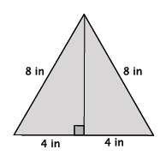
- An equilateral triangle is shown below. Determine the area of the triangle. Round your answer to the tenths place.

