Lesson 18: Applications of the Pythagorean Theorem

Student Outcomes
- Students apply the Pythagorean Theorem to real world and mathematical problems in two dimensions.

Lesson Notes
It is recommended that students have access to a calculator as they work through the exercises. However, it is not recommended that students use the calculator to answer the questions but only to check their work or estimate the value of an irrational number using rational approximation. Make clear to students that they can use a calculator but that all mathematical work should be shown. This lesson includes a Fluency Exercise that will take approximately 10 minutes to complete. The Fluency Exercise is a white board exchange with problems on volume that can be found at the end of this lesson. It is recommended that the Fluency take place at the beginning of the lesson or after the discussion that concludes the lesson.

Classwork
Exploratory Challenge
Exercises 1–5 (20 minutes)
Students complete Exercises 1–5 in pairs or small groups. These problems are applications of the Pythagorean Theorem, and are an opportunity to remind students of Mathematical Practice 1: Make sense of problems and persevere in solving them. Students should compare their solutions and solution methods in their pairs, small groups, and as a class. If necessary, remind students that we are finding lengths, which means we need only consider the positive square root of a number.
MP.1
Exercises 1–5
- The area of the right triangle shown below is $26.46$ in². What is the perimeter of the right triangle? Round your answer to the tenths place.
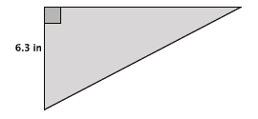
Let $b$ represent the base of the triangle where $h=6.3$.
$$A=\frac{bh}{2} \\ 26.46=\frac{6.3b}{2} \\ 52.92=6.3b \\ \frac{52.92}{6.3}=\frac{6.3b}{6.3} \\ 8.4=b$$
Let $c$ represent the length of the hypotenuse.
$$6.3^{2}+8.4^{2}=c^{2} \\ 39.69+70.56=c^{2} \\ 110.25=c^{2} \\ \sqrt{110.25}=\sqrt{c^{2}} \\ \sqrt{110.25}=c$$The number $\sqrt{110.25}$ is between $10$ and $11$. When comparing with tenths, the number is actually equal to $10.5$ because $10.5^{2}=110.25$. Therefore, the length of the hypotenuse is $10.5$ inches.
The perimeter of the triangle is $6.3+8.4+10.5=25.2$ inches.
- The diagram below is a representation of a soccer goal.
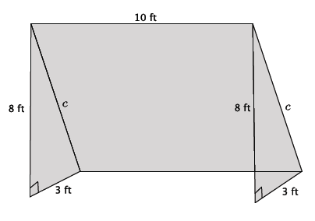

  - Determine the length of the bar, $c$, that would be needed to provide structure to the goal. Round your answer to the tenths place.
Note to Teacher:
Check in with students to make sure they understand how TVs are measured, i.e., in terms of their diagonal length, and what is meant by the ratio of $4:3.$ To complete the problem students must be clear that the size of a TV is not denoted by its length or width but by the length of the diagonal (hypotenuse). Also, students must have some sense that the ratio of length to width must be some multiple of the ratio $4:3,$otherwise the TV would not give a good perspective. Consider showing students what a TV would look like with a ratio of $9:12$. They should notice that such dimensions yield a TV screen that is different than what they are familiar with.
Let $c$ represent the hypotenuse of the right triangle.
$$8^{2}+3^{2}=c^{2} \\ 64+9=c^{2} \\ 73=c^{2} \\ \sqrt{73}=\sqrt{c^{2}}$$The number $\sqrt{73}$ is between $8$ and $9$. In the sequence of tenths, it is between $8.5$ and $8.6$ because $8.5^{2}<{\left(\sqrt{73}\right)}^{2}<8.6^{2}$. In the sequence of hundredths, the number is between $8.54$ and $8.55$ because $8.54^{2}<{\left(\sqrt{73}\right)}^{2}<8.55^{2}$. Since the number $\sqrt{73}$ is between$8.54$ and$8.55$, it would round to$8.5$. The length of the bar that provides structure for the goal is $8.5$ ft.

  - How much netting (in square feet) is needed to cover the entire goal?
The area of the triangles are each $12$ft². The area of the rectangle in the back is $85$ ft². The total area of netting required to cover the goal is $109$ ft².

- The typical ratio of length to width that is used to produce televisions is $4:3$.
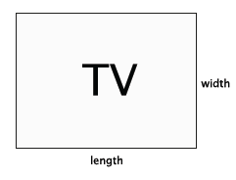

  - A TV with those exact measurements would be quite small, so generally the size of the television is enlarged by multiplying each number in the ratio by some factor of $x$. For example a reasonably sized television might have dimensions of $4×5:3×5$, where the original ratio $4:3$ was enlarged by a scale factor of $5$. The size of a television is described in inches, such as a $60$” TV, for example. That measurement actually refers to the diagonal length of the TV (distance from an upper corner to the opposite lower corner). What measurement would be applied to a television that was produced using the ratio of $4×5:3×5$?
Let $c$ be the length of the diagonal.
$$20^{2}+15^{2}=c^{2} \\ 400+225=c^{2} \\ 625=c^{2} \\ \sqrt{625}=\sqrt{c^{2}} \\ 25=c$$
Since the TV has a diagonal length of $25$ inches, then it is a $25$” TV.

  - A $42$” TV was just given to your family. What are the length and width measurements of the TV?
Let $x$ be the factor applied to the ratio $4:3.$
$${\left(3x\right)}^{2}+{\left(4x\right)}^{2}=42^{2} \\ 9x^{2}+16x^{2}=1,764 \\ \left(9+16\right)x^{2}=1,764 \\ 25x^{2}=1,764 \\ \frac{25x^{2}}{25}=\frac{1,764}{25} \\ x^{2}=70.56 \\ \sqrt{x^{2}}=\sqrt{70.56} \\ x=\sqrt{70.56}$$
The number $\sqrt{70.56}$ is between $8$ and $9$. In working with the sequence of tenths, I realized the number $\sqrt{70.56}$ is actually equal to $8.4$ because $8.4^{2}=70.56$. Therefore, $x=8.4$ and the dimensions of the TV are $4×8.4=33.6$ inches and $3×8.4=25.2$inches.

  - Check that the dimensions you got in part (b) are correct using the Pythagorean Theorem.
$$33.6^{2}+25.2^{2}=42^{2} \\ 1,128.96+635.04=1,764 \\ 1,764=1,764$$

  - The table that your TV currently rests on is $30$” in length. Will the new TV fit on the table? Explain.
The dimension for the length of the TV is $33.6$ inches. It will not fit on a table that is $30$ inches in length.

- Determine the distance between the following pairs of points. Round your answer to the tenths place. Use graph paper if necessary.
  - $\left(7, 4\right)$ and $\left(-3, -2\right)$
Let $c$ represent the distance between the two points.
$$10^{2}+6^{2}=c^{2} \\ 100+36=c^{2} \\ 136=c^{2} \\ \sqrt{136}=\sqrt{c^{2}} \\ \sqrt{136}=c$$
The number $\sqrt{136}$ is between $11$ and $12$. In the sequence of tenths, it is between $11.6$ and $11.7$ because $11.6^{2}<{\left(\sqrt{136}\right)}^{2}<11.7^{2}$. In the sequence of hundredths, it is between $11.66$ and $11.67$, which means the number will round to $11.6$. The distance between the two points is $11.6$ units.
  - $(-5, 2)$ and $(3, 6)$
Let $c$ represent the distance between the two points.
$$8^{2}+4^{2}=c^{2} \\ 64+16=c^{2} \\ 80=c^{2} \\ \sqrt{80}=\sqrt{c^{2}} \\ \sqrt{80}=c$$
The number $\sqrt{80}$ is between $8$ and$9$. In the sequence of tenths, it is between $8.9$ and $9$because $8.9^{2}<{\left(\sqrt{80}\right)}^{2}<9^{2}$. In the sequence of hundredths, it is between $8.94$ and $8.95$, which means it will round to $8.9$. The distance between the two points is $8.9$ units.

  - Challenge: $(x_{1}, y_{1})$ and $\left(x_{2}, y_{2}\right)$. Explain your answer.
Note: Deriving the distance formula using the Pythagorean Theorem is not part of the standard but does present an interesting challenge to students. Assign it only to students that need a challenge.
Let $c$ represent the distance between the two points.
$${\left(x_{1}-x_{2}\right)}^{2}+{\left(y_{1}-y_{2}\right)}^{2}=c^{2} \\ \sqrt{{\left(x_{1}-x_{2}\right)}^{2}+{\left(y_{1}-y_{2}\right)}^{2}}=\sqrt{c^{2}} \\ \sqrt{{\left(x_{1}-x_{2}\right)}^{2}+{\left(y_{1}-y_{2}\right)}^{2}}=c$$
I noticed that the dimensions of the right triangle were equal to the difference in $x$ values and difference in $y$-values. Using those expressions and what I knew about solving radical equations, I was able to determine the length of $c$.

- What length of ladder will be needed to reach a height of $7$feet along the wall when the base of the ladder is $4$ feet from the wall? Round your answer to the tenths place.
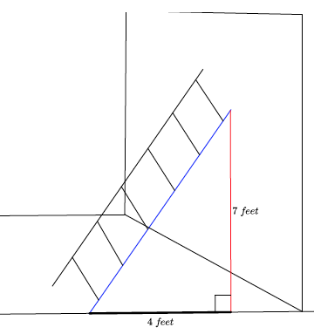
Let $c$ represent the length of the ladder.
$$7^{2}+4^{2}=c^{2} \\ 49+16=c^{2} \\ 65=c^{2} \\ \sqrt{65}=\sqrt{c^{2}} \\ \sqrt{65}=c$$
The number $\sqrt{65}$ is between $8$ and $9$. In the sequence of tenths, it is between $8$ and $8.1$ because $8^{2}<{\left(\sqrt{65}\right)}^{2}<8.1^{2}$. In the sequence of hundredths, it is between $8.06$ and $8.07$, which means the number will round to $8.1$. The ladder must be$8.1$ feet long to reach $7$ feet up a wall when placed $4$ feet from the wall.

Discussion (5 minutes)
This discussion provides a challenge question to students about how the Pythagorean Theorem might be applied to a three dimensional situation. The next lesson focuses on using the Pythagorean Theorem to answer questions about cones and spheres.
- The majority of our work with Pythagorean Theorem has been in two dimensions. Can you think of any applications we have seen so far that are in three dimensions?
  - The soccer goal is three-dimensional. A ladder propped up against a wall is three-dimensional.
- What new applications of Pythagorean Theorem in three dimensions do you think we will work on next?
(Provide students time to think about this in pairs or small groups.)
  - We have worked with solids this year so there may be an application involving cones and spheres.

Fluency Exercise (10 minutes)
Please see the White Board Exchange Fluency Exercise at the end of this lesson. Display the problems one at a time on a whiteboard, document camera, or PowerPoint. Give students about 1 minute to solve each problem, and go over them as a class.

Closing (5 minutes)
Summarize, or ask students to summarize, the main points from the lesson:
- We know some basic applications of the Pythagorean Theorem in terms of measures of a television, length of a ladder, area and perimeter of right triangles, etc.
- We know that there will be some three-dimensional applications of the theorem beyond what we have already seen.

Exit Ticket (5 minutes)
Name Date
Lesson 18: Applications of the Pythagorean Theorem

Exit Ticket

- Use the diagram of the equilateral triangle shown below to answer the following questions. Show work that leads to your answers.
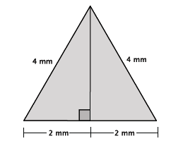
  - What is the perimeter of the triangle?

  - What is the height, $h$, of the equilateral triangle? Write an exact answer using a square root and approximate answer rounded to the tenths place.

  - Using the approximate height found in part (b), estimate the area of the equilateral triangle.

Exit Ticket Sample Solutions

- Use the diagram of the equilateral triangle shown below to answer the following questions. Show work that leads to your answers.
  - What is the perimeter of the triangle?
$$4+4+4=12$$
The perimeter is $12$ mm.

  - What is the height, $h,$ of the equilateral triangle? Write an exact answer using a square root and approximate answer rounded to the tenths place.
Using the fact that the height is one leg length of a right triangle, and I know the hypotenuse is $4$ mm and the other leg length is $2$ mm, I can use the Pythagorean Theorem to find $h$.
$$2^{2}+h^{2}=4^{2} \\ 4+h^{2}=16 \\ 4-4+h^{2}=16-4 \\ h^{2}=12 \\ h=\sqrt{12} \\ h=\sqrt{4×3} \\ h=\sqrt{4}×\sqrt{3} \\ h=2\sqrt{3}$$
The number $\sqrt{3}$ is between $1$ and $2$. In the sequence of tenths, it is between $1.7$ and $1.8$ because
$1.7^{2}<{\left(\sqrt{3}\right)}^{2}<1.8^{2}$. In the sequence of hundredths, it is between $1.73$ and $1.74$, which means it would round to $1.7$. Then $2×1.7=3.4$mm is the approximate length of the hypotenuse and $\sqrt{12}=2\sqrt{3}$cm is the exact length.

  - Using the approximate height found in part (b), estimate the area of the equilateral triangle.
$$A=\frac{bh}{2} \\ A=\frac{4(3.4)}{2} \\ A=\frac{13.6}{2} \\ A=6.8$$
The approximate area of the equilateral triangle is $6.8$ mm².

Problem Set Sample Solutions
Students continue applying the Pythagorean Theorem to solve real-world and mathematical problems.

- A $70$” TV is advertised on sale at a local store. What are the length and width of the television?
The TV is in the ratio of $4:3$ and has measurements of $4x:3x$, where $x$ is the scale factor of enlargement.
$${\left(3x\right)}^{2}+{\left(4x\right)}^{2}=70^{2} \\ 9x^{2}+16x^{2}=4,900 \\ 25x^{2}=4,900 \\ \frac{25x^{2}}{25}=\frac{4,900}{25} \\ x^{2}=196 \\ \sqrt{x^{2}}=\sqrt{196} \\ x=14$$
The length of the TV is $4×14=56$inches and the width is $3×14=42$inches.

- There are two paths that one can use to go from Sarah’s house to James’ house. One way is to take C Street, and the other way requires you to use A Street and B Street. How much shorter is the direct path along C Street?
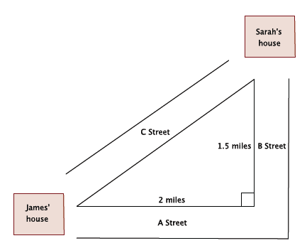
Let $c$ represent the hypotenuse of the right triangle.
$$2^{2}+1.5^{2}=c^{2} \\ 4+2.25=c^{2} \\ 6.25=c^{2} \\ \sqrt{6.25}=\sqrt{c^{2}} \\ 2.5=c$$
The path using A Street and B Street is $3.5$ miles. The path along C Street is $2.5$ miles. The path along C Street is exactly $1$ mile shorter than the path along A Street and B Street.

- An isosceles right triangle refers to a right triangle with equal leg lengths, $s$, as shown below.
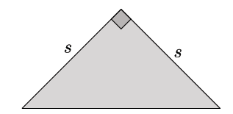
What is the length of the hypotenuse of an isosceles right triangle with a leg length of $9$ cm? Write an exact answer using a square root and an approximate answer rounded to the tenths place.
Let $c$ be the hypotenuse of the isosceles triangle.
$$9^{2}+9^{2}=c^{2} \\ 81+81=c^{2} \\ 162=c^{2} \\ \sqrt{162}=\sqrt{c^{2}} \\ \sqrt{81×2}=c \\ \sqrt{81}×\sqrt{2}=c \\ 9\sqrt{2}=c$$
The number $\sqrt{2}$ is between $1$and $2$. In the sequence of tenths, it is between $1.4$ and $1.5$ because $1.4^{2}<{\left(\sqrt{2}\right)}^{2}<1.5^{2}$. Since the number $2$ is closer to $1.4^{2}$ than $1.5^{2},$ it would round to $1.4$. Then $9×1.4=12.6$cm is the approximate length of the hypotenuse, and $9\sqrt{2}$cm is the exact length.
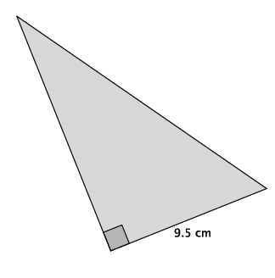
- The area of the right triangle shown below is $66.5$ cm².
  - What is the height of the triangle?
$$A=\frac{bh}{2} \\ 66.5=\frac{9.5h}{2} \\ 133=9.5h \\ \frac{133}{9.5}=\frac{9.5h}{9.5} \\ 14=h$$

  - What is the perimeter of the right triangle? Round your answer to the tenths place.
Let $c$ represent the length of the hypotenuse.
$$9.5^{2}+14^{2}=c^{2} \\ 90.25+196=c^{2} \\ 286.25=c^{2} \\ \sqrt{286.25}=\sqrt{c^{2}} \\ \sqrt{286.25}=c$$
The number $\sqrt{286.25}$ is between $16$ and $17$. In the sequence of tenths, the number is between $16.9$ and $17$ because $16.9^{2}<{\left(\sqrt{286.25}\right)}^{2}<17^{2}.$Since $286.25$ is closer to $16.9^{2}$ than $17^{2}$, then the approximate length of the hypotenuse is $16.9$cm.
The perimeter of the triangle is $9.5+14+16.9=40.4$ cm.

- What is the distance between points $(1, 9)$ and $\left(-4, -1\right)$? Round your answer to the tenths place.
Let $c$ represent the distance between the points.
$${10}^{2}+5^{2}=c^{2} \\ 100+25=c^{2} \\ 125=c^{2} \\ \sqrt{125}=\sqrt{c^{2}} \\ \sqrt{125}=c \\ 11.2≈c$$
The distance between the points is approximately $11.2$ units.

- An equilateral triangle is shown below. Determine the area of the triangle. Round your answer to the tenths place.
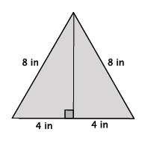
Let $h$ represent the height of the triangle.
$$4^{2}+h^{2}=8^{2} \\ 16+h^{2}=64 \\ h^{2}=48 \\ \sqrt{h^{2}}=\sqrt{48} \\ h=\sqrt{48} \\ h≈6.9$$

$$A=\frac{8(6.9)}{2}=4\left(6.9\right)=27.6$$
The area of the triangle is $27.6$ in².

Fluency Exercise: White Board Exchange [Key]
- Find the area of the square shown below.
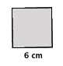
$$A=6^{2} \\ =36 cm^{2}$$

- Find the volume of the cube shown below.
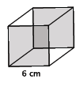
$$V=6^{3} \\ =216 cm^{3}$$

- Find the area of the rectangle shown below.
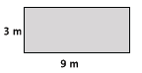
$$A=9(3) \\ =27 m^{2}$$

- Find the volume of the rectangular prism show below.
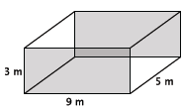
$$V=27\left(5\right) \\ =135 m^{3}$$

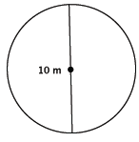
- Find the area of the circle shown below.

$$A=5^{2}π \\ =25π m^{2}$$

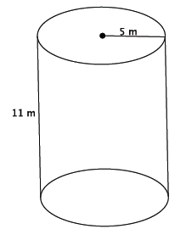
- Find the volume of the cylinder show below.

$$V=25π\left(11\right) \\ =275π m^{3}$$

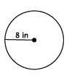
- Find the area of the circle shown below.

$$A=8^{2}π \\ =64π in^{2}$$

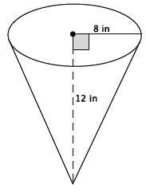
- Find the volume of the cone show below.

$$V=\left(\frac{1}{3}\right)64π\left(12\right) \\ =256π in^{3}$$

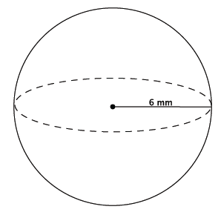
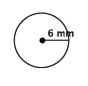
- Find the area of the circle shown below.

$$A=6^{2}π \\ =36π mm^{2}$$

- Find the volume of the sphere shown below.
$$V=\left(\frac{4}{3}\right)π\left(6^{3}\right) \\ =\frac{864}{3}π \\ =288π mm^{3}$$

