Lesson 22
Objective: Write word problems of varied types.

Suggested Lesson Structure
 Fluency Practice (15 minutes)
 Concept Development (33 minutes)
 Student Debrief (12 minutes)
Total Time (60 minutes)
Fluency Practice (15 minutes)
- Race and Roll Addition 1.OA.6 (3 minutes)
- Sprint: Related Addition and Subtraction Within 10 and 20 1.OA.6 (10 minutes)
- Longer/Shorter K.CC.7 (2 minutes)
Race and Roll Addition (3 minutes)
Materials: (S) 1 die per set of partners
Note: In previous Race and Roll Addition games, students raced to 20. Today, change the target number to 10 and practice both addition and subtraction. As students play, pay attention to their automaticity. When students demonstrate strong fluency to 10, increase the target number to 12.
Repeat Race and Roll Addition from Lesson 21. Instead of racing to 20 and stopping, students start at 0 and roll and add until they hit 10. Once they do, they roll to get back to 0 by subtracting.
Sprint: Related Addition and Subtraction Within 10 and 20 (10 minutes)
Materials: (S) Related Addition and Subtraction Within 10 and 20 Sprint
Note: During the last few days of fluency, students have been reviewing the relationship between addition and subtraction using the context of a number bond. In this Sprint, students apply this knowledge to solve equations, first within 10, and then within 20. Students who reach the final two questions of the fourth quadrants will be challenged to apply their understanding of analogous addition equations to analogous subtraction equations (2.NBT.5).

Longer/Shorter (2 minutes)
Materials: (T) Board or document camera
Note: This fluency activity enables students to practice visualizing quantities in relationship to other quantities.
Write one pair of numbers on the board at a time (e.g., 10 and 20). Draw a rectangle under the first number.
T: This rectangle can fit a row of 10 dots.
T: (Point to the second number, which in this example is 20.) I’m going to start to draw a rectangle that can fit a row of 20 dots of the same size. Tell me when to stop.
T/S: (Begin drawing a rectangle, and give students the chance to say “Stop!” when it is approximately twice the size of the first rectangle.)
T: Why did you say “stop” there?
S: It is about double the length of the first rectangle. A rectangle for 20 has to fit 10 + 10.
Repeat this process for the following sequence of numbers: 10 and 5, 4 and 4, 4 and 8, 4 and 2, 8 and 10,
10 and 9. Only draw the actual dots for the first example. With each example, help students talk about how the first number compares, or relates, to the second number using language such as a little longer, a little shorter, much longer, double, etc.
Concept Development (33 minutes)
Materials: (T) Chart paper (S) Folder with Application Problems from Lessons 13–18 and Problem Sets from Lessons 19–21, personal white board
Have students bring all materials to the meeting area.
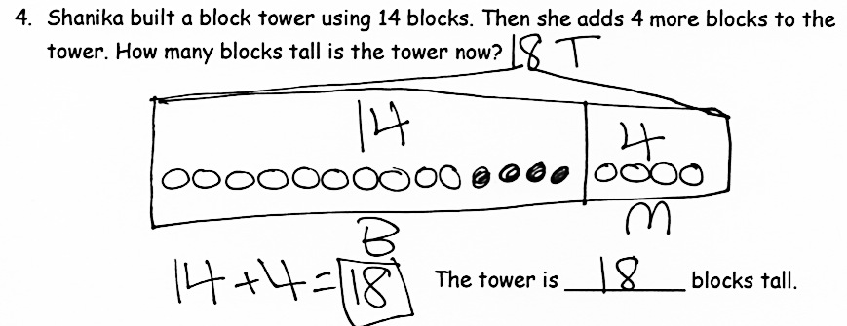
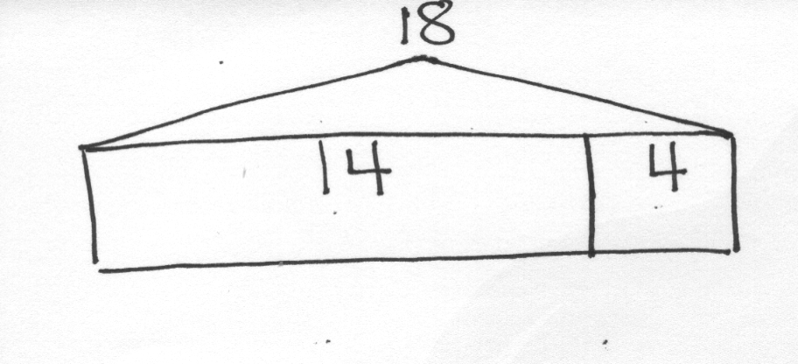
T: (Display the tape diagram shown in the image to the right.) I found this drawing on a piece of paper on the floor. It went with someone’s word problem from this week. Does anyone know which one it went to? Look through your Problem Sets with a partner, and see if you can figure it out. Talk about how you know.
Lesson 21 Problem 4
S: (Look back at Problem Sets with partner and discuss what is the same about the problem and the tape diagram.)
T: Which problem does this tape diagram go with?

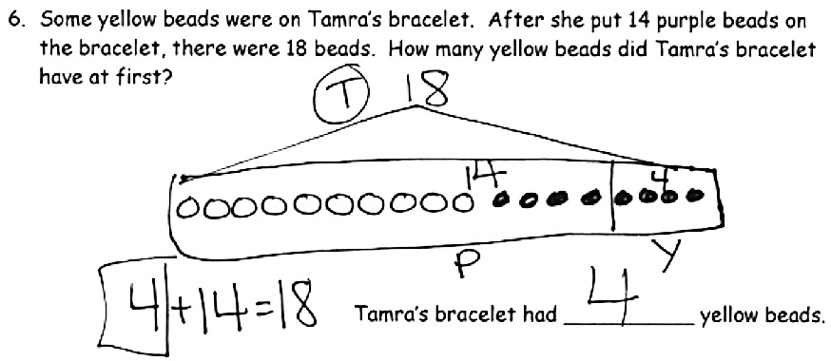
S: This tape diagram goes with the problem about Shanika’s tower (Problem 4 in Lesson 21). (Explains how the referents align with the problem story.) I think it goes with the one about Tamra’s yellow and purple beaded bracelet (Problem 6 in Lesson 20). (Explains how the referents align with the problem story.)
Lesson 20 Problem 6
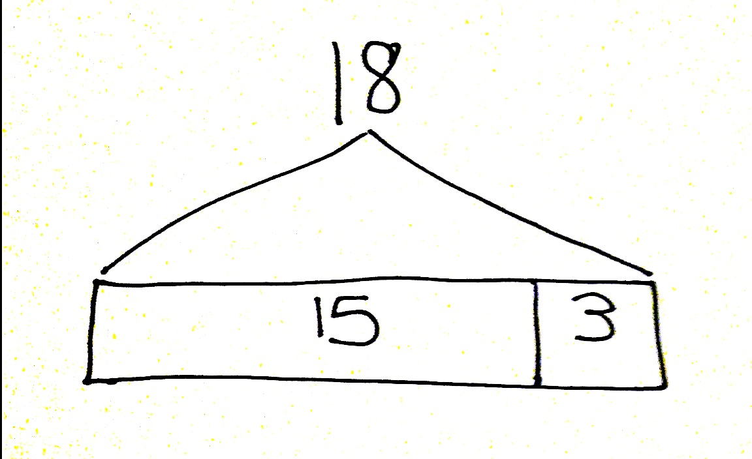
T: Hmm. They both sound like they could match this tape diagram.
T: (Draw tape diagram shown in the image on the right.) This is a tape diagram for a problem from yesterday’s lesson. Which problem does this match?
S: (Look back at Problem Set for Lesson 21 with partner and discuss what is the same about the problem and the tape diagram.)
Lesson 21 Problem 5
T: Which problem does the tape diagram go with?
S: It’s the one where Nikil builds a tower with 15 blocks and then adds some more. It’s Problem 5. (Explains how the referents align with the problem story.)
T: With your partner, try to come up with a different story that could go with this tape diagram. You can use your tape diagram template as you discuss your idea.

NOTES ON
MULTIPLE MEANS
OF ACTION AND EXPRESSION:
Giving students an opportunity to share their thinking allows them to evaluate their process and practice. English language learners also benefit from hearing others explain their thinking.

MP.2
T: (While students are discussing, circulate and listen.)
Listen to the students as they generate their story ideas, and choose three student math stories to use as samples for the class. Present the stories in the following order:
- A story that parallels the examples using a different topic. (An add to with a change unknown problem type, where the 3 is the unknown number, e.g.,
15 + ? = 18.)
- An add to with a result unknown problem type, e.g.,
15 + 3 = ?.

NOTES ON
MULTIPLE MEANS
OF REPRESENTATION:
Highlight the vocabulary used in the Problem Set to ensure understanding of all words. This supports vocabulary development, especially with English language learners.
- A different add to or take from with a change unknown problem or an add to with the start unknown problem, e.g., 3 + ? = 18, 18 - ? = 15, or ? + 15 = 18.
As the students share the problem with the class, redraw the tape diagram, label appropriately for the given story, and write the accompanying number sentences and statement.
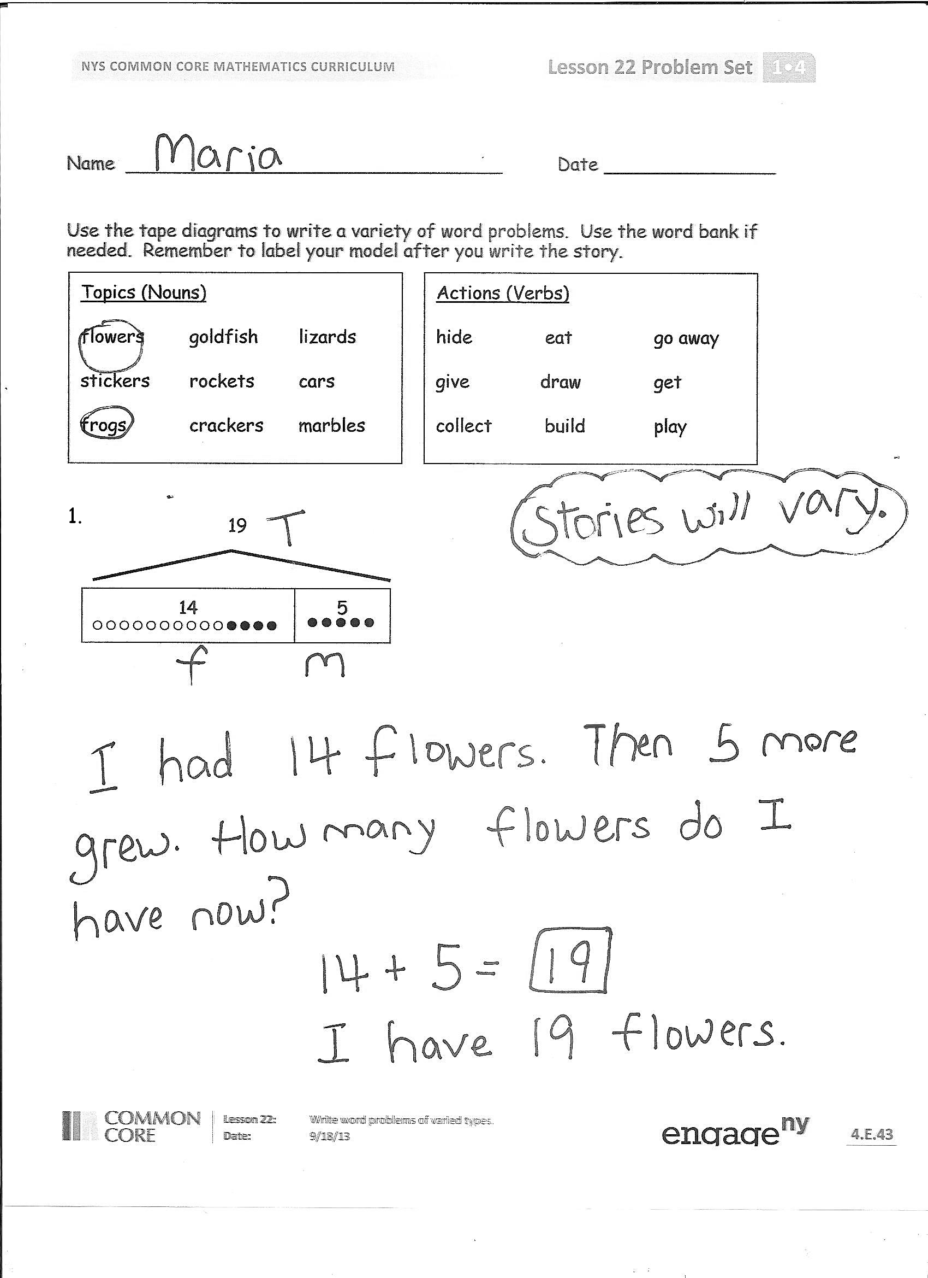
T: What was similar in all of these problems?
S: All of our problems used the same tape diagram.
T: What was different in each story problem?
S: The topic was different. Sometimes, the unknown or mystery number was different.
Sometimes, my number sentence was an addition sentence, and sometimes it was a subtraction sentence. The statement answered the question, and the question was different for each story problem.
T: How could knowing the answer to one story problem help you with a different story problem?
S: Sometimes, they do use the same number sentence. Even when the number sentences were different, they used a related fact, like 15 + 3 = 18 can still help you with
18 – 15 = 3, since they use the same number bond.
Problem Set (15 minutes)
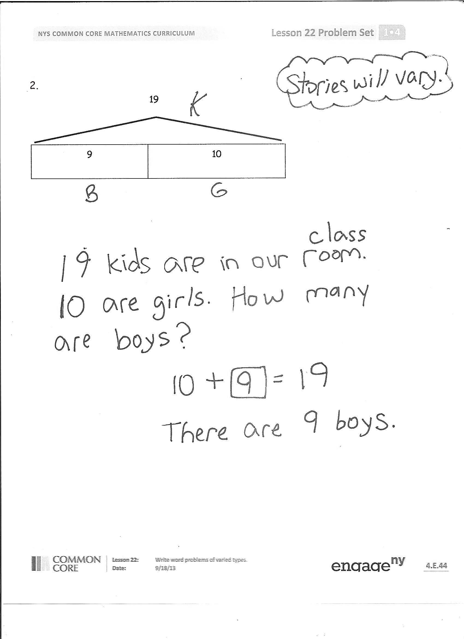
Students should do their personal best to complete the Problem Set within the allotted 15 minutes. For some classes, it may be appropriate to modify the assignment by specifying which problems they work on first. Some problems do not specify a method for solving. Students should solve these problems using the RDW approach used for Application Problems.
Student Debrief (12 minutes)
Lesson Objective: Write word problems of varied types.
The Student Debrief is intended to invite reflection and active processing of the total lesson experience.
Invite students to review their solutions for the Problem Set. They should check work by comparing answers with a partner before going over answers as a class. Look for misconceptions or misunderstandings that can be addressed in the Debrief. Guide students in a conversation to debrief the Problem Set and process the lesson.
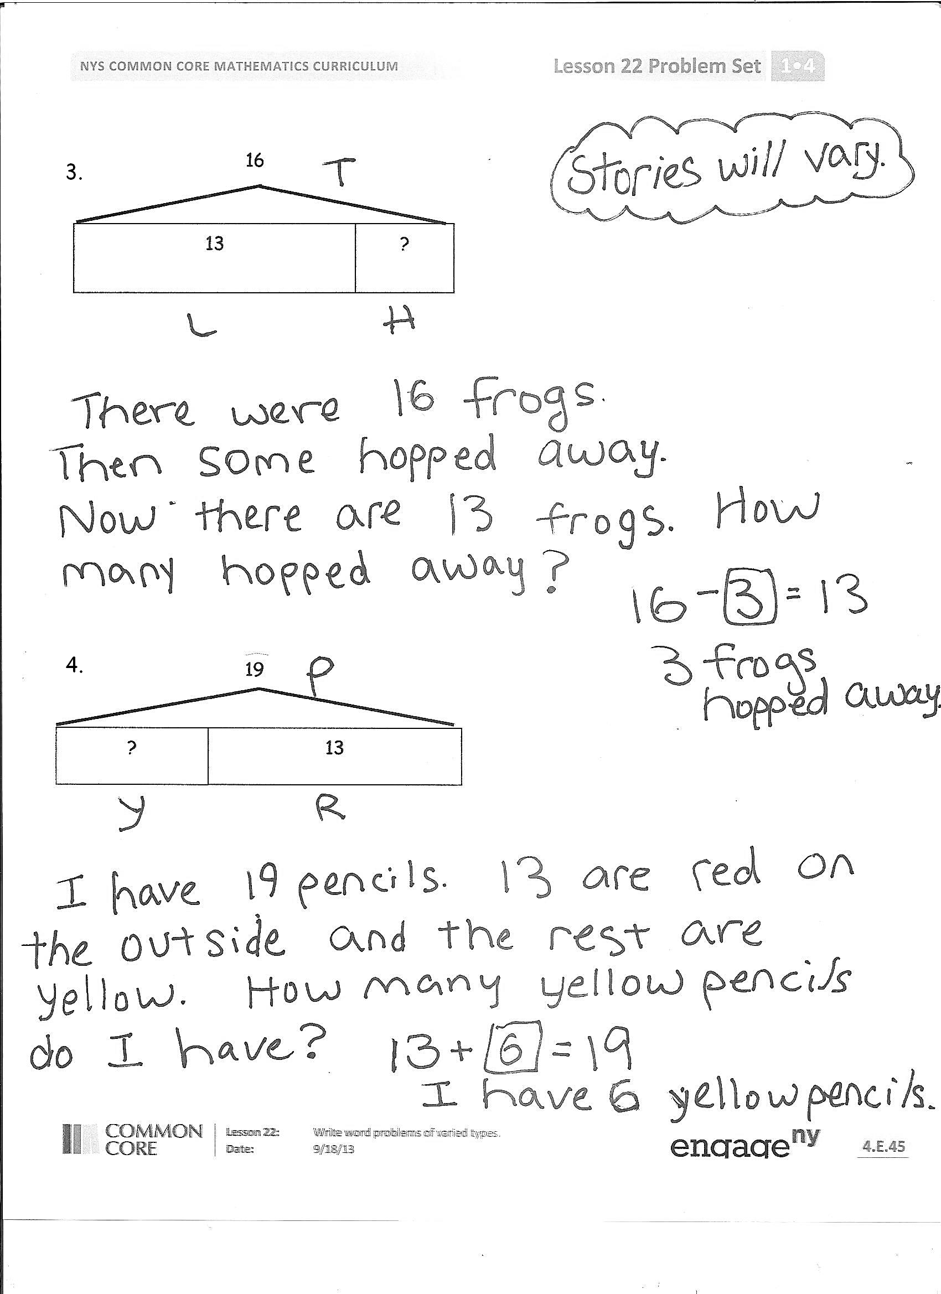
Any combination of the questions below may be used to lead the discussion.
- Look at Problem A. What story problem did you write? Share with the class. Pose to the rest of the class: What is the unknown number in the question? What number sentence would help you solve the question? Invite one or two more students to share. How did you decide on your labels for your tape diagrams?
- Which problems were the easiest for you to think of ideas for? Which were harder? Why?
- Look at your Application Problems from Lessons 13–18 and your Problem Sets from Lessons 19–21. What do you notice about your work? What part of your word problem work has been improving?
Exit Ticket (3 minutes)
After the Student Debrief, instruct students to complete the Exit Ticket. A review of their work will help with assessing students’ understanding of the concepts that were presented in today’s lesson and planning more effectively for future lessons. The questions may be read aloud to the students.

Name Date
Number Correct:
A
*Write the missing number. Pay attention to the + and – signs.
1 | 2 + 2 = ☐ |  | 16 | 2 + ☐ = 8
2 | 2 + ☐ = 4 |  | 17 | 6 + ☐ = 8
3 | 4 - 2 = ☐ |  | 18 | 8 - 6 = ☐
4 | 3 + 3 = ☐ |  | 19 | 8 - 2 = ☐
5 | 3 + ☐ = 6 |  | 20 | 9 + 2 = ☐
6 | 6 - 3 = ☐ |  | 21 | 9 + ☐ = 11
7 | 4 + ☐ = 7 |  | 22 | 11 - 9 = ☐
8 | 3 + ☐ = 7 |  | 23 | 9 + ☐ = 15
9 | 7 - 3 = ☐ |  | 24 | 15 - 9 = ☐
10 | 7 - 4 = ☐ |  | 25 | 8 + ☐ = 15
11 | 5 + 4 = ☐ |  | 26 | 15 - ☐ = 8
12 | 4 + ☐ = 9 |  | 27 | 8 + ☐ = 17
13 | 9 - 4 = ☐ |  | 28 | 17 - ☐ = 8
14 | 9 - 5 = ☐ |  | 29 | 27 - ☐ = 8
15 | 9 - ☐ = 4 |  | 30 | 37 - ☐ = 8
Name Date
Number Correct:
B
*Write the missing number. Pay attention to the + and – signs.
1 | 3 + 3 = ☐ |  | 16 | 2 + ☐ = 9
2 | 3 + ☐ = 6 |  | 17 | 7 + ☐ = 9
3 | 6 - 3 = ☐ |  | 18 | 9 - 7 = ☐
4 | 4 + 4 = ☐ |  | 19 | 9 - 2 = ☐
5 | 4 + ☐ = 8 |  | 20 | 9 + 5 = ☐
6 | 8 - 4 = ☐ |  | 21 | 9 + ☐ = 14
7 | 4 + ☐ = 9 |  | 22 | 14 - 9 = ☐
8 | 5 + ☐ = 9 |  | 23 | 9 + ☐ = 16
9 | 9 - 5 = ☐ |  | 24 | 16 - 9 = ☐
10 | 9 - 4 = ☐ |  | 25 | 8 + ☐ = 16
11 | 3 + 4 = ☐ |  | 26 | 16 - ☐ = 8
12 | 4 + ☐ = 7 |  | 27 | 8 + ☐ = 16
13 | 7 - 4 = ☐ |  | 28 | 16 - ☐ = 8
14 | 7 - 3 = ☐ |  | 29 | 26 - ☐ = 8
15 | 7 - ☐ = 3 |  | 30 | 36 - ☐ = 8

Name Date
Use the tape diagrams to write a variety of word problems. Use the word bank if needed. Remember to label your model after you write the story.
Topics (Nouns)
flowers goldfish lizards
stickers rockets cars
frogs crackers marbles

Actions (Verbs)
hide eat go away
give draw get
collect build play

1.
5
14
19

2.
9

10
19
3.
?
13
16

4.
19
?
13

Name Date
Circle the 2 story problems that match the tape diagram.
?
14
17

- There are 14 ants on the picnic blanket. Then, some more ants came over. Now, there are 17 ants on the picnic blanket. How many ants came over?

- 14 children are on the playground from one class. Then, 17 children from another class came to the playground. How many children are on the playground now?

- 17 grapes were on the plate. Willie ate 14 grapes. How many grapes are on the plate now?

Name Date
Use the tape diagrams to write a variety of word problems. Use the word bank if needed. Remember to label your model after you write the story.
Actions (Verbs)
hide eat go away
give draw get
collect build play

Topics (Nouns)
flowers goldfish lizards
stickers rockets cars
frogs crackers marbles

1.
5
12
17

2.
7
?
16

