Lesson 21
Objective: Recognize and make use of part–whole relationships within tape diagrams when solving a variety of problem types.

Suggested Lesson Structure
 Fluency Practice (12 minutes)
 Concept Development (38 minutes)
 Student Debrief (10 minutes)
Total Time (60 minutes)
Fluency Practice (12 minutes)
- Race and Roll Addition 1.OA.6 (4 minutes)
- Number Bond Addition and Subtraction 1.OA.6 (4 minutes)
- Take Out 1 or 10 1.OA.6 (2 minutes)
- Longer/Shorter K.CC.7 (2 minutes)
Race and Roll Addition (4 minutes)
Materials: (S) 1 die per set of partners
Note: In this fluency activity, students practice adding and subtracting within 20. The competitive nature of Race and Roll Addition and Subtraction promotes students’ engagement while increasing their brains’ ability to retain information (since the partners are trying to stand quickly).
All students start at 0. Partners take turns rolling a die, saying a number sentence, and adding the number rolled to the total. For example, Partner A rolls 6 and says, “0 + 6 = 6.” Then, Partner B rolls 3 and says,
“6 + 3 = 9.” They continue rapidly rolling and saying number sentences until they get to 20 without going over. Partners stand when they reach 20. For example, if they are at 18 and roll 5, they would take turns rolling until one of them rolls a 2 or a 1 and a 1. Then, they would both stand.
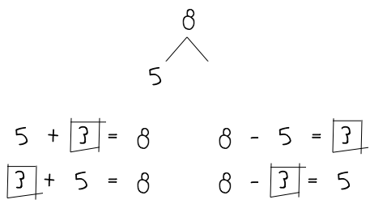
Number Bond Addition and Subtraction (4 minutes)
Materials: (S) Personal white board
Note: This fluency activity builds a student’s ability to add and subtract within 10. Reviewing the relationship between addition and subtraction is especially beneficial for students who continue to find subtraction challenging.
Write a number bond for a number between 0 and 10, with a missing part or whole. Today, students write two addition and two subtraction sentences with a box for the missing number in each equation. They then solve for the missing number.
Take Out 1 or 10 (2 minutes)
Note: This activity reviews place value to prepare students for Topic F.
Choose numbers between 10 and 20 and follow the paradigm below.
T: Say 15 the Say Ten Way.
S: Ten 5.
T: Take out 1.
S: Ten 4.
Repeat for 25 and 35. Then, take out 10 from 15, 25, and 35, respectively.
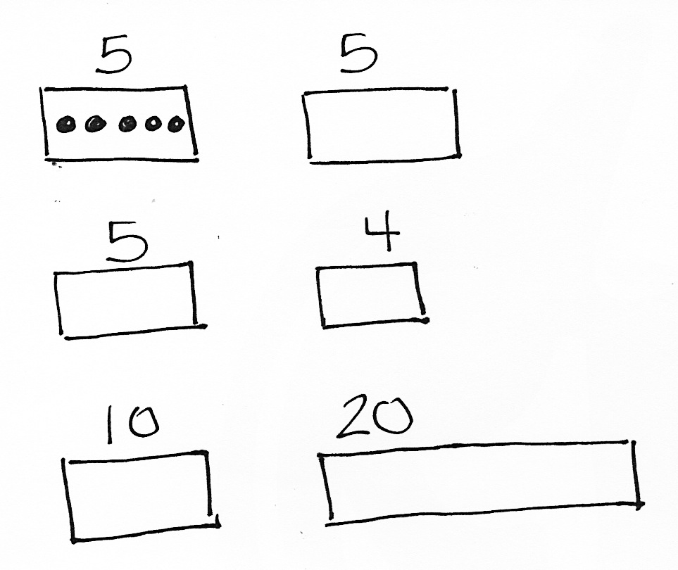
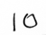
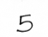
Longer/Shorter (2 minutes)
Materials: (T) Board or document camera
Note: Working with visualizing proportional relationships between numbers can support students’ number sense development. By using tape diagram models, students can recognize methods for representing numbers in relation to other numbers.
Write one pair of numbers on the board at a time (e.g., 5 and 5). Draw a rectangle under the first number.
T: This rectangle is long enough to hold this row of 5 dots. (Draw 5 dots so that they fill the space.)
T: (Point to the second number, which in this first example is also 5.) I’m going to start drawing a rectangle that is long enough to hold a row of 5 dots of the same size. Tell me when to stop.
T/S: (Begin drawing a rectangle, and give students the chance to say “Stop!” when it is approximately the same size as the first rectangle.)
T: Why did you say “stop” there?
S: It is about the same size as the first rectangle.
Repeat this process for the following sequence of numbers: 5 and 4, 5 and 10, 1 and 3, 4 and 6, 10 and 20. Only draw the dots for the first example. Have students talk about how the first number relates to the second number using language such as a little longer, a little shorter, much longer, double, etc. Have students who find this challenging use a number line with their left pointer finger on zero and their right pointer finger on the number (endpoint).
Concept Development (38 minutes)
Materials: (S) Problem Set
Note: As in Lessons 19 and 20, the suggested delivery of instruction for Lesson 21 is an integration of student work on Problem Sets with guided instruction interspersed between each problem. If students have been highly successful with the past days’ lessons, have them try representing the quantities in each part using the number and label without including the shapes inside each part. The goal is to support students in identifying a process for making sense of a problem today.
By working with the tape diagrams as drawings related to the varying problem types, students can internalize an entry point into any problem. Can you draw something? What can you draw? What can you tell from looking at your drawing? Tape diagrams, even without shapes inside each part, can be considered a type of drawing. Remember to have students hold on to the Problem Sets so they can use them as a reference later in the topic.
Suggested Delivery of Instruction for Solving Word Problems
1. Model the problem, calculate, and write a statement.

NOTES ON
MULTIPLE MEANS
OF REPRESENTATION:
Encourage students who have difficulty moving to the tape diagram representation as the position of the unknown changes to draw a number bond as part of their work. Some students more easily relate to the tape diagram through its similarities with number bonds.
Choose two pairs of students who have been accurately solving the Application Problems from Topic D and using simple shapes in a straight line when drawing. Invite these two pairs of students to work on chart paper while the others work independently or in pairs at their seats. Vary the selected students as the problems become more complex. Review the following questions before beginning the first problem:
- Can you draw something?
- What can you draw?
- What can you tell from looking at your drawing?
As students work, circulate and support. After two minutes, have the two pairs of students share only their labeled diagrams. Give the students two to three minutes to finish work on that question, sharing their work and thinking with a peer. All should write their equations and statements of the answer.

NOTES ON
MULTIPLE MEANS
OF ACTION AND EXPRESSION:
If students do not have experience with a context such as the one used in Problem 2, act out the problem with a few student volunteers before having the class begin to draw and solve the problem.

2. Assess the solution for reasonableness.
Give students one to two minutes to assess and explain the reasonableness of their solution. For about one minute, have the demonstrating students receive and respond to feedback and questions from their peers.

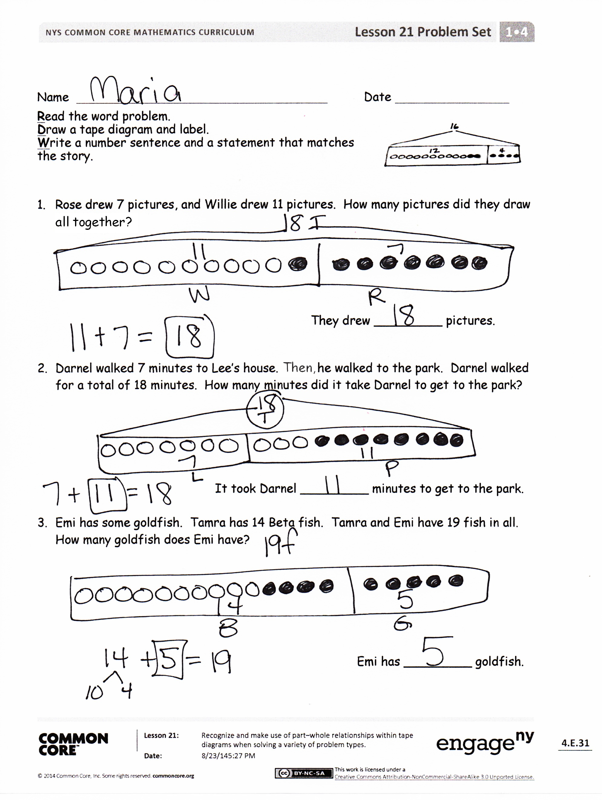
3. As a class, notice the ways the drawing depicts the story and the solution.
Ask questions to help students recognize how each part of their drawing matches the story and solution. This will help students begin to see how the same process can help them solve varying word problems. Keep at least one chart paper sample of each solution for reference later in the lesson.
Problem 1
Rose drew 7 pictures, and Willie drew 11 pictures. How many pictures did they draw altogether?
This problem, a put together with total unknown, is one of the easiest problem types. After the students have explained their drawings and solutions accurately, point to sections of the tape diagram and ask the class questions such as, “What does this part represent? How do you know? What did the student draw or write to help us remember?”
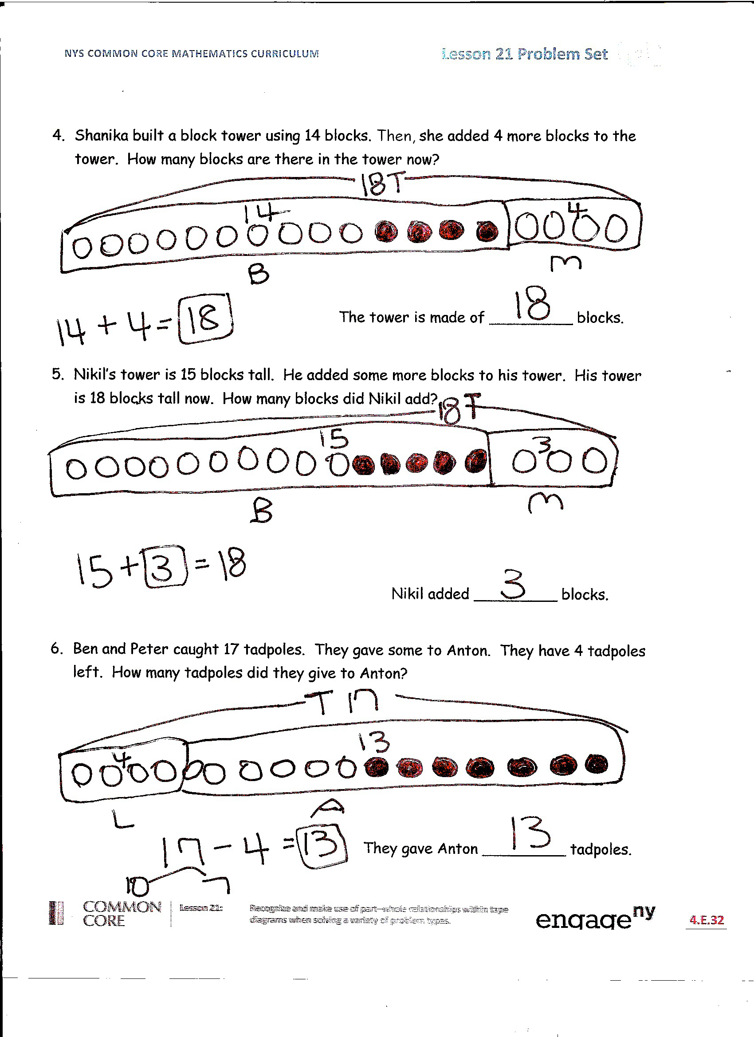
For the next five problems, move quickly from one to the next, having only the students at the board share their work, so that students have time to work through and discuss all six problems. Choose one or two probing questions similar to Problems 1 and 2 to support student development as needed.
Problem 2
Darnel walked 7 minutes to Lee’s house. Then, he walked to the park. Darnel walked for a total of 18 minutes. How many minutes did it take Darnel to get to the park?
Problem 3
Emi has some goldfish. Tamra has 14 betta fish. Tamra and Emi have 19 fish in all. How many goldfish does Emi have?
Problem 4
Shanika built a block tower using 14 blocks. Then, she added 4 more blocks to the tower. How many blocks are there in the tower now?

Problem 5
Nikil’s tower is 15 blocks tall. He added some more blocks to his tower. His tower is 18 blocks tall now. How many blocks did Nikil add?
Problem 6
Ben and Peter caught 17 tadpoles. They gave some to Anton. They have 4 tadpoles left. How many tadpoles did they give to Anton?
Student Debrief (10 minutes)
Lesson Objective: Recognize and make use of part–whole relationships within tape diagrams when solving a variety of problem types.
The Student Debrief is intended to invite reflection and active processing of the total lesson experience.
Guide students in a conversation to debrief the Problem Set and process the lesson. Look for misconceptions or misunderstandings that can be addressed in the Debrief.
Any combination of the questions below may be used to lead the discussion.
- Look at Problem 1. What did you draw? How did your drawing help you solve the problem?
- Look at Problem 2. What did you draw first? How is your drawing similar or different from the drawing you made for Problem 1?
- Look at Problem 3. How did you draw this problem? How is your drawing similar to or different from your partner’s drawing?
- Look at Problem 5. Did you solve this the same way you solved Problem 3, or did you solve it in a different way? Share your drawing and explain your thinking.
- In an earlier lesson, we were looking at smaller, single-digit addition facts inside two-digit addition problems. Can you find any simpler addition facts inside your number sentences? Share your examples. How can you draw your tape diagrams in ways that help you see simple problems inside the larger ones?
- Using a highlighter, underline the question in each problem. Highlight the part of the tape diagram that shows the answer to the question. What do you notice?
- Some people write only numbers and not circles inside the parts of a tape diagram. Why might we want to include the circles in each part? Why might we choose sometimes to use only the number and leave out the circles in each part?
Exit Ticket (3 minutes)
After the Student Debrief, instruct students to complete the Exit Ticket. A review of their work will help with assessing students’ understanding of the concepts that were presented in today’s lesson and planning more effectively for future lessons. The questions may be read aloud to the students.

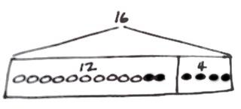
Name Date
Read the word problem.
Draw a tape diagram and label.
Write a number sentence and a statement that matches the story.

- Rose drew 7 pictures, and Willie drew 11 pictures. How many pictures did they draw all together?

They drew _________ pictures.

- Darnel walked 7 minutes to Lee’s house. Then, he walked to the park. Darnel walked for a total of 18 minutes. How many minutes did it take Darnel to get to the park?

It took Darnel _________ minutes to get to the park.

- Emi has some goldfish. Tamra has 14 betta fish. Tamra and Emi have 19 fish in all. How many goldfish does Emi have?

Emi has _________ goldfish.
- Shanika built a block tower using 14 blocks. Then, she added 4 more blocks to the tower. How many blocks are there in the tower now?

The tower is made of _________ blocks.

- Nikil’s tower is 15 blocks tall. He added some more blocks to his tower. His tower is 18 blocks tall now. How many blocks did Nikil add?

Nikil added _________ blocks.

- Ben and Peter caught 17 tadpoles. They gave some to Anton. They have 4 tadpoles left. How many tadpoles did they give to Anton?

They gave Anton _________ tadpoles.

Name Date
Read the word problem.
Draw a tape diagram and label.
Write a number sentence and a statement that matches the story.

- Shanika read some pages on Monday. On Tuesday, she read 6 pages. She read 13 pages during the 2 days. How many pages did she read on Monday?
Shanika read _________ pages on Monday.
Name Date
Read the word problem.
Draw a tape diagram and label.
Write a number sentence and a statement that matches the story.

- Fatima has 12 colored pencils in her bag. She has 6 regular pencils, too. How many pencils does Fatima have?

Fatima has ________ pencils.

- Julio swam 7 laps in the morning. In the afternoon, he swam some more laps. He swam a total of 14 laps. How many laps did he swim in the afternoon?

Julio swam ______ laps in the afternoon.

- Peter built 18 models. He built 13 airplanes and some cars. How many car models did he build?

Peter built ________ car models.

- Kiana found some shells at the beach. She gave 8 shells to her brother. Now, she has 9 shells left. How many shells did Kiana find at the beach?

Kiana found ______ shells.

