Lesson 16: Converse of the Pythagorean Theorem

Classwork
Proof of the Converse of the Pythagorean Theorem

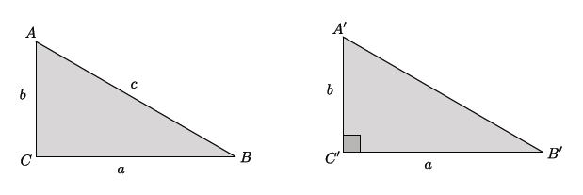

Exercises 1–7
- Is the triangle with leg lengths of $3$ mi.,$8$ mi., and hypotenuse of length $\sqrt{73}$mi. a right triangle? Show your work, and answer in a complete sentence.

- What is the length of the unknown side of the right triangle shown below? Show your work, and answer in a complete sentence. Provide an exact answer and an approximate answer rounded to the tenths place.
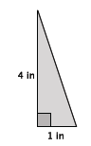

- What is the length of the unknown side of the right triangle shown below? Show your work, and answer in a complete sentence. Provide an exact answer and an approximate answer rounded to the tenths place.
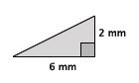

- Is the triangle with leg lengths of $9$ in., $9$in., and hypotenuse of length $\sqrt{175}$in. a right triangle? Show your work, and answer in a complete sentence.

- Is the triangle with leg lengths of $\sqrt{28}$ cm, $6$cm, and hypotenuse of length$8$cm a right triangle? Show your work, and answer in a complete sentence.

- What is the length of the unknown side of the right triangle shown below? Show your work, and answer in a complete sentence.
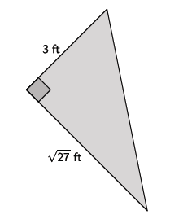

.

- The triangle shown below is an isosceles right triangle. Determine the length of the legs of the triangle. Show your work, and answer in a complete sentence.
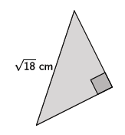

Problem Set
Lesson Summary
The converse of the Pythagorean Theorem states that if a triangle with side lengths $a$,$b$, and $c$ satisfies
$a^{2}+b^{2}=c^{2}$, then the triangle is a right triangle.
The converse can be proven using concepts related to congruence.

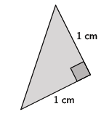
- What is the length of the unknown side of the right triangle shown below? Show your work, and answer in a complete sentence. Provide an exact answer and an approximate answer rounded to the tenths place.
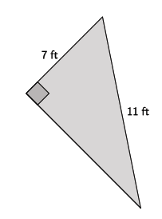
- What is the length of the unknown side of the right triangle shown below? Show your work, and answer in a complete sentence. Provide an exact answer and an approximate answer rounded to the tenths place.
- Is the triangle with leg lengths of $\sqrt{3}$cm, $9$cm, and hypotenuse of length$\sqrt{84}$cm a right triangle? Show your work, and answer in a complete sentence.

- Is the triangle with leg lengths of $\sqrt{7}$km, $5$km, and hypotenuse of length$\sqrt{48}$km a right triangle? Show your work, and answer in a complete sentence.

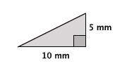
- What is the length of the unknown side of the right triangle shown below? Show your work, and answer in a complete sentence. Provide an exact answer and an approximate answer rounded to the tenths place.
- Is the triangle with leg lengths of $3$, $6$, and hypotenuse of length$\sqrt{45}$ a right triangle? Show your work, and answer in a complete sentence.

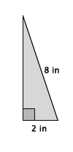
- What is the length of the unknown side of the right triangle shown below? Show your work, and answer in a complete sentence. Provide an exact answer and an approximate answer rounded to the tenths place.
- Is the triangle with leg lengths of $1$, $\sqrt{3}$, and hypotenuse of length$2$ a right triangle? Show your work, and answer in a complete sentence.

- Corey found the hypotenuse of a right triangle with leg lengths of $2$ and $3$ to be $\sqrt{13}$. Corey claims that since $\sqrt{13}=3.61$ when estimating to two decimal digits, that a triangle with leg lengths of $2$, $3,$ and a hypotenuse of $3.61$ is a right triangle. Is he correct? Explain.

- Explain a proof of the Pythagorean Theorem.

- Explain a proof of the converse of the Pythagorean Theorem.

