Lesson 20
Objective: Recognize and make use of part–whole relationships within tape diagrams when solving a variety of problem types.

Suggested Lesson Structure
 Fluency Practice (11 minutes)
 Concept Development (39 minutes)
 Student Debrief (10 minutes)
Total Time (60 minutes)
Fluency Practice (11 minutes)
- Beep Counting by Ones and Tens 1.OA.5, 1.NBT.3 (2 minutes)
- Number Bond Addition and Subtraction 1.OA.6 (4 minutes)
- Addition and Subtraction with Cards 1.NBT.4 (5 minutes)
Beep Counting by Ones and Tens (2 minutes)
Note: This fluency activity allows students to practice their counting sequences as well as practicing mentally adding 10 and subtracting 10 from a given number.
Say a series of four numbers, but replace one of the numbers with the word “beep” (e.g., “1, 2, 3, beep”). When signaled, students say the number that was replaced by the word “beep” in the sequence. Scaffold number sequences, beginning with easy sequences and moving to more complex ones. Choose sequences that count forward and backward by ones and tens within 40.
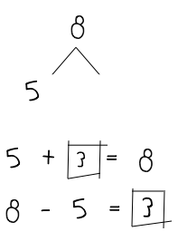
Suggested sequence type: 10, 11, 12, beep; 20, 21, 22, beep; 20, 19, 18, beep; 30, 29, 28 beep; 0, 10, 20, beep; 1, 11, 21, beep; 40, 30, 20, beep; 39, 29, 19, beep. Continue with similar sequences, changing the sequential placement of the beep.
Number Bond Addition and Subtraction (4 minutes)
Materials: (S) Personal white board
Note: This fluency activity builds students’ ability to add and subtract within 10 or 20, while reinforcing the relationship between addition and subtraction. The first two to three minutes should be spent reviewing the core fluency within 10. In the last one to two minutes, allow students who are very strong with sums and differences to 10 to work with a partner and choose totals between 10 and 20.
Write a number bond for a number between 0 and 10, with a missing part or whole. Students write an addition and a subtraction sentence with a box for the missing number in each equation. They then solve for the missing number.
Addition and Subtraction with Cards (5 minutes)
Materials: (S) Addition and subtraction cards (Lesson 12 Template), addition and subtraction cards set 2 (Lesson 17 Template)
Note: This fluency game reviews the problem types presented in Topics A─D, as well as subtraction from Module 2.
Follow the directions in Lesson 12’s Concept Development.
Concept Development (39 minutes)

NOTES ON
MULTIPLE MEANS
OF EXPRESSION:
Grouping students in pairs and asking them to explain their work to each other can support students’ language development. Students can ask each other the same questions that the teacher asks. Be sure to have students switch roles so that all students have the opportunity to practice verbalizing their thinking and listening.

Materials: (S) Problem Set, highlighter
Note: During Lesson 20, the suggested delivery of instruction is an integration of student work on the Problem Set with guided instruction interspersed between each problem. Today, the unknown in each problem will vary between a part and the total. The sequence of problems has been designed to support students in using the RDW process—particularly to keep track of information as they determine whether they are looking for a part or the total—and to use the visual representation of the information to support calculations.
Suggested Delivery of Instruction for Solving Word Problems
1. Model the problem, calculate, and write a statement.

NOTES ON
MULTIPLE MEANS
OF ENGAGEMENT:
Appropriate scaffolds help all students feel successful. Students may use translators, interpreters, or sentence frames to present their solutions or respond to feedback. Models shared may include concrete manipulatives.

Choose two pairs of students who have been accurately solving the Application Problems from Topic D and using simple shapes in a straight line when drawing. Invite these two pairs of students to work on chart paper while the others work independently or in pairs at their seats. Vary the selected students as the problems become more complex. Review the following questions before beginning the first problem:
- Can you draw something?
- What can you draw?
- What can you tell from looking at your drawing?
As students work, circulate. Reread Problem 1 and reiterate the questions above. After a maximum of two minutes, have the pairs of students share their labeled diagrams. Give the students two to three minutes to finish work on that question, sharing their work and thinking with a peer. All should write their equations and statements of the answer.
2. Assess the solution for reasonableness.
Give students one to two minutes to assess and explain the reasonableness of their solution. For about one minute, have the demonstrating students receive and respond to feedback and questions from their peers.
3. As a class, notice the ways the drawing depicts the story and the solution.
Ask questions to help students recognize how each part of their drawing matches the story and solution. This will help students begin to see how the same process can help them solve varying word problems. Keep at least one chart paper sample of each solution for reference later in the lesson.
Problem 1
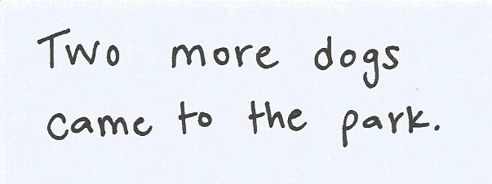
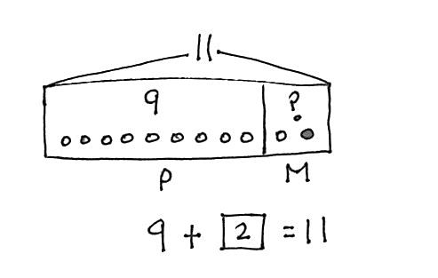
9 dogs were playing at the park. Some more dogs came to the park. Then, there were 11 dogs. How many more dogs came to the park?
Problem 1: 9 dogs were playing at the park. Some more dogs came to the park. Then there were 11 dogs. How many more dogs came to the park?
To support students’ methods for keeping track of their information, ask some of the following questions:
- What labels did the student use to show the part consisting of the dogs that were playing at first?
- How did she separate them from the part consisting of the dogs that came later?
- What label did she use for the total number of dogs?
- Where did she put the label for the total number of dogs? How did that help?
Be sure to discuss the solution and the number sentence, noting which number from the number sentence is the solution number. This number should have a rectangle around it, as shown.
Problem 2
16 strawberries are in a basket for Peter and Julio. Peter eats 8 of them. How many are there for Julio to eat?
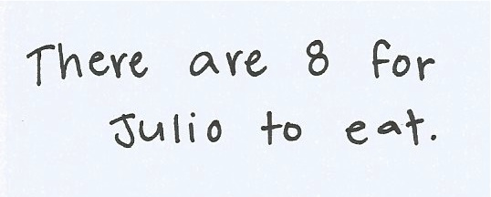
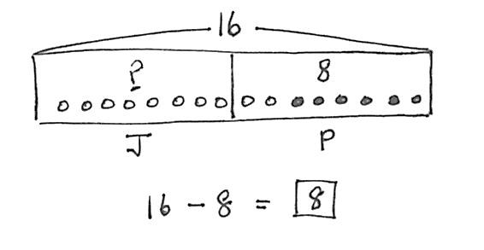
Problem 2: 16 strawberries are in a basket for Peter and Julio. Peter eats 8 of them. How many are there for Julio to eat?

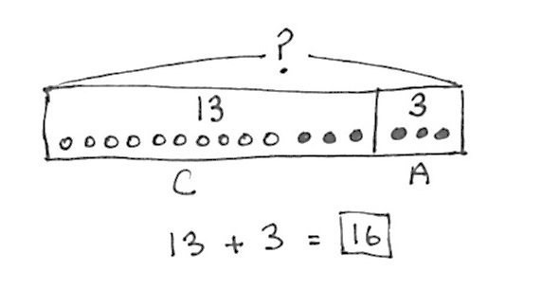
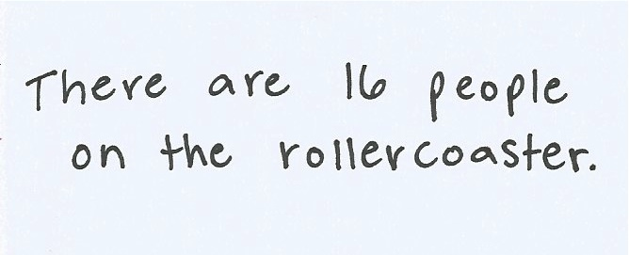
Problem 3
Problem 3: 13 children are on the roller coaster. 3 adults are on the roller coaster. How many people are on the roller coaster?
13 children are on the roller coaster. 3 adults are on the roller coaster. How many people are on the roller coaster?
Have the class read one sentence of the problem at a time while the students at the board show where the information is within their drawings, pointing out the number and letter labels. Discuss where they can find the solution within the number sentence, and ensure that everyone has placed a rectangle around this number.
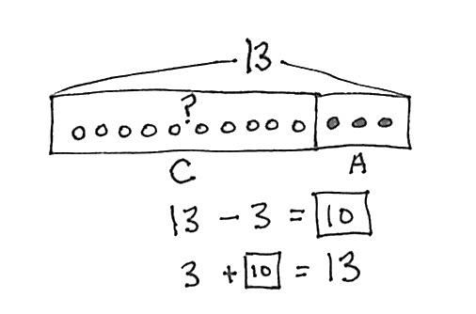
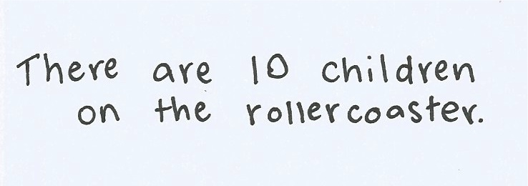
Some students will initially assume this problem requires subtraction. The process of walking through each sentence to ask, “Is this a new part, or does this include the part I already drew?” can support students who are internalizing a process for making sense of word problems.
Problem 4: 13 people are on the roller coaster now. 3 adults are on the roller coaster, and the rest are children. How many children are on the roller coaster?
Problem 4
13 people are on the roller coaster now. 3 adults are on the roller coaster, and the rest are children. How many children are on the roller coaster?
While this problem uses the same context as Problem 3, the problem type is different. As students consider the question,
“Is this a new part, or is this a part of what I already drew?” they will recognize that in this problem the unknown number is a part of the total 13.
During the Debrief, Problems 3 and 4 will be compared.
Problem 5
Ben has 6 baseball practices in the morning this month. If Ben also has 6 practices in the afternoon, how many baseball practices does Ben have?
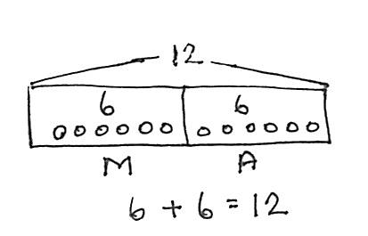
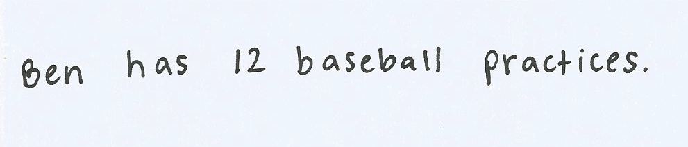
Choose probing questions appropriate to the successes and challenges of the class. Notice students who are improving, and ask them to share their increasing understanding.
Problem 5: Ben has 6 baseball practices in the morning this month. If Ben also has 6 practices in the afternoon, how many baseball practices does Ben have?

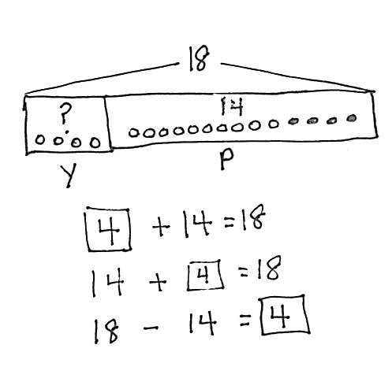
Problem 6
Problem 6: Some yellow beads were on Tamra’s bracelet. After she put 14 purple beads on the bracelet, there were 18 beads. How many yellow beads did Tamra’s bracelet have at first?
Some yellow beads were on Tamra’s bracelet. After she put 14 purple beads on the bracelet, there were 18 beads. How many yellow beads did Tamra’s bracelet have at first?
As an add to with start unknown problem type, this will most likely be the most challenging problem of the set.
In this example, the student approaches the problem by first drawing an empty box for the yellow beads and putting the question mark in it. Next, the 14 are drawn, and the total of 18 is labeled. Finally, the student counts up from 14 to 18 while drawing in the additional 4 beads to find the missing part.
The number sentences are written. The most probable solution equation would be the center one, 14 + ___ = 18. Not many first graders will opt to start with a part unknown or subtract 14 from 18.
Student Debrief (10 minutes)
Lesson Objective: Recognize and make use of part–whole relationships within tape diagrams when solving a variety of problem types.
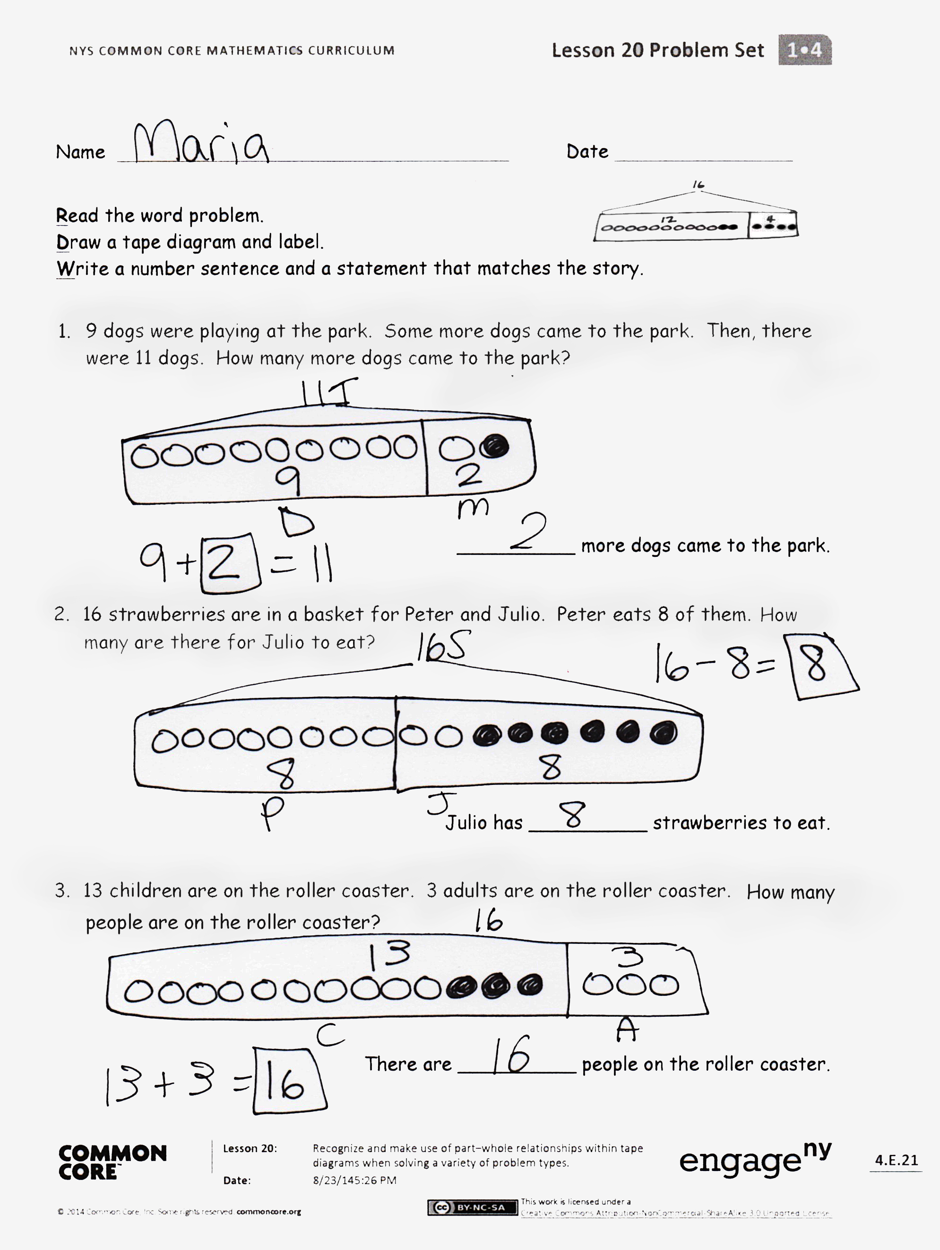
The Student Debrief is intended to invite reflection and active processing of the total lesson experience.
Guide students in a conversation to debrief the Problem Set and process the lesson. Look for misconceptions or misunderstandings that can be addressed in the Debrief.
Any combination of the questions below may be used to lead the discussion.
- How are Problems 3 and 4 alike? How are they different? How did your drawings help you to solve each problem?
- In which problems could making ten help you? Explain your thinking.
- Look at Problem 2 and Problem 3. What is similar, and what is different between the two problems? What do you notice about the size of the rectangles around each part in Problem 2? What do you notice in Problem 3?
- Look at Problem 6. How did you solve this problem? What did you draw first? Next? Did anyone do it a different way?
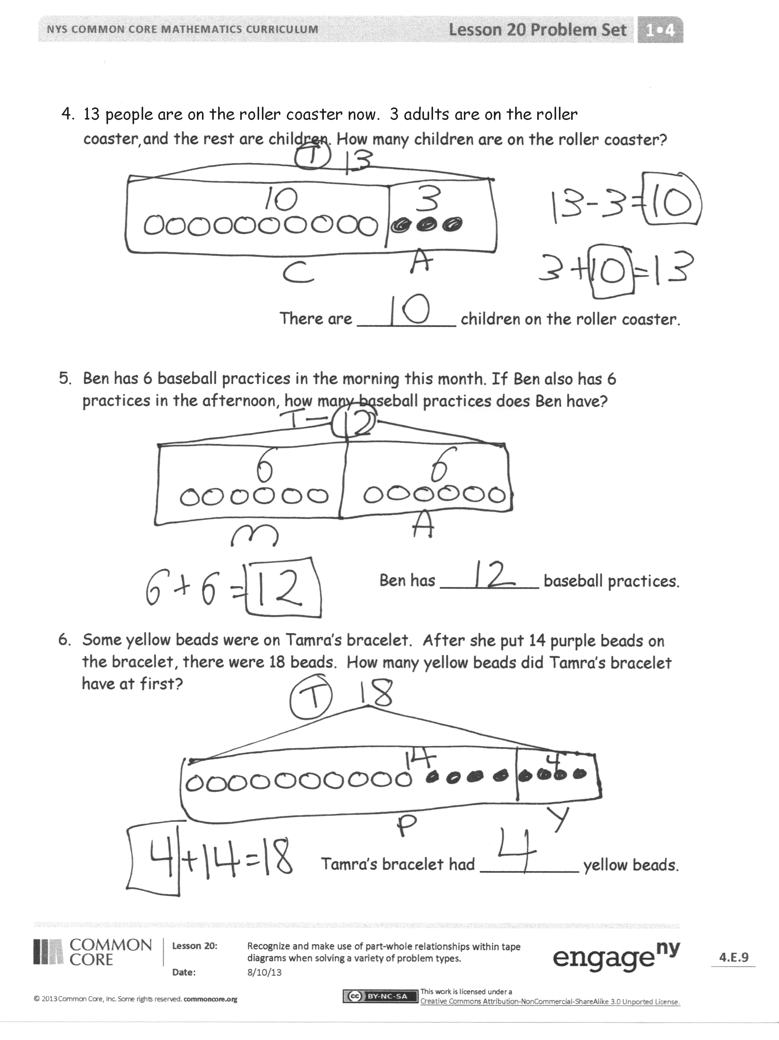
- Using a highlighter, underline the question in each problem. Highlight the part of the tape diagram that shows the answer to the question. What do you notice?
- Some people only write numbers and not circles inside the parts of a tape diagram. Why do we draw the circles sometimes? Why do we just use numbers at times?
Exit Ticket (3 minutes)
After the Student Debrief, instruct students to complete the Exit Ticket. A review of their work will help with assessing students’ understanding of the concepts that were presented in today’s lesson and planning more effectively for future lessons. The questions may be read aloud to the students.
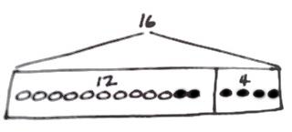
Name Date
Read the word problem.
Draw a tape diagram and label.
Write a number sentence and a statement that matches the story.

- 9 dogs were playing at the park. Some more dogs came to the park. Then, there were 11 dogs. How many more dogs came to the park?

__________ more dogs came to the park.

- 16 strawberries are in a basket for Peter and Julio. Peter eats 8 of them. How many are there for Julio to eat?

Julio has __________ strawberries to eat.

- 13 children are on the roller coaster. 3 adults are on the roller coaster. How many people are on the roller coaster?

There are __________ people on the roller coaster.
- 13 people are on the roller coaster now. 3 adults are on the roller coaster, and the rest are children. How many children are on the roller coaster?

There are __________ children on the roller coaster.

- Ben has 6 baseball practices in the morning this month. If Ben also has 6 practices in the afternoon, how many baseball practices does Ben have?

Ben has __________ baseball practices.

- Some yellow beads were on Tamra’s bracelet. After she put 14 purple beads on the bracelet, there were 18 beads. How many yellow beads did Tamra’s bracelet have at first?

Tamra’s bracelet had __________ yellow beads.

Name Date
Read the word problem.
Draw a tape diagram and label.
Write a number sentence and a statement that matches the story.

There were 6 turtles in the tank. Dad bought some more turtles. Now, there are 12 turtles. How many turtles did Dad buy?

Dad bought __________ turtles.

Name Date
Read the word problem.
Draw a tape diagram and label.
Write a number sentence and a statement that matches the story.

- Rose has 12 soccer practices this month. 6 practices are in the afternoon, but the rest are in the morning. How many practices will be in the morning?

Rose has ______ practices in the morning.

- Ben caught 16 fish. He put some back in the lake. He brought home 7 fish. How many fish did he put back in the lake?

Ben put ______ fish back in the lake.
- Nikil solved 9 problems on the first Sprint. He solved 11 problems on the second Sprint. How many problems did he solve on the two Sprints?

Nikil solved ______ problems on the Sprints.

- Shanika returned some books to the library. She had 16 books at first, and she still has 13 books left. How many books did she return to the library?

Shanika returned ______ books to the library.

