Lesson 15: Pythagorean Theorem, Revisited

Classwork
Proof of the Pythagorean Theorem
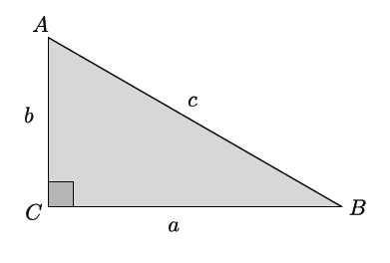

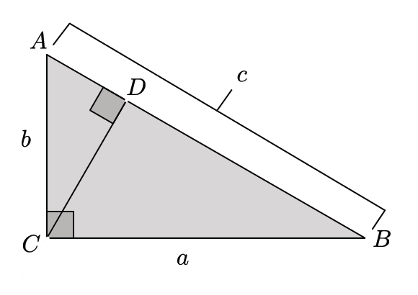

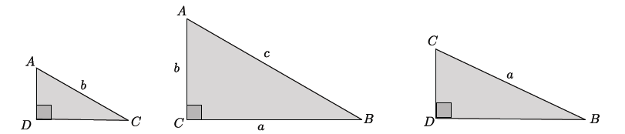

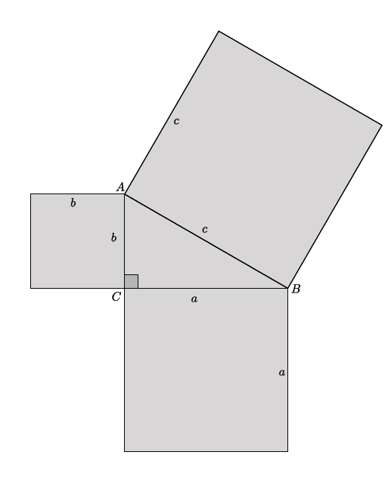

Problem Set
Lesson Summary
The Pythagorean Theorem can be proven by showing that the sum of the areas of the squares constructed off of the legs of a right triangle is equal to the area of the square constructed off of the hypotenuse of the right triangle.

- For the right triangle shown below, identify and use similar triangles to illustrate the Pythagorean Theorem.
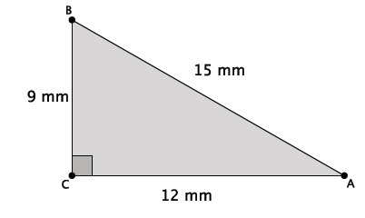
- For the right triangle shown below, identify and use squares formed by the sides of the triangle to illustrate the Pythagorean Theorem.
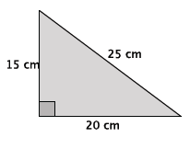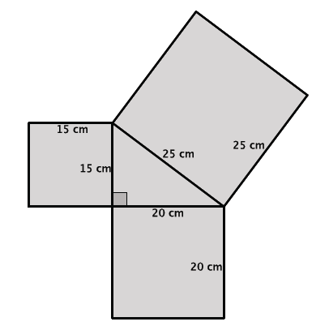

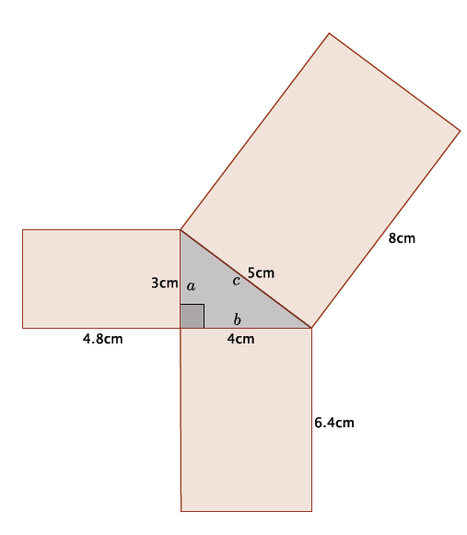
- Reese claimed that any figure can be drawn off the sides of a right triangle and that as long as they are similar figures, then the sum of the areas off of the legs will equal the area off of the hypotenuse. She drew the diagram at right by constructing rectangles off of each side of a known right triangle. Is Reese’s claim correct for this example? In order to prove or disprove Reese’s claim, you must first show that the rectangles are similar. If they are, then you can use computations to show that the sum of the areas of the figures off of the sides $a$ and $b$ equal the area of the figure off of side $c.$

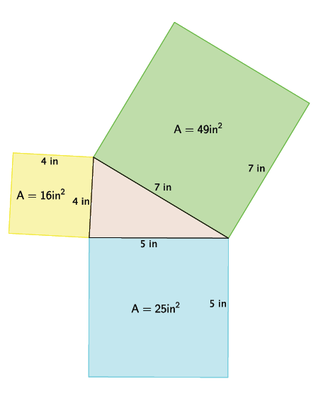
- After learning the proof of the Pythagorean Theorem using areas of squares, Joseph got really excited and tried explaining it to his younger brother using the diagram to the right. He realized during his explanation that he had done something wrong. Help Joseph find his error. Explain what he did wrong.

- Draw a right triangle with squares constructed off of each side that Joseph can use the next time he wants to show his younger brother the proof of the Pythagorean Theorem.

- Explain the meaning of the Pythagorean Theorem in your own words.

- Draw a diagram that shown an example illustrating the Pythagorean Theorem.

