Lesson 15: The Pythagorean Theorem, Revisited

Student Outcomes
- Students know that the Pythagorean Theorem can be interpreted as a statement about the areas of similar geometric figures constructed on the sides of a right triangle.
- Students explain a proof of the Pythagorean Theorem.

Lesson Notes
The purpose of this lesson is for students to review and practice presenting the proof of the Pythagorean Theorem using similar triangles. Then, students will apply this knowledge to another proof that uses areas of similar figures such as squares.

Classwork
Discussion (20 minutes)
This discussion is an opportunity for students to practice explaining a proof of the Pythagorean Theorem using similar triangles. Instead of leading the discussion, consider posing the questions, one at a time, to small groups of students and allow time for discussions. Then, have select students share their reasoning while others critique.
- To prove the Pythagorean Theorem, $a^{2}+b^{2}=c^{2}$, use a right triangle, shown below. Begin by drawing a segment from the right angle, perpendicular to side $AB$ through point $C.$ Label the intersection of the segments point $D.$
Proof of the Pythagorean Theorem
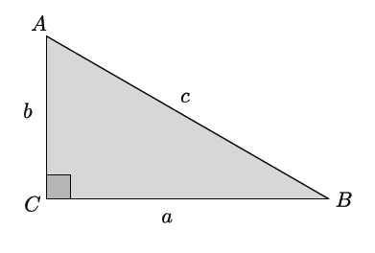
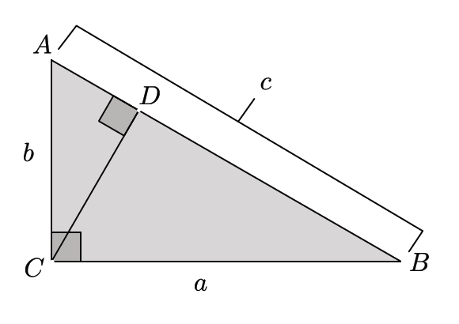
Scaffolding:
- A good hands-on visual that can be used here requires a $3×5$ notecard. Have students draw the diagonal, then draw the perpendicular line from $C$ to side $AB$.
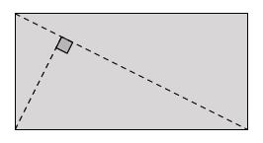
- Make sure students label all of the parts to match the triangle to the left. Next, have students cut out the three triangles. Students will then have a notecard version of the three triangles shown below and can use them to demonstrate the similarity among them.
- The next scaffolding box shows a similar diagram for the concrete case of a $6$-$8$-$10$ triangle.
- Using one right triangle, we created $3$ right triangles. Name those triangles.
  - The three triangles are $△ABC$, $△ACD$, and $△BCD$.
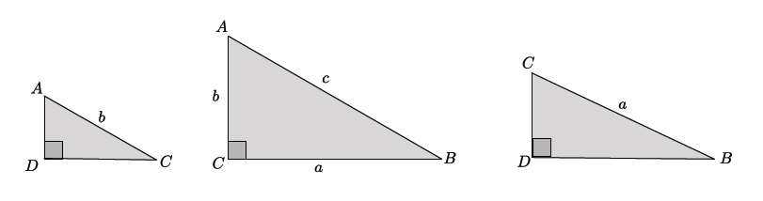
- We can use our basic rigid motions to reorient the triangles so they are easier to compare, as shown below.

- The next step is to show that these triangles are similar. Begin by showing that
$△ADC∽ △ACB$. Discuss in your group.
  - The triangles $△ADC$and $△ACB$ are similar because they each have a right angle, and they each share $∠A$. Then, by the AA criterion for similarity, $△ADC∽ △ACB.$
Scaffolding:
You may also consider showing a concrete example, such as a $6$-$8$-$10$ triangle, along with the general proof.
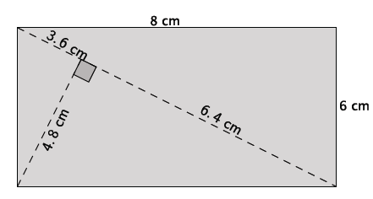
You can have students verify similarity using a protractor to compare corresponding angle measures. There is a reproducible available at the end of the lesson.
- Now show that $△ACB∽ △CDB$. Discuss in your group.
  - The triangle $△ACB∽ △CDB$ because they each have a right angle and they each share $∠B$. Then, by the AA criterion for similarity, $△ACB∽ △CDB$.
- Are triangles $△ADC$ and $△CDB$ similar? Discuss in your group.
  - We know that similarity has the property of transitivity; therefore, since $△ADC∽ △ACB$, and $△ACB∽ △CDB$, then $△ADC∽ △CDB$.

- If we consider $△ADC$ and $△ACB$, we can write a statement about corresponding sides being equal in ratio that will help us reach our goal of showing $a^{2}+b^{2}=c^{2}$. Discuss in your group.
  - Using $△ADC$ and $△ACB$, we can write:
$$\frac{\left|AC\right|}{\left|AB\right|}=\frac{\left|AD\right|}{\left|AC\right|},$$
which is equal to
$${\left|AC\right|}^{2}=\left|AB\right|∙\left|AD\right|.$$
Since $\left|AC\right|=b,$ we have
$$b^{2}=\left|AB\right|∙\left|AD\right|.$$
- Consider that $△ACB$ and $△CDB$ will give us another piece that we need. Discuss in your group.
  - Using $△ACB$and$△CDB$, we can write:
$$\frac{\left|BA\right|}{\left|BC\right|}=\frac{\left|BC\right|}{\left|BD\right|},$$
which is equal to
$${\left|BC\right|}^{2}=\left|BA\right|∙\left|BD\right|.$$
Since $\left|BC\right|=a$, we have
$$a^{2}=\left|BA\right|∙\left|BD\right|.$$
- The two equations, $b^{2}=\left|AB\right|∙\left|AD\right|$ and $a^{2}=\left|BA\right|∙\left|BD\right|$ are all that we need to finish the proof. Discuss in your group.
  - By adding the equations together, we have
$$a^{2}+b^{2}=\left|AB\right|∙\left|AD\right|+\left|BA\right|∙\left|BD\right|.$$
The length $\left|AB\right|=|BA|=c$, so by substitution we have
$$a^{2}+b^{2}=c∙\left|AD\right|+c∙\left|BD\right|.$$
Using the distributive property
$$a^{2}+b^{2}=c∙\left(\left|AD\right|+\left|BD\right|\right).$$
The length $\left|AD\right|+\left|BD\right|=c$, so by substitution
$$a^{2}+b^{2}=c∙c \\ a^{2}+b^{2}=c^{2}$$

Discussion (15 minutes)
- Now, let’s apply this knowledge to another proof of the Pythagorean Theorem. Compare the area of similar figures drawn from each side of a right triangle. We begin with a right triangle:
- Next, we will construct squares off of each side of the right triangle in order to compare the areas of similar figures. However, are all squares similar? Discuss in your group.
  - Yes, all squares are similar. Assume you have a square with side length equal to $1$ unit. You can dilate from a center by any scale factor to make a square of any size similar to the original one.

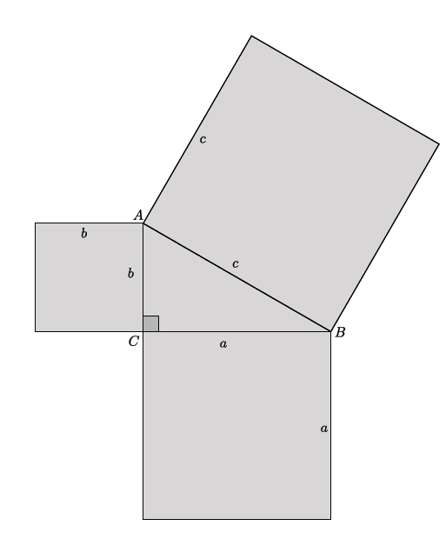
Scaffolding:
Consider using concrete values for the sides of the right triangle (e.g., $3$, $4$, $5$, then $5$, $12$, $13$, then $6$, $8$, $10$), then moving to the general triangle with sides $a$, $b$,$c.$ Given a triangle with sides $3$, $4$, $5$ drawn on grid paper, students will be able to count squares or cut the them out and physically place them on top of the larger square to compare the areas. An example of this is shown at the end of the lesson.

- What would it mean, geometrically, for $a^{2}+b^{2}$ to equal $c^{2}$?
  - It means that the sum of the areas of $a^{2}$ and $b^{2}$ is equal to the area $c^{2}$.
There are two possible ways to continue; one way is by examining special cases on grid paper, as mentioned in the scaffolding box above, and showing the relationship between the squares physically. The other way is by using the algebraic proof of the general case that continues below.
- This is where the proof using similar triangles will be helpful.
- When we compared triangles $△ACB$ and $△CDB$, we wrote a statement about their corresponding side lengths, $\frac{\left|BA\right|}{\left|BC\right|}=\frac{\left|BC\right|}{\left|BD\right|}$, leading us to state that ${\left|BC\right|}^{2}=\left|BA\right|∙\left|BD\right|$ and $a^{2}=\left|BA\right|∙\left|BD\right|$. How might this information be helpful in leading us to show that the areas of $a^{2}+b^{2}$ are equal to the area of $c^{2}$? Discuss in your group.
  - Since $\left|BA\right|=c$, then we have $a^{2}=c∙\left|BD\right|$, which is part of the area of $c^{2}$ that we need.
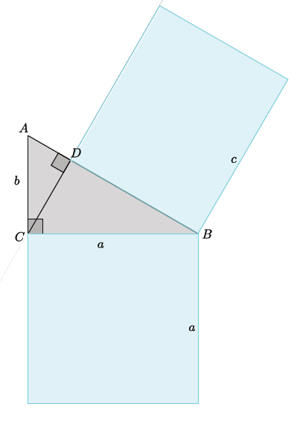
- Explain the statement $a^{2}=c\left|BD\right|$ in terms of the diagram below.
MP.2
- The square built from the leg of length $a$ is equal, in area, to the rectangle built from segment $BD$, with length $c$. This is part of the area of the square with side $c.$

- Now we must do something similar with the area of $b^{2}$. Discuss in your group.
  - Using $△ADC$ and $△ACB$, we wrote:
$$\frac{\left|AC\right|}{\left|AB\right|}=\frac{\left|AD\right|}{\left|AC\right|},$$
which is equal to
$${\left|AC\right|}^{2}=\left|AB\right|∙\left|AD\right|$$
By substitution
$$b^{2}=\left|AB\right|∙\left|AD\right| \\ b^{2}=c∙\left|AD\right|$$
- Explain the statement, $b^{2}=c|AD|$ in terms of the diagram below.
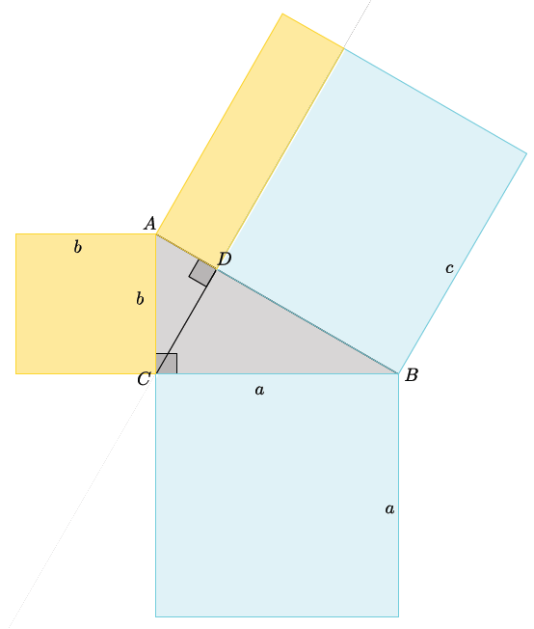
  - The square built from the leg of length $b$ is equal, in area, to the rectangle built from segment $AD$, with length $c$. This is the other part of the area of the square with side $c.$
MP.2
- Our knowledge of similar figures, as well as our understanding of the proof of the Pythagorean Theorem using similar triangles, led us to another proof where we compared the areas of similar figures constructed off the sides of a right triangle. In doing so, we have shown that $a^{2}+b^{2}=c^{2}$, in terms of areas.

- Explain how the diagram shows that the Pythagorean Theorem is true.
  - The Pythagorean Theorem states that given a right triangle with lengths $a, b, c$ that $a^{2}+b^{2}=c^{2}.$ The diagram shows that the area of the squares off of the legs $a$ and $b$ are equal to the area off of the hypotenuse $c.$ Since the area of a square is found by multiplying a side by itself, then the area of a square with length $a$ is $a^{2}$, $b$ is $b^{2}$, and $c$ is $c^{2}.$ The diagram shows that the areas $a^{2}+b^{2}$ is equal to the area of $c^{2}$, which is exactly what the theorem states.
MP.2
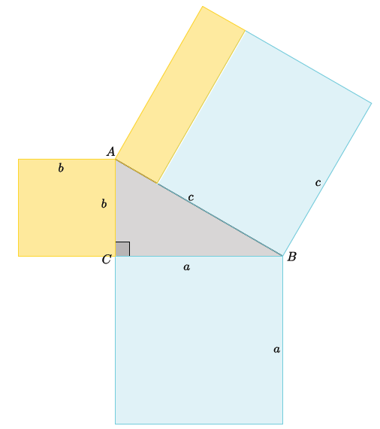
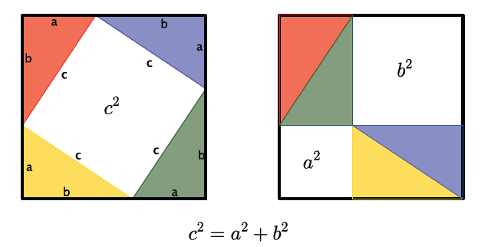
To solidify students’ understanding of the proof, consider showing the six minute video to students located at http://www.youtube.com/watch?v=QCyvxYLFSfU. If you have access to multiple computers or tablets, have small groups of students watch the video together so they can pause and replay parts of the proof as necessary.
Scaffolding:
The geometric illustration of the proof, shown to the left, can be used as further support or as an extension to the claim that the sum of the areas of the smaller squares is equal to the area of the larger square.
Closing (5 minutes)
Consider having students explain how to show the Pythagorean Theorem, using area, for a triangle with legs of length $40$ units and $9$ units, and a hypotenuse of $41$ units. Have students draw a diagram to accompany their explanation.
Summarize, or ask students to summarize, the main points from the lesson:
- We know the proof of the Pythagorean Theorem using similarity better than before.
- We can prove the Pythagorean Theorem using what we know about similar figures, generally, and what we know about similar triangles, specifically.
- We know a proof for the Pythagorean Theorem that uses area.
Lesson Summary
The Pythagorean Theorem can be proven by showing that the sum of the areas of the squares constructed off of the legs of a right triangle is equal to the area of the square constructed off of the hypotenuse of the right triangle.

Exit Ticket (5 minutes)
Name Date
Lesson 15: The Pythagorean Theorem, Revisited

Exit Ticket

Explain a proof of the Pythagorean Theorem in your own words. Use diagrams and concrete examples, as necessary, to support your explanation.

Exit Ticket Sample Solutions

Explain a proof of the Pythagorean Theorem in your own words. Use diagrams and concrete examples, as necessary, to support your explanation.
Proofs will vary. The critical parts of the proof that demonstrate proficiency include an explanation of the similar triangles $△ADC$, $△ACB$, and $△CDB$, including a statement about the ratio of their corresponding sides being equal, leading to the conclusion of the proof.

Problem Set Sample Solutions
Students apply the concept of similar figures to show the Pythagorean Theorem is true.

- For the right triangle shown below, identify and use similar triangles to illustrate the Pythagorean Theorem.
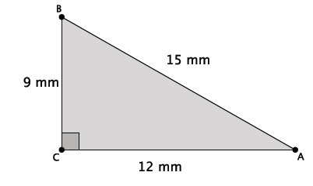
First, I must draw a segment that is perpendicular to side $AB$ that goes through point $C$. The point of intersection of that segment and side $AB$ will be marked as point $D$.
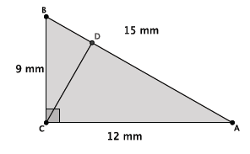
Then, I have three similar triangles: $△ABC$, $△CBD$, $△ACD$, as shown below.
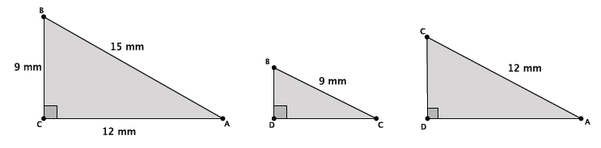
The triangles $△ABC$and $△CBD$ are similar because each one has a right angle, and they all share $∠B$. By AA criterion, $△ABC \sim △CBD$. The triangles $△ABC$and $△ACD$are similar because each one has a right angle, and they all share $∠A$. By AA criterion, $△ABC \sim △ACD$. By the transitive property, we also know that $△ACD \sim △CBD$.
Since the triangles are similar, they have corresponding sides that are equal in ratio. For triangles$△ABC$and $△CBD$:
$$\frac{9}{15}=\frac{\left|BD\right|}{9},$$
which is the same as $9^{2}=15\left(\left|BD\right|\right)$.
For triangles $△ABC$and $△ACD$:
$$\frac{12}{15}=\frac{\left|AD\right|}{12},$$
which is the same as $12^{2}=15\left(\left|AD\right|\right)$.
Adding these two equations together I get:
$$9^{2}+12^{2}=15\left(\left|BD\right|\right)+15\left(\left|AD\right|\right).$$
By the distributive property:
$$9^{2}+12^{2}=15\left(\left|BD\right|+\left|AD\right|\right);$$
however, $\left|BD\right|+\left|AD\right|=\left|AC\right|=15$; therefore,
$$9^{2}+12^{2}=15\left(15\right) \\ 9^{2}+12^{2}=15^{2}$$

- For the right triangle shown below, identify and use squares formed by the sides of the triangle to illustrate the Pythagorean Theorem.
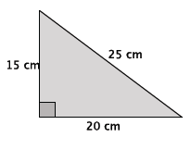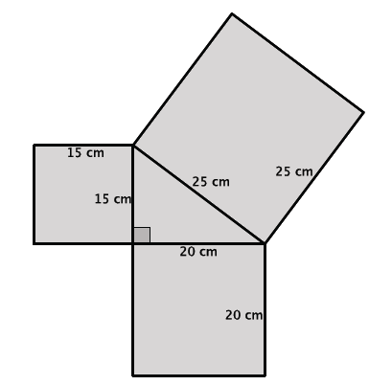
The sum of the areas of the smallest squares is $15^{2}+20^{2}=625$cm². The area of the largest square is $25^{2}=625$ cm². The sum of the areas of the squares off of the legs is equal to the area of the square off of the hypotenuse; therefore, $a^{2}+b^{2}=c^{2}$.

- Reese claimed that any figure can be drawn off the sides of a right triangle and that as long as they are similar figures, then the sum of the areas off of the legs will equal the area off of the hypotenuse. She drew the diagram below by constructing rectangles off of each side of a known right triangle. Is Reese’s claim correct for this example? In order to prove or disprove Reese’s claim, you must first show that the rectangles are similar. If they are, then you can use computations to show that the sum of the areas of the figures off of the sides $a$and $b$ equal the area of the figure off of side $c$.
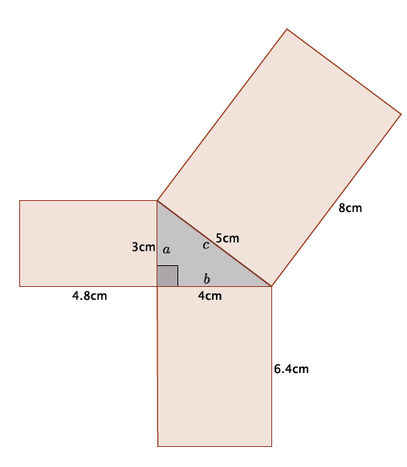
The rectangles are similar because their corresponding side lengths are equal in scale factor. That is, if we compare the longest side of the rectangle to the side with the same length as the right triangle sides, we get the ratios
$$\frac{4.8}{3}=\frac{6.4}{4} \\ =\frac{8}{5}=1.6$$
Since the corresponding sides were all equal to the same constant, then we know we have similar rectangles. The areas of the smaller rectangles are $14.4$cm² and $25.6$cm², and the area of the largest rectangle is $40$ cm². The sum of the smaller areas is equal to the larger area:
$$14.4+24.6=40 \\ 40=40$$
Therefore, we have shown that the sum of the areas of the two smaller rectangles is equal to the area of the larger rectangle, and Reese’s claim is correct.

- After learning the proof of the Pythagorean Theorem using areas of squares, Joseph got really excited and tried explaining it to his younger brother. He realized during his explanation that he had done something wrong. Help Joseph find his error. Explain what he did wrong.
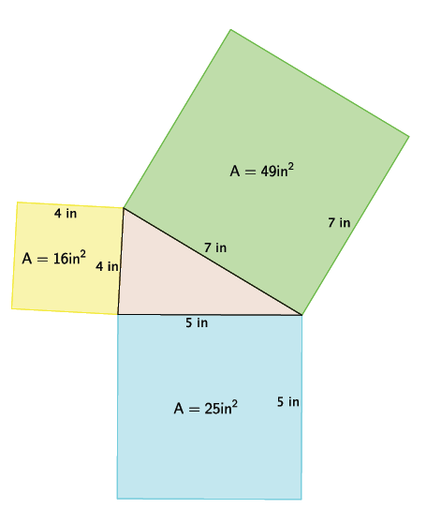
Based on the proof shown in class, we would expect the sum of the two smaller areas to be equal to the sum of the larger area, i.e., $16+25$ should equal $49$. However, $16+25=41$. Joseph correctly calculated the areas of each square, so that was not his mistake. His mistake was claiming that a triangle with sides lengths of $4$,$5$, and $7$ was a right triangle. We know that the Pythagorean Theorem only works for right triangles. Considering the converse of the Pythagorean Theorem, when we use the given side lengths, we do not get a true statement.
$$4^{2}+5^{2}=7^{2} \\ 16+25=49 \\ 41≠49$$
Therefore, the triangle Joseph began with is not a right triangle, so it makes sense that the areas of the squares were not adding up like we expected.

- Draw a right triangle with squares constructed off of each side that Joseph can use the next time he wants to show his younger brother the proof of the Pythagorean Theorem.
Answers will vary. Verify that students begin, in fact, with a right triangle and do not make the same mistake that Joseph did. Consider having students share their drawings and explanations of the proof in future class meetings.

- Explain the meaning of the Pythagorean Theorem in your own words.
If a triangle is a right triangle, then the sum of the squares of the legs will be equal to the square of the hypotenuse. Specifically, if the leg lengths are $a$ and $b$, and the hypotenuse is length $c$, then for right triangles $a^{2}+b^{2}=c^{2}$.

- Draw a diagram that shows an example illustrating the Pythagorean Theorem.
Diagrams will vary. Verify that students draw a right triangle with side lengths that satisfy the Pythagorean Theorem.

Diagrams referenced in scaffolding boxes can be reproduced for use student use.

