Lesson 19
Objective: Use tape diagrams as representations to solve put together/take apart with total unknown and add to with result unknown word problems.

Suggested Lesson Structure
 Fluency Practice (10 minutes)
 Concept Development (40 minutes)
 Student Debrief (10 minutes)
Total Time (60 minutes)
Fluency Practice (10 minutes)
- Sprint: Analogous Addition Within 40 1.OA.6, 1.NBT.4 (10 minutes)
Sprint: Analogous Addition Within 40 (10 minutes)
Materials: (S) Analogous Addition Within 40 Sprint
Note: The progression of this Sprint mirrors the progression of concepts taught in Topic D thus far. It begins with addition sentences conducive to counting on, transitions into sentences in which the sums of the ones are less than ten, and ends with problems that cross ten.
Concept Development (40 minutes)
Materials: (T) Document camera (S) Problem Set
Note: During this lesson, students will complete the Problem Set as the teacher guides instruction. This method allows students to alternately practice a problem and then analyze both the process and solution before moving on to their next practice problem. Although today’s Problem Set includes both put together and add to problem types, all the problems have an unknown result or total. The focus of today’s lesson is to support the use of the tape diagram within the RDW process:
- Read.
- Draw and label.
- Write a number sentence and a statement.
In Lesson 20, students will grapple with solving both addition and subtraction problem types. Students should keep their Problem Sets in a folder, along with the Application Problems from Lessons 13–18.
Distribute Problem Sets and have students work from their seats.

NOTES ON
MULTIPLE MEANS
OF ENGAGEMENT:
Appropriate scaffolds help all students feel successful. Students may use translators, interpreters, or sentence frames to present their solutions or respond to feedback. Models shared may include concrete manipulatives.

T: (Project Problem 1 on the board.) Let’s read the problem together.
S/T: Lee saw 6 yellow squashes and 7 pumpkins growing in his garden. How many vegetables did he see growing in his garden?
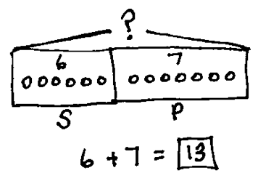
T: On your own, work on solving the problem. Remember that we always read the problem, draw and label, and write the number sentence and the statement that answers the question.
Problem 1: Lee saw 6 squashes and 7 pumpkins growing in his garden. How many vegetables did he see growing in his garden?
S/T: (Reread the problem as students begin to solve. Provide a maximum of two minutes for students to draw and label.)
T: How did you use drawing to make sense of the problem? Talk with a partner and explain your drawing.
S: (Provide students 30–45 seconds to share with a partner.) I drew the 6 squashes in a straight line, and then 7 pumpkins. I figured out that was 13. (Project students’ work as they describe their drawings to the class. Choose student work that most closely resembles the tape diagram shown to the right.)
T: Look at this student’s work. Where in the drawing can I find the squashes?
S: (Point to the picture.)

NOTES ON
MULTIPLE MEANS
OF ENGAGEMENT:
If anticipating students will struggle with the problems because of the size of the numbers or the complexity of the language, follow up with a similar problem that uses either smaller quantities or less complex language as a scaffold step. Be sure to provide at least one challenging problem to all students to help them build stamina and perseverance in problem solving.

T: (If the 6 squashes are not inside a rectangle or circle to show the part, include this next sentence.) The label helps find this part of the drawing. Let’s put a rectangle around it, so I can keep track of this part more easily.
T: How many are there?
S: 6.
T: How can I tell quickly? (If the number is not labeled in the drawing, or is not near the picture, reword the second question to, “What can I do so I can tell quickly?”)
S: He wrote 6 next to his picture.
Repeat the process asking about the pumpkins, using the same student work sample.
T: (Ask a student to read the question from the story again for the class.) How many vegetables are there?
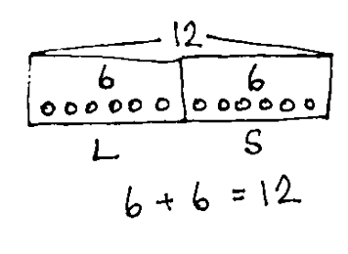
S: 13 vegetables.
Problem 2: Kiana caught 6 lizards. Her brother caught 6 snakes. How many reptiles do they have all together?
T: So, from here (pointing to one end of the squashes) to here (pointing to the other end of the pumpkins), we have 13 vegetables?
S: Yes!
T: Let’s show that above our drawing, so we can keep track. (Draw as shown, so that the bracket, or arms, represent that everything from one end to the other has a total of 13. Label with 13.) When we connect our two parts like this and show the total, we call it a tape diagram. If you didn’t show this in your drawing, add it now.
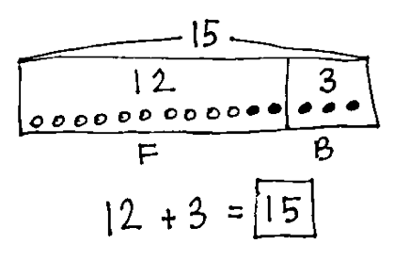
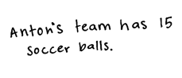
Repeat the process for each of the next problems. Use the questions to move students toward placing rectangles around each part and labeling with the number inside the part, as well as using a letter label outside of the shape. Encourage students to make their rectangles touch, so that they have one large rectangle for showing the total—the whole.
Problem 3: Anton’s team has 12 soccer balls on the field and 3 soccer balls in the coach’s bag. How many soccer balls does Anton’s team have?
When discussing Problem 3, after students have had a chance to solve it, include the following question.
- How could using a color change at 10 help you keep track of the number of soccer balls on the field?
Before moving on to the next problem, ensure that all students have added labels to each part of their drawings and written the number sentence and completed the statement.
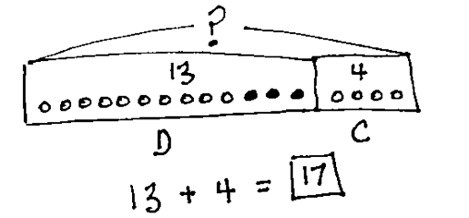
Choose probing questions appropriate to the successes and challenges of the class. Encourage early finishers to write their own word problems on another sheet of paper. They can write the problem on one side and then write the solution using a drawing, number sentence, and statement on the other side.
Problem 4: Emi had 13 friends over for dinner. 4 more friends came over for cake. How many friends came over to Emi’s house?

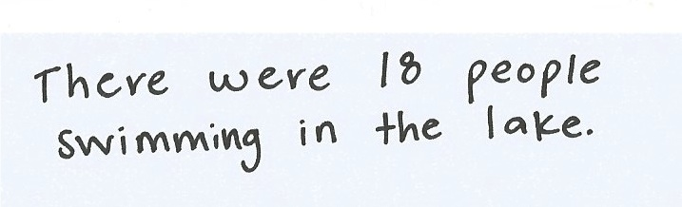
Problem 6: Rose has a vase with 13 flowers. She puts 7 more flowers in the vase. How many flowers are in the vase?
Problem 5: 6 adults and 12 children were swimming in the lake. How many people were swimming in the lake?

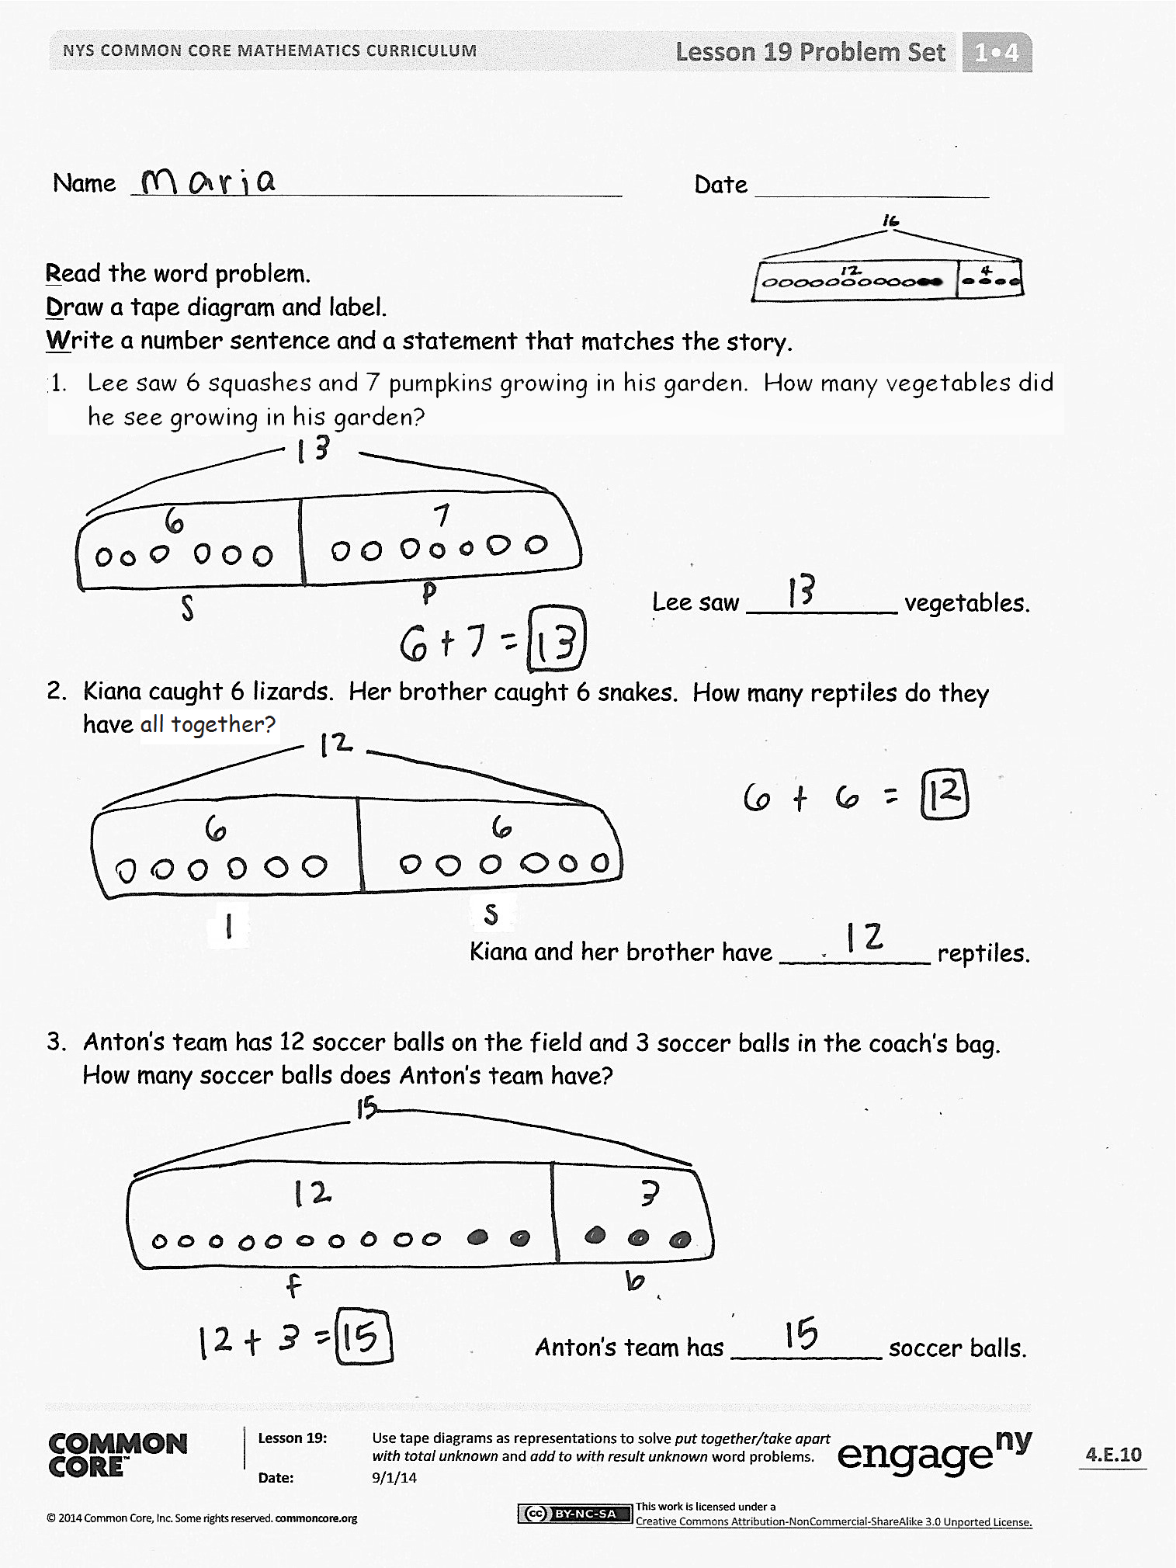
Student Debrief (10 minutes)
Lesson Objective: Use tape diagrams as representations to solve put together/take apart with total unknown and add to with result unknown word problems.
The Student Debrief is intended to invite reflection and active processing of the total lesson experience.
Guide students in a conversation to debrief the Problem Set and process the lesson. Look for misconceptions or misunderstandings that can be addressed in the Debrief.
Any combination of the questions below may be used to lead the discussion.
- Today, we called our drawings tape diagrams. Think about the diagrams we draw in science class. Why might we use the word diagram here? What are the important parts of our tape diagram?
- Look at Problem 2. What do you notice about the size of each rectangle around the parts? Why is that?
- Look at Problem 5. How is the tape diagram similar to the one you made for Problem 2? How is it different? Compare the size of the two rectangles around each part of Problem 5. What do you notice?
- What do you notice about the story problems we completed today? Who created a problem that puts together two known parts to find an unknown total? Share your story problem with the class.
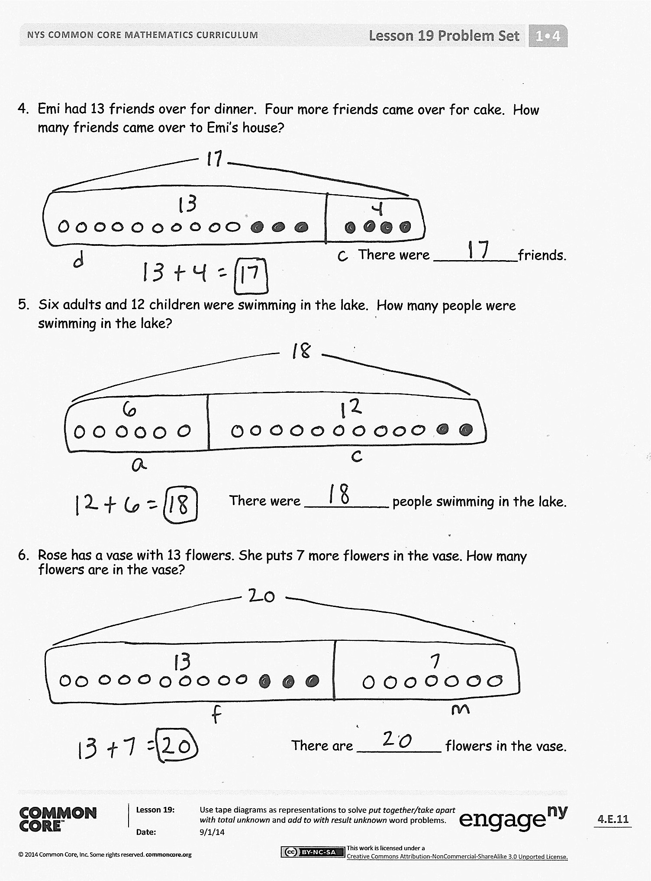
- You know your tape diagram has good labels when you can tell the story by looking at it. Who can use the tape diagram to tell the soccer ball story?
- How can a tape diagram help us share our thinking?
Exit Ticket (3 minutes)
After the Student Debrief, instruct students to complete the Exit Ticket. A review of their work will help with assessing students’ understanding of the concepts that were presented in today’s lesson and planning more effectively for future lessons. The questions may be read aloud to the students.
Name Date
Number Correct:
A
*Write the missing number.
1 | 6 + 1 = ☐ |  | 16 | 6 + 3 = ☐
2 | 16 + 1 = ☐ |  | 17 | 16 + 3 = ☐
3 | 26 + 1 = ☐ |  | 18 | 26 + 3 = ☐
4 | 5 + 2 = ☐ |  | 19 | 4 + 5 = ☐
5 | 15 + 2 = ☐ |  | 20 | 15 + 4 = ☐
6 | 25 + 2 = ☐ |  | 21 | 8 + 2 = ☐
7 | 5 + 3 = ☐ |  | 22 | 18 + 2 = ☐
8 | 15 + 3 = ☐ |  | 23 | 28 + 2 = ☐
9 | 25 + 3 = ☐ |  | 24 | 8 + 3 = ☐
10 | 4 + 4 = ☐ |  | 25 | 8 + 13 = ☐
11 | 14 + 4 = ☐ |  | 26 | 8 + 23 = ☐
12 | 24 + 4 = ☐ |  | 27 | 8 + 5 = ☐
13 | 5 + 4 = ☐ |  | 28 | 8 + 15 = ☐
14 | 15 + 4 = ☐ |  | 29 | 28 + ☐ = 33
15 | 25 + 4 = ☐ |  | 30 | 25 + ☐ = 33
Name Date
Number Correct:
B
*Write the missing number.
1 | 5 + 1 = ☐ |  | 16 | 6 + 3 = ☐
2 | 15 + 1 = ☐ |  | 17 | 16 + 3 = ☐
3 | 25 + 1 = ☐ |  | 18 | 26 + 3 = ☐
4 | 4 + 2 = ☐ |  | 19 | 3 + 5 = ☐
5 | 14 + 2 = ☐ |  | 20 | 15 + 3 = ☐
6 | 24 + 2 = ☐ |  | 21 | 9 + 1 = ☐
7 | 5 + 3 = ☐ |  | 22 | 19 + 1 = ☐
8 | 15 + 3 = ☐ |  | 23 | 29 + 1 = ☐
9 | 25 + 3 = ☐ |  | 24 | 9 + 2 = ☐
10 | 6 + 2 = ☐ |  | 25 | 9 + 12 = ☐
11 | 16 + 2 = ☐ |  | 26 | 9 + 22 = ☐
12 | 26 + 2 = ☐ |  | 27 | 9 + 5 = ☐
13 | 4 + 3 = ☐ |  | 28 | 9 + 15 = ☐
14 | 14 + 3 = ☐ |  | 29 | 29 + ☐ = 34
15 | 24 + 3 = ☐ |  | 30 | 25 + ☐ = 34

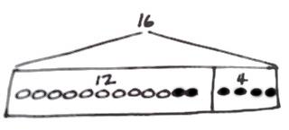
Name Date
Read the word problem.
Draw a tape diagram and label.
Write a number sentence and a statement that matches the story.
- Lee saw 6 squashes and 7 pumpkins growing in his garden. How many vegetables did he see growing in his garden?

Lee saw __________ vegetables.

- Kiana caught 6 lizards. Her brother caught 6 snakes. How many reptiles do they have all together?

Kiana and her brother have __________ reptiles.

- Anton’s team has 12 soccer balls on the field and 3 soccer balls in the coach’s bag. How many soccer balls does Anton’s team have?

Anton’s team has __________ soccer balls.
- Emi had 13 friends over for dinner. 4 more friends came over for cake. How many friends came over to Emi’s house?

There were __________ friends.

- 6 adults and 12 children were swimming in the lake. How many people were swimming in the lake?

There were __________ people swimming in the lake.

6. Rose has a vase with 13 flowers. She puts 7 more flowers in the vase. How many flowers are in the vase?

There are __________ flowers in the vase.

Name Date
Read the word problem.
Draw a tape diagram and label.
Write a number sentence and a statement that matches the story.

- Peter counted 14 ladybugs in a garden, and Lee counted 6 ladybugs outside of the garden. How many ladybugs did they count in all?

They counted _____________ ladybugs.

Name Date
Read the word problem.
Draw a tape diagram and label.
Write a number sentence and a statement that matches the story.

- Darnel is playing with his 4 red robots. Ben joins him with 13 blue robots. How many robots do they have all together?

They have ________ robots.

- Rose and Emi had a jump rope contest. Rose jumped 14 times, and Emi jumped 6 times. How many times did Rose and Emi jump?
They jumped ________ times.
- Pedro counted the airplanes taking off and landing at the airport. He saw 7 airplanes take off and 6 airplanes land. How many airplanes did he count altogether?

Pedro counted _______ airplanes.

4. Tamra and Willie scored all the points for their team in their basketball game. Tamra scored 13 points, and Willie scored 5 points. What was their team’s score for the game?

The team’s score was _______ points.

