Lesson 14: The Decimal Expansion of $π$

Student Outcomes
- Students calculate the decimal expansion of $π$ using basic properties of area.
- Students estimate the value of expressions such as${ π}^{2}$.

Lesson Notes
For this lesson, students will need grid paper and a compass. Lead students through the activity that produces the decimal expansion of$π$. Quarter circles on grids of $10$ by $10$ and $20$ by $20$ are included at the end of the lesson if you would prefer to hand out the grids as opposed to students making their own with grid paper and a compass.

Classwork
Opening Exercises 1–3 (5 minutes)
The purpose of the Opening Exercises is to activate students’ prior knowledge of $π$and of what that number means.
Opening Exercises
- Write an equation for the area, $A$, of the circle shown.
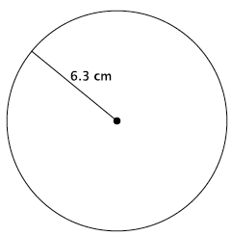
$$A=π6.3^{2} \\ =39.69π$$
The area of the circle is $39.69π$ cm².

- Write an equation for the circumference, $C$, of the circle shown.
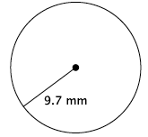
$$C=π2(9.7) \\ =19.4π$$
The circumference of the circle is $19.4π$mm.

- Each of the squares in the grid below has an area of $1$ unit².
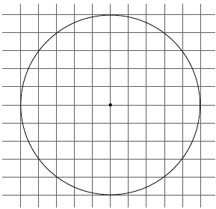

  - Estimate the area of the circle shown by counting squares.
Estimates will vary. The approximate area of the circle is $78$units².

  - Calculate the area of the circle using a radius of $5$ units and $3.14$ for $π.$
$$A=3.14\left(5^{2}\right) \\ =78.5$$
The area of the circle is $78.5$ units².

Discussion (25 minutes)
- The number pi, $π$, is defined as the ratio of the circumference to the diameter of a circle. The number $π$is also the area of a unit circle. A unit circle is a circle with a radius of one unit. Our goal in this lesson is to determine the decimal expansion of $π.$ What do you think that is?
  - Students will likely state that the decimal expansion of $π$ is $3.14$ because that is the number they have used in the past to approximate $π.$
- The number $3.14$ is often used to approximate $π$, but it is not its decimal expansion. How might we determine its real decimal expansion?

Provide time for students to try to develop a plan for determining the decimal expansion of $π.$ Have students share their ideas with the class.
- To determine the decimal expansion of $π$, we will use the fact that the number $π$is the area of a unit circle together with the counting strategy used in Exercise 3(a). Since the area of the unit circle is equal to $π$, and we will be counting squares, we can decrease our work by focusing on the area of just $\frac{1}{4}$of the circle. What is the area of $\frac{1}{4}$ of a unit circle?
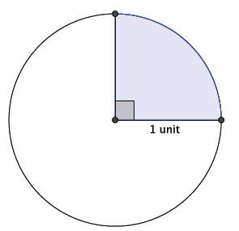
  - Since the unit circle has an area of $π,$then $\frac{1}{4}π$ will be the area of $\frac{1}{4}$ of the unit circle.
- On a piece of graph paper, mark a center $O$, near the center of the paper. Use your ruler and draw two lines through $O$, one horizontal and one vertical. Our unit will be $10$ of the grid squares on the graph paper. Use your compass to measure $10$ of the grid squares, and then make an arc to represent the outer edge of the quarter circle. Make sure your arc intersects the horizontal and vertical lines you drew.
Verify that all students have a quarter circles on their graph paper.
- What we have now are inner squares, those that are inside the quarter circle, and outer squares, those that are outside of the quarter circle. What we want to do is mark a border just inside the circle and just outside the circle, but as close to the arc of the circle as possible. Mark a border inside the circle that captures all of the whole squares; that is, you should not include any partial squares in this border (shown in red below). Mark a border just outside the arc that contains all of the whole squares within the quarter circle and parts of the squares that are just outside the circle (shown in black below).
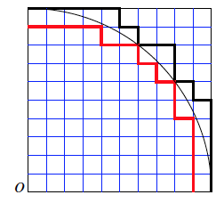
- The squares of the grid paper are congruent; that is, they are all equal in size and, thus, area. We will let $r_{2}$ denote the totality of all of the inner squares and $s_{2}$ the totality of all of the outer squares. Then, clearly,
$$r_{2}<\frac{π}{4}<s_{2}.$$
- Count how many squares are contained within $r_{2}$ and $s_{2}$.
  - There are $69$ inner squares and $86$ outer squares.
- If we consider the area of the square with side length equal to $10$ squares of the grid paper, then $r_{2}=\frac{69}{100}$. What does $s_{2}$equal?
  - The area of $s_{2}=\frac{86}{100}.$
- By substitution we see that
$$r_{2}<\frac{π}{4}<s_{2} \\ \frac{69}{100}<\frac{π}{4}<\frac{86}{100} \\ 0.69<\frac{π}{4}<0.86$$
Multiplying by $4$ throughout gives
$$2.76<π<3.44.$$
- Is this inequality showing a value for $π$ that we know to be accurate? Explain.
  - Yes, because we frequently use $3.14$ to represent $π$, and $2.76<3.14<3.44$.
- Of course we can improve our estimate of $π$ by taking another look at those grid squares. Columns have been labeled at the top, A-H.
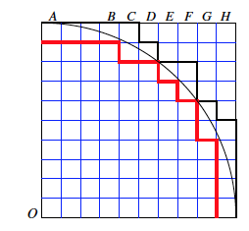

- Look at the top row, columns A through B. There are some significant portions of squares that were not included in the area of the quarter circle. If we wanted to represent that portion of the circle with a whole number of grid squares, about how many do you think it would be?
Accept any reasonable answers that students give for this and the next few questions about columns A-G. Included in the text below is a possible scenario; however, your students may make better estimations and decide on different numbers of squares to include in the area.
  - It looks like there would be at least $2$ whole squares, but likely less than $3$.
- Now look at columns C and D. Using similar reasoning, about how many grid squares do you think we should add to the area of the quarter circle using just columns C and D?
  - It looks like we should add $1$ more to the area of the quarter circle.
- Now look at columns E and F. What should we add to the area of the quarter circle?
  - We should add $1$ more to the area.
- What about column G?
  - We should add at least $1$ more square to the area.
- Finally, look at column H. What should we add to the area to represent the portion of the quarter circle not accounted for yet?
  - It looks like column H is just like columns A to B, so we should add $2$ more to the area.
- We began by counting only the number of whole squares within the border of the quarter circle, which totals $69$. By estimating partial amounts of squares in columns A through H, we have decided to improve our estimate by adding another $2, 1, 1, 1, 2$ squares, making our total number of grid squares represented by the quarter circle $76$. Therefore, we have refined $r_{2}$ to $76$, which means that
MP.6
$$\frac{76}{100}<\frac{π}{4}<\frac{86}{100},$$
which is equal to
$$\frac{304}{100}<π<\frac{344}{100} \\ 3.04<π<3.44$$
Does this inequality still represent a value we expect $π$ to be?
  - Yes, because $3.04<3.14<3.44$.
- We can reason the same way as before to refine the estimate of $s_{2}$.
Provide students time to refine their estimate of $s_{2}$. It is likely that students will come up with different numbers, but they should all be very close. Expect students to say that they have refined their estimate of $s_{2}$ to $80$, instead of the original $86$.
- Thus, we have
$$\frac{76}{100}<\frac{π}{4}<\frac{80}{100} \\ \frac{304}{100}<π<\frac{320}{100} \\ 3.04<π<3.20$$
Does this inequality still represent a value we expect $π$ to be?
  - Yes, because $3.04<3.14<3.20$.
- These are certainly respectable approximations of $π.$ What would make our approximation better?
  - We could decrease the size of the squares we are using to develop the area of the quarter circle. We could go back and make better estimations of the squares to include in $r_{2}$ and the squares not to include in $s_{2}$.
MP.8
- As you have stated, one way to improve our approximation is by using smaller squares. Suppose we divide each square horizontally and vertically so that instead of having $100$ squares, we have $400$ squares.
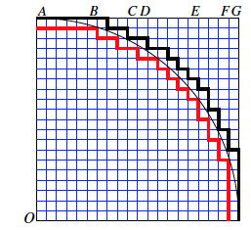
If time permits, allow students to repeat the process that we just went through when we had only $100$ squares in the unit square. If time does not permit, then provide them with the information below.
- Then, the inner region, $r_{2}$, is comprised of $294$ squares, and the outer region, $s_{2}$, is comprised of $333$ squares. This means that
$$\frac{294}{400}<\frac{π}{4}<\frac{333}{400}.$$Multiplying by $4$ throughout, we have
$$\frac{294}{100}<π<\frac{333}{100} \\ 2.94<π<3.33$$
- By looking at partial squares that can be combined, the refined estimate of $r_{2}$ is $310$ and $s_{2}$is $321$. Then, the inequality is
$$\frac{310}{400}<\frac{π}{4}<\frac{321}{400} \\ \frac{310}{100}<π<\frac{321}{100} \\ 3.10<π<3.21$$

- How does this inequality compare to what we know $π$ to be.
  - This inequality is quite accurate as $3.10<3.14<3.21$; there is only a difference of $\frac{4}{100}$ for the lower region and $\frac{7}{100}$ for the upper region.
- We could continue the process of refining our estimate several more times to see that
$$3.14159<π<3.14160$$
and then continue on to get an even more precise estimate of $π$. But at this point, it should be clear that we have a fairly good one already.
- We finish by making one more observation about $π$ and irrational numbers in general. When we take the square of an irrational number such as $π$, we are doing it formally without exactly knowing the value of $π^{2}$. Since we can use a calculator to show that
$$3.14159<π<3.14160,$$
then, we also know that
$${3.14159}^{2}<π^{2}<{3.14160}^{2} \\ 9.8695877281<π^{2}<9.86965056$$
Notice that the first $4$ digits, $9.869$, appear in the inequality. Therefore, we can say that $π^{2}=9.869$ is correct up to $3$ decimal digits.

Exercises 4–7 (5 minutes)
Students work on Exercises 4–7 independently or in pairs. If necessary, model for students how to use the given decimal digits of the irrational number to “trap” the number in the inequality for Exercises 5–7. An online calculator was used to determine the decimal values of the squared numbers in Exercises 5–7. If handheld calculators are used, then the decimal values will be truncated to $8$ places. However, this will not affect the estimate of the irrational numbers.
Exercises
- Gerald and Sarah are building a wheel with a radius of $6.5$ cm and are trying to determine the circumference. Gerald says, “Because $6.5×2×3.14=40.82$, the circumference is $40.82$cm.” Sarah says, “Because $6.5×2×3.10=40.3$ and $6.5×2×3.21=41.73$, the circumference is somewhere between $40.3$ and $41.73$.” Explain the thinking of each student.
Gerald is using a common approximation for the number $π$ to determine the circumference of the wheel. That is why he used $3.14$ in his calculation. Sarah is using an interval between which the value of $π$ falls, based on the work we did in class. We know that $3.10<π<3.21$; therefore, her calculations of the circumference uses numbers we know $π$ to be between.

- Estimate the value of the irrational number ${(6.12486…)}^{2}$.
$$6.12486^{2}<{(6.12486…)}^{2}<6.12487^{2} \\ 37.5139100196<{(6.12486…)}^{2}<37.5140325169$$
${(6.12486…)}^{2}=37.51$ is correct up to $2$ decimal digits.

- Estimate the value of the irrational number ${(9.204107…)}^{2}$.
$$9.204107^{2}<{\left(9.204107…\right)}^{2}<9.204108^{2} \\ 84.715585667449< {(9.204107…)}^{2}<84.715604075664$$
${(9.204107…)}^{2}=84.715$ is correct up to $3$ decimal digits.
- Estimate the value of the irrational number ${(4.014325…)}^{2}$.
$$4.014325^{2}<{\left(4.014325…\right)}^{2}<4.014326^{2} \\ 16.114805205625<{\left(4.014325…\right)}^{2}<16.11481324276$$
${(4.014325…)}^{2}=16.1148$ is correct up to $4$ decimal digits.

Closing (5 minutes)
Summarize, or ask students to summarize, the main points from the lesson:
- The area of a unit circle is $π$.
- We learned a method to estimate the value of $π$ using graph paper, a unit circle, and areas.
- When we square the decimal expansion of an irrational number, we are doing it formally. This is similar to using approximation for computations. For that reason, we may only be accurate to a few decimal digits.
Lesson Summary
Irrational numbers, such as $π$, are frequently approximated in order to compute with them. Common approximations for $π$ are $3.14$ and $\frac{22}{7}$. It should be understood that using an approximate value of an irrational number for computations produces an answer that is accurate to only the first few decimal digits.

Exit Ticket (5 minutes)

Name Date
Lesson 14: The Decimal Expansion of $π$

Exit Ticket

Describe how we found a decimal approximation for $π$.

Exit Ticket Sample Solutions

Describe how we found a decimal approximation for $π.$
To make our work easier, we looked at the number of unit squares in a quarter circle that comprised its area. We started by counting just the whole number of unit squares. Then, we continued to revise our estimate of the area by looking at parts of squares, specifically to see if parts could be combined to make a whole unit square. We looked at the inside and outside boundaries and said that the value of $π$ would be between these two numbers. The inside boundary is a conservative estimate of the value of π, and the outside boundary is an overestimate of the value of $π$. We could continue this process with smaller squares in order to refine our estimate for the decimal approximation of $π$.

Problem Set Sample Solutions
Students estimate the values of irrational numbers squared.

- Caitlin estimated $π$ to be $3.10<π<3.21.$ If she uses this approximation of $π$ to determine the area of a circle with a radius of $5$cm, what could the area be?
The area of the circle with radius $5$ cm will be between $77.5$ cm² and $80.25$cm².

- Myka estimated the circumference of a circle with a radius of $4.5$ in. to be $28.44$ in. What approximate value of $π$ did she use? Is it an acceptable approximation of $π$? Explain.
$$C=2πr \\ 28.44=2π\left(4.5\right) \\ 28.44=9π \\ \frac{28.44}{9}=π \\ 3.16=π$$
Myka used $3.16$ to approximate $π.$This is an acceptable approximation for $π$because it is in the interval, $3.10<π<3.21$, that we approximated $π$ to be in the lesson.

- A length of ribbon is being cut to decorate a cylindrical cookie jar. The ribbon must be cut to a length that stretches the length of the circumference of the jar. There is only enough ribbon to make one cut. When approximating $π$ to calculate the circumference of the jar, which number in the interval $3.10<π<3.21$ should be used? Explain.
In order to make sure the ribbon is long enough, we should use an estimate of $π$that is closer to $3.21$. We know that $3.10$ is a fair estimate of $π$, but less than the actual value of $π.$ Similarly, we know that $3.21$ is a fair estimate of $π$, but greater than the actual value of $π.$ Since we can only make one cut, we should cut the ribbon so that there will be a little more, not less than, what we need. For that reason, an approximation of $π$ closer to $3.21$ should be used.

- Estimate the value of the irrational number ${(1.86211…)}^{2}$.
$$1.86211^{2}<{\left(1.86211…\right)}^{2}<1.86212^{2} \\ 3.4674536521<{(1.86211…)}^{2}<3.4674908944$$
${(1.86211…)}^{2}=3.4674$ is correct up to $4$ decimal digits.

- Estimate the value of the irrational number ${(5.9035687…)}^{2}$.
$$5.9035687^{2}<{(5.9035687…)}^{2}<5.9035688^{2} \\ 34.85212339561969< {(5.9035687…)}^{2}<34.85212457633344$$
${(5.9035687…)}^{2}=34.85212$ is correct up to $5$ decimal digits.
- Estimate the value of the irrational number ${(12.30791…)}^{2}$.
$$12.30791^{2}<{(12.30791…)}^{2}<12.30792^{2} \\ 151.4846485681<{(12.30791…)}^{2}<151.4848947264$$
${(12.30791…)}^{2}=151.484$ is correct up to $3$ decimal digits.

- Estimate the value of the irrational number ${\left(0.6289731…\right)}^{2}$.
$$0.6289731^{2}< {\left(0.6289731…\right)}^{2}<0.6289732^{2} \\ 0.39560716052361< {\left(0.6289731…\right)}^{2}<0.39560728631824$$
${\left(0.6289731…\right)}^{2}=0.395607$ is correct up to $6$ decimal digits.

- Estimate the value of the irrational number ${\left(1.112223333…\right)}^{2}$.
$$1.112223333^{2}<{\left(1.112223333…\right)}^{2}<1.112223334^{2} \\ 1.2370407424696289<{\left(1.112223333…\right)}^{2}<1.2370407446940756$$
${\left(1.112223333…\right)}^{2}=1.23704074$ is correct up to $8$ decimal digits.

- Which number is a better estimate for $π$, $\frac{22}{7}$ or $3.14$? Explain.
Allow for both answers to be correct as long as the student provides a reasonable explanation.
Sample answer might be as follows.
I think that $3.14$ is a better estimate because when I find the decimal expansion, $\frac{22}{7}≈3.142857…$; the number $3.14$ is closer to the actual value of $π.$

- To how many decimal digits can you correctly estimate the value of the irrational number ${\left(4.56789012…\right)}^{2}$?
$$4.56789012^{2}<{\left(4.56789012…\right)}^{2}<4.56789013^{2} \\ 20.8656201483936144<{\left(1.112223333…\right)}^{2}<20.8656202397514169$$
${\left(4.56789012…\right)}^{2}=20.865620$ is correct up to $6$ decimal digits.

$10$ by $10$ Grid

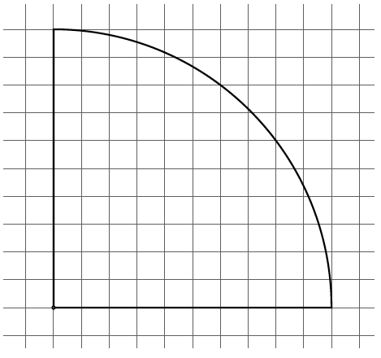

$20$ by $20$ Grid

