Lesson 18
Objective: Share and critique peer strategies for adding two-digit numbers.

Suggested Lesson Structure
 Application Problems (5 minutes)
 Fluency Practice (12 minutes)
 Concept Development (33 minutes)
 Student Debrief (10 minutes)
Total Time (60 minutes)
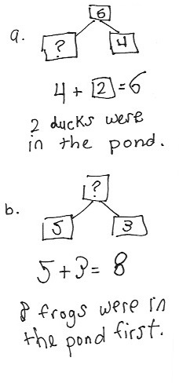
Application Problems (5 minutes)
Use the RDW process to solve one or both of the problems.
- Some ducks were in a pond. 4 baby ducks joined them. Now, there are 6 ducks in the pond. How many ducks were in the pond at first?
- Some frogs were in the pond. Three jumped out, and now there are 5 frogs in the pond. How many frogs were in the pond at first?
Note: Today’s Application Problems use add to and take from problems with the unknown in the starting position. For most students, this is a difficult problem type, so the numbers in the stories are small.
Notice how students attempt the problem. Those who simply add the two numbers in the first problem or subtract the two numbers in the last problem may need additional reinforcement in reading one sentence at a time as they review their drawings to find the matching story parts.
Fluency Practice (12 minutes)
- Core Addition Fluency Review: Missing Addends 1.OA.6 (5 minutes)
- Relating Addition and Subtraction 1.OA.4 (2 minutes)
- Analogous Addition Sentences 1.NBT.4 (5 minutes)

Core Addition Fluency Review: Missing Addends (5 minutes)
Materials: (S) Missing Addends Core Addition Fluency Review (Lesson 17 Core Addition Fluency Review)

NOTES ON
MULTIPLE MEANS
OF ENGAGEMENT:
Scaffold Sprints and fluency reviews for students who may be having a difficult time remembering basic math facts. Privately provide a modified version of the Sprint, or review so students can feel successful while building fluency with math facts.
Note: This review sheet contains the majority of addition facts with sums of 5–10, which is part of the required core fluency for Grade 1. The focus on missing addends strengthens students’ ability to count on, a Level 2 strategy that first graders should master.
Students complete as many problems as they can in three minutes. Choose a counting sequence for early finishers to practice on the back of their papers. When time runs out, read the answers aloud so students can correct their work. Celebrate improvement by having students compare yesterday’s total correct with today’s total correct. Share a class cheer for the student(s) with the most improved score.
Relating Addition and Subtraction (2 minutes)
Materials: (S) Missing Addends Core Addition Fluency Review (from previous activity)
Note: This fluency activity targets the Grade 1 core fluency requirement and 1.OA.4.
Students choose a column from the review sheet and rewrite each problem as a subtraction equation, seeing how many they can complete in two minutes.
Analogous Addition Sentences (5 minutes)
Materials: (S) Personal white board, die or numeral cards 0–10.
Note: Today, assign partners of equal ability. Give students who have a strong understanding of sums and differences to 12 numeral cards instead of dice. The cards go up to 10, so they will be more of a challenge since there will be more opportunities to make ten.
Repeat the activity from Lesson 16.
Concept Development (33 minutes)
Materials: (T) Student work samples (Template), projector (S) Personal white board
Have students come to the meeting area and sit in a semicircle.
T: (Write 17 + 4 on the board.) Turn and talk to your partner about how you would solve this problem.
S: (Discuss as teacher circulates and listens.)
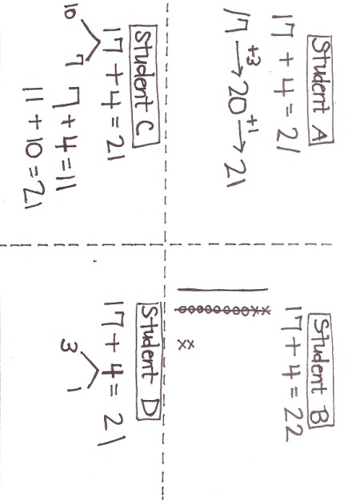
T: (Project Student A work.) Turn and talk to your partner about how he showed his solution to 17 + 4, and think about how we can label his work.
S: Let’s label it the arrow way. He got to the next ten by adding 3. Then, he added the 1 that was left and got 21.
T: Yes! The arrow way and the number sentences clearly show what he was thinking. I am going to label this work The Arrow Way. (Label work A.)
T: (Project Student B work.) How did this student show how to solve 17 + 4?
S: She drew quick tens.
T: (Label this work Quick Ten Drawing.)
S: (Continue.) It looks like she added the ones together. She showed how she made a ten by drawing a line through the 10 ones. She added 2 tens and 2 ones and got 22. I noticed a mistake! She drew 18 first instead of 17. She drew an extra circle. She added 4 correctly using Xs, but because she started out by drawing the wrong number, her answer is wrong. She should have drawn 17 and 4. She should have gotten 21 as the answer.
T: What are some ways this student can improve her work?
S: She needs to count carefully, especially when she’s drawing her ones. She should check her work with her partner. Then, she might have caught her mistake.
T: Even though drawing is easy for many of you, it’s not always the best way to get the correct answer, because sometimes you have to make so many circles and Xs. Somewhere along the way, you can lose count and make a mistake.
T: Work carefully, and show 17 + 4 using the quick ten drawing on your personal white board. Then, check your work with your partner.
S: (Make a quick ten drawing showing 21 as the sum, and check with partner.)
T: (Project Student C and D work.) Let’s compare Student C’s work and Student D’s work. Did they solve the problem in the same way? What similarities and differences do you notice? Turn and talk to your partner.
S: They both used number bonds.
T: (Label these works Number Bond.)
S: (Continue.) They used number bonds but broke apart different numbers. Student C added the ones first. Student D made the next ten.
T: Turn and talk to your partner about which student work best shows the tens.
S: I think Student D shows the tens the best because I can see that 17 + 3 = 20 and that is 2 tens.
I think Student C shows the tens the best because I can see that 17 is 10 and 7. I see the 10 in 17.

T: Can both students’ work be correct, even though they broke apart different numbers?
MP.3
S: Yes. You can break apart different numbers and get the correct answer, as long as you add every part.

NOTES ON
MULTIPLE MEANS
OF REPRESENTATION:
Facilitate student discussions to provide multiple opportunities for comprehension. Guide students to recognize strategies that can make math easier—for example, breaking a larger number into number bonds as well as looking for patterns and structures in their work.
T: What is a compliment you can give to each of these students?
S: They drew correct number bonds. Student C added the ones together first. She clearly showed her two steps by writing both addition sentences. Student D made the next ten from 17. He did a good job breaking apart 4 into 3 and 1 so that he could make 20 with 17 and 3.
T: What are some ways they could improve their work?
S: Student D could have written two addition sentences to show how he got 21.
T: (Write 19 + 5 on the board.) It’s your turn to solve a problem. You may use any method to solve, but you must show your work. When you are finished, swap your work with your partner and study it. Give her a compliment and a suggestion about how to improve her work.
Have students swap boards with their partners and discuss the following:
- How did your partner show his solution?
- How was his work different from your work?
- How was your work the same?
- Give your partner a compliment on his work.
- Give a suggestion for how he could improve his work.
T: (Project 3 work samples from the class, showing each of the methods: a quick ten drawing, a number bond, and the arrow way.) Which student work best helps you not have to count all?
S: The number bond, because I counted on. The arrow way, because I got to the next ten and counted on.
T: Good thinking! Why does the quick ten allow you to count all?
S: The drawing shows all the numbers, so I can count them all instead of counting on.
T: How is the student work shown different from your partner’s work?
S: My partner drew the quick tens. My partner drew circles and Xs for the ones. My partner bonded a different number. My partner started with a different number to get to 20 using the arrow way.
If time allows, have students solve 18 + 6, and share another set of student work from the class.
Problem Set (10 minutes)
Students should do their personal best to complete the Problem Set within the allotted 10 minutes. For some classes, it may be appropriate to modify the assignment by specifying which problems they work on first. Some of the problems may have more than one correct way to work for each problem.
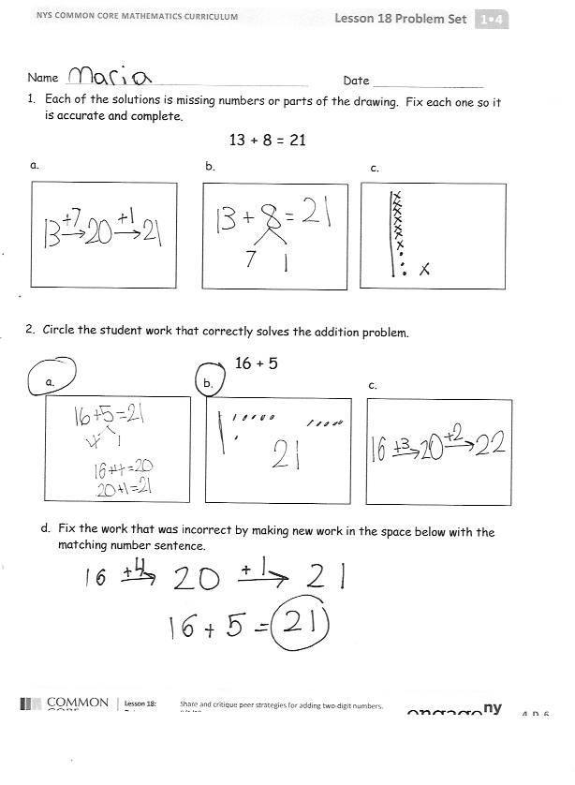
Student Debrief (10 minutes)
Lesson Objective: Share and critique peer strategies for adding two-digit numbers.
The Student Debrief is intended to invite reflection and active processing of the total lesson experience.
Invite students to review their solutions for the Problem Set. They should check work by comparing answers with a partner before going over answers as a class. Look for misconceptions or misunderstandings that can be addressed in the Debrief. Guide students in a conversation to debrief the Problem Set and process the lesson.
Any combination of the questions below may be used to lead the discussion.
- Look at Problem 2. What did you do to fix the student work?
- Look at Problem 2(b). What suggestion do you have for this student so she can improve her work?
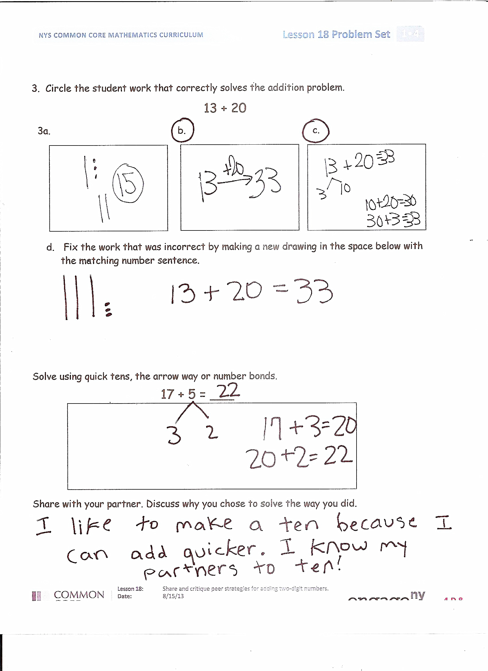
- Look at Problem 3(a). How can you help this student improve?
- Compare your work on Problem 4 with your partner. Did you solve the same way? Do you think her way was easier or harder to solve? Explain why.
- (Project Student Work A–D from today’s Concept Development.) Which student work best helps you not count all?
- How did today’s fluency help you to be successful with the lesson?
Exit Ticket (3 minutes)
After the Student Debrief, instruct students to complete the Exit Ticket. A review of their work will help with assessing students’ understanding of the concepts that were presented in today’s lesson and planning more effectively for future lessons. The questions may be read aloud to the students.

Name Date
- Each of the solutions is missing numbers or parts of the drawing. Fix each one so it is accurate and complete.
13 + 8 = 21

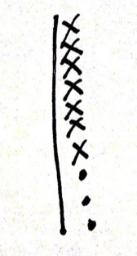
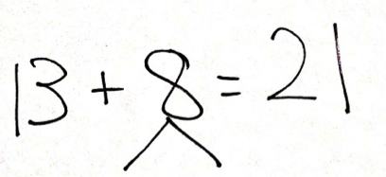
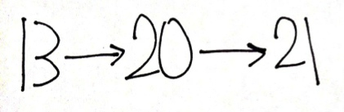
a. b. c.

- Circle the student work that correctly solves the addition problem.
16 + 5

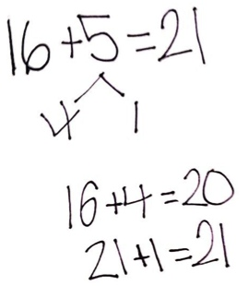
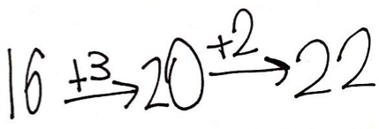
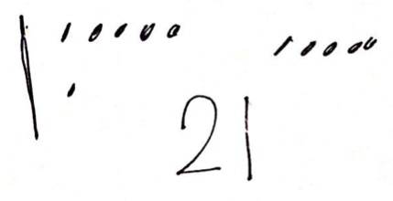
a. b. c.

- Fix the work that was incorrect by making new work in the space below with the matching number sentence.
7 + 8 =5
- Circle the student work that correctly solves the addition problem.
13 + 20
a. b. c.
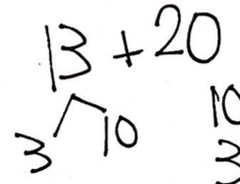
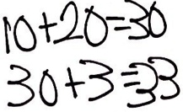
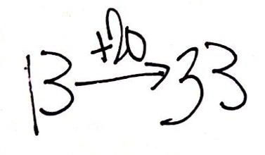
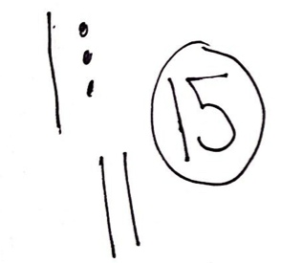

- Fix the work that was incorrect by making a new drawing in the space below with the matching number sentence.
7 + 8 =5

- Solve using quick tens, the arrow way, or number bonds.
17 + 5 = ___

Share with your partner. Discuss why you chose to solve the way you did.
Name Date
  - Circle the work that correctly solves the addition problem.
17 + 9
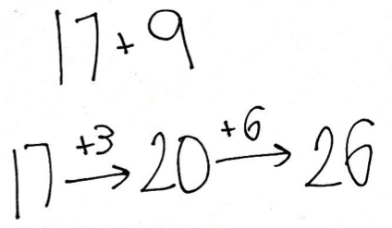
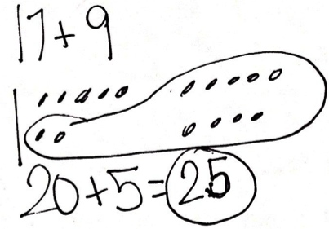
c.

b.

a.
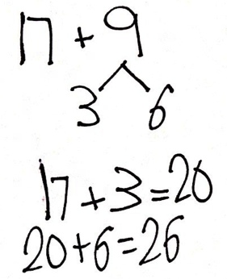

- Fix the work that was incorrect by making a new drawing in the space below with the matching number sentence.
Name Date
- Two students both solved the addition problem below using different methods.
18 + 9

Are they both correct? Why or why not?

- Another two students solved the same problem using quick tens.

Are they both correct? Why or why not?

- Circle any student work that is correct.
19 + 6
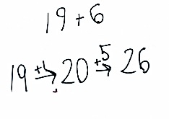
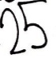
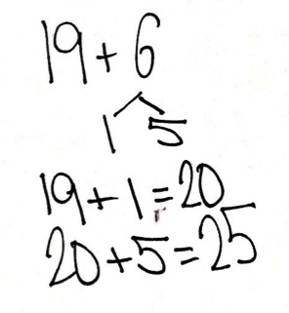
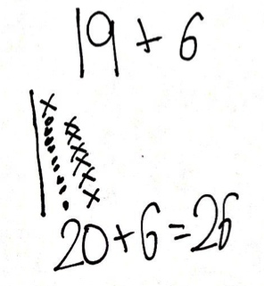
Student C
Student B
Student A

Fix the student work that was incorrect by making a new drawing or drawings in the space below.

Choose a correct student work and give a suggestion for improvement.

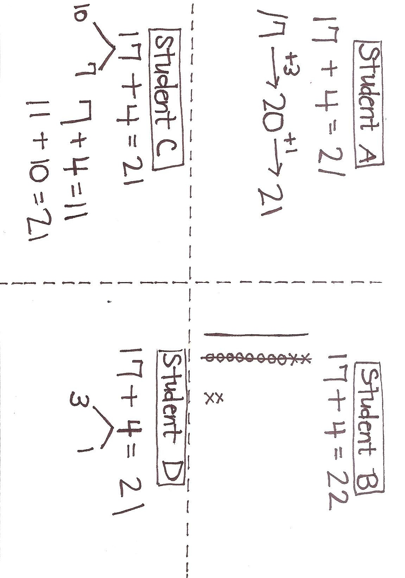

student work samples

