Lesson 13: Comparison of Irrational Numbers

Classwork
Exercises 1–11
- Rodney thinks that $\sqrt[3]{64}$ is greater than $\frac{17}{4}$. Sam thinks that $\frac{17}{4}$ is greater. Who is right and why?

- Which number is smaller, $\sqrt[3]{27}$ or $2.89$? Explain.

- Which number is smaller, $\sqrt{121}$or $\sqrt[3]{125}$? Explain.

- Which number is smaller, $\sqrt{49}$ or $\sqrt[3]{216}$? Explain.

- Which number is greater, $\sqrt{50}$or $\frac{319}{45}$? Explain.

- Which number is greater, $\frac{5}{11}$ or $0.\overline{4}$? Explain.

- Which number is greater, $\sqrt{38}$ or $\frac{154}{25}$? Explain.

- Which number is greater, $\sqrt{2}$ or $\frac{15}{9}$? Explain.

- Place the following numbers at their approximate location on the number line: $\sqrt{25}$, $\sqrt{28}$, $\sqrt{30}$,$\sqrt{32}$, $\sqrt{35}$,$\sqrt{36}$.

- Challenge: Which number is larger $\sqrt{5}$ or $\sqrt[3]{11}$?

- A certain chessboard is being designed so that each square has an area of $3$ in². What is the length, rounded to the tenths place, of one edge of the board? (A chessboard is composed of $64$ squares as shown.)
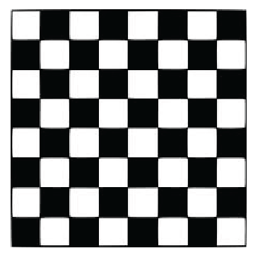

Problem Set
Lesson Summary
The decimal expansion of rational numbers can be found by using long division, equivalent fractions, or the method of rational approximation.
The decimal expansion of irrational numbers can be found using the method of rational approximation.

- Which number is smaller, $\sqrt[3]{343}$ or $\sqrt{48}$? Explain.

- Which number is smaller, $\sqrt{100}$or $\sqrt[3]{1000}$? Explain.

- Which number is larger, $\sqrt{87}$or $\frac{929}{99}$? Explain.

- Which number is larger, $\frac{9}{13}$ or $0.\overline{692}$? Explain.

- Which number is larger, $9.1$ or $\sqrt{82}$? Explain.

- Place the following numbers at their approximate location on the number line:$\sqrt{144}$, $\sqrt[3]{1000}$,$\sqrt{130}$, $\sqrt{110}$, $\sqrt{120}$, $\sqrt{115}$, $\sqrt{133}$. Explain how you knew where to place the numbers.

- Which of the two right triangles shown below, measured in units, has the longer hypotenuse? Approximately how much longer is it?
