Lesson 17
Objective: Add ones and ones or tens and tens.

Suggested Lesson Structure
 Application Problems (5 minutes)
 Fluency Practice (12 minutes)
 Concept Development (33 minutes)
 Student Debrief (10 minutes)
Total Time (60 minutes)
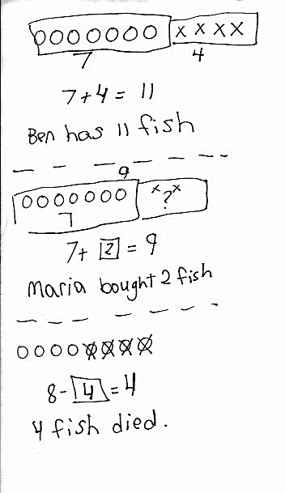
Application Problems (5 minutes)

Use the RDW process to solve one or more of the problems.
- Ben had 7 fish. He bought 4 fish at the store. How many fish does Ben have?
- Maria had 7 fish in her tank this morning. She bought some more fish, and now she has 9. How many did she buy?
- Anton had 8 fish. Some of the fish died, and now Anton has 4 fish. How many fish died?
Note: Today, students solve similar math stories within a new context. Notice students who easily solved the problems with cubes but found today’s problems more challenging. These students may need support visualizing story contexts.
Fluency Practice (12 minutes)
- Core Addition Fluency Review: Missing Addends 1.OA.6 (5 minutes)
- Relating Addition and Subtraction 1.OA.4 (2 minutes)
- Analogous Addition Sentences 1.NBT.4 (5 minutes)
Core Addition Fluency Review: Missing Addends (5 minutes)
Materials: (S) Missing Addends Core Addition Fluency Review
Note: This review sheet contains the majority of addition facts with sums of 5–10, which is part of the required core fluency for Grade 1. The focus on missing addends strengthens students’ ability to count on, a
Level 2 strategy that first graders should master. Keep this activity out so students can use it in the next fluency activity.

NOTES ON
MULTIPLE MEANS
OF ENGAGEMENT:
Encourage students to set goals for improvement on Sprints and fluency reviews. Provide scaffolds, strategies, and opportunities for practice to help them reach their personal goals.
Students complete as many problems as they can in three minutes. Choose a counting sequence for early finishers to practice on the back of their papers. When time runs out, read the answers aloud so students can correct their work. Encourage students to remember how many problems they answered correctly in the allotted time so they can work to improve their scores on future Missing Addends Core Addition Fluency Reviews.
Relating Addition and Subtraction (2 minutes)
Materials: (S) Missing Addends Core Addition Fluency Review from previous activity
Note: This fluency activity targets the Grade 1 core fluency requirement. Reviewing the relationship between addition and subtraction is especially beneficial for students who continue to find subtraction challenging.
Students choose a column from the review sheet and rewrite each problem as a subtraction equation, seeing how many they can complete in two minutes.
Analogous Addition Sentences (5 minutes)
Materials: (S) Personal white board, one die per student
Note: This is the second day students are performing this partner activity. As students work, ask if it is easier the second day.
Follow instructions in Lesson 16.
Concept Development (33 minutes)
Materials: (T) Ten-sticks, chart paper (S) Ten-sticks from math toolkit, personal white board, addition and subtraction cards set 2 (Template)

NOTES ON
MULTIPLE MEANS
OF REPRESENTATION:
Highlight the critical vocabulary such as quick ten drawings, number bonds, tens, ones, and addends, and use pictorial representations to support student understanding. Have students use these terms as they share their thinking. This will support vocabulary development.
Students gather in the meeting area with their partners and materials.
T: (Write 19 + 2 on chart paper and show 19 red cubes on the floor.) What are we adding to 19?
S: 2.
T: 2 what?
S: 2 ones.
T: Where should we add the 2 ones—to the tens or the ones? Turn and talk to your partner about why.
S: The ones! To 9 ones! It’s easier to add ones together.
T: Use your cubes to solve 19 + 2.
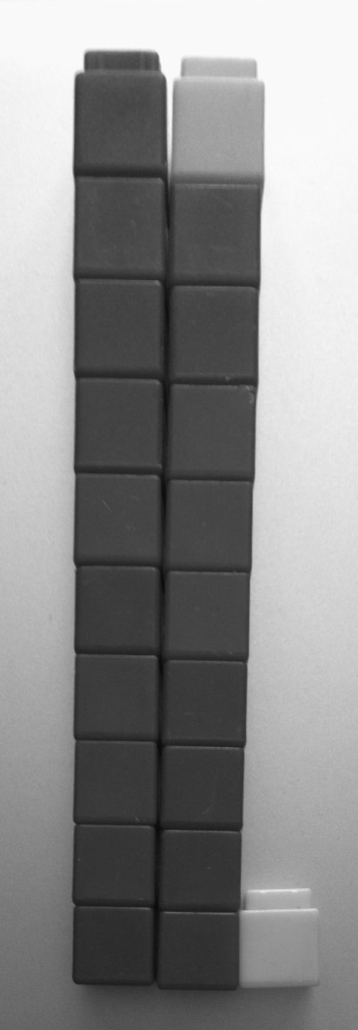
T: (Circulate to observe the different strategies students are using, and select students to demonstrate.)
S: We knew that 19 needs 1 more to make the next ten. So, we took 1 from the 2 and made a ten. Now, we have 20 and 1. That’s 21. We saw 10 ones in 9 + 1. We now have 2 tens and 1 one. That’s 21. We added the ones together. 9 + 2 = 11. One more ten is 21.
T: Excellent strategies! Just like we did yesterday, let’s add the ones together. 9 and 2 is…?
S: 11.
T: What more do we still have to add?
S: 1 ten.
T: 11 and 10 is…?
S: 21.
T: Say the number sentence starting with 19.
S: 19 + 2 = 21.
Have students represent their work in quick ten drawings.
T: Let’s represent our work using a number bond. Which number did we break apart?
S: We broke apart 19 into 10 and 9. That makes it easier to see the ones. I can add 9 and 2 first, then add 10.
T: Great. (Chart the number bond and complete the number sentence. Point to each number as you say it.) 9 and 2 is…?
S: 11.
T: 11 and 10 is…?
S: 21.
T: 19 + 2 is…?
S: 21.
T: (Write 19 + 20 on the chart.) Show 19 using your cubes or quick ten drawings.
S: (Show or draw 1 ten-stick and 9 ones.)
T: Before adding the next addend with your cubes, we should ask…?
S: Am I adding tens, or am I adding ones?
T: Correct! So, which are we adding? Tens or ones?
S: Tens.
T: Yes. Add 2 tens. (Pause.) 1 ten and 2 tens is…?
S: 3 tens.
T: How many ones are there?
S: 9 ones.
T: 3 tens 9 ones is…?
S: 39.
Guide students as they make the number bond to represent 19 + 20 and write two addition sentences.
Repeat the process following the suggested sequence:
- 16 + 2 and 16 + 20
- 2 + 13 and 20 + 13
- 10 + 28 and 28 + 1
- 8 + 27
Have students practice asking, “Do I add to the ones or add to the tens?” before representing their work with cubes or quick tens and the number bond with two sentences. When appropriate, have students choose just one method to solve and explain their choice to their partner or to the whole group. For more challenging examples, have students add dimes and pennies when using the sequence above.
MP.5
For the remainder of time, have partners play Addition and Subtraction with Cards (Lesson 12) with the new cards labeled D.
Problem Set (10 minutes)
Students should do their personal best to complete the Problem Set within the allotted 10 minutes. For some classes, it may be appropriate to modify the assignment by specifying which problems they work on first.
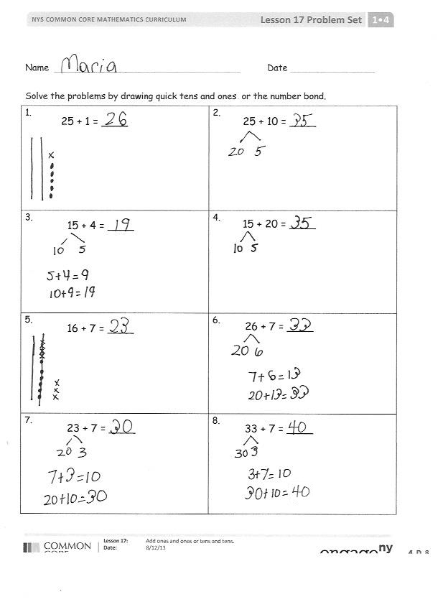
Student Debrief (10 minutes)
Lesson Objective: Add ones and ones or tens and tens.
The Student Debrief is intended to invite reflection and active processing of the total lesson experience.
Invite students to review their solutions for the Problem Set. They should check work by comparing answers with a partner before going over answers as a class. Look for misconceptions or misunderstandings that can be addressed in the Debrief. Guide students in a conversation to debrief the Problem Set and process the lesson.
Any combination of the questions below may be used to lead the discussion.
- Share with your partner how you solved each problem in the Problem Set. Did you use quick tens and ones? Did you use a number bond? Why did you make each choice?
- How can solving 11(a) help you solve 11(b)?
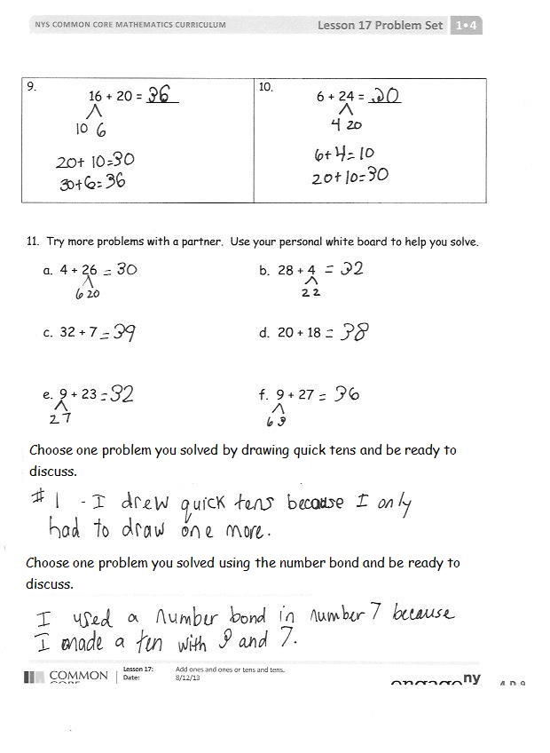
- Look at Problems 3 and 5. In both problems, we added ones to ones. In the answer, why did the tens stay the same in Problem 3, but then changed in Problem 5?
- How can your fluency work with the die (Analogous Addition Sentences) help you solve addition problems in today’s lesson?
Exit Ticket (3 minutes)
After the Student Debrief, instruct students to complete the Exit Ticket. A review of their work will help with assessing students’ understanding of the concepts that were presented in today’s lesson and planning more effectively for future lessons. The questions may be read aloud to the students.

Name Date
Core Addition Fluency Review: Missing Addends
1. | 5 + ___ = 5 | 16. | 6 + ___ = 7 | 31. | 9 + ___ = 9
2. | 4 + ___ = 5 | 17. | 1 + ___ = 7 | 32. | 0 + ___ = 9
3. | 2 + ___ = 5 | 18. | 0 + ___ = 7 | 33. | 1 + ___ = 9
4. | 3 + ___ = 5 | 19. | 7 + ___ = 7 | 34. | 2 + ___ = 9
5. | 0 + ___ = 5 | 20. | 3 + ___ = 7 | 35. | 7 + ___ = 9
6. | 1 + ___ = 5 | 21. | 4 + ___ = 7 | 36. | 6 + ___ = 9
7. | 1 + ___ = 6 | 22. | 4 + ___ = 8 | 37. | 5 + ___ = 9
8. | 0 + ___ = 6 | 23. | 5 + ___ = 8 | 38. | 3 + ___ = 9
9. | 6 + ___ = 6 | 24. | 6 + ___ = 8 | 39. | 4 + ___ = 9
10. | 5 + ___ = 6 | 25. | 2 + ___ = 8 | 40. | 4 + ___ = 10
11. | 3 + ___ = 6 | 26. | 3 + ___ = 8 | 41. | 5 + ___ = 10
12. | 4 + ___ = 6 | 27. | 0 + ___ = 8 | 42. | 6 + ___ = 10
13. | 2 + ___ = 6 | 28. | 8 + ___ = 8 | 43. | 3 + ___ = 10
14. | 2 + ___ = 7 | 29. | 7 + ___ = 8 | 44. | 1 + ___ = 10
15. | 5 + ___ = 7 | 30. | 1 + ___ = 8 | 45. | 2 + ___ = 10

Name Date
Solve the problems by drawing quick tens and ones or a number bond.
1.  25 + 1 = ____ | 2.  25 + 10 = ____
3.  15 + 4 = ____ | 4.  15 + 20 = ____
5.  16 + 7 = ____ | 6.  26 + 7 = ____
7.  23 + 7 = ____ | 8.  33 + 7 = ____
9.  16 + 20 = ____ | 10.  6 + 24 = ____

11. Try more problems with a partner. Use your personal white board to help you solve.
- 4 + 26 b. 28 + 4

- 32 + 7 d. 20 + 18

- 9 + 23 f. 9 + 27

Choose one problem you solved by drawing quick tens, and be ready to discuss.

Choose one problem you solved using the number bond, and be ready to discuss.
Name Date
Find the totals using quick ten drawings or number bonds.
1. 17 + 8 | 2. 28 + 7
3. 24 + 10 | 4. 19 + 20

Name Date
Use quick ten drawings or number bonds to make true number sentences.
1. 13 + 20 = _____ | 2. 23 + 6 = _____
3. 10 + 23 = _____ | 4. 28 + 6 = _____
5. 26 + 7 = _____ | 6. 20 + 17 = _____

7. How did you solve Problem 5? Why did you choose to solve it that way?

Solve using quick ten drawings or number bonds.
8. 23 + 9 = _____ | 9. 27 + 7 = _____
10. 24 + 10 = _____ | 11. 20 + 18 = _____
12. 28 + 9 = _____ | 13. 29 + 9 = _____

- How did you solve Problem 11? Why did you choose to solve it that way?

35 + 4  D | 24 + 3  D
24 + 6  D | 28 + 4  D
35 + 5  D | 22 + 8  D
17 + 7  D | 31 + 6  D
24 + 9  D | 8 + 28  D
26 + 8  D | 3 + 33  D
7 + 32  D | 29 + 7  D
3 + 18  D | 18 - 3  D
17 - 4  D | 19 - 5  D

addition and subtraction cards set 2
addition and subtraction cards set 2

