Lesson 16

Objective: Add ones and ones or tens and tens.

Suggested Lesson Structure

 Application Problems (5 minutes)

 Fluency Practice (9 minutes)

 Concept Development (36 minutes)

 Student Debrief (10 minutes)

**Total Time (60 minutes)**

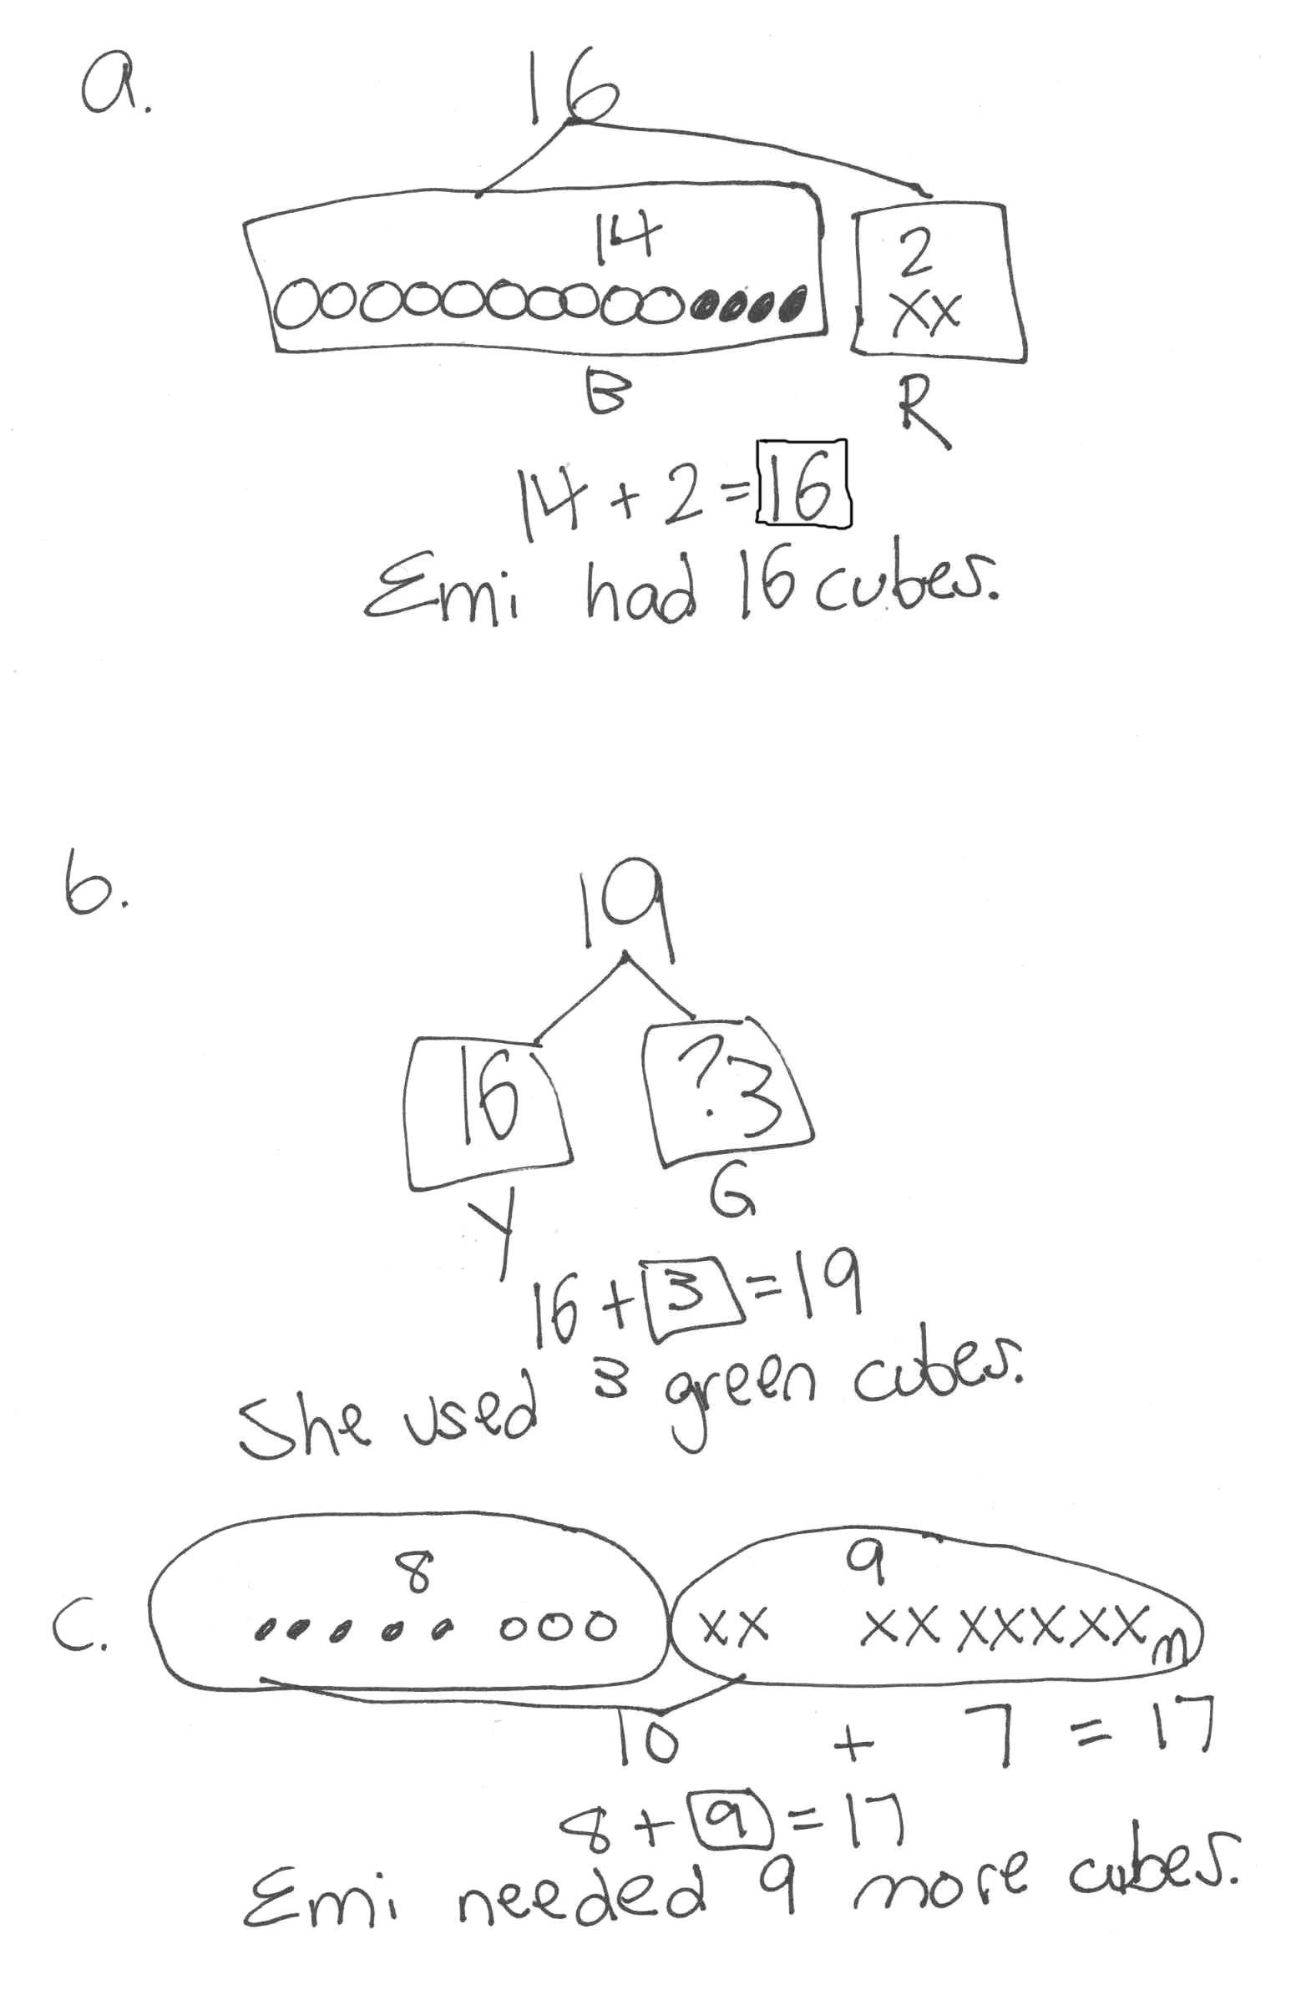Application Problems (5 minutes)

Use the RDW process to solve one or more of the problems without using linking cubes.

1. Emi had a linking cube train with 14 blue cubes and 2 red cubes. How many cubes were in her train?
2. Emi made another train with 16 yellow cubes and some green cubes. The train was made of 19 linking cubes. How many green cubes did she use?
3. Emi wants to make her train of 8 linking cubes into a train of 17 cubes. How many cubes does Emi need?

Note: Today, students use larger numbers to solve problems that are similar to the Application Problems solved throughout the past few days. Make note of students who were successful with the earlier sets but struggled with the problem today. These students may have difficulty envisioning the relationships between the larger quantities. Encourage these students to change from empty circles to filled-in circles at the ten, as shown in the first image, to help them break down and visualize the larger numbers.

Fluency Practice (9 minutes)

* Analogous Addition Sentences **1.NBT.4** (5 minutes)
* Digit Detective **1.NBT.2** (4 minutes)

Analogous Addition Sentences (5 minutes)

Materials: (S) Personal white board, one die

Note: This fluency activity reviews yesterday’s lesson. Some students may wish to show their work with number bonds, while others may choose to work mentally.

Students work in pairs. For students who struggle, consider replacing the 6 on the die with a 0 so the sums do not cross ten.

Partner A

4 + 3 = 7

14 + 3 = 17

24 + 3 = 27

34 + 3 = 37

Partner B

3 + 4 = 7

13 + 4 = 17

23 + 4 = 27

33 + 4 = 37

STEP 2

Partner A

4

14

24

34

Partner B

3

13

23

33

STEP 1

1. Each student rolls one die and writes the number rolled. They then make a list, adding 1 ten to their number on each new line up to 3 tens. (See diagram to the right.)
2. Students write equations, adding the number on their partner’s die to each line.
3. Partners exchange boards and check each other’s work.

As students work, make sure to circulate and monitor their understanding of recently introduced concepts.

Digit Detective (4 minutes)

Materials: (T/S) Personal white board

Note: This activity reviews place value, which prepares students for adding ones to ones or tens to tens in today’s lesson. As always, pause to give students enough time to think and write before signaling.

Write a number on your personal white board, but do not show students.

T: The digit in the tens place is 3. The digit in the ones place is 1. What’s my number? (Signal.)

S: 31.

T: What’s the value of the 3? (Signal.)

S: 30.

T: What’s the value of the 1? (Signal.)

S: 1.

Repeat sequence with a ones digit of 3 and a tens digit of 3.

T: The digit in the tens place is 1 more than 2. The digit in the ones place is equal to 7 – 4. What’s my number? (Snap.)

S: 33.

T: The digit in the ones place is equal to 2 + 6. The digit in the tens place is equal to 8 – 6. What’s my number? (Snap.)

S: 28.

As with the above example, begin with easy clues and gradually increase the complexity.

Concept Development (36 minutes)

Materials: (T) 4 ten-sticks, 4 dimes, 10 pennies, chart paper (S) 4 ten-sticks, 4 dimes, and 10 pennies from the math toolkit, personal white board

Students gather in the meeting area with their partners and materials.

T: (Write 16 + 2 and 16 + 20 on the board.) Partner A, using your linking cubes, show how you would solve 16 + 2. Partner B, show how you would solve 16 + 20.

**MP.6**

S: (Solve.)

T: Share your work with your partner. How are they similar? How are they different?

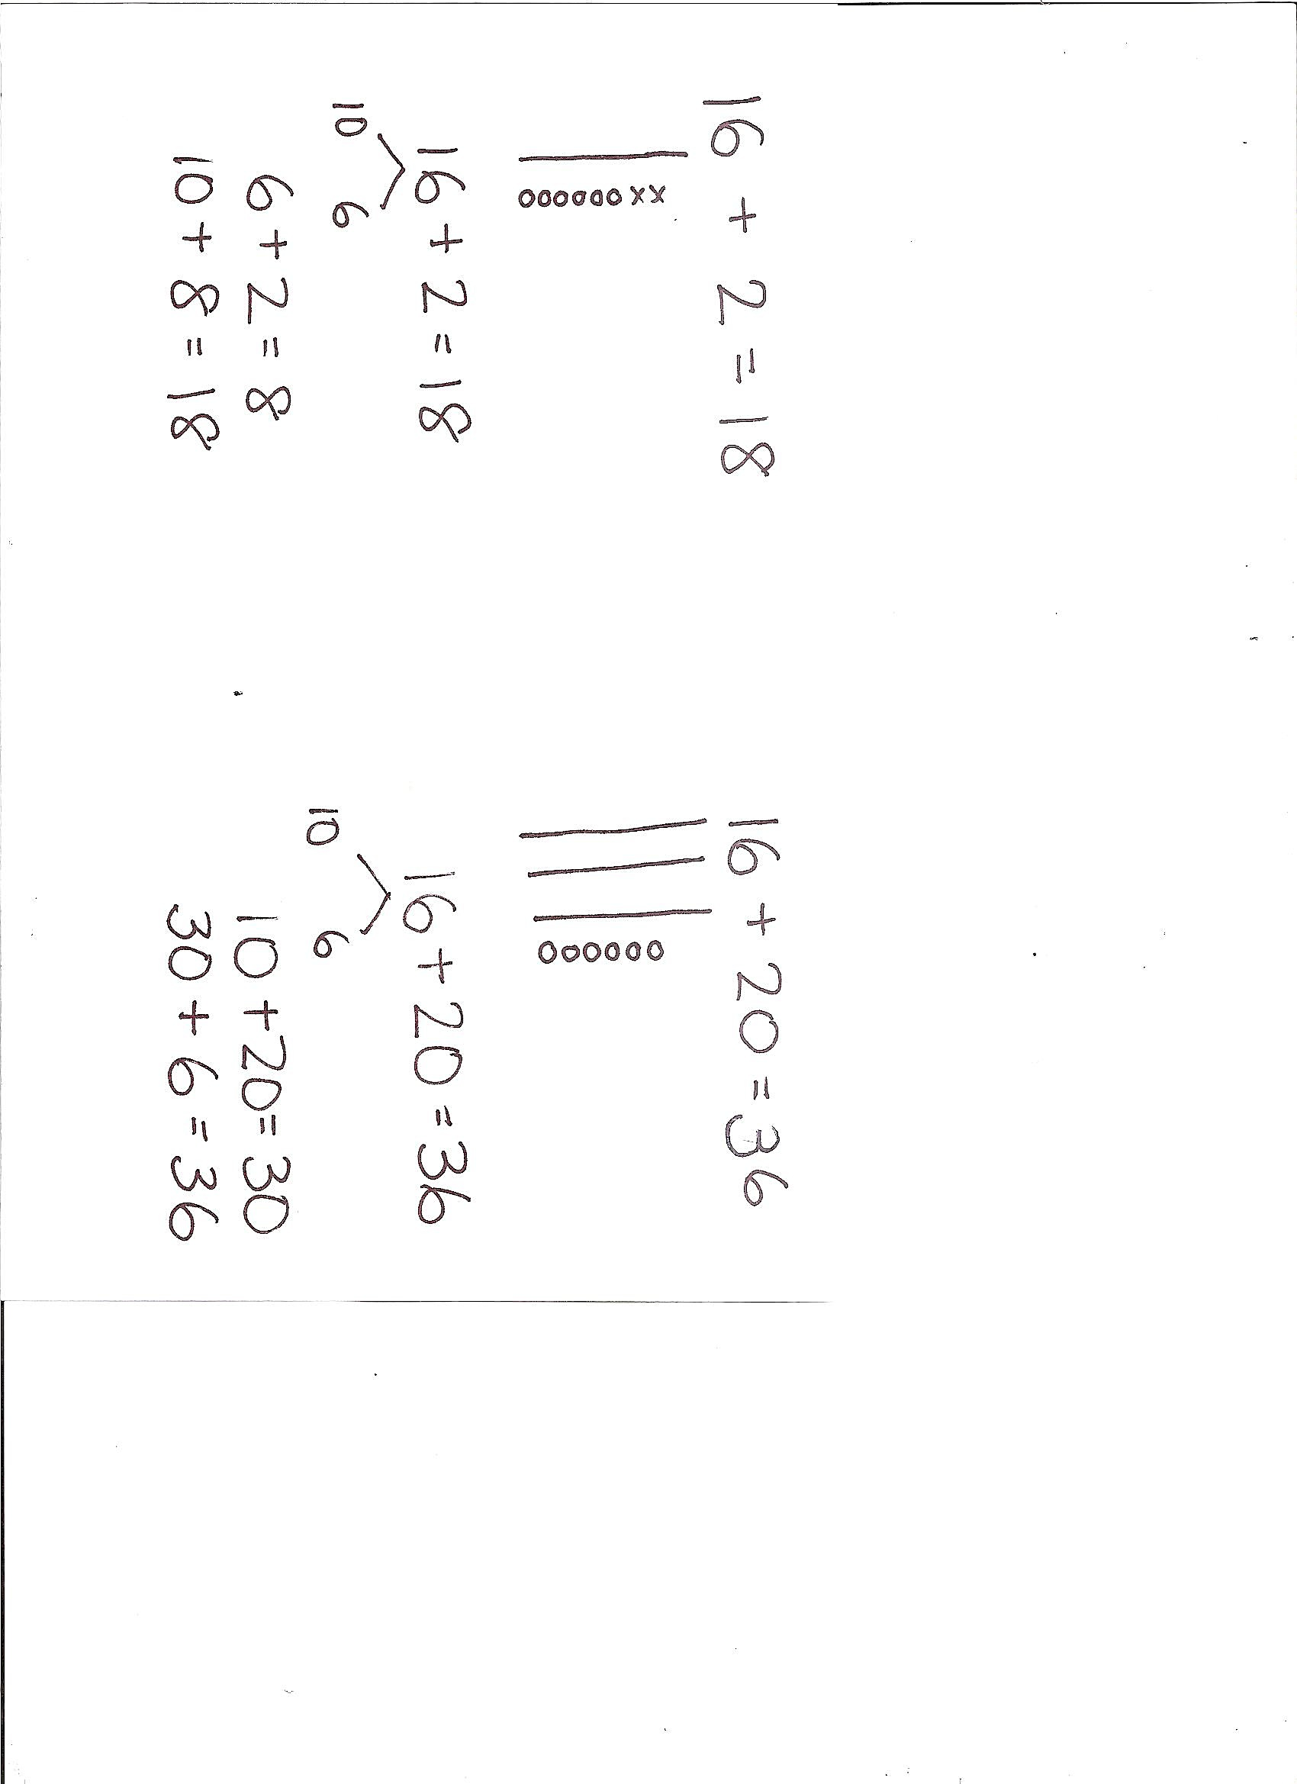S: We both started with the same number—16. 🡪 We added a different number to 16. I added 2, but my partner added 20. 🡪 But we both added 2 more things to 16. I added 2 ones. My partner added 2 tens. 🡪 I added my 2 ones to 6 ones. My partner added his 2 tens to 1 ten.

T: Excellent job comparing. Let’s make quick ten drawings to show how we can solve these problems. Start by drawing 16.

S: (Draw 16 on personal white board.)

T: Let’s add 2 ones. Should we add to the ones or to the tens? Why?

S: To the 6 ones, because we are adding 6 ones and 2 ones. 🡪 We can add to the tens or the ones. We can do 10 + 2 = 12, and then 12 + 6 = 18. 🡪 But it’s much easier to add the ones. 6 and 2 is 8. 10 and 8 is 18. 🡪 The ones!

T: You’re right. Adding the ones together is much easier. Add 2 to your ones. (Wait.) 6 ones and 2 ones is…?

S: 8 ones.

T: How many tens are there?

S: 1 ten.

T: 1 ten 8 ones is…?

S: 18.

T: (Make a number bond for 16.) Turn and talk to your partner about why 16 is broken apart into 10 and 6.

S: We added 6 ones and 2 ones, so it’s smart to break apart 16 into 10 and 6. 🡪 That makes it easy for me to see the ones. 🡪 I like adding 6 + 2. It’s easy for me. 10 + 6 is easy, too. That’s 16.

T: 6 and 2 is…? (Write 6 + 2 = 8 once students have answered.)

S: 8.

T: 10 and 8 is…? (Write 10 + 8 = 18 once students have answered.)

S: 18.

T: (Point to 16 + 20.) This time, what’s different?

S: Instead of adding 2 ones, we are adding 2 tens.

T: In our drawing, should we add 2 tens to the tens or the ones? Turn to your partner and explain your reason.

S: To the tens! 🡪 1 ten + 2 tens = 3 tens. That’s easy. 🡪 We can add it to the ones. But we’ll have to think, “What’s 16 + 20?” That’s not so easy. But if we add to the tens, it’s much easier. 🡪 When you see 3   
ten-sticks, it’s easy to see that it’s 30. 30 + 6 is easy, too.

T: You are right! Adding tens to tens is much easier. Show what that looks like in your drawing. Add 20, or 2 tens. (Wait.) How many tens are there?

S: 3 tens.

T: How many ones?

S: 6 ones.

T: 3 tens 6 ones is…?

S: 36.

T: Turn and talk to your partner about breaking apart to add 2 tens to the tens first.

S: Break apart 16 into 10 and 6. 🡪 It takes out the ten that we need to add to the 2 tens. 20 and 10 is 30. Then, we add 6 more to get 36.

T: Write down two number sentences to show how we add the tens first, and then the rest, to solve.

|  |  |
| --- | --- |
|  | NOTES ON  MULTIPLE MEANS  OF REPRESENTATION: |
| Students working below grade level might benefit from place value charts as well as concrete models to help them determine whether to add to the tens or ones. | |

S: (Write 10 + 20 = 30 and 30 + 6 = 36.)

T: When we have an addition problem, what is a good question to ask ourselves before adding the second addend? (Point to the chart.) Think about how we solved 16 + 2 and 16 + 20.

S: Ask and decide, “Should we add to the ones or to the tens?” 🡪 When you add ones to ones or tens to tens, it makes the problem easier to solve.

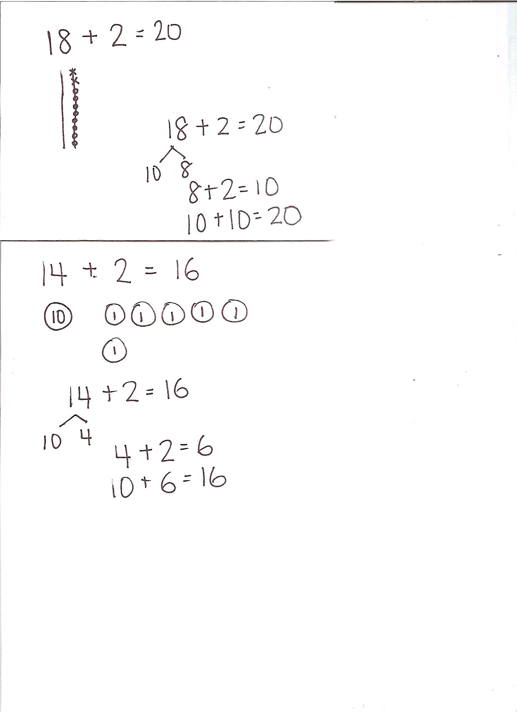Repeat the process, having Student A solve 18 + 20 and Student B solve 18 + 2 using cubes and quick ten drawings. Then, compare their work.

T: Everyone, show 18 with your cubes. (Wait.) Let’s add 2. But first, we need to ask…?

S: Should we add to the ones or to the tens?

T: What should we add the 2 to?

S: The ones!

T: Add 2 to the ones. (Wait.) 18 + 2 is…?

S: 20.

T: Turn and tell your partner how you got your answer.

S: I added 2 cubes to the 8 cubes. It made another ten-stick! 🡪 I now have 2 ten-sticks. 10 and 10 is 20. 🡪 8 plus 2 equals 10; 10 plus 10 equals 20.

T: Use a quick ten drawing and a number bond to show how you added ones and ones together.

|  |  |
| --- | --- |
|  | NOTES ON  MULTIPLE MEANS  OF ENGAGEMENT: |
| Adjust the lesson structure based on the needs of the students. Some students may be ready for challenging problems, while others may need to develop one method of representation at a time. Provide challenging problems for students who are ready, while spending time with students who may be struggling with one or more of the ways to represent their work (number bonds, quick ten drawings, and coin drawings). | |

S: (Complete drawings and number bonds.)

Repeat the process as partner work following the suggested sequence:

* 17 + 20 and 17 + 2
* 19 + 1 and 19 + 10
* 15 + 20 and 15 + 2

To help students see the relationship between tens and ones and dimes and pennies, have every student use coins, coin drawings, and number bonds to solve: 14 + 2, 14 + 20,   
26 + 10, and 26 + 4.

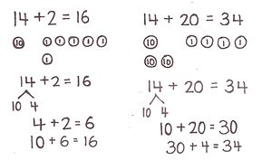Problem Set (10 minutes)

Students should do their personal best to complete the Problem Set within the allotted 10 minutes. For some classes, it may be appropriate to modify the assignment by specifying which problems they work on first.

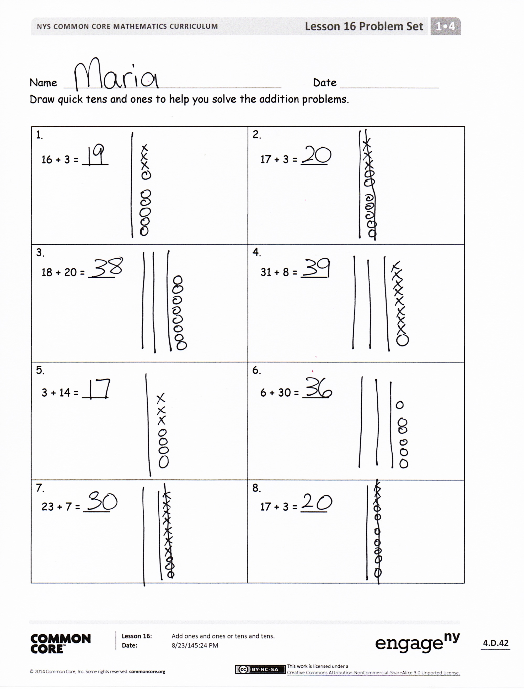Student Debrief (10 minutes)

**Lesson Objective:** Add ones and ones or tens and tens.

The Student Debrief is intended to invite reflection and active processing of the total lesson experience.

Invite students to review their solutions for the Problem Set. They should check work by comparing answers with a partner before going over answers as a class. Look for misconceptions or misunderstandings that can be addressed in the Debrief. Guide students in a conversation to debrief the Problem Set and process the lesson.

Any combination of the questions below may be used to lead the discussion.

* Share your quick ten drawing for Problem 6 with your partner. How did you make your math drawing? Why?
* 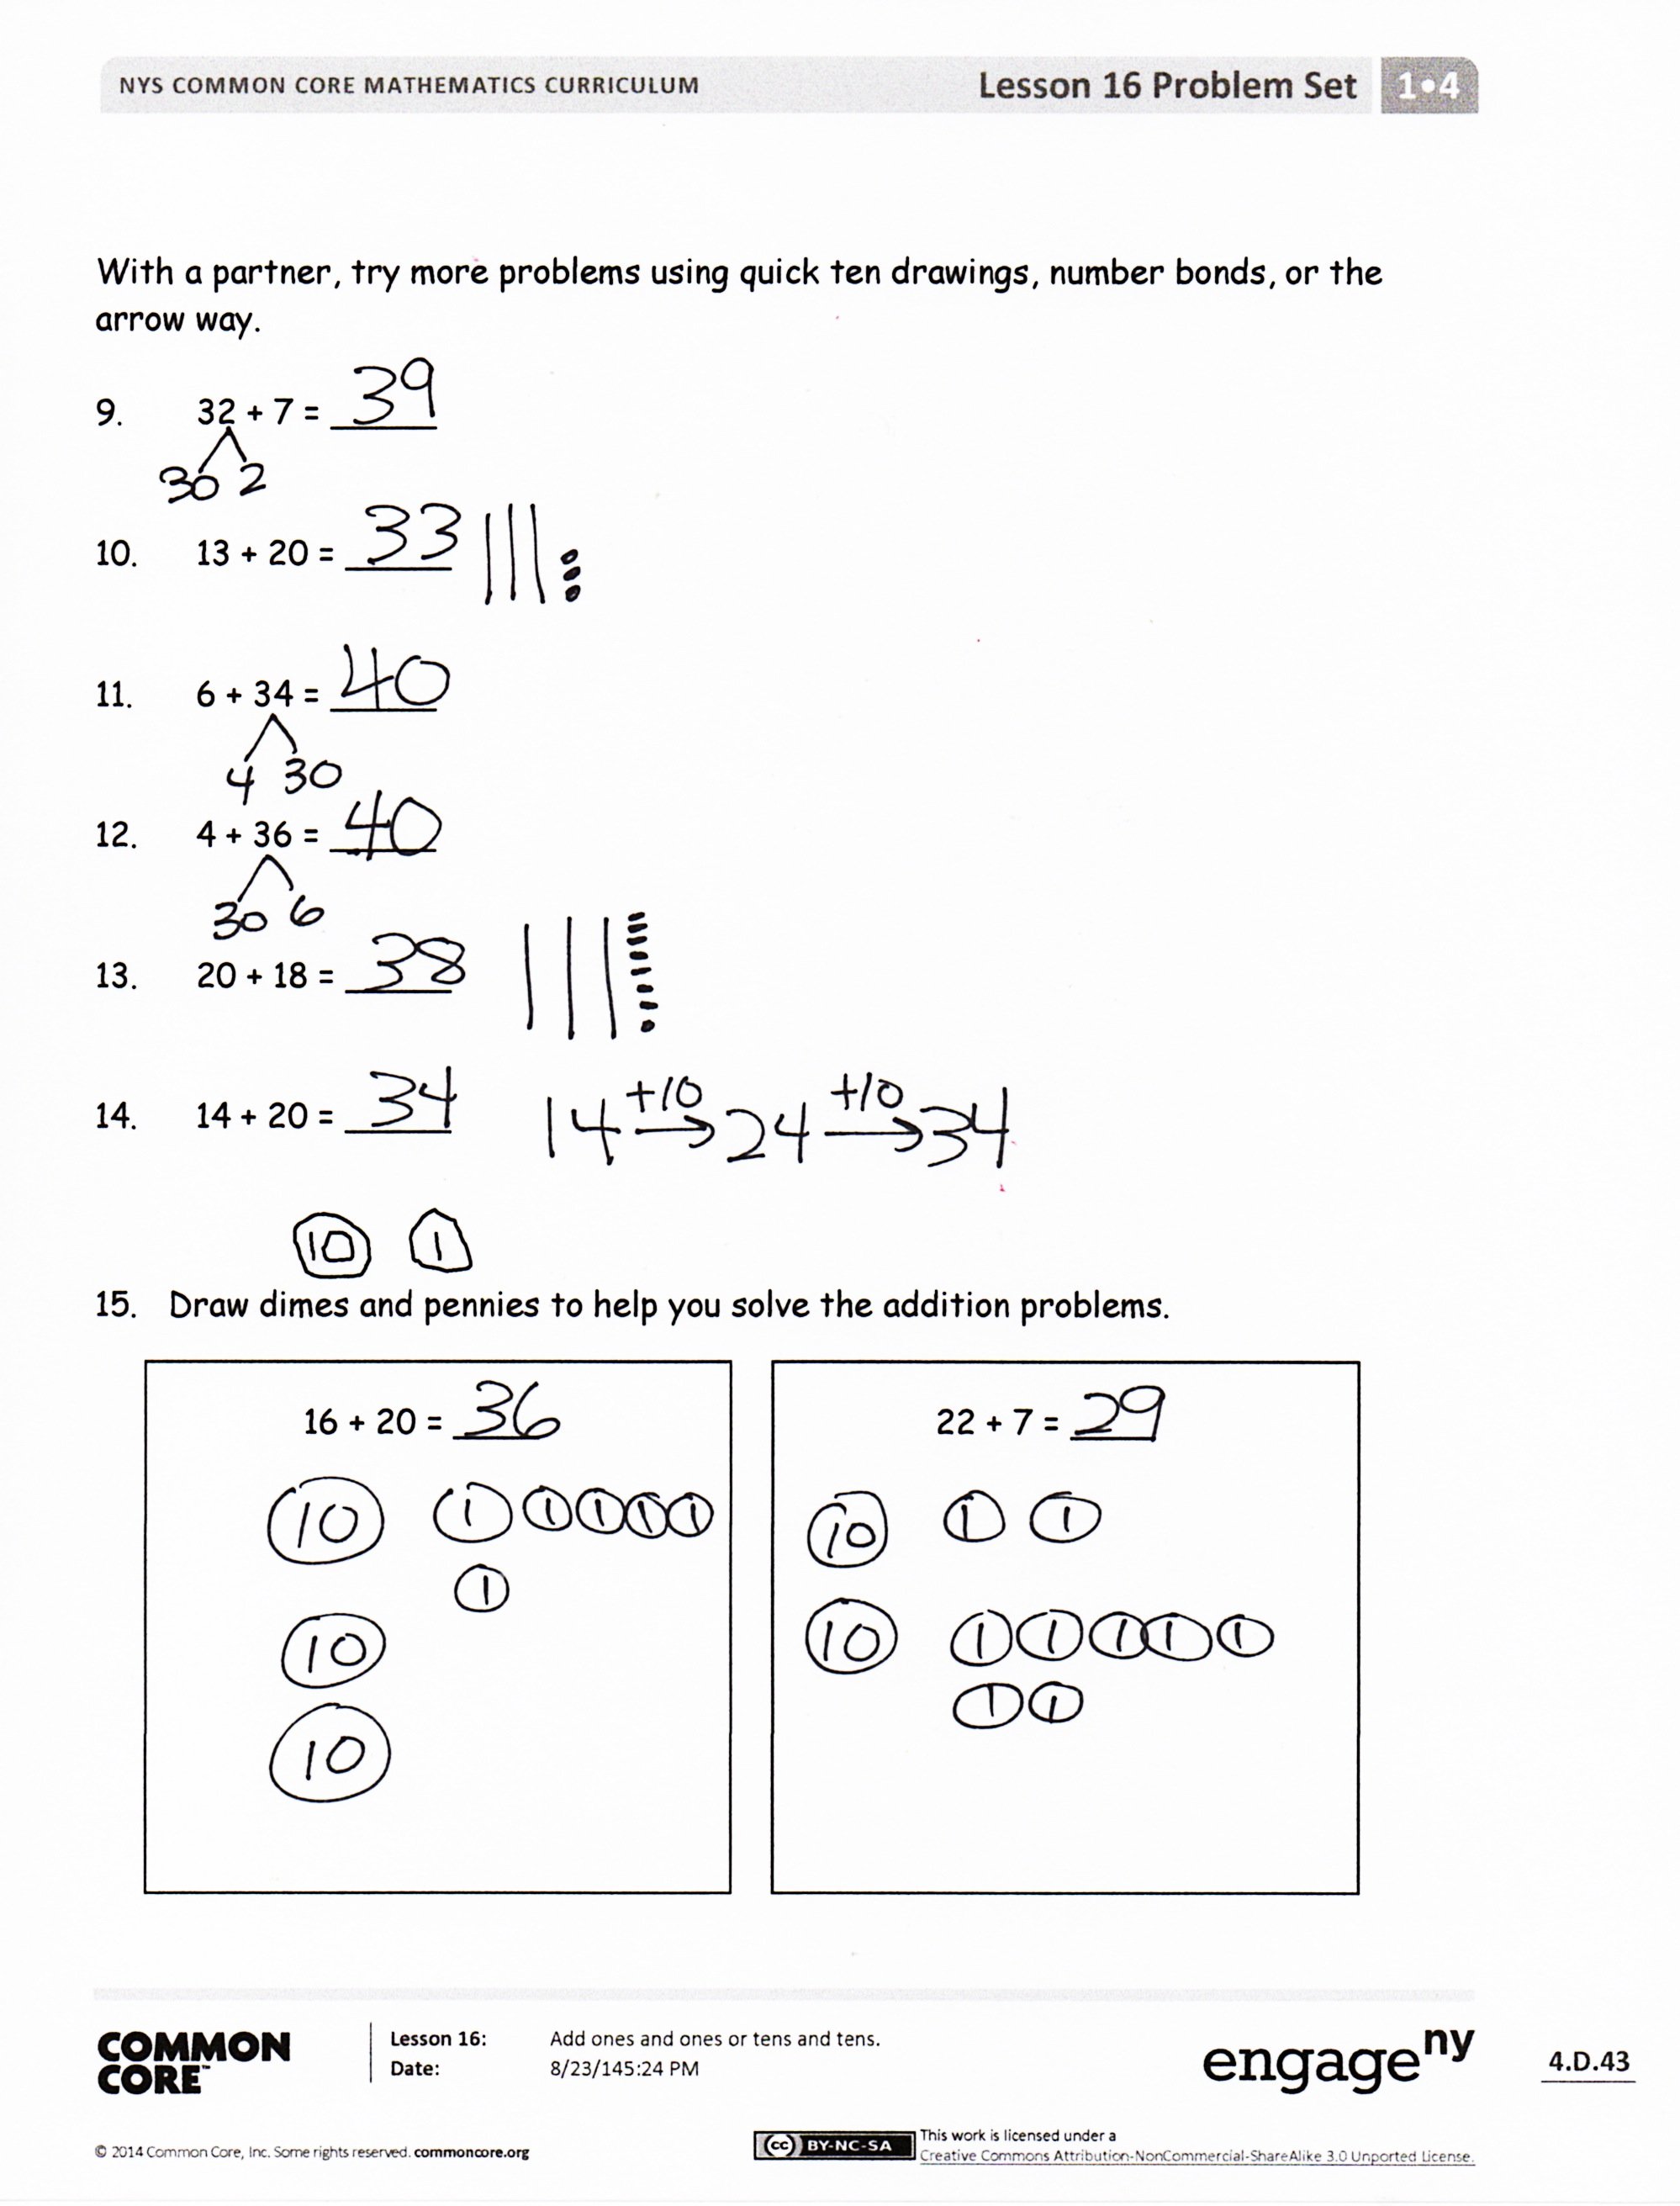How was solving Problem 7 helpful in solving Problem 8?
* How are Problems 11 and 12 related?
* For Problem 5, a student says 3 + 14 = 44. How can you help him understand his mistake?
* How did you determine whether to add to the ones place or tens place?
* How did the Application Problems connect to today’s lesson?

Exit Ticket (3 minutes)

After the Student Debrief, instruct students to complete the Exit Ticket. A review of their work will help with assessing students’ understanding of the concepts that were presented in today’s lesson and planning more effectively for future lessons. The questions may be read aloud to the students.

Name Date

Draw quick tens and ones to help you solve the addition problems.

|  |  |
| --- | --- |
| 1.  16 + 3 = ____ | 2.  17 + 3 = ____ |
| 3.  18 + 20 = ____ | 4.  31 + 8 = ____ |
| 5.  3 + 14 = ____ | 6.  6 + 30 = ____ |
| 7.  23 + 7 = ____ | 8.  17 + 3 = ____ |

With a partner, try more problems using quick ten drawings, number bonds, or the arrow way.

1. 32 + 7 = _____
2. 13 + 20 = _____
3. 6 + 34 = _____
4. 4 + 36 = _____
5. 20 + 18 = _____
6. 14 + 20 = _____
7. Draw dimes and pennies to help you solve the addition problems.
8. 16 + 20 = ____

b. 22 + 7 = ____

22 + 7 = ____

16 + 20 = ____

Name Date

Solve using quick ten drawings to show your work.

2. 14 + 20

1. 24 + 5

Draw number bonds to solve.

3. 19 + 20

4. 36 + 3

1. Draw dimes and pennies to help you solve the addition problem.

13 + 20

Name Date

Draw quick tens and ones to help you solve the addition problems.

|  |  |
| --- | --- |
| 1.  17 + 2 = _____ | 2.  17 + 3 = _____ |
| 3.  14 + 3 = _____ | 4.  24 + 10 = _____ |

Make a number bond or use the arrow way to solve the addition problems.

|  |  |
| --- | --- |
| 5.  6 + 24 = _____ | 6.  14 + 20 = _____ |

1. Solve each addition sentence and match.

a.

22 + 1 = _____

b.

13 + 6 = _____

13 + 6

26  29

e.

22 + 10 = _____

d.

37 + 3 = _____

c.

3 + 26 = _____

10

3