Lesson 15
Objective: Use single-digit sums to support solutions for analogous sums to 40.

Suggested Lesson Structure
 Application Problems (5 minutes)
 Fluency Practice (14 minutes)
 Concept Development (31 minutes)
 Student Debrief (10 minutes)
Total Time (60 minutes)
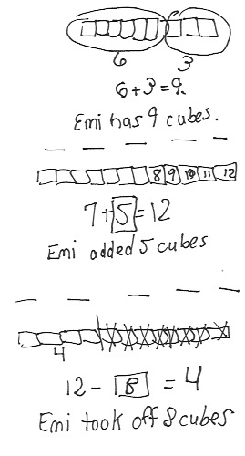
Application Problems (5 minutes)
Today, students should focus on pictorial representations. They should solve without using linking cubes. They read, draw, and write (RDW) to solve one or more of the problems.

- Emi had a linking cube train of 6 cubes. She added 3 cubes to the train. How many cubes are in her linking cube train?
- Emi made another train of linking cubes. She started with 7 cubes and added some more cubes until her train was 12 cubes long. How many cubes did Emi add?
- Emi made one more train of linking cubes. It was made of 12 linking cubes. She took some cubes off, and her train became 4 linking cubes long. How many cubes did Emi take off?
Note: Continue to notice students’ strengths and challenges with each problem type presented. Encourage students who seem to struggle when the linking cubes have been removed to visualize, imagine, or draw the cubes, as shown in the student work to the right.
Fluency Practice (14 minutes)
- Number Bond Addition and Subtraction 1.OA.5 (4 minutes)
- Make Ten Addition with Partners 1.OA.6 (6 minutes)
- Add Tens 1.NBT.4 (4 minutes)
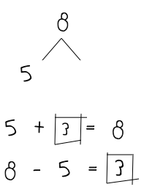
Number Bond Addition and Subtraction (4 minutes)
Materials: (S) Personal white board
Note: This fluency activity builds a student’s ability to add and subtract within 10 while reinforcing the relationship between addition and subtraction.
Write a number bond for a number between 0 and 10, with a missing part or whole. Students write an addition and a subtraction sentence with a box for the missing number in each equation. They then solve for the missing number.
Make Ten Addition with Partners (6 minutes)
Materials: (S) Personal white board
Note: This fluency activity reviews how to use the Level 3 strategy of making ten to add two single-digit numbers. Reviewing the make ten strategy will prepare students for today’s lesson, in which they systematically connect these problem types to analogous problems within 40 (e.g., students will make ten to solve 9 + 5 and then apply the same strategy to solve 19 + 5 and 29 + 5).
Repeat the activity from Lesson 14.
Add Tens (4 minutes)
Note: This fluency activity reviews adding multiples of 10, which will help prepare students for today’s lesson.
T: (Flash 3 on fingers. Pause.) Add ten. The total is…?
S: 13.
T: (Flash 3 again.) Add 2 tens. The total is…?
S: 23.
Continue flashing numbers from 0 to 10 and instructing students to add multiples of 10. After a minute, say the multiples of 10 the regular way (e.g., 20 instead of 2 tens). For the last minute, say teen numbers and instruct students to add 10 or 2 tens or 20.
Concept Development (31 minutes)
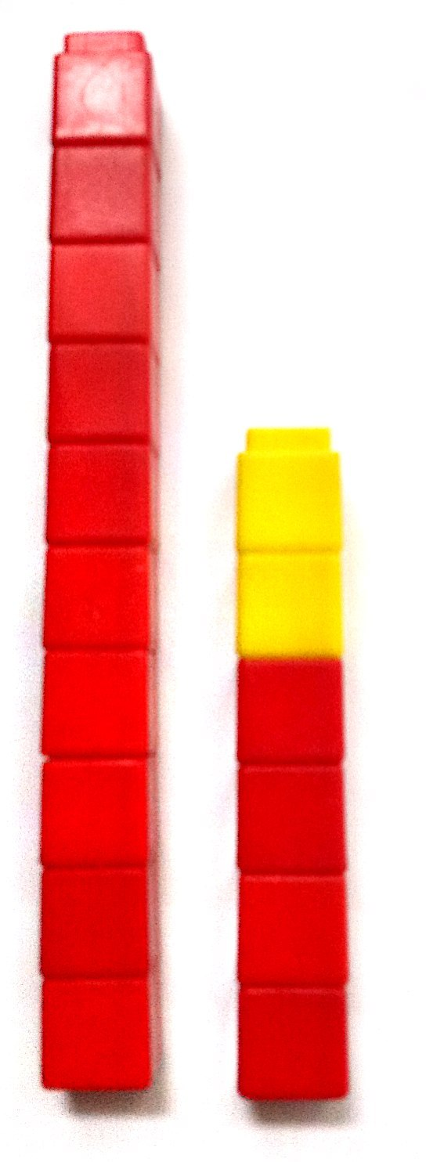
Materials: (T) 5 ten-sticks (e.g., 4 red and 1 yellow), chart paper (S) 4 ten-sticks from the math toolkit, personal white board
Students gather in the meeting area with their materials.
T: (Show 4 red and 2 yellow cubes in a stick.) What is the addition sentence that matches the cubes?

NOTES ON
MULTIPLE MEANS OF REPRESENTATION:
Students may still struggle with coin values and therefore it will be hard for them to connect them to tens and ones. Offer frequent opportunities to engage with these coins and relate them to tens and ones so that the connection is eventually made.
S: 4 + 2 = 6.
T: (Record on the chart. Place a red ten-stick to the left of 4 and 2 cubes, showing
14 + 2.) How many linking cubes are there now?
S: 16.

NOTES ON
MULTIPLE MEANS
OF REPRESENTATION:
Provide opportunities for students to practice their math facts within 10 throughout the day. Students struggling with mastery of the grade-level fluency goal benefit from focused extra practice. Elicit from them which facts they find harder to understand in order to determine that focus. Keep parents informed of these details and offer effective ways they can support the students.
T: What is the number sentence to add these red and yellow cubes?
S: 14 + 2 = 16.
T: (Record on the chart. Add another red ten-stick, showing 24 + 2.) How many linking cubes are there now? Say the number sentence. (Allow time for students to think of their answers.)
S: 24 + 2 = 26.
T: (Record on the chart.) What do you think I’ll do next? Turn and talk to your partner.
S: You’ll add another ten-stick. The next problem will be 34 + 2.
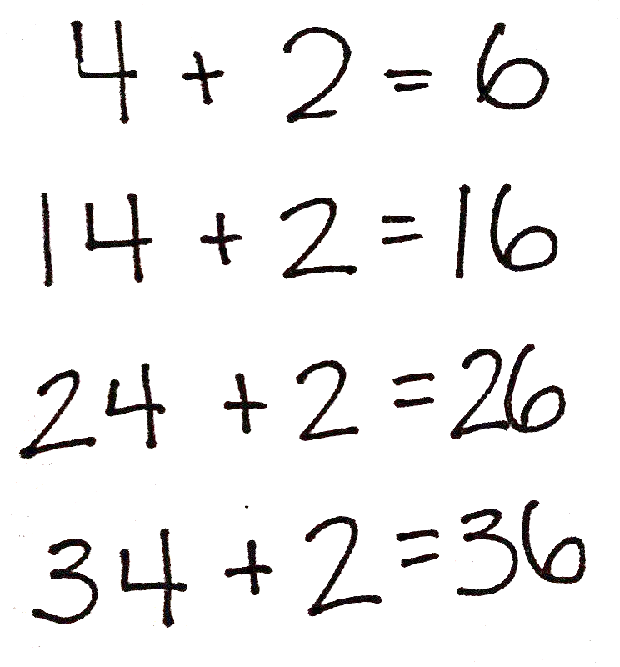
T: You’re right. (Add another red ten-stick, showing
34 + 2.) How many linking cubes are there now? Say the number sentence. (Allow time for students to think of their answers.)
S: 34 + 2 = 36.
T: (Record on the chart.) Many of you got the answer to these questions very quickly. Why? Turn and talk to your partner.
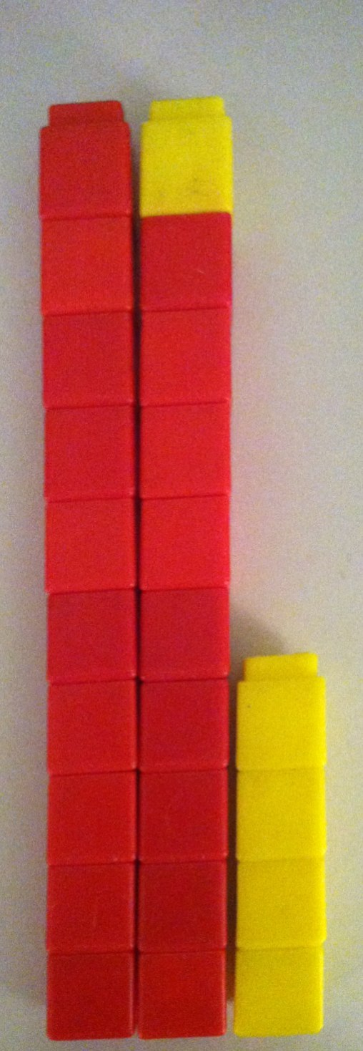
S: The digit in the tens place in the first addend keeps going up. The same thing is happening to the answers, too. This reminds me of when we added only tens to a number. The ones digit stayed the same, but the tens digit changed. We’re always adding 4 and 2.
In every problem, the tens are changing, but the ones are not because we are not touching the ones.
T: Great observations! Let’s try another problem.
T: (Write and show 9 + 5 with 9 red and 5 yellow linking cubes.) Talk to your partner about how you can solve 9 + 5.
S: I can count every cube. I can count on from 9. I can make ten first.
10 + 4 = 14.
T: (Call up a volunteer to show 10 and 4 with linking cubes, as shown to the right. Record the answer. )
T: (Add another red ten-stick and show 19 + 5.) What is the new addition problem starting with 19?
S: 19 + 5.
T: (Record on the chart.) Turn and talk to your partner about how you can figure out how many cubes there are now.

S: I can see the cubes. There are 2 tens and 4 ones. That’s 24. I knew that 9 + 5 was 14. That’s the simpler problem. We added 10 more to 14. That’s 24.
MP.7
T: The strategy of using what we already know is a very important math strategy for solving problems. (Cover 1 ten-stick with a hand.) We know that 9 + 5 = 14. 19 + 5 is just 10 more than 9 + 5. (Reveal the ten-stick.) 10 more than 14 is…?
S: 24.
T: When you show 19 as tens and ones, you can easily see the simpler problem, 9 + 5. (Write the number bond for 19 as 10 and 9.) 9 + 5 is…?
S: 14.
T: (Create a chart like the one shown to the right. 9 + 5 = 14.) 10 more than 14 is…?
S: 24.
T: (Write 14 + 10 = 24. Add another red ten-stick and show 29 + 5.) Write down the new addition problem on your personal white board, starting with 29.
S: (Write 29 + 5.)
T: (Record on the chart.) Break apart 29 into tens and ones. What is the simpler problem?
S: (Make a number bond with 29.) 9 + 5.
T: 9 + 5 is…?
S: 14.
T: 20 more than 14 is…?
S: 34.
T: 29 + 5 is…?
S: 34.
T: Using your number bond, let’s write the two number sentences that helped us solve this problem.
T/S: Write 9 + 5 = 14, 14 + 20 = 34.
T: (Create a chart, as shown to the right.) Turn and talk to your partner about the patterns you notice.
S: The ones stayed the same. But the tens changed because we kept adding more tens. Every time we add 10 more, the answer also shows 10 more. 9 + 5 = 14 is always the simpler problem. We solved 9 + 5, which is 14 first. When we added 1 more ten, then the answer went up by 1 more ten.

NOTES ON
MULTIPLE MEANS
OF ENGAGEMENT:
Choose just right numbers to provide ample opportunities for students to experience success and build confidence in their math skills.

Repeat the process, and have student pairs work with their linking cubes and record their work using the following sequence:
- 5 + 4, 15 + 4, 25 + 4, 35 + 4
- 4 + 6, 14 + 6, 24 + 6, 34 + 6
- 2 + 7, 12 + 7, 22 + 7, 32 + 7
- 9 + 3, 19 + 3, 29 + 3
- 8 + 6, 18 + 6, 28 + 6
- 8 + 8, 18 + 8, 28 + 8
- 5 + 7, 5 + 17, 5 + 27
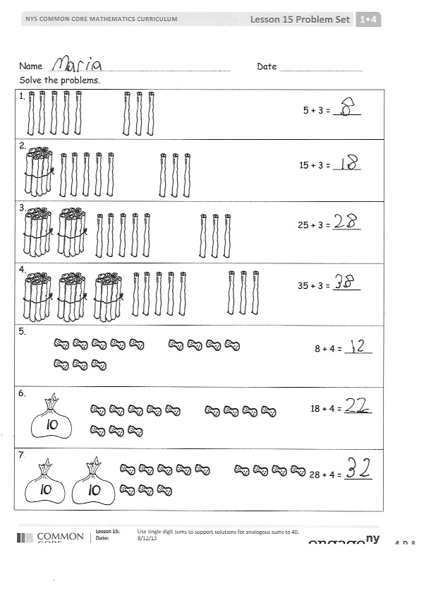
Next, follow the suggested sequence and have students identify the simpler problem before solving the given problem: 17 + 2, 19 + 2, 28 + 2, 28 + 4, 27 + 6, and 25 + 7.
Problem Set (10 minutes)
Students should do their personal best to complete the Problem Set within the allotted 10 minutes. For some classes, it may be appropriate to modify the assignment by specifying which problems they work on first.
Student Debrief (10 minutes)
Lesson Objective: Use single-digit sums to support solutions for analogous sums to 40.
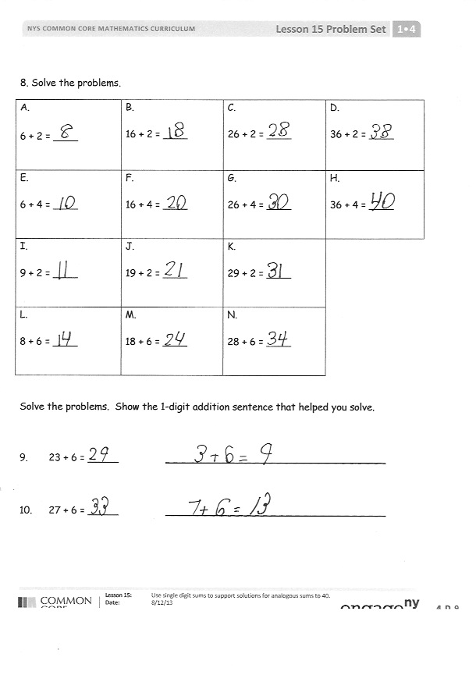
The Student Debrief is intended to invite reflection and active processing of the total lesson experience.
Invite students to review their solutions for the Problem Set. They should check work by comparing answers with a partner before going over answers as a class. Look for misconceptions or misunderstandings that can be addressed in the Debrief. Guide students in a conversation to debrief the Problem Set and process the lesson.
Any combination of the questions below may be used to lead the discussion.
- How did looking for patterns help you solve the problems on the second page of your Problem Set?
- Look at Problem 8(a–d) and 8(i–k). In (a–d), the tens in the answers are the same as the tens in the first addend of each problem, but in (i–k), the tens in the answers do not match the tens in the first addends. Explain why this is so.

- You solved 36 + 2 easily in Problem 8(d). How can this problem help you solve 36 + 3? How can knowing 36 + 3 then help us solve 26 + 3?
- What new strategy did you learn to solve addition problems when one addend is a two-digit number?
- Look at the Application Problems and the answers from the Problem Set. Find the related addition sentence that could have helped you solve the subtraction problem.
Exit Ticket (3 minutes)
After the Student Debrief, instruct students to complete the Exit Ticket. A review of their work will help with assessing students’ understanding of the concepts that were presented in today’s lesson and planning more effectively for future lessons. The questions may be read aloud to the students.

Name Date
Solve the problems.
1.

5 + 3 = _____
2.

15 + 3 = _____
3.

25 + 3 = _____
4.

35 + 3 = _____
5.

8 + 4 = _____
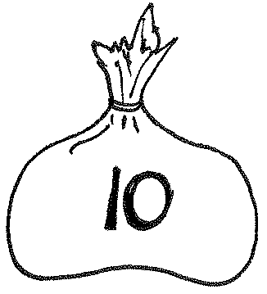
6.

18 + 4 = _____

7.

28 + 4 = _____
- Solve the problems.
a.  6 + 2 = ____ | b.  16 + 2 = ____ | c.  26 + 2 = ____ | d.  36 + 2 = ____
e.  6 + 4 = ____ | f.  16 + 4 = ____ | g.  26 + 4 = ____ | h.  36 + 4 = ____
i.  9 + 2 = ____ | j.  19 + 2 = ____ | k.  29 + 2 = ____
l.  8 + 6 = ____ | m.  18 + 6 = ____ | n.  28 + 6 = ____

Solve the problems. Show the 1-digit addition sentence that helped you solve.
- 23 + 6 = _____ ___________________________

- 27 + 6 = _____ ___________________________

Name Date
- Solve the problems.
a.

7 + 5 = ____
b.

17 + 5 = ____
c.

27 + 5 = ____

Solve the problems.
- a. 5 + 3 = _____ 3. a. 5 + 8 = _____
b. 15 + 3 = _____ b. 15 + 8 = ____
c. 25 + 3 = _____ c. 25 + 8 = ____
d. 35 + 3 = _____

Name Date
Solve the problems.
1. |  | 5 + 4 = ____
2. | 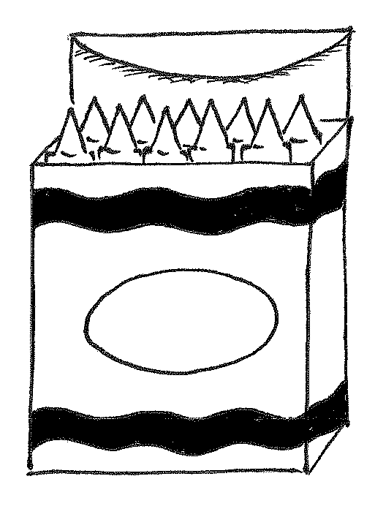 | 15 + 4 = ____
3. |  | 25 + 4 = ____
4. |  | 35 + 4 = ____
5. |  | 8 + 4 = ____
6. | 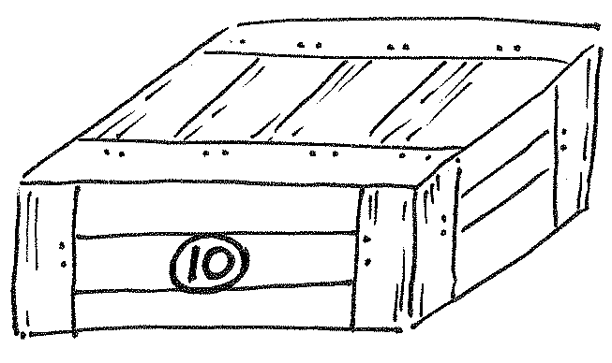 | 18 + 4 = ____
7. |  | 28 + 4 = ____
Use the first number sentence in each set to help you solve the other problems.
8. | a. 5 + 2 = ____  b. 15 + 2 = ____  c. 25 + 2 = ____  d. 35 + 2 = ____ | 9. | a. 5 + 5 = ____  b. 15 + 5 = ____  c. 25 + 5 = ____  d. 35 + 5 = ____
10. | a. 2 + 7 = ____  b. 12 + 7 = ____  c. 22 + 7 = ____ | 11. | a. 7 + 4 = ____  b. 17 + 4 = ____  c. 27 + 4 = ____
12. | a. 8 + 7 = ____  b. 18 + 7 = ____  c. 28 + 7 = ____ | 13. | a. 3 + 9 = ____  b. 13 + 9 = ____  c. 23 + 9 = ____

Solve the problems. Show the 1-digit addition sentence that helped you solve.
14. 24 + 5 = _____ ___________________________
15. 24 + 7 = _____ ___________________________

