Lesson 14
Objective: Use counting on and the make ten strategy when adding across a ten.

Suggested Lesson Structure
 Application Problems (5 minutes)
 Fluency Practice (12 minutes)
 Concept Development (33 minutes)
 Student Debrief (10 minutes)
Total Time (60 minutes)
Application Problems (5 minutes)
Use linking cubes and the RDW process to solve one or more of the problems.
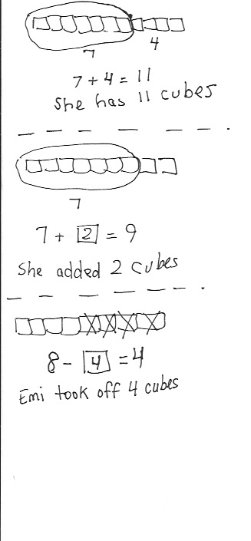
- Emi had a linking cube train of 7 cubes. She added 4 cubes to the train. How many cubes are in her linking cube train?

- Emi made another train of linking cubes. She started with 7 cubes and added some more cubes until her train was 9 cubes long. How many cubes did Emi add?

- Emi made one more train of linking cubes. It was made of 8 linking cubes. She took some cubes off, and then her train was
4 linking cubes long. How many cubes did Emi take off?
Note: Each problem is successively more challenging. Remind children that they are not expected to complete all three, but instead to do their best during the five-minute time frame.
Notice which students are successful with the first problem, where the unknown number is the result, or total, but who struggle with later problems where the unknown number is in a different position. Keep track of this analysis in preparation for Topic E instruction, where it might be useful to select or emphasize particular problem types.
The similarity to yesterday’s problems is intended to promote perseverance and confidence for students who may be struggling with Application Problems at this point in the year. For students who are successful with all problems, challenge them to find the total of all the cubes used, ask how many more cubes the first train has than the last, or encourage them to write their own additional linking cube train story.
Fluency Practice (12 minutes)
- Addition Within 40: Counting On 1.NBT.4 (3 minutes)
- Get to 10 1.NBT.4 (3 minutes)
- Make Ten Addition with Partners 1.OA.6 (6 minutes)
Addition Within 40: Counting On (3 minutes)
Note: This fluency activity reviews yesterday’s lesson. Some students may count on, as they learned to do yesterday. Others may already make the connection between the single-digit addition facts and their analogous addition sentences. As always, pause to provide thinking time.
T: 5 + 2 is…? (Snap.) Give me the number sentence.
S: 5 + 2 = 7.
T: 10 + 7 is…? (Snap.)
S: 10 + 7 = 17.
T: 15 + 2 is…? (Snap.)
S: 15 + 2 = 17.
Continue with 25 + 2 and 35 + 2. Repeat, beginning with other single-digit addition facts with sums to 10. Make sure one addend is conducive to counting on (e.g., 1, 2, or 3).
Get to 10 (3 minutes)
Materials: (T) Rekenrek
Note: In this fluency activity, students apply their knowledge of partners to ten to find analogous partners to 20, 30, and 40, which will prepare them for today’s lesson.
For the first minute, say numbers 0–10. Students say partners to ten on your snap. Then, take out the Rekenrek.
T: (Show 9.) Say the number.
S: 9.
T: Give me the number sentence to make ten.
S: 9 + 1 = 10.
T: (Move 1 bead to make 10. Show 19.)
T: Say the number.
S: 19.
T: Give me the number sentence to make 20.
S: 19 + 1 = 20.
Suggested sequence: 29, 39; 5, 15, 25, 35; 8, 18, 28, 38; 7, 17, 27, 37; etc.
Make Ten Addition with Partners (6 minutes)
Materials: (S) Personal white board
Note: This fluency activity reviews how to use the Level 3 strategy of making ten to add two single-digit numbers. In today’s lesson, students will learn how to apply this strategy when adding a one-digit number to a two-digit number.
- Assign partners of equal ability.

NOTES ON
MULTIPLE MEANS
OF ENGAGEMENT:
Carefully selecting pairs for collaborative work is essential to achieving expected outcomes. Some lessons lend themselves to groupings of students with similar skill sets, while others work better when students are heterogeneously grouped. Some students might benefit from the opportunity to work independently and share with the teacher or another pair after they have completed the task.

- Partners choose an addend from 1 to 10 for each other.
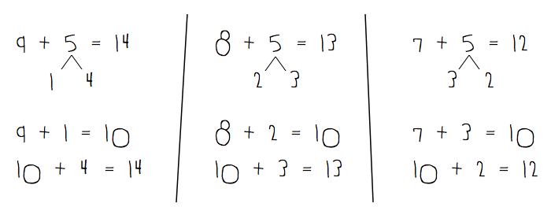
- On their personal white boards, students add their number to 9, 8, and 7. Remind students to write the two addition sentences they learned in Module 2.
- Partners then exchange boards and check each other’s work.
Concept Development (33 minutes)
Materials: (T) 4 ten-sticks, chart paper (S) 4 ten-sticks from the math toolkit, personal white board
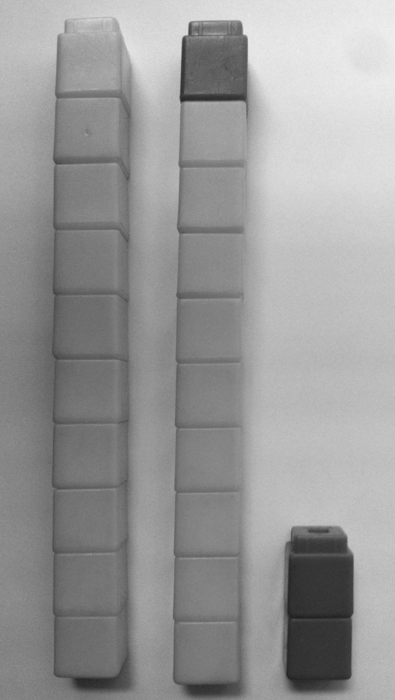
Note: During today’s lesson, the make ten strategy is used. This requires students to break apart the single-digit addend, as in Module 2, whereas yesterday they broke apart the double-digit addend. This is part of how students gain confidence in using number bonds flexibly.
Have students sit in a semicircle formation in the meeting area with their materials.
T: (Write 19 + 3 on the chart.) How many cubes do I start with?
S: 19 cubes. 1 ten-stick and 9 ones. You also need 3 ones.
T: (Show 19 + 3 with cubes.) Turn and talk to your partner about how you can solve 19 + 3.
While students discuss, circulate and listen for sharing of both counting on and make ten strategies.
T: (Ask student volunteers to share their strategies.)

S: I can count on. Nineteen, 20, 21, 22. You can make another ten. 9 plus 1 more makes 10. 2 tens, and then you still have 2 ones left. 19 and 1 is 20. 20 + 2 is 22.
T: Just like we did yesterday, we can make a new ten-stick! How many more ones to make 19 get to the next ten, 20?
S: 1.
T: From where can we get the 1?

NOTES ON
MULTIPLE MEANS
OF ACTION AND EXPRESSION:
Giving students an opportunity to share their thinking allows them to evaluate their process and practice. English language learners also benefit from hearing other students explain their thinking.

S: From the 3.
T: (Hold up 3 cubes. Break off 1 cube and complete a
ten-stick.) How many tens are there now?
S: 2 tens.
T: How many ones are left?
S: 2 ones.
T: What is 2 tens and 2 ones?
S: 22.
T: 19 + 3 is…?
S: 22.
T: Excellent work! Let’s try some more!
Have students collaborate with their partners and combine their linking cubes to find the sum for each addition expression following the suggested sequence: 18 + 4, 28 + 4, 26 + 5, 26 + 7, and 15 + 8. When appropriate, have students also draw quick tens to show how they solved the problems. (See image to the right.)
T: (Write 19 + 3 on the board again and represent the expression using linking cubes.) Let’s record what we did to solve 19 + 3 using a number bond. Can we make a ten?
S: Yes.
T: How many more do we need to get to the next ten from 19? Where can we get that amount?
S: Take 1 from the 3.
T: (Ask a student volunteer to take 1 from 3 using the linking cubes.) Look at what we did with 3 to make the next ten. We broke 3 into…?
S: 1 and 2.
T: (Make a number bond as shown to the right.) What is 19 and 1?
S: 20.
T: (Write 19 + 1 = 20.) 20 and 2 is…?
S: 22.
T: (Write 20 + 2 = 22.) Let’s use the arrow way to record what we did. (Write 19 and model the arrow way as you talk through the notation.) We started with 19, then added 1 to make the next ten, which is 20. Then, we had 2 left over, so we added 2 to 20 to get to 22.
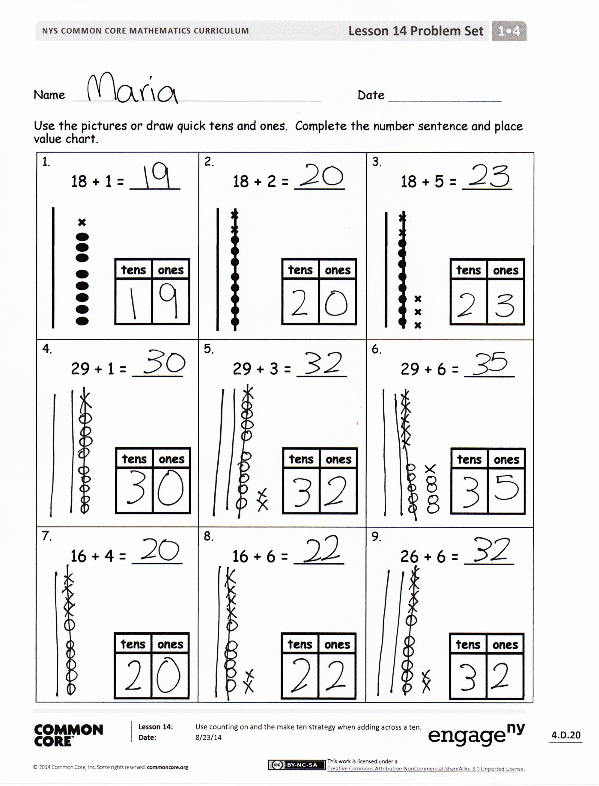
T: So, 19 + 3 =…?
S: 22.
Repeat the process following the suggested sequence:
29 + 3, 19 + 5, 18 + 3, 17 + 3 (use 1 arrow), 26 + 3 (use 1 arrow), 26 + 7, and 28 + 7.
When appropriate, have students choose to use only number bonds with two number sentences or the arrow way to solve instead of using the linking cubes. When sharing solutions, students should show their notations and explain their choices.
MP.5
Problem Set (10 minutes)
Students should do their personal best to complete the Problem Set within the allotted 10 minutes. For some classes, it may be appropriate to modify the assignment by specifying which problems they work on first.
Student Debrief (10 minutes)
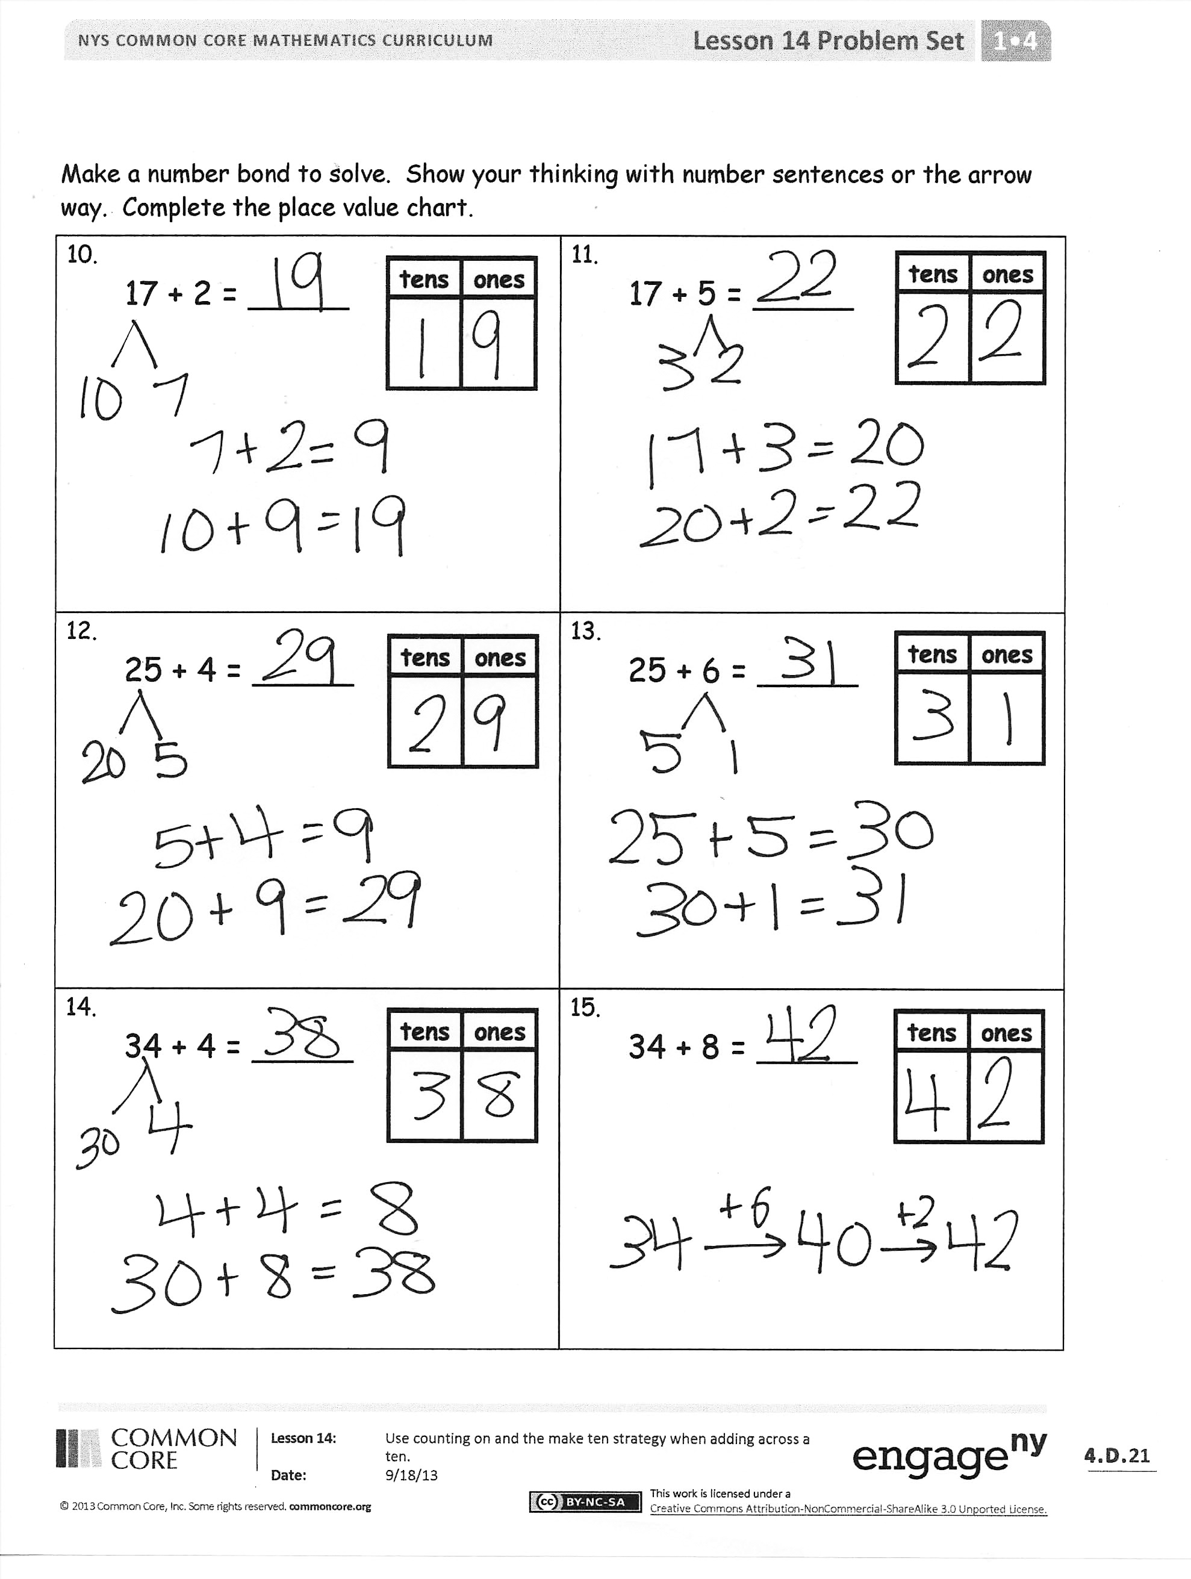
Lesson Objective: Use counting on and the make ten strategy when adding across a ten.
The Student Debrief is intended to invite reflection and active processing of the total lesson experience.
Invite students to review their solutions for the Problem Set. They should check work by comparing answers with a partner before going over answers as a class. Look for misconceptions or misunderstandings that can be addressed in the Debrief. Guide students in a conversation to debrief the Problem Set and process the lesson.
Any combination of the questions below may be used to lead the discussion.
- How could Problem 8 help you solve Problem 9? What smaller problem is in both Problems 8 and 9?
- With your partner, compare your work for Problem 9. Which method did you use to solve, and why? How are the different methods of using quick ten drawings, the number bond, and the arrow way similar?
- How did we record the ways we added today?
- (Post the chart using a number bond and the arrow way to solve 19 + 3.) Do you notice any similarities in our number bond and the arrow way?
- How did your fluency work in Get to Ten help you during today’s lesson?
Exit Ticket (3 minutes)
After the Student Debrief, instruct students to complete the Exit Ticket. A review of their work will help with assessing students’ understanding of the concepts that were presented in today’s lesson and planning more effectively for future lessons. The questions may be read aloud to the students.

Name Date
1.  18 + 1 = _____    | 2.  18 + 2 = _____ | 3.  18 + 5 = _____
4.  29 + 1 = _____ | 5.  29 + 3 = _____ | 6.  29 + 6 = _____
7.  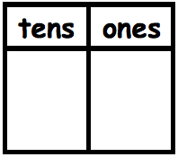  16 + 4 = _____ | 8.  16 + 6 = _____ | 9.  26 + 6 = _____
Use the pictures or draw quick tens and ones. Complete the number sentence and place value chart.
Make a number bond to solve. Show your thinking with number sentences or the arrow way. Complete the place value chart.
10.  17 + 2 = _____ | 11.  17 + 5 = _____
12.  25 + 4 = _____ | 13.  25 + 6 = _____
14.  34 + 4 = _____ | 15.  34 + 8 = _____

Name Date
1.  17 + 1 = _____ | 2.  17 + 3 = _____ | 3.  17 + 6 = _____
Draw quick tens and ones. Complete the number sentence and place value chart.

Make a number bond to solve. Show your thinking with number sentences or the arrow way. Complete the place value chart.
4.  32 + 7 = _____ | 5.  26 + 9 = _____

Name Date
1.  15 + 3 = _____ | 2.  15 + 5 = _____ | 3.  15 + 6 = _____  ✗
4.  28 + 2 = _____ | 5.  28 + 4 = _____ | 6.  28 + 7 = _____
7.  17 + 3 = _____ | 8.  17 + 7 = _____ | 9.  27 + 7 = _____
Use the pictures or draw quick tens and ones. Complete the number sentence and place value chart.
Make a number bond to solve. Show your thinking with number sentences or the arrow way. Complete the place value chart.
10.  13 + 6 = _____ | 11.  13 + 7 = _____
12.  25 + 5 = _____ | 13.  25 + 8 = _____
14.  24 + 8 = _____ | 15.  23 + 9 = _____

