Lesson 13
Objective: Use counting on and the make ten strategy when adding across a ten.

Suggested Lesson Structure
 Application Problems (5 minutes)
 Fluency Practice (12 minutes)
 Concept Development (33 minutes)
 Student Debrief (10 minutes)
Total Time (60 minutes)
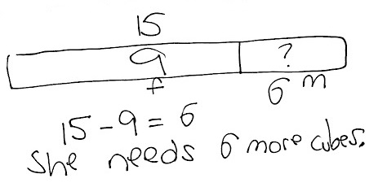
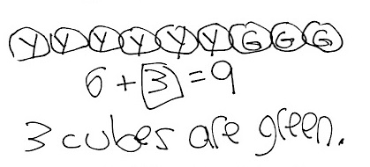
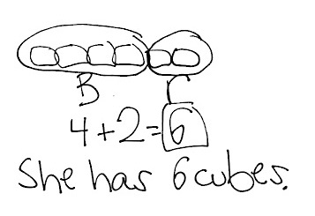
Application Problems (5 minutes)
Use linking cubes as you read, draw, and write (RDW) to solve the problems.
- Emi had a linking cube train with 4 blue cubes and 2 red cubes. How many cubes were in her train?
- Emi made another train with 6 yellow cubes and some green cubes. The train was made of 9 linking cubes. How many green cubes did she use?
- Emi wants to make her train of 9 linking cubes into a train of 15 cubes. How many cubes does Emi need?
Note: Throughout Topic D, the Application Problem comes before the Fluency Practice. Each day, there are three problems, sequenced from simple to complex. Limit students’ work time to five minutes. The problems are designed to pinpoint student strengths and challenges prior to Topic E, which focuses on word problems.
Take note of students who typically struggle to solve the Application Problem but who are successful with the problems in today’s Concept Development. They may need support moving from concrete to pictorial problem-solving strategies. Also notice which students struggle when the position of the unknown changes.
Students should keep all Application Problems from Topic D to use during the Debriefs in Topic E.

Fluency Practice (12 minutes)
- Adding and Subtracting with Cards 1.NBT.4 (4 minutes)
- Race and Roll Addition 1.OA.6 (3 minutes)
- Core Addition Fluency Review 1.OA.6 (5 minutes)
Addition and Subtraction with Cards (4 minutes)
Materials: (S) Addition and subtraction cards (Lesson 12 Template)
Note: This fluency game was played during the previous lesson’s Concept Development. It reviews adding and subtracting multiples of 10 within 40.
Follow the directions in Lesson 12’s Concept Development.
Race and Roll Addition (3 minutes)
Materials: (S) 1 die for each set of partners
Note: In this fluency activity, students practice adding and subtracting within 20. The competitive nature of Race and Roll Addition and Subtraction promotes students’ engagement while increasing their brains’ ability to retain information (since the partners are trying to stand quickly).
All students start at 0. Partners take turns rolling a die, saying a number sentence, and adding the number rolled to the total. For example, Partner A rolls 6 and says, “0 + 6 = 6,” then Partner B rolls 3 and says,
“6 + 3 = 9.” They continue rapidly rolling and saying number sentences until they get to 20, without going over. Partners stand when they reach 20. For example, if the partners are at 18 and roll 5, they take turns rolling until one of them rolls a 2 or rolls 1 twice, and then both stand.
Core Addition Fluency Review (5 minutes)
Materials: (S) Core Addition Fluency Review (Lesson 2 Core Addition Fluency Review)
Note: This fluency activity assesses students’ progress toward mastery of the required addition fluency for first graders. Differentiated Practice Sets can be found in Lesson 23, which may be helpful in supporting students toward these goals.
Students complete as many problems as they can in three minutes. Choose a counting sequence for early finishers to practice on the back of their papers. When time runs out, read the answers aloud so students can correct their work and celebrate improvement.
Concept Development (33 minutes)
Materials: (T) 4 ten-sticks from the personal math toolkit, place value chart drawn on chart paper
(S) 4 ten-sticks from the personal math toolkit, personal white board
Have students sit in semicircle formation in a meeting area with their personal math toolkits.
T: (Show 13 as 1 ten and 3 ones using linking cubes.) How many linking cubes are there?
S: 13 linking cubes.

NOTES ON
MULTIPLE MEANS
OF ACTION AND EXPRESSION:
Students love listening to and learning from music. Find a song on iTunes about place value. One suggestion is “The Place Value Song” by Math Fiesta.
T: (Add 4 more linking cubes of a different color.) How many linking cubes are there now? Turn and talk to your partner about how you know.
S: There are 17 cubes. I started with 13 and counted on. Thirteeeen, 14, 15, 16, 17. I added 3 ones and 4 ones. That makes 7 ones. 1 ten and 7 ones is 17.
4 more than 13 is 17.
T: Nice thinking! Let’s try counting on to find our solution.
S: (Point as students count.) Thirteeeen, 14, 15, 16, 17.
T: Now, add the ones first. How many are in the ones place in 13?
S: 3 ones.
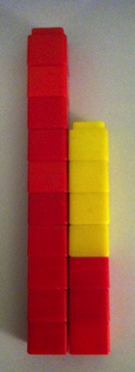
T: (Point to 3 cubes.) 3 ones and 4 ones is…?
S: 7 ones.
T: (Snap the ones cubes together to make 7. Write 7 in the ones place in the place value chart.) How many tens do we have?
S: 1 ten.
T: (Write 1 in the tens place in the place value chart.)
T: 1 ten 7 ones is…?
S: 17.
Note: Since there were no changes in tens, another option is to write 1 in the tens place first, and then 7 in the ones place.
T: What are some different addition sentences we could use to put together 13 cubes and 4 cubes?
S: 13 + 4 = 17. 10 + 7 = 17. 10 + 3 + 4 = 17.
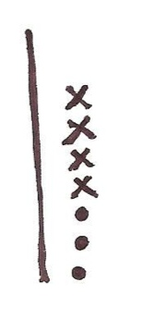
T: Use quick tens to draw the number of linking cubes we started with.
S/T: (Draw 1 quick ten and 3 dots for 3 ones.)
T: Draw to show the number of cubes we added to 13 using Xs in
5-group column formation.
S/T: (Draw 4 Xs above the 3 circles.)
T: Say the number sentence using your drawing.
S: 13 + 4 = 17.
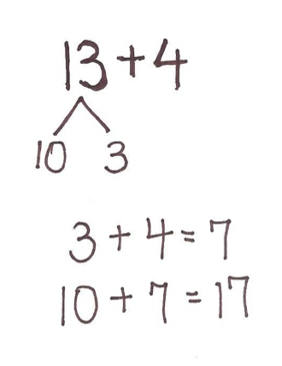
T: Let’s use a number bond. (Write 13 + 4.) 13 cubes is 1 ten and 3 ones. (Break 13 apart into 10 and 3.) We next added 3 ones and 4 ones. Use this number bond to solve the problem on your personal white board. Turn and talk to your partner about what you did.
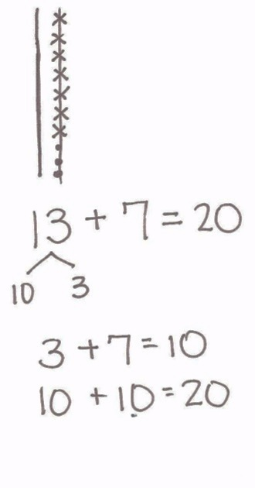
S: First, I added 3 and 4 and got 7. Then, I added 10 and 7 and got 17.
T: Let’s record how we added as 2 number sentences. (Write
3 + 4 = 7 and 10 + 7 = 17.) Let’s solve another problem. Use your cubes to show 13.
S: (Show 1 ten-stick and 3 individual cubes in a 5-group column.)
T: Using a different color, add 7 more.
S: (Add 7 more cubes using a different color.)
T: How many cubes do you have now? Show your partner what you did, and talk about how you got the answer.
S: I put the 7 cubes next to 13 cubes. I know 3 and 7 is 10. And 10 and 10 is 20. I stacked 7 cubes on top of the other 3. It made another ten-stick! Now I see 2 ten-sticks. That’s 20!
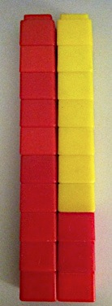
T: (Model with cubes.) You are right! 3 ones and 7 ones is…?
S: 10 ones.
T: 10 ones is the same as…?
S: 1 ten.
T: How many tens are there now? (Hold up each ten.)
S: 2 tens.
T: Where does the digit 2 go in our place value chart?
S: In the tens place.
T: (Write 2 in the tens place.) Since 3 ones and 7 ones make 1 ten, which we recorded in the tens place (point to place value chart), how many ones do we have now?
S: 0.
T: So we write 0 in the…?
S: Ones place.

NOTES ON
MULTIPLE MEANS
OF REPRESENTATION:
Often students learn math concepts in an isolated fashion. Although they may be able to use them with familiar problems, they do not see how to transfer their application to new situations. Be sure to incorporate math at other times in the students’ day.
.
T: (Write 0 in the ones place.) Say the number sentence.
S: 13 + 7 = 20.
T: Draw quick tens to show the addition. Explain your drawing to your partner.
S: I framed my 7 crosses and 3 circles to show that I made a ten. I drew a long line through my 10 ones to make it look like a quick ten.
T: I love the idea of drawing a line through the new ten to make it look more like a quick ten! (Model.)
T: Make a number bond to show how you added the ones together.
S: (Write 13 + 7 = 20 by taking apart 13 into 10 and 3.)
T: How does making the number bond help you solve the problem?
S: I can see easily that I can add 3 and 7. That’s 10. Then, I add 10 and 10 and get 20.
T: (Write two number sentences.) Great! Now let’s try some more!
Repeat the process using the following sequence: 17 + 2, 18 + 2, 28 + 2, 23 + 6, 33 + 6, 23 + 7, and 33 + 7. As soon as possible, write the addition expression on the board and have students use quick ten math drawings and number bonds to solve rather than working with linking cubes. Some students may count on when adding 1 and 2. Counting on becomes less efficient as the second addend increases. When the second addend is larger than 3, encourage students to use Level 3 strategies such as thinking of doubles or using the make ten strategy.
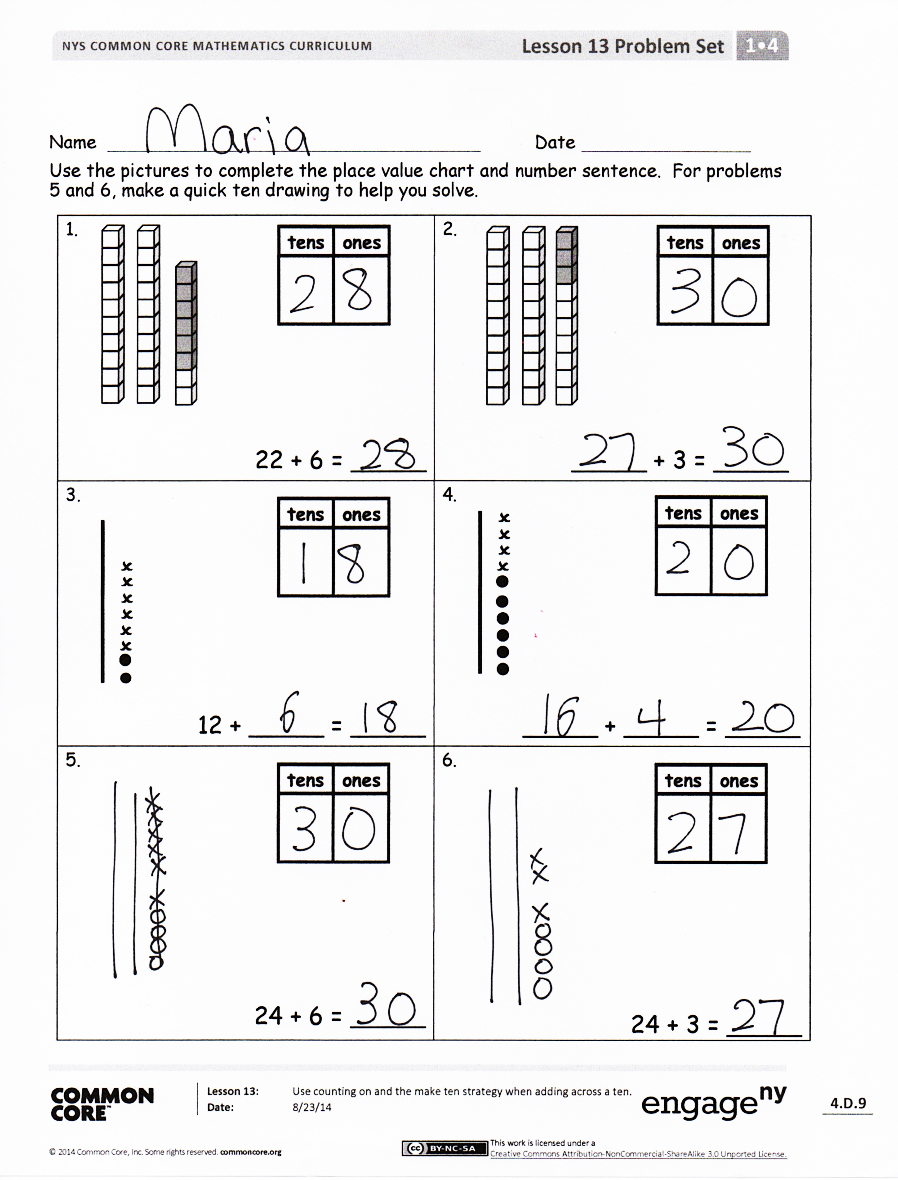
Problem Set (10 minutes)
Students should do their personal best to complete the Problem Set within the allotted 10 minutes. For some classes, it may be appropriate to modify the assignment by specifying which problems they work on first.
Student Debrief (10 minutes)
Lesson Objective: Use counting on and the make ten strategy when adding across a ten.
The Student Debrief is intended to invite reflection and active processing of the total lesson experience.
Invite students to review their solutions for the Problem Set. They should check work by comparing answers with a partner before going over answers as a class. Look for misconceptions or misunderstandings that can be addressed in the Debrief. Guide students in a conversation to debrief the Problem Set and process the lesson.
Any combination of the questions below may be used to lead the discussion.
- How can solving Problem 1 help you solve Problem 3?
- In Problem 9, explain why there is a 0 in the ones place in the answer when there are some ones in both addends.
- For Problem 10, a student said he has 2 tens and 10 ones. Is he right? Explain your thinking.
- What strategies did we use today to solve addition problems?
- How does your fluency work with the sums to ten help you in today’s lesson?
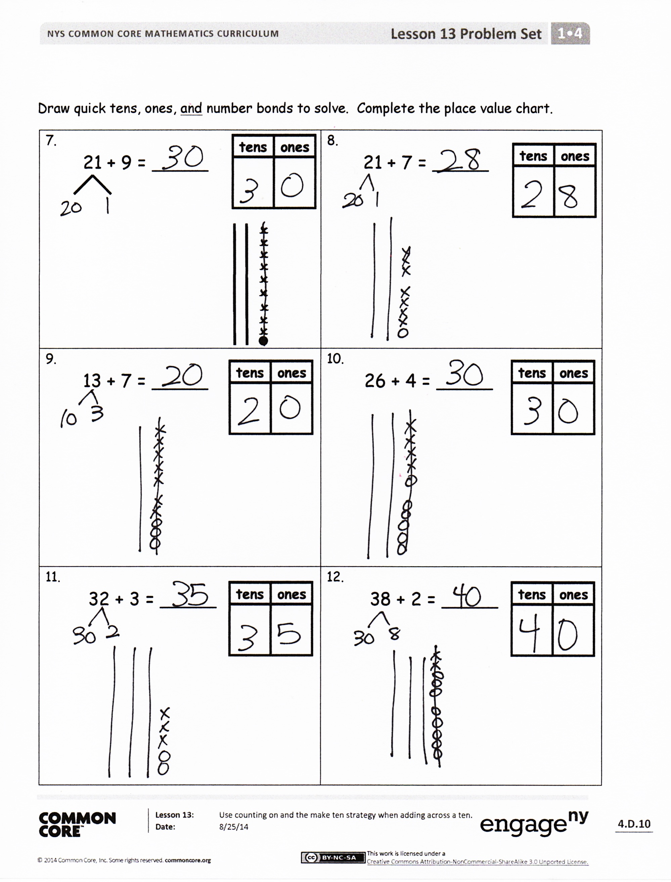
Exit Ticket (3 minutes)
After the Student Debrief, instruct students to complete the Exit Ticket. A review of their work will help with assessing students’ understanding of the concepts that were presented in today’s lesson and planning more effectively for future lessons. The questions may be read aloud to the students.

Name Date
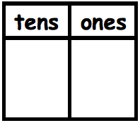
Use the pictures to complete the place value chart and number sentence. For Problems 5 and 6, make a quick ten drawing to help you solve.
1.  22 + 6 = _____ | 2.  _____ + 3 = _____
3.  12 + _____ = _____ | 4.  _____ + _____ = _____
5.  24 + 6 = _____ | 6.  24 + 3 = _____
7.  21 + 9 = _____ | 8.  21 + 7 = _____
9.  13 + 7 = _____ | 10.  26 + 4 = _____
11.  32 + 3 = _____ | 12.  38 + 2 = _____

Draw quick tens, ones, and number bonds to solve. Complete the place value chart.
Name Date
Fill in the place value chart and write a number sentence to match the picture.
1.  _____ + _____ = _____ | 2.  _____ + _____ = _____

Draw quick tens, ones, and number bonds to solve. Complete the place value chart.
3.  33 + 6 = _____ | 4.  23 + 7 = _____

Name Date
Use quick tens and ones to complete the place value chart and number sentence.
1.  21 + 4 = _____ | 2.  21 + 8 = _____
3.  25 + 4 = _____ | 4.  25 + 5 = _____
5.  33 + 3 = _____ | 6.  33 + 7 = _____
7.  26 + 2 = _____ | 8.  36 + 3 = _____
9.  26 + 4 = _____ | 10.  24 + 6 = _____
Draw quick tens, ones, and number bonds to solve. Complete the place value chart.

Solve. You may draw quick tens and ones or number bonds to help.
11. a. 22 + 7 = _____ b. 22 + 8 = _____ c. 32 + 8 = _____

