Lesson 7: Infinite Decimals

Student Outcomes
- Students know the intuitive meaning of an infinite decimal.
- Students will be able to explain why the infinite decimal $0.\overline{9}$ is equal to $1$.

Lesson Notes
The purpose of this lesson is to show the connection between the various forms of a number, specifically the decimal expansion, the expanded form of a decimal, and a visual representation on the number line. Given the decimal expansion of a number, students use what they know about place value to write the expanded form of the number. That expanded form is then shown on the number line by looking at increasingly smaller intervals of $10$, beginning with tenths, then hundredths, then thousandths, and so on. The strategy of examining increasingly smaller intervals of negative powers of $10$ is how students will learn to write the decimal expansions of irrational numbers.

Classwork
Opening Exercises 1–4 (7 minutes)
Opening Exercises 1–4
- Write the expanded form of the decimal $0.3765$ using powers of $10$.
$$0.3765=\frac{3}{10}+\frac{7}{10^{2}}+\frac{6}{10^{3}}+\frac{5}{10^{4}}$$

- Write the expanded form of the decimal $0.3333333…$ using powers of $10$.
$$0.333333=\frac{3}{10}+\frac{3}{10^{2}}+\frac{3}{10^{3}}+\frac{3}{10^{4}}+\frac{3}{10^{5}}+\frac{3}{10^{6}}…$$

- What is an infinite decimal? Give an example.
An infinite decimal is a decimal with digits that do not end. They may repeat, but they never end. An example of an infinite decimal is $0.333333…$.

- Do you think it is acceptable to write that $1=0.99999…$? Why or why not?
Answers will vary. Have a brief discussion with students about this exercise. The answer will be revisited in the Discussion below.
MP.3

Discussion (20 minutes)
Example 1
Example 1
The number $0.253$ on the number line:
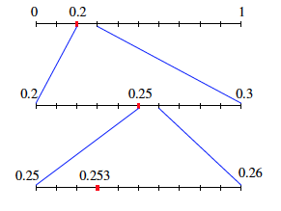

- Each decimal digit is another division of a power of $10$. Visually, the number $0.253$ can be represented first as the segment from $0$ to $1$, divided into ten equal parts, noting the first division as $0.2$. Then the segment from $0.2$ to $0.3$ is divided into $10$ equal parts, noting the fifth division as $0.25$. Then the segment from $0.25$ to $0.26$ is divided into $10$ equal parts, noting the third division as $0.253$.
- What we have done here is represented increasingly smaller increments of negative powers of $10$: $\frac{2}{10}$, then $\frac{25}{{10}^{2}}$, and finally $\frac{253}{{10}^{3}}.$
- Now consider the expanded form of the decimal with denominators that are powers of $10$, i.e., $\frac{1}{{10}^{n}}$ where $n$ is a whole number. The finite decimal can be represented in three steps:
The first decimal digit, $0.2=\frac{2}{10}$.
The first two decimal digits, $0.25=\frac{2}{10}+\frac{5}{{10}^{2}}=\frac{25}{{10}^{2}}$.
The first three decimal digits, $0.253=\frac{2}{10}+\frac{5}{{10}^{2}}+\frac{3}{{10}^{3}}=\frac{253}{{10}^{3}}$.
- This number $0.253$can be completely represented because there are a finite number of decimal digits. The value of the number $0.253$can clearly be represented by the fraction $\frac{253}{{10}^{3}}$, i.e., $\frac{253}{1000}=0.253.$
- Explain how $0.253$, the number lines, and the expanded form of the number are related.
  - The number $0.253$ is equal to the sum of the following fractions: $\frac{2}{10}+\frac{5}{{10}^{2}}+\frac{3}{{10}^{3}}.$ Then, $0.253=\frac{2}{10}+\frac{5}{{10}^{2}}+\frac{3}{{10}^{3}}$. The first number line above shows the first term of the sum, $\frac{2}{10}.$ When the interval from $0.2$ to $0.3$ is examined in hundredths, we can locate the second term of the sum, $\frac{5}{{10}^{2}}$, and specifically the sum of the first two terms $\frac{2}{10}+\frac{5}{{10}^{2}}=\frac{25}{100}.$ Then the interval between $0.25$ and $0.26$ is examined in thousandths. We can then locate the third term of the sum, $\frac{3}{{10}^{3}}$, and specifically the entire sum of the expanded form of $0.253$, which is $\frac{253}{1000}.$
- What do you think the sequence would look like for an infinite decimal?
  - The sequence for an infinite decimal would never end; it would go on infinitely.

Example 2
Example 2
The number $\frac{5}{6}=0.833333…=0.8\overline{3}$ on the number line:
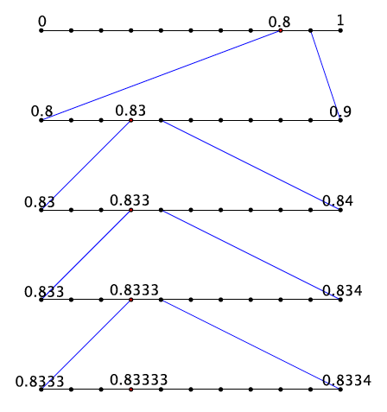

- Now consider the equality $\frac{5}{6}=0.833333…=0.8\overline{3}$. Notice that at the second step, the work begins to repeat, which coincides with the fact that the decimal digit of $3$ repeats.
- What is the expanded form of the decimal $0.833333…$?
Scaffolding:
The words finite and infinite would appear to have similar pronunciations, when in fact the stresses and vowel sounds are different. Helping students make the text or speech connection will be useful so that they recognize the words when written and when spoken.
  - $0.833333…=\frac{8}{10}+\frac{3}{{10}^{2}}+\frac{3}{{10}^{3}}+\frac{3}{{10}^{4}}+\frac{3}{{10}^{5}}+\frac{3}{{10}^{6}}+…$
- We see again that at the second step the work begins to repeat.
- Each step can be represented by increasing powers of $10$ in the denominator: $\frac{8}{10}$, $\frac{83}{{10}^{2}}$, $\frac{833}{{10}^{3}}$,$\frac{8,333}{{10}^{4}}$, $\frac{83,333}{{10}^{5}}$, $\frac{833,333}{{10}^{6}}$, and so on. When will it end? Explain.
  - It will never end because the decimal is infinite.
- Notice that in the last few steps, the value of the number being represented gets increasingly smaller. For example in the sixth step, we have included $\frac{3}{{10}^{6}}$more of the value of the number. That is $0.000003$. As the steps increase, we are dealing with incrementally smaller numbers that approach a value of $0$. Consider the $20$^{th} step, we would be adding $\frac{3}{{10}^{20}}$ to the value of the number, which is $0.00000000000000000003.$ It should be clear that $\frac{3}{{10}^{20}}$ is a very small number and is fairly close to a value of $0$.
- At this point in our learning we know how to convert a fraction to a decimal, even if it is infinite. How do we do that?
  - We use long division when the fraction is equal to an infinite decimal.
- We will soon learn how to write an infinite decimal as a fraction; in other words, we will learn how to convert a number in the form of $0.8\overline{3}$ to a fraction, $\frac{5}{6}.$
- Now back to Exercise 4. Is it acceptable to write that $1=0.9999999…$ ? With an increased understanding of infinite decimals, have you changed your mind about whether or not this is an acceptable statement?

Have a discussion with students about Exercise 4. If students have changed their minds, ask them to explain why.
- When you consider the infinite steps that represent the decimal $0.9999999…$, it is clear that the value we add with each step is an increasingly smaller value so it makes sense to write that $0.\overline{9}=1.$
- A concern may be that the left side is not really equal to one; it only gets closer and closer to $1$. However, such a statement confuses the process of representing a finite decimal with an infinite decimal. That is, as we increase the steps, we are adding smaller and smaller values to the number. It is so small, that the amount we add is practically zero. That means with each step, we are showing that the number $0.\overline{9}$ is getting closer and closer to $1$. Since the process is infinite, it is acceptable to write $0.\overline{9}=1.$
Provide students time to convince a partner that $0.\overline{9}=1.$ Encourage students to be as critical as possible. Select a student to share his or her argument with the class.
MP.3
- In many (but not all) situations, we often treat infinite decimals as finite decimals. We do this for the sake of computation. Imagine multiplying the infinite decimal $0.83333333…$ by any other number or even another infinite decimal. To do this work precisely, you would never finish writing one of the infinite decimals, let alone perform the multiplication. For this reason, we often shorten the infinite decimal using the repeat block as our guide for performing operations.
- Every finite decimal is the sum of a whole number (which could be zero) and a finite decimal that is less than $1$. Show that this is true for the number $3.141592.$
MP.3
  - The number $3.141592$ is equal to the whole number $3$ plus the finite decimal $0.141592:$
$$3.141592=3+0.141592$$
- By definition of a finite decimal (one whose denominators can be expressed as a product of $2$’s and $5$’s), the number $3.141592$ is equivalent to
$$\frac{3141592}{{10}^{6}}=\frac{\left(3×{10}^{6}\right)+141592}{{10}^{6}} \\ =\frac{3×{10}^{6}}{{10}^{6}}+\frac{141592}{{10}^{6}} \\ =3+\frac{141592}{{10}^{6}} \\ =3+0.141592$$
- We will soon claim that every infinite decimal is the sum of a whole number and an infinite decimal that is less than $1$. Consider the infinite decimal $3.141592…$
$$3.141592…=3+0.141592…$$
This fact will help us to write an infinite decimal as a fraction in Lesson 10.

Exercises 5–10 (8 minutes)
Students complete Exercises 5–10 independently or in pairs.
Exercises 5–10
- a. Write the expanded form of the decimal $0.125$ using powers of $10$.
$$0.125=\frac{1}{10}+\frac{2}{10^{2}}+\frac{5}{10^{3}}$$

  - Show on the number line the representation of the decimal $0.125$.
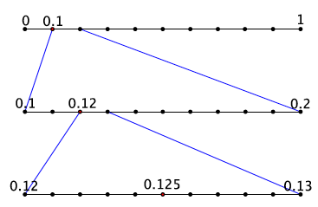

  - Is the decimal finite or infinite? How do you know?
The decimal $0.125$ is finite because it can be completely represented by a finite number of steps.

- a. Write the expanded form of the decimal $0.3875$ using powers of $10$.
$$0.3875=\frac{3}{10}+\frac{8}{10^{2}}+\frac{7}{10^{3}}+\frac{5}{10^{4}}$$

  - Show on the number line the representation of the decimal $0.3875$.
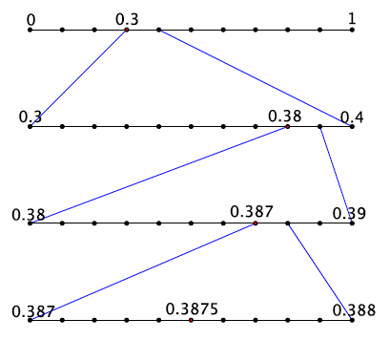

  - Is the decimal finite or infinite? How do you know?
The decimal $0.3875$ is finite because it can be completely represented by a finite number of steps.

- a. Write the expanded form of the decimal $0.777777…$using powers of $10$.
$$0.777777…=\frac{7}{10}+\frac{7}{10^{2}}+\frac{7}{10^{3}}+\frac{7}{10^{4}}+\frac{7}{10^{5}}+\frac{7}{10^{6}}+…$$
and so on.

  - Show on the number line the representation of the decimal $0.777777…$.
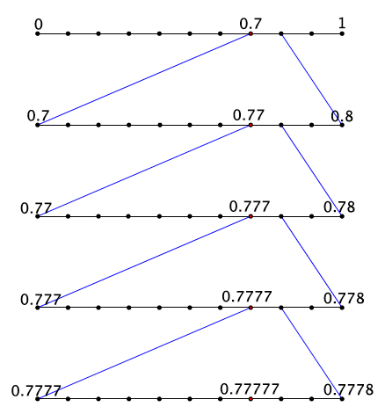

  - Is the decimal finite or infinite? How do you know?
The decimal $0.777777…$ is infinite because it cannot be represented by a finite number of steps. Because the number $7$ continues to repeat, there will be an infinite number of steps in the sequence.

- a. Write the expanded form of the decimal $0.\overline{45}$using powers of $10$.
$$0.\overline{45}=\frac{4}{10}+\frac{5}{10^{2}}+\frac{4}{10^{3}}+\frac{5}{10^{4}}+\frac{4}{10^{5}}+\frac{5}{10^{6}}+…$$and so on.

  - Show on the number line the representation of the decimal $0.\overline{45}$.
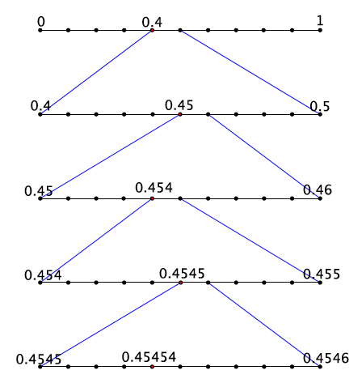
  - Is the decimal finite or infinite? How do you know?
The decimal $0.\overline{45}$ is infinite because it cannot be represented by a finite number of steps. Because the digits $4$ and $5$ continue to repeat, there will be an infinite number of steps in the sequence.

- Order the following numbers from least to greatest: $2.121212$, $2.1$,$2.2$, and $2.\overline{12}.$
$2.1$,$2.121212$,$2.\overline{12}$,$2.2$

- Explain how you knew which order to put the numbers in.
Each number is the sum of the whole number $2$ and a decimal. When you write each number in this manner you get
$$2.121212=2+\frac{1}{10}+\frac{2}{10^{2}}+\frac{1}{10^{3}}+\frac{2}{10^{4}}+\frac{1}{10^{5}}+\frac{2}{10^{6}} \\ 2.1=2+\frac{1}{10} \\ 2.2=2+\frac{2}{10} \\ 2.\overline{12}=2+\frac{1}{10}+\frac{2}{10^{2}}+\frac{1}{10^{3}}+\frac{2}{10^{4}}+\frac{1}{10^{5}}+\frac{2}{10^{6}}+\frac{1}{10^{7}}+\frac{2}{10^{8}}+…$$
In this form it is clear that $2.1$ is the least of the four numbers, followed by the finite decimal $2.121212$, then the infinite decimal $2.\overline{12}$, and finally $2.2.$

Closing (5 minutes)
Summarize, or ask students to summarize, the main points from the lesson:
- We know that an infinite decimal is a decimal whose expanded form and number line representation is infinite.
- We know that each step in the sequence of an infinite decimal adds an increasingly smaller value to the number, so small that the amount approaches zero.
- We know that the infinite decimal $0.\overline{9}=1$ and can explain why this is true.

Lesson Summary
An infinite decimal is a decimal whose expanded form and number line representation are infinite.
Example:
The expanded form of the decimal $0.83333…$ is $0.8\overline{3}=\frac{8}{10}+\frac{3}{{10}^{2}}+\frac{3}{{10}^{3}}+\frac{3}{{10}^{4}}+…$
The number is represented on the number line shown below. Each new line is a magnification of the interval shown above it. For example, the first line is the unit from $0$ to $1$ divided into $10$ equal parts, or tenths. The second line is the interval from$0.8$to $0.9$ divided into ten equal parts, or hundredths. The third line is the interval from $0.83$ to $0.84$ divided into ten equal parts, or thousandths, and so on.
With each new line we are representing an increasingly smaller value of the number, so small that the amount approaches a value of 0. Consider the $20$^{th} line of the picture above. We would be adding $\frac{3}{{10}^{20}}$ to the value of the number, which is $0.00000000000000000003$. It should be clear that $\frac{3}{{10}^{20}}$ is a very small number and is fairly close to a value of $0$.
This reasoning is what we use to explain why the value of the infinite decimal $0.\overline{9}$ is $1$.

Exit Ticket (5 minutes)
There are three items as part of the Exit Ticket, but it may be necessary to only use the first two to assess students’ understanding.
Name Date
Lesson 7: Infinite Decimals

Exit Ticket

- a. Write the expanded form of the decimal $0.829$ using powers of $10$.

  - Show on the number line the representation of the decimal $0.829$.

  - Is the decimal finite or infinite? How do you know?

- a. Write the expanded form of the decimal $0.55555…$using powers of $10$.

  - Show on the number line the representation of the decimal $0.555555…$

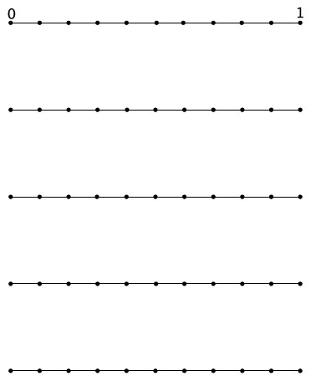

  - Is the decimal finite or infinite? How do you know?

- a. Write the expanded form of the decimal $0.\overline{573}$using powers of $10$.

  - Show on the number line the representation of the decimal $0.\overline{573}.$

  - Is the decimal finite or infinite? How do you know?
Exit Ticket Sample Solutions

- a. Write the expanded form of the decimal $0.829$ using powers of $10$.
$$0.829=\frac{8}{10}+\frac{2}{10^{2}}+\frac{9}{10^{3}}$$

  - Show on the number line the representation of the decimal $0.829$.
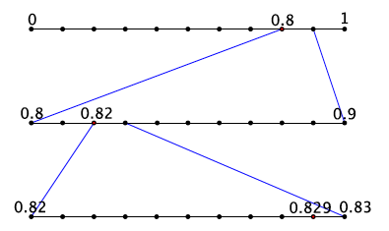

  - Is the decimal finite or infinite? How do you know?
The decimal $0.829$ is finite because it can be completely represented by a finite number of steps.

- a. Write the expanded form of the decimal $0.55555…$using powers of $10$.
$$0.55555…=\frac{5}{10}+\frac{5}{10^{2}}+\frac{5}{10^{3}}+\frac{5}{10^{4}}+\frac{5}{10^{5}}+\frac{5}{10^{6}}+…$$and so on.

  - Show on the number line the representation of the decimal $0.555555…$
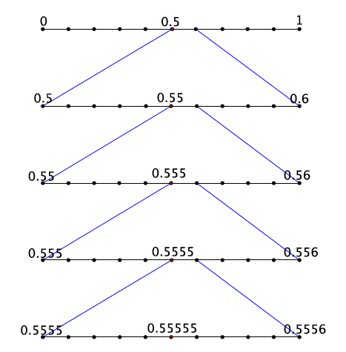

  - Is the decimal finite or infinite? How do you know?
The decimal $0.555555…$ is infinite because it cannot be represented by a finite number of steps. Because the number $5$ continues to repeat, there will be an infinite number of steps.
- a. Write the expanded form of the decimal $0.\overline{573}$using powers of $10$.
$$0.\overline{573}=\frac{5}{10}+\frac{7}{10^{2}}+\frac{3}{10^{3}}+\frac{5}{10^{4}}+\frac{7}{10^{5}}+\frac{3}{10^{6}}+…$$
and so on.

  - Describe the sequence that would represent the decimal $0.\overline{573}.$
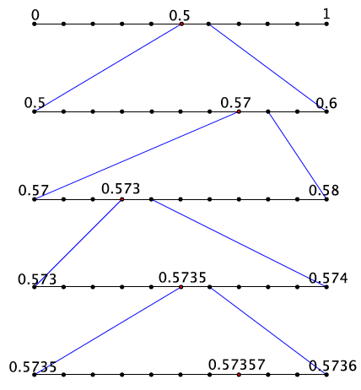

  - Is the decimal finite or infinite? How do you know?
The decimal $0.\overline{573}$ is infinite because it cannot be represented by a finite number of steps. Because the digits $5$, $7$, and $3$ continue to repeat, there will be an infinite number of steps.

Problem Set Sample Solutions

- a. Write the expanded form of the decimal $0.625$ using powers of $10$.
$$0.625=\frac{6}{10}+\frac{2}{10^{2}}+\frac{5}{10^{3}}$$

  - Show on the number line the representation of the decimal $0.625$.
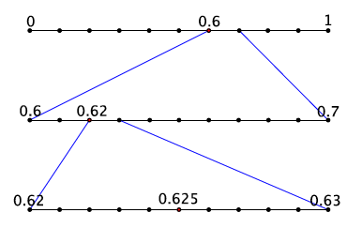

  - Is the decimal finite or infinite? How do you know?
The decimal $0.625$ is finite because it can be completely represented by a finite number of steps in the sequence.
- a. Write the expanded form of the decimal $0.\overline{370}$using powers of $10$.
$$0.\overline{370}=\frac{3}{10}+\frac{7}{10^{2}}+\frac{0}{10^{3}}+\frac{3}{10^{4}}+\frac{7}{10^{5}}+\frac{0}{10^{6}}+…$$
and so on.

  - Show on the number line the representation of the decimal $0.370370…$
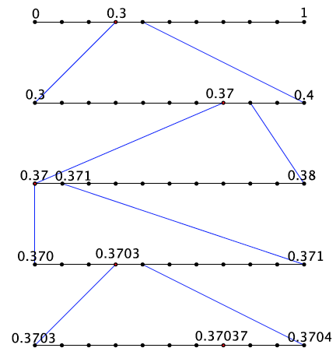

  - Is the decimal finite or infinite? How do you know?
The decimal $0.\overline{370}$ is infinite because it cannot be represented by a finite number of steps. Because the digits $3$, $7$, and $0$ continue to repeat, there will be an infinite number of steps in the sequence.

- Which is a more accurate representation of the number $\frac{2}{3}:$ $0.6666$ or $0.\overline{6}$? Explain. Which would you prefer to compute with?
The number $\frac{2}{3}$ is more accurately represented by the decimal $0.\overline{6}$ compared to $0.6666$. The long division algorithm with $\frac{2}{3}$ shows that the digit $6$ repeats. Then the expanded form of the decimal $0.\overline{6}=\frac{6}{10}+\frac{6}{10^{2}}+\frac{6}{10^{3}}+\frac{6}{10^{4}}+\frac{6}{10^{5}}+\frac{6}{10^{6}}+…$, and so on, where the number $0.6666=\frac{6}{10}+\frac{6}{10^{2}}+\frac{6}{10^{3}}+\frac{6}{10^{4}}$. For this reason, $0.\overline{6}$is more accurate. For computations, I would prefer to use $0.6666$. My answer would be less precise, but at least I’d be able to compute with it. When attempting to compute with an infinite number, you would never finish writing it, thus you could never compute with it.

- Explain why we shorten infinite decimals to finite decimals to perform operations. Explain the effect of shortening an infinite decimal on our answers.
We often shorten infinite decimals to finite decimals to perform operations because it would be impossible to represent an infinite decimal precisely because the sequence that describes infinite decimals has an infinite number of steps. Our answers are less precise; however, they are not that much less precise because with each additional digit in the sequence we include, we are adding a very small amount to the value of the number. The more decimals we include, the closer the value we add approaches zero. Therefore, it does not make that much of a difference with respect to our answer.

- A classmate missed the discussion about why $0.\overline{9}=1$. Convince your classmate that this equality is true.
When you consider the infinite sequence of steps that represents the decimal $0.9999999…$, it is clear that the value we add with each step is an increasingly smaller value, so it makes sense to write that $0.\overline{9}=1$. As we increase the number of steps in the sequence, we are adding smaller and smaller values to the number. Consider the $12^{th}$ step: $0.999999999999$. The value added to the number is just $0.000000000009$, which is a very small amount. The more steps that we include, the closer that value is to zero. Which means that with each new step, the number $0.\overline{9}$ gets closer and closer to $1$. Since this process is infinite, the number $0.\overline{9}=1$.

- Explain why $0.3333<0.33333$.
The number $0.3333=\frac{3}{10}+\frac{3}{10^{2}}+\frac{3}{10^{3}}+\frac{3}{10^{4}}$, and the number $0.33333=\frac{3}{10}+\frac{3}{10^{2}}+\frac{3}{10^{3}}+\frac{3}{10^{4}}+\frac{3}{10^{5}}$. That means that $0.33333$ is exactly $\frac{3}{10^{5}}$ larger than $0.3333.$ If we examined the numbers on the number line, $0.33333$ is to the right of $0.3333$ meaning that it is larger than $0.3333$.

