Lesson 2: Square Roots

Student Outcomes
- Students know that for most integers n, n is not a perfect square, and they understand the square root symbol, $\sqrt{n}$ . Students find the square root of small perfect squares.
- Students approximate the location of square roots on the number line.

Classwork
Discussion (10 minutes)
As an option, the discussion can be framed as a challenge. Distribute compasses and ask students, “How can we determine an estimate for the length of the diagonal of the unit square?”
MP.1
- Consider a unit square, a square with side lengths equal to $1$. How can we determine the length of the diagonal, $s$, of the unit square?
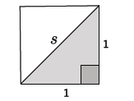
  - We can use the Pythagorean Theorem to determine the length of the diagonal.
$$1^{2}+1^{2}=s^{2} \\ 2=s^{2}$$
- What number, $s$, times itself is equal to $2$?
  - We don't know exactly, but we know the number has to be between $1$ and $2$.
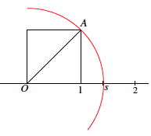
- We can show that the number must be between $1$ and $2$ if we place the unit square on a number line. Then consider a circle with center $O$ and radius length equal to the hypotenuse of the triangle, $OA$.
Scaffolding:
- Depending on students’ experience, it may be useful to review or teach the concept of square numbers and perfect squares.
We can see that the length $OA$ is somewhere between $1$ and $2$, but precisely at point $s$. But what is that number $s?$
- From our work with the Pythagorean Theorem, we know that $2$ is not a perfect square. Thus, the length of the diagonal must be between the two integers $1$ and $2,$ and that is confirmed on the number line. To determine the number, $s$, we should look at that part of the number line more closely. To do so, we need to discuss what kinds of numbers lie between the integers on a number line. What do we already know about those numbers?
Lead a discussion about the types of numbers found between the integers on a number line. Students should identify that rational numbers, such as fractions and decimals, lie between the integers. Have students give concrete examples of numbers found between the integers $1$ and $2$. Consider asking students to write a rational number, $x$, so that $1<x<2$, on a sticky note and then to place it on a number line drawn on a poster or white board. At the end of this part of the discussion, make clear that all of the numbers students identified are rational and in the familiar forms of fractions, mixed numbers, and decimals. Then continue with the discussion below about square roots.
Scaffolding:
- Students may benefit from an oral recitation of square roots of perfect squares here and throughout the module. Consider some repeated “quick practice,” calling out examples: “What’s the square root of $81$?” and “What’s the square root of $100$?” and asking for choral or individual responses.
- There are other numbers on the number line between the integers. They are called square roots. Some of the square roots are equal to whole numbers, but most lie between the integers on the number line. A positive number whose square is equal to a positive number $b$ is denoted by the symbol $\sqrt{b}$. The symbol $\sqrt{b}$ automatically denotes a positive number (e.g., $\sqrt{4}$ is always $2$, not $-2$). The number $\sqrt{b}$ is called a positive square root of $b$. We will soon learn that it is the positive square root, that is, there is only one.
- What is $\sqrt{25}$, i.e., the positive square root of $25$? Explain.
Scaffolding:
- If students are struggling with the concept of a square root, it may help to refer to visuals that relate numbers and their squares. Showing this visual:

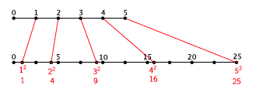
and asking questions (e.g., “What is the square root of $9$?”) will build students’ understanding of square roots through their understanding of squares.
  - The positive square root of $25$ is $5$ because $5^{2}=25.$
- What is $\sqrt{9}$, i.e., the positive square root of $9$? Explain.
  - The positive square root of $9$ is $3$ because $3^{2}=9.$

Exercises 1–4 (5 minutes)
Students complete Exercises 1–4 independently.
Exercises 1–4
- Determine the positive square root of $81$, if it exists. Explain.
The square root of $81$ is $9$ because $9^{2}=81.$

- Determine the positive square root of $225$, if it exists. Explain.
The square root of $225$ is $15$ because ${15}^{2}=225.$

- Determine the positive square root of $-36$, if it exists. Explain.
The number $-36$does not have a square root because there is no number squared that can produce a negative number.

- Determine the positive square root of$49$, if it exists. Explain.
The square root of $49$ is $7$ because $7^{2}=49.$
Discussion (15 minutes)
- Now back to our unit square. We said that the length of the diagonal was $s^{2}=2.$ Now that we know about square roots, we can say that the length of $s=\sqrt{2}$ and that the number $\sqrt{2}$ is between integers $1$ and $2$. Let’s look at the number line more generally to see if we can estimate the value of $\sqrt{2}.$
- Take a number line from $0$ to $4$:
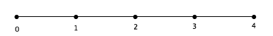
Discussion

- Place the numbers $\sqrt{1},$ $\sqrt{4}$, $\sqrt{9}$, and $\sqrt{16}$ on the number line and explain how you knew where to place them.
Solutions are shown below in red.
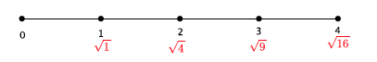

- Place the numbers $\sqrt{2}$ and $\sqrt{3}$ on the number line. Be prepared to explain your reasoning.
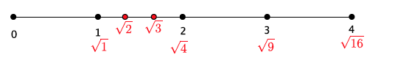
Solutions are shown below in red. Students should reason that the numbers $\sqrt{2}$ and$\sqrt{3}$ belong on the number line between $\sqrt{1}$and $\sqrt{4}.$ They could be more specific by saying that if you divide the segment between integers $1$ and $2$ into three equal parts, then $\sqrt{2}$ would be at the first division and $\sqrt{3}$ would be at the second division and $\sqrt{4}$ is already at the third division, $2$ on the number line. Given that reasoning, students should be able to estimate the value of $\sqrt{2}≈1\frac{1}{3}.$
Place the numbers $\sqrt{5} , \sqrt{6}$, $\sqrt{7} , \sqrt{8}$on the number line. Be prepared to explain your reasoning.
MP.3
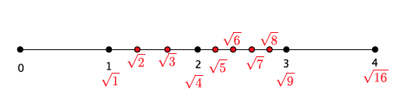
Solutions are shown below in red. The discussion about placement should be similar to the previous one.
- Place the numbers $\sqrt{10}$, $\sqrt{11}$, $\sqrt{12}$, $\sqrt{13}$, $\sqrt{14}$, and $\sqrt{15}$ on the number line. Be prepared to explain your reasoning.
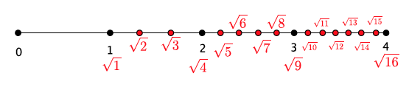
Solutions are shown below in red. The discussion about placement should be similar to the previous one.
MP.3
- Our work on the number line shows that there are many more square root numbers that are not perfect squares than those that are perfect squares. On the number line above, we have four perfect square numbers and twelve that are not! After we do some more work with roots, in general, we will cover exactly how to describe these numbers and how to approximate their values with greater precision. For now, we will estimate their locations on the number line using what we know about perfect squares.

Exercises 5–9 (5 minutes)
Students complete Exercises 5–9 independently. Calculators may be used for approximations.

Exercises 5–9
Determine the positive square root of the number given. If the number is not a perfect square, determine which integer the square root would be closest to, then use “guess and check” to give an approximate answer to one or two decimal places.
- $\sqrt{49}$
$$7$$

- $\sqrt{62}$
The square root of $62$ is close to $8$. The square root of $62$ is approximately $7.9$ because $7.9^{2}=62.41.$

- $\sqrt{122}$
The square root of $122$ is close to $11$. Students may guess a number between $122$ and $122.1$ because $11.05^{2}=122.1025.$

- $\sqrt{400}$
$$20$$

- Which of the numbers in Exercises 5–8 are not perfect squares? Explain.
The numbers$62$and $122$ are not perfect squares because there is no integer $x$ to satisfy $x^{2}=62$ or $x^{2}=122$.

Closing (5 minutes)
Summarize, or ask students to summarize, the main points from the lesson:
- We know that there are numbers on the number line between the integers. The ones we looked at in this lesson are square roots of non-perfect square numbers.
- We know that when a positive number $x$ is squared and the result is $b$, then $\sqrt{b}$ is equal to $x.$
- We know how to approximate the square root of a number and its location on a number line by figuring out which two perfect squares it is between.
Lesson Summary
A positive number whose square is equal to a positive number $b$ is denoted by the symbol $\sqrt{b}$. The symbol $\sqrt{b}$ automatically denotes a positive number. For example, $\sqrt{4}$ is always $2$, not $-2.$ The number $\sqrt{b}$ is called a positive square root of $b$.
Perfect squares have square roots that are equal to integers. However, there are many numbers that are not perfect squares.

Exit Ticket (5 minutes)
Name Date
Lesson 2: Square Roots

Exit Ticket

- Write the positive square root of a number $x$ in symbolic notation.

- Determine the positive square root of $196$, if it exists. Explain.

- Determine the positive square root of $50$, if it exists. Explain.

- Place the following numbers on the number line below: $\sqrt{16}, \sqrt{9}, \sqrt{11}, 3.5.$

Exit Ticket Sample Solutions

- Write the square root of a number $x$ in symbolic notation.
$$\sqrt{x}$$

- Determine the positive square root of $196$, if it exists. Explain.
$\sqrt{196}=14$ because $14^{2}=196$.

- Determine the positive square root of $50$, if it exists. Explain.
$\sqrt{50}$is between $7$ and $8$, but closer to $7$. The reason is that $7^{2}=49$ and $8^{2}=64.$ The number $50$ is between $49$ and $64$, but closer to $49$. Therefore, the square root of $50$ is close to $7$.

- Place the following numbers on the number line below: $\sqrt{16}, \sqrt{9}, \sqrt{11}, 3.5.$
Solutions are shown in red below.
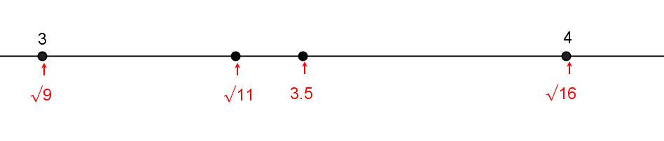

Problem Set Sample Solutions

Determine the positive square root of the number given. If the number is not a perfect square, determine the integer to which the square root would be closest.
- $\sqrt{169}$
$$13$$

- $\sqrt{256}$
$$16$$

- $\sqrt{81}$
$$9$$

- $\sqrt{147}$
The number $147$ is not a perfect square. It is between the perfect squares $144$ and $169$, but closer to $144$. Therefore, the square root of $147$ is close to $12$.

- $\sqrt{8}$
The number $8$ is not a perfect square. It is between the perfect squares $4$ and $9$, but closer to $9$. Therefore, the square root of $8$ is close to $3$.
- Which of the numbers in Problems 1–5 are not perfect squares? Explain.
The numbers$147$ and $8$ are not perfect squares because there is no integer $x$ so that $x^{2}=147$ or $x^{2}=8.$

- Place the following list of numbers in their approximate locations a number line:
$$\sqrt{32} \sqrt{12} \sqrt{27} \sqrt{18} \sqrt{23} \sqrt{50}$$
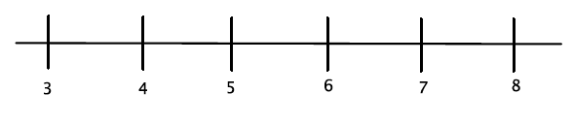
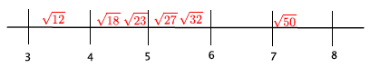Answers are noted in red.

- Between which two integers will $\sqrt{45}$be located? Explain how you know.
The number $45$ is not a perfect square. It is between the perfect squares $36$ and $49$, but closer to $49$. Therefore,
the square root of $45$ is between the integers $6$ and $7$ because $\sqrt{36}=6$ and $\sqrt{49}=7$ and $\sqrt{36}<\sqrt{45}<\sqrt{49}$.

