Lesson 1: The Pythagorean Theorem

Student Outcomes
- Students know that when the square of a side of a right triangle represented as $a^{2}$, $b^{2}$, or $c^{2}$ is not a perfect square, they can estimate the side length as between two integers and identify the integer to which the length is closest.

Lesson Notes
Before beginning this lesson it is imperative that students are familiar with the lessons in Modules 2 and 3 that relate to the Pythagorean Theorem. This lesson assumes knowledge of the theorem and its basic applications. Students should not use calculators during this lesson.
Scaffolding:
- In teaching about right triangles and guiding students in learning to identify the hypotenuse, it may be necessary to provide additional support in addressing the differences between the terms: long, longer, and longest in English, as comparative words like these (with the same root) may not yet be familiar for students new to English.
In this lesson, students are exposed to expressions that are equivalent to irrational numbers, but they will not learn the definition of an irrational number until Topic B. It is important for students to understand that these irrational numbers can be approximated, but it is not yet necessary that they know the definition.

Classwork
Opening (5 minutes)
Show students the three triangles below. Give students the direction to determine as much as they can about the triangles. If necessary, give the direction to apply the Pythagorean Theorem, in particular. Then have a discussion with students about their recollection of the theorem. Basic points should include the theorem, the converse of the theorem and the fact that when the theorem leads them to an answer of the form $c^{2}=x^{2}$, then $c=x$(perfect squares).
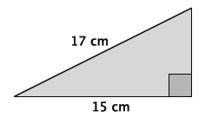
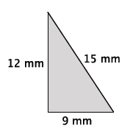
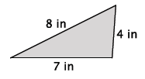

The first triangle requires students to use the Pythagorean Theorem to determine that the unknown side length, $x,$ is $8$ cm because ${17}^{2}-{15}^{2}=x^{2}$, and $64=x^{2}$. Since $64$is a perfect square, then students should identify the unknown side length as $8$ cm.
MP.3
The second triangle requires students to use the converse of the theorem to determine that it is a right triangle.
The third triangle requires students to use the converse of the theorem to determine that it is not a right triangle.
Example 1 (3 minutes)
- Recall the Pythagorean Theorem and its converse for right triangles.
  - The Pythagorean Theorem states that a right triangle with leg lengths $a$ and $b$ and hypotenuse $c$ will satisfy $a^{2}+b^{2}=c^{2}.$ The converse of the theorem states that if a triangle with side lengths $a$,$b$, and $c$ satisfy the equation $a^{2}+b^{2}=c^{2}$, then the triangle is a right triangle.
Example 1
Write an equation that will allow you to determine the length of the unknown side of the right triangle.
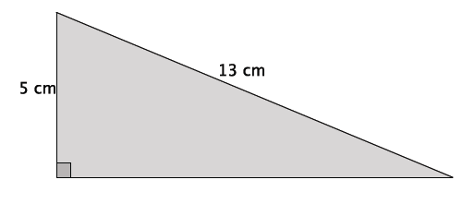
Scaffolding:
- Consider using cut-outs of the triangles in this lesson to further illustrate the difference between triangles with whole number hypotenuses and those without. Then call on students to measure the lengths directly. Cut-outs are provided at the end of the lesson.
- Write an equation that will allow you to determine the length of the unknown side of the right triangle.
Note: Students may use a different symbol to represent the unknown side length.
  - Let $b$ represent the unknown side length: $5^{2}+b^{2}={13}^{2}$
Verify that students wrote the correct equation, then allow them to solve it. Ask them how they knew the correct answer was $12$. They should respond that ${13}^{2}-5^{2}=144$, and since $144$ is a perfect square, they knew that the unknown side length must be $12$ cm.

Example 2 (5 minutes)
Example 2
Write an equation that will allow you to determine the length of the unknown side of the right triangle.
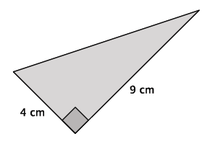
MP.1

- Write an equation that will allow you to determine the length of the unknown side of the right triangle.
  - Let $c$ represent the length of the hypotenuse: $4^{2}+9^{2}=c^{2}$
- There’s something different about this triangle. What is the length of the missing side? Come up with the best answer you can.
MP.1
Provide students time to determine the best answer they can for the length of the unknown side. Select students to share their answers and explain their reasoning. Use the points below to guide their thinking as needed.

- How is this problem different from the last one?
  - The answer is $c^{2}=97$. Since $97$ is not a perfect square, we cannot determine the exact length of the hypotenuse. All we know now is that the length is not equal to an integer.
- Since $97$ is not a perfect square, we cannot determine the exact length of hypotenuse; however, we can make an estimate. Think about all of the perfect squares we have seen and calculated in past discussions. The number $97$ is between which two perfect squares?
  - The number $97$ is between $81$ and $100$.
- If the length of the hypotenuse were $c^{2}=81$, what would it be?
  - The length would be $9$ cm.
- If the length of the hypotenuse were $c^{2}=100,$ what would it be?
  - The length would be $10$ cm.
- At this point we know that the length of the hypotenuse is somewhere between $9$ cm and $10$ cm. Think about the length to which it is closest. The actual length of the hypotenuse is $c^{2}=97.$ To which perfect square number, $100$ or $81$, is $97$ closer?
  - The number $97$ is closer to the perfect square $100$ than to the perfect square $81$.
- Now that we know that the length of the hypotenuse of this right triangle is between $9$ cm and $10$ cm, but closer to $10$ cm, let’s try to get an even better estimate of the length. Choose a number between $9$ and $10$, but closer to $10$. Square that number. Do this a few times to see how close you can get to the number $97$.

Provide students time to check a few numbers between $9$ and $10$. Students should see that the length is somewhere between $9.8$ and $9.9$ because ${9.8}^{2}=96.04$ and ${9.9}^{2}=98.01.$ Some students may even check $9.85$, ${9.85}^{2}=97.0225.$ This activity will show students that an estimation of the length being between $9$ cm and $10$ cm is indeed accurate, and it will help students develop an intuitive sense of how to estimate square roots.

Example 3 (4 minutes)

Example 3
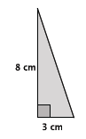
Write an equation to determine the length of the unknown side of the right triangle.

- Write an equation to determine the length of the unknown side of the right triangle.
  - Let $c$ represent the length of the hypotenuse: $3^{2}+8^{2}=c^{2}$.
Verify that students wrote the correct equation, and then allow them to solve it. Instruct them to estimate the length, if necessary. Then continue to let them work. When most students have finished, ask the questions below.
- Could you determine a precise answer for the length of the hypotenuse?
  - No, the length of the hypotenuse is $c^{2}=73.$

Optionally, you can ask, “Can anyone find the exact length of side $c$?” It is important that students recognize that no one can determine the exact length of the hypotenuse at this point.

- Since $73$ is not a perfect square, we cannot determine the exact length of hypotenuse. Let’s estimate the length. Between which two numbers is the length of the hypotenuse? Explain.
  - Since $73$ is between the two perfect squares $64$ and $81$, then we know the length of the hypotenuse must be between $8$ cm and $9$ cm.
- Is the length closer to $8$ cm or $9$ cm? Explain.
  - The length is closer to $9$ cm, because $73$ is closer to $81$ than it is to $64$.
- The length of the hypotenuse is between $8$ cm and $9$ cm, but closer to $9$ cm.

Example 4 (8 minutes)

Example 4
In the figure below, we have an equilateral triangle with a height of $10$ inches. What do we know about an equilateral triangle?
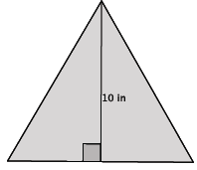

- In the figure below, we have an equilateral triangle with a height of $10$ inches. What do we know about an equilateral triangle?
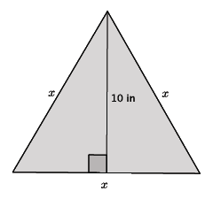
  - Equilateral triangles have sides that are all the same length and angles that are all are the same angle, $60°$.
- Let’s say the length of the sides is $x$. Determine the approximate length of the sides of the triangle.

- What we actually have here are two congruent right triangles. The height is the line of reflection.
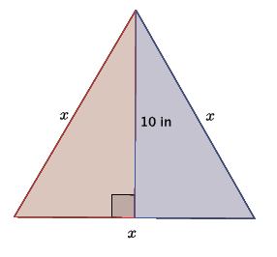
Trace one of the right triangles on a transparency and reflect across the line representing the height of the triangle to convince students that an equilateral triangle is comprised of two congruent right triangles.
- With this knowledge, we need to determine the length of the base of one of the right triangles. If we know that the length of the base of the equilateral triangle is $x$, then what is the length of the base of one of the right triangles? Explain.
MP.1
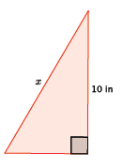
  - The length of the base of one of the right triangles must be $\frac{1}{2}x$ because the equilateral triangle has a base of length $x$. Since the equilateral triangle is comprised of two right triangles and we saw that in terms of the basic rigid motion reflection, then we know that the base of each of the right triangles is the same (reflections preserve lengths of segments). Therefore, each right triangle has a base length of $\frac{1}{2}x.$

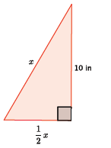
- Now that we know the length of the base of the right triangle, write an equation for this triangle using the Pythagorean Theorem.

  - ${\left(\frac{1}{2}x\right)}^{2}+{10}^{2}=x^{2}$
Verify that students wrote the correct equation, and then ask students to explain the meaning of each term of the equation. Allow students time to solve the equation in pairs or small groups. Instruct them to make an estimate of the length, if necessary. Then continue to let them work. When most students have finished, continue with the discussion below.
MP.1
- Explain your thinking about this problem. What did you do with the equation ${\left(\frac{1}{2}x\right)}^{2}+{10}^{2}=x^{2}$?
If students are stuck, ask them questions that help them work through the computations below. For example, you can ask them what they recall about the laws of exponents to simplify the term ${\left(\frac{1}{2}x\right)}^{2}$ or how to use the properties of equality to get the answer in the form of $x^{2}$ equal to a constant.
  - We had to solve for $x$:
$${\left(\frac{1}{2}x\right)}^{2}+{10}^{2}=x^{2} \\ \frac{1}{4}x^{2}+100=x^{2} \\ \frac{1}{4}x^{2}-\frac{1}{4}x^{2}+100=x^{2}-\frac{1}{4}x^{2} \\ 100=\frac{3}{4}x^{2} \\ \frac{400}{3}=x^{2} \\ 133.3≈x^{2}$$
- Now that we know that $x^{2}≈133.3$, estimate the length of $x.$ Explain your thinking.
  - The length of $x$ is approximately $12$ in. The number $133.3$ is between the perfect squares $121$ and $144.$ Since $133.3$ is closer to $144$ than $121$, we know that the value of $x$ is between $11$ and $12$, but closer to $12$.
Exercises 1–3 (7 minutes)
Students complete Exercises 1–3 independently.
Exercises 1–3
- Use the Pythagorean Theorem to estimate the length of the unknown side of the right triangle. Explain why your estimate makes sense.
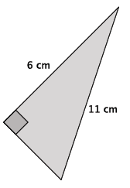
Let $x$ be the length of the unknown side.
$$6^{2}+x^{2}=11^{2} \\ 36+x^{2}=121 \\ x^{2}=85$$
The length of unknown side of the triangle is approximately $9$ cm. The number $85$ is between the perfect squares $81$ and $100$. Since $85$ is closer to $81$ than $100$, then the length of the unknown side of the triangle is closer to $9$ than it is to $10$.

- Use the Pythagorean Theorem to estimate the length of the unknown side of the right triangle. Explain why your estimate makes sense.
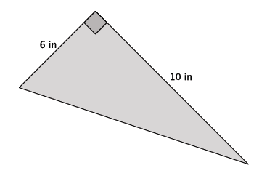
Let $c$ be the length of the hypotenuse.
$$6^{2}+10^{2}=c^{2} \\ 36+100=c^{2} \\ 136=c^{2}$$
The length of the hypotenuse is approximately $12$ in.. The number $136$ is between the perfect squares $121$ and $144$. Since $136$ is closer to $144$ than $121$, then the length of the unknown side of the triangle is closer to $12$ than it is to $11$.

- Use the Pythagorean Theorem to estimate the length of the unknown side of the right triangle. Explain why your estimate makes sense.
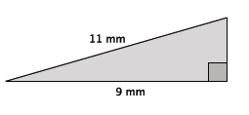
Let $x$ be the length of the unknown side.
$$9^{2}+x^{2}=11^{2} \\ 81+x^{2}=121 \\ x^{2}=40$$
The length of the hypotenuse is approximately $6 mm$. The number $40$ is between the perfect squares $36$ and $49$. Since $40$ is closer to $36$ than $49$, then the length of the unknown side of the triangle is closer to $6$ than it is to $7$.
Discussion (3 minutes)
- Our estimates for the lengths in the problems in this lesson are alright, but we can do better. Instead of saying that a length is between two particular numbers and closer to one compared to the other, we will soon learn how to make more precise estimates.
- Obviously, since the lengths have been between two integers (e.g., between $8$ and $9)$, we will need to look at the numbers between the integers: the rational numbers (fractions). That means we will need to learn more about rational numbers and all numbers between the integers on the number line, in general.
- The examination of those numbers will be the focus of the next several lessons.

Closing (5 minutes)
Summarize, or ask students to summarize, the main points from the lesson:
- We know what a perfect square number is.
- We know that when the square of the length of an unknown side of a triangle is not equal to a perfect square, we can estimate the side length by determining which two perfect squares the number is between.
- We know that we will need to look more closely at the rational numbers in order to make better estimates of the lengths of unknown sides of a right triangle.
Let $c$ represent the length of the hypotenuse. Then,
$$3^{2}+7^{2}=c^{2} \\ 9+49=c^{2} \\ 58=c^{2}$$
The number $58$ is not a perfect square, but it is between the perfect squares $49$ and $64$. Therefore, the length of the hypotenuse is between $7$and $8$, but closer to $8$ because $58$ is closer to the perfect square $64$ than it is to the perfect square $49$.

Lesson Summary
Perfect square numbers are those that are a product of an integer factor multiplied by itself. For example, the number $25$ is a perfect square number because it is the product of $5$ multiplied by $5.$
When the square of the length of an unknown side of a right triangle is not equal to a perfect square, you can estimate the length by determining which two perfect squares the number is between.
Example:
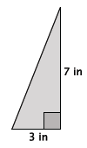

Exit Ticket (5 minutes)

Name Date
Lesson 1: The Pythagorean Theorem

Exit Ticket

- Determine the length of the unknown side of the right triangle. If not a perfect square, determine which two integers the length is between and the integer to which it is closest.
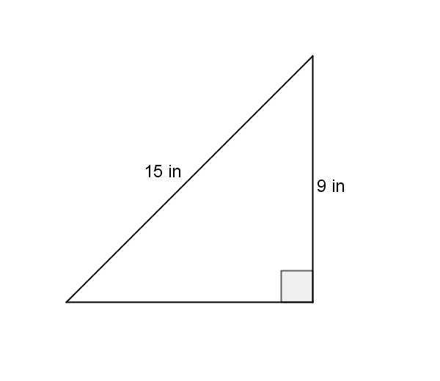

- Determine the length of the unknown side of the right triangle. If not a perfect square, determine which two integers the length is between and the integer to which it is closest.
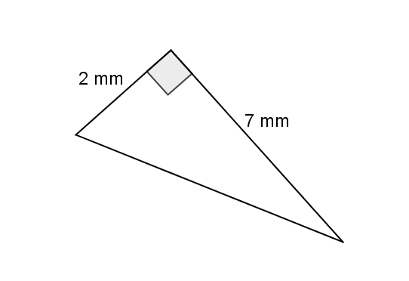

Exit Ticket Sample Solutions

- Determine the length of the unknown side of the right triangle. If not a perfect square, determine which two integers the length is between and the integer to which it is closest.
Let $x$ be the length of the unknown side.
$$9^{2}+x^{2}=15^{2} \\ 81+x^{2}=225 \\ x^{2}=144 \\ x=12$$
The length of the unknown side is $12$ in. The Pythagorean Theorem led me to the fact that the square of the unknown side is $144$. We know $144$ is a perfect square, $144$ is equal to ${12}^{2}$; therefore, $x=12$ and the unknown length of the triangle is $12$ in.

- Determine the length of the unknown side of the right triangle. If not a perfect square, determine which two integers the length is between and the integer to which it is closest.
Let $x$ be the length of the unknown side.
$$2^{2}+7^{2}=x^{2} \\ 4+49=x^{2} \\ 53=x^{2}$$
The number $53$ is between the perfect squares $49$ and $64$. Since $53$ is closer to $49$ than $64$, then the length of the unknown side of the triangle is closer to $7$ than $8$.

Problem Set Sample Solutions

- Use the Pythagorean Theorem to estimate the length of the unknown side of the right triangle. Explain why your estimate makes sense.
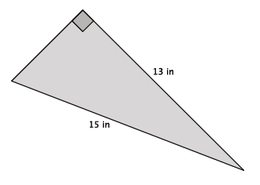
Let $x$ be the length of the unknown side.
$$13^{2}+x^{2}=15^{2} \\ 169+x^{2}=225 \\ x^{2}=56$$
The number $56$ is between the perfect squares $49$ and $64$. Since $56$ is closer to $49$ than it is to $64$, then the length of the unknown side of the triangle is closer to $7$ than it is to $8$.

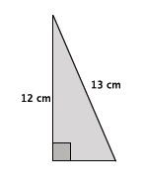
- Use the Pythagorean Theorem to estimate the length of the unknown side of the right triangle. Explain why your estimate makes sense.

Let $x$ be the length of the unknown side.
$$x^{2}+12^{2}=13^{2} \\ x^{2}+144=169 \\ x^{2}=25 \\ x=5$$
The length of the unknown side is $5$ cm. The Pythagorean Theorem led me to the fact that the square of the unknown side is $25$. Since $25$ is a perfect square, $25$ is equal to $5^{2}$; therefore, $x=5$ and the unknown length of the triangle is $5$ cm.

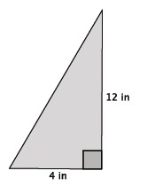
- Use the Pythagorean Theorem to estimate the length of the unknown side of the right triangle. Explain why your estimate makes sense.

Let $c$ be the length of the hypotenuse.
$$4^{2}+12^{2}=c^{2} \\ 16+144=c^{2} \\ 160=c^{2}$$
The number $160$ is between the perfect squares $144$ and $169$. Since $160$ is closer to $169$ than it is to $144$, then the length of the hypotenuse of the triangle is closer to $13$ than it is to $12$.

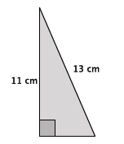
- Use the Pythagorean Theorem to estimate the length of the unknown side of the right triangle. Explain why your estimate makes sense.

Let $x$ be the length of the unknown side.
$$x^{2}+11^{2}=13^{2} \\ x^{2}+121=169 \\ x^{2}=48$$
The number $48$ is between the perfect squares $36$ and $49$. Since $48$ is closer to $49$ than it is to $36$, then the length of the unknown side of the triangle is closer to $7$ than it is to $6$.

- Use the Pythagorean Theorem to estimate the length of the unknown side of the right triangle. Explain why your estimate makes sense.
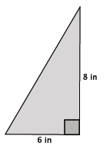
Let $c$ be the length of the hypotenuse.
$$6^{2}+8^{2}=c^{2} \\ 36+64=c^{2} \\ 100=c^{2} \\ 10=c$$
The length of the hypotenuse is $10$ in. The Pythagorean Theorem led me to the fact that the square of the unknown side is $100$. We know $100$ is a perfect square, $100$ is equal to $10^{2}$; therefore, $c=10$ and the length of the hypotenuse of the triangle is $10$ in.

- Determine the length of the unknown side of the right triangle. Explain how you know your answer is correct.
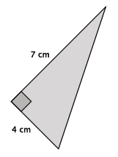
Let $c$ be the length of the hypotenuse.
$$7^{2}+4^{2}=c^{2} \\ 49+16=c^{2} \\ 65=c^{2}$$
The number $65$ is between the perfect squares $64$ and $81$. Since $65$ is closer to $64$ than it is to $81$, then the length of the hypotenuse of the triangle is closer to $8$ than it is to $9$.

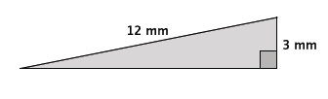
- Use the Pythagorean Theorem to estimate the length of the unknown side of the right triangle. Explain why your estimate makes sense.

Let $x$ be the length of the unknown side.
$$3^{2}+x^{2}=12^{2} \\ 9+x^{2}=144 \\ x^{2}=135$$

The number $135$ is between the perfect squares $121$ and $144$. Since $135$ is closer to $144$ than it is to $121$, then the length of the unknown side of the triangle is closer to $12$ than it is to $11$.

- The triangle below is an isosceles triangle. Use what you know about the Pythagorean Theorem to determine the approximate length of base of the isosceles triangle.
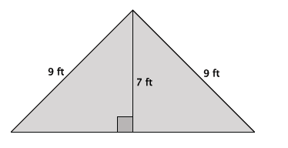
Let $x$ represent the length of the base of one of the right triangles of the isosceles triangle.
$$x^{2}+7^{2}=9^{2} \\ x^{2}+49=81 \\ x^{2}=32$$

Since $32$ is between the perfect squares $25$ and $36$, but closer to $36$, the approximate length of the base of the right triangle is $6$ ft. Since there are two right triangles, then the length of the base of the isosceles triangle is approximately $12$ ft.

- Give an estimate for the area of the triangle shown below. Explain why it is a good estimate.
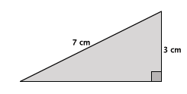
Let $x$ represent the length of the base of the right triangle.
$$x^{2}+3^{2}=7^{2} \\ x^{2}+9=49 \\ x^{2}=40$$

Since $40$ is between the perfect squares $36$ and $49$, but closer to $36$, the approximate length of the base is $6$ cm. Then the approximate area of the triangle is
$$\frac{6\left(3\right)}{2}=9$$
$9$cm² is a good estimate because of the approximation of the length of the base. Further, since the hypotenuse is the longest side of the right triangle, approximating the length of the base as$6$ cm makes mathematical sense because it has to be shorter than the hypotenuse.

Example 1
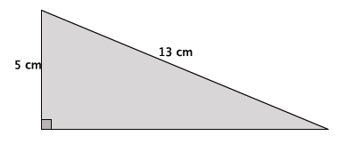

Example 2
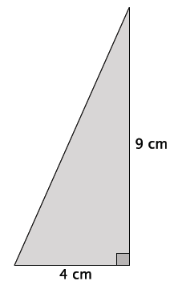

Example 3
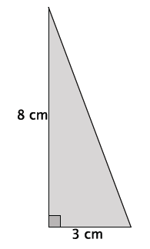

Example 4

