Lesson 12

Objective: Add tens to a two-digit number.

Suggested Lesson Structure

 Fluency Practice (15 minutes)

 Application Problem (5 minutes)

 Concept Development (30 minutes)

 Student Debrief (10 minutes)

**Total Time (60 minutes)**

Fluency Practice (15 minutes)

* Sprint: Related Addition and Subtraction Within 10 **1.NBT.3, 1.OA.6** (10 minutes)
* Add and Subtract Tens Within 40 **1.OA.6, 1.NBT.2** (3 minutes)
* Count by Tens with Coins **1.NBT.5** (2 minutes)

Sprint: Related Addition and Subtraction Within 10 (10 minutes)

Materials: (S) Related Addition and Subtraction Within 10 Sprint

Note: This Sprint provides practice with the Grade 1 core fluency standard, while reviewing the relationship between addition and subtraction.

Add and Subtract Tens Within 40 (3 minutes)

Materials: (S) Personal white board

Note: This fluency activity strengthens students’ understanding of the relationship between addition and subtraction while providing practice with adding and subtracting multiples of 10.

Write two related addition and subtraction sentences using 0–4 tens in unit form (e.g., 4 tens – 3 tens = ☐ tens and 3 tens + ☐ tens = 4 tens). Students convert the number sentences to numeral form and solve   
(e.g., 40 – 30 = 10 and 30 + 10 = 40).

Count by Tens with Coins (2 minutes)

Materials: (T) Enlarged pennies and dimes (Fluency Template)

Note: Reviewing counting by tens prepares students to add multiples of 10 in today’s lesson.

Print and prepare 10 enlarged dimes and 6 enlarged pennies. Sit in a circle with students. Lay out and remove dimes to direct students to count forward and backward by tens within 100. Then, lay out 6 pennies and add and remove dimes to count by tens, starting at 6 (e.g., 6, 16, 26…).

Application Problem (5 minutes)

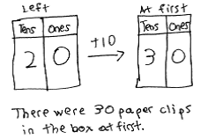Thomas has a box of paper clips. He used 10 of them to measure the length of his big book. There are 20 paper clips still in the box. Use the arrow way to show how many paper clips were in the box at first.

Note: This *take apart with start unknown* problem allows students to review the concept of mentally adding or subtracting 10 and using arrow notation to express their understanding. During the Debrief, students will share their thinking and notation to explain their solution. Some students may show their solution as 20 + 10 = 30, while others may solve using 30 – 10 = 20. Accept both solutions.

Concept Development (30 minutes)

Materials: (T) 4 ten-sticks, 4 dimes, and 10 pennies from personal math toolkit, double place value chart drawn on chart paper (S) 4 ten-sticks, 4 dimes, and 10 pennies from personal math toolkit, personal white board, addition and subtraction cards (Template)

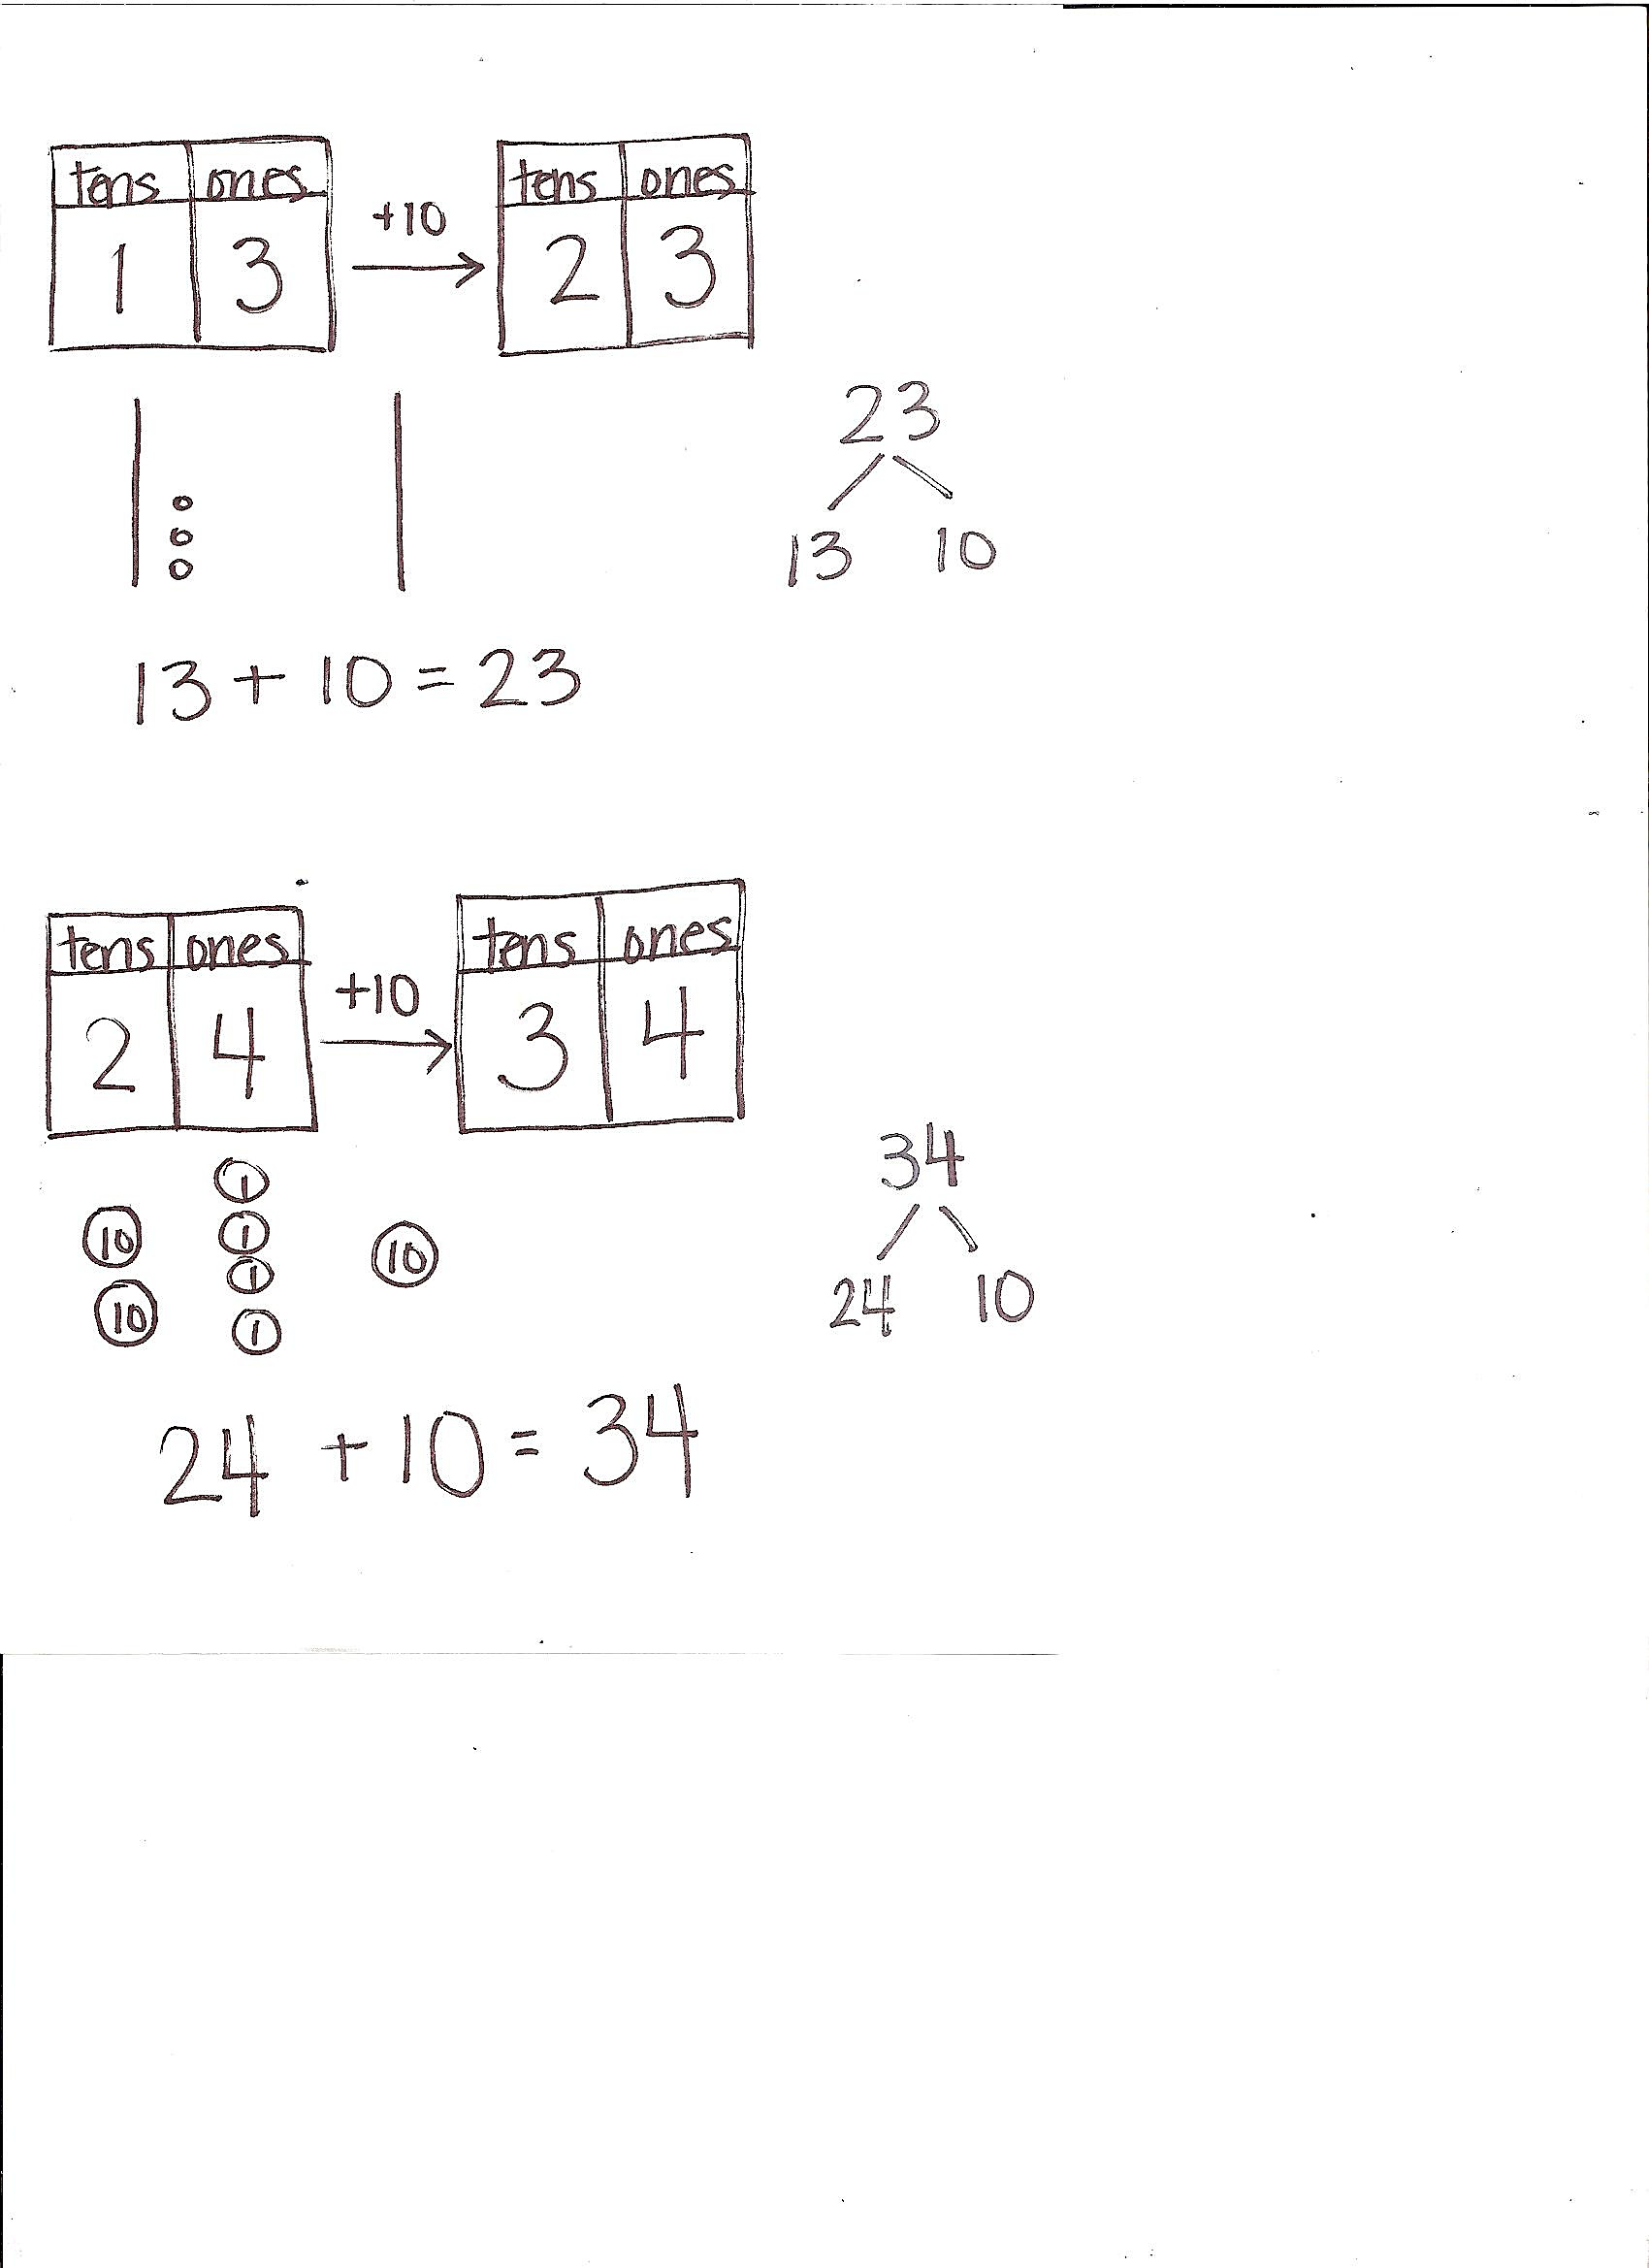Note: The cards for the game Addition and Subtraction with Cards are labeled with the letter *c* to indicate that these cards correspond with the concepts taught in Topic C. Additional cards will be created in future topics with their corresponding topic letters.

Have students gather in the meeting area in a semicircle formation with their materials.

T: Using your linking cubes, show me 13.

S: (Show 1 ten-stick and 3 ones.)

T: (Point to the chart.) Let’s fill out the place value chart. How many tens and ones are here?

S: 1 ten 3 ones.

|  |  |
| --- | --- |
|  | NOTES ON  MULTIPLE MEANS  OF REPRESENTATION: |

Students may still struggle with coin values. With more frequent opportunities to engage students and relate the value of these coins to tens and ones, students will have more success making the connections.

T: (Write +10 above the arrow.) Do what the arrow shows, and show how many cubes we’ll have next.

S: (Add a stick of 10.)

T: How many cubes are there now?

S: 23.

T: Say the number sentence, beginning with the number of cubes we started with.

S: 13 + 10 = 23.

T: Use the quick ten drawing to show how we got 23.

S: (Draw.)

T: (Draw after the students have shown their work.) Which digit changed, and which digit remained the same? Turn and talk to your partner and explain your thinking.

S: The digit in the tens place changed because we added 1 ten. We didn’t touch the ones. 🡪 1 ten more than 1 ten is 2 tens. That’s why we have 2 in the tens place. We didn’t add anything to the ones, so the ones digit stays at 3.

T: Write the number bond that shows how we changed 13 to make 23.

S: (Write 23 as the whole with 13 and 10 as the parts.)

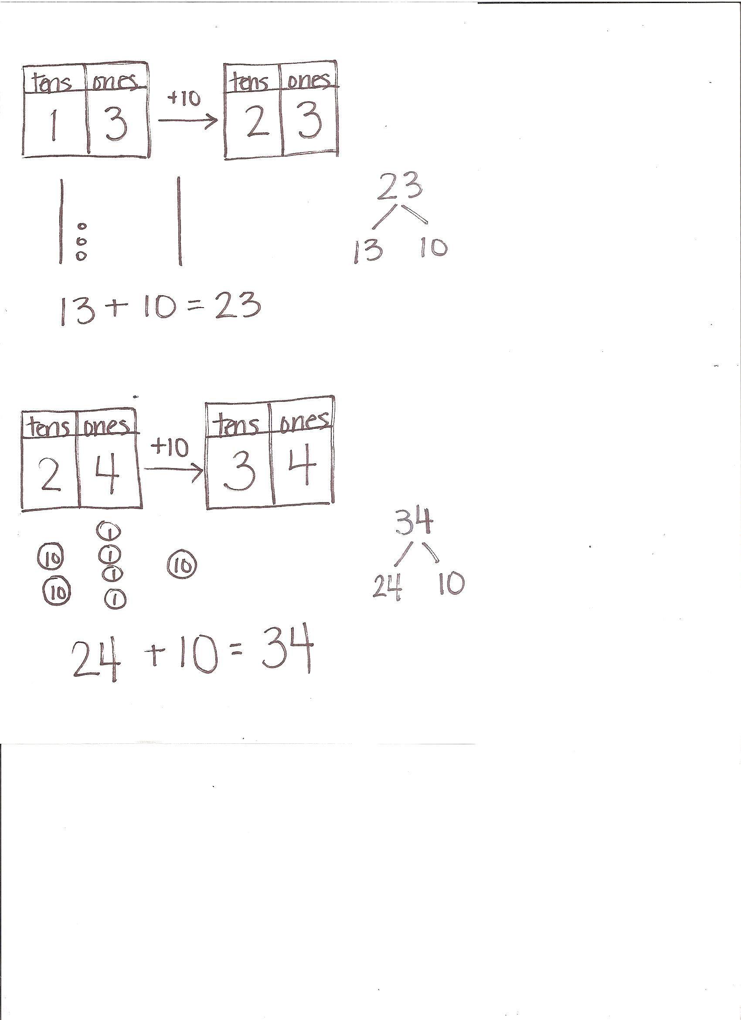Continue the process following the suggested sequence where the unknown is in the sum: 16 + 10, 26 + 10, 15 + 20, and 20 + 18. Next, have students use their ten-sticks and drawings to solve problems in which the unknown appears as the change or the starting number: 13 + ___ = 23, 16 + ___ = 36, ___ + 10 = 35, and   
___ + 20 = 37.

T: Show me 24 using your dimes and pennies.

S: (Show 2 dimes and 4 pennies.)

T: How many tens and ones are in 24?

S: 2 tens 4 ones.

T: (Fill in the place value chart. Write + 10 above the arrow.) Do what the arrow way says.

S: (Add 1 dime.)

T: How many tens are there now?

|  |  |
| --- | --- |
|  | NOTES ON  MULTIPLE MEANS  OF REPRESENTATION: |

Moving forward in small steps is what some students need. It may be necessary to explicitly connect coin drawings to quick ten drawings so that students start to see the relationship between coins and quick ten drawings. Displaying a chart that shows the quick ten and coin relationship may benefit some students.

S: 3 tens.

T: How many ones are there?

S: 4 ones.

T: Let’s use coin drawings to show what you did. (Model by using circles marked with 10 or 1 to show dimes and pennies.)

T: Say the number sentence.

S: 24 + 10 = 34.

Continue the process following the suggested sequence:   
15 + 10, 15 + 20, 17 + 20, 10 + 17, 20 + 14, 18 + ___ = 28, and   
18 + ___ = 38.

Have students play a game called Addition and Subtraction with Cards.

1. Students place the deck of cards facedown between them.
2. Each partner flips over one card, solves the problem, and then says the number sentence.
3. The partner with the greater total wins the cards. (If the totals are equal, leave the cards until the next round when one student does have a greater total.)

After the first minute of play, change the rules so that the person with the total that is *less* wins the cards. Alternate between the two rules for the remaining time.

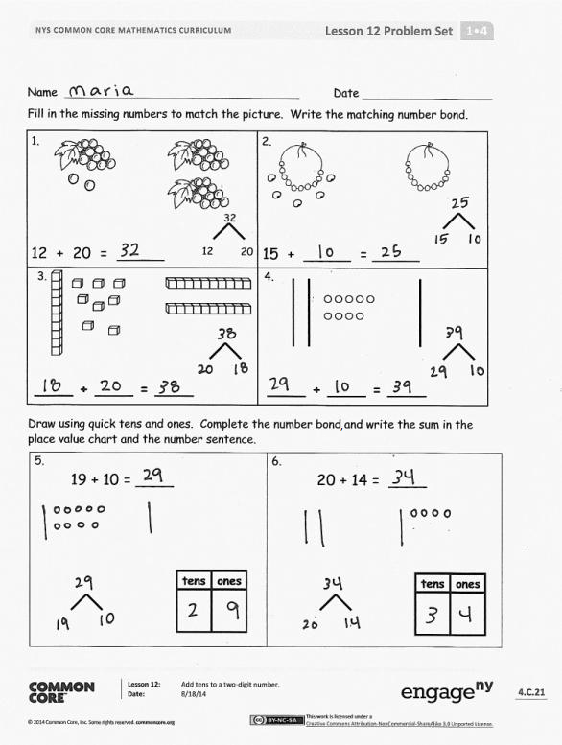Problem Set (10 minutes)

Students should do their personal best to complete the Problem Set within the allotted 10 minutes. For some classes, it may be appropriate to modify the assignment by specifying which problems they work on first.

Student Debrief (10 minutes)

**Lesson Objective:** Add tens to a two-digit number.

The Student Debrief is intended to invite reflection and active processing of the total lesson experience.

Invite students to review their solutions for the Problem Set. They should check work by comparing answers with a partner before going over answers as a class. Look for misconceptions or misunderstandings that can be addressed in the Debrief. Guide students in a conversation to debrief the Problem Set and process the lesson.

Any combination of the questions below may be used to lead the discussion.

* 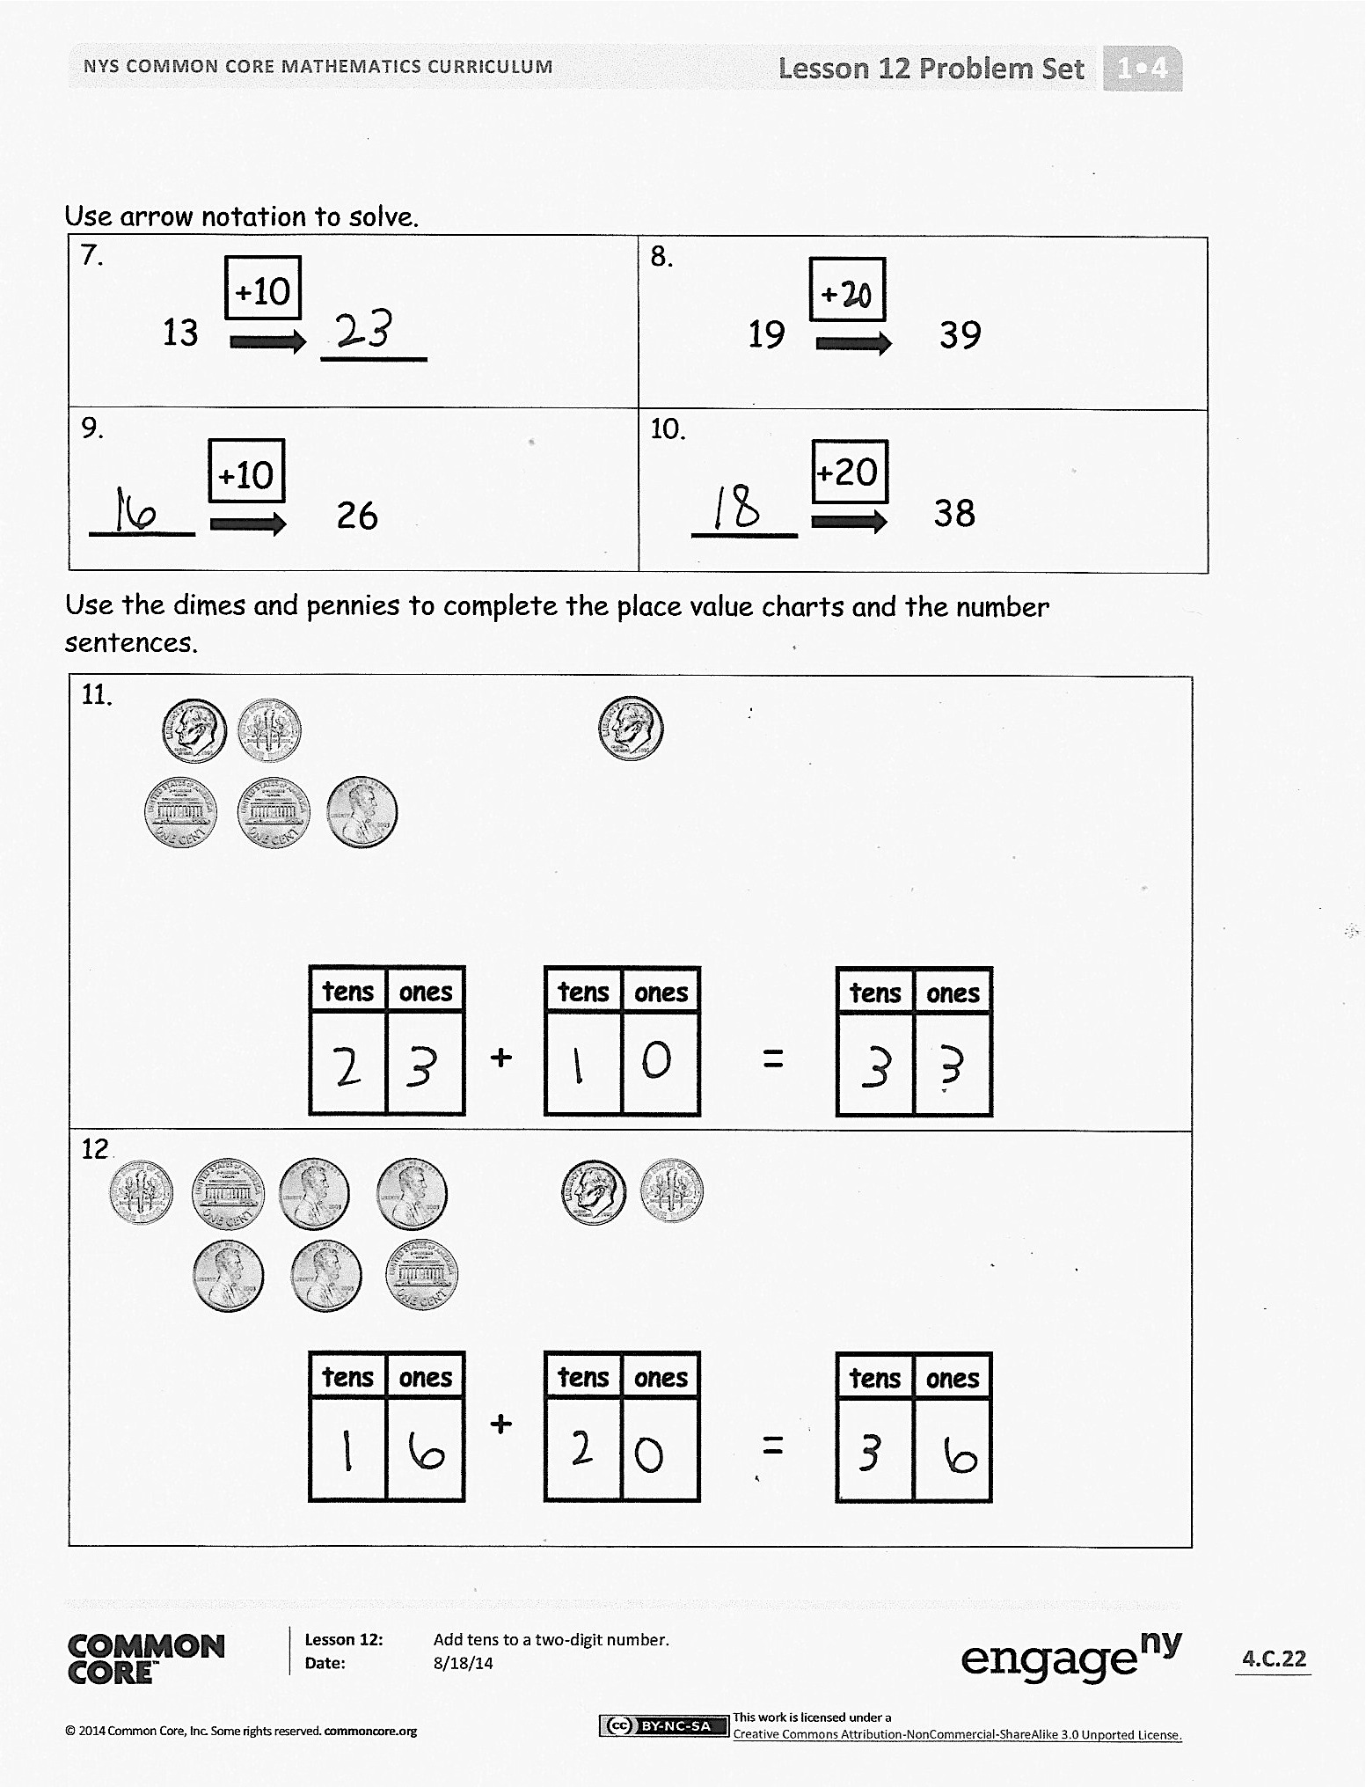How is solving Problem 7 different from solving Problem 9?
* With your partner, compare the ways you solved Problem 6. Which number did you draw first? Why?
* Look at Problem 11 or 12. Which coin is represented in the tens place? Which coin is represented in the ones place?
* Look at Problem 11. Explain why the ones digit didn’t change from the starting number to the ending number.
* Share your answer to today’s Application Problem. Explain how you found your answer.

Exit Ticket (3 minutes)

After the Student Debrief, instruct students to complete the Exit Ticket. A review of their work will help with assessing students’ understanding of the concepts that were presented in today’s lesson and planning more effectively for future lessons. The questions may be read aloud to the students.

Name Date

Number Correct:

**A**

*Write the missing number. Pay attention to the + and – signs.

|  |  |  |  |  |  |
| --- | --- | --- | --- | --- | --- |
| 1 | 3 + ☐ = 4 |  | 16 | 3 + ☐ = 7 |  |
| 2 | 1 + ☐ = 4 |  | 17 | 7 = 4 + ☐ |  |
| 3 | 4 - 1 = ☐ |  | 18 | 7 - 4 = ☐ |  |
| 4 | 4 - 3 = ☐ |  | 19 | 7 – 3 = ☐ |  |
| 5 | 3 + ☐ = 5 |  | 20 | 3 + ☐ = 8 |  |
| 6 | 2 + ☐ = 5 |  | 21 | 8 = 5 + ☐ |  |
| 7 | 5 - 2 = ☐ |  | 22 | ☐ = 8 - 5 |  |
| 8 | 5 - 3 = ☐ |  | 23 | ☐ = 8 - 3 |  |
| 9 | 4 + ☐ = 6 |  | 24 | 3 + ☐ = 9 |  |
| 10 | 2 + ☐ = 6 |  | 25 | 9 = 6 + ☐ |  |
| 11 | 6 - 2 = ☐ |  | 26 | ☐ = 9 - 6 |  |
| 12 | 6 - 4 = ☐ |  | 27 | ☐ = 9 - 3 |  |
| 13 | 6 - 3 = ☐ |  | 28 | 9 - 4 = ☐ + 2 |  |
| 14 | 3 + ☐ = 6 |  | 29 | ☐ + 3 = 9 - 3 |  |
| 15 | 6 - ☐ = 3 |  | 30 | ☐ - 7 = 8 - 6 |  |

Name Date

Number Correct:

**B**

*Write the missing number. Pay attention to the + and – signs.

|  |  |  |  |  |  |
| --- | --- | --- | --- | --- | --- |
| 1 | 4 + ☐ = 4 |  | 16 | 2 + ☐ = 7 |  |
| 2 | 0 + ☐ = 4 |  | 17 | 7 = 5 + ☐ |  |
| 3 | 4 - 0 = ☐ |  | 18 | 7 - 5 = ☐ |  |
| 4 | 4 - 4 = ☐ |  | 19 | 7 – 2 = ☐ |  |
| 5 | 4 + ☐ = 5 |  | 20 | 2 + ☐ = 8 |  |
| 6 | 1 + ☐ = 5 |  | 21 | 8 = 6 + ☐ |  |
| 7 | 5 - 1 = ☐ |  | 22 | ☐ = 8 - 6 |  |
| 8 | 5 - 4 = ☐ |  | 23 | ☐ = 8 - 2 |  |
| 9 | 5 + ☐ = 6 |  | 24 | 2 + ☐ = 9 |  |
| 10 | 1 + ☐ = 6 |  | 25 | 9 = 7 + ☐ |  |
| 11 | 6 - 1 = ☐ |  | 26 | ☐ = 9 - 7 |  |
| 12 | 6 - 5 = ☐ |  | 27 | ☐ = 9 - 2 |  |
| 13 | 2 + ☐ = 6 |  | 28 | 9 - 3 = ☐ + 3 |  |
| 14 | 4 + ☐ = 6 |  | 29 | ☐ + 2 = 9 - 4 |  |
| 15 | 6 - 4 = ☐ |  | 30 | ☐ - 6 = 8 - 3 |  |

Name Date

Fill in the missing numbers to match the picture. Write the matching number bond.

1. 2.

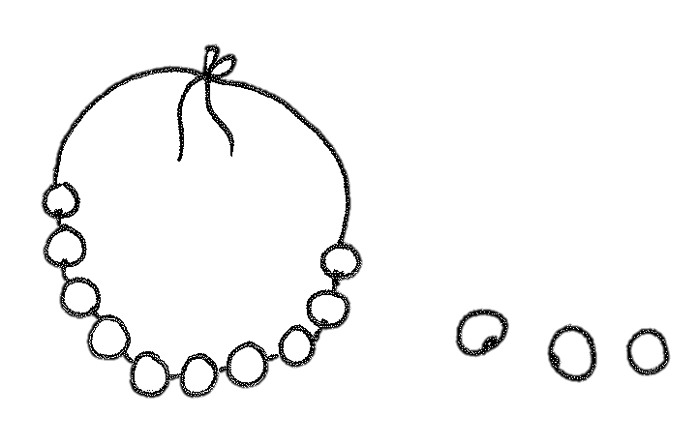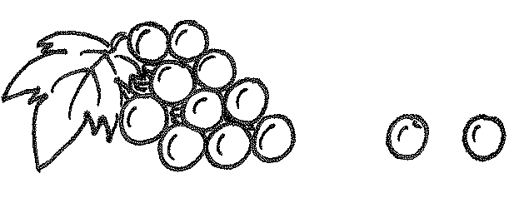

3222

122

20

15 + _____ = _____

12 + 20 = _____

3.

4.

**____ + ____ = ____**

**____ + ____ = ____**

Draw using quick tens and ones. Complete the number bond, and write the sum in the place value chart and the number sentence.

|  |  |
| --- | --- |
| 5.  19 + 10 = ____ | 6.  20 + 14 = ____ |

Use arrow notation to solve.

|  |  |
| --- | --- |
| 7.  13  +10 | 8.  19  +  39 |
| 9.  +10  26 | 10.  38  +20 |

Use the dimes and pennies to complete the place value charts and the number sentences.

|  |
| --- |
| http://upload.wikimedia.org/wikipedia/commons/thumb/1/10/2005-Dime-unc-GS_%28reverse%29.png/120px-2005-Dime-unc-GS_%28reverse%29.pnghttp://upload.wikimedia.org/wikipedia/commons/thumb/8/84/2005-Dime-Obv-Unc-P.png/120px-2005-Dime-Obv-Unc-P.pnghttp://upload.wikimedia.org/wikipedia/commons/thumb/8/84/2005-Dime-Obv-Unc-P.png/120px-2005-Dime-Obv-Unc-P.png11.  http://upload.wikimedia.org/wikipedia/commons/thumb/6/63/US_penny_2003.jpg/120px-US_penny_2003.jpgFile:United States penny, reverse.jpg  =  + |
| http://upload.wikimedia.org/wikipedia/commons/thumb/6/63/US_penny_2003.jpg/120px-US_penny_2003.jpghttp://upload.wikimedia.org/wikipedia/commons/thumb/6/63/US_penny_2003.jpg/120px-US_penny_2003.jpghttp://upload.wikimedia.org/wikipedia/commons/thumb/6/63/US_penny_2003.jpg/120px-US_penny_2003.jpghttp://upload.wikimedia.org/wikipedia/commons/thumb/6/63/US_penny_2003.jpg/120px-US_penny_2003.jpghttp://upload.wikimedia.org/wikipedia/commons/thumb/1/10/2005-Dime-unc-GS_%28reverse%29.png/120px-2005-Dime-unc-GS_%28reverse%29.pngFile:United States penny, reverse.jpghttp://upload.wikimedia.org/wikipedia/commons/thumb/8/84/2005-Dime-Obv-Unc-P.png/120px-2005-Dime-Obv-Unc-P.pnghttp://upload.wikimedia.org/wikipedia/commons/thumb/1/10/2005-Dime-unc-GS_%28reverse%29.png/120px-2005-Dime-unc-GS_%28reverse%29.png12.  File:United States penny, reverse.jpg    =  + |

Name Date

Complete the number sentences. Use quick tens, the arrow way, or coins to show your thinking.

28 + 10 = _____

14 + 20 = _____

Name Date

Fill in the missing numbers to match the picture. Complete the number bond to match.

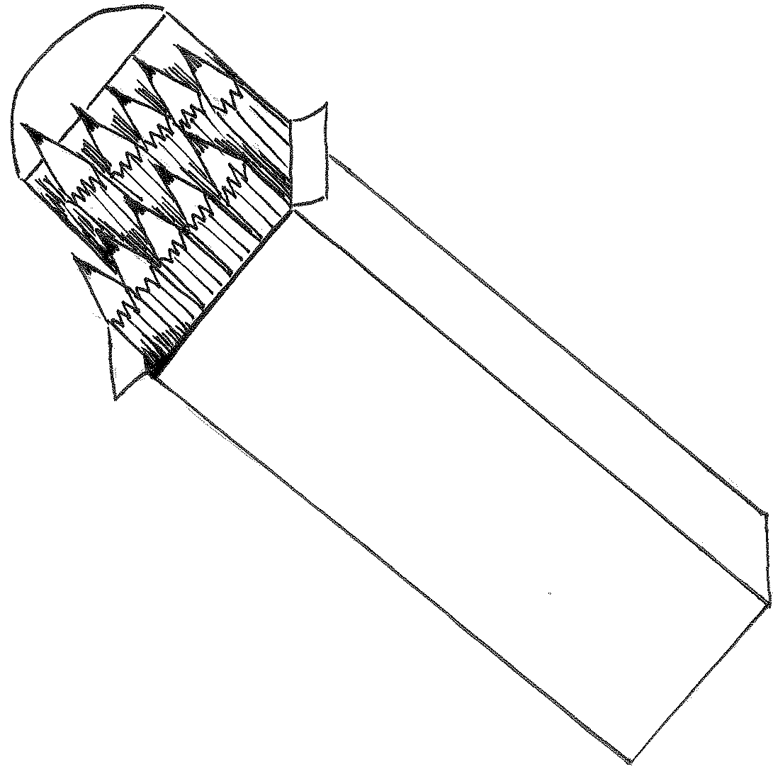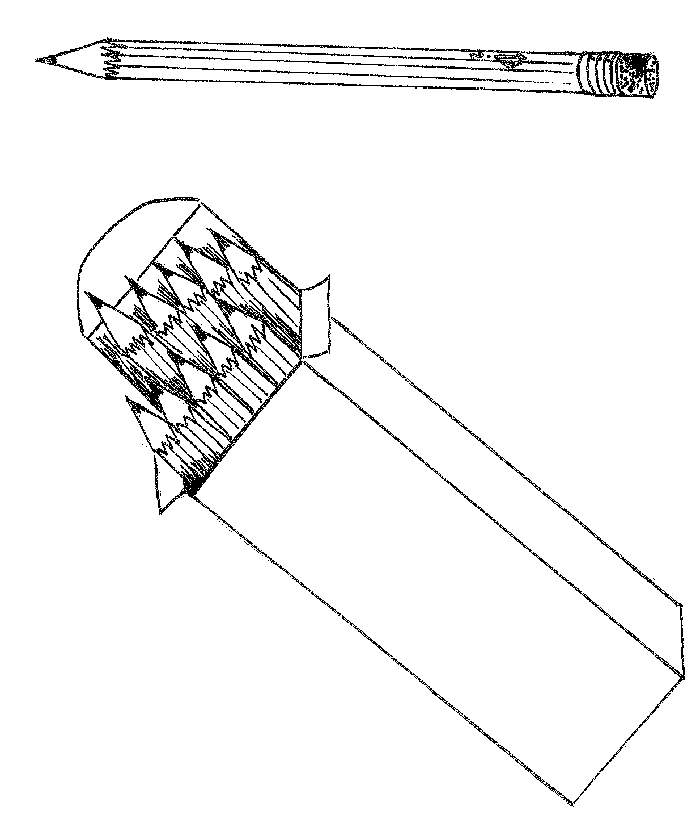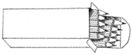

|  |  |
| --- | --- |
| 1.    20 + 13 = ____ | 2.      17 + ____ = ____ |
| 3.    ____ + ____ = ____ | 4.    ____ + ____ = ____ |

Draw using quick tens and ones. Complete the number bond and the number sentence.

|  |  |
| --- | --- |
| 5.  **+**  1  0  1  7    ____ + ____ = ____ | 6.  **=**    1  9  **+**    39  ____ + ____ = ____ |

Use arrow notation to solve.

|  |  |
| --- | --- |
| 7.  19  +10 | 8.  9  +30 |
| 9.  3826  +100 | 10.  31  +20 |

Use the dimes and pennies to complete the place value charts.

|  |
| --- |
| http://upload.wikimedia.org/wikipedia/commons/thumb/1/10/2005-Dime-unc-GS_%28reverse%29.png/120px-2005-Dime-unc-GS_%28reverse%29.pnghttp://upload.wikimedia.org/wikipedia/commons/thumb/8/84/2005-Dime-Obv-Unc-P.png/120px-2005-Dime-Obv-Unc-P.pnghttp://upload.wikimedia.org/wikipedia/commons/thumb/6/63/US_penny_2003.jpg/120px-US_penny_2003.jpgFile:United States penny, reverse.jpgFile:United States penny, reverse.jpgFile:United States penny, reverse.jpgFile:United States penny, reverse.jpgFile:United States penny, reverse.jpghttp://upload.wikimedia.org/wikipedia/commons/thumb/6/63/US_penny_2003.jpg/120px-US_penny_2003.jpghttp://upload.wikimedia.org/wikipedia/commons/thumb/6/63/US_penny_2003.jpg/120px-US_penny_2003.jpghttp://upload.wikimedia.org/wikipedia/commons/thumb/8/84/2005-Dime-Obv-Unc-P.png/120px-2005-Dime-Obv-Unc-P.png11.  ++  == |

**[1]**

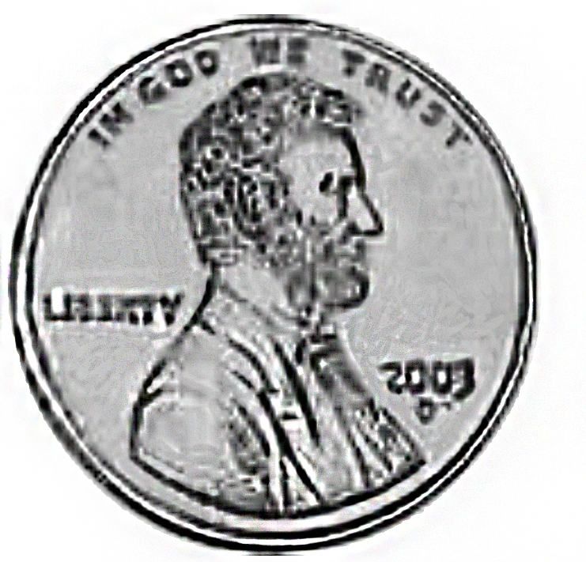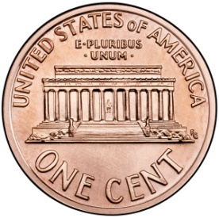

**[2]**

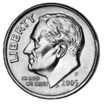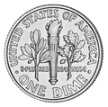

|  |  |
| --- | --- |
| **39 + 1**  **C** | **30 - 1**  **C** |
| **20 + 20**  **C** | **10 + 30**  **C** |
| **40 - 20**  **C** | **40 - 30**  **C** |
| **30 - 20**  **C** | **30 - 10**  **C** |
| **40 - 40**  **[3] C** | **30 - 30**  **C** |
| **10[4] + 14**  **C** | **15 + 20**  **C** |
| **12 + 20**  **C** | **27 + 10**  **C** |
| **29 + 10**  **C** | **20 + 19**  **C** |
| **20 + 16**  **C** | **12 + 20**  **C** |

1. enlarged pennies and dimes
2. enlarged pennies and dimes
3. addition and subtraction cards
4. addition and subtraction cards