Lesson 11
Objective: Add and subtract tens from a multiple of 10.

Suggested Lesson Structure
 Fluency Practice (12 minutes)
 Application Problem (5 minutes)
 Concept Development (33 minutes)
 Student Debrief (10 minutes)
Total Time (60 minutes)
Fluency Practice (12 minutes)
- Compare Numbers 1.NBT.3, 1.OA.6 (5 minutes)
- Number Bond Addition and Subtraction 1.OA.6 (5 minutes)
- Happy Counting by Tens 1.NBT.5 (2 minutes)
Compare Numbers (5 minutes)
Materials: (S) Personal white board
Student:
5 < 8
15 < 18
25 < 28
Teacher:
5 8
15 18
25 28

Student:
6 > 3
16 > 13
26 > 23
Teacher:
6 3
ten 6 ten 3
2 tens 6 2 tens 3

Note: In this fluency activity, students review yesterday’s lesson and use their understanding of place value to compare numbers.
Say and write sets of numbers from 0 to 40 in various ways (e.g., as numerals, as tens and ones, the Say Ten Way). Students write a number sentence in the same order it is written on the board and then read their sentences aloud.
Suggested sets:
- 5 and 8, 15 and 18, 25 and 28
- 6 and 3, ten 6 and ten 3, 2 tens 6 and 2 tens 3
- 3 and 3, 3 tens and 3 tens, 3 tens and 3 ones
- 3 and 4, 3 tens 4 ones and 4 tens 3 ones,
3 ones 4 tens and 4 ones 3 tens

Number Bond Addition and Subtraction (5 minutes)
Materials: (S) Personal white board
Note: By reviewing the relationship between addition and subtraction within 10, students approach today’s problem types with familiar strategies. In today’s lesson, students make the connection that differences for multiples of 10 such as 40 – 30 can be viewed as
4 tens – 3 tens.
Write a number bond for a number between 0 and 10 with a missing part. Students write an addition and a subtraction sentence to find the missing part and solve.
Happy Counting by Tens (2 minutes)
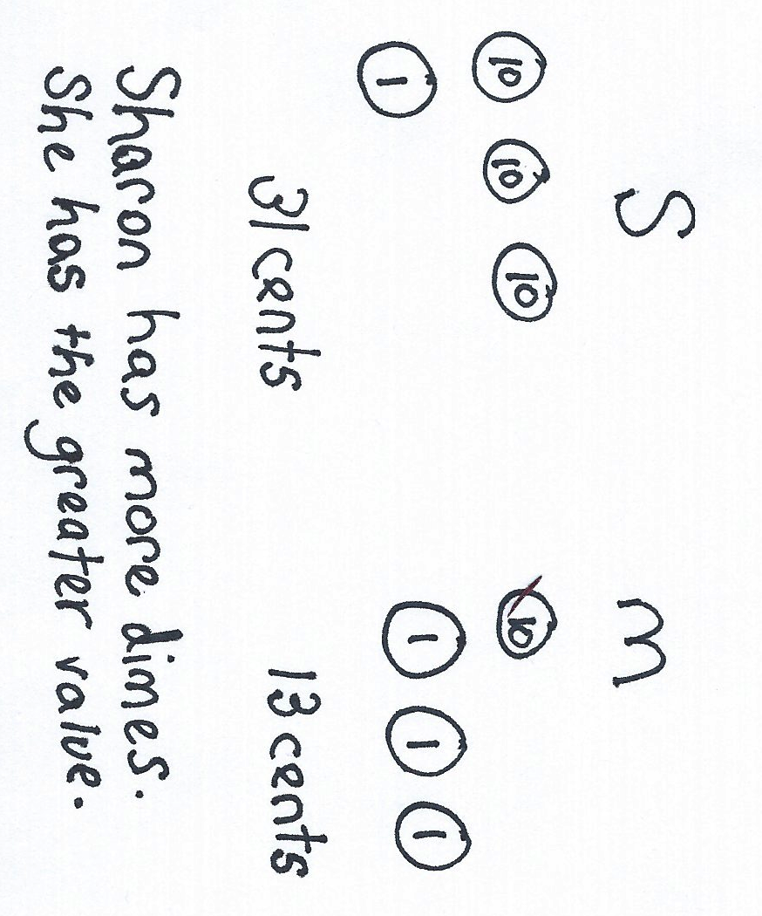
Note: Reviewing Happy Counting by Tens prepares students to recognize the efficiency of counting groups of 10 in today’s lesson.
Happy Count by tens the regular way and Say Ten Way from 0 to 120 (see Lesson 1). To reinforce place value, try alternating between counting the regular way and the Say Ten Way.
Application Problem (5 minutes)
Sharon has 3 dimes and 1 penny. Mia has 1 dime and 3 pennies. Whose amount of money has a greater value?
Note: Money is used in this problem as a way to extend place value concepts and continue to familiarize students with coins and their value.
Concept Development (33 minutes)

NOTES ON
MULTIPLE MEANS
OF REPRESENTATION:
The use of charts in the next few lessons provides students with visual guides to use as resources in the classroom as they are learning more about place value. Some students may benefit from having a smaller version of the charts in their personal white boards or folders to refer to as needed.
Materials: (T) Chart paper (S) Personal white board, number bond/number sentence set (Template)
Students sit in the meeting area in a semicircle formation.
T: (Write 2 + 1 on the chart. Call up two volunteers.) Using your magic counting sticks, show us 2 + 1.
S: (Student A shows 2 fingers. Student B shows 1 finger.)
T: How many fingers are there? Say the number sentence.
S: 2 + 1 = 3.
T: (Complete the number sentence on the chart.)
On their personal white boards, have students write the number sentence, use math drawings to show 2 + 1 = 3, and make a number bond as you record the information in a chart.
T: Let’s pretend these circles stand for bananas! Say the number sentence using bananas as the unit.
S: 2 bananas + 1 banana = 3 bananas.
T: (Call for an additional volunteer to join the two volunteers.) Show us 2 tens + 1 ten using your magic counting sticks.
S: (Clasp hands to show 2 tens and 1 ten.)
T: (Help the first two students stand closer together to show 20.)
T: (Point to the first two students.) How many tens do we have here?
S: 2 tens.
T: (Point to the third student.) How many tens do we have here?
S: 1 ten.
T: How many tens are there in all?

NOTES ON
MULTIPLE MEANS
OF REPRESENTATION:
Students demonstrate a true understanding of math concepts when they apply them in a variety of situations. Some students may not be able to make the connection between different number bonds as seen in this lesson. Their path to abstract thinking may be a little longer than others’. Support these students with use of manipulatives and ample practice on their personal white boards.

S: 3 tens.
T: Say the number sentence using the unit tens. (If students struggle, say, “Say the number sentence starting with 2 tens.”)
S: 2 tens + 1 ten = 3 tens.
T: (Record the number sentence on the chart.)
Have students write the number sentence, use math drawings, and make a number bond. Chart their responses as shown to the right.
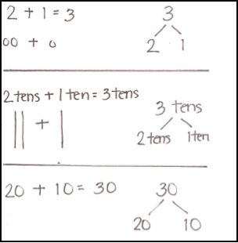
Repeat the process and record the following suggested sequence on the chart: 3 tens + 1 ten, 2 tens + 2 tens, and 1 ten + 3 tens. Progress through the units from ones to bananas to tens (e.g.,
3 + 1 = 4 → 3 bananas + 1 banana = 4 bananas → 3 tens + 1 ten =
4 tens). Have students write the number sentence, make math drawings, and write the number bond (using the same format from the teacher-generated chart) for each problem. These charts will be used later in this lesson.
Chart 1
T: (Point to the first problem on the chart.) Hmmm, how can knowing 2 + 1 = 3 help us with 2 tens + 1 ten? Turn and talk to your partner.
MP.7
S: 2 tens + 1 ten = 3 tens is just like 2 + 1 = 3. It’s 2 things and 1 thing make 3 things. 2 circles and 1 circle make 3 circles.
2 bananas and 1 banana make 3 bananas. 2 tens and 1 ten make 3 tens!
T: The numbers stay the same. The numbers, 2 and 1 and 3, stay the same, but the units change.
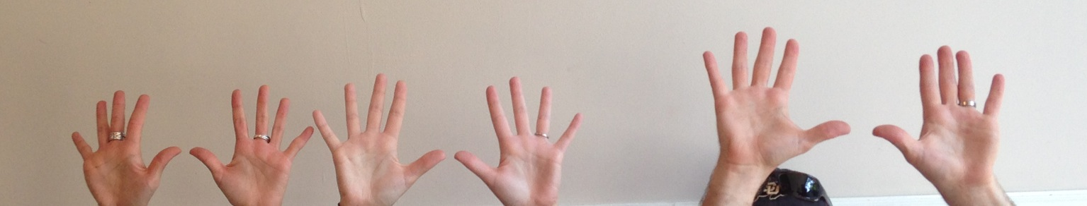
T: (Call up three volunteers to show
2 tens + 1 ten = 3 tens again.) Now, unbundle your magic counting sticks.
S: (Open hands to show 10 fingers.)
T: (Point to the first two students.) What did 2 tens become?
S: 20.
T: (Point to the third student.) What did 1 ten become?
S: 10.
T: What is 20 + 10? Say the number sentence.
S: 20 + 10 = 30.
T: (Write the number sentence on the chart.) When we say 20 + 10 = 30, we’ll call this the regular way. When we say the place value units, 2 tens plus 1 ten equals 3 tens, we call this the unit way.
T: Did we change the number of magic counting sticks when we had 2 tens + 1 ten = 3 tens?
S: No.
Elicit responses to make a number bond, and chart responses as shown on Chart 1. Have students fill in the last part of the template on their boards.
Repeat the process by revisiting the previous problems written on the charts, and write them again using only numerals. For example, 1 ten + 3 tens = 4 tens is now written as 10 + 30 = 40.
Next, repeat the process following the suggested sequence for solving subtraction problems as shown on Chart 2: 30 – 10, 30 – 20, 40 – 20, 40 – 40, and 40 – 0. Introduce each expression starting with ones and bananas, then tens, and finally as numerals (e.g., 2 – 1 = 1 → 2 bananas – 1 banana = 1 banana → 2 tens – 1 ten = 1 ten → 20 – 10 = 10).
T: (Write 4 tens – 3 tens on the chart.) What parts of the number bond can we fill in with these numbers?
S: 4 tens on top, with 3 tens as one of the parts. (Show the number bond with 1 ten still missing.)
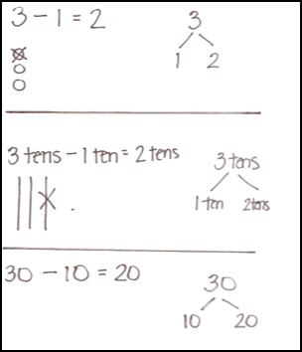
T: What addition sentence can we write to match this number bond? Remember, we can say “unknown” or “mystery number” for the part we don’t know yet.
Chart 2
S: 3 tens + “the mystery number” = 4 tens. (Record on the chart.)
T: What is the missing part?
S: 1 ten!
T: (Add the missing part to each section.) Say the subtraction sentence and the related addition sentence we created.
S: 4 tens – 3 tens = 1 ten. 3 tens + 1 ten = 4 tens.
T: Let’s say it the regular way, too.
S: 40 – 30 = 10. 30 + 10 = 40.
Repeat the process as needed to support students’ understanding.
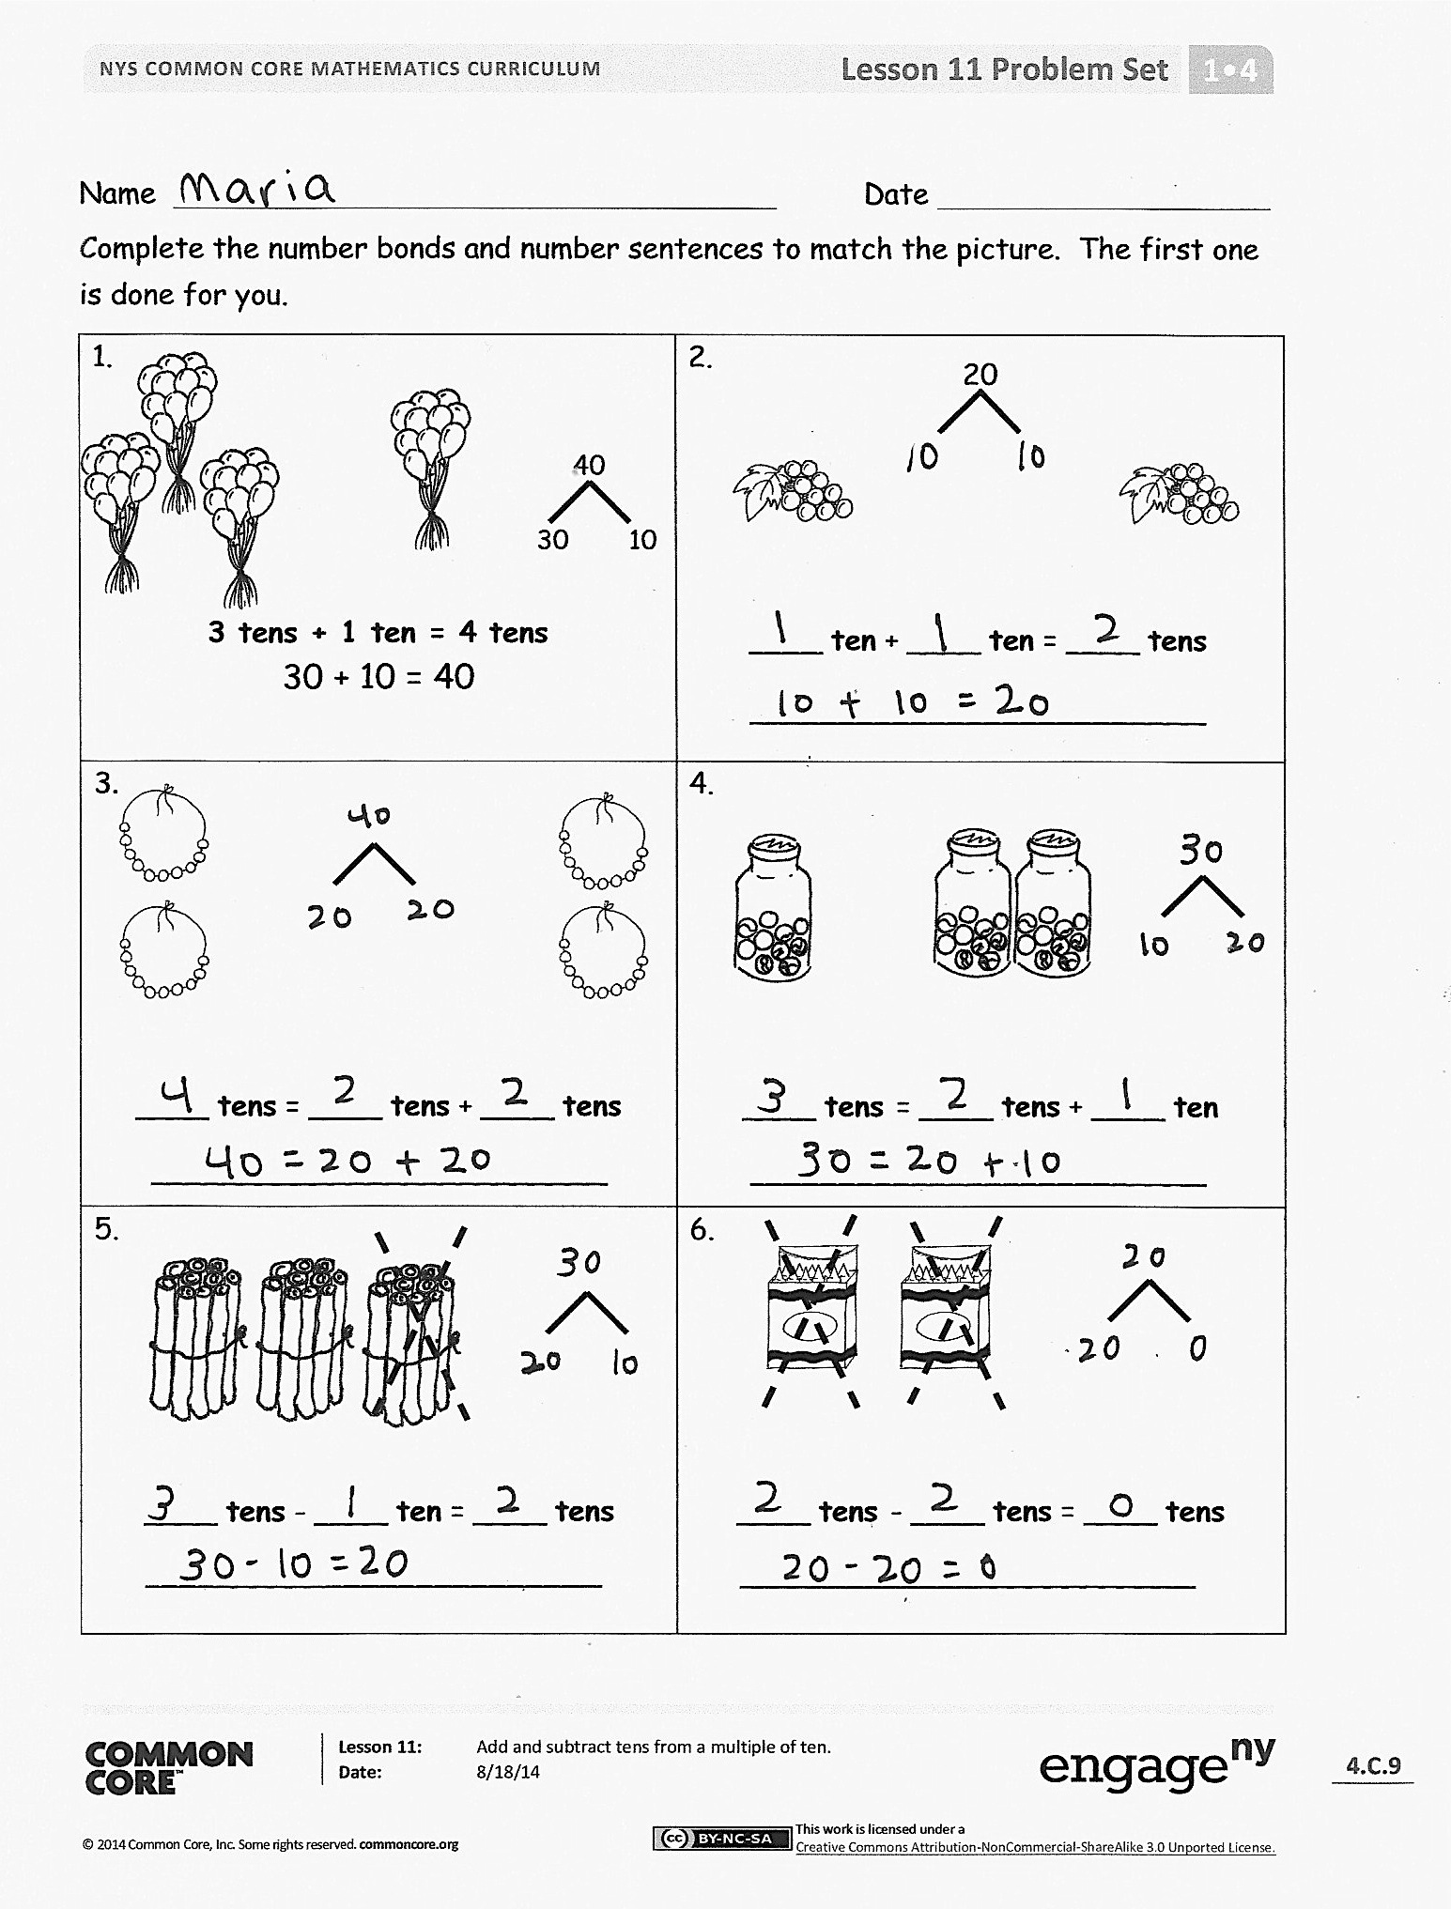
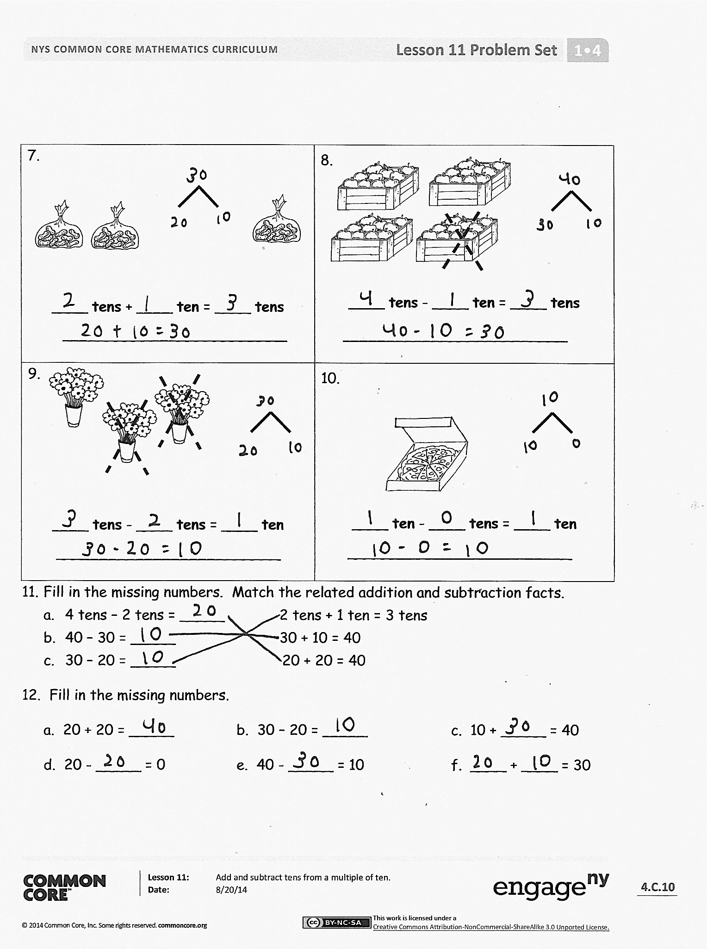
Problem Set (10 minutes)
Students should do their personal best to complete the Problem Set within the allotted 10 minutes. For some classes, it may be appropriate to modify the assignment by specifying which problems they work on first.
Student Debrief (10 minutes)
Lesson Objective: Add and subtract tens from a multiple of 10.
The Student Debrief is intended to invite reflection and active processing of the total lesson experience.
Invite students to review their solutions for the Problem Set. They should check work by comparing answers with a partner before going over answers as a class. Look for misconceptions or misunderstandings that can be addressed in the Debrief. Guide students in a conversation to debrief the Problem Set and process the lesson. Any combination of the questions below may be used to lead the discussion.
- Look at Problem 3. What simpler problem can help you solve this problem?
- How are Problems 4 and 5 related?
- Look at Problem 10. Share your solution with your partner. Did you solve the problem the same way? (Accept all possible interpretations of this picture as long as the students can support their thinking.)
- Look at Problem 12. Can you find an addition and a subtraction sentence that are related?
- Use the arrow way to represent the adding and subtracting of Problems 12(a), 12(b), and 12(c).
- Explain how you solved the Application Problem.
Exit Ticket (3 minutes)
After the Student Debrief, instruct students to complete the Exit Ticket. A review of their work will help with assessing students’ understanding of the concepts that were presented in today’s lesson and planning more effectively for future lessons. The questions may be read aloud to the students.
Name Date
1.  3 tens + 1 ten = 4 tens  30  10  30 + 10 = 40 | 2.  20  ____ ten + ____ ten = ____ tens  _________________________
3.  ____ tens = ____ tens + ____ tens  _________________________ | 4.  ____ tens = ____ tens + ____ ten  _________________________
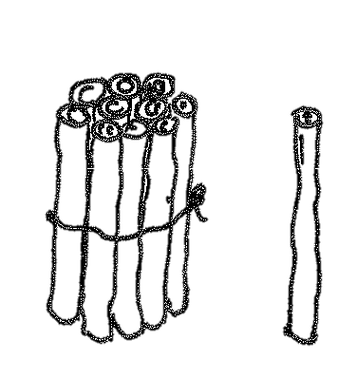  5.  ____ tens - ____ ten = ____ tens  _________________________ | 6.  ____ tens - ____ tens = ____ tens  _________________________
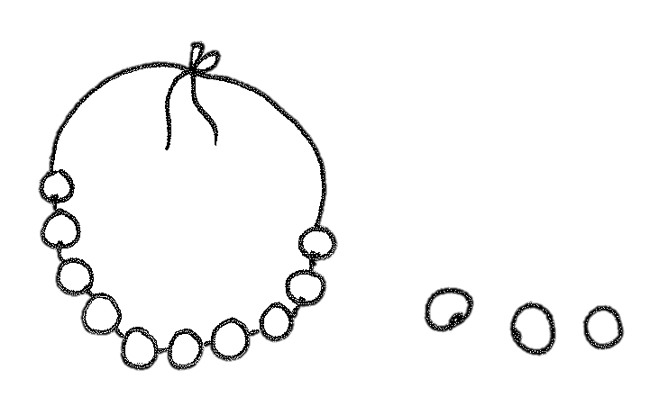
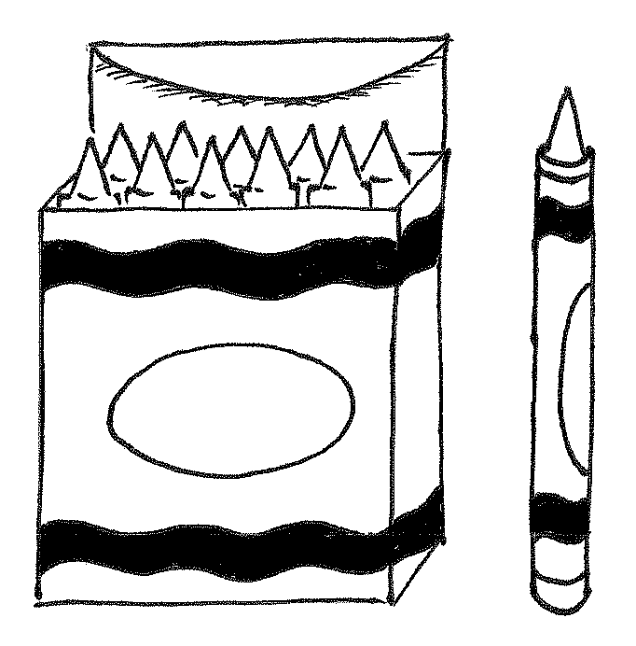
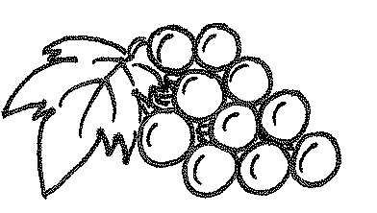
Complete the number bonds and number sentences to match the picture. The first one is done for you.
40
7.  ____ tens + ____ ten = ____ tens  _________________________ | 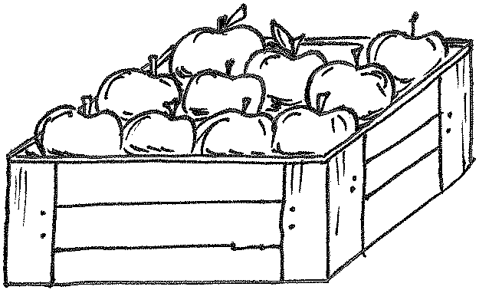  8.  ____ tens - ____ ten = ____ tens  _________________________
9.  ____ tens - ____ tens = ____ ten  _________________________ | 10.  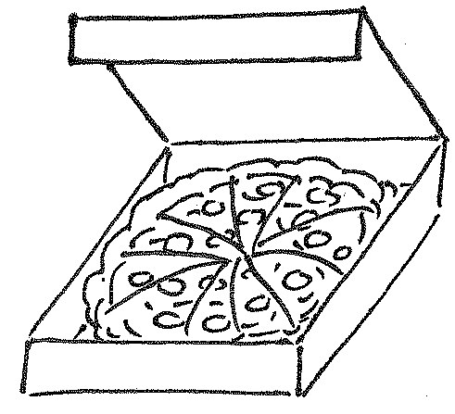  ____ ten - ____ tens = ____ ten  _________________________

- Fill in the missing numbers. Match the related addition and subtraction facts.
- 4 tens – 2 tens = _____ 2 tens + 1 ten = 3 tens
- 40 – 30 = _____ 30 + 10 = 40
- 30 – 20 = _____ 20 + 20 = 40

- Fill in the missing numbers.
a. 20 + 20 = _____ b. 30 – 20 = _____ c. 10 + _____ = 40
d. 20 - _____ = 0 e. 40 - _____ = 10 f. ____ + ____ = 30
Name Date
1.  1 ten + 1 ten = _____ tens  20  ______ + ______ = ______ | 2.  _____ tens = _____ tens + _____ ten  ______ = ______ + ______
3.  _____ tens - _____ ten = _____ tens  ______ - ______ = ______ | 4.  _____ tens - _____ tens = _____ tens  ______ - ______ = ______
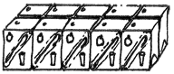
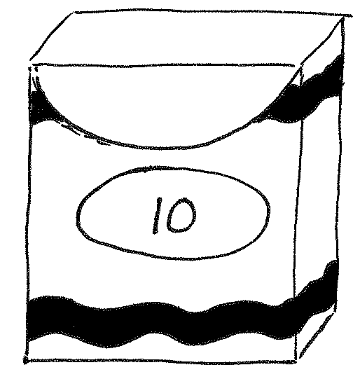
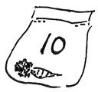
Complete the number bonds and number sentences.
20

Name Date
Draw a number bond, and complete the number sentences to match the pictures.
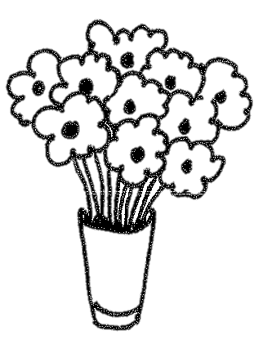  1.  ____ tens + ____ ten = ____ tens | 2.  ____ tens = ____ ten + ____ tens  _____________________
3.  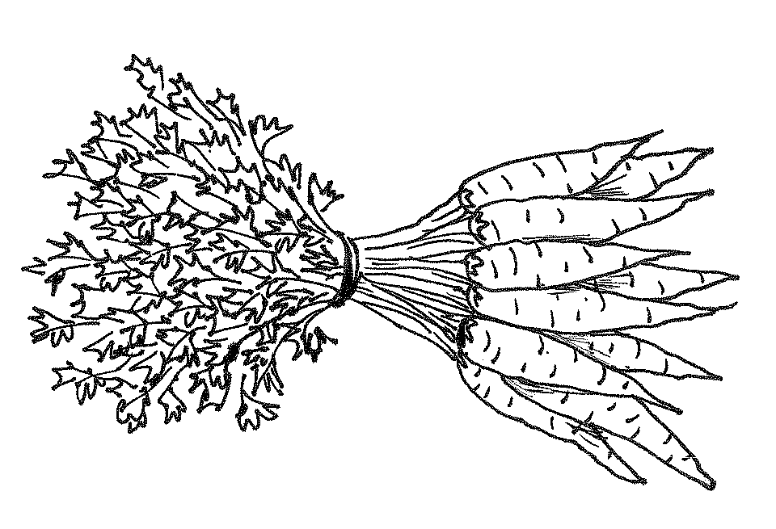  ____ tens - ____ ten = ____ tens  _____________________ | 4.  ____ tens - ____ tens = ____ tens  _____________________
5.  ____ tens - ____ tens = ____ tens  _____________________ | 6.  ____ tens + ____ tens = ____ tens  _____________________
Draw quick tens and a number bond to help you solve the number sentences.
7.  10 + 20 = _____ | 8.  30 – 10 = _____
9.  20 - 10 = _____ | 10.  30 + 10 = _____

Add or subtract.
11. 2 tens + 1 ten = _____ 12. 20 + 20 = _____ 13. 40 – 10 = ____

14. _____= 20 + 10 15. 3 tens – 2 tens = _____ 16. 20 – 10 = _____

17. 10 – 10 = _____ 18. _____ = 30 + 10 19. 40 – 30 = _____

_____ _____ _____

_____ ten _____ ten _____ ten

______ ______ ______

number bond/number sentence set

