Lesson 12: Nonlinear Models in a Data Context

Classwork
Example 1: Growing Dahlias
A group of students wanted to determine whether or not compost is beneficial in plant growth. The students used the dahlia flower to study the effect of composting. They planted eight dahlias in a bed with no compost and another eight plants in a bed with compost. They measured the height of each plant over a $9$-week period. They found the median growth height for each group of eight plants. The table below shows the results of the experiment for the dahlias grown in non-compost beds.
Week | Median Height in Non-Compost Bed (inches)
$$1$$ | $$9.00$$
$$2$$ | $$12.75$$
$$3$$ | $$16.25$$
$$4$$ | $$19.50$$
$$5$$ | $$23.00$$
$$6$$ | $$26.75$$
$$7$$ | $$30.00$$
$$8$$ | $$33.75$$
$$9$$ | $$37.25$$

Exercises 1–15
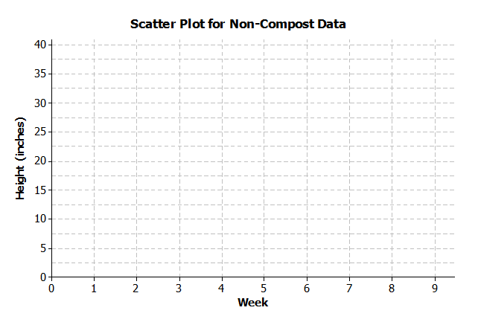
- On the grid below, construct a scatter plot of non-compost data.

- Draw a line that you think fits the data reasonably well.
- Find the rate of change of your line. Interpret the rate of change in terms of growth (in height) over time.

- Describe the growth (change in height) from week to week by subtracting the previous week’s height from the current height. Record the weekly growth in the third column in the table below. The median growth for the dahlias from Week $1$ to Week $2$ was $3.75$ inches (i.e., $12.75-9.00=3.75$).
Week | Median Height in  Non-Compost Bed (inches) | Weekly Growth (inches)
$$1$$ | $$9.00$$ | $$-$$
$$2$$ | $$12.75$$ | $$3.75$$
$$3$$ | $$16.25$$
$$4$$ | $$19.50$$
$$5$$ | $$23.00$$
$$6$$ | $$26.75$$
$$7$$ | $$30.00$$
$$8$$ | $$33.75$$
$$9$$ | $$37.25$$

- As the number of weeks increases, describe how the weekly growth is changing.

- How does the growth each week compare to the slope of the line that you drew?

- Estimate the median height of the dahlias at $8\frac{1}{2}$ weeks. Explain how you made your estimate.

The table below shows the results of the experiment for the dahlias grown in compost beds.
Week | Median Height in  Compost Bed (inches)
$$1$$ | $$10.00$$
$$2$$ | $$13.50$$
$$3$$ | $$17.75$$
$$4$$ | $$21.50$$
$$5$$ | $$30.50$$
$$6$$ | $$40.50$$
$$7$$ | $$65.00$$
$$8$$ | $$80.50$$
$$9$$ | $$91.50$$

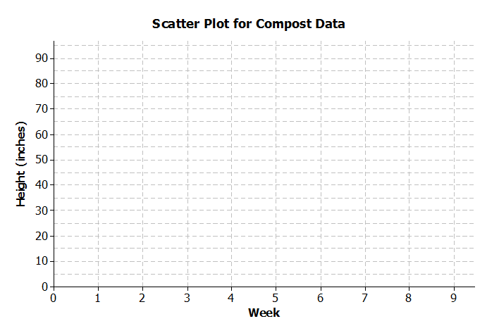
- Construct a scatter plot of height versus week on the grid below.

- Do the data appear to form a linear pattern?

- Describe the weekly growth from week to week by subtracting the height from the previous week from the current height. Record the weekly growth in the third column in the table below. The median weekly growth for the dahlias from Week $1$ to Week $2$ is $3.5$ inches. (i.e., $13.5-10=3.5$).
Week | Compost Height  (inches) | Weekly Growth  (inches)
$$1$$ | $$10.00$$ | $$-$$
$$2$$ | $$13.50$$ | $$3.50$$
$$3$$ | $$17.75$$
$$4$$ | $$21.50$$
$$5$$ | $$30.50$$
$$6$$ | $$40.50$$
$$7$$ | $$65.00$$
$$8$$ | $$80.50$$
$$9$$ | $$91.50$$

- As the number of weeks increases, describe how the growth changes.

- Sketch a curve through the data. When sketching a curve do not connect the ordered pairs, but draw a smooth curve that you think reasonably describes the data.

- Use the curve to estimate the median height of the dahlias at$8\frac{1}{2}$weeks. Explain how you made your estimate.

- How does the weekly growth of the dahlias in the compost beds compare to the weekly growth of the dahlias in the non-compost beds?

- When there is a car accident how do the investigators determine the speed of the cars involved? One way is to measure the skid marks left by the car and use this length to estimate the speed.
The table below shows data collected from an experiment with a test car. The first column is the length of the skid mark (in feet) and the second column is the speed of the car (in miles per hour).
Skid-Mark Length ($ft.$) | Speed ($mph$)
$$5$$ | $$10$$
$$17$$ | $$20$$
$$65$$ | $$40$$
$$105$$ | $$50$$
$$205$$ | $$70$$
$$265$$ | $$80$$
  - Construct a scatter plot of speed versus skid-mark length on the grid below.
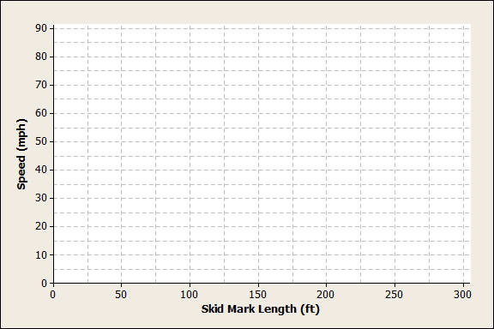
  - The relationship between speed and skid-mark length can be described by a curve. Sketch a curve through the data that best represents the relationship between skid-mark length and speed of the car. Remember to draw a smooth curve that does not just connect the ordered pairs.

  - If the car left a skid mark of $60 ft.$, what is an estimate for the speed of the car? Explain how you determined the estimate.

  - A car left a skid mark of $150 ft$. Use the curve you sketched to estimate the speed at which the car was traveling.

  - If a car leaves a skid mark that is twice as long as another skid mark, was the car going twice as fast? Explain.

Lesson Summary
When data follow a linear pattern, the rate of change is a constant. When data follow a nonlinear pattern, the rate of change is not constant.

Problem Set

- Once the brakes of the car have been applied, the car does not stop immediately. The distance that the car travels after the brakes have been applied is called the braking distance. The table below shows braking distance (how far the car travels once the brakes have been applied) and the speed of the car.
Speed ($mph$) | Distance Until Car Stops ($ft.$)
$$10$$ | $$5$$
$$20$$ | $$17$$
$$30$$ | $$37$$
$$40$$ | $$65$$
$$50$$ | $$105$$
$$60$$ | $$150$$
$$70$$ | $$205$$
80 | 265
  - Construct a scatterplot of distance versus speed on the grid below.
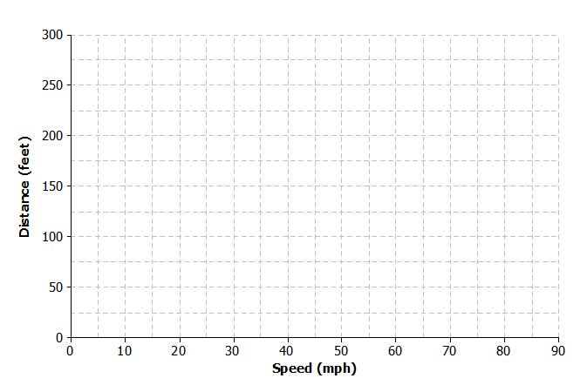

  - Find the amount of additional distance a car would travel after braking for each speed increase of $10$ mph. Record your answers in the table below.
Speed ($mph$) | Distance Until Car Stops ($ft.$) | Amount of Distance Increase
$$10$$ | $$5$$ | $$-$$
$$20$$ | $$17$$
$$30$$ | $$37$$
$$40$$ | $$65$$
$$50$$ | $$105$$
$$60$$ | $$150$$
$$70$$ | $$205$$
$$80$$ | $$265$$
  - Based on the table, do you think the data follow a linear pattern? Explain your answer.
  - Describe how the distance it takes a car to stop changes as the speed of the car increases.
  - Sketch a smooth curve that you think describes the relationship between braking distance and speed.
  - Estimate braking distance for a car traveling at $52 mph$. Estimate braking distance for a car traveling at $75 mph$. Explain how you made your estimates.

- The scatter plot below shows the relationship between cost (in dollars) and radius length (in meters) of fertilizing different sized circular fields. The curve shown was drawn to describe the relationship between cost and radius.
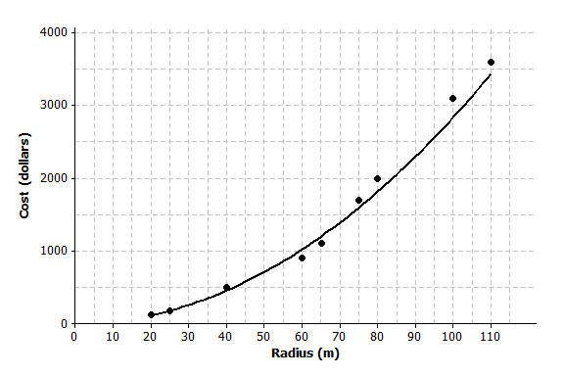

  - Is the curve a good fit for the data? Explain.
  - Use the curve to estimate the cost for fertilizing a circular field of radius $30 m$. Explain how you made your estimate.
  - Estimate the radius of the field if the fertilizing cost were $\$2,500$. Explain how you made your estimate.

- A dolphin is fitted with a GPS system that monitors its position in relationship to a research ship. The table below contains the time (in seconds) after the dolphin is released from the ship and the distance (in feet) the dolphin is from the research ship.
Time ($sec.$) | Distance from Ship ($ft.$) | Increase in Distance from the Ship
$$0$$ | $$0$$ | $$-$$
$$50$$ | $$85$$
$$100$$ | $$190$$
$$150$$ | $$398$$
$$200$$ | $$577$$
$$250$$ | $$853$$
$$300$$ | $$1,122$$
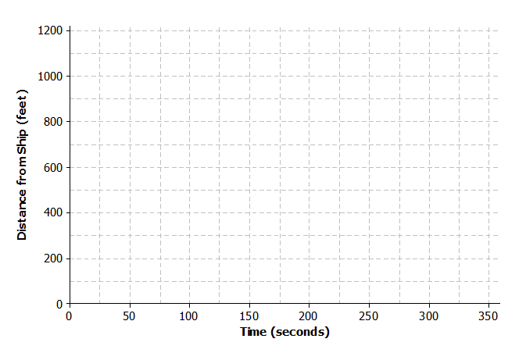
  - Construct a scatter plot of distance versus time on the grid below.
  - Find the additional distance the dolphin traveled for each increase of $50$ seconds. Record your answers in the table above.
  - Based on the table, do you think that the data follow a linear pattern? Explain your answer.
  - Describe how the distance that the dolphin is from the ship changes as the time increases.
  - Sketch a smooth curve that you think fits the data reasonably well.
  - Estimate how far the dolphin will be from the ship after $180$ seconds? Explain how you made your estimate.

