Lesson 12: Nonlinear Models in a Data Context (Optional)

Student Outcomes
- Students give verbal descriptions of how $y$ changes as $x$ changes given the graph of a nonlinear function.
- Students draw nonlinear functions that are consistent with a verbal description of a nonlinear relationship.

Lesson Notes
The Common Core Standards do not require that eighth-grade students fit curves to nonlinear data. This lesson is included as an optional extension to provide a deeper understanding of the key features of linear relationships in contrast to nonlinear ones.
Previous lessons focused on finding the equation of a line and interpreting the slope and intercept for data that followed a linear pattern. In the next two lessons, the focus shifts to data that does not follow a linear pattern. Instead of drawing lines through data, we will use a curve to describe the relationship observed in a scatter plot.
In this lesson, students will calculate the change in height of plants grown in beds with and without compost. The change in growth in the non-compost beds approximately follows a linear pattern. The change in growth in the compost beds follows a curved pattern, rather than a linear pattern. Students are asked to compare the growth changes and recognize that the change in growth for a linear pattern shows a constant change, while nonlinear patterns show a rate of growth that is not constant.

Classwork
Example 1 (3 minutes): Growing Dahlias
Present the experiment for the two methods of growing dahlias. One method was to plant eight dahlias in a bed of soil that has no compost. The other was to plant eight dahlias in a bed of soil that has been enriched with compost. Explain that the students measured the height of each plant at the end of each week and recorded the median height of the eight dahlias.
Scaffolding:
- An image of a growth experiment may help ELL students understand the context of the example.
- The words compost and bed may be unfamiliar to students in this context.
- Compost is a mixture of decayed plants and other organic matter used by gardeners to enrich soil.
- Bed has multiple meanings. In this context, bed refers to a section of ground planted with flowers.
- Showing visuals of these terms to accompany the exercises will aid in student comprehension.

Before students begin Example 1, ask the following:
- Is there a pattern in the median height of the plants?
  - The median height is increasing every week by about $3.5$ inches.

Example 1: Growing Dahlias
A group of students wanted to determine whether or not compost is beneficial in plant growth. The students used the dahlia flower to study the effect of composting. They planted eight dahlias in a bed with no compost and another eight plants in a bed with compost. They measured the height of each plant over a $9$-week period. They found the median growth height for each group of eight plants. The table below shows the results of the experiment for the dahlias grown in non-compost beds.
Week | Median Height in  Non-Compost Bed (inches)
$$1$$ | $$9.00$$
$$2$$ | $$12.75$$
$$3$$ | $$16.25$$
$$4$$ | $$19.50$$
$$5$$ | $$23.00$$
$$6$$ | $$26.75$$
$$7$$ | $$30.00$$
$$8$$ | $$33.75$$
$$9$$ | $$37.25$$
Scaffolding:
Median is developed in Grades 6 and 7 as a measure of center that is used to identify a typical value for a skewed data distribution.

Exercises 1–7 (13 minutes)
The problems in this exercise set are designed as a review of the previous lesson on fitting a line to data.
The scatter plot shows that a line will fit the data reasonably well. Exercise 3 asks students to find only the slope of the line. You may want to have students write the equation of the line. They could then use this equation to help answer Exercise 7.
As students complete the table in Exercise 4, emphasize how the values of the change in height are all approximately equal and that they center around the value of the slope of the line that they have drawn.
Allow students to work in small groups to complete the exercises. Discuss the answers as a class.
Exercises
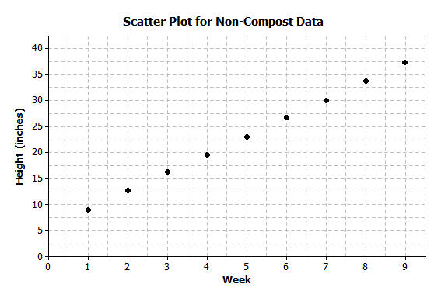
- On the grid below, construct a scatter plot of non-compost height versus week.

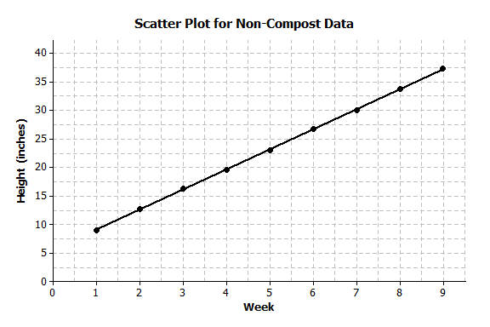
- Draw a line that you think fits the data reasonably well.

- Find the rate of change of your line. Interpret the rate of change in terms of growth (in height) over time.
Most students should have a rate of change of approximately $3.5$ inches per week. A rate of change of $3.5$ means that the median height of the eight dahlias increased by about $3.5$ inches each week.

- Describe the growth (change in height) from week to week by subtracting the previous week’s height from the current height. Record the weekly growth in the third column in the table below. The median growth for the dahlias from Week $1$ to Week $2$ was $3.75$ inches (i.e., $12.75-9.00=3.75$).
Week | Median Height in Non-Compost Bed  (inches) | Weekly Growth  (inches)
$$1$$ | $$9.00$$ | $$-$$
$$2$$ | $$12.75$$ | $$3.75$$
$$3$$ | $$16.25$$ | $$3.5$$
$$4$$ | $$19.50$$ | $$3.25$$
$$5$$ | $$23.00$$ | $$3.5$$
$$6$$ | $$26.75$$ | $$3.75$$
$$7$$ | $$30.00$$ | $$3.25$$
$$8$$ | $$33.75$$ | $$3.75$$
$$9$$ | $$37.25$$ | $$3.5$$

- As the number of weeks increases, describe how the weekly growth is changing.
The growth each week remains about the same—approximately $3.5$ inches.

- How does the growth each week compare to the slope of the line that you drew?
The amount of growth per week varies from $3.25$ to $3.75$ but centers around $3.5$, which is the slope of the line.

- Estimate the median height of the dahlias at $8\frac{1}{2}$ weeks. Explain how you made your estimate.
An estimate is $35.5$ inches. Students can use the graph, the table, or the equation of their line.

Exercises 8–14 (13 minutes)
These exercises presents a set of data that does not follow a linear pattern. Students are asked to draw a curve through the data that they think fits the data reasonably well. Students will want to connect the ordered pairs, but encourage them to draw a smooth curve. A piece of thread or string can be used to sketch a smooth curve rather than connecting the ordered pairs. In this lesson, it is not expected that students will find a function (nor are they given a function) that would fit the data. The main focus is that the rate of growth is not a constant when the data does not follow a linear pattern.
MP.7
Allow students to work in small groups to complete the exercises. Then, discuss answers as a class.
The table below shows the results of the experiment for the dahlias grown in compost beds.
Week | Median Height in Compost Bed (inches)
$$1$$ | $$10.00$$
$$2$$ | $$13.50$$
$$3$$ | $$17.75$$
$$4$$ | $$21.50$$
$$5$$ | $$30.50$$
$$6$$ | $$40.50$$
$$7$$ | $$65.00$$
$$8$$ | $$80.50$$
$$9$$ | $$91.50$$

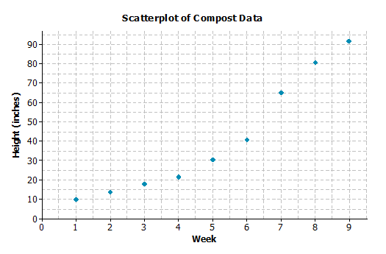
- Construct a scatter plot of height versus week on the grid below.

- Do the data appear to form a linear pattern?
No, the pattern in the scatter plot is curved.

- Describe the growth from week to week by subtracting the height from the previous week from the current height. Record the weekly growth in the third column in the table below. The median weekly growth for the dahlias from Week $1$ to Week $2$ is $3.5$ inches. (i.e., $13.5-10=3.5$).
Week | Compost Height  (inches) | Weekly Growth  (inches)
$$1$$ | $$10.00$$ | $$-$$
$$2$$ | $$13.50$$ | $$3.50$$
$$3$$ | $$17.75$$ | $$4.25$$
$$4$$ | $$21.50$$ | $$3.75$$
$$5$$ | $$30.50$$ | $$9.0$$
$$6$$ | $$40.50$$ | $$10.0$$
$$7$$ | $$65.00$$ | $$24.5$$
$$8$$ | $$80.50$$ | $$15.50$$
$$9$$ | $$91.50$$ | $$11.0$$

- As the number of weeks increases, describe how the growth changes.
The amount of growth per week varies from week to week. In Weeks $1$ through $4$, the growth is around $4$ inches each week. From Weeks $5$ to $7$, the amount of growth increases, and then the growth slows down for Weeks $8$
and $9$.

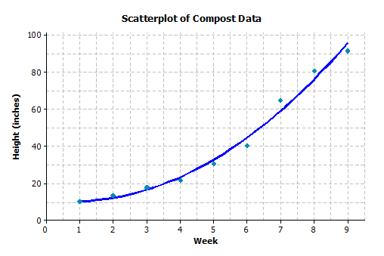
- Sketch a curve through the data. When sketching a curve, do not connect the ordered pairs, but draw a smooth curve that you think reasonably describes the data.

- Use the curve to estimate the median height of the dahlias at$8\frac{1}{2}$weeks. Explain how you made your estimate.
Answers will vary. A reasonable estimate of the median height at $8\frac{1}{2}$ weeks is approximately $85$ inches. Starting at $8\frac{1}{2}$ on the $x$-axis, move up to the curve, and then over to the $y$-axis for the estimate of the height.

- How does the weekly growth of the dahlias in the compost beds compare to the weekly growth of the dahlias in the non-compost beds?
The growth in the non-compost is about the same each week. The growth in the compost starts the same as the non-compost, but after four weeks, the dahlias begin to grow at a faster rate.

Exercise 15 (7 minutes)

- When there is a car accident how do the investigators determine the speed of the cars involved? One way is to measure the skid marks left by the car and use this length to estimate the speed.
The table below shows data collected from an experiment with a test car. The first column is the length of the skid mark (in feet) and the second column is the speed of the car (in miles per hour).
Skid-Mark Length ($ft.$) | Speed ($mph$)
$$5$$ | $$10$$
$$17$$ | $$20$$
$$65$$ | $$40$$
$$105$$ | $$50$$
$$205$$ | $$70$$
$$265$$ | $$80$$
  - Construct a scatter plot of speed versus skid-mark length on the grid below.
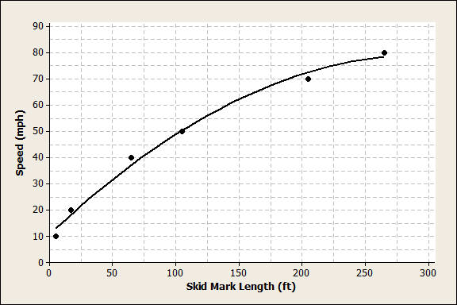
  - The relationship between speed and skid-mark length can be described by a curve. Sketch a curve through the data that best represents the relationship between skid-mark length and speed of the car. Remember to draw a smooth curve that does not just connect the ordered pairs.
See the plot above.

  - If the car left a skid mark of $60 ft.$, what is an estimate for the speed of the car? Explain how you determined the estimate.
Approximately $38 mph$. Using the graph, for a skid mark of $65 ft$. the speed was$40 mph$, so the estimate is slightly less than $40 mph$.

  - A car left a skid mark of $150 ft$. Use the curve you sketched to estimate the speed at which the car was traveling.
$$62.5 mph$$

  - If a car leaves a skid mark that is twice as long as another skid mark, was the car going twice as fast? Explain.
No, when the skid mark was$105 ft.$ long, the car was traveling $50 mph$. When skid mark was $205 ft.$ long (about twice the $105 ft.$), the car was traveling $70 mph$, which is not twice as fast.
Closing (1 minute)
Review the Lesson Summary with students.
Lesson Summary
When data follow a linear pattern, the rate of change is a constant. When data follow a nonlinear pattern, the rate of change is not constant.

Exit Ticket (8 minutes)
Name ___________________________________________________ Date____________________
Lesson 12: Nonlinear Models in a Data Context

Exit Ticket

The table shows the population of New York City from 1850–2000 for every $50$ years.
Year | Population | Population Growth (Change over $50$-year Time Period)
1850 | $$515,547$$ | $$-$$
1900 | $$3,437,202$$
1950 | $$7,891,957$$
2000 | $$8,008,278$$

- Find the growth of the population from 1850–1900. Write your answer in the table in the row for the year 1900.

- Find the growth of the population from 1900–1950. Write your answer in the table in the row for the year 1950.

- Find the growth of the population from 1950–2000. Write your answer in the table in the row for the year 2000.

- Does it appear that a linear model is a good fit for this data? Why or why not?

- Describe how the population changes as the number of years increases.

- Construct a scatter plot of time versus population on the grid below. Draw a line or curve that you feel reasonably describes the data.
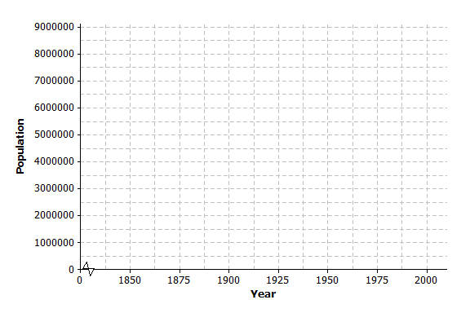

- Estimate the population of New York City in 1975. Explain how you found your estimate.

Exit Ticket Sample Solutions
The table shows the population of New York City from 1850 to 2000 for every $50$ years.
Year | Population | Population Growth (Change over $50$-Year Time Period)
1850 | $$515,547$$ | $$-$$
1900 | $$3,437,202$$ | $$2,921,655$$
1950 | $$7,891,957$$ | $$4,454,755$$
2000 | $$8,008,278$$ | $$116,321$$

- Find the growth of the population from 1850–1900. Write your answer in the table in the row for the year 1900.

- Find the growth of the population from 1900–1950. Write your answer in the table in the row for the year 1950.

- Find the growth of the population from 1950–2000. Write your answer in the table in the row for the year 2000.

- Does it appear that a linear model is a good fit for this data? Why or why not?
No, the rate of population growth is not constant; the values in the change in population column are all different. A linear model will not be a good fit for this data.

- Describe how the population changes as the years increase.
As the years increase, the change in population is increasing.

- Construct a scatter plot of time versus population on the grid below. Draw a line or curve that you feel reasonably describes the data.
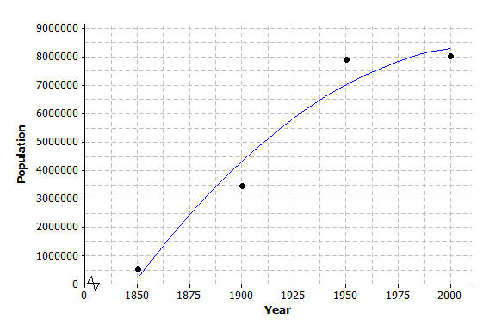
Students should sketch a curve. If students use a straight line, point out that the line will not reasonably describe the data as some of the data points will be far away from the line.

7. Estimate the population of New York City in 1975. Explain how you found your estimate.
Approximately $8,000,000$. An estimate can be found by recognizing that the growth of the city did not change very much from 1950–2000. You could also find the mean of the 1950 population and the 2000 population.
Problem Set Sample Solutions

- Once the brakes of the car have been applied, the car does not stop immediately. The distance that the car travels after the brakes have been applied is called the braking distance. The table below shows braking distance (how far the car travels once the brakes have been applied) and the speed of the car.
Speed ($mph$) | Distance Until Car Stops ($ft.$)
$$10$$ | $$5$$
$$20$$ | $$17$$
$$30$$ | $$37$$
$$40$$ | $$65$$
$$50$$ | $$105$$
$$60$$ | $$150$$
$$70$$ | $$205$$
$$80$$ | $$265$$
  - Construct a scatterplot of distance versus speed on the grid below.
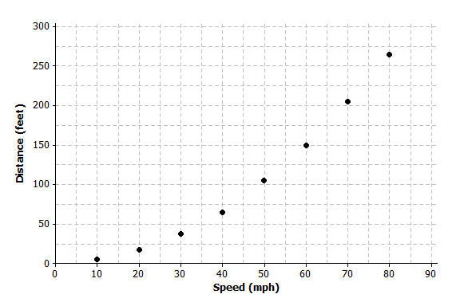
  - Find the amount of additional distance a car would travel after braking for each speed increase of $10 mph$. Record your answers in the table below.
Speed ($mph$) | Distance Until Car Stops ($ft.$) | Amount of Distance Increase
$$10$$ | $$5$$ | $$-$$
$$20$$ | $$17$$ | $$12$$
$$30$$ | $$37$$ | $$20$$
$$40$$ | $$65$$ | $$28$$
$$50$$ | $$105$$ | $$40$$
$$60$$ | $$150$$ | $$45$$
$$70$$ | $$205$$ | $$55$$
$$80$$ | $$265$$ | $$60$$

  - Based on the table, do you think the data follow a linear pattern? Explain your answer.
No, if the relationship is linear the values in the Amount of Distance Increase column would be approximately equal.

  - Describe how the distance it takes a car to stop changes as the speed of the car increases.
As the speed of the car increases, the distance it takes the car to stop also increases.
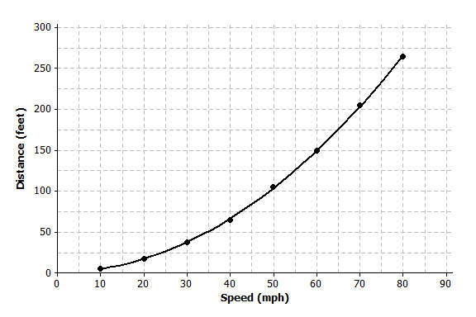
  - Sketch a smooth curve that you think describes the relationship between braking distance and speed.

  - Estimate braking distance for a car traveling at $52 mph$. Estimate braking distance for a car traveling at $75 mph$. Explain how you made your estimates.
For $52 mph$, braking distance is about $115 ft$.
For $75 mph$, braking distance is about $230 ft$.
Both estimates can be made by starting on the $x$-axis, moving up to the curve, and then moving over to the
$y$-axis for the estimate of distance.

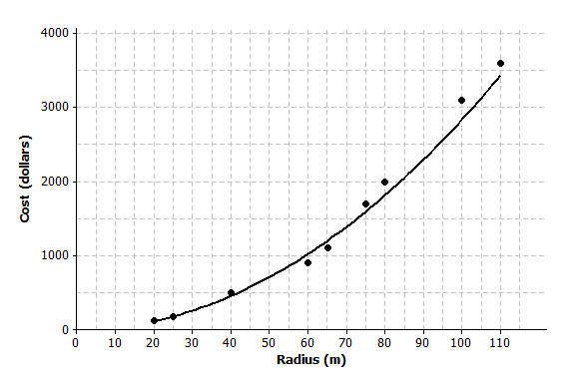
- The scatter plot below shows the relationship between cost (in dollars) and radius length (in meters) of fertilizing different sized circular fields. The curve shown was drawn to describe the relationship between cost and radius.
  - Is the curve a good fit for the data? Explain.
Yes, the curve fits the data very well. The data points lie close to the curve.

  - Use the curve to estimate the cost for fertilizing a circular field of radius $30 m$. Explain how you made your estimate.
Using the curve drawn on the graph, the cost is approximately $\$200$–$250$.

  - Estimate the radius of the field if the fertilizing cost were $\$2,500$. Explain how you made your estimate.
Using the curve, an estimate for the radius is approximately $94 m$. Locate the approximate cost of $\$2,500$. The approximate radius for that point is $94 m$.
- A dolphin is fitted with a GPS system that monitors its position in relationship to a research ship. The table below contains the time (in seconds) after the dolphin is released from the ship and the distance (in feet) the dolphin is from the research ship.
Time ($sec.$) | Distance from Ship ($ft.$) | Increase in Distance from the Ship
$$0$$ | $$0$$ | $$-$$
$$50$$ | $$85$$ | $$85$$
$$100$$ | $$190$$ | $$105$$
$$150$$ | $$398$$ | $$208$$
$$200$$ | $$577$$ | $$179$$
$$250$$ | $$853$$ | $$276$$
$$300$$ | $$1,122$$ | $$269$$
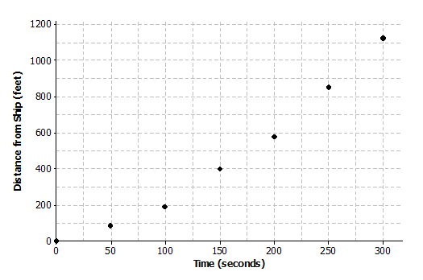
  - Construct a scatter plot of distance versus time on the grid below.

  - Find the additional distance the dolphin traveled for each increase of $50$ seconds. Record your answers in the table above.
See the table above.

  - Based on the table, do you think that the data follow a linear pattern? Explain your answer.
No, the change in distance from the ship is not constant.

  - Describe how the distance that the dolphin is from the ship changes as the time increases.
As the time away from the ship increases, the distance the dolphin is from the ship is also increasing. The farther the dolphin is from the ship, the faster it is swimming.

  - Sketch a smooth curve that you think fits the data reasonably well.
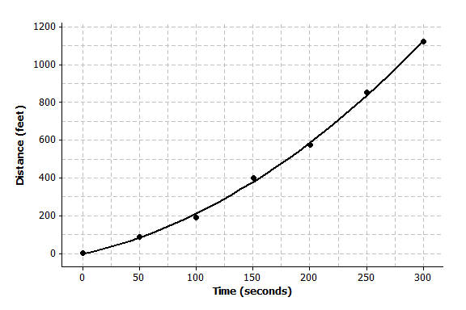

  - Estimate how far the dolphin will be from the ship after $180$ seconds? Explain how you made your estimate.
About $500 ft.$ Starting on the $x$-axis at approximately $180$ seconds, move up to the curve, and then over to the $y$-axis to find an estimate of the distance.

