Lesson 10
Objective: Use the symbols >, =, and < to compare quantities and numerals.

Suggested Lesson Structure
 Fluency Practice (15 minutes)
 Application Problem (5 minutes)
 Concept Development (30 minutes)
 Student Debrief (10 minutes)
Total Time (60 minutes)
Fluency Practice (15 minutes)
- Sprint: Number Sequences Within 40 1.NBT.3 (10 minutes)
- Digit Detective 1.NBT.3 (5 minutes)
Sprint: Number Sequences Within 40 (10 minutes)
Materials: (S) Number Sequences Within 40 Sprint
Note: In this Sprint, students recognize forward and backward counting patterns. As with all Sprints, the sequence progresses from simple to complex, with the final quadrant being the most challenging. The last four problems of this particular Sprint involve counting by twos, a Grade 2 standard. Grade 1 students who complete enough problems to encounter this challenge may use their understanding of the relationship between counting and addition to solve these problems (1.OA.5).
Digit Detective (5 minutes)
Materials: (T/S) Personal white board, place value chart (Lesson 2 Template 2)
Note: This fluency activity was conducted as a teacher-directed fluency in the previous lesson. Today, students practice in partners and compare their numbers using inequality symbols.
Students work in partners. Each student writes a number from 0 to 40 in his place value chart but does not show his/her partner. Partners then can either tell which digit is in each place or give addition or subtraction clues about the digits. Partners guess each other’s numbers and then write and say an inequality sentence comparing them. Circulate and ask questions to encourage students to realize that their inequality sentences may be different, but both may be true (e.g., 14 < 37 and 37 > 14).
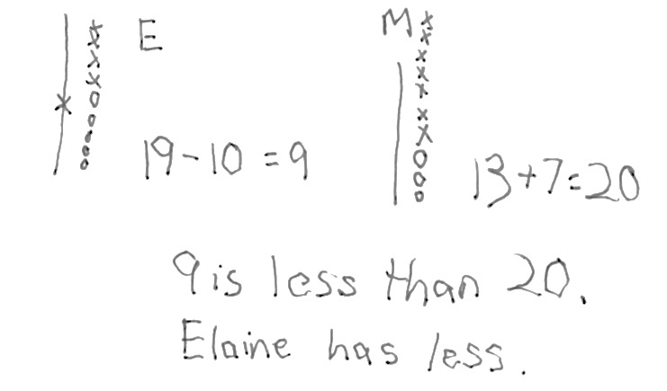
Application Problem (5 minutes)
Elaine and Mike were picking blueberries. Elaine had 19 blueberries and ate 10. Mike had 13 and picked 7 more. Compare Elaine and Mike’s blueberries after Elaine ate some and Mike picked some more.
- Use words and pictures to show how many blueberries each person has.
- Use the term greater than or less than in your statement.
Note: In this problem, students apply several elements from their previous learning, such as mentally adding 10 and using comparative language. During the Debrief, students will write the number sentence using the proper comparative symbol. If the challenge of wielding both Elaine and Mike poses too much of a challenge for your students, invite them to work in pairs and let one student be Mike, the other Elaine.

NOTES ON
MULTIPLE MEANS
OF ENGAGEMENT:
Connect learning to areas of interest. Students who enjoy writing can be given the challenge to write their own Application Problem using tens and ones. Practicing writing skills during math is a great cross-curricular activity. Students can also present their problems to the class to solve.

Concept Development (30 minutes)
Materials: (T) Double-sided alligator card (Lesson 9 Template), comparison cards (Lesson 8 Template), projector (S) Comparison cards (Lesson 8 Template), erasers, personal white board
Gather students in the meeting area with their materials.

NOTES ON
MULTIPLE MEANS
OF ENGAGEMENT:
A few students should keep the teeth on their alligators while the rest of the class removes their teeth. This will help the class see that the symbols are the same with or without teeth. The students who initially keep their teeth can be those who may need additional support reading the statements correctly. At some point during the lesson, switch the job to other students to support movement toward greater independence.

T: (Project 28 and 37 in place value charts.) Which number would the hungry alligator want to eat?
S: 37.
T: (Project or hold up the greater than alligator symbol.) Why?
S: 37 is greater than 28. There are more tens in 37 than in 28. The digit 3 in 37 shows there are more tens in 37 than there are in 28.
T: Today, we will use math symbols to compare numbers. You just said that 37 is greater than 28. (Hold up the greater than card with the symbol side showing.) I will use this math symbol to make the number sentence 37 is greater than 28. (Tape card below the alligator, and rewrite the numbers on either side of the symbol.)
T: What do you notice is similar between the alligator and the math symbol? Turn and talk with a partner.
S: The symbol looks like the alligator’s mouth. The symbol is open on the side that the alligator likes to eat.
T: We call this symbol the greater than sign.
T: (Project 15 and 18 in place value charts.) Can you figure out the symbol we will use between these numbers? Talk with a partner.
S: (Share quickly.) The less than sign!
T: We need to place the less than sign because 15 is less than 18. What does this sign look like? Draw it in the air.
S: (Draw in the air.)
T: Yes, it looks like this. (Draw or tape the less than symbol between 15 and 18.) How did you know?
S: It is like the alligator’s mouth. It should be opened toward the greater number. The smaller end points to the smaller number. The open part faces the greater number.
T: Today, let’s erase the teeth we made on our comparison cards and try to use the math symbol to make true number sentences like the two we just made.
T: We will play Compare It! again today. We need someone to remind us of the rules.
S: We play with a partner. Each of us writes a number from 0 to 40 on our personal white board, without showing our partner. When we are both ready, we put them down next to each other. For the first round, Partner A uses the cards to put the symbol between the boards.
T: Today, Partner B then reads the true number sentence that you made. Remember that we always read the number sentences from left to right. (Demonstrate with the number sentence on the board.)
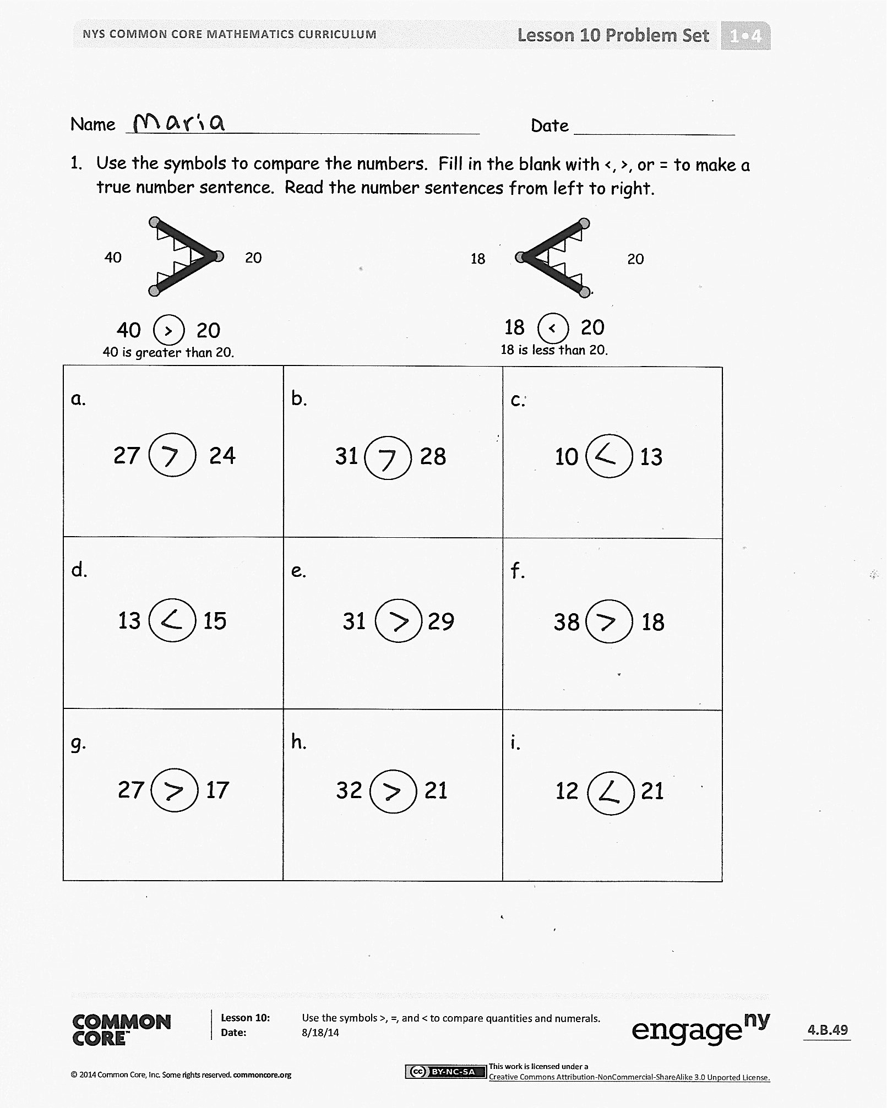
At the end of the first round, have partners use Partner B’s cards. Alternate for each round until the students have played for four minutes. During that time, circulate and notice which students are successful and which may need more support. Encourage students to make the game more challenging by varying how they represent the number, using quick tens, place value charts, and writing the numbers as tens and ones.
Problem Set (10 minutes)
Students should do their personal best to complete the Problem Set within the allotted 10 minutes. For some classes, it may be appropriate to modify the assignment by specifying which problems they work on first.

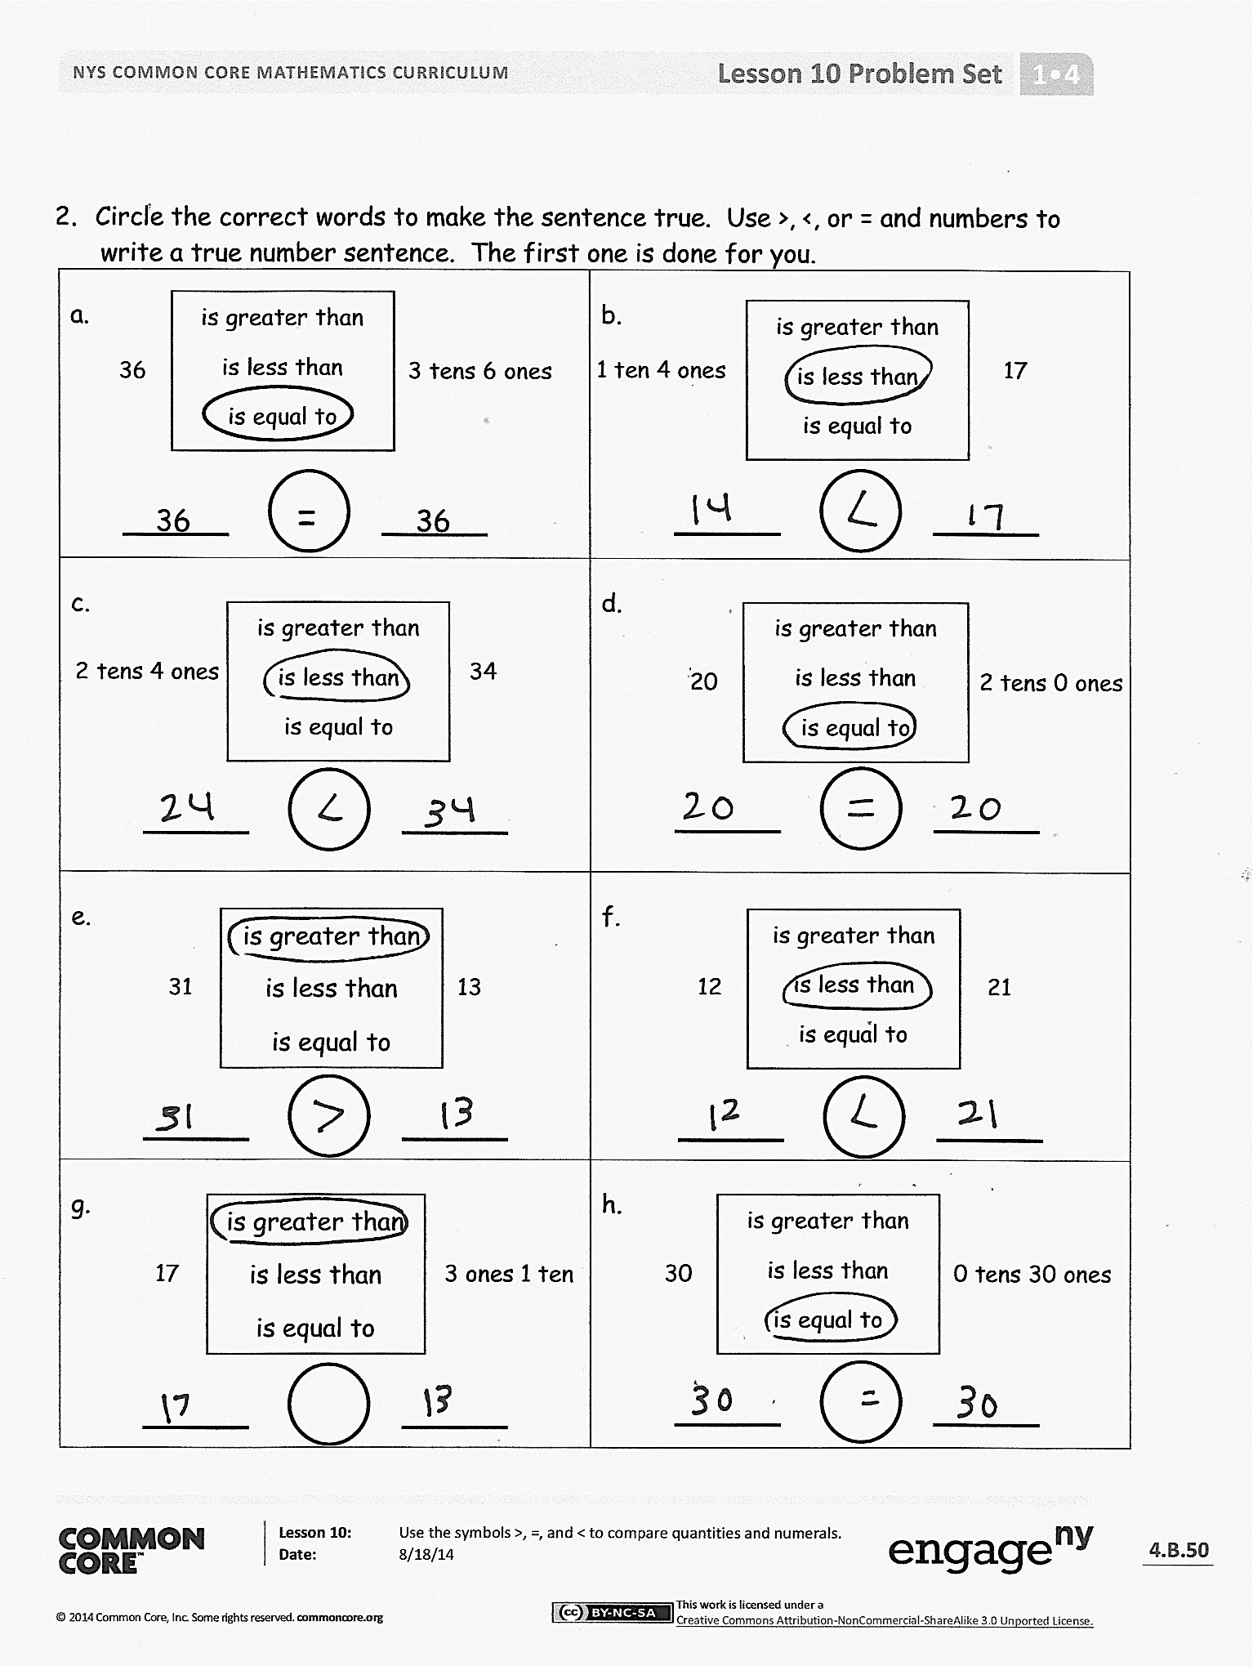
Student Debrief (10 minutes)
Lesson Objective: Use the symbols >, =, and < to compare quantities and numerals.
The Student Debrief is intended to invite reflection and active processing of the total lesson experience.
Invite students to review their solutions for the Problem Set. They should check work by comparing answers with a partner before going over answers as a class. Look for misconceptions or misunderstandings that can be addressed in the Debrief. Guide students in a conversation to debrief the Problem Set and process the lesson.
Any combination of the questions below may be used to lead the discussion.
- Look at Problems 1(a) and 1(b). How was the way you solved 1(a) different from how you solved 1(b)? Explain your thinking.
- Look at Problem 2(f). How are the numbers the same? How are they different? Compare the digit 2 in each number. How does changing the position of the digit change the value of the number?
- What are some different ways you can remember each of the symbols?
- Look at the Application Problem. How did you find the answer? Use the symbols from today’s lesson to write a number sentence that matches your statement.
Exit Ticket (3 minutes)
After the Student Debrief, instruct students to complete the Exit Ticket. A review of their work will help with assessing students’ understanding of the concepts that were presented in today’s lesson and planning more effectively for future lessons. The questions may be read aloud to the students.

Name Date
Number Correct:
A
*Write the missing number in the sequence.
1 | 0, 1, 2, __ |  | 16 | 15, __, 13, 12
2 | 10, 11, 12, __ |  | 17 | __, 24, 23, 22
3 | 20, 21, 22, __ |  | 18 | 6, 16, __, 36
4 | 10, 9, 8, __ |  | 19 | 7, __, 27, 37
5 | 20, 19, 18, __ |  | 20 | __, 19, 29, 39
6 | 40, 39, 38, __ |  | 21 | __, 26, 16, 6
7 | 0, 10, 20, __ |  | 22 | 34, __, 14, 4
8 | 2, 12, 22, __ |  | 23 | __, 20, 21, 22
9 | 5, 15, 25, __ |  | 24 | 29, __, 31, 32
10 | 40, 30, 20, __ |  | 25 | 5, __, 25, 35
11 | 39, 29, 19, __ |  | 26 | __, 25, 15, 5
12 | 7, 8, 9, __ |  | 27 | 2, 4, __, 8
13 | 7, 8, __, 10 |  | 28 | __, 14, 16, 18
14 | 17, __, 19, 20 |  | 29 | 8, __, 4, 2
15 | 15, 14, __, 12 |  | 30 | __, 18, 16, 14
Name Date
Number Correct:
B
*Write the missing number in the sequence.
1 | 1, 2, 3, __ |  | 16 | 13, __, 11, 10
2 | 11, 12, 13 __ |  | 17 | __, 22, 21, 20
3 | 21, 22, 23 __ |  | 18 | 5, 15, __, 35
4 | 10, 9, 8, __ |  | 19 | 4, __, 24, 34
5 | 20, 19, 18, __ |  | 20 | __, 17, 27, 37
6 | 30, 29, 28, __ |  | 21 | __, 29, 19, 9
7 | 0, 10, 20, __ |  | 22 | 31, __, 11, 1
8 | 3, 13, 23, __ |  | 23 | __, 30, 31, 32
9 | 6, 16, 26, __ |  | 24 | 19, __, 21, 22
10 | 40, 30, 20, __ |  | 25 | 5, __, 25, 35
11 | 38, 28, 18, __ |  | 26 | __, 25, 15, 5
12 | 6, 7, 8, __ |  | 27 | 2, 4, __, 8
13 | 6, 7, __, 9 |  | 28 | __, 12, 14, 16
14 | 16, __, 18, 19 |  | 29 | 12, __, 8, 6
15 | 16, __, 14, 13 |  | 30 | __, 20, 18, 16

Name Date
- Use the symbols to compare the numbers. Fill in the blank with <, >, or = to make a true number sentence. Read the number sentences from left to right.
a.  27 24  27 is ________ than 24. | b.  31 28  31 is ________ than 28. | c.  10 13  13 is ________ than 10.
d.  13 15  13 is ________ than 15. | e.  31 29  31 is ________ than 29. | f.  38 18  8 is ________ than 18.
g.  27 17  27 is ________ than 17. | h.  32 21  32 is ________ than 21. | i.  12 21  12 is ________ than 21.
18
20
18 < 20
18 is less than 20.
40
20
40 > 20
40 is greater than 20.

2. Circle the correct words to make the sentence true. Use >, <, or = and numbers to
write a true number sentence. The first one is done for you.
a.  36 3 tens 6 ones  is greater than  is less than  is equal to  1 ten 4 ones 17  is greater than  is less than  is equal to  36 = 36 | b.
c.  2 tens 4 ones 34  is greater than  is less than  is equal to | d.  20 2 tens 0 ones  is greater than  is less than  is equal to
e. | f.  31 13  is greater than  is less than  is equal to  12 21  is greater than  is less than  is equal to
g.  17 3 ones 1 ten  is greater than  is less than  is equal to | h.  30 0 tens 30 ones  is greater than  is less than  is equal to

Name Date
Circle the correct words to make the sentence true. Use >, <, or = and numbers to write a true number sentence.
a.  29 2 tens 6 ones  is greater than  is less than  is equal to  1 ten 8 ones 19  is greater than  is less than  is equal to | b.
c.  2 tens 9 ones 40  is greater than  is less than  is equal to | d.  is greater than  is less than  is equal to  39 4 tens 0 ones

Name Date
- Use the symbols to compare the numbers. Fill in the blank with <, >, or = to make a true number sentence. Complete the number sentence with a phrase from the word bank.
Word Bank
18
20
18 < 20
18 is less than 20.
40
20
40 > 20
40 is greater than 20.
is greater than
is less than
is equal to

.
32 23
32 ____________ 23
38 28
38 ____________ 28
36 36
36 ____________ 36
25 32
25 ____________ 32
e.
f.
c.
d.
b.
a.
17 13
17 ____________ 13
23 33
23____________ 33
3 tens 30 33
3 tens __________ 30
g.
h.
1 ten 5 ones 14
1 ten 5 ones _______ 14
3 tens 36 33
3 tens ___________36
4 tens 39
4 tens ___________ 39

19 2 tens 3 ones
19 _________2 tens 3 ones
j.
i.
29 2 tens 7 ones
29 _______ 2 tens 7 ones

35 3 tens 5 ones
35 _________ 3 tens 5 ones
3 tens 1 one 13
3 tens 1 one __________ 13
k.
l.

2 tens 3 ones 32 13
2 tens 3 ones ________ 32
n.
m.
29 3 tens 9 ones
29 _______ 3 tens 9 ones
o.
p.

