Lesson 9: Determining the Equation of a Line Fit to Data

Classwork

**Example 1: Crocodiles and Alligators**

Scientists are interested in finding out how different species adapt to finding food sources. One group studied crocodilian to find out how their bite force was related to body mass and diet. The table below displays the information they collected on body mass (in pounds) and bite force (in pounds).

**Crocodilian Biting**

|  |  |  |
| --- | --- | --- |
| **Species** | **Body Mass (pounds)** | **Bite Force (pounds)** |
| Dwarf Crocodile |  |  |
| Crocodile F |  |  |
| Alligator A |  |  |
| Caiman A |  |  |
| Caiman B |  |  |
| Caiman C |  |  |
| Crocodile A |  |  |
| Nile Crocodile |  |  |
| Crocodile B |  |  |
| Crocodile C |  |  |
| Crocodile D |  |  |
| Caiman D |  |  |
| Indian Gharial Crocodile |  |  |
| Crocodile G |  |  |
| American Crocodile |  |  |
| Crocodile D |  |  |
| Crocodile E |  |  |
| American Alligator |  |  |
| Alligator B |  |  |
| Alligator C |  |  |

Data Source: PLoS One Greg Erickson biomechanics, Florida State University

As you learned in the previous lesson, it is a good idea to begin by looking at what a scatter plot tells you about the data. The scatter plot below displays the data on body mass and bite force for the crocodilian in the study.

Exercises 1–6

1. Describe the relationship between body mass and bite force for the crocodilian shown in the scatter plot.
2. Draw a line to represent the trend in the data. Comment on what you considered in drawing your line.
3. Based on your line, predict the bite force for a crocodilian that weighs pounds. How does this prediction compare to the actual bite force of the -pound crocodilian in the data set?
4. Several students decided to draw lines to represent the trend in the data. Consider the lines drawn by Sol, Patti, Marrisa, and Taylor, which are shown below.

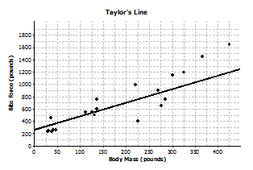

For each student, indicate whether or not you think the line would be a good line to use to make predictions. Explain your thinking.

1. Sol’s line
2. Patti’s line
3. Marrisa’s line
4. Taylor’s line
5. What is the equation of your line? Show the steps you used to determine your line. Based on your equation, what is your prediction for the bite force of a crocodilian weighing pounds?
6. Patti drew vertical line segments from two points to the line in her scatter plot. The first point she selected was for a Dwarf Crocodile. The second point she selected was for an Indian Gharial Crocodile.



* 1. Would Patti’s line have resulted in a predicted bite force that was closer to the actual bite force for the Dwarf Crocodile or for the Indian Gharial Crocodile? What aspect of the scatter plot supports your answer?
  2. Would it be preferable to describe the trend in a scatter plot using a line that makes the differences in the actual and predicted values large or small? Explain your answer.

Exercise 7: Used Cars

1. The plot below shows the age (in years) and price (in dollars) of used Honda Civic cars that were advertised in a local newspaper.



* 1. Based on the scatter plot above, describe the relationship between the age and price of the used cars.
  2. Nora drew a line she thought was close to many of the points and found the equation of the line. She used the points and on her line to find the equation. Explain why those points made finding the equation easy.
  3. Find the equation of Nora’s line for predicting the price of a used car given its age. Summarize the trend described by this equation.
  4. Based on the line, for which car in the data set would the predicted value based on the line be farthest from the actual value? How can you tell?
  5. What does the equation predict for the cost of a -year-old car? How close was the prediction using the line to the actual cost of the -year-old car in the data set? Given the context of the data set, do you think the difference between the predicted price and the actual price is large or small?
  6. Is typical of the differences between predicted prices and actual prices for the cars in this data set? Justify your answer.

Lesson Summary

* A line can be used to represent the trend in a scatter plot.
* Evaluating the equation of the line for a value of the independent variable will determine a value predicted by the line.
* A good line for prediction is one that goes through the middle of the points in a scatter plot and for which the points tend to fall close to the line.

Problem Set

1. Monopoly is a popular board game in many countries. The scatter plot below shows the distance from “Go” to a property (in number of spaces moving from “Go” in a clockwise direction) and the price of the properties on the Monopoly board. The equation of the line is , where represents the price (in Monopoly dollars) and represents the distance (in number of spaces).

|  |  |  |  |  |
| --- | --- | --- | --- | --- |
| **Distance from “Go”**  **(number of spaces)** | **Price of Property**  **(Monopoly dollars)** |  | **Distance from “Go”**  **(number of spaces)** | **Price of Property**  **(Monopoly dollars)** |
|  |  |  |  |  |
|  |  |  |  |  |
|  |  |  |  |  |
|  |  |  |  |  |
|  |  |  |  |  |
|  |  |  |  |  |
|  |  |  |  |  |
|  |  |  |  |  |
|  |  |  |  |  |
|  |  |  |  |  |
|  |  |  |  |  |
|  |  |  |  |  |
|  |  |  |  |  |
|  |  |  |  |  |

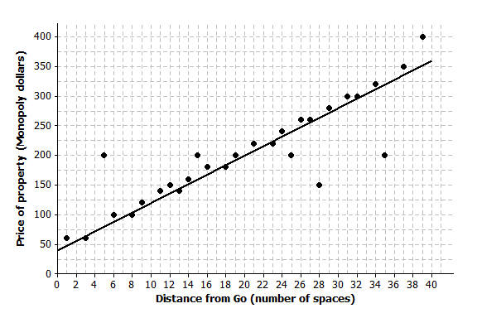**Price of Property vs. Distance from “Go” in Monopoly**

* 1. Use the equation to find the difference (observed value predicted value) for the most expensive property and for the property that is spaces from “Go.”
  2. Five of the points seem to lie in a horizontal line. What do these points have in common? What is the equation of the line containing those five points?
  3. Four of the five points described in part (b) are the railroads. If you were fitting a line to predict price with distance from “Go,” would you use those four points? Why or why not?

1. The table below gives the coordinates of the five points shown in the scatter plots that follow. The scatter plots show two different lines.

|  |  |  |
| --- | --- | --- |
| **Data Point** | **Independent Variable** | **Response Variable** |
|  |  |  |
|  |  |  |
|  |  |  |
|  |  |  |
|  |  |  |

Line 1 Line 2



* 1. Find the predicted response values for each of the two lines.

|  |  |  |  |
| --- | --- | --- | --- |
| **Independent** | **Observed Response** | **Response Predicted by Line 1** | **Response Predicted by Line 2** |
|  |  |  |  |
|  |  |  |  |
|  |  |  |  |
|  |  |  |  |
|  |  |  |  |

* 1. For which data points is the prediction based on Line 1 closer to the actual value than the prediction based on Line 2?
  2. Which line (Line 1 or Line 2) would you select as a better fit?

1. The scatter plots below show different lines that students used to model the relationship between body mass (in pounds) and bite force (in pounds) for crocodilian.
   1. Match each graph to one of the equations below and explain your reasoning. Let represent bite force (in pounds) and represent body mass (in pounds).

|  |  |  |
| --- | --- | --- |
| Equation 1 | Equation 2 | Equation 3 |
|  |  |  |

|  |  |
| --- | --- |
| **Equation:** |  |
| **Equation:** |  |
| **Equation:** |  |

* 1. Which of the lines would best fit the trend in the data? Explain your thinking.

1. Comment on the following statements:
   1. A line modeling a trend in a scatter plot always goes through the origin.
   2. If the response variable increases as the independent variable decreases, the slope of a line modeling the trend will be negative.