Lesson 8
Objective: Compare quantities and numerals from left to right.

Suggested Lesson Structure
 Fluency Practice (13 minutes)
 Application Problem (5 minutes)
 Concept Development (32 minutes)
 Student Debrief (10 minutes)
Total Time (60 minutes)
Fluency Practice (13 minutes)
- Subtraction with Cards 1.OA.6 (5 minutes)
- Core Subtraction Fluency Review 1.OA.6 (5 minutes)
- Beep Counting by Ones and Tens 1.OA.5, 1.NBT.3 (3 minutes)
Subtraction with Cards (5 minutes)
Materials: (S) 1 pack of numeral cards 0–10 per set of partners (Lesson 4 Fluency Template)
Note: This fluency activity reviews yesterday’s lesson and provides practice with subtraction within 10. Students’ fluency with these facts will be assessed after this game.
Students combine their numeral cards and place them facedown between them. Each partner flips over two cards and subtracts the smaller number from the larger one. The partner with the smallest difference says a less than sentence and keeps the cards played by both players. If both players have the same difference, each partner flips two more cards, and the player with the smaller difference says a less than sentence and keeps all the cards. The player with the most cards at the end of the game wins.
Core Subtraction Fluency Review (5 minutes)
Materials: (S) Core Subtraction Fluency Review
Note: This subtraction review sheet contains the majority of subtraction facts within 10 (excluding some –0 and –1 facts), which are part of the required core fluency for Grade 1. Consider using this sheet to monitor progress toward mastery.
Students complete as many problems as they can in three minutes. Choose a counting sequence for early finishers to practice on the back of their papers. When time runs out, read the answers aloud so students can correct their work. Encourage students to remember how many they got correct today, so they can try to improve their scores on future Core Subtraction Fluency Reviews.
Beep Counting by Ones and Tens (3 minutes)
Say a series of four numbers, but replace one of the numbers with the word beep (e.g., 1, 2, 3, beep). When signaled, students say the number that was replaced by the word beep in the sequence. Scaffold number sequences, beginning with easy sequences and moving to more complex ones. Choose sequences that count forward and backward by ones and tens within 40.
Suggested sequence type: 10, 11, 12, beep; 20, 21, 22, beep; 20, 19, 18, beep; 30, 29, 28, beep; 0, 10, 20, beep; 1, 11, 21, beep; 40, 30, 20, beep; 39, 29, 19, beep. Continue with similar sequences, changing the sequential placement of the beep.
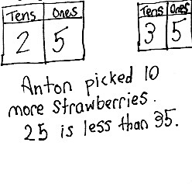
Application Problem (5 minutes)
Anton picked 25 strawberries. He picked some more strawberries.
Then, he had 35 strawberries.
- Use a place value chart to show how many more strawberries Anton picked.
- Write a statement comparing the two amounts of strawberries using one of these phrases: greater than, less than, or equal to.
Note: In this add to with change unknown problem, students are now asked to use their understanding of place value to identify how many more strawberries Anton picked and compare the beginning and ending quantities.
Concept Development (32 minutes)
Materials: (T) Comparison cards (Template) (S) Comparison cards (Template), personal white board,
ten-sticks and coins from personal math toolkit
Note: For this lesson, use the word side of the comparison cards. The symbol side will be used in future lessons.
Project the following two sequences on the board, both of which were used in today’s beep counting: 10, 11, 12, 13 and 40, 30, 20, 10.

NOTES ON
MULTIPLE MEANS
OF REPRESENTATION:
Be sure English language learners understand the word compare. Remind students about comparing the length of objects as they did in Module 3, and show some concrete examples. Help students make the connection between comparing length and comparing numbers.

T: You said these numbers during beep counting. What is different about them?
S: One set goes up, and one set goes down. In one set, we count up by ones, and in the other, we count down by tens.
T: What does “goes up” mean?
S: The numbers get bigger.
T: Let’s use our math language to explain that. Who remembers the words we used yesterday when we were comparing two numbers?
S: Greater than. Less than. Equal to.
T: Are you saying this number (point to 10) is less than or greater than 11 (point to 11)?
S: Less than.
T: What about the next numbers? 11 is…?
S: Less than 12.
T: Let’s say the whole sequence and use the comparison words as we compare each number in the set.
S/T: (Continue pointing to each number.) 10 is less than 11. 11 is less than 12. 12 is less than 13.
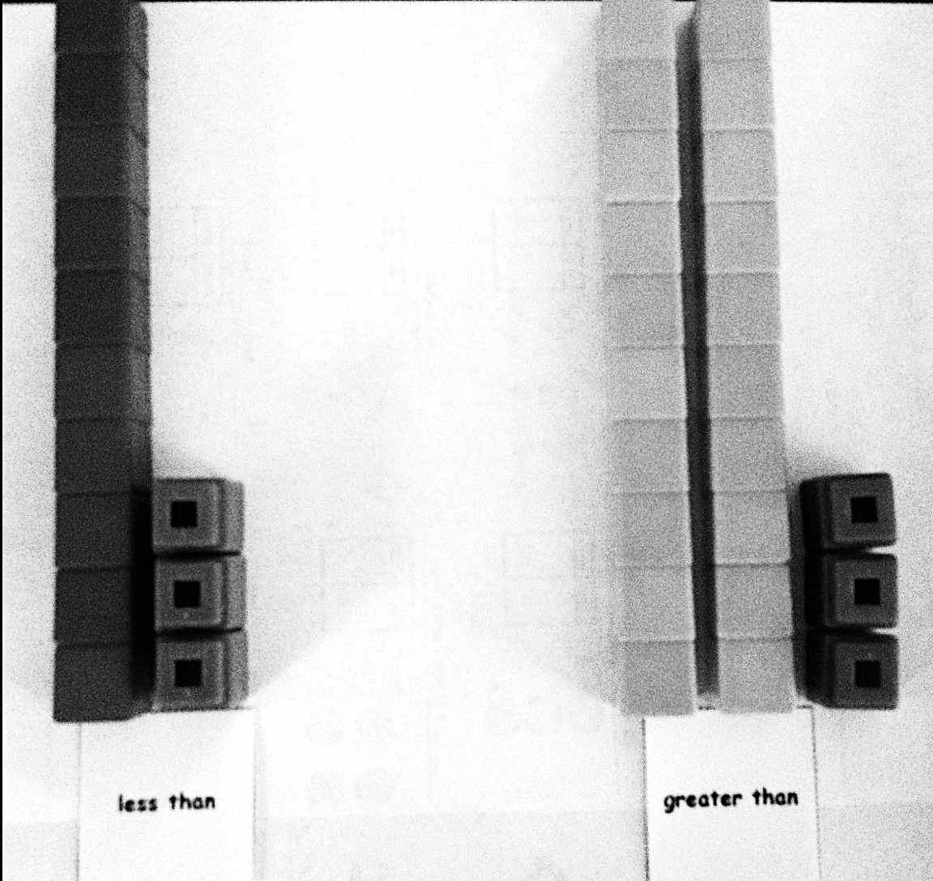
T: When we compare numbers using words, we read from left to right, just like when we are reading a sentence in a book or when we are reading a number sentence.
T: 40, 30, 20, 10 is in a different order. Turn to your partner and discuss which word we will use when comparing them. Remember, we start with 40.
S: (Discuss.) Greater than!
T: Let’s read the whole sequence, using greater than to compare the number pairs as we go.
S/T: 40 is greater than 30. 30 is greater than 20. 20 is greater than 10.
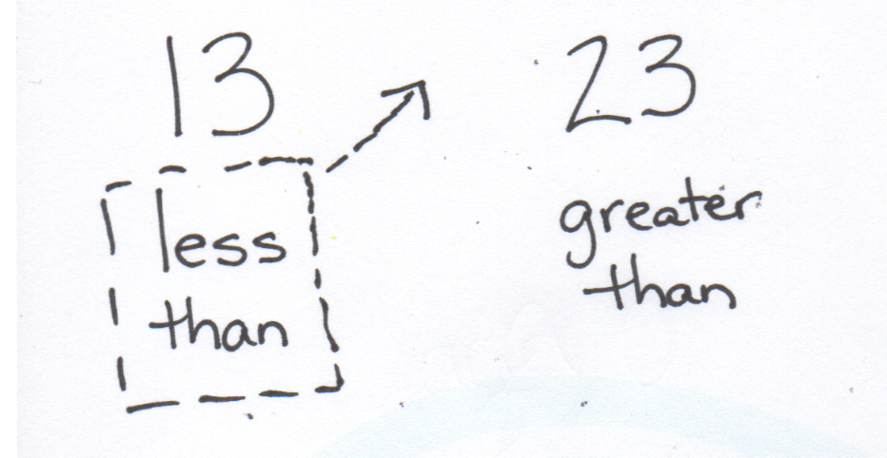
T: Today, we are reading left to right when we compare numbers. (Distribute comparison cards to students. Write 13 and 23 on the board.) Partner A (seated on the left), show 13 with your ten-sticks. Partner B, show 23 with your ten-sticks. Find the card with the comparison words that show how your number compares to your partner’s number and put it below your ten-sticks.
S: (Partners place cubes and cards.)
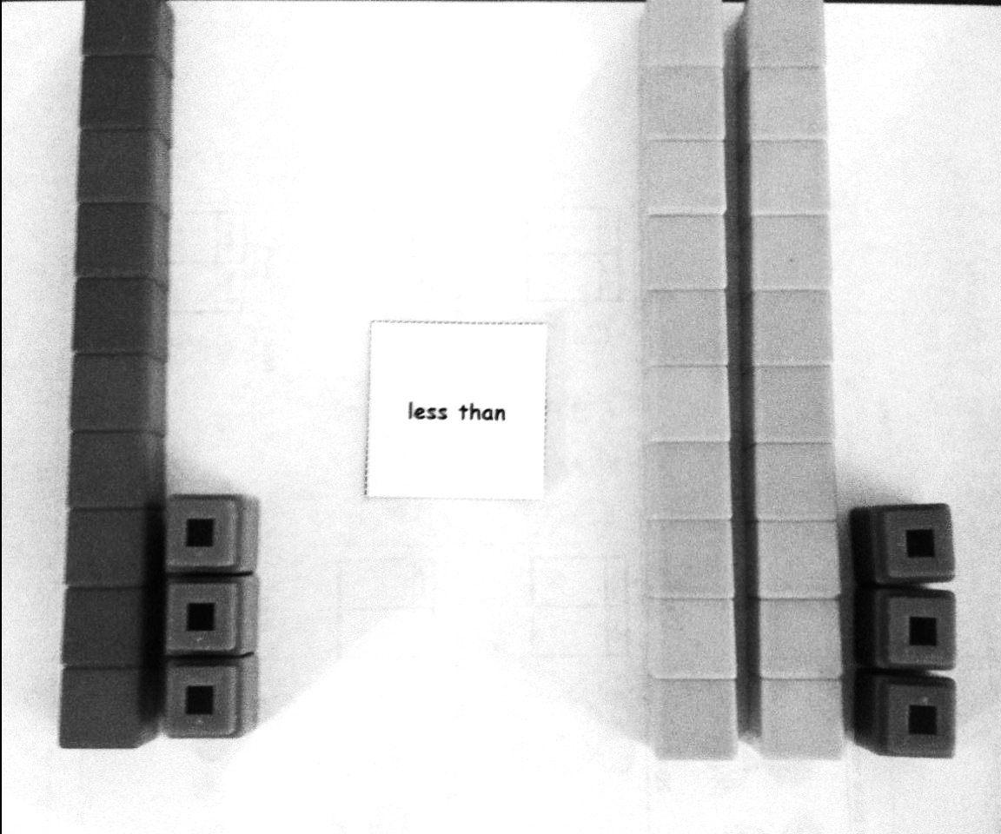
T: I see these cards under your numbers. (Write less than under 13 and greater than under 23.) To read this from left to right, we would say 13 is…?
S: Less than 23.
T: Yes, less than. Let’s move the less than card between our numbers. We’ll read together. (Move card between 13 and 23.)
S/T: 13 is less than 23.
Repeat the process with the following suggested sequence:
15 and 19, 21 and 19, 3 tens 5 ones and 2 tens 8 ones, 21 and 31, 18 and 9, 38 and 12, and 27 and 19. Move quickly to quick ten drawings or no visual supports as appropriate for the group of students. Grouping students by readiness levels will make this easier.

NOTES ON
MULTIPLE MEANS
OF ACTION AND EXPRESSION:
Some students may still need concrete models after others are ready to move on. When moving to using numbers only, ask the students who need more concrete support to be class helpers by modeling the numbers with linking cubes.

T: Does anyone else notice something interesting about which card we have been using when we read the comparison from left to right?
S: We always use Partner A’s card!
T: Do we even need Partner B’s card to say our comparison sentence?
S: No!
T: Okay, switch spots so that we can use Partner B’s card. (Partners switch spaces so that Partner B is sitting on the left.)
Repeat the process with the following suggested sequence:
14 and 17, 3 tens and 2 tens, 2 tens 9 ones and 3 tens, 24 and 38, and 34 and 28. This time, only Partner B should use the comparison cards, since it has been determined that only the comparison card on the left gets moved into the middle to read the comparison sentence.

NOTES ON
MULTIPLE MEANS
OF REPRESENTATION:
Highlight the critical vocabulary for English language learners while teaching the lesson by showing objects as a visual. In this lesson, vocabulary that must be highlighted includes in order, in front of, before, and between. Without understanding these words, English language learners will have difficulty placing numbers into the tens sequence.

T: (Leave 34 and 28 on display.) Which digit in each number did you look at first to compare them?
S: We looked at the digit in the tens place!
T: Why do we look at the tens place first when we compare two numbers? Turn and talk to your partner.
S: The digit 3 in 34 stands for 30. The digit 2 in 24 stands for 20. 30 is greater than 20. Even if there were 9 ones, that’s still less than a ten.
T: (Write the multiples of 10 from 0 to 40 across the board, with space in between the numbers. Write the following five numbers above the sequence:
29, 38, 7, 14, and 24.) If I want to place these numbers into this set of numbers, in order, where would they go? Where would I put 29?
S: In front of the 30. It’s less than 30. (Write 29 between 20 and 30.)
T: Where would I put 38?
S: Between 30 and 40. It’s greater than 30 and less than 40. (Write 38 between 30 and 40. Continue with this process until all the numbers are placed.)
T: (Leave this sequence on the board. Write the numbers 40, 30, 20, 10, and 0 on the board with space in between the numbers.) Let’s put those same numbers, in order, into this set.
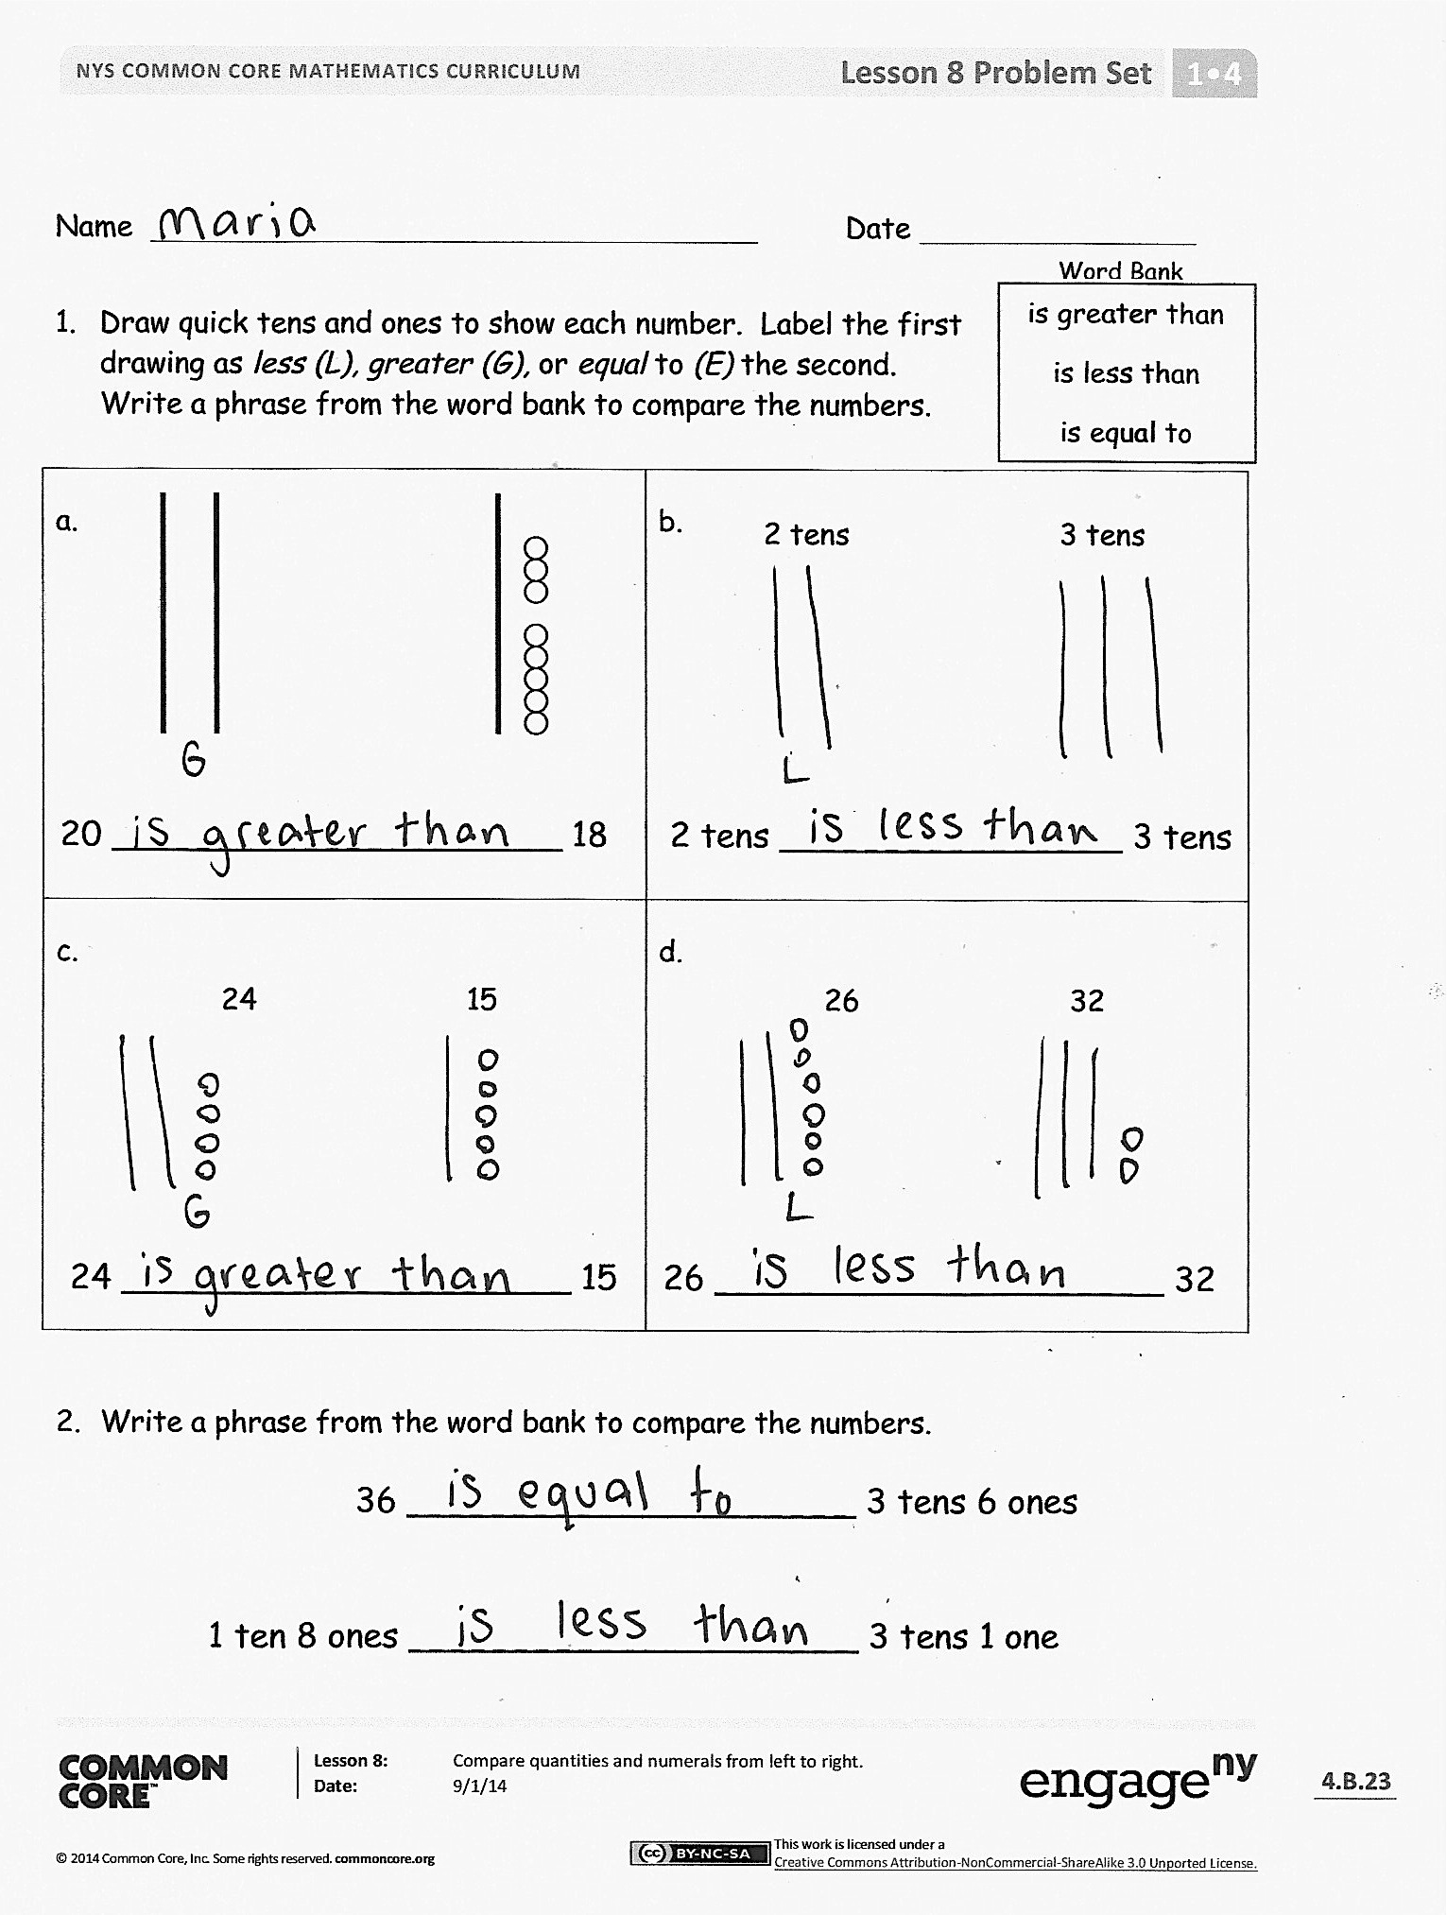
T: Where does 29 go now?
S: Between the 30 and 20. 29 is less than 30. It’s greater than 20. (Place the numbers in order in the sequence.)
T: Let’s read the first sequence we made, starting on the...?
S: Left!
S/T: (Point to the numbers as students read the sequence.) 0 is less than 7. 7 is less than 10. (Continue through the sequence.)
T: What will we say when we are comparing the numbers in the second set?
S: Greater than!
S/T: (Point to the numbers as students read the sequence.) 40 is greater than 38. 38 is greater than 30. (Continue through the sequence.)
Problem Set (10 minutes)
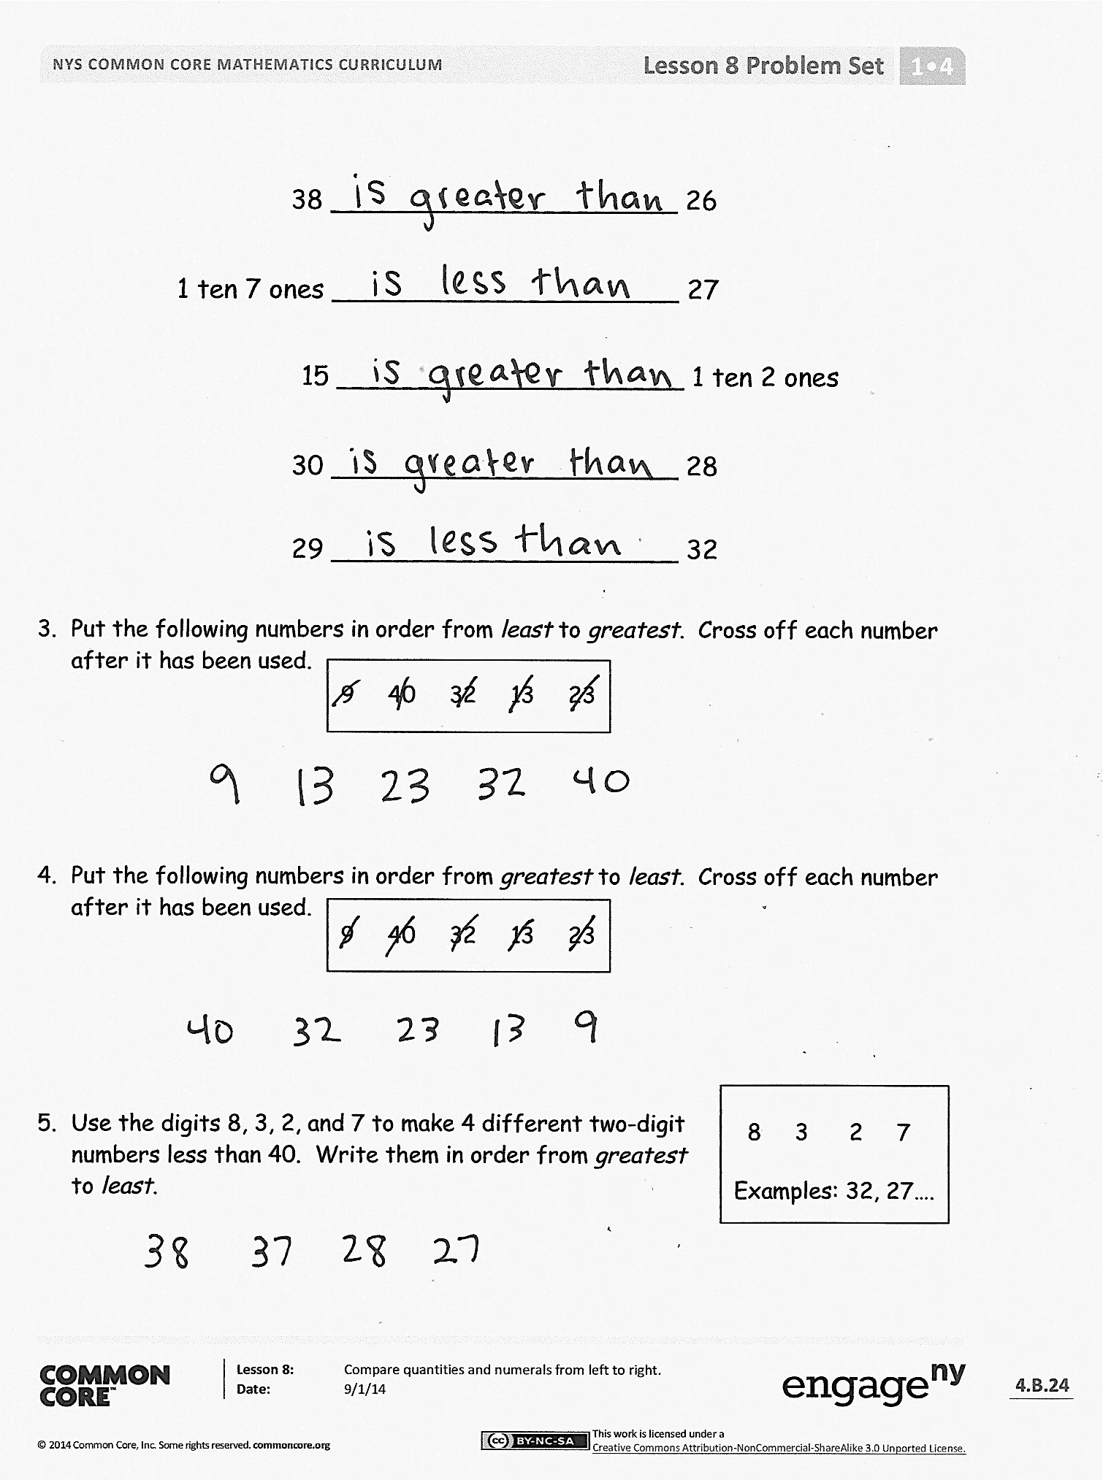
In this Problem Set, students order numbers from least to greatest and greatest to least. It would be helpful to review the meaning of the words least and greatest to prepare students to answer these questions. Students should do their personal best to complete the Problem Set within the allotted 10 minutes. For some classes, it may be appropriate to modify the assignment by specifying which problems they work on first.
Student Debrief (10 minutes)
Lesson Objective: Compare quantities and numerals from left to right.
The Student Debrief is intended to invite reflection and active processing of the total lesson experience.
Invite students to review their solutions for the Problem Set. They should check work by comparing answers with a partner before going over answers as a class. Look for misconceptions or misunderstandings that can be addressed in the Debrief. Guide students in a conversation to debrief the Problem Set and process the lesson.

Any combination of the questions below may be used to lead the discussion.
- Look at Problem 2. Use math drawings, materials, or place value charts to prove your solution for
36 _______ 3 tens 6 ones.
- How did Problem 3 help you solve Problem 4? What is the same about these two problems? What is different?
- Rewrite your statement for the Application Problem using only numbers and the phrase greater than or less than to compare the two sets of strawberries. Start with Anton’s strawberries.
- Share your solution to Problem 5 with your partner. Did you have the same solution? If your solutions were different, explain how they could both be correct.
Exit Ticket (3 minutes)
After the Student Debrief, instruct students to complete the Exit Ticket. A review of their work will help with assessing students’ understanding of the concepts that were presented in today’s lesson and planning more effectively for future lessons. The questions may be read aloud to the students.

Name Date
Core Subtraction Fluency Review
1. | 8 - 0 = ___ | 16. | 9 - 3 = ___ | 31. | 5 - 5 = ___
2. | 8 – 1 = ___ | 17. | 10 - 3 = ___ | 32. | 6 - 5 = ___
3. | 7 - 7 = ___ | 18. | 10 - 4 = ___ | 33. | 7 - 5 = ___
4. | 3 - 3 = ___ | 19. | 10 - 2 = ___ | 34. | 8 - 5 = ___
5. | 3 - 2 = ___ | 20. | 10 – 8 = ___ | 35. | 8 - 4 = ___
6. | 4 - 2 = ___ | 21. | 10 - 7 = ___ | 36. | 10 - 5 = ___
7. | 5 - 2 = ___ | 22. | 10 - 6 = ___ | 37. | 9 - 5 = ___
8. | 5 - 3 = ___ | 23. | 6 - 6 = ___ | 38. | 9 - 4 = ___
9. | 9 - 2 = ___ | 24. | 7 - 7 = ___ | 39. | 6 - 3 = ___
10. | 8 - 2 = ___ | 25. | 7 - 6 = ___ | 40. | 6 - 4 = ___
11. | 7 - 2 = ___ | 26. | 8 - 8 = ___ | 41. | 7 - 3 = ___
12. | 4 - 4 = ___ | 27. | 8 - 7 = ___ | 42. | 7 - 4 = ___
13. | 4 - 3 = ___ | 28. | 9 - 9 = ___ | 43. | 8 - 6 = ___
14. | 5 - 4 = ___ | 29. | 9 - 8 = ___ | 44. | 9 - 6 = ___
15. | 8 - 3 = ___ | 30. | 10 - 9 = ___ | 45. | 9 - 7 = ___

Name Date
Word Bank
- Draw quick tens and ones to show each number. Label the first drawing as less (L), greater (G), or equal to (E) the second. Write a phrase from the word bank to compare the numbers.
is greater than
is less than
is equal to

2 tens 3 tens
2 tens ________________ 3 tens
20 _____________________ 18
a. | b.
c. | d.
24 15
26 32
24 _____________________ 15
26 _____________________ 32
- Write a phrase from the word bank to compare the numbers.
1 ten 8 ones _____________________ 3 tens 1 one
36 _____________________ 3 tens 6 ones
38 _____________________ 26
1 ten 7 ones _____________________ 27
15 _____________________ 1 ten 2 ones
30 _____________________ 28
29 _____________________ 32

- Put the following numbers in order from least to greatest. Cross off each number after it has been used.
9 40 32 13 23

- Put the following numbers in order from greatest to least. Cross off each number after it has been used.
9 40 32 13 23

8 3 2 7
Examples: 32, 27….
- Use the digits 8, 3, 2, and 7 to make 4 different two-digit numbers less than 40. Write them in order from greatest to least.

Name Date
- Write the numbers in order from greatest to least.
30
29
39
40

- Complete the sentence frames using the phrases from the word bank to compare the two numbers.
Word Bank
is greater than
is less than
is equal to
17 __________________________ 24
a.

b.
23 __________________________ 2 tens 3 ones
29 __________________________ 20

c.

Name Date
Word Bank
- Draw the numbers using quick tens and circles. Use the phrases from the word bank to complete the sentence frames to compare the numbers. The first one has been done for you.
is greater than
is less than
is equal to

20 30  is less than  20 ___________________ 30 | 14 22  14 __________________ 22
15 1 ten 5 ones  15 ________________ 1 ten 5 ones | 39 29  39 _____________________ 29
31 13  31 ___________________ 13 | 23 33  23 ____________________ 33
2. Circle the numbers that are greater than 28.
32 29 2 tens 8 ones 4 tens 18
3. Circle the numbers that are less than 31.
29 3 tens 6 ones 3 tens 13 3 tens 9 ones
4. Write the numbers in order from least to greatest.
23
29
32
30

Where would the number 27 go in this order? Use words or rewrite the numbers to explain.

5. Write the numbers in order from greatest to least.
40
31
13
30

Where would the number 23 go in this order? Use words or rewrite the numbers to explain.

- Use the digits 9, 4, 3, and 2 to make 4 different
two-digit numbers less than 40. Write them in order from least to greatest.
9 3 4 2
Examples: 34, 29…
> | < | = | <
> | < | = | >
> | < | = | =
> | < | =

less than | equal to | less than | greater than
greater than | equal to | less than | greater than
equal to | equal to | less than | greater than
 | equal to | less than | greater than

comparison cards, p. 1. Print double-sided on cardstock. Distribute each of the three cards to students.
comparison cards, p. 2. Print double-sided on cardstock. Distribute each of the three cards to students.

