Lesson 7
Objective: Compare two quantities, and identify the greater or lesser of the two given numerals.

Suggested Lesson Structure
 Fluency Practice (16 minutes)
 Application Problem (5 minutes)
 Concept Development (29 minutes)
 Student Debrief (10 minutes)
Total Time (60 minutes)
Fluency Practice (16 minutes)
- 1 More/Less, 10 More/Less 1.NBT.5 (6 minutes)
- Sprint: +1, –1, +10, –10 1.NBT.5 (10 minutes)
1 More/Less, 10 More/Less (6 minutes)
Materials: (S) Personal math toolkit (4 ten-sticks, 4 dimes, and 10 pennies), personal white board, large place value chart (Fluency Template)
Note: This fluency activity provides practice with both proportional (linking cubes) and non-proportional (coins) representations of tens and ones. Students review the connection between place value and adding or subtracting ten or one.
T: Show 20 cubes. Add 1. Say the addition sentence, starting with 20.
S: 20 + 1 = 21.
T: Add 10. Say the addition sentence, starting with 21.
S: 21 + 10 = 31.
T: Subtract 1. Say the subtraction sentence, starting with 31.
S: 31 – 1 = 30.
T: Show 39. Add 1. Say the addition sentence, starting with 39.
S: 39 + 1 = 40.
Continue adding or subtracting 10 or 1, choosing different start numbers within 40, as appropriate. After three minutes, use coins instead of linking cubes. When using coins, be careful not to ask students to subtract 1 from a multiple of 10, as students have not yet learned to subtract by decomposing a dime into 10 pennies.
Sprint: +1, –1, +10, –10 (10 minutes)
Materials: (S) +1, –1, +10, –10 Sprint
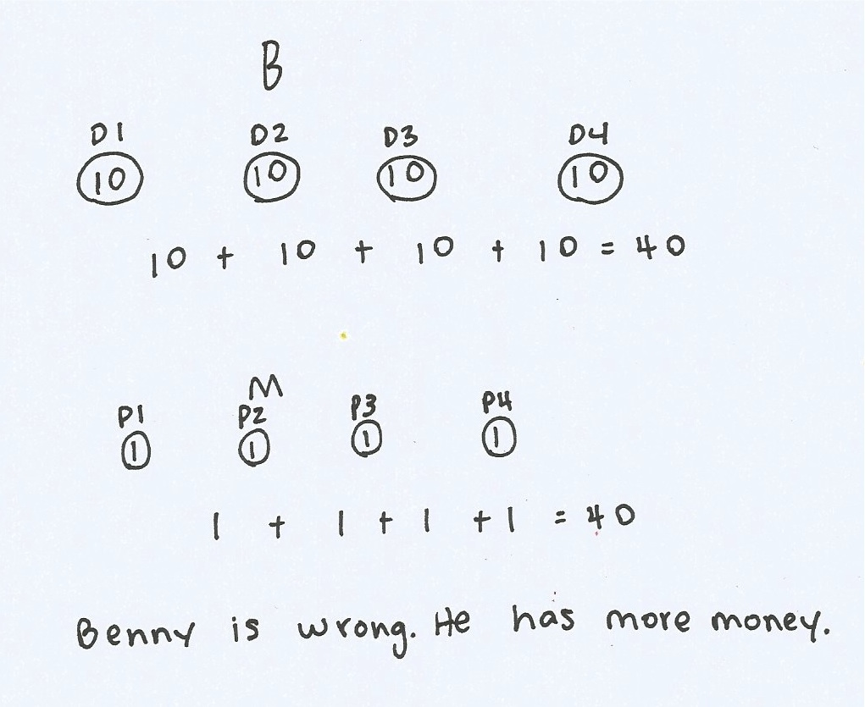
Note: This Sprint reviews the concepts taught in Lesson 5 and supports students’ understanding of place value.
Application Problem (5 minutes)
Benny has 4 dimes. Marcus has 4 pennies. Benny says, “We have the same amount of money!” Is he correct? Use drawings or words to explain your thinking.
Note: This problem enables a teacher to identify which students understand, or are beginning to understand, the importance of the value of a unit. Differentiating between the two types of coins and their values is the most essential understanding gained from this problem.
Concept Development (29 minutes)
Materials: (T) Enlarged dimes and pennies for display, large place value chart (Fluency Template)
(S) 5-group cards, dimes and pennies from personal math toolkit
Students gather in the meeting area with their materials.

NOTES ON
MULTIPLE MEANS
OF ENGAGEMENT:
Challenge advanced students with more questions about the 4 pennies and 4 dimes such as the following:
- How much money do the boys have together?
- How many more cents does Benny have than Marcus?
- Do you know of any other combinations of coins that could make 40 cents?
T: Look at the Application Problem. Which boy has the greater total value of money?
S: Benny does! 40 cents is more than 4 cents.
T: (Write greater under the 4 dimes and circle this side of the work.) Correct. The word greater means more.
40 is more than 4. 40 is greater than 4.
T: How could you describe 4 (circle Marcus’s pennies with your finger) compared to 40? 4 is...?
S: Smaller than 40. Less than 40. Fewer than 40.
T: Yes, we would say 4 is less than 40. Let’s compare some more numbers. Let’s find the greater number in each pair of numbers.

Write the following suggested sequence of number pairs one at a time:
- 5 and 12

NOTES ON
MULTIPLE MEANS
OF ENGAGEMENT:
Some students may have difficulty comparing numbers that have similar digits, such as 12 and 21, or numbers that sound similar, such as 14 and 40 or 13 and 30. Use linking cubes along with the place value chart so students can see the comparison with manipulatives.
- 39 and 21
- 23 and 32
- 17 and 15
- 14 and 40
- 30 and 13
- 1 ten 9 ones and 2 tens 1 one
- 3 tens 1 one and 1 ten 3 ones
Note: 17 and 15 above is the first example in which the ones place must be considered to compare the numbers; it will be discussed in the Debrief.
Use ten-sticks or quick ten drawings. Each time, ask students to explain how they know which number is greater. Encourage students to use the language of tens and ones as they compare the tens and the ones in each number.
Repeat the process, next finding the number that is less in each pair.
T: (Display 28 and 38 in place value charts.) Which number is greater?
S: 38.
T: Look at the place value charts. Do you look at the tens place or ones place to help you find the greater number? Turn and talk with a partner.
S: There is an 8 in the ones place for both numbers. You look at the tens place first, though.
T: (Point to each digit while explaining.) Yes, 3 tens is greater than 2 tens. 38 is greater than 28.
T: (Display 29 and 32 in place value charts.) Which number is greater?
S: 32.
T: Look at the place value charts. 9 is a lot greater than either of the digits in 32. Does that mean 29 is greater than 32? Turn and talk to your partner.
S: We still have to look at the tens place first. Tens are greater than ones. There are only 2 tens in 29, and there are 3 tens in 32. The tens place is where you have to look.
T: (Point to each digit while explaining.) Yes, 3 tens is greater than 2 tens. Let’s remember the value of the digits when comparing!
Comparison with Cards Game
Partner A and Partner B
- Each partner turns over two cards.
- Add the two numbers together and find the total.
- Partner A says a sentence to compare the totals using the words greater than or equal to.
- The partner with the greater total wins the cards. (If the totals are equal, leave the cards until the next round when one student does have a greater total.)
- Repeat with Partner B making the comparison statement.
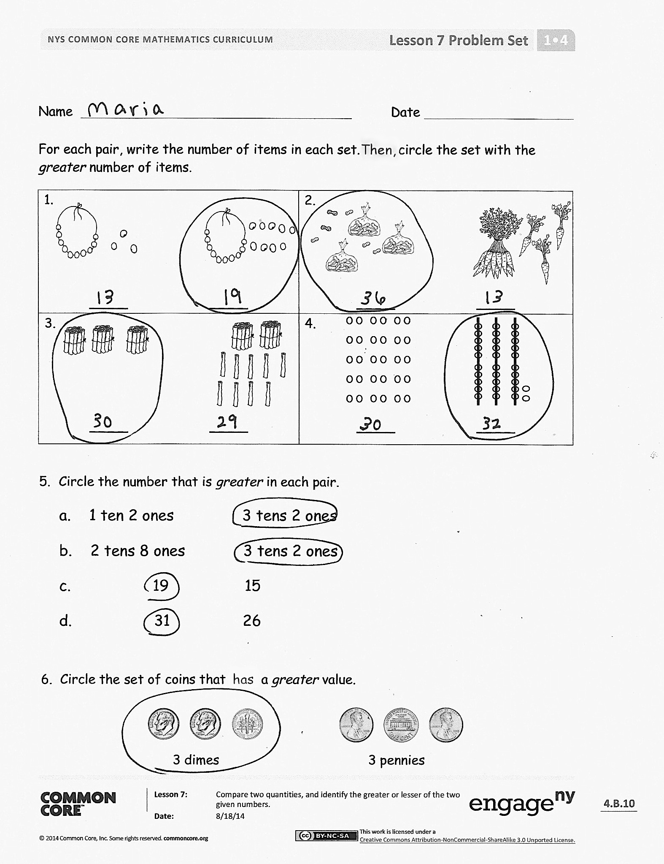
After the first minute of play, change the rules so that the person with the total that is less wins the cards. Partners should use the words less than when comparing the cards during this round. Alternate between the two rules for four minutes. At the five-minute mark, change the rules so that if the totals are equal, the game is over. Have students save one pair of cards to compare with a partner during the Debrief using a place value chart.
Problem Set (10 minutes)
Students should do their personal best to complete the Problem Set within the allotted 10 minutes. For some classes, it may be appropriate to modify the assignment by specifying which problems they work on first.
Student Debrief (10 minutes)
Lesson Objective: Compare two quantities, and identify the greater or lesser of the two given numerals.
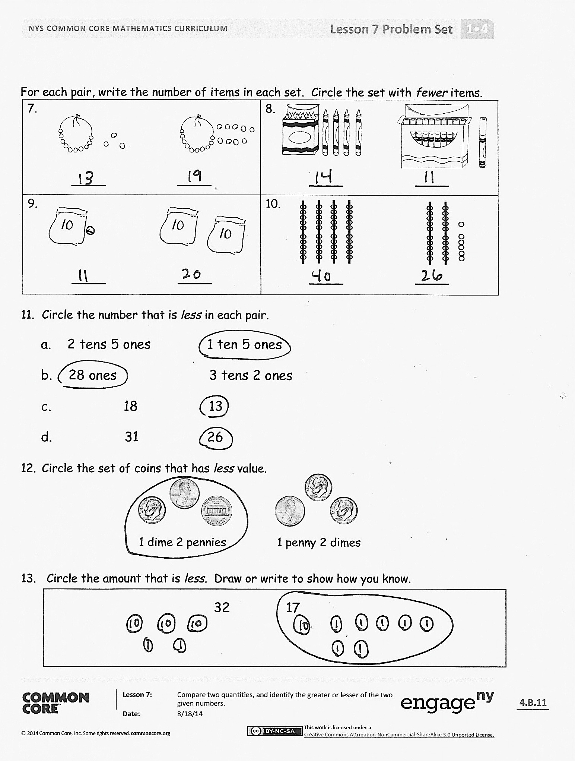
The Student Debrief is intended to invite reflection and active processing of the total lesson experience.
Invite students to review their solutions for the Problem Set. They should check work by comparing answers with a partner before going over answers as a class. Look for misconceptions or misunderstandings that can be addressed in the Debrief. Guide students in a conversation to debrief the Problem Set and process the lesson.
Any combination of the questions below may be used to lead the discussion.
- In Problem 3, did you look at the tens or ones to compare? Why?
- Look at your Problem Set with a partner and find an example where you needed to look at the
ones place to compare. Talk about why you must sometimes look at the ones place to compare numbers.
- How are dimes and pennies similar to tens and ones?
- Look at Problem 4. Was this pair more difficult for you to compare? Why?
- We call the numeral in the tens place a digit. The numeral in the ones place can also be called a digit. Look at the pair of numbers in Problem 5(d) and identify the digit in the tens place and the digit in the ones place for both numbers.
- Take out the cards you kept from today’s Comparison with Cards game. What is the total of each pair of cards? Write your total in a place value chart on your personal white board and compare with your partner.
- Share your answer to today’s Application Problem with a partner. Restate your answer using the words greater or less.
Exit Ticket (3 minutes)
After the Student Debrief, instruct students to complete the Exit Ticket. A review of their work will help with assessing students’ understanding of the concepts that were presented in today’s lesson and planning more effectively for future lessons. The questions may be read aloud to the students.

Name Date
Number Correct:
A
*Write the missing number. Pay attention to the addition or subtraction sign.
1 | 5 + 1 = ☐ |  | 16 | 29 + 10 = ☐
2 | 15 + 1 = ☐ |  | 17 | 9 + 1 = ☐
3 | 25 + 1 = ☐ |  | 18 | 19 + 1 = ☐
4 | 5 + 10 = ☐ |  | 19 | 29 + 1 = ☐
5 | 15 + 10 = ☐ |  | 20 | 39 + 1 = ☐
6 | 25 + 10 = ☐ |  | 21 | 40 - 1 = ☐
7 | 8 - 1 = ☐ |  | 22 | 30 - 1 = ☐
8 | 18 - 1 = ☐ |  | 23 | 20 - 1 = ☐
9 | 28 - 1 = ☐ |  | 24 | 20 + ☐ = 21
10 | 38 - 1 = ☐ |  | 25 | 20 + ☐ = 30
11 | 38 - 10 = ☐ |  | 26 | 27 + ☐ = 37
12 | 28 - 10 = ☐ |  | 27 | 27 + ☐ = 28
13 | 18 - 10 = ☐ |  | 28 | ☐ + 10 = 34
14 | 9 + 10 = ☐ |  | 29 | ☐ - 10 = 14
15 | 19 + 10 = ☐ |  | 30 | ☐ - 10 = 24

Name Date
Number Correct:
B
*Write the missing number. Pay attention to the addition or subtraction sign.
1 | 4 + 1 = ☐ |  | 16 | 28 + 10 = ☐
2 | 14 + 1 = ☐ |  | 17 | 9 + 1 = ☐
3 | 24 + 1 = ☐ |  | 18 | 19 + 1 = ☐
4 | 6 + 10 = ☐ |  | 19 | 29 + 1 = ☐
5 | 16 + 10 = ☐ |  | 20 | 39 + 1 = ☐
6 | 26 + 10 = ☐ |  | 21 | 40 - 1 = ☐
7 | 7 - 1 = ☐ |  | 22 | 30 - 1 = ☐
8 | 17 - 1 = ☐ |  | 23 | 20 - 1 = ☐
9 | 27 - 1 = ☐ |  | 24 | 10 + ☐ = 11
10 | 37 - 1 = ☐ |  | 25 | 10 + ☐ = 20
11 | 37 - 10 = ☐ |  | 26 | 22 + ☐ = 32
12 | 27 - 10 = ☐ |  | 27 | 22 + ☐ = 23
13 | 17 - 10 = ☐ |  | 28 | ☐ + 10 = 39
14 | 8 + 10 = ☐ |  | 29 | ☐ - 10 = 19
15 | 18 + 10 = ☐ |  | 30 | ☐ - 10 = 29

Name Date
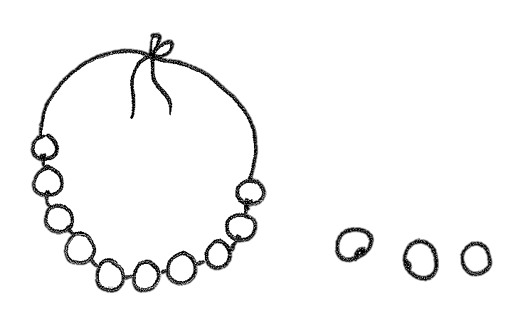  1.  ____ ____ | 2.  ____ ____
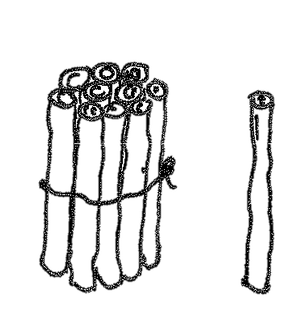  3.  ____ ____ | 4.  ____ ____
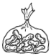
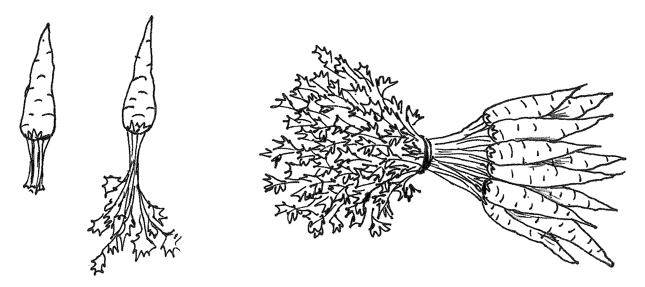
For each pair, write the number of items in each set. Then, circle the set with the greater number of items.

- Circle the number that is greater in each pair.
a. 1 ten 2 ones 3 tens 2 ones
b. 2 tens 8 ones 3 tens 2 ones
c. 19 15
d. 31 26
6. Circle the set of coins that has a greater value.
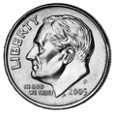
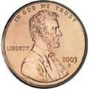
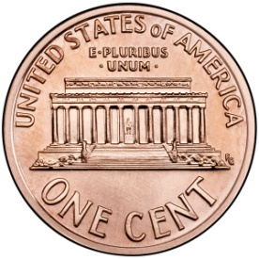
For each pair, write the number of items in each set. Circle the set with fewer items.
3 dimes 3 pennies
7.  ____ ____ | 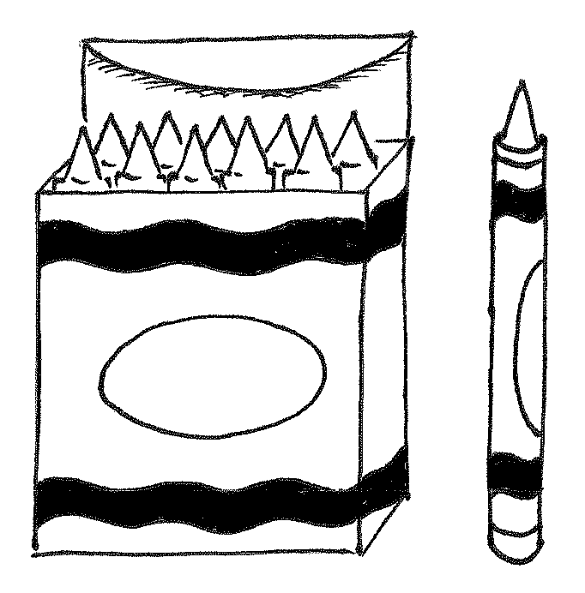  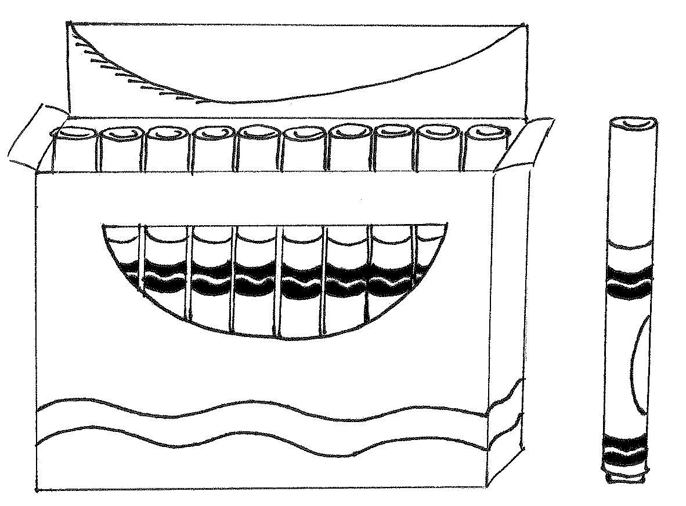  8.  ____ ____
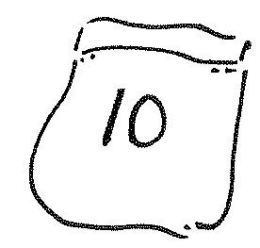  9.  ____ ____ | 10.  ____ ____
11. Circle the number that is less in each pair.
a. 2 tens 5 ones 1 ten 5 ones
b. 28 ones 3 tens 2 ones
c. 18 13
d. 31 26

12. Circle the set of coins that has less value.

1 dime 2 pennies 1 penny 2 dimes
13. Circle the amount that is less. Draw or write to show how you know.
32 17

Name Date
- Write the number of items in each set. Then, circle the set that is greater in number. Write a statement to compare the two sets.
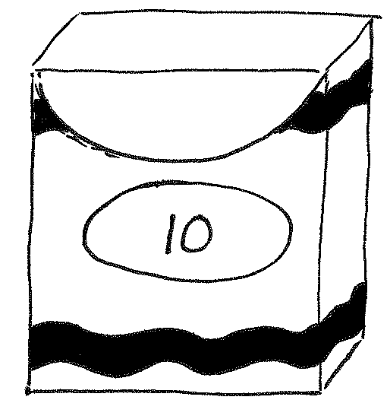
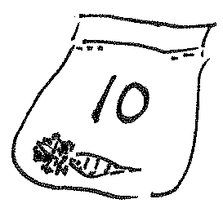

_______ _______

______ is greater than _______.

- Write the number of items in each set. Then, circle the set that is less in number.
Say a statement to compare the two sets.
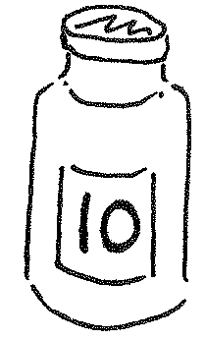
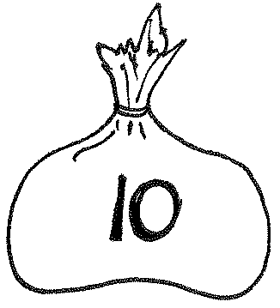

_______ _______

______ is less than _______.

- Circle the set of coins that has a greater value.

- Circle the set of coins that has less value.
Name Date
Write the number, and circle the set that is greater in each pair. Say a statement to compare the two sets.

____ ____

____ ____

1. 2.

Circle the number that is greater for each pair.
3 tens 8 ones
3 tens 9 ones
25
35
3. 4.

Write the number, and circle the set that is less in each pair. Say a statement to compare the two sets.
5. 6.

____ ____

____ ____

Circle the number that is less for each pair.
22
29
7. 8.
2 tens 7 ones
3 tens 7 ones

9. Circle the set of coins that has less value.

10. Circle the set of coins that has greater value.

Katelyn and Johnny are playing comparison with cards. They have recorded the totals for each round. For each round, circle the total that won the cards, and write the statement. The first one is done for you.
ROUND 1: The total that is greater wins.
Katelyn’s Total
16

Johnny’s Total
19

19 is greater than 16.
a. ROUND 2: The total that is less wins.
Johnny’s Total
24

Katelyn’s Total
27

b. ROUND 3: The total that is greater wins.
Katelyn’s Total
32

Johnny’s Total
22

c. ROUND 4: The total that is less wins.
Katelyn’s Total
29

Johnny’s Total
26

d. If Katelyn’s total is 39, and Johnny’s total has 3 tens 9 ones, who would have a greater total? Draw a math drawing to explain how you know.

tens | ones

large place value chart

