Lesson 6: Scatter Plots

Classwork
Example 1
A bivariate data set consists of observations on two variables. For example, you might collect data on $13$ different car models. Each observation in the data set would consist of an $(x, y)$ pair.
$x$ = weight (in pounds, rounded to the nearest $50$ pounds)
and
$y$ = fuel efficiency (in miles per gallon, mpg)
The table below shows the weight and fuel efficiency for $13$ car models with automatic transmissions manufactured in 2009 by Chevrolet.
Model | Weight (pounds) | Fuel Efficiency (mpg)
$$1$$ | $$3,200$$ | $$23$$
$$2$$ | $$2,550$$ | $$28$$
$$3$$ | $$4,050$$ | $$19$$
$$4$$ | $$4,050$$ | $$20$$
$$5$$ | $$3,750$$ | $$20$$
$$6$$ | $$3,550$$ | $$22$$
$$7$$ | $$3,550$$ | $$19$$
$$8$$ | $$3,500$$ | $$25$$
$$9$$ | $$4,600$$ | $$16$$
$$10$$ | $$5,250$$ | $$12$$
$$11$$ | $$5,600$$ | $$16$$
$$12$$ | $$4,500$$ | $$16$$
$$13$$ | $$4,800$$ | $$15$$

Exercises 1–8
- In the table above, the observation corresponding to Model 1 is ($3200, 23$). What is the fuel efficiency of this car? What is the weight of this car?

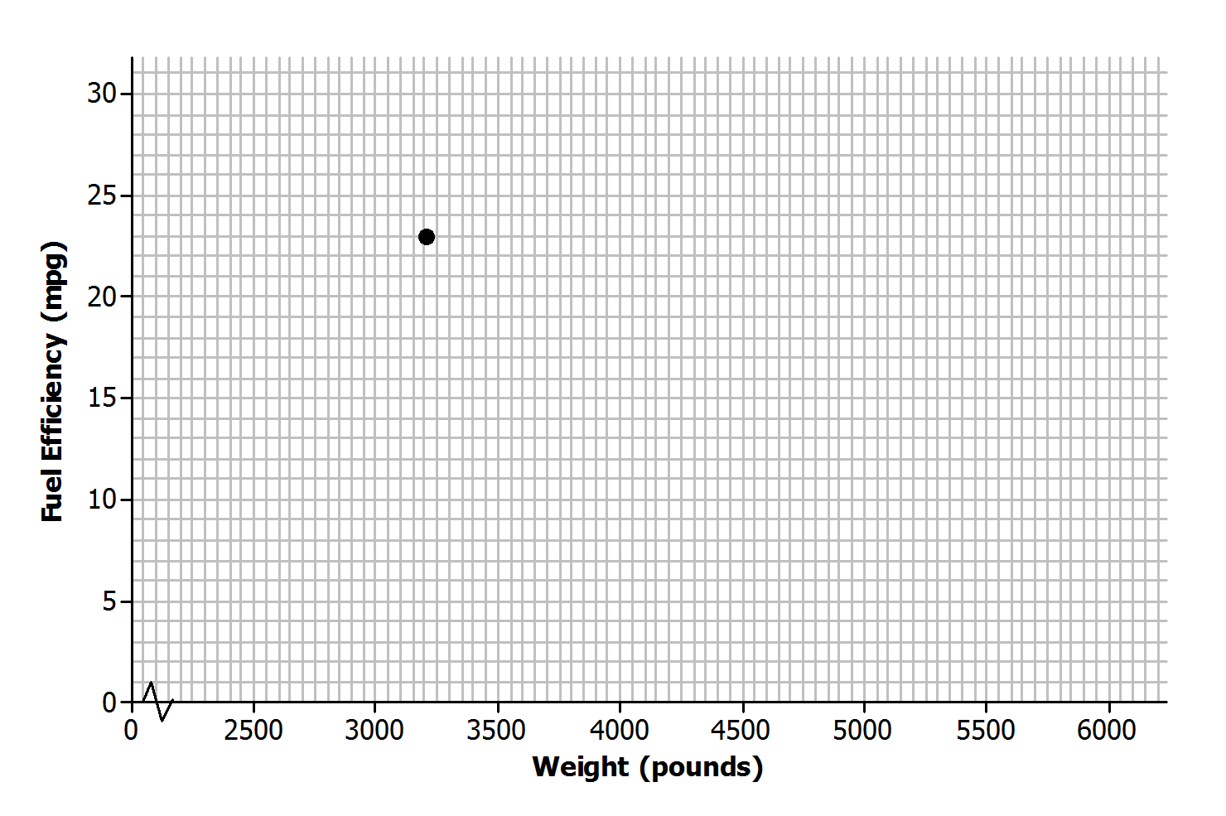
- Add the points corresponding to the other $12$ observations to the scatter plot.

- Do you notice a pattern in the scatter plot? What does this imply about the relationship between weight ($x$) and fuel efficiency ($y$)?

Is there a relationship between price and the quality of athletic shoes? The data in the table below are from the Consumer Reports website.
$x$ = price (in dollars)
and
$y$ = Consumer Reports quality rating
The quality rating is on a scale of $0$ to $100$, with $100$ being the highest quality.
Shoe | Price (dollars) | Quality Rating
$$1$$ | $$65$$ | $$71$$
$$2$$ | $$45$$ | $$70$$
$$3$$ | $$45$$ | $$62$$
$$4$$ | $$80$$ | $$59$$
$$5$$ | $$110$$ | $$58$$
$$6$$ | $$110$$ | $$57$$
$$7$$ | $$30$$ | $$56$$
$$8$$ | $$80$$ | $$52$$
$$9$$ | $$110$$ | $$51$$
$$10$$ | $$70$$ | $$51$$
- One observation in the data set is$\left(110, 57\right)$. What does this ordered pair represent in terms of cost and quality?

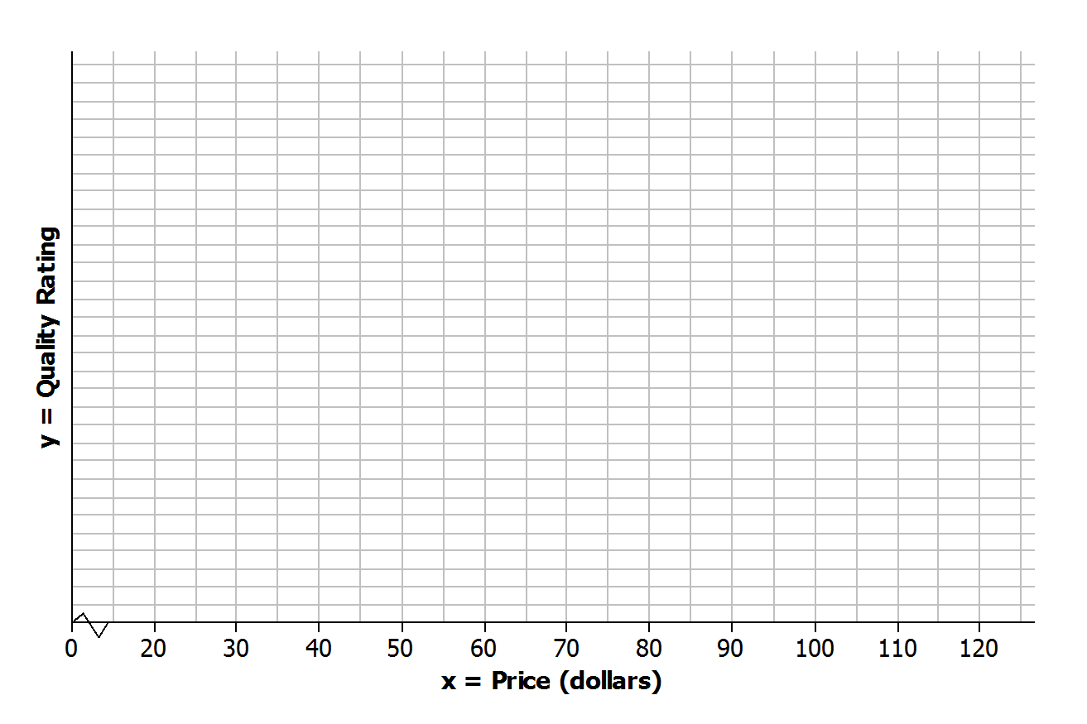
- To construct a scatter plot of these data, you need to start by thinking about appropriate scales for the axes of the scatter plot. The prices in the data set range from$\$30$ to $\$110$, so one reasonable choice for the scale of the $x$-axis would range from$\$20$to $\$120$, as shown below. What would be a reasonable choice for a scale for the $y$-axis?
- Add a scale to the $y$-axis. Then, use these axes to construct a scatter plot of the data.

- Do you see any pattern in the scatter plot indicating that there is a relationship between price and quality rating for athletic shoes?

- Some people think that if shoes have a high price, they must be of high quality. How would you respond?

Example 2: Statistical Relationships
A pattern in a scatter plot indicates that the values of one variable tend to vary in a predictable way as the values of the other variable change. This is called a statistical relationship. In the fuel efficiency and car weight example, fuel efficiency tended to decrease as car weight increased.
This is useful information, but be careful not to jump to the conclusion that increasing the weight of a car causes the fuel efficiency to go down. There may be some other explanation for this. For example, heavier cars may also have bigger engines, and bigger engines may be less efficient. You cannot conclude that changes to one variable cause changes in the other variable just because there is a statistical relationship in a scatter plot.

Exercises 9–10
- Data were collected on
$x$= shoe size
and
$y$ = score on a reading-ability test
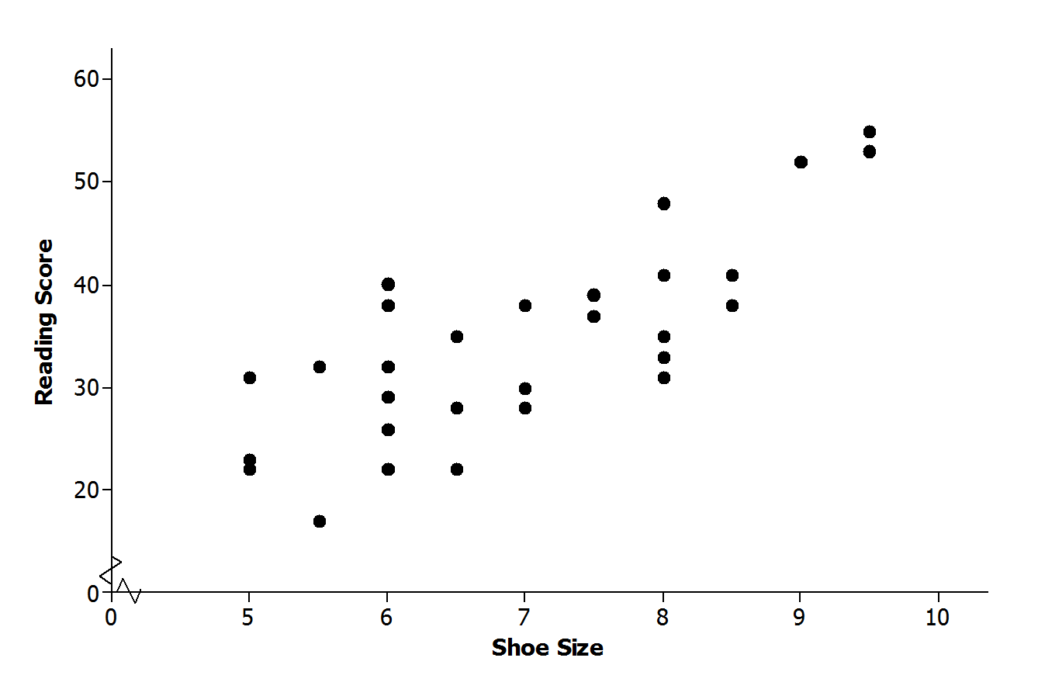
for $30$ elementary school students. The scatter plot of these data is shown below. Does there appear to be a statistical relationship between shoe size and score on the reading test?

- Explain why it is not reasonable to conclude that having big feet causes a high reading score. Can you think of a different explanation for why you might see a pattern like this?

Lesson Summary
- A scatter plot is a graph of numerical data on two variables.
- A pattern in a scatter plot suggests that there may be a relationship between the two variables used to construct the scatter plot.
- If two variables tend to vary together in a predictable way, we can say that there is a statistical relationship between the two variables.
- A statistical relationship between two variables does not imply that a change in one variable causes a change in the other variable (a cause-and-effect relationship).

Problem Set

- The table below shows the price and overall quality rating for $15$ different brands of bike helmets.
Data Source: www.consumerreports.org
Helmet | Price (dollars) | Quality Rating
A | $$35$$ | $$65$$
B | $$20$$ | $$61$$
C | $$30$$ | $$60$$
D | $$40$$ | $$55$$
E | $$50$$ | $$54$$
F | $$23$$ | $$47$$
G | $$30$$ | $$47$$
H | $$18$$ | $$43$$
I | $$40$$ | $$42$$
J | $$28$$ | $$41$$
K | $$20$$ | $$40$$
L | $$25$$ | $$32$$
M | $$30$$ | $$63$$
N | $$30$$ | $$63$$
O | $$40$$ | $$53$$

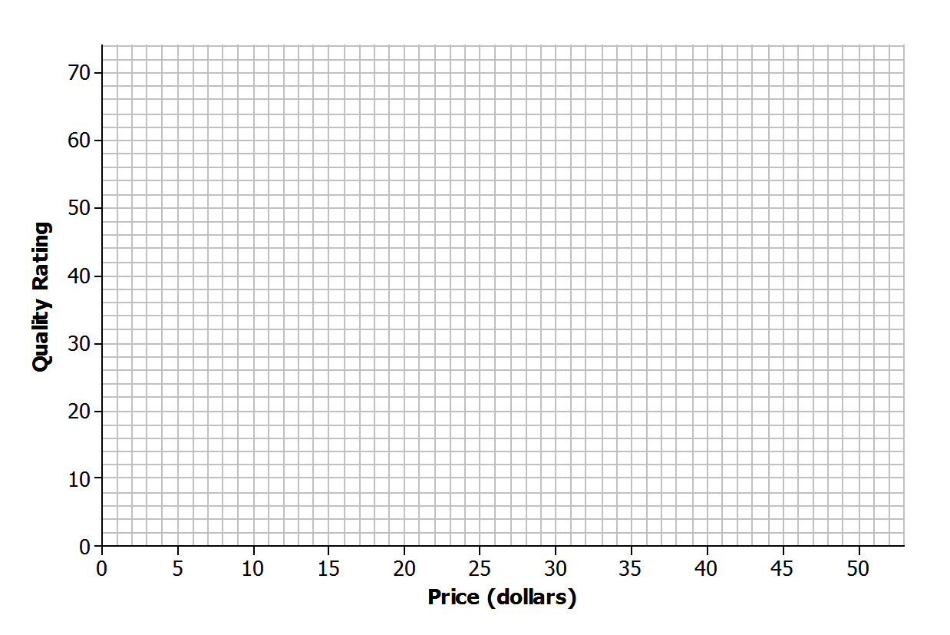
Construct a scatter plot of price ($x$) and quality rating ($y$). Use the grid below.

- Do you think that there is a statistical relationship between price and quality rating? If so, describe the nature of the relationship.

- Scientists are interested in finding out how different species adapt to finding food sources. One group studied crocodilian species to find out how their bite force was related to body mass and diet. The table below displays the information they collected on body mass (in pounds) and bite force (in pounds).
Species | Body Mass (pounds) | Bite Force (pounds)
Dwarf crocodile | $$35$$ | $$450$$
Crocodile F | $$40$$ | $$260$$
Alligator A | $$30$$ | $$250$$
Caiman A | $$28$$ | $$230$$
Caiman B | $$37$$ | $$240$$
Caiman C | $$45$$ | $$255$$
Croc A | $$110$$ | $$550$$
Nile crocodile | $$275$$ | $$650$$
Croc B | $$130$$ | $$500$$
Croc C | $$135$$ | $$600$$
Croc D | $$135$$ | $$750$$
Caiman D | $$125$$ | $$550$$
Indian Gharial croc | $$225$$ | $$400$$
Crocodile G | $$220$$ | $$1,000$$
American croc | $$270$$ | $$900$$
Croc D | $$285$$ | $$750$$
Croc E | $$425$$ | $$1,650$$
American Alligator | $$300$$ | $$1,150$$
Alligator B | $$325$$ | $$1,200$$
Alligator C | $$365$$ | $$1,450$$
Data Source: PLoS One Greg Erickson biomechanics, Florida State University
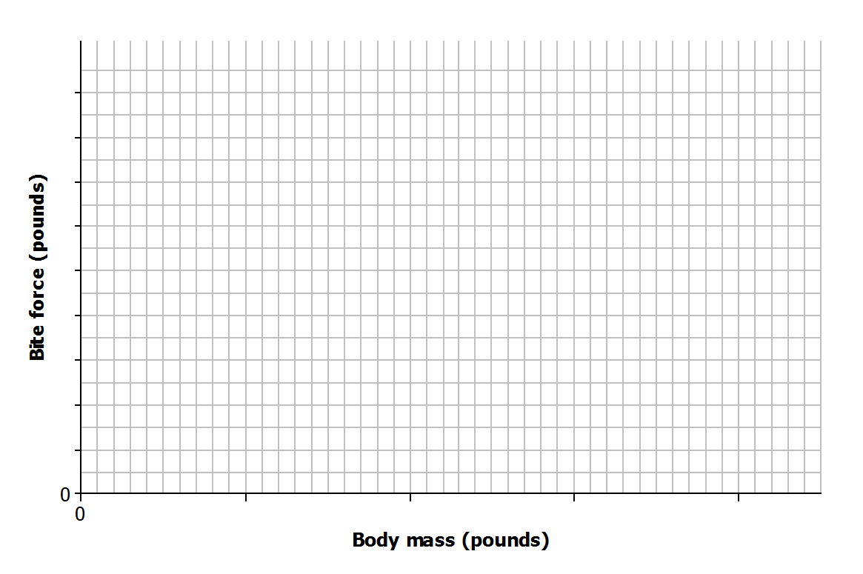
Construct a scatter plot of body mass ($x$) and bite force ($y$). Use the grid below, and be sure to add an appropriate scale to the axes.

- Do you think that there is a statistical relationship between body mass and bite force? If so, describe the nature of the relationship.

- Based on the scatter plot, can you conclude that increased body mass causes increased bite force? Explain.

