Lesson 5: Increasing and Decreasing Functions

Classwork
Example 1: Nonlinear Functions in the Real World
Not all real-world situations can be modeled by a linear function. There are times when a nonlinear function is needed to describe the relationship between two types of quantities. Compare the two scenarios:
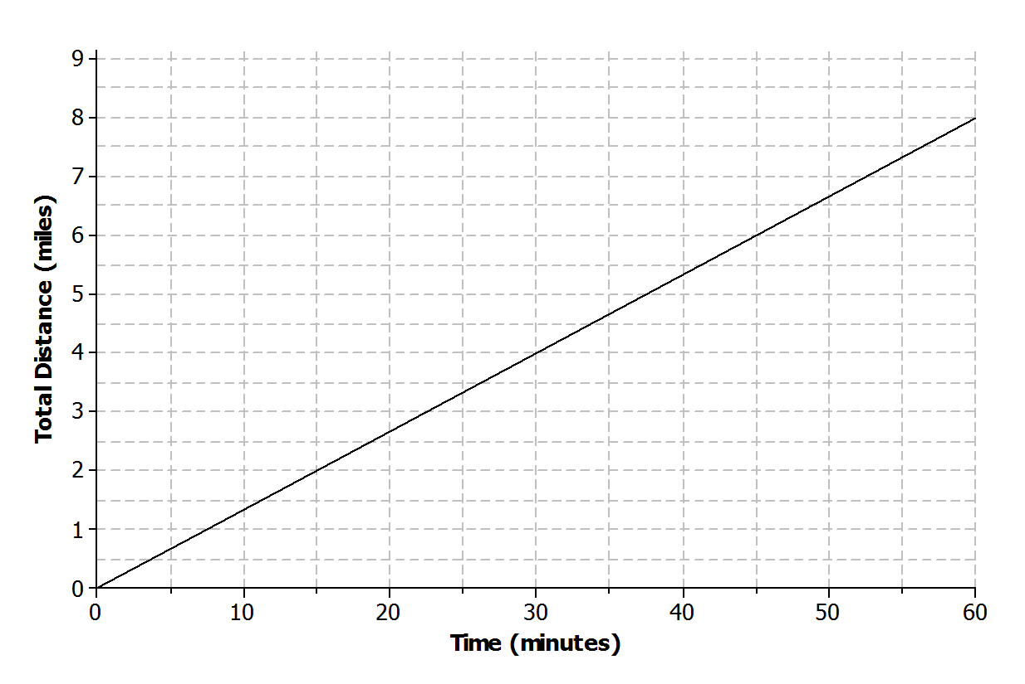
  - Aleph is running at a constant rate on a flat paved road. The graph below represents the total distance he covers with respect to time.

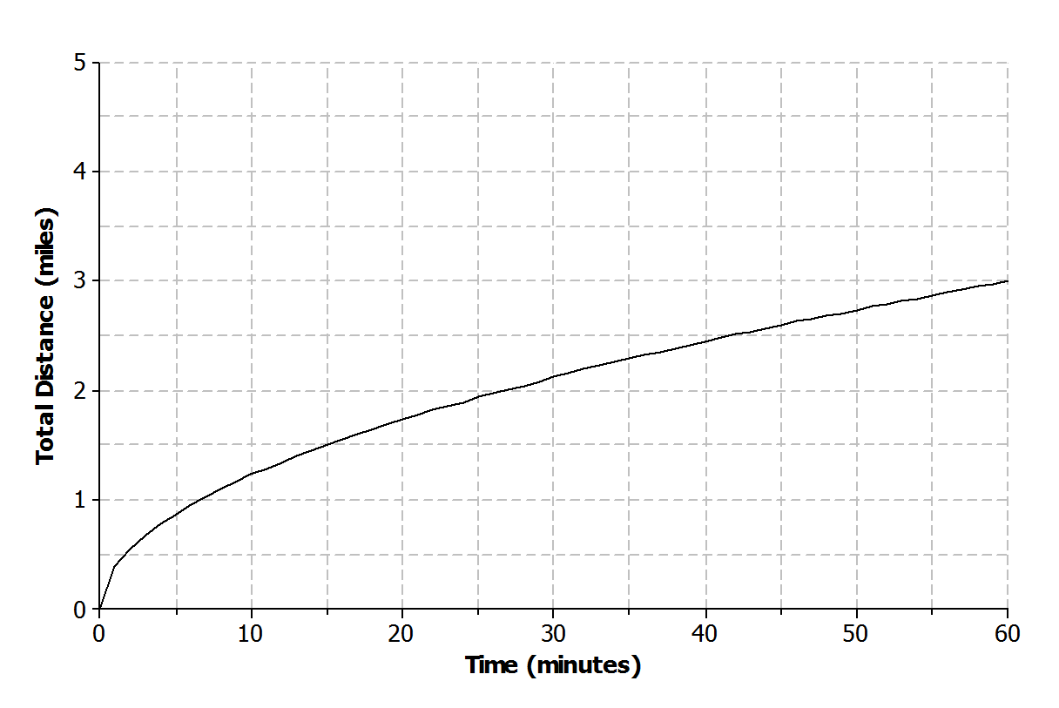
  - Shannon is running on a flat, rocky trail that eventually rises up a steep mountain. The graph below represents the total distance she covers with respect to time.
Exercises 1–2
- In your own words, describe what is happening as Aleph is running during the following intervals of time.
  - $0$ to $15$minutes

  - $15$ to $30$ minutes

  - $30$ to $45$ minutes

  - $45$ to $60$ minutes

- In your own words, describe what is happening as Shannon is running during the following intervals of time.
  - $0$ to $15$ minutes

  - $15$to $30$ minutes

  - $30$ to $45$ minutes

  - $45$ to $60$minutes

Example 2: Increasing and Decreasing Functions
The rate of change of a function can provide useful information about the relationship between two quantities. A linear function has a constant rate of change. A nonlinear function has a variable rate of change.
Linear Functions | Nonlinear Functions
Linear function increasing at a constant rate  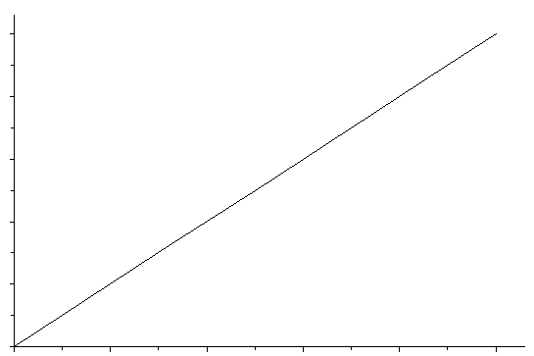 | Nonlinear function increasing at a variable rate  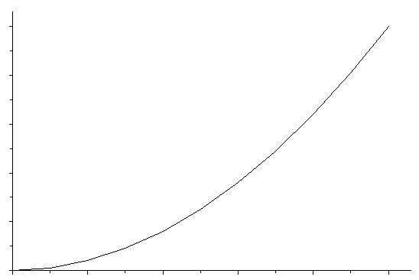
Linear function decreasing at a constant rate  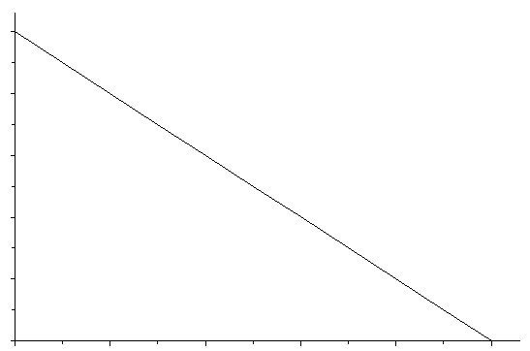 | Nonlinear function decreasing at a variable rate  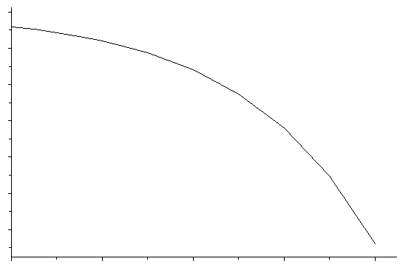
Linear function with a constant rate  $$x$$ $$y$$  $$0$$ $$7$$  $$1$$ $$10$$  $$2$$ $$13$$  $$3$$ $$16$$  $$4$$ $$19$$ | Nonlinear function with a variable rate  $$x$$ $$y$$  $$0$$ $$0$$  $$1$$ $$2$$  $$2$$ $$4$$  $$3$$ $$8$$  $$4$$ $$16$$

Exercises 3–5
- Different breeds of dogs have different growth rates. A large breed dog typically experiences a rapid growth rate from birth to age $6$months. At that point, the growth rate begins to slow down until the dog reaches full growth around$2$years of age.
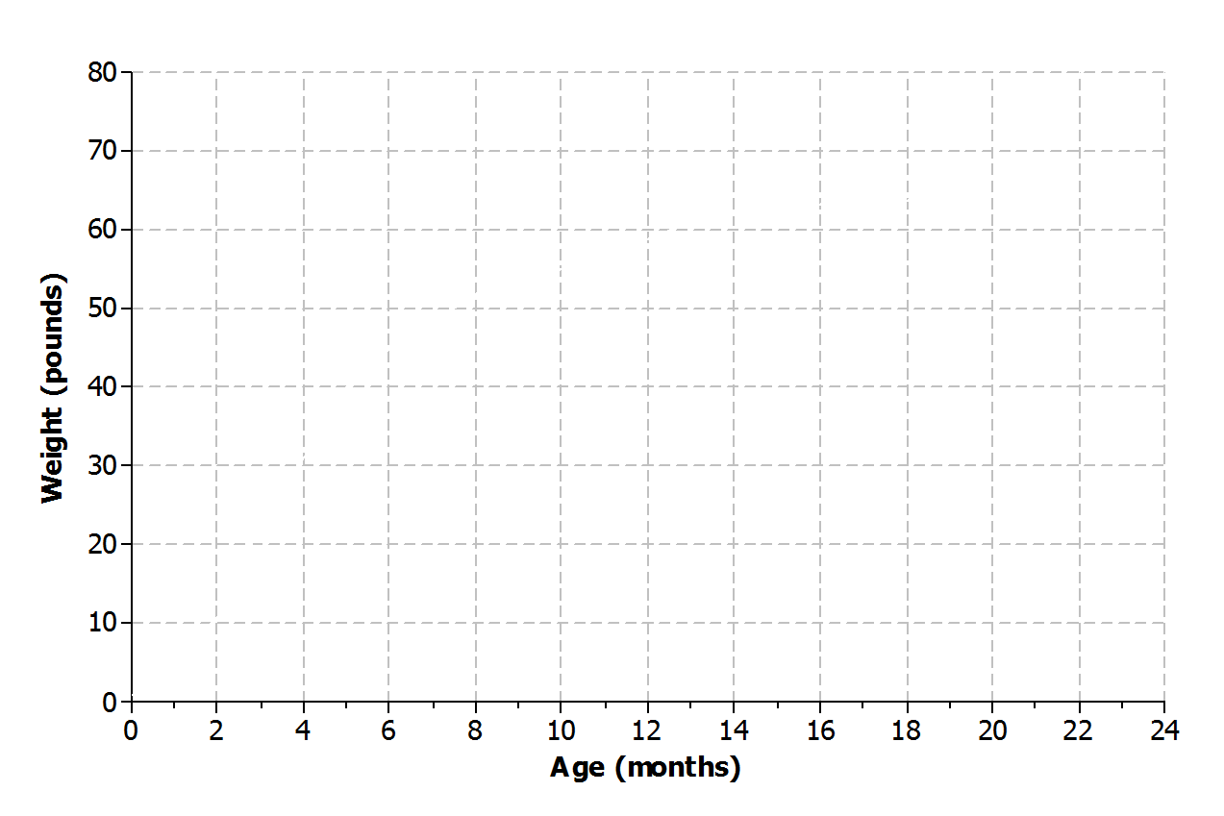
  - Sketch a graph that represents the weight of a large breed dog from birth to $2$ years of age.
  - Is the function represented by the graph linear or nonlinear? Explain.

  - Is the function represented by the graph increasing or decreasing? Explain.

- Nikka took her laptop to school and drained the battery while typing a research paper. When she returned home, Nikka connected her laptop to a power source, and the battery recharged at a constant rate.
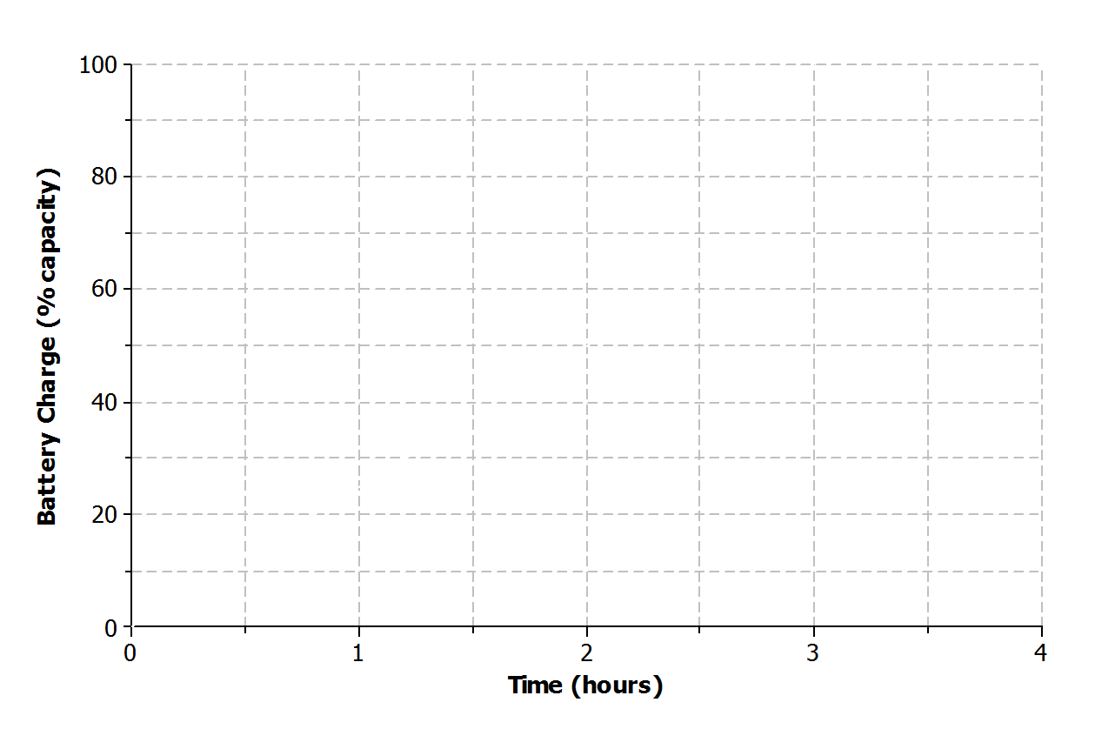
  - Sketch a graph that represents the battery charge with respect to time.
  - Is the function represented by the graph linear or nonlinear? Explain.

  - Is the function represented by the graph increasing or decreasing? Explain.

- The long jump is a track and field event where an athlete attempts to leap as far as possible from a given point. Mike Powell of the United States set the long jump world record of $8.95$ meters ($29.4$ feet) during the 1991 World Championships in Tokyo, Japan.
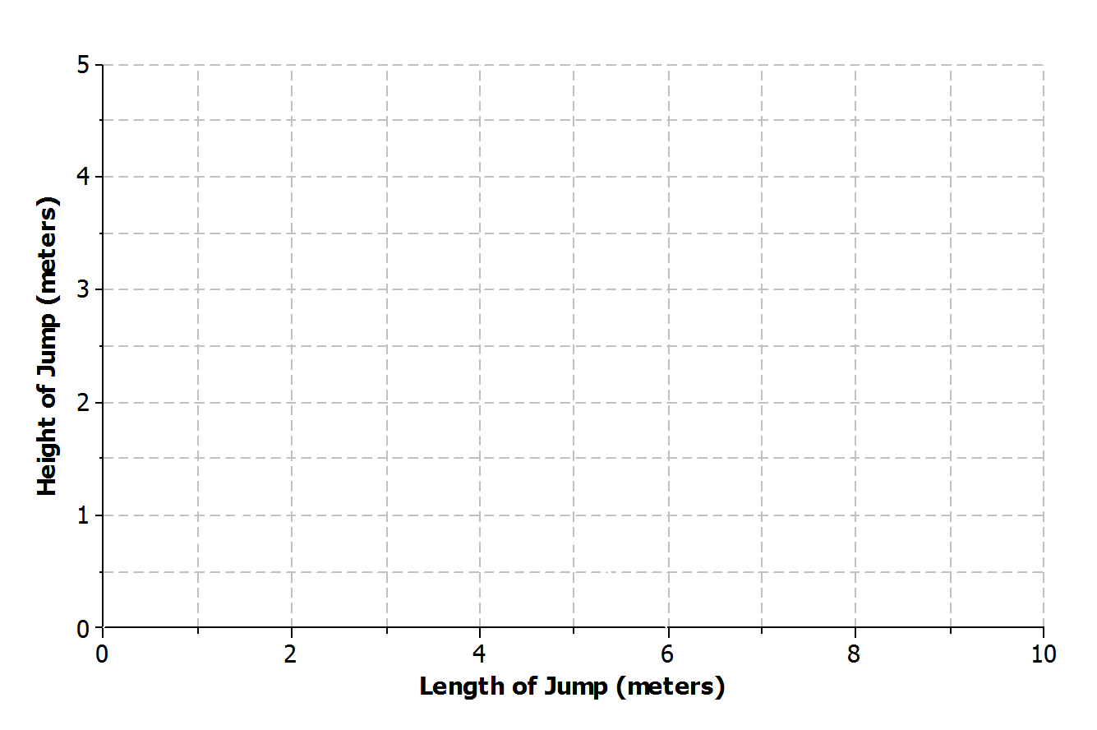
  - Sketch a graph that represents the path of a high school athlete attempting the long jump.
  - Is the function represented by the graph linear or nonlinear? Explain.

  - Is the function represented by the graph increasing or decreasing? Explain.

Example 3: Ferris Wheel
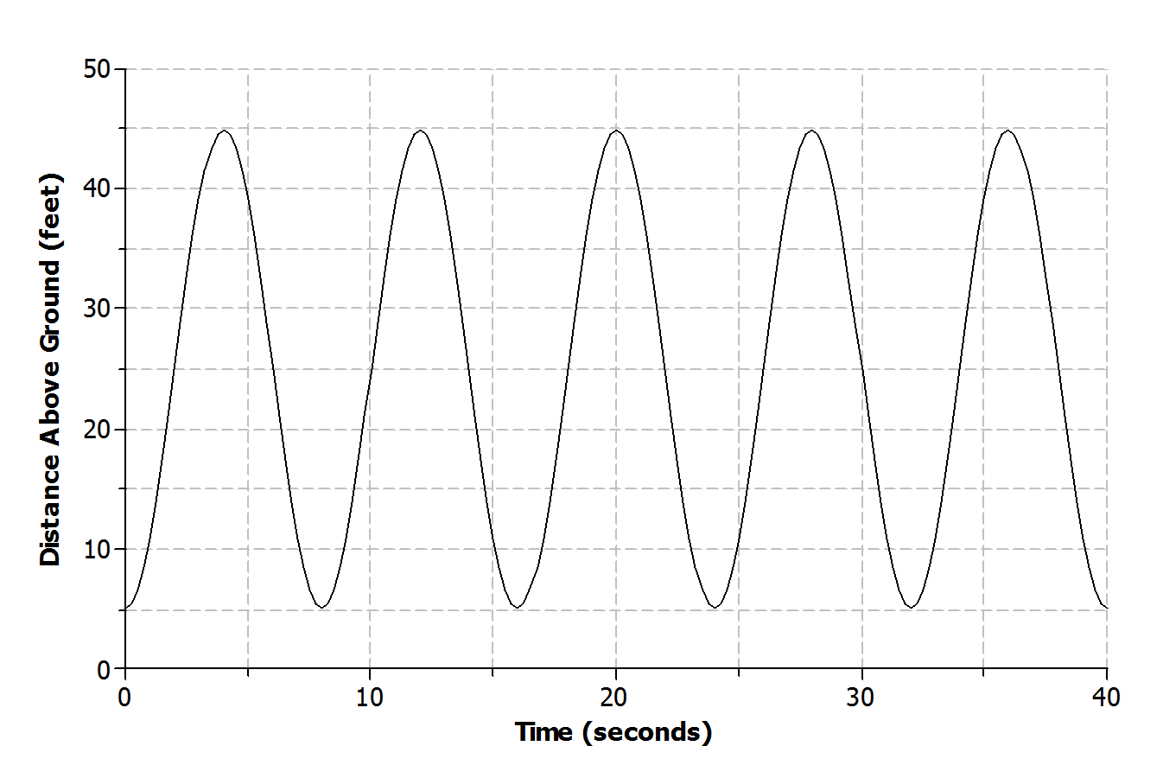
Lamar and his sister are riding a Ferris wheel at a state fair. Using their watches, they find that it take $8$ seconds for the Ferris wheel to make a complete revolution. The graph below represents Lamar and his sister’s distance above the ground with respect to time.

Exercises 6–9
- Use the graph from Example 3 to answer the following questions.
  - Is the function represented by the graph linear or nonlinear?

  - Where is the function increasing? What does this mean within the context of the problem?

  - Where is the function decreasing? What does this mean within the context of the problem?

- How high above the ground is the platform for passengers to get on the Ferris wheel? Explain your reasoning.

- Based on the graph, how many revolutions does the Ferris wheel complete during the $40$second time interval? Explain your reasoning.

- What is the diameter of the Ferris wheel? Explain your reasoning.

Lesson Summary
The graph of a function can be used to help describe the relationship between two quantities.
A linear function has a constant rate of change. A nonlinear function does not have a constant rate of change.
- A function whose graph has a positive rate of change is an increasing function.
- A function whose graph has a negative rate of change is a decreasing function.
- Some functions may increase and decrease over different intervals.

.

Problem Set

- Read through the following scenarios and match each to its graph. Explain the reasoning behind your choice.
  - This shows the change in a smartphone battery charge as a person uses the phone more frequently.
  - A child takes a ride on a swing.
  - A savings account earns simple interest at a constant rate.
  - A baseball has been hit at a little league game.
Scenario: ____ | Scenario: ___  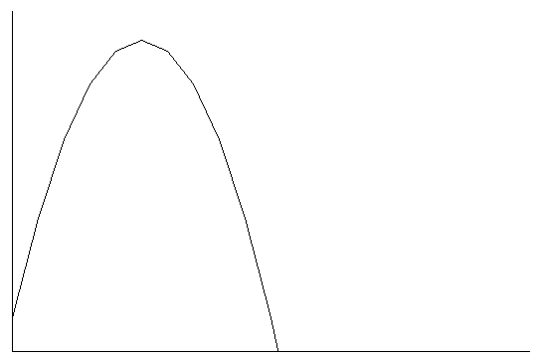

Scenario: ___  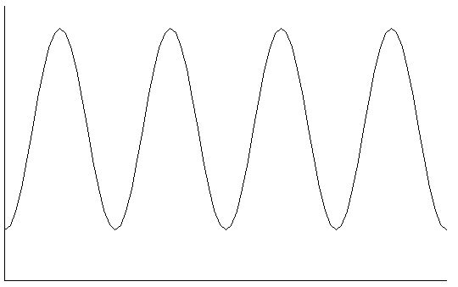 | Scenario: ___  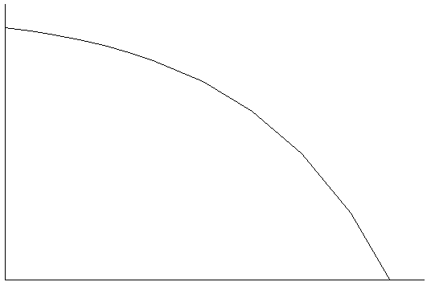

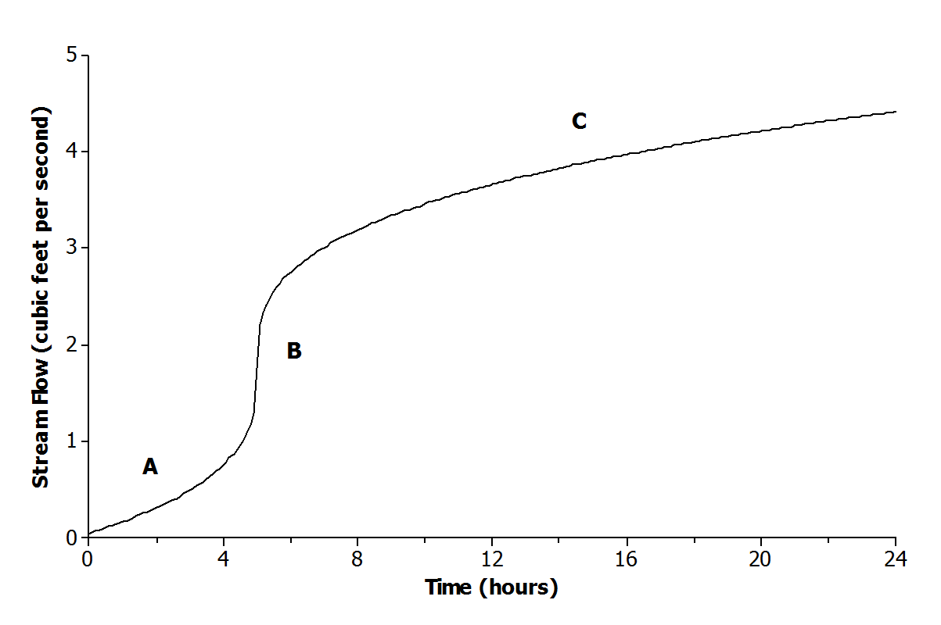
- The graph below shows the volume of water for a given creek bed during a $24$-hour period. On this particular day, there was wet weather with a period of heavy rain.
Describe how each part (A, B, and C) of the graph relates to the scenario.

- Half-life is the time required for a quantity to fall to half of its value measured at the beginning of the time period. If there are $100$ grams of a radioactive element to begin with, there will be $50$grams after the first half-life, $25$ grams after the second half-life, and so on.
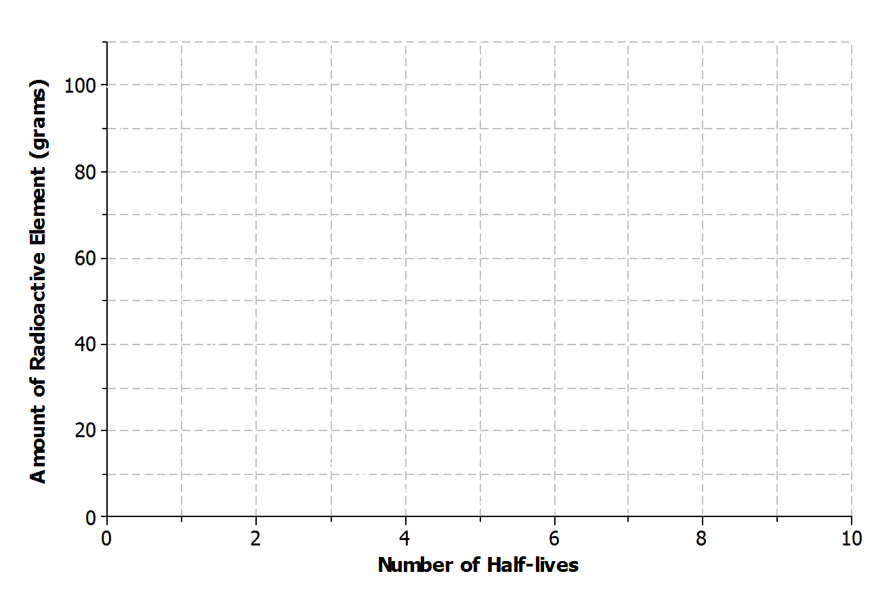
  - Sketch a graph that represents the amount of the radioactive element left with respect to the number of half-lives that have passed.
  - Is the function represented by the graph linear or nonlinear? Explain.
  - Is the function represented by the graph increasing or decreasing?

- Lanae parked her car in a No Parking zone. Consequently, her car was towed to an impound lot. In order to release her car, she needs to pay the impound lot charges. There is an initial charge on the day the car is brought to the lot. However, $10\%$ of the previous day’s charges will be added to the total charge for every day the car remains in the lot.
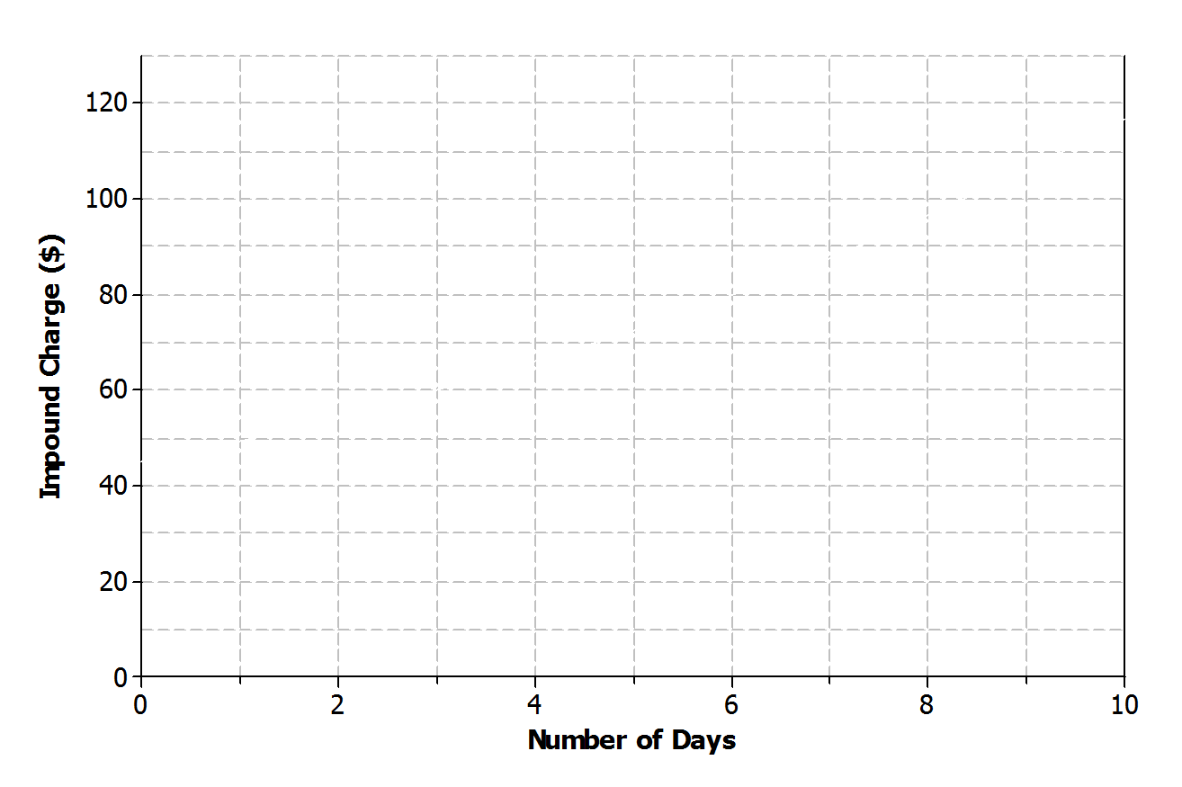
  - Sketch a graph that represents the total charges with respect to the number of days a car remains in the impound lot.
  - Is the function represented by the graph linear or nonlinear? Explain.
  - Is the function represented by the graph increasing or decreasing? Explain.

- Kern won a $\$50$ gift card to his favorite coffee shop. Every time he visits the shop, he purchases the same coffee drink.
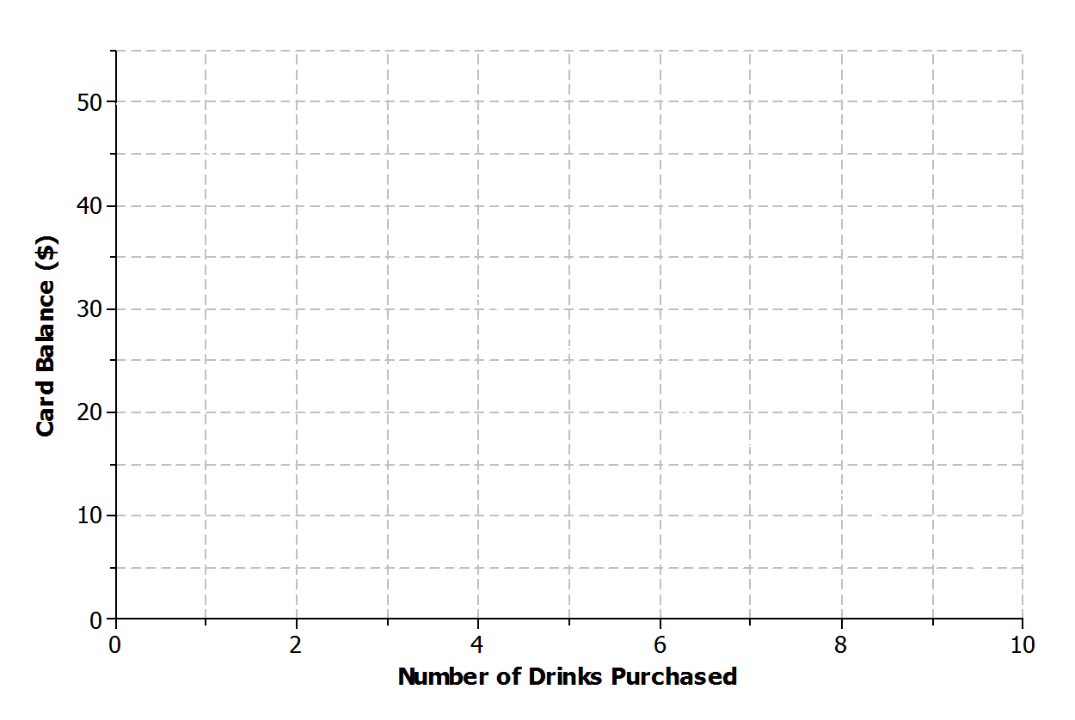
  - Sketch a graph of a function that can be used to represent the amount of money that remains on the gift card with respect to the number of drinks purchased.
  - Is the function represented by the graph linear or nonlinear? Explain.
  - Is the function represented by the graph increasing or decreasing? Explain.

- Jay and Brooke are racing on bikes to a park $8$ miles away. The tables below display the total distance each person biked with respect to time.
Jay  Time (minutes) Distance (miles)  $$0$$ $$0$$  $$5$$ $$0.84$$  $$10$$ $$1.86$$  $$15$$ $$3.00$$  $$20$$ $$4.27$$  $$25$$ $$5.67$$ | Brooke  Time (minutes) Distance (miles)  $$0$$ $$0$$  $$5$$ $$1.2$$  $$10$$ $$2.4$$  $$15$$ $$3.6$$  $$20$$ $$4.8$$  $$25$$ $$6.0$$
  - Which person’s biking distance could be modeled by a nonlinear function? Explain.
  - Who would you expect to win the race? Explain.

- Using the axes below, create a story about the relationship between two quantities.
  - Write a story about the relationship between two quantities. Any quantities can be used (e.g., distance and time, money and hours, age and growth). Be creative! Include keywords in your story such as increase and decrease to describe the relationship.
  - Label each axis with the quantities of your choice, and sketch a graph of the function that models the relationship described in the story.
