|  |
| --- |
|  |

Lesson 5: Increasing and Decreasing Functions

Student Outcomes

* Students qualitatively describe the functional relationship between two types of quantities by analyzing a graph.
* Students sketch a graph that exhibits the qualitative features of linear and nonlinear functions based on a verbal description.

Lesson Notes

This lesson extends the concepts introduced in Lesson 4 and focuses on graphs and the role they play in analyzing functional relationships between quantities. Students begin the lesson by comparing and contrasting linear and nonlinear functions. Encourage students to distinguish a linear function from a nonlinear function by analyzing a graph using the rate of change for an interval instead of just stating that “it looks like a straight line.” Students sketch nonlinear functions given a contextual situation but do not construct the functions.

Classwork

**Example 1 (3–5 minutes): Nonlinear Functions in the Real World**

Read through the scenarios as a class. A linear function is used to model the first scenario, and a nonlinear function is used to model the second scenario.

Example 1: Nonlinear Functions in the Real World

Not all real-world situations can be modeled by a linear function. There are times when a nonlinear function is needed to describe the relationship between two types of quantities. Compare the two scenarios:

1. 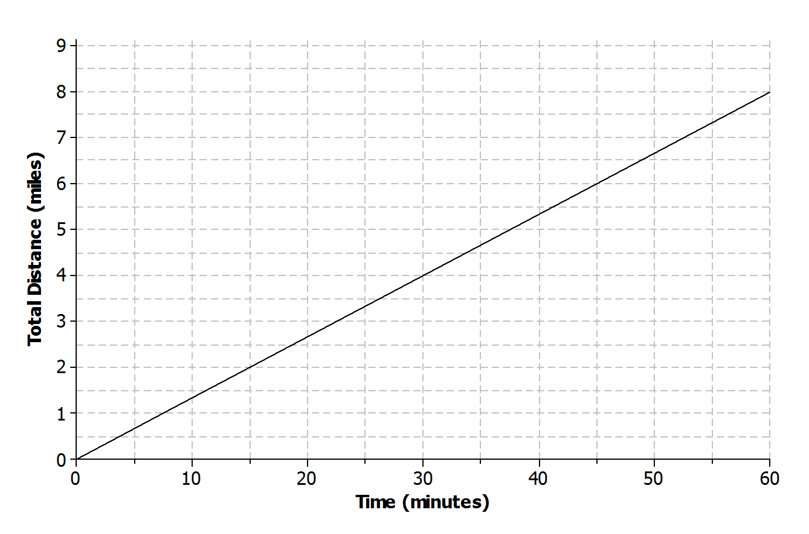Aleph is running at a constant rate on a flat paved road. The graph below represents the total distance he covers with respect to time.
2. 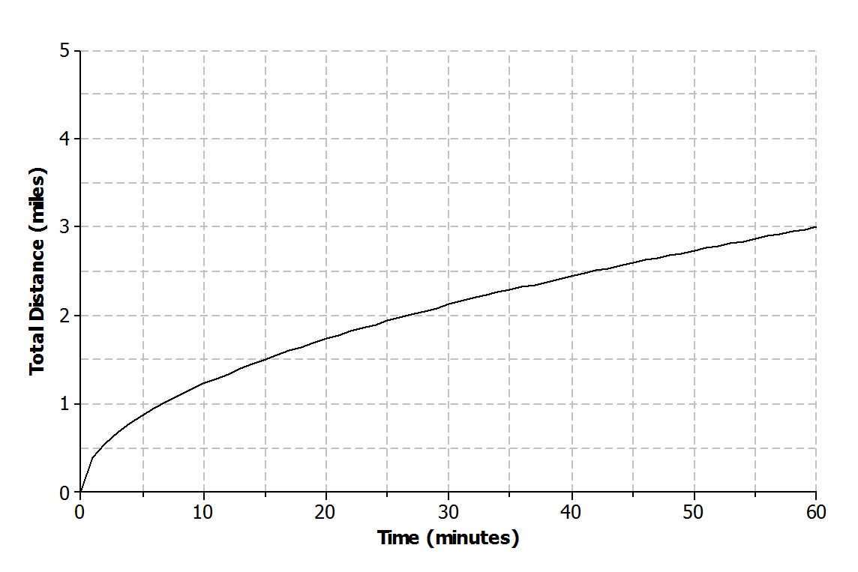Shannon is running on a flat, rocky trail that eventually rises up a steep mountain. The graph below represents the total distance she covers with respect to time.

Exercises 1–2 (5–7 minutes)

Students will be looking at the rate of change for different intervals for the scenarios presented in Example 1. Let students work with a partner. Then, discuss answers as a class. Remind students of increasing, decreasing, and constant *linear* functions from the previous lesson.

* Why might the distance that Shannon runs during each minute interval decrease?
  + *Shannon is running up a mountain. Maybe the mountain is getting steeper, which is causing her to run slower.*
* Are these increasing or decreasing functions?
  + *They are both increasing functions because the total distance is increasing with respect to time. The function that models Aleph’s total distance is an increasing linear function, and Shannon’s total distance is an increasing nonlinear function.*

Exercises 1–2

1. In your own words, describe what is happening as Aleph is running during the following intervals of time.
   1. to minutes

Aleph runs miles in minutes.

* 1. to minutes

Aleph runs another miles in minutes for a total of miles.

* 1. to minutes

Aleph runs another miles in minutes for a total of miles.

* 1. to minutes

Aleph runs another miles in minutes for a total of miles.

1. In your own words, describe what is happening as Shannon is running during the following intervals of time.
   1. to minutes

Shannon runs miles in minutes.

* 1. to minutes

Shannon runs another miles in minutes for a total of miles.

* 1. to minutes

Shannon runs another miles in minutes for a total of miles.

* 1. to minutes

Shannon runs another miles in minutes for a total of miles.

Example 2 (5 minutes): Increasing and Decreasing Functions

Convey to students that linear functions have a constant rate of change while nonlinear functions *do not* have a constant rate of change. Consider using a table of values for additional clarification using the information from Exercises 1 and 2.

* How would you describe the rate of change of the function modeling Shannon’s total distance? Explain.
  + *The function is increasing, but at a decreasing rate of change. The rate of change is decreasing for every minute interval.*

Example 2: Increasing and Decreasing Functions

The rate of change of a function can provide useful information about the relationship between two quantities. A linear function has a constant rate of change. A nonlinear function has a variable rate of change.

|  |  |
| --- | --- |
| Linear Functions | Nonlinear Functions |
| Linear function *increasing* at a constant rate | Nonlinear function *increasing* at a variable rate |
| Linear function *decreasing* at a constant rate | Nonlinear function *decreasing* at a variable rate |

|  |  |  |  |  |  |  |  |  |  |  |  |  |  |  |  |  |  |  |  |  |  |  |  |  |  |
| --- | --- | --- | --- | --- | --- | --- | --- | --- | --- | --- | --- | --- | --- | --- | --- | --- | --- | --- | --- | --- | --- | --- | --- | --- | --- |
| Linear function with a constant rate   |  |  | | --- | --- | |  |  | |  |  | |  |  | |  |  | |  |  | |  |  | | Nonlinear function with a variable rate   |  |  | | --- | --- | |  |  | |  |  | |  |  | |  |  | |  |  | |  |  | |

Exercises 3–5 (15 minutes)

Students will sketch graphs of functions based on a verbal description. Note that the graph should just be a rough sketch that matches the verbal description. Allow students to work with a partner or in a small group. Discuss and compare answers as a class.

Exercises 3–5

1. Different breeds of dogs have different growth rates. A large breed dog typically experiences a rapid growth rate from birth to age months. At that point, the growth rate begins to slow down until the dog reaches full growth aroundyears of age.
   1. Sketch a graph that represents the weight of a large breed dog from birth to years of age.

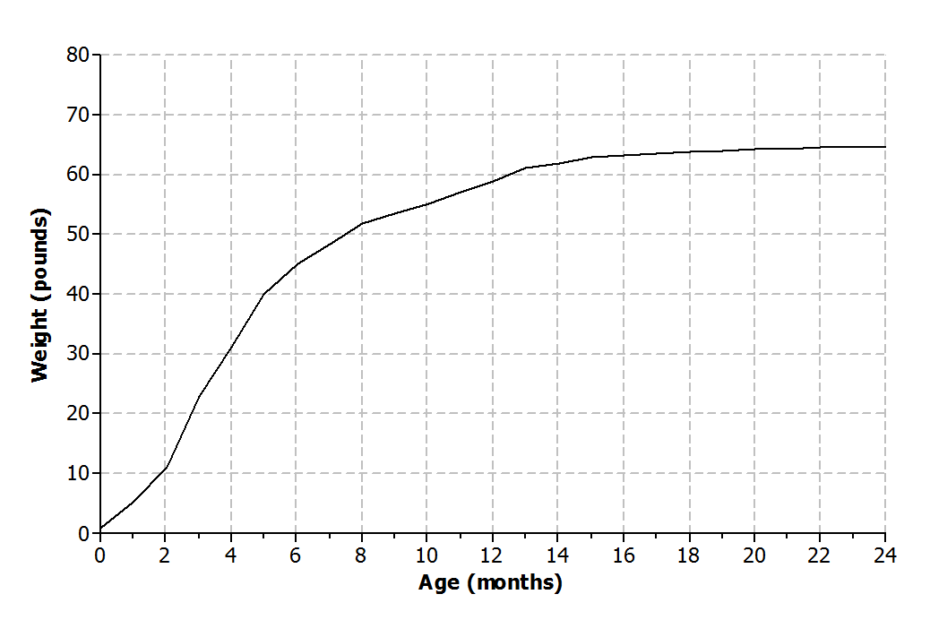Answers will vary.

* 1. Is the function represented by the graph linear or nonlinear? Explain.

The function is nonlinear because the growth rate is not constant.

* 1. Is the function represented by the graph increasing or decreasing? Explain.

The function is increasing but at a decreasing rate. There is rapid growth during the first months, and then the growth rate decreases.

1. Nikka took her laptop to school and drained the battery while typing a research paper. When she returned home, Nikka connected her laptop to a power source, and the battery recharged at a constant rate.
   1. Sketch a graph that represents the battery charge with respect to time.

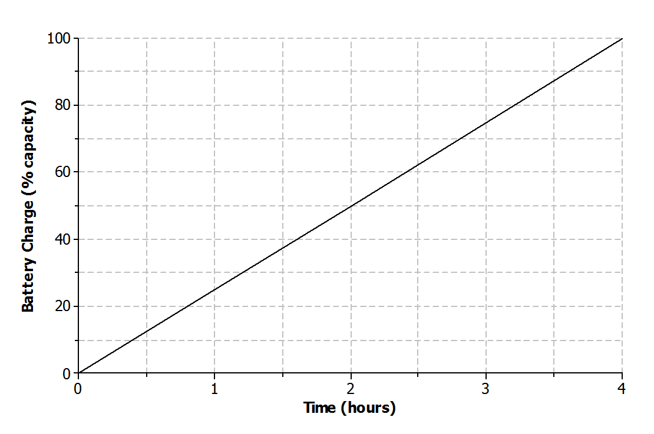Answers will vary.

* 1. Is the function represented by the graph linear or nonlinear? Explain.

The function is linear because the battery is recharging at a constant rate.

* 1. Is the function represented by the graph increasing or decreasing? Explain.

The function is increasing because the battery is being recharged.

1. The long jump is a track and field event where an athlete attempts to leap as far as possible from a given point. Mike Powell of the United States set the long jump world record of meters ( feet) during the 1991 World Championships in Tokyo, Japan.
   1. Sketch a graph that represents the path of a high school athlete attempting the long jump.

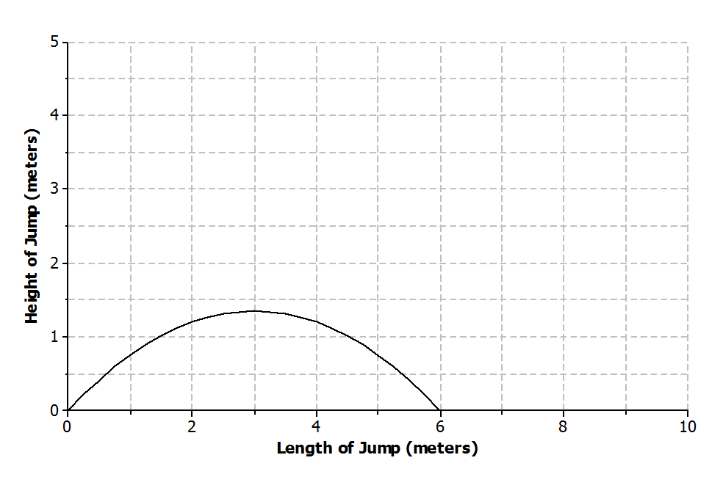Answers will vary.

Note: If students have trouble visualizing the path of a jump, use the following table for students to begin their sketch. Remind students to draw a curve and not to connect points with a straight line.

|  |  |
| --- | --- |
|  |  |
|  |  |
|  |  |
|  |  |
|  |  |
|  |  |
|  |  |
|  |  |

* 1. Is the function represented by the graph linear or nonlinear? Explain.

The function is nonlinear. The rate of change is not constant.

* 1. Is the function represented by the graph increasing or decreasing? Explain.

The function both increases and decreases over different intervals. The function increases as the athlete begins the jump and reaches a maximum height. The function decreases after the athlete reaches maximum height and begins descending back toward the ground.

Example 3 (5–7 minutes): Ferris Wheel

This example presents students with a graph of a nonlinear function that both increases and decreases over different intervals of time. Students may have a difficult time connecting the graph to the scenario. Remind students that the graph is relating time to a rider’s distance above the ground. Consider doing a rough sketch of the Ferris wheel scenario on a personal white board for further clarification using a similar object such as a hamster wheel or a K’NEX construction toy. There are also videos that can be found online that relate this type of motion to nonlinear curves. The website [www.graphingstories.com](http://www.graphingstories.com) has a great video that relates the motion of a playground merry-go-round to the distance of a camera that produces a graph similar to the Ferris wheel example.

Example 3: Ferris Wheel

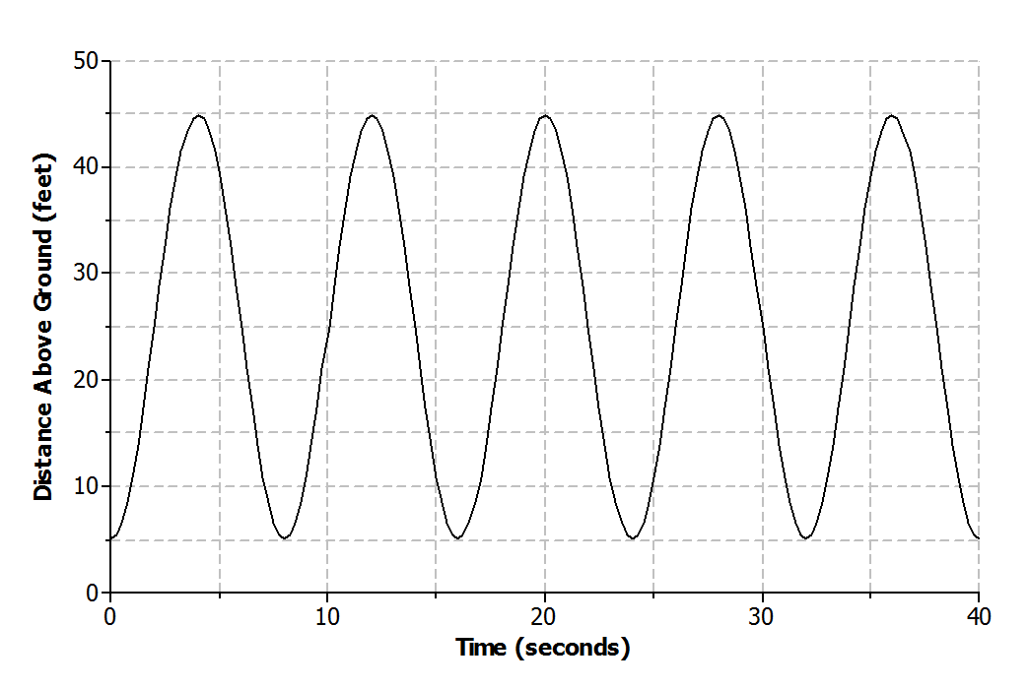Lamar and his sister are riding a Ferris wheel at a state fair. Using their watches, they find that it take seconds for the Ferris wheel to make a complete revolution. The graph below represents Lamar and his sister’s distance above the ground with respect to time.

Exercises 6–9 (5–7 minutes)

Allow students to work with a partner or in a small group to complete the following exercises. Confirm answers as a class.

Exercises 6–9

1. Use the graph from Example 3 to answer the following questions.
   1. Is the function represented by the graph linear or nonlinear?

The function is nonlinear. The rate of change is not constant.

* 1. Where is the function increasing? What does this mean within the context of the problem?

The function is increasing during the following intervals of time: to seconds, to seconds, to seconds, to seconds, and to seconds. It means that Lamar and his sister are rising in the air.

* 1. Where is the function decreasing? What does this mean within the context of the problem?

The function is decreasing during the following intervals of time: to seconds, to seconds, to seconds, to seconds, and to seconds. Lamar and his sister are traveling back down toward the ground.

1. How high above the ground is the platform for passengers to get on the Ferris wheel? Explain your reasoning.

The lowest point on the graph, which is at feet, can represent the platform where the riders get on the Ferris wheel.

1. Based on the graph, how many revolutions does the Ferris wheel complete during the second time interval? Explain your reasoning.

The Ferris wheel completes revolutions. The lowest points on the graph can represent Lamar and his sister at the beginning of a revolution or at the entrance platform of the Ferris wheel. So, one revolution occurs between and seconds, and seconds, and seconds, and seconds, and and seconds.

1. What is the diameter of the Ferris wheel? Explain your reasoning.

The diameter of the Ferris wheel is feet. The lowest point on the graph represents the base of the Ferris wheel, and the highest point on the graph represents the top of the Ferris wheel. The difference between the two values is feet, which is the diameter of the wheel.

Closing (2 minutes)

Review the Lesson Summary with students.

* Refer back to Exercises 3 and 4 (dog growth rate and laptop battery recharge problems). Note that both functions were increasing. Is it possible for those functions to continue to increase within the context of the problem? Explain.
  + *No. Both functions cannot continue to increase.*
  + *The dog’s weight will increase until it reaches full growth. At that point, the weight would remain constant or may fluctuate based on diet and exercise.*
  + *The laptop battery capacity can only reach . At that point, it is fully charged. The function could not continue to increase.*

Lesson Summary

**The graph of a function can be used to help describe the relationship between two quantities.**

**A linear function has a constant rate of change. A nonlinear function does not have a constant rate of change.**

* **A function whose graph has a positive rate of change is an *increasing function*.**
* **A function whose graph has a negative rate of change is a *decreasing function*.**
* **Some functions may increase and decrease over different intervals.**

.

Exit Ticket (5 minutes)

Name Date

Lesson 5: Increasing and Decreasing Functions

Exit Ticket

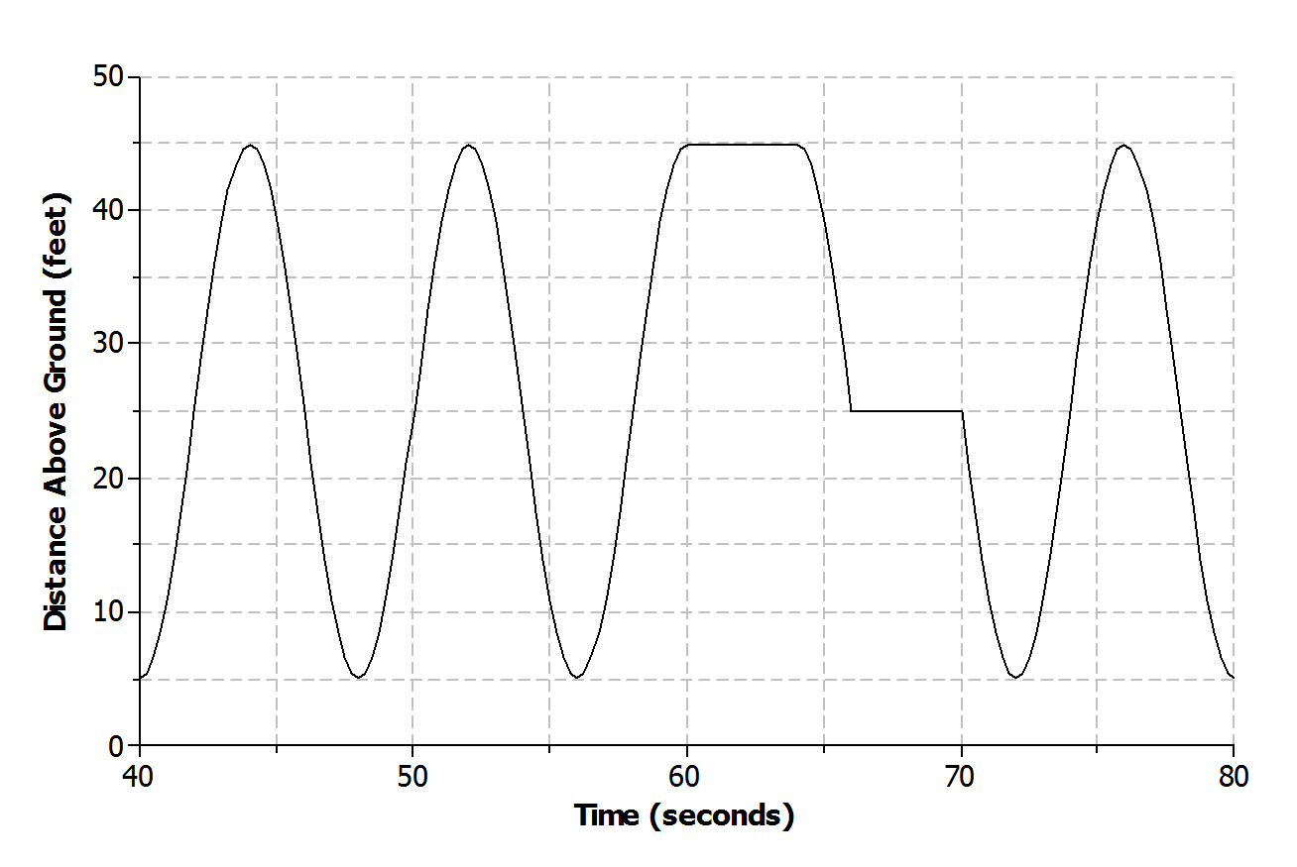Lamar and his sister continue to ride the Ferris wheel. The graph below represents Lamar and his sister’s distance above the ground with respect to time during the next seconds of their ride.

* 1. Name one interval where the function is increasing.
  2. Name one interval where the function is decreasing.
  3. Is the function linear or nonlinear? Explain.
  4. What could be happening during the interval of time from to seconds?
  5. Based on the graph, how many complete revolutions are made during this second interval?

Exit Ticket Sample Solutions

  
Lamar and his sister continue to ride the Ferris wheel. The graph below represents Lamar and his sister’s distance above the ground with respect to time during the next seconds of their ride.

* 1. Name one interval where the function is increasing.

The function is increasing during the following intervals of time: to seconds, to seconds, to seconds, and to seconds.

* 1. Name one interval where the function is decreasing.

The function is decreasing during the following intervals of time: to seconds, to seconds, to seconds, to seconds, and to seconds.

* 1. Is the function linear or nonlinear? Explain.

The function is both linear and nonlinear during different intervals of time. It is linear from toseconds and from to seconds. It is nonlinear from to seconds and from to seconds.

* 1. What could be happening during the interval of time from to seconds?

The Ferris wheel is not moving during that time, so riders may be getting off or getting on.

* 1. Based on the graph, how many complete revolutions are made during this second interval?

Four revolutions are made during this time period.

Problem Set Sample Solutions

1. Read through the following scenarios and match each to its graph. Explain the reasoning behind your choice.
   1. This shows the change in a smartphone battery charge as a person uses the phone more frequently.
   2. A child takes a ride on a swing.
   3. A savings account earns simple interest at a constant rate.
   4. A baseball has been hit at a little league game.

|  |  |
| --- | --- |
| Scenario: **c**  The savings account is earning interest at a constant rate, which means that the function is linear. | Scenario: **d**  The baseball is hit into the air, reaches a maximum height, and falls back to the ground at a variable rate. |
| Scenario: **b**  The distance from the ground increases as the child swings up into the air and then decreases as the child swings back down toward the ground. | Scenario: **a**  The battery charge is decreasing as a person uses the phone more frequently. |

1. 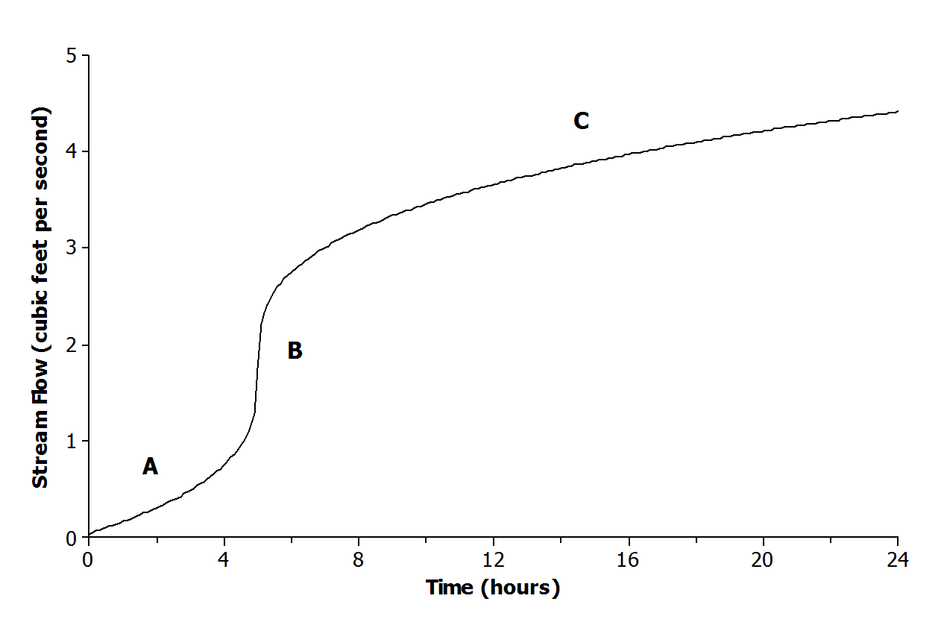The graph below shows the volume of water for a given creek bed during a -hour period. On this particular day, there was wet weather with a period of heavy rain.

Describe how each part (A, B, and C) of the graph relates to the scenario.

A: The rain begins, and the amount of water flowing in the creek bed begins to increase.

B: A period of heavy rain occurs causing the amount of water to increase.

C: The heavy rain begins to subside, and the amount of water continues to increase.

1. Half-life is the time required for a quantity to fall to half of its value measured at the beginning of the time period. If there are grams of a radioactive element to begin with, there will be grams after the first half-life, grams after the second half-life, and so on.
   1. Sketch a graph that represents the amount of the radioactive element left with respect to the number of half-lives that have passed.

Answers will vary.



* 1. Is the function represented by the graph linear or nonlinear? Explain.

The function is nonlinear. The rate of change is not constant with respect to time.

* 1. Is the function represented by the graph increasing or decreasing?

The function is decreasing.

1. Lanae parked her car in a No Parking zone. Consequently, her car was towed to an impound lot. In order to release her car, she needs to pay the impound lot charges. There is an initial charge on the day the car is brought to the lot. However, of the previous day’s charges will be added to the total charge for every day the car remains in the lot.
   1. Sketch a graph that represents the total charges with respect to the number of days a car remains in the impound lot.

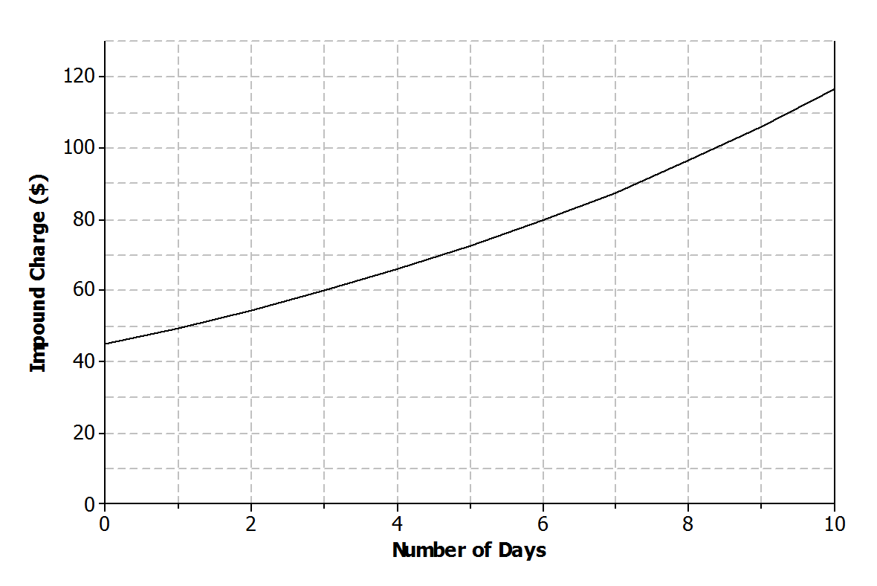Answers will vary.

* 1. Is the function represented by the graph linear or nonlinear? Explain.

The function is nonlinear. The function is increasing.

* 1. Is the function represented by the graph increasing or decreasing? Explain.

The function is increasing. The total charge is increasing as the number of days the car is left in the lot increases.

1. Kern won a gift card to his favorite coffee shop. Every time he visits the shop, he purchases the same coffee drink.
   1. Sketch a graph of a function that can be used to represent the amount of money that remains on the gift card with respect to the number of drinks purchased.

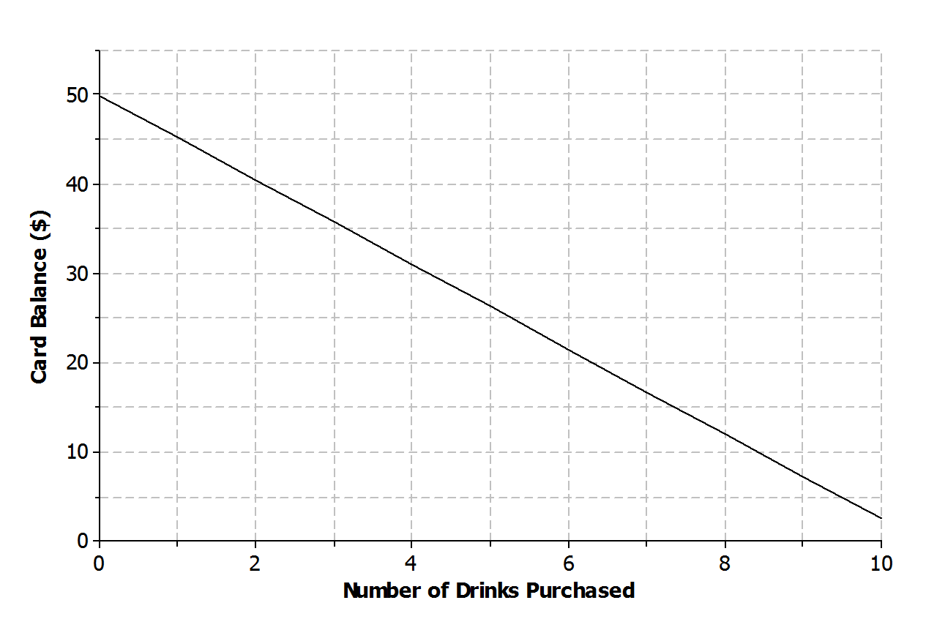Answers will vary.

* 1. Is the function represented by the graph linear or nonlinear? Explain.

The function is linear. Since Kern purchases the same drink every visit, the balance is decreasing by the same amount or, in other words, at a constant rate of change.

* 1. Is the function represented by the graph increasing or decreasing? Explain.

The function is decreasing. With each drink purchased, the amount of money on the card decreases.

1. Jay and Brooke are racing on bikes to a park miles away. The tables below display the total distance each person biked with respect to time.

|  |  |  |  |  |  |  |  |  |  |  |  |  |  |  |  |  |  |  |  |  |  |  |  |  |  |  |  |  |  |
| --- | --- | --- | --- | --- | --- | --- | --- | --- | --- | --- | --- | --- | --- | --- | --- | --- | --- | --- | --- | --- | --- | --- | --- | --- | --- | --- | --- | --- | --- |
| Jay   |  |  | | --- | --- | | Time  (minutes) | Distance  (miles) | |  |  | |  |  | |  |  | |  |  | |  |  | |  |  | | Brooke   |  |  | | --- | --- | | Time  (minutes) | Distance  (miles) | |  |  | |  |  | |  |  | |  |  | |  |  | |  |  | |

* 1. Which person’s biking distance could be modeled by a nonlinear function? Explain.

The distance that Jay biked could be modeled by a nonlinear function because the rate of change is not constant. The distance that Brooke biked could be modeled by a linear function because the rate of change is constant.

* 1. Who would you expect to win the race? Explain.

Jay will win the race. The distance he bikes during each five-minute interval is increasing, while Brooke’s biking distance remains constant. If the trend remains the same, it is estimated that both Jay and Brooke will travel about miles in minutes. So, Jay will overtake Brooke during the last minutes to win the race.

1. Using the axes below, create a story about the relationship between two quantities.
   1. Write a story about the relationship between two quantities. Any quantities can be used (e.g., distance and time, money and hours, age and growth). Be creative! Include keywords in your story such as *increase* and *decrease* to describe the relationship.

Answers will vary.

A person in a car is at a red stoplight. The light turns green, and the person presses down on the accelerator with increasing pressure. The car begins to move and accelerate. The rate at which the car accelerates is not constant.

* 1. Label each axis with the quantities of your choice, and sketch a graph of the function that models the relationship described in the story.

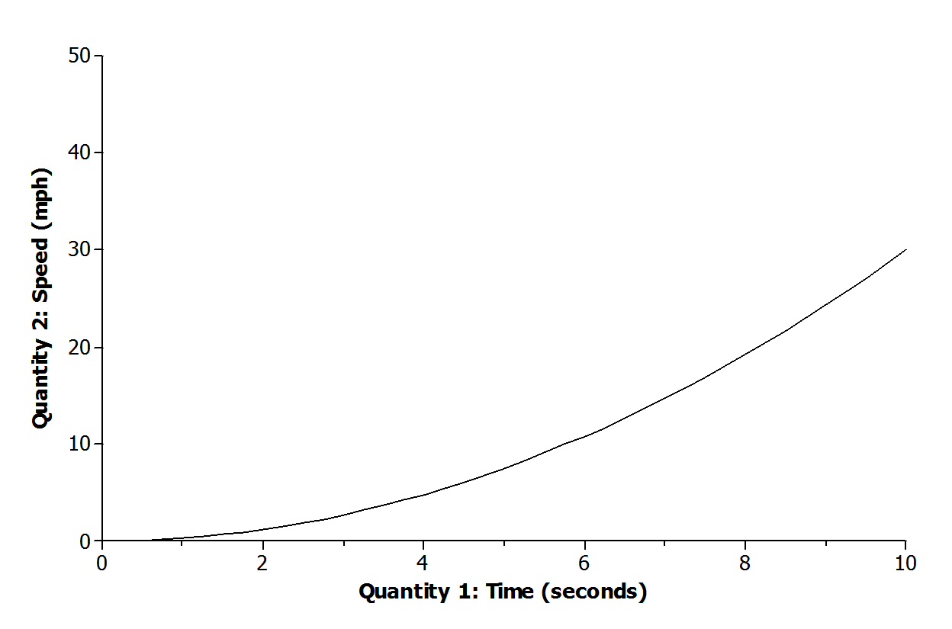Answers will vary based on the story from part (a).