Lesson 4: Increasing and Decreasing Functions

Classwork
Graphs are useful tools in terms of representing data. They provide a visual story, highlighting important facts that surround the relationship between quantities.
The graph of a linear function is a line. The slope of the line can provide useful information about the functional relationship between the two types of quantities:
- A linear function whose graph has a positive slope is said to be an increasing function.
- A linear function whose graph has a negative slope is said to be a decreasing function.
- A linear function whose graph has a zero slope is said to be a constant function.

Exercises
- Read through each of the scenarios and choose the graph of the function that best matches the situation. Explain the reason behind each choice.
  - A bathtub is filled at a constant rate of $1.75$ gallons per minute.
  - A bathtub is drained at a constant rate of $2.5$gallons per minute.
  - A bathtub contains $2.5$ gallons of water.
  - A bathtub is filled at a constant rate of $2.5$ gallons per minute.
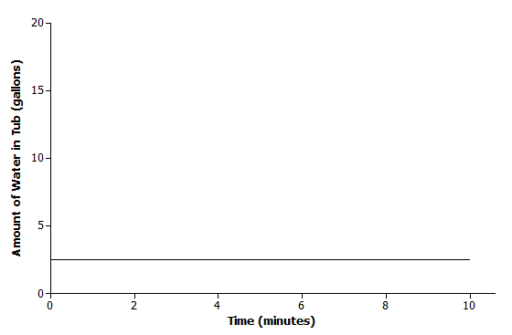 | Scenario:  Explanation:
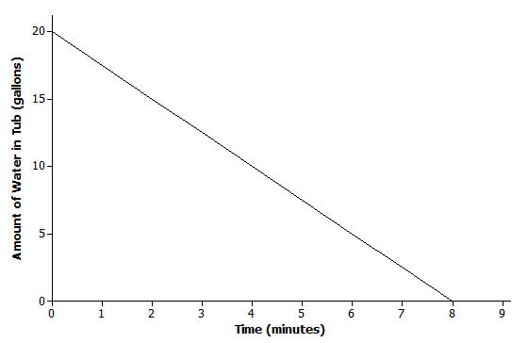 | Scenario:  Explanation:
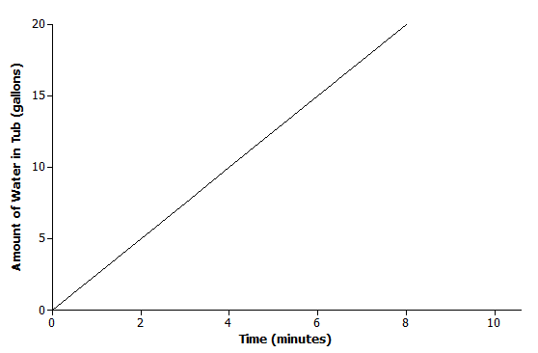 | Scenario:  Explanation:
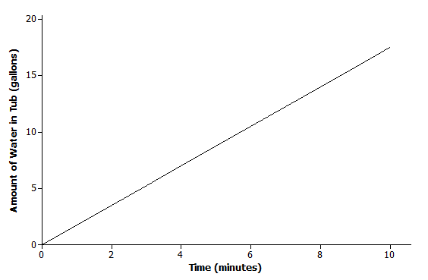 | Scenario:  Explanation:
- Read through each of the scenarios, and sketch a graph of a function that models the situation.
  - A messenger service charges a flat rate of $\$4.95$ to deliver a package regardless of distance to the destination.
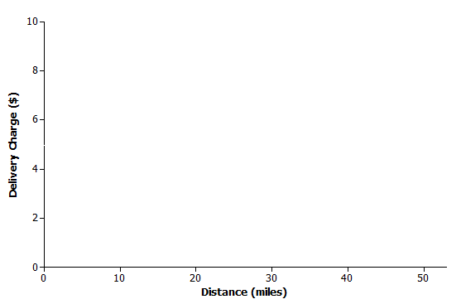

  - At sea level, the air that surrounds us presses down on our bodies at $14.7$ pounds per square inch (psi). For every $10$ meters that you dive under water, the pressure increases by $14.7$psi.
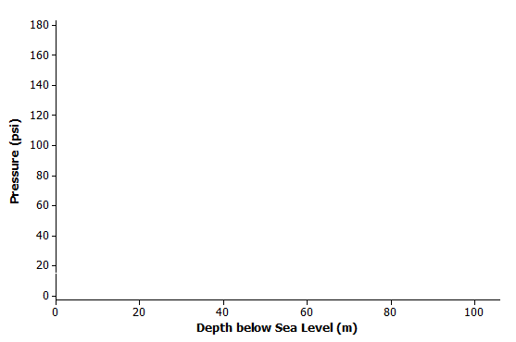

  - The range (driving distance per charge) of an electric car varies based on the average speed the car is driven. The initial range of the electric car after a full charge is $400$ miles. However, the range is reduced by $20$ miles for every $10$mph increase in average speed the car is driven.
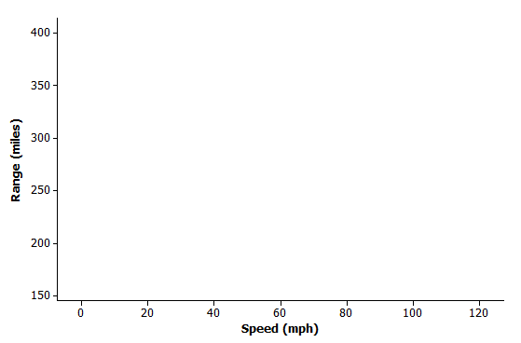

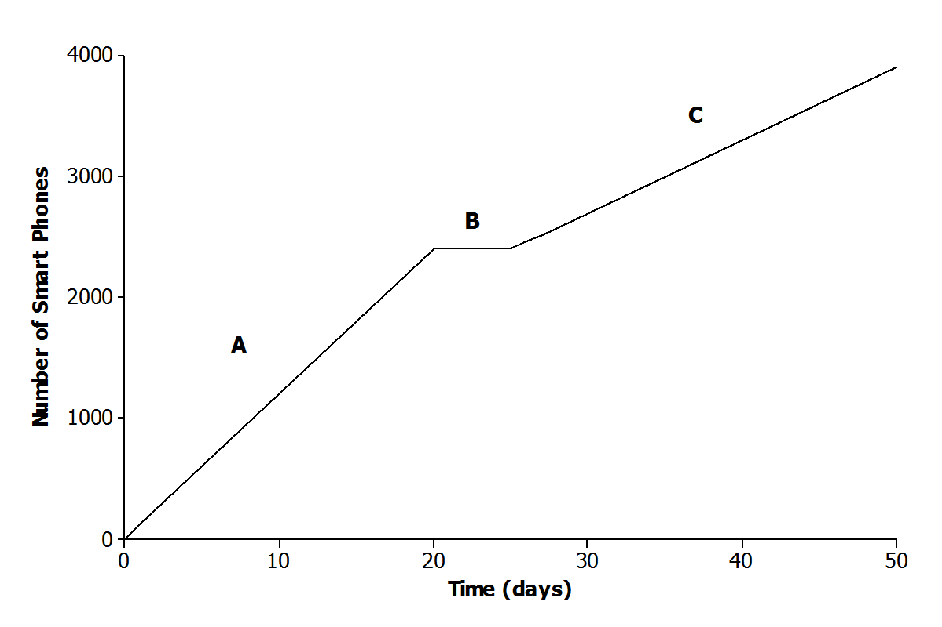
- The graph below represents the total number of smart phones that are shipped to a retail store over the course of $50$ days.
Match each part of the graph (A, B, and C) to its verbal description. Explain the reasoning behind your choice.
    - Half of the factory workers went on strike, and not enough smartphones were produced for normal shipments.

    - The production schedule was normal, and smartphones were shipped to the retail store at a constant rate.

    - A defective electronic chip was found, and the factory had to shut down; so, no smartphones were shipped.

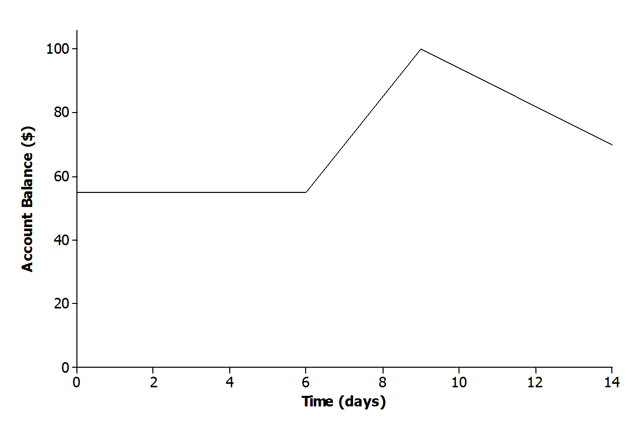
- The relationship between Jameson’s account balance and time is modeled by the graph below.
  - Write a story that models the situation represented by the graph.

  - When is the function represented by the graph increasing? How does this relate to your story?

  - When is the function represented by the graph decreasing? How does this relate to your story?

Lesson Summary
The graph of a function can be used to help describe the relationship between two quantities.
The slope of the line can provide useful information about the functional relationship between two quantities:
- A function whose graph has a positive slope is said to be an increasing function.
- A function whose graph has a negative slope is said to be a decreasing function.
- A function whose graph has a zero slope is said to be a constant function.

Problem Set

- Read through each of the scenarios, and choose the graph of the function that best matches the situation. Explain the reason behind each choice.
  - The tire pressure on Regina’s car remains at $30$psi.
  - Carlita inflates her tire at a constant rate for $4$ minutes.
  - Air is leaking from Courtney’s tire at a constant rate.
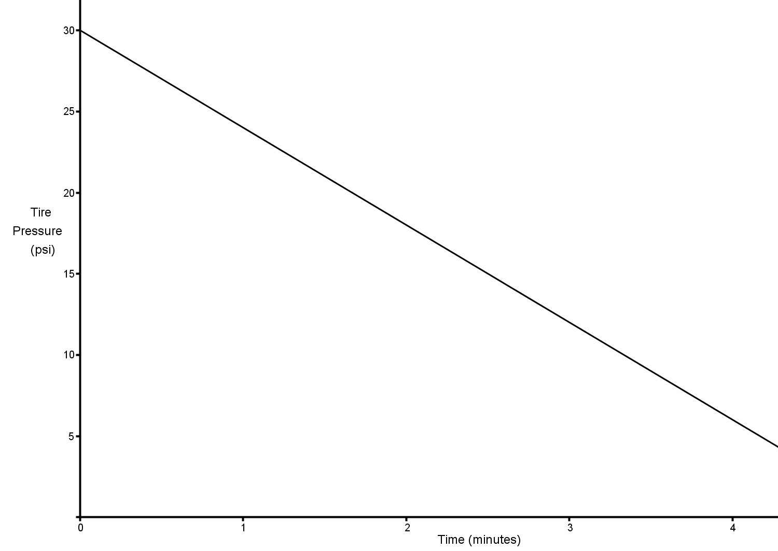 | Scenario:  Explanation:
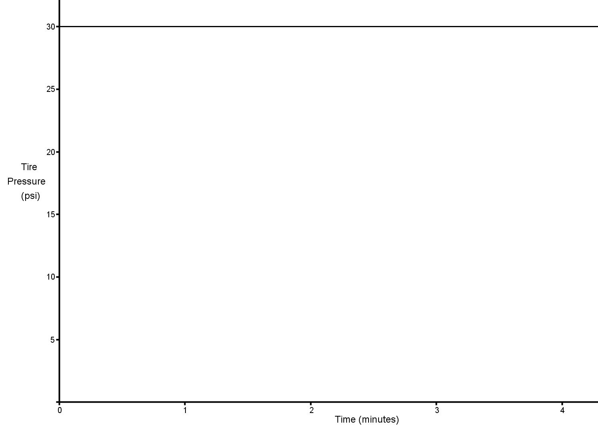 | Scenario:  Explanation:
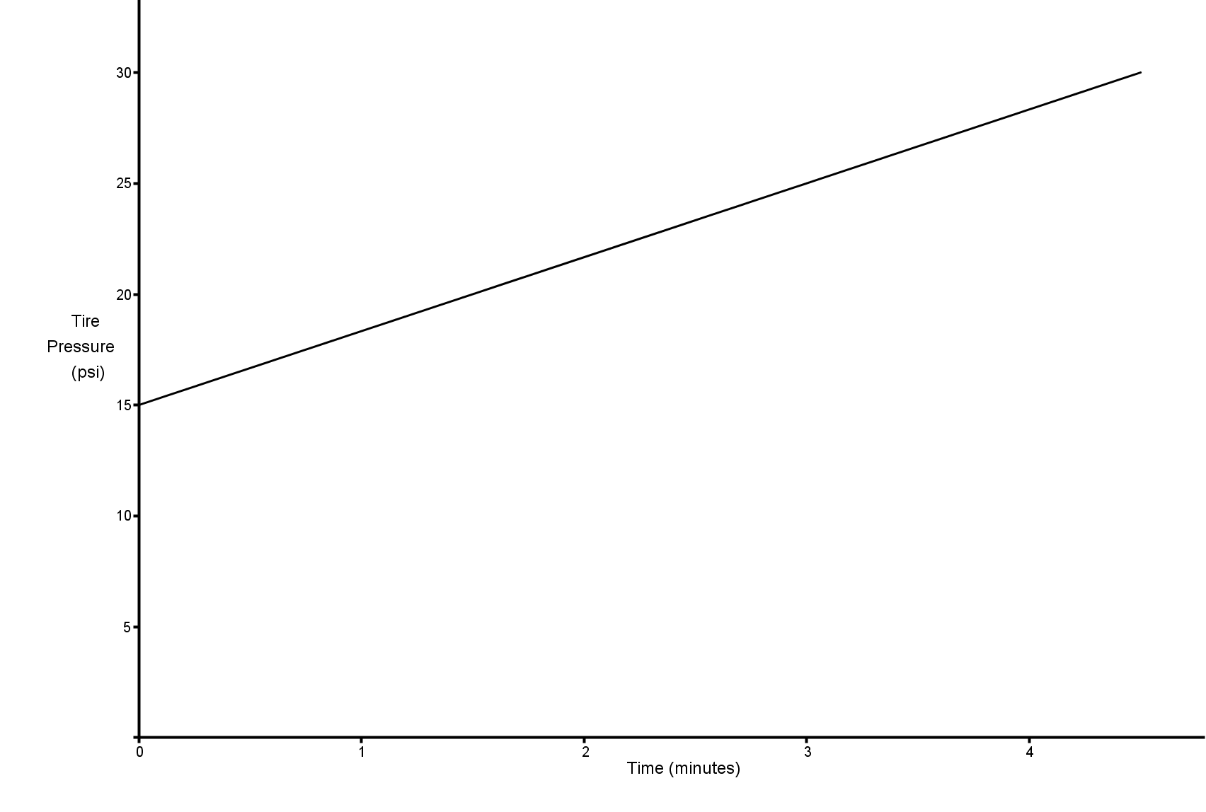 | Scenario:  Explanation:

- A home was purchased for $\$275,000$. Due to a recession, the value of the home fell at a constant rate over the next $5$ years.
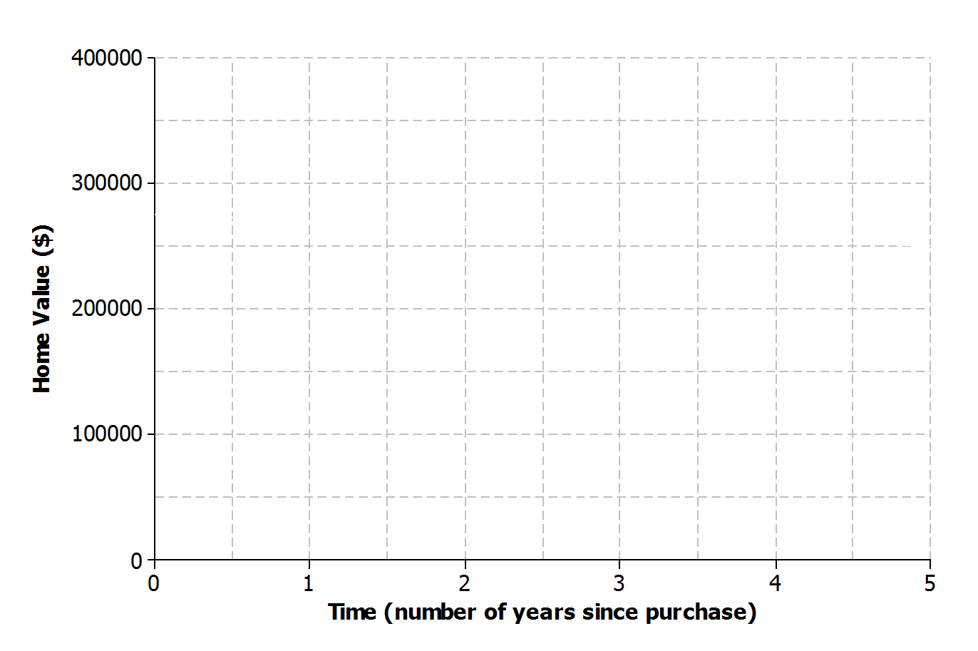
  - Sketch a graph of a function that models the situation.
  - Based on your graph, how is the home value changing with respect to time?

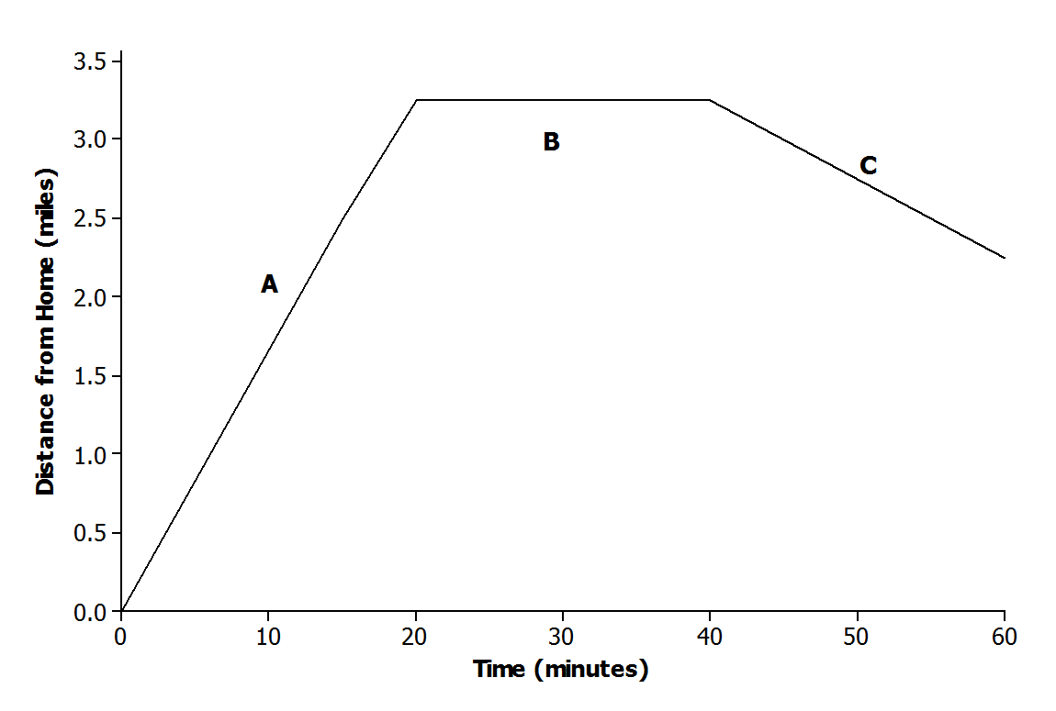
- The graph below displays the first hour of Sam’s bike ride.
Match each part of the graph (A, B, and C) to its verbal description. Explain the reasoning behind your choice.
    - Sam rides his bike to his friend’s house at a constant rate.
    - Sam and his friend bike together to an ice cream shop that is between their houses.
    - Sam plays at his friend’s house.

- Using the axes below, create a story about the relationship between two quantities.
  - Write a story about the relationship between two quantities. Any quantities can be used (e.g., distance and time, money and hours, age and growth). Be creative! Include keywords in your story such as increase and decrease to describe the relationship.
  - Label each axis with the quantities of your choice, and sketch a graph of the function that models the relationship described in the story.
