Lesson 4: Increasing and Decreasing Functions

Student Outcomes
- Students describe qualitatively the functional relationship between two types of quantities by analyzing a graph.
- Students sketch a graph that exhibits the qualitative features of a function based on a verbal description.

Lesson Notes
This lesson focuses on graphs and the role they play in analyzing functional relationships between quantities. Students have been introduced to increasing and decreasing functions in a prior lesson in Grade 8. This lesson references a constant function, one in which the graph of the function is a line with zero slope. Piecewise functions are also used throughout the lesson to demonstrate how the functional relationship can increase or decrease between different intervals. Rate of change should be discussed among the intervals, but the term piecewise function does not need to be defined. This lesson also focuses on linear relationships. Nonlinear examples are presented in the next lesson.

Classwork
Opening
Graphs are useful tools in terms of representing data. They provide a visual story, highlighting important facts that surround the relationship between quantities.
The graph of a linear function is a line. The slope of the line can provide useful information about the functional relationship between the two types of quantities:
- A linear function whose graph has a positive slope is said to be an increasing function.
- A linear function whose graph has a negative slope is said to be a decreasing function.
- A linear function whose graph has a zero slope is said to be a constant function.

Exercise 1 (7–9 minutes)
Read through the opening text with students. Remind students that knowing the slope of the line that represents the function will tell them if the function is increasing or decreasing. Introduce the term constant function. Present examples of functions that are constant; for example, your cell phone bill is $\$79$ every month for unlimited calls and data. Let students work independently on Exercise 1; then, discuss and confirm answers as a class.
Exercises
- Read through each of the scenarios and choose the graph of the function that best matches the situation. Explain the reason behind each choice.
- A bathtub is filled at a constant rate of $1.75$ gallons per minute.
- A bathtub is drained at a constant rate of $2.5$gallons per minute.
- A bathtub contains $2.5$ gallons of water.
- A bathtub is filled at a constant rate of $2.5$ gallons per minute.
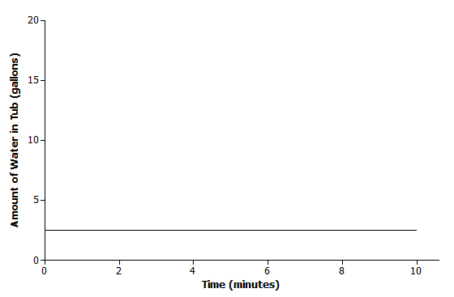 | Scenario: c  Explanation: The amount of water in the tub does not change over time; it remains constant.
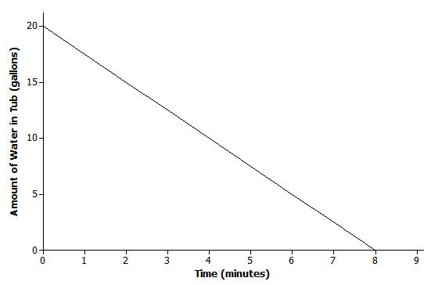 | Scenario: b  Explanation: The bathtub is being drained. So, the amount of water is decreasing, which means that the slope of the line is negative. The graph of the function also shows that there are initially $20$ gallons of water in the tub.
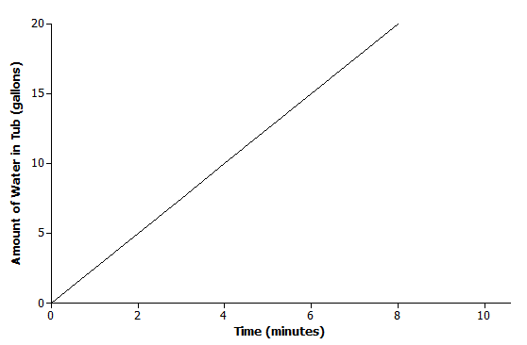 | Scenario: d  Explanation: The tub is being filled, which implies that the amount of water in the tub is increasing, so the line has a positive slope. Based on the graph, the amount of water is also increasing at a faster rate than in choice (a).

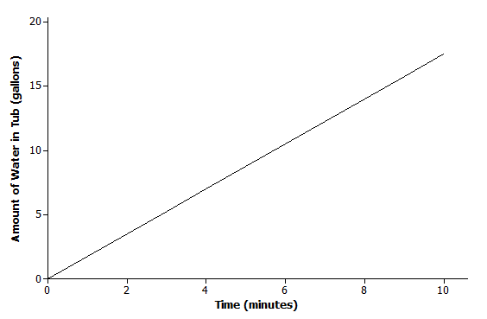 | Scenario: a  Explanation: The bathtub is being filled, so the amount of water is increasing. This implies that the slope should be positive; however, the rate at which the tub is being filled is less than the rate for choice (d).

Exercise 2 (8–10 minutes)
In this exercise, students will sketch a graph of a functional relationship given a verbal description. Allow students to work with a partner and then confirm answers as a class. Refer to the functions as increasing or decreasing when discussing answers.
Students may misinterpret the meaning of flat rate in part (a). Discuss the meaning as a class. Tell students that it could also be called a flat fee.
After students have graphed the scenario presented in part (b), consider generating another graph where “meters under water” is represented using negative numbers. This provides an opportunity for students to see a real world scenario with a negative slope graphed in the second quadrant. Ask students if both graphs model the same situation.
MP.2

- Read through each of the scenarios, and sketch a graph of a function that models the situation.
  - A messenger service charges a flat rate of $\$4.95$ to deliver a package regardless of distance to the destination.
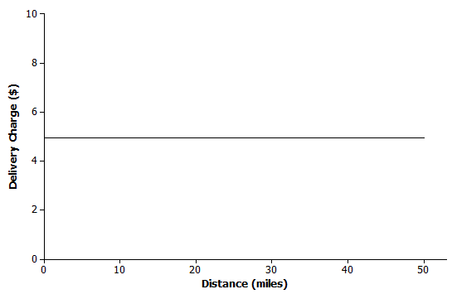
The delivery charge remains constant regardless of the distance to destination.

  - At sea level, the air that surrounds us presses down on our bodies at $14.7$ pounds per square inch (psi). For every $10$ meters that you dive under water, the pressure increases by $14.7$psi.
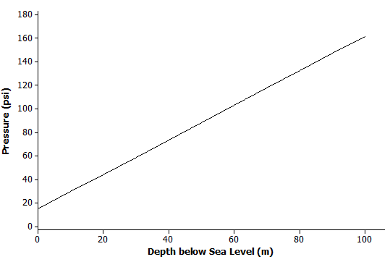
The initial value is $14.7$ psi. The function increases at a rate of $14.7$ psi for every $10$ meters, or $1.47$ psi per meter.

  - The range (driving distance per charge) of an electric car varies based on the average speed the car is driven. The initial range of the electric car after a full charge is $400$ miles. However, the range is reduced by $20$ miles for every $10$mph increase in average speed the car is driven.
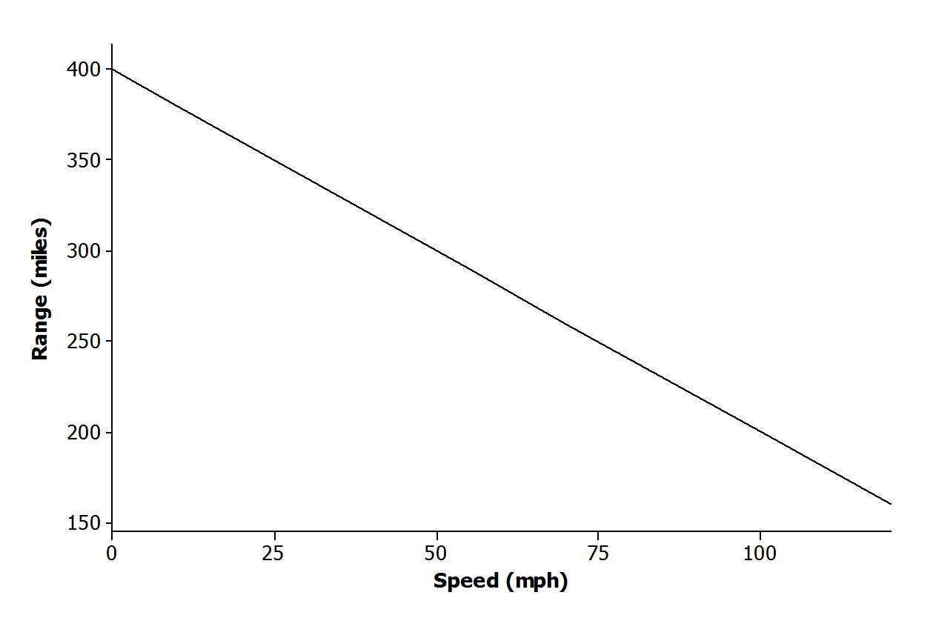
The initial value of the function is$400$. The function is decreasing by $20$ miles for $10$ mph increase in speed. In other words, the function decreases by $2$ miles for every $1$ mph increase in speed.

Exercise 3 (7–9 minutes)
Graphs of piecewise functions are introduced in this exercise. Students match verbal descriptions to a given graph. Let students work with a partner. Then, discuss and confirm answers as a class.

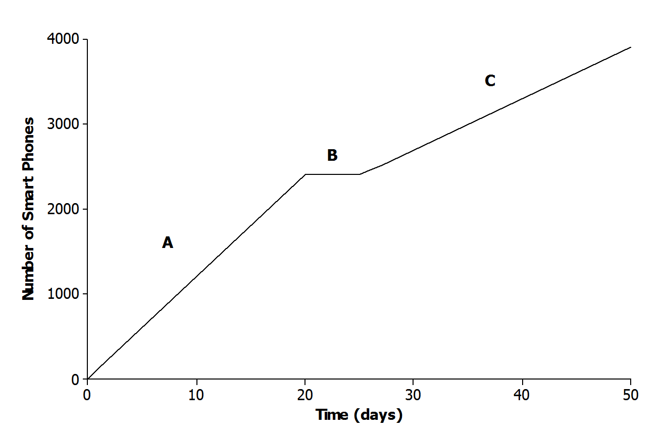
- The graph below represents the total number of smart phones that are shipped to a retail store over the course of $50$ days.
Match each part of the graph (A, B, and C) to its verbal description. Explain the reasoning behind your choice.
    - Half of the factory workers went on strike, and not enough smartphones were produced for normal shipments.
C; if half of the workers went on strike, then the number of smartphones produced would be less than normal. The rate of change for C is less than the rate of change for A.

    - The production schedule was normal, and smartphones were shipped to the retail store at a constant rate.
A; if the production schedule is normal, the rate of change or interval A is greater than the rate of change of interval C.

    - A defective electronic chip was found, and the factory had to shut down, so no smartphones were shipped.
B; if no smartphones are shipped to the store, the total number remains constant during that time.

Exercise 4 (10–12 minutes)
Let students work in small groups to create a story around the function represented by the graph. Then, compare stories as a class. Consider asking the following questions to connect the graph of the function to real-world experiences before groups begin writing their stories.
- What reason might explain why the account balance increases between days $6$ and $9$, and then decreases between days $9$ and $14$?
  - Answers will vary. Maybe the person holding the account earned $\$15$ each day mowing lawns and deposited the money each day to his account. Then, the same person needed to debit his account$\$6$ each day to pay for lunch.
- What reason might explain why the account balance does not change during the first few days?
  - Answers will vary. Jameson is sick and cannot work to earn money to deposit into his account.

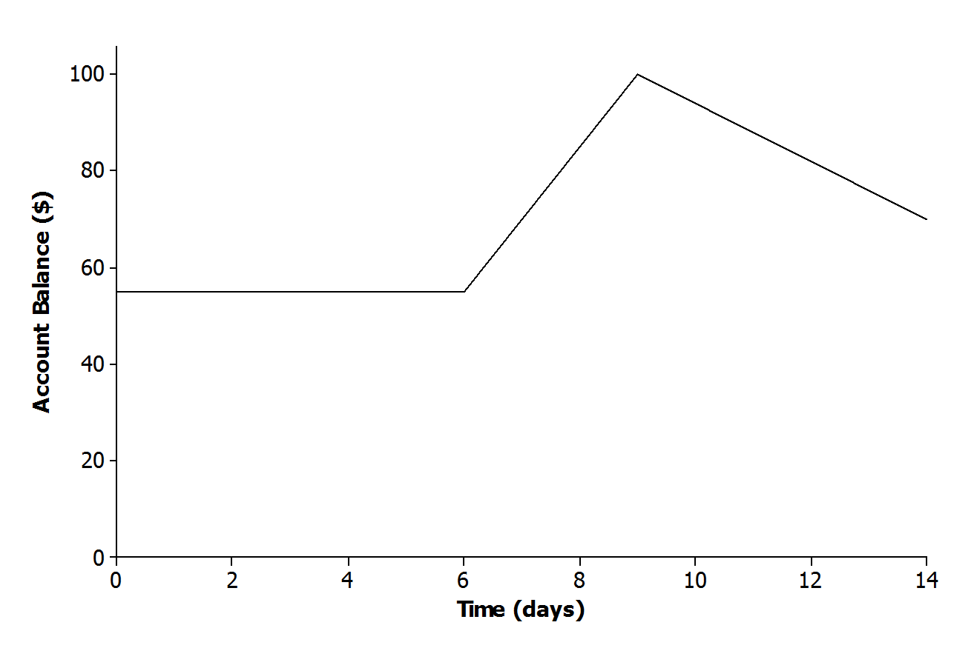
- The relationship between Jameson’s account balance and time is modeled by the graph below.
  - Write a story that models the situation represented by the graph.
Answers will vary.
Jameson was sick and did not work for almost a whole week. Then, he mowed several lawns over the next few days and deposited the money into his account after each job. It rained several days, so instead of working, Jameson withdrew money from his account each day to go to the movies and out to lunch with friends.

  - When is the function represented by the graph increasing? How does this relate to your story?
Between $6$ and $9$ days. Jameson earned money mowing lawns and made a deposit to his account each day. The money earned for each day was constant for these days. This is represented by a straight line.

  - When is the function represented by the graph decreasing? How does this relate to your story?
Between $9$ and $14$ days. Since days $9$–$14$ are represented by a straight line, this means that Jameson spent the money constantly over these days. Jameson cannot work because it is raining. Perhaps he withdraws money from his account to spend on different activities each day because he cannot work.

Closing (3–4 minutes)
Review the Lesson Summary with the class.
- Refer back to Exercise 1. In parts (a) and (d), the bathtub was being filled at a constant rate. Is it reasonable within the context of the problem for the function in the graph to continue increasing?
  - No. At some point the tub will be full, and the amount of water cannot continue to increase.
- Refer back to Exercise 2, part (b). The amount of pressure that an underwater diver experiences continues to increase as the diver continues to descend. Is it reasonable within the context of the problem for the function in the graph to continue increasing?
  - No. At some point, the pressure will be too great, and the diver will not be able to descend any farther.
- Is there a scenario that would require a function that modeled the situation to increase indefinitely? Explain.
  - Yes. Students may use the example of money left in a savings account. It may need to be pointed out that this scenario is not necessarily linear, but if no money is withdrawn, the total would continue to increase.
Lesson Summary
The graph of a function can be used to help describe the relationship between two quantities.
The slope of the line can provide useful information about the functional relationship between two quantities:
- A function whose graph has a positive slope is said to be an increasing function.
- A function whose graph has a negative slope is said to be a decreasing function.
- A function whose graph has a zero slope is said to be a constant function.

Exit Ticket (8 minutes)

Name ___________________________________________________ Date____________________
Lesson 4: Increasing and Decreasing Functions

Exit Ticket

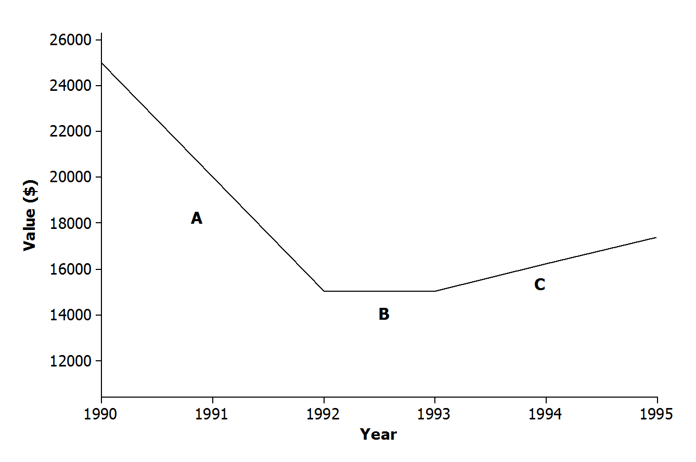
- The graph below shows the relationship between a car’s value and time.
Match each part of the graph (A, B, and C) to its verbal description. Explain the reasoning behind your choice.
    - The value of the car holds steady due to a positive consumer report on the same model.

    - There is a shortage of used cars on the market, and the value of the car rises at a constant rate.

    - The value of the car depreciates at a constant rate.

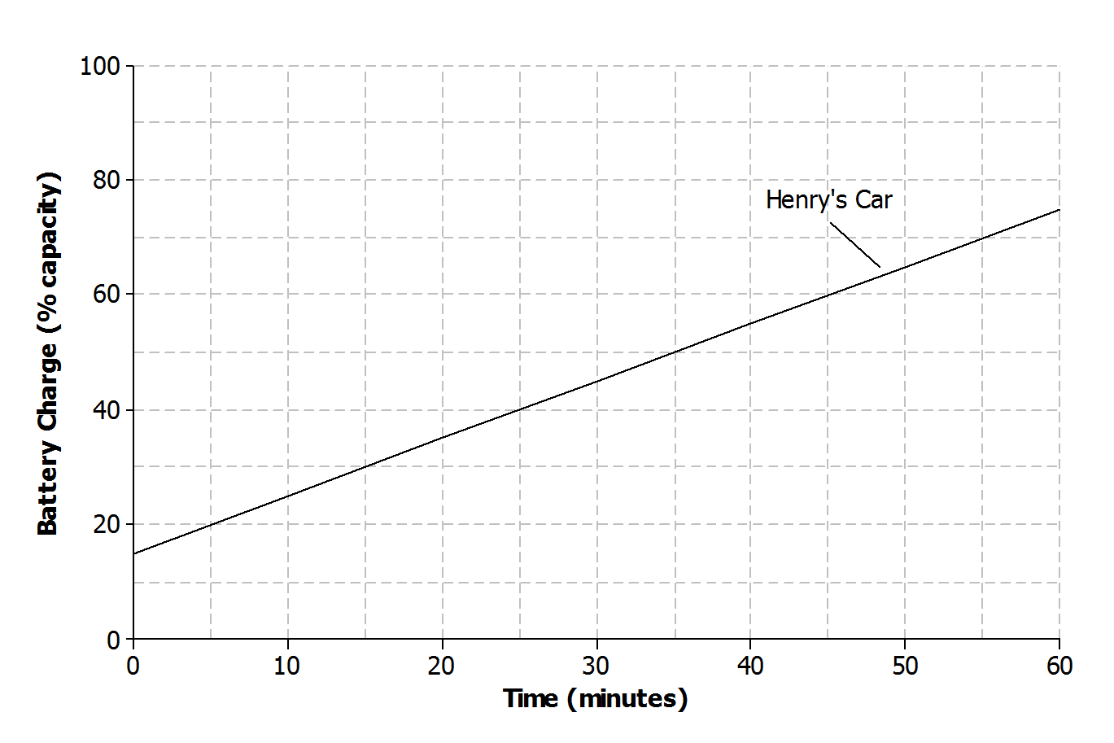
- Henry and Roxy both drive electric cars that need to be recharged before use. Henry uses a standard charger at his home to recharge his car. The graph below represents the relationship between the battery charge and the amount of time it has been connected to the power source for Henry’s car.
  - Describe how Henry’s car battery is being recharged with respect to time.

  - Roxy has a supercharger at her home that can charge about half of the battery in $20$ minutes. There is no remaining charge left when she begins recharging the battery. Sketch a graph that represents the relationship between the battery charge and the amount of time on the axes above. Assume the relationship is linear.

  - Which person’s car will be recharged to full capacity first? Explain.

Exit Ticket Sample Solutions

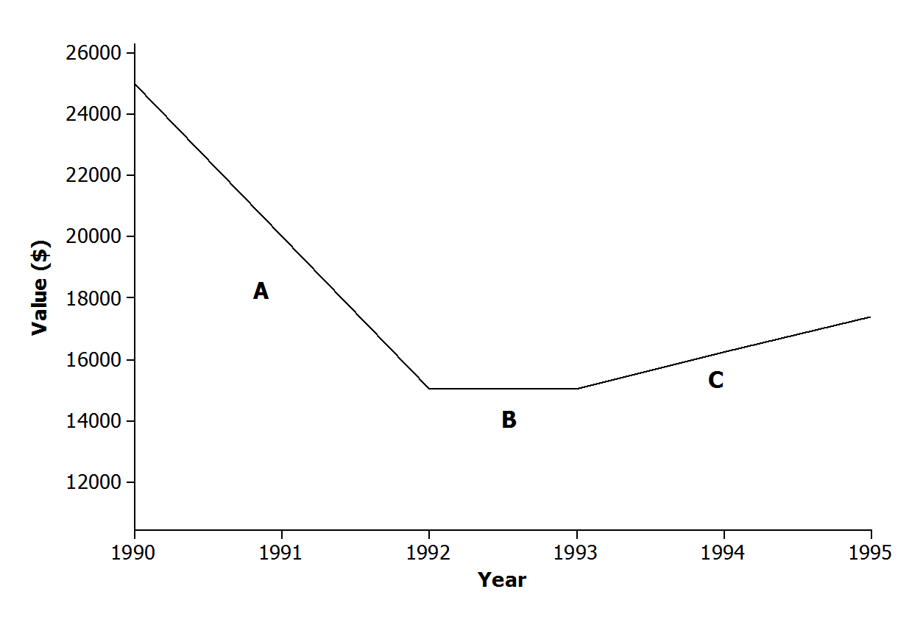
- The graph below shows the relationship between a car’s value and time.
Match each part of the graph (A, B, and C) to its verbal description. Explain the reasoning behind your choice.
    - The value of the car holds steady due to a positive consumer report on the same model.
B; if the value is holding steady, there is no change in the car’s value between years.

    - There is a shortage of used cars on the market, and the value of the car rises at a constant rate.
C; if the value of the car is rising, it represents an increasing function.

    - The value of the car depreciates at a constant rate.
A; if the value depreciates, it represents a decreasing function.

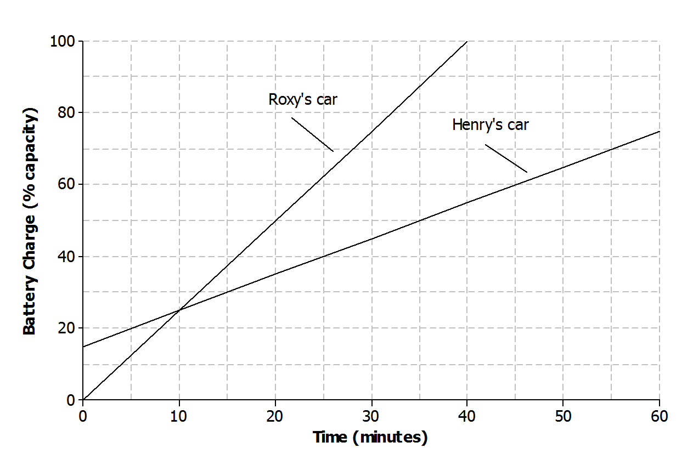
- Henry and Roxy both drive electric cars that need to be recharged before use. Henry uses a standard charger at his home to recharge his car. The graph below represents the relationship between the battery charge and the amount of time it has been connected to the power source for Henry’s car.

  - Describe how Henry’s car battery is being recharged with respect to time.
The battery charge is increasing at a constant rate of $10\%$ every $10$ minutes.
  - Roxy has a supercharger at her home that can charge about half of the battery in $20$ minutes. There is no remaining charge left when she begins recharging the battery. Sketch a graph that represents the relationship between the battery charge and the amount of time on the axes above. Assume the relationship is linear.
See graph above.

  - Which person’s car will be recharged to full capacity first? Explain.
Roxy’s car will be completely recharged first. Her supercharger has a greater rate of change compared to Henry’s charger.

Problem Set Sample Solutions

- Read through each of the scenarios, and choose the graph of the function that best matches the situation. Explain the reason behind each choice.
  - The tire pressure on Regina’s car remains at $30$psi.
  - Carlita inflates her tire at a constant rate for $4$ minutes.
  - Air is leaking from Courtney’s tire at a constant rate.

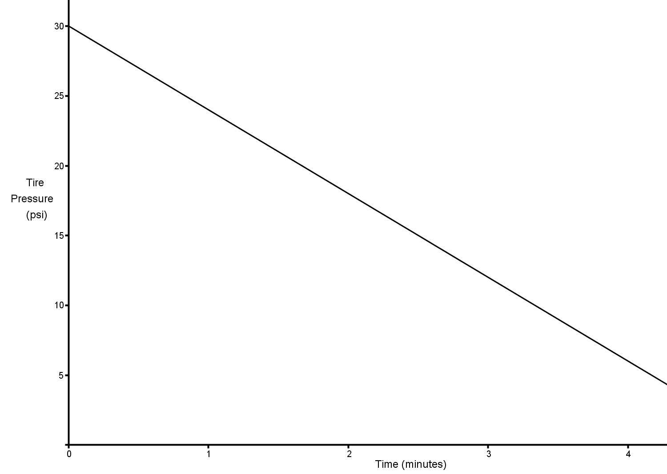 | Scenario: c  Explanation: The tire pressure decreases each minute at a constant rate.
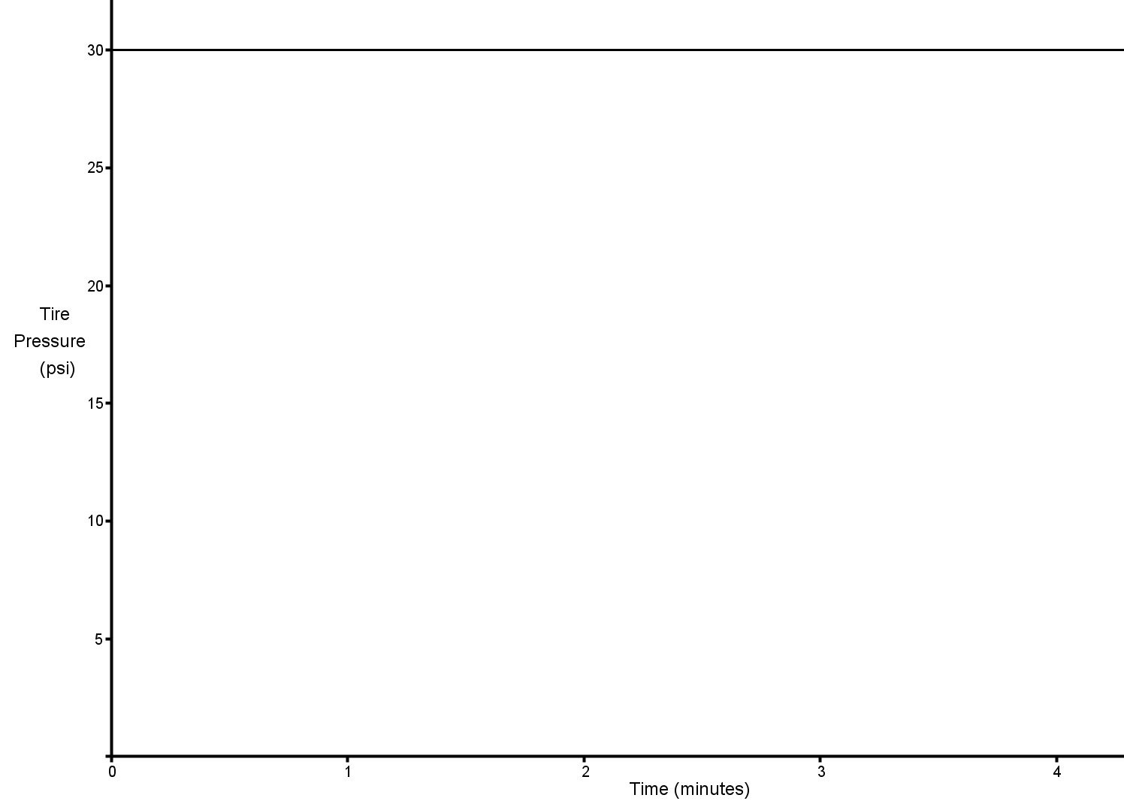 | Scenario: a  Explanation: The tire pressure remains the same.

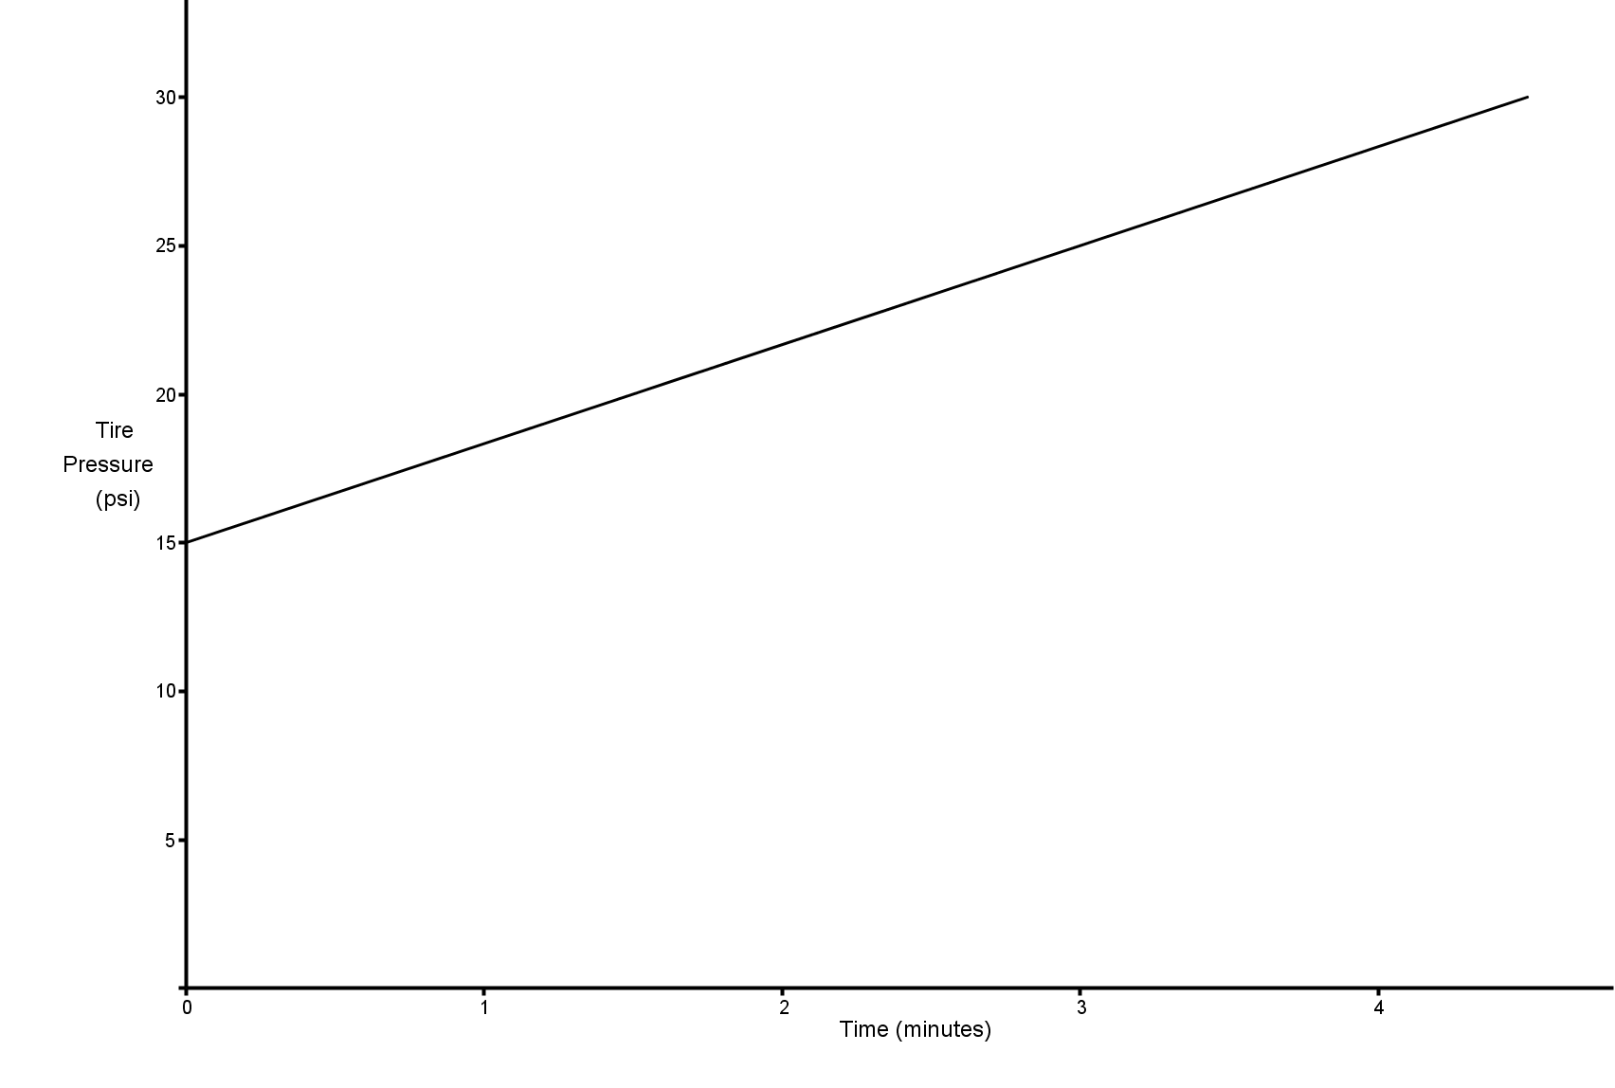 | Scenario: b  Explanation: The tire pressure is increasing each minute at a constant rate.

- A home was purchased for $\$275,000$. Due to a recession, the value of the home fell at a constant rate over the next $5$ years.
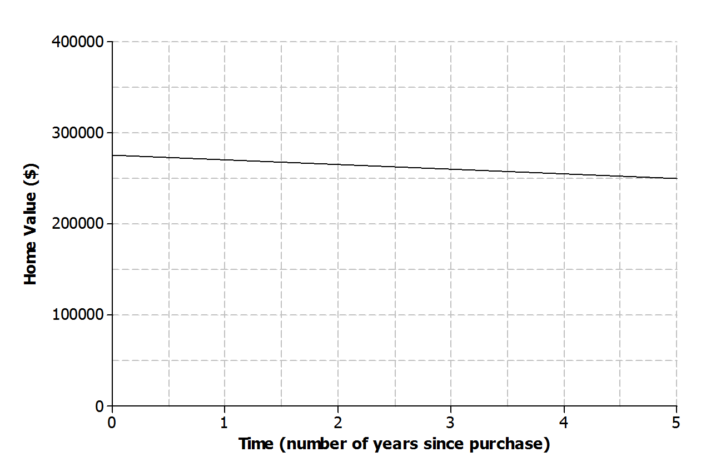
  - Sketch a graph of a function that models the situation.

  - Based on your graph, how is the home value changing with respect to time?
The value is decreasing by$\$25,000$ over $5$ years or at a constant rate of $\$5,000$ per year.

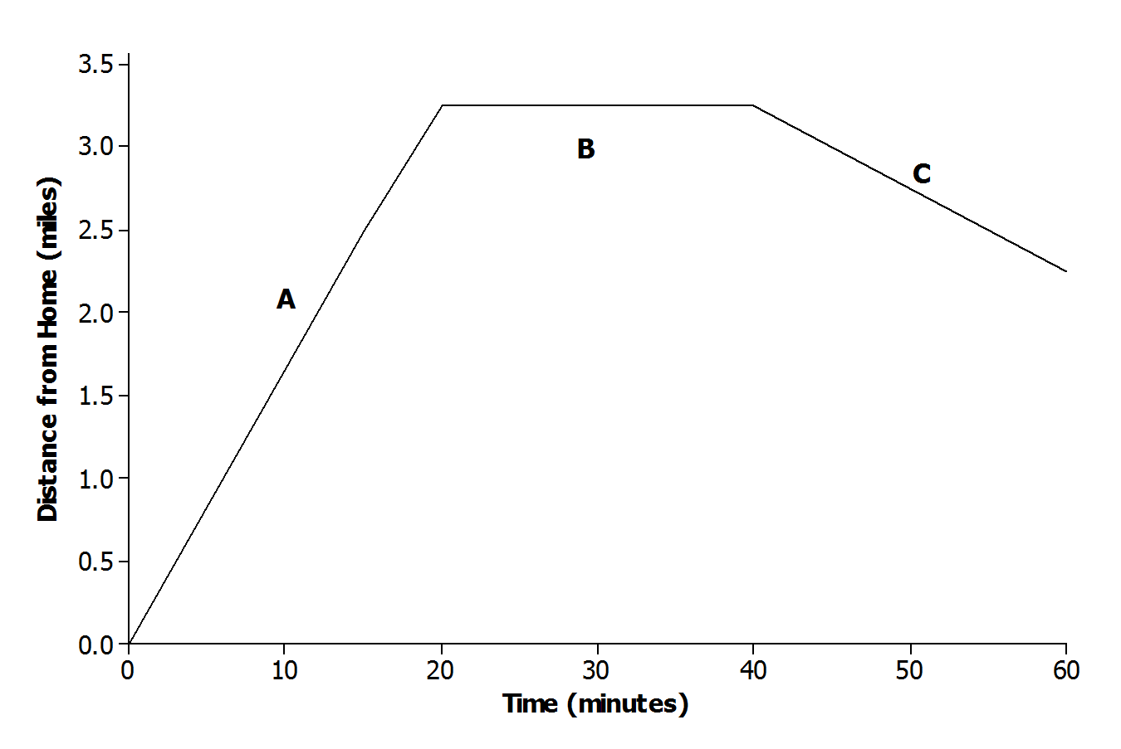
- The graph below displays the first hour of Sam’s bike ride.
Match each part of the graph (A, B, and C) to its verbal description. Explain the reasoning behind your choice.
    - Sam rides his bike to his friend’s house at a constant rate.
A; the distance from home should be increasing as Sam is riding toward his friend’s house.
    - Sam and his friend bike together to an ice cream shop that is between their houses.
C; Sam was at his friend’s house, but as they start biking to the ice cream shop, the distance from Sam’s home begins to decrease.

    - Sam plays at his friend’s house.
B; Sam remains at the same distance from home while he is at his friend’s house.

- Using the axes below, create a story about the relationship between two quantities.
  - Write a story about the relationship between two quantities. Any quantities can be used (e.g., distance and time, money and hours, age and growth). Be creative! Include keywords in your story such as increase and decrease to describe the relationship.
Answers will vary. Give students the freedom to write a basic linear story or a piecewise story.
A rock climber begins his descent from a height of $50$ feet. He slowly descends at a constant rate for $4$ minutes. He takes a break for$1$ minute; he then realizes he left some of his gear on top of the rock and climbs more quickly back to the top at a constant rate.

  - Label each axis with the quantities of your choice, and sketch a graph of the function that models the relationship described in the story.
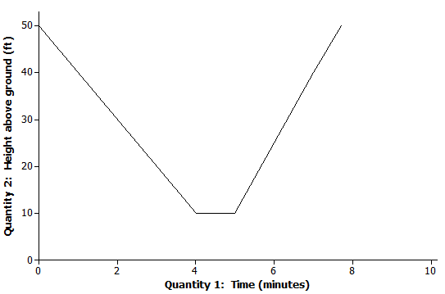
Answers will vary based on story from part (a).

