Lesson 6

Objective: Use dimes and pennies as representations of tens and ones.

Suggested Lesson Structure
 Fluency Practice (5 minutes)
 Application Problem (5 minutes)
 Concept Development (40 minutes)
 Student Debrief (10 minutes)
Total Time (60 minutes)

Fluency Practice (5 minutes)
- Quick Tens 1.NBT.2 (3 minutes)
- Count Coins 1.NBT.2 (2 minutes)

Quick Tens (3 minutes)
Materials: (T) Variety of materials to show tens and ones (e.g., 100-bead Rekenrek, linking cubes with ten-sticks and extra cubes, place value chart)
Note: This fluency activity reinforces place value because quick tens are an abstract representation of the unit ten.
Show and say numbers from 11 to 40 in varied ways for two minutes. Students draw the number with quick tens and circles (in 5-group columns). Use the materials listed above to show numbers. Choose different ways to say the numbers:
- The Say Ten Way
- As an addition expression
- As a more than statement
- As a number bond with two parts filled in
For the next minute, represent numbers using quick tens and ones. Students say the numbers aloud.

Count Coins (2 minutes)

Materials: (T) 10 pennies and 4 dimes
Note: This fluency activity provides practice with recognizing pennies and dimes and counting with abstract representations of tens and ones, which will prepare students for today’s lesson.
Lay out 2 dimes. Students count up from 20 by ones as you lay out 10 pennies into 5-groups. Repeat, but this time, change the 10 pennies for another dime once 40 has been reached.

Application Problem (5 minutes)
Sheila has 3 bags with 10 pretzels in each bag and 9 extra pretzels. She gives 1 bag to a friend. How many pretzels does she have now?
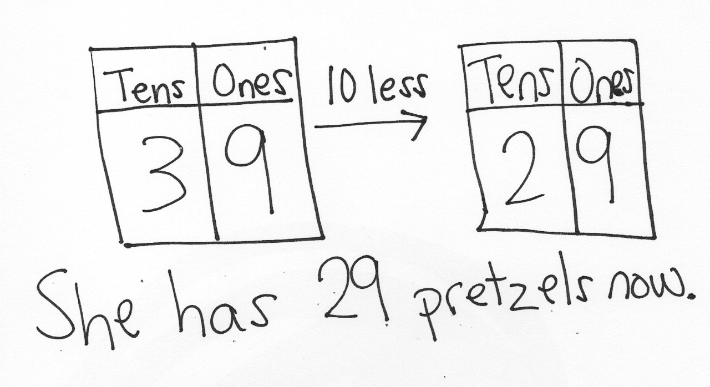
Extension: John has 19 pretzels. How many more pretzels does he need to have as many as Sheila has now?
Note: Depending on their strategies for solving, students may subtract in quantities larger than the grade-level standard of within 20. Some students may subtract 1 bag from 3 bags as their method for solving, while others may recognize that sharing 1 bag of 10 pretzels means that they have to find what number is 10 less than 39. In the Debrief, students model the quantity and use place value charts to demonstrate their method for solving.

Concept Development (40 minutes)
Materials: (T) Personal math toolkit with 4 ten-sticks of linking cubes, 4 dimes and 10 pennies, projector
(S) 4 dimes and 10 pennies, personal white board, coin and place value charts (Template)
Students gather in the meeting area with their personal math toolkits in a semicircle formation.
T: (Lay a ten-stick on the floor.) How many ones, or individual cubes, are in a ten-stick?
S: 10 ones.
T: (Lay 10 individual cubes into 5-groups next to the ten-stick.) What is the same or different about these two groups of cubes?
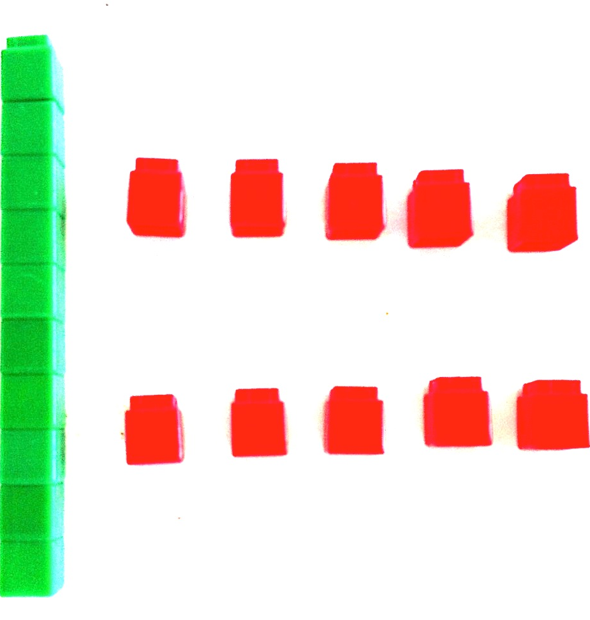
S: They are different because one of them is a ten, and the other is 10 ones. They are the same amount. The ten-stick is made up of 10 cubes. The 10 ones are also made of 10 cubes. If you put 10 ones together, they’ll become a ten-stick.
T: You are right! They are worth the same amount; they have the same value. Also, they are both made of 10 cubes. (Lay a dime underneath the ten-stick.) How many pennies have the same value as 1 dime?
S: 10 pennies.
T: (Lay 10 pennies into 5-groups next to the dime directly below the 10 individual cubes.) What is the same or different about these two groups of coins?
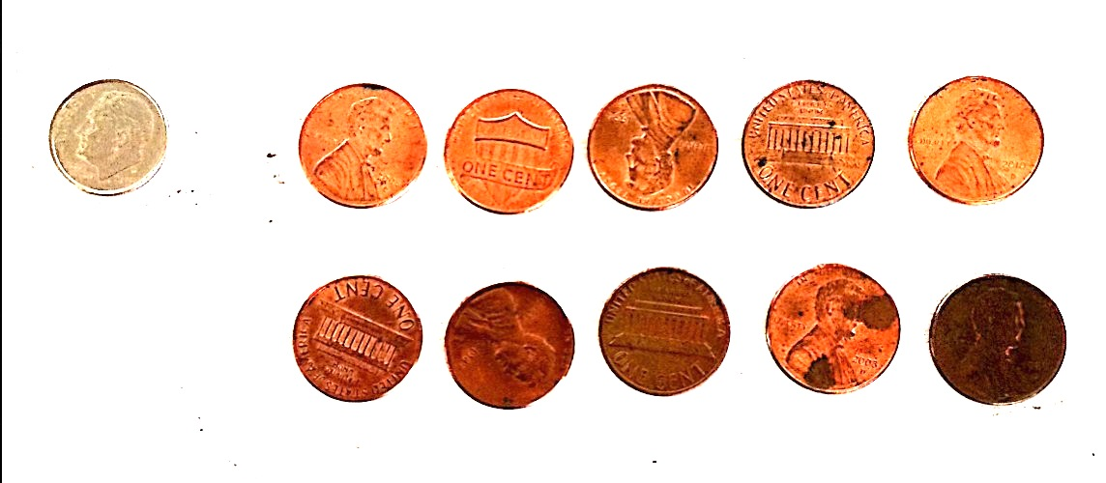
S: A dime is 10 cents. 10 pennies are worth 10 cents. The dime is only made of 1 coin. The pennies group is made up of 10 coins. The coins are different.
T: Great observations! So, 1 ten-stick has the same value as 10 individual cubes. And 1 dime has the same value as…?
S: 10 pennies!
T: I can take a ten-stick and break it apart into 10 individual cubes. Can I do the same with a dime?
S: No. A dime is just 1 coin.
T: That’s another difference. The ten-stick has a value of 10 ones, and we can see why. It’s actually made up of 10 ones, and we can see them. The dime has the same value as 10 pennies, but it’s just 1 coin. There are no pennies hiding inside. But it still has the same value as 10 pennies.
T: (Project a ten-stick and 3 single cubes.) How many tens and ones are there?

NOTES ON
MULTIPLE MEANS
OF ENGAGEMENT:
Remember to adjust the lesson structure to suit specific learning needs. Some students may have more success working with a partner since this lesson calls for a great deal of counting and manipulation of materials.

S: 1 ten 3 ones.
T: How can I use my coins to show the same number as the cubes? Show 1 ten 3 ones with your coins, and then share with your partner.
Students discuss as the teacher circulates. While circulating, be sure to address any misconceptions. Some students may want to put down 13 pennies, but won’t be able to since each student is only given 10 pennies.
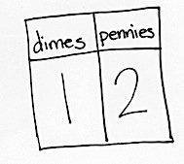
T: I noticed that some students wanted to lay down 13 pennies, but found that they didn’t have enough. What can we do to help?
MP.7
S: Use 1 dime for 1 ten, and then use 3 pennies for 3 ones.
T: Great idea! It’s just like using the ten-stick to represent 1 ten. (Choose a student volunteer to show 1 dime and 3 pennies directly below the linking cubes.)
Repeat the process using the suggested sequence: 15, 18, 28, 38, 31, 13, 40, and 39.
T: (Show 39 cents with 3 dimes and 9 pennies.)
T: How many dimes?

NOTES ON
MULTIPLE MEANS
OF REPRESENTATION:
Dimes are an abstract representation of tens, particularly because they are smaller than pennies, rather than 10 times the size of a penny. For students who are struggling to grasp quantities of tens and ones, continue to use linking cubes or bundled straws to visually present the comparative quantities.

S: 3 dimes.
T: (Fill in the dimes and pennies place value chart.) How many pennies?
S: 9 pennies.
T: (Fill in the dimes and pennies place value chart.) How many tens?
S: 3 tens.
T: (Fill in the tens and ones place value chart.) How many ones?
S: 9 ones.
T: (Fill in the tens and ones place value chart.) What is the value of 3 dimes and 9 pennies?
S: 39 cents.
T: Give a number sentence to show the total of 39 cents by adding your dimes and pennies.
S: 30 cents + 9 cents = 39 cents.
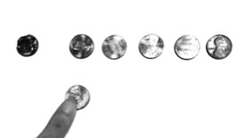
Repeat the process using the following sequence: 1 dime and 4 pennies, 1 dime and 5 pennies, 2 dimes and
5 pennies, 3 dimes, 6 pennies and 3 dimes, and 2 dimes and 8 pennies. Additionally, have students use the place value chart on their personal white boards to write down the value of these coins. Be sure to flip the coins in order for the students to become familiar with both heads and tails.

Give students one minute to study their 4 dimes and 10 pennies, noticing the similarities and differences of these coins.
T: Show 15 cents.
S: (Show 1 dime 5 pennies.)
T: Now, show me 1 more penny and write how much you have in the place value chart.
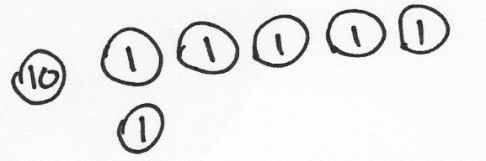
S: (Add a penny and write 16.)
T: So, what is 1 more than 15? Say it in a whole sentence.
S: 1 more than 15 is 16.
Repeat the process using the same number for 10 more, 1 less, and 10 less. For further practice, use the following suggested sequence: 3 tens 5 ones, 27, 1 ten 9 ones, 31, and 1 ten 3 ones. When appropriate, have students move on to drawing instead of using the coins as shown.
Note: As students share their work with the coins, remind them to use the unit cents. Have students add their dimes and pennies to their personal math toolkits.
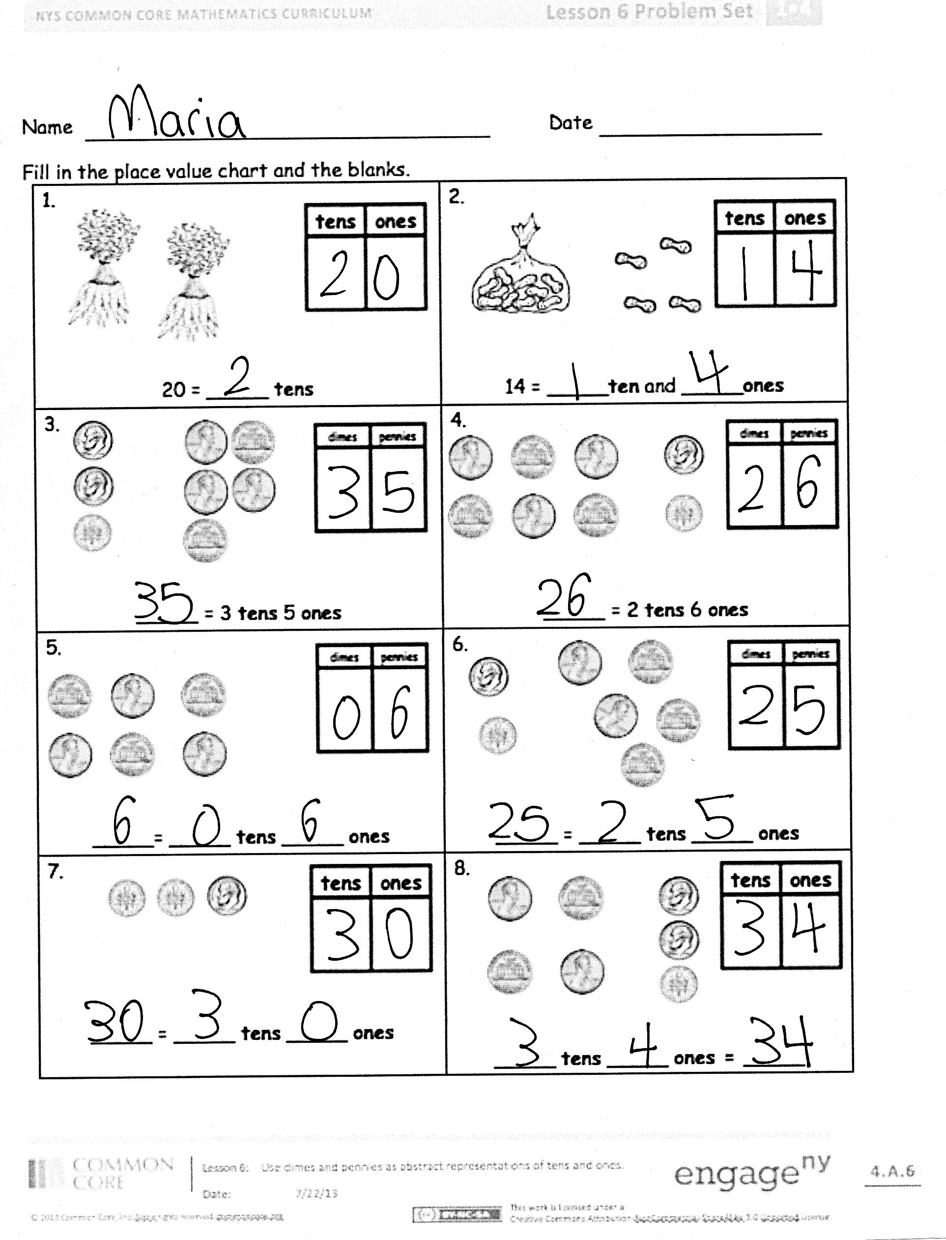
Problem Set (10 minutes)
Students should do their personal best to complete the Problem Set within the allotted 10 minutes. For some classes, it may be appropriate to modify the assignment by specifying which problems they work on first.
Student Debrief (10 minutes)
Lesson Objective: Use dimes and pennies as representations of tens and ones.
The Student Debrief is intended to invite reflection and active processing of the total lesson experience.
Invite students to review their solutions for the Problem Set. They should check work by comparing answers with a partner before going over answers as a class. Look for misconceptions or misunderstandings that can be addressed in the Debrief. Guide students in a conversation to debrief the Problem Set and process the lesson.
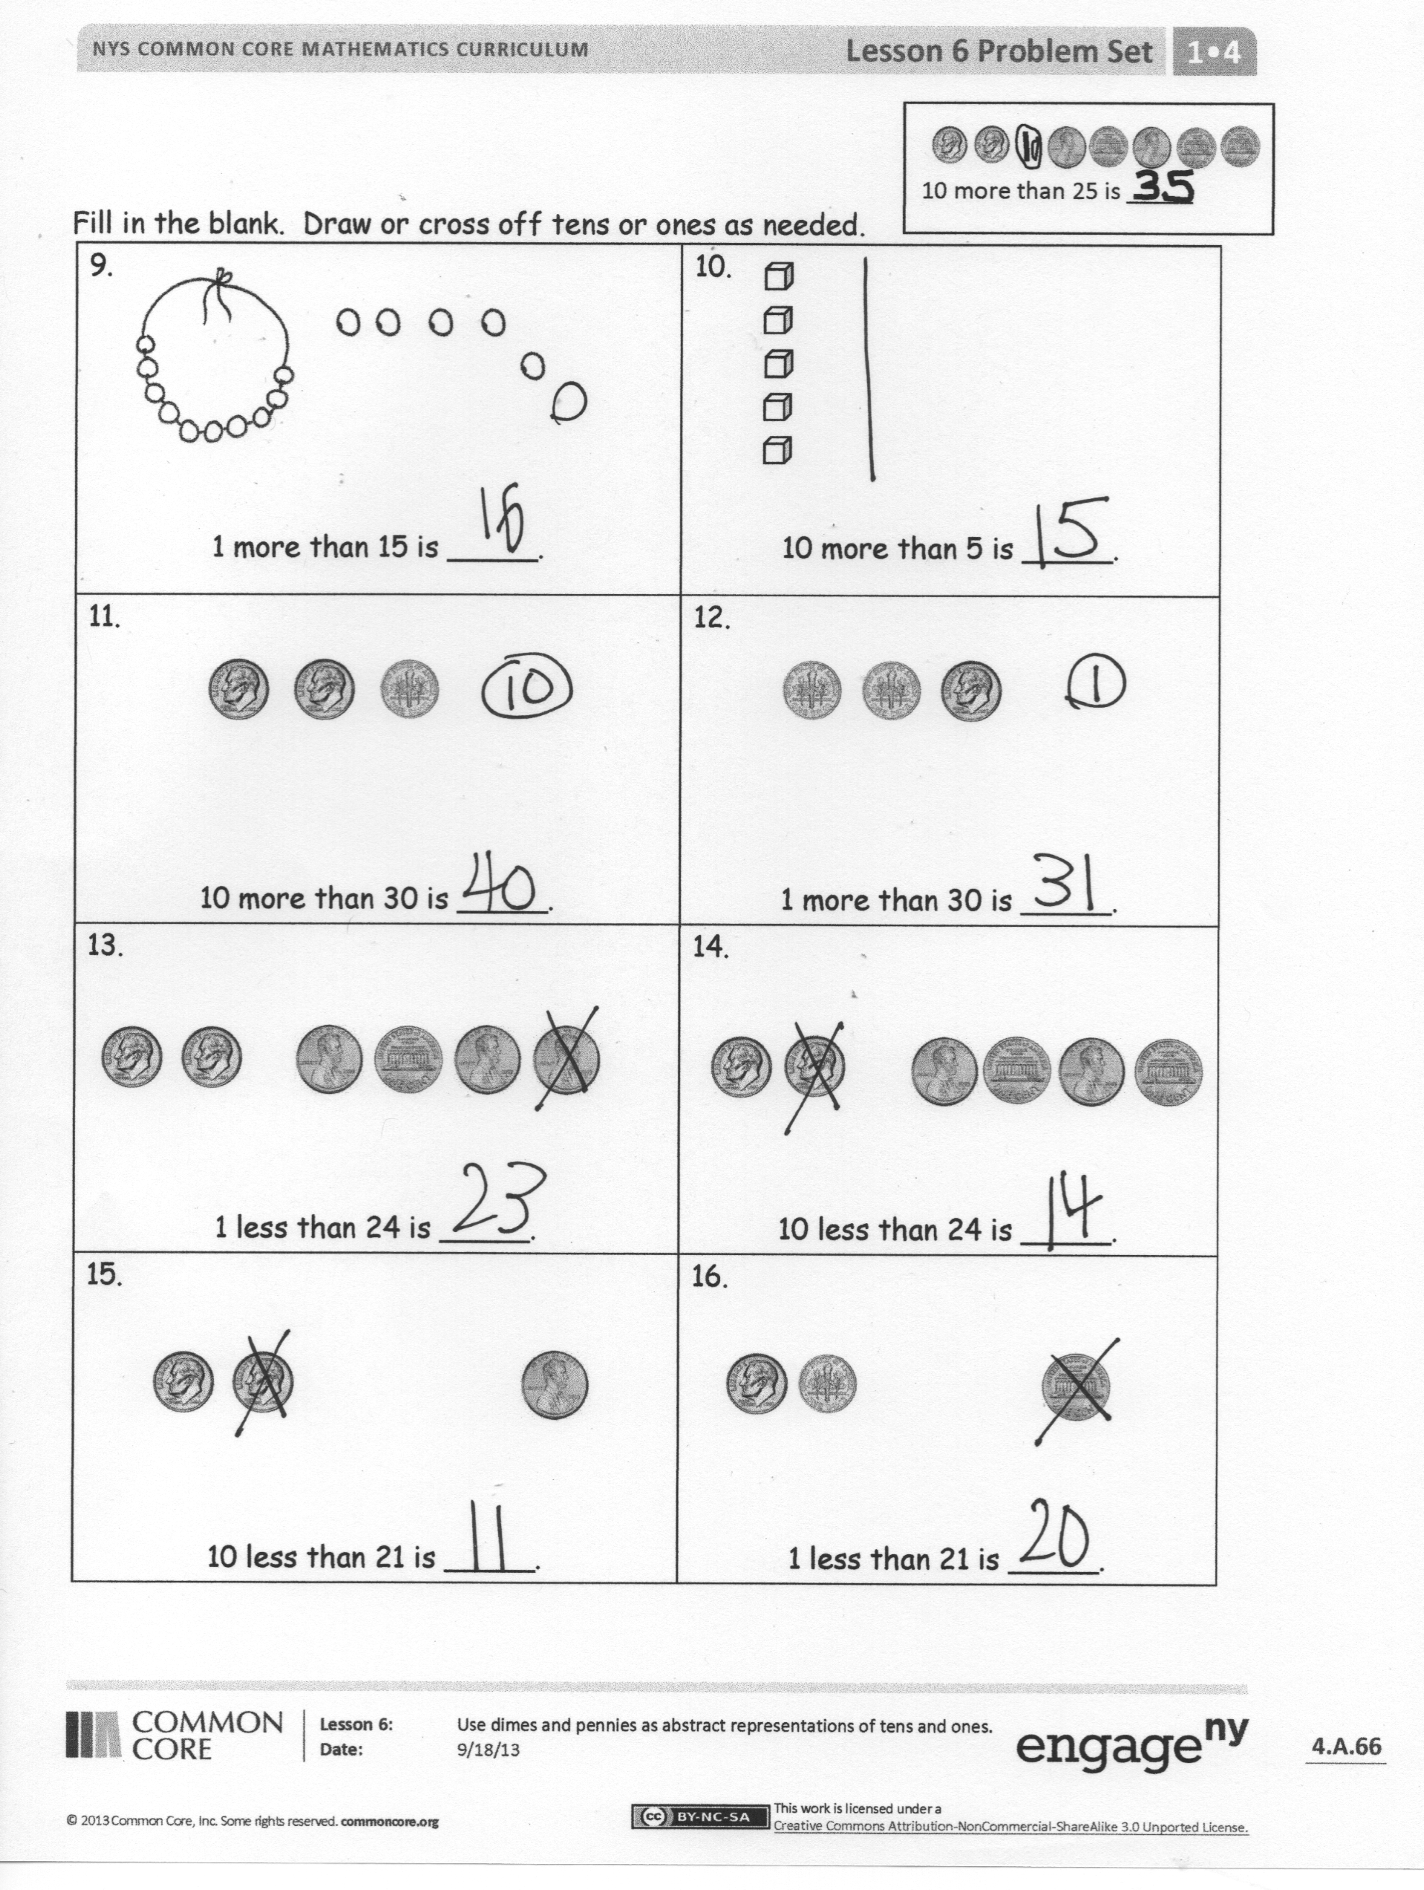
Any combination of the questions below may be used to lead the discussion.
- Look at Problem 2. If you were to show that amount with dimes and pennies, how many of each coin would you use?
- Look at Problems 3 and 6. How is Problem 6 different from Problem 3? What is different about the amount shown in the pictures?
- Look at Problems 13 and 14. What did you cross off in 13? What did you cross off in 14? Why did you cross off a different coin in each problem?
- How are the tools that represent 1 ten different from one another? (Project the ten-stick and the dime.)
- What are some ways that a dime is different from a penny?
- Look at your Application Problem. Discuss how you solved it with a partner. How could you represent this amount in a place value chart? How is this problem connected to today’s lesson?

Exit Ticket (3 minutes)
After the Student Debrief, instruct students to complete the Exit Ticket. A review of their work will help with assessing students’ understanding of the concepts that were presented in today’s lesson and planning more effectively for future lessons. The questions may be read aloud to the students.
Name Date
Fill in the place value chart and the blanks.
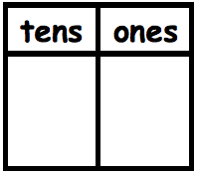  1.  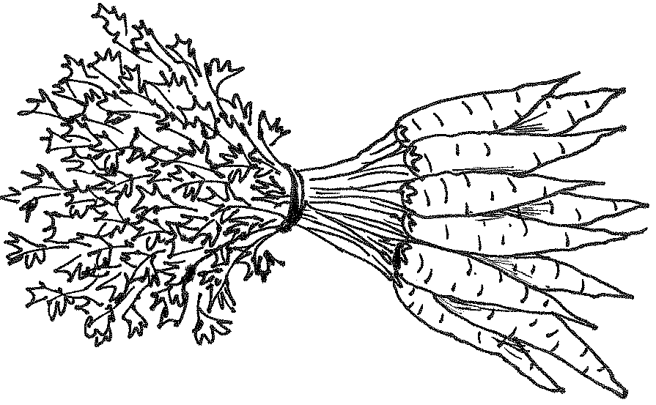  20 = _____ tens. | 2.  14 = _____ten and _____ones.
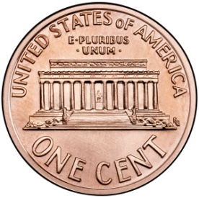  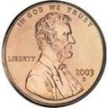  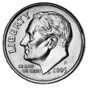  3.  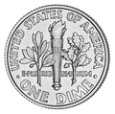  _____ = 3 tens 5 ones. | 4.  _____ = 2 tens 6 ones.
5.  _____= _____ tens _____ ones. | 6.  _____ = _____ tens _____ ones.
7.  _____ = _____ tens _____ ones. | 8.  _____ tens _____ ones = _____.

Fill in the blank. Draw or cross off tens or ones as needed.

10 more than 25 is _____
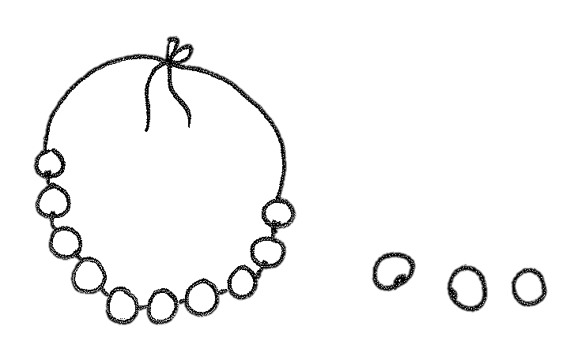  9.  1 more than 15 is _____. | 10.  10 more than 5 is _____.
11.  10 more than 30 is _____. | 12.  1 more than 30 is _____.
13.  1 less than 24 is _____. | 14.  10 less than 24 is _____.
15.  10 less than 21 is _____. | 16.  1 less than 21 is _____.

Name Date
Fill in the blank. Draw or cross off tens or ones as needed.
1.  10 more than 23 is _____. | 2.  1 more than 13 is _____.
3.  10 less than 31 is _____. | 4.  1 less than 14 is _____.

Name Date
Fill in the place value chart and the blanks.
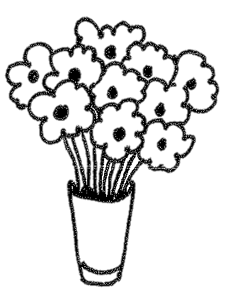  1.  30 = _____ tens | 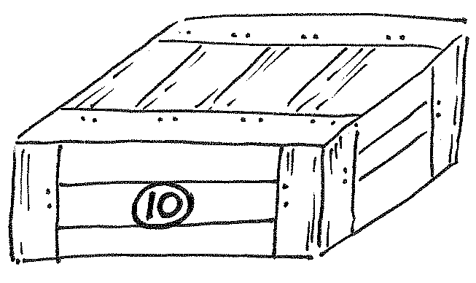  2.  17 = _____ ten and _____ ones
3.  _____ = 2 tens 2 ones | 4.  _____ = 3 tens 3 ones
5.  _____= _____ tens _____ ones | 6.  _____ = _____ tens _____ ones
7.  _____ = _____ ten _____ ones | 8.  _____ tens _____ ones = _____

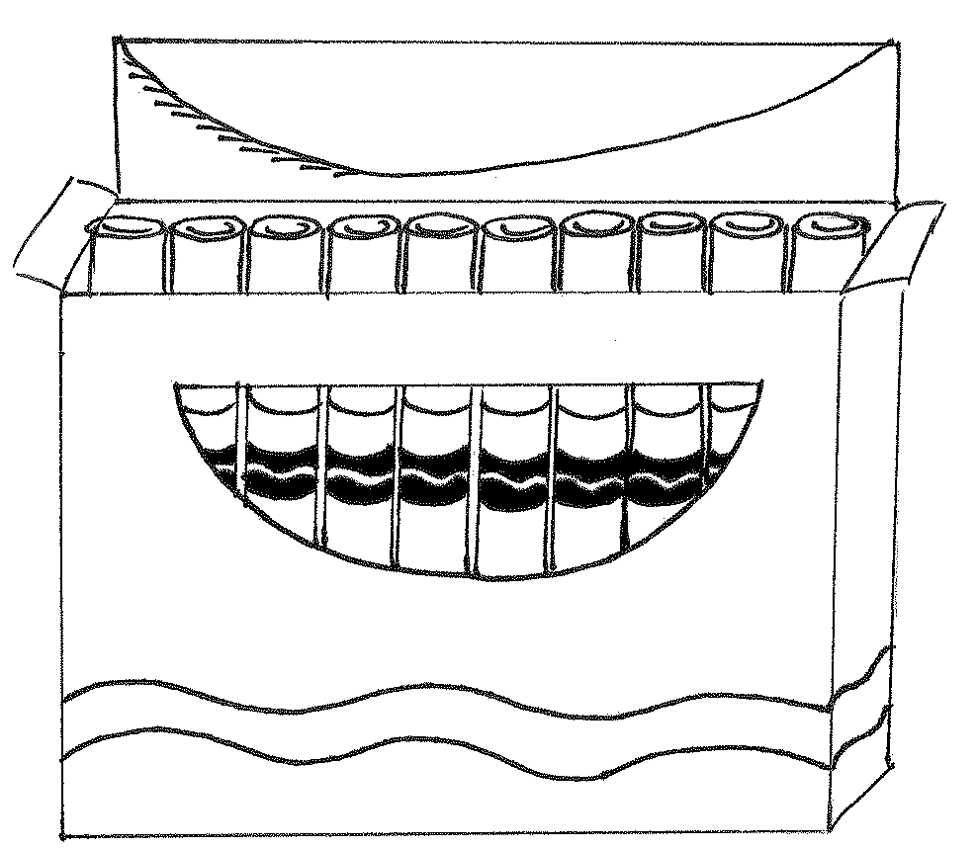  9.  1 more than 12 is _____. | 10.  10 more than 3 is _____.
11.  10 more than 22 is _____. | 12.  1 more than 22 is _____.
13.  1 less than 39 is _____. | 14.  10 less than 39 is _____.
15.  10 less than 33 is _____. | 16.  1 less than 33 is _____.
Fill in the blank. Draw or cross off tens or ones as needed.

10 more than 25 is _____

dimes | pennies

tens | ones

coin and place value charts

