Lesson 5
Objective: Identify 10 more, 10 less, 1 more, and 1 less than a two-digit number.

Suggested Lesson Structure
 Fluency Practice (10 minutes)
 Application Problem (5 minutes)
 Concept Development (35 minutes)
 Student Debrief (10 minutes)
Total Time (60 minutes)

Fluency Practice (10 minutes)
- Sprint: 10 More, 10 Less Review 1.OA.6 (10 minutes)

Sprint: 10 More, 10 Less Review (10 minutes)

Materials: (S) 10 More, 10 Less Review Sprint
Note: This review Sprint provides practice with addition and subtraction within 20 and prepares students to extend this skill for numbers to 40 in today’s lesson.

Application Problem (5 minutes)
Lee has 4 pencils and buys 10 more. Kiana has 17 pencils and loses 10 of them. Who has more pencils now? Use drawings, words, and number sentences to explain your thinking.
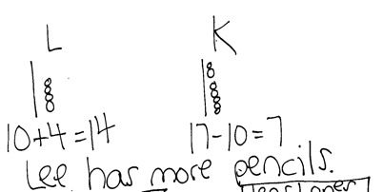
Note: This problem gives students a chance to add and subtract 10 using their own methods. At this point in the year, students should feel quite comfortable adding and subtracting 10 with numbers within 20. Circulate and notice students’ understanding. Link this to today’s lesson as students notice ways to more quickly add and subtract 10 to and from larger numbers.

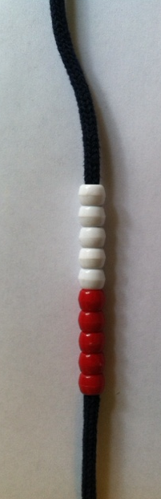
Concept Development (35 minutes)
Rekenrek bracelet
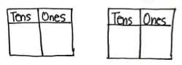
Materials: (T) 4 Rekenrek bracelets stretched into a straight line as shown,
5 additional red beads, 5 additional white beads, 4 ten-sticks,
2 pieces of chart paper with two pairs of place value charts as shown (S) Personal math toolkit of 4 ten-sticks of linking cubes, personal white board, double place value charts (Template)
Students sit at their desks with all of the materials.
T: (Show the Rekenrek bracelet stretched out as a vertical line.) When we made drawings to show this Rekenrek bracelet stretched out, we called it a…?
S: 5-group column!
T: You’re right! We drew 10 circles showing the beads. We also drew a line through it to show that there are 10 circles or beads. (Draw a 5-group column on the board.)
T: (Place 4 individual beads next to the Rekenrek bracelet.) How many beads are there?
S: 14 beads.
T: Say an addition sentence that represents how many beads there are, starting with 10.
S: 10 + 4 = 14.
T: Draw the number of beads using 5-group columns.
S: (Draw one 5-group column and four beads.)
T: (Add two more Rekenrek bracelets representing 34.) How many beads are here now? Let’s count.
S/T: (Point to each bracelet as you count by tens, and then to each bead for the last four beads.) 10, 20, 30. (Pause.) 31, 32, 33, 34.
T: Draw the number of beads using 5-group columns. (Give 10 seconds to draw.) Your time is up!
S: I didn’t have enough time to draw all 34 beads!
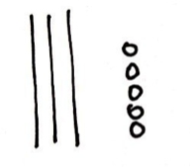
T: Wow, drawing 34 beads would take us a long time! Let me show you a shortcut to drawing tens. Watch how quickly I can represent 34. (Draw 3 quick tens and 4 circles.)
T: Now, you try drawing 34 using quick tens.
S: (Draw.)
T: We call each of these lines a quick ten. How do you think it got its name?
S: It’s a line that holds 10 beads. It represents a ten, so we don’t have to draw all the beads!
It’s so quick to draw a ten now!
Have students practice representing numbers with quick tens for two minutes. Show or call out using numbers from 11 to 40 in varied ways (e.g., using Rekenrek bracelets and extra beads, ten-sticks and extra linking cubes, place value chart, the Say Ten Way, an addition expression, a more than statement, and a number bond with two parts filled in). For the next minute, switch roles. Draw quick tens, and have students say what number they represent.
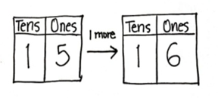
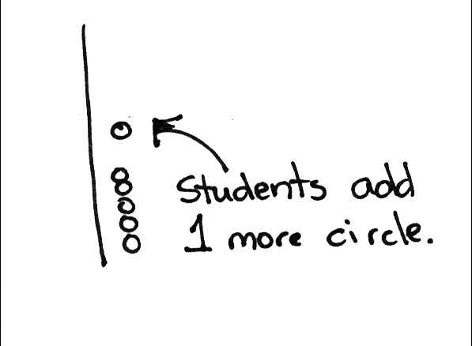
T: Draw 15.

S: (Draw a quick ten and 5 circles.)
T: How many tens and ones are there?
S: 1 ten and 5 ones.
T: (Write 15 on the double place value chart.)
T: Show me 1 more than 15.

NOTES ON
MULTIPLE MEANS
OF ENGAGEMENT:
Some students may not be able to imagine adding or subtracting a ten at this point. Support these students with all of the materials used in the lesson and give them plenty of practice. Their path to abstract thinking may be a little longer than those of other students.

S: (Draw 1 more circle.)
T: What is 1 more than 15? Say the whole sentence.
S: 1 more than 15 is 16. (Write 16 on the place value chart.)
T: So, from 15 to 16, we added 1 more. (Draw an arrow from the first place value chart to the second, and then write + 1 above the arrow.)
T: Look at the place value chart. What changed and what didn’t? Turn and talk to your partner about why this is so.
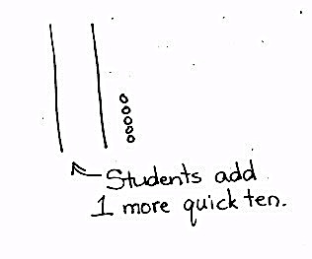
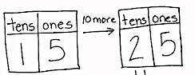
S: The tens didn’t change. They both stayed as 1 ten because we only added 1 more. The ones changed from 5 to 6 because we added 1 more. 6 is 1 more than 5. To figure out 1 more, I just have to add 1 more to the number in the ones place!

T: Great thinking! Show me 15 with your drawing again.
S: (Show 15.)
T: (Write 15 on a new place value chart.) Now, how can you show 10 more than 15? (Draw an arrow and write + 10 above it.) Turn and talk to your partner, and then show with your cubes.
S: Just draw one more quick ten!

T: That’s an efficient way to show 10 more! Let’s have everyone show 10 more this way, drawing just one more quick ten. What is 10 more than 15? Say the whole sentence.

NOTES ON
MULTIPLE MEANS
OF ENGAGEMENT:
Other students may be able to visualize adding and subtracting ones and tens. Since these students have moved from concrete to abstract thinking, challenge them by giving problems that consist of adding or subtracting 2 ones/tens or 3 ones/tens.

S: 10 more than 15 is 25.
T: I’m about to write the new number on the place value chart to show 10 more than 15. Talk to your partner about what you think will change and what will remain the same.
MP.6
S: The tens changed this time from 1 ten to 2 tens because we added 10 more. The ones didn’t change because we just added a ten-stick. We could add 10 extra ones, but once you get 10, we make them into a
ten-stick, so why bother? We can add a ten quickly. I just have to add 1 more to the number in the tens place!
MP.6
T: We added 10 more to 15 to get 25. (Complete the second place value chart with 2 and 5.)
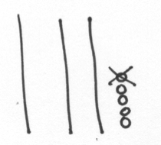
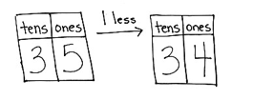
Repeat the process using 1 less (as shown to the right) and 10 less with 35.

Then, follow the suggested sequence:
- 1 more/10 more than 14
- 1 less/10 less than 16
- 1 more/1 less than 36
- 10 more/10 less than 38
- 1 more/1 less than 32
- 10 more/10 less than 23
- 1 more than 29
- 1 less than 30

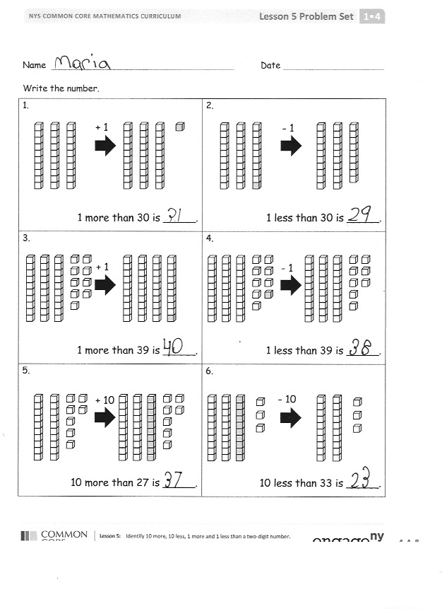
Problem Set (10 minutes)
Students should do their personal best to complete the Problem Set within the allotted 10 minutes. For some classes, it may be appropriate to modify the assignment by specifying which problems they work on first.

Student Debrief (10 minutes)
Lesson Objective: Identify 10 more, 10 less, 1 more, and 1 less than a two-digit number.
The Student Debrief is intended to invite reflection and active processing of the total lesson experience.
Invite students to review their solutions for the Problem Set. They should check work by comparing answers with a partner before going over answers as a class. Look for misconceptions or misunderstandings that can be addressed in the Debrief. Guide students in a conversation to debrief the Problem Set and process the lesson.
Any combination of the questions below may be used to lead the discussion.
- Look at Problem 11. What is 10 less than 26? Which digit changed when you went from 26 to 16?
- Look at Problem 12. What is 1 less than 26? Which digit changed when you went from 26 to 25?
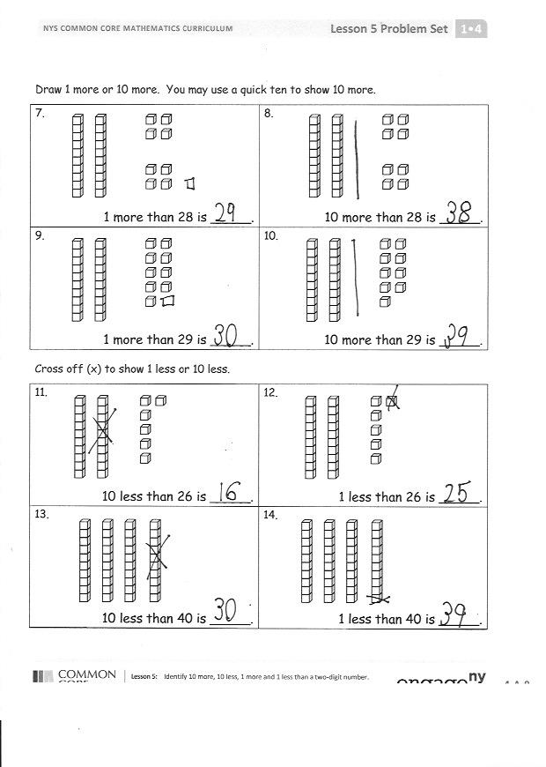
- Look at Problem 9. In what ways did the pictures change from the starting number to the end number? Explain why this is so. Which digit changed? What happened to the digits when you went from 29 to 30? Why is this so? Is this similar to and different from our other problems?
- What does the word digit mean?
- Look at your solution to Problem 14. What changed in the number? Even though we added 1 more in Problem 9 and made 1 less in Problem 14, why did the numbers in both the tens and the ones change?
- What new math drawing did we use to work more efficiently? (Quick ten drawings.)
- How did the Application Problem connect to today’s lesson?

Exit Ticket (3 minutes)
After the Student Debrief, instruct students to complete the Exit Ticket. A review of their work will help with assessing students’ understanding of the concepts that were presented in today’s lesson and planning more effectively for future lessons. The questions may be read aloud to the students.

Name Date
Number Correct:
A
*Write the missing number.
1 | 10 + 3 = ☐ |  | 16 | 10 + ☐ = 11
2 | 10 + 2 = ☐ |  | 17 | 10 + ☐ = 12
3 | 10 + 1 = ☐ |  | 18 | 5 + ☐ = 15
4 | 1 + 10 = ☐ |  | 19 | 4 + ☐ = 14
5 | 4 + 10 = ☐ |  | 20 | ☐ + 10 = 17
6 | 6 + 10 = ☐ |  | 21 | 17 - ☐ = 7
7 | 10 + 7 = ☐ |  | 22 | 16 - ☐ = 6
8 | 8 + 10 = ☐ |  | 23 | 18 - ☐ = 8
9 | 12 - 10 = ☐ |  | 24 | ☐ - 10 = 8
10 | 11 - 10 = ☐ |  | 25 | ☐ - 10 = 9
11 | 10 - 10 = ☐ |  | 26 | 1 + 1 + 10 = ☐
12 | 13 - 10 = ☐ |  | 27 | 2 + 2 + 10 = ☐
13 | 14 - 10 = ☐ |  | 28 | 2 + 3 + 10 = ☐
14 | 15 - 10 = ☐ |  | 29 | 4 + ☐ + 3 = 17
15 | 18 - 10 = ☐ |  | 30 | ☐ + 5 + 10 = 18

Name Date
Number Correct:
B
*Write the missing number.
1 | 10 + 1 = ☐ |  | 16 | 10 + ☐ = 10
2 | 10 + 2 = ☐ |  | 17 | 10 + ☐ = 11
3 | 10 + 3 = ☐ |  | 18 | 2 + ☐ = 12
4 | 4 + 10 = ☐ |  | 19 | 3 + ☐ = 13
5 | 5 + 10 = ☐ |  | 20 | ☐ + 10 = 13
6 | 6 + 10 = ☐ |  | 21 | 13 - ☐ = 3
7 | 10 + 8 = ☐ |  | 22 | 14 - ☐ = 4
8 | 8 + 10 = ☐ |  | 23 | 16 - ☐ = 6
9 | 10 - 10 = ☐ |  | 24 | ☐ - 10 = 6
10 | 11 - 10 = ☐ |  | 25 | ☐ - 10 = 8
11 | 12 - 10 = ☐ |  | 26 | 2 + 1 + 10 = ☐
12 | 13 - 10 = ☐ |  | 27 | 3 + 2 + 10 = ☐
13 | 15 - 10 = ☐ |  | 28 | 2 + 3 + 10 = ☐
14 | 17 - 10 = ☐ |  | 29 | 4 + ☐ + 4 = 18
15 | 19 - 10 = ☐ |  | 30 | ☐ + 6 + 10 = 19

Name Date
Write the number.
1.  + 1  1 more than 30 is _____. | 2.  - 1  1 less than 30 is _____.
3.  + 1  1 more than 39 is _____. | 4.  - 1  1 less than 39 is _____.
5.  + 10  10 more than 27 is _____. | 6.  - 10  10 less than 33 is _____.
Draw 1 more or 10 more. You may use a quick ten to show 10 more.
7.  1 more than 28 is _____. | 8.  10 more than 28 is _____.
9.  1 more than 29 is _____. | 10.  10 more than 29 is _____.
Cross off (x) to show 1 less or 10 less.
11.  10 less than 26 is _____. | 12.  1 less than 26 is _____.
13.  10 less than 40 is _____. | 14.  1 less than 40 is _____.

Name Date
Draw 1 more or 10 more. You may use a quick ten to show 10 more.
1.  1 more than 24 is _____. | 2.  10 more than 24 is _____.

Cross off (x) to show 1 less or 10 less.
3.  10 less than 30 is _____. | 4.  1 less than 30 is _____.

Name Date
Draw quick tens and ones to show the number. Then, draw 1 more or 10 more.
1.  1 more than 38 is _____. | 2.  10 more than 38 is _____.
3.  1 more than 35 is _____. | 4.  10 more than 35 is _____.

Draw quick tens and ones to show the number. Cross off (x) to show 1 less or 10 less.
5.  10 less than 23 is _____. | 6.  1 less than 23 is _____.
7.  10 less than 31 is _____. | 8.  1 less than 31 is _____.
Match the words to the picture that shows the right amount.
9.
1 less than 30.
•
•

10.
1 more than 23 is 24.
•
•

11.
•
10 less than 36.
•

12.
•
10 more than 20.
•

tens | ones
tens | ones

double place value charts

