Lesson 4
Objective: Write and interpret two-digit numbers as addition sentences that combine tens and ones.

Suggested Lesson Structure
 Fluency Practice (12 minutes)
 Application Problem (5 minutes)
 Concept Development (33 minutes)
 Student Debrief (10 minutes)
Total Time (60 minutes)

Fluency Practice (12 minutes)
- Subtraction with Cards 1.OA.6 (5 minutes)
- Dime Exchange 1.NBT.2 (5 minutes)
- 10 More 1.NBT.5 (2 minutes)

Subtraction with Cards (5 minutes)
Materials: (S) 1 pack of numeral cards 0─10 per set of partners (Fluency Template)
Note: This fluency activity strengthens students’ abilities to subtract within 10, which is a required core fluency for Grade 1.
Students combine their numeral cards and place them facedown between them. Each partner flips over two cards and subtracts the smaller number from the larger one. The partner with the smallest difference keeps the cards played by both players. If the differences are equal, the cards are set aside, and the winner of the next round keeps the cards from both rounds. The player with the most cards at the end of the game wins.

Dime Exchange (5 minutes)

Materials: (S) 10 pennies and 2 dimes per pair
Note: This fluency activity is necessary to prepare students to utilize coins as abstract representations of tens and ones in Lesson 6. If there are not enough coins to do this activity in pairs, it may be done as a teacher-directed activity.
Students work in pairs. Partner A begins with 2 dimes. Partner B begins with 10 pennies. Partner A whisper-counts as she lays 2 dimes, “10 cents, 20 cents.” Partner B exchanges 1 dime for 10 pennies, lays them out in 5-groups, and says, “1 dime is equal to 10 pennies.” Students whisper-count as Partner A takes away 1 penny at a time (20 cents, 19 cents, etc.). When they get to 10, they exchange the dime for 10 pennies and whisper-count to 0. Partners A and B switch roles and repeat.

10 More (2 minutes)
Note: This fluency activity reviews adding 10 to a single-digit number, which prepares students for today’s lesson.
T: What’s 10 more than 5?
S: 15.
T: Say 15 the Say Ten Way.
S: Ten 5.
T: Say it as an addition sentence, starting with 5.
S: 5 + 10 = 15.
T: Say the addition sentence, starting with 10.
S: 10 + 5 = 15.
Repeat, beginning with other numbers between 0 and 10.

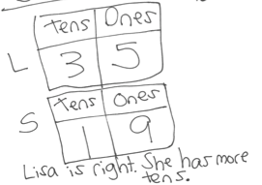
Application Problem (5 minutes)
Lisa has 3 boxes of 10 crayons, as well as 5 extra crayons. Sally has 19 crayons. Sally says she has more crayons, but Lisa disagrees. Who is right?
Note: In this problem, students use what they learned in Lesson 3 about interpreting a two-digit number in terms of tens and ones and apply this to a problem involving a comparison of two quantities. To decide which is larger, students really only need to compare how many tens Lisa and Sally each have. Be sure to note which students understand and which do not understand that Sally has a larger number of ones than Lisa does, but that Lisa still has a larger amount of crayons because she has more tens.

Concept Development (33 minutes)
Materials: (T) 40 linking cubes, chart paper with a place value chart, Hide Zero cards (Lesson 2 Fluency Template), piece of blank paper to cover sections (S) Personal math toolkit of 4 ten-sticks, personal white board, place value chart (Lesson 2 Template 2), numeral cards (Fluency Template)
Students gather in the meeting area in a semicircle formation with their personal white boards. The toolkits of 4 ten-sticks are at their individual desks or tables.
T: (On the floor, lay out 3 ten-sticks and 7 individual cubes.) Say this number as tens and ones.
S: 3 tens 7 ones.
T: Which is the same as the number…?
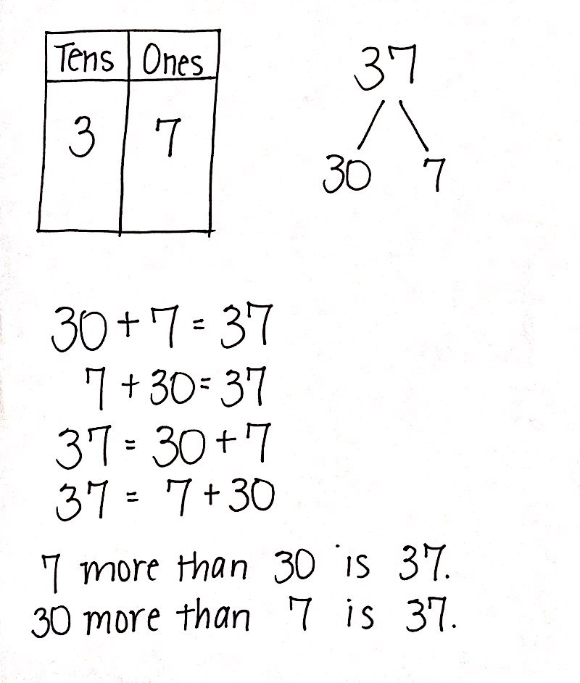
S: 37.
T: (Fill in the place value chart.) 3 is the digit in the tens place. 7 is the digit in the ones place. (Point to each digit in the chart.)
T: On your personal white board, make a number bond that shows the tens and the ones.
S: (Take apart 37 into 30 and 7.)
T: (Record the number bond on the chart.) Write as many addition sentences as you can that use your number bond.
Circulate and ensure that students are only using the three numbers from this bond: 37, 30, and 7. If students begin writing subtraction sentences, remind them of the directions. Perhaps challenge some students to consider subtraction sentences, but these sentences will not be addressed during the course of the lesson.
T: Say a number sentence that matches this number bond. Start with the part that represents the tens. (Record on the chart as students answer.)
S: 30 + 7 = 37.
T: Start your number sentence with the ones. (Record on the chart.)
S: 7 + 30 = 37.
T: 37 is the same as…? (Write 37 = and complete the number sentence as students answer.)
S: 30 plus 7.
T: This time start with the ones. 37 is the same as…? (Write 37 = and complete the number sentence.)
S: 7 plus 30.
T: Talk to your partner. What do you notice about the addends in all of these number sentences?

NOTES ON
MULTIPLE MEANS
OF EXPRESSION:
Students may need additional support with the language of “___ is the same as ___,” “___ is ___ more than ___,” etc. Insert a sentence frame into their personal white boards, and allow students to fill in the blanks. Pointing to each word and number as it is read can provide a bridge between the concrete and the abstract.

S: There is one that tells how many tens there are, and the other tells how many ones there are. You can switch the addends around, and the total is still the same. That was true with smaller numbers, too!
The larger number also tells how many ones are in the tens.
T: Great. (Point to 7.) 7 more than 30 is…? Say the whole sentence.
S: 7 more than 30 is 37. (Record on the chart.)
T: (Point to 30.) 30 more than 7 is…? Say the whole sentence.
S: 30 more than 7 is 37. (Record on the chart.)
Repeat the process following the suggested sequence: 18, 28, 38, 12, 21, 23, 32, 30, and 40. When appropriate, switch to modeling with Hide Zero cards, and then have students write their responses on their personal white boards. Use different language to elicit a variety of answers for each number (e.g., 18 is the same as…; 10 plus 8 is…; 8 more than 10 is…; 10 more than 8 is…).
For the remainder of time, have partners play Combine Tens and Ones using the directions below. Leave the chart for 37 up on the board as a reference to support students.
- Prepare two decks by combining numeral cards 0–9 from both players. The first deck comprises one set of digits 1–3. The rest of the cards are in the second deck.

NOTES ON
MULTIPLE MEANS
OF ENGAGEMENT:
To support students, it is very important to model how games are played. Oral instructions alone will not help all of the class understand how the game is played. Have two students demonstrate Partner A and Partner B roles so that all students see and hear the way the game is played.

- Pick a card from the first deck. This number is placed in the tens place on the place value chart (e.g., 2 is drawn and placed in the tens place).
- Pick a card from the second deck. This number is placed in the ones place on the place value chart (e.g., 7 is drawn and placed in the ones place).
- Partners A and B make a number bond decomposing the number into tens and ones.
- Partner A writes two addition number sentences (e.g., 20 + 7 = 27, 7 + 20 = 27, 27 = 20 + 7, 27 = 7 + 20).
- Partner B writes a 1 more than statement that combines tens and ones (e.g., 20 more than 7 is 27;
7 more than 20 is 27; 27 is 7 more than 20; 27 is 20 more than 7).

NOTES ON
MULTIPLE MEANS OF ENGAGEMENT:
When introducing a new game to your students modeling how the game is played is very important. Oral instructions alone are not going to help all of your class learn the game. Have two students demonstrate the “Shaker” and “Recorder” roles so that all students see and hear the way the game is played.

- Switch roles for the next set of cards drawn.

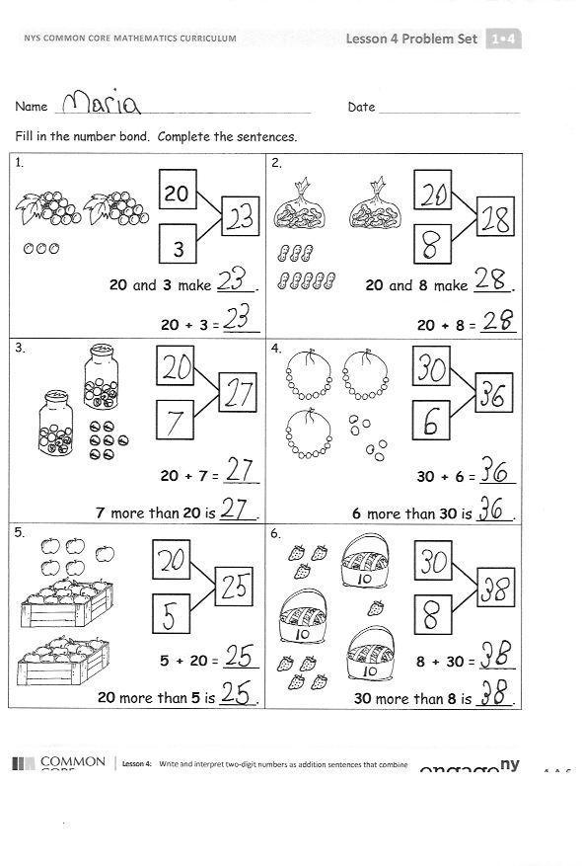
Problem Set (10 minutes)
Students should do their personal best to complete the Problem Set within the allotted 10 minutes. For some classes, it may be appropriate to modify the assignment by specifying which problems they work on first.

Student Debrief (10 minutes)
Lesson Objective: Write and interpret two-digit numbers as addition sentences that combine tens and ones.
The Student Debrief is intended to invite reflection and active processing of the total lesson experience.
Invite students to review their solutions for the Problem Set. They should check work by comparing answers with a partner before going over answers as a class. Look for misconceptions or misunderstandings that can be addressed in the Debrief. Guide students in a conversation to debrief the Problem Set and process the lesson.
Any combination of the questions below may be used to lead the discussion.
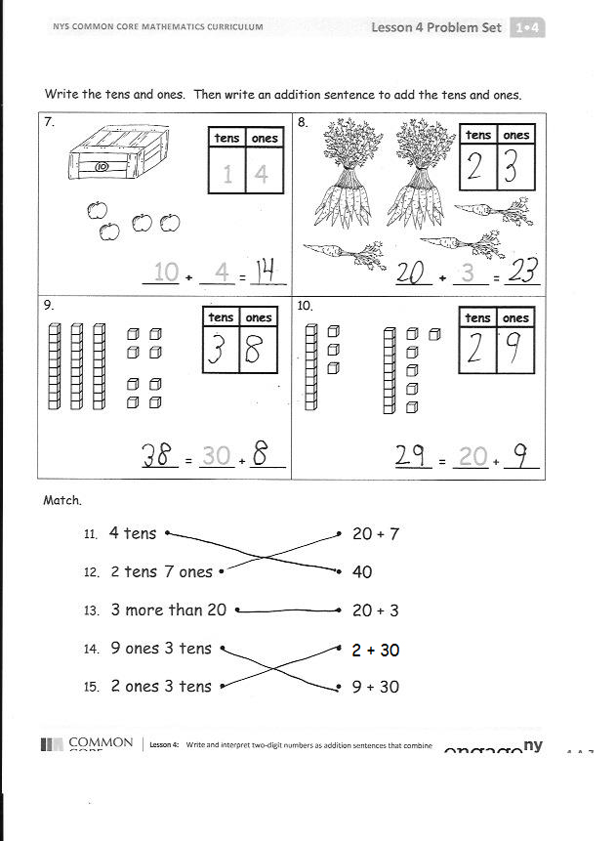
- How can solving Problem 1 help you solve Problem 2?
- How did you solve Problem 5? Is it easier to start with the ones first or the tens first?
- Look at Problem 15. Explain why the answer is not 23. Write the number in a place value chart. Which digit is in the tens place? Which digit is in the ones place?
- Based on our work today, what do you think the word digit means? (Digits are the symbols 0–9 that can be used to create any number. 32 is a two-digit number. The numeral 3 is the digit in the tens place, and the numeral 2 is the digit in the ones place.)
- When you played Combine Tens and Ones, did you ever pick a 0 card? What did you write for your number sentences and number bond?
- Look at your Application Problem. Share your thinking with a partner. How many crayons does Lisa have? Write the number of crayons Lisa has using two number sentences, as we did during today’s lesson.

Exit Ticket (3 minutes)
After the Student Debrief, instruct students to complete the Exit Ticket. A review of their work will help with assessing students’ understanding of the concepts that were presented in today’s lesson and planning more effectively for future lessons. The questions may be read aloud to the students.
Name Date
Fill in the number bond. Complete the sentences.
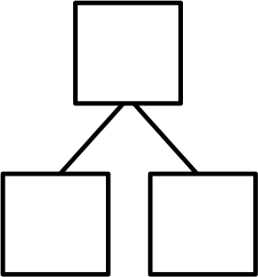  1.  20  3  20 and 3 make ____.  20 + 3 = ____. | 2.  20 and 8 make ____.  20 + 8 = ____.
3.  20 + 7 = ____.  7 more than 20 is ____. | 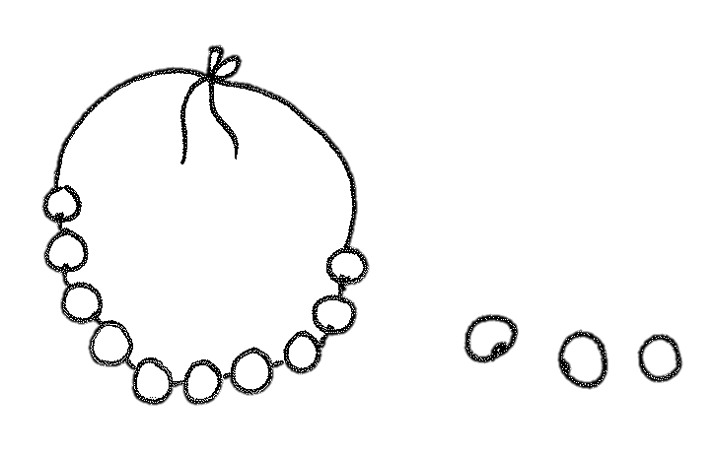  4.  30 + 6 = ____.  6 more than 30 is ____.
5.  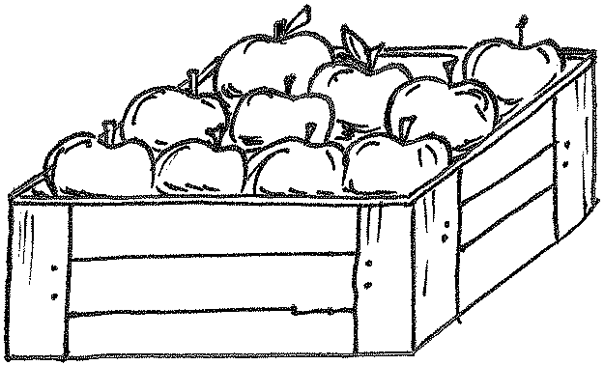  5 + 20 = ____.  20 more than 5 is ____. | 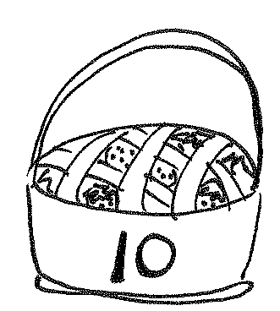  6.  8 + 30 = ____.  30 more than 8 is ____.
Write the tens and ones. Then, write an addition sentence to add the tens and ones.
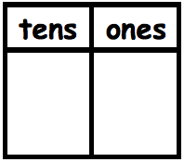  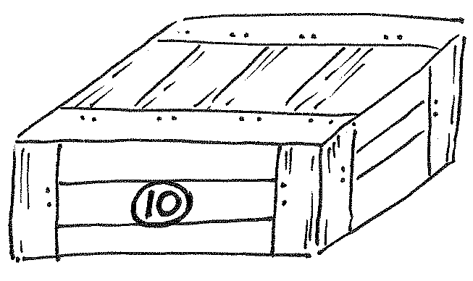  7.  10  4  1  4  ____ + ____ = ____ | 8.  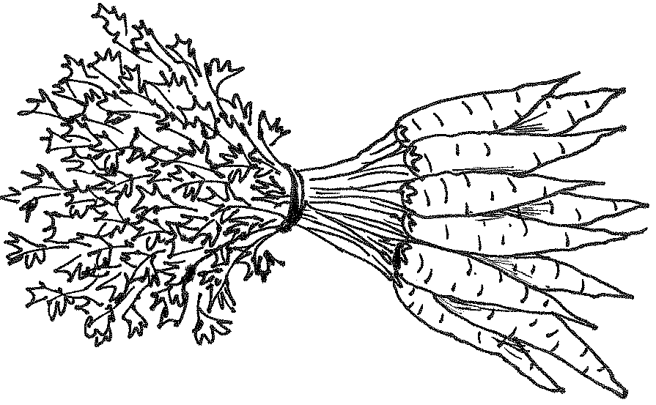  3  ____ + ____ = ____  .
9.  30  ____ = ____ + ____ | 10.  20  ____ = ____ + ____
Match.
11. 4 tens • • 20 + 7
12. 2 tens 7 ones • • 40
13. 3 more than 20 • • 20 + 3
14. 9 ones 3 tens • • 2 + 30
15. 2 ones 3 tens • • 9 + 30
Name Date
Write the tens and ones. Then, write an addition sentence to add the tens and ones.
1.  10  ____ + ____ = ____ | 2.  4  ____ + ____ = ____
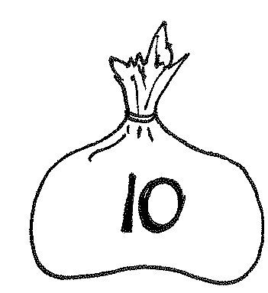  3.  30  ____ = ____ + ____ | 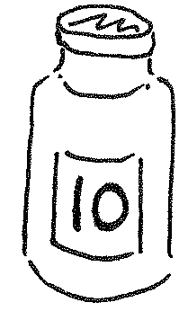  4.  6  ____ = ____ + ____

Name Date
Fill in the number bond or write the tens and ones. Complete the addition sentences.
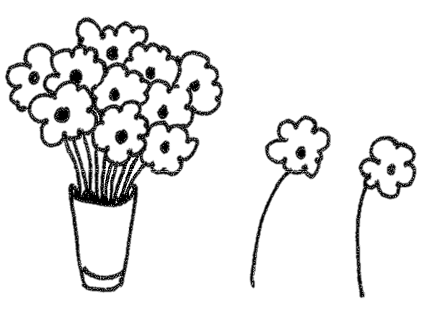  1.  3 + 20 = ____.  20 more than 3 is ____. | 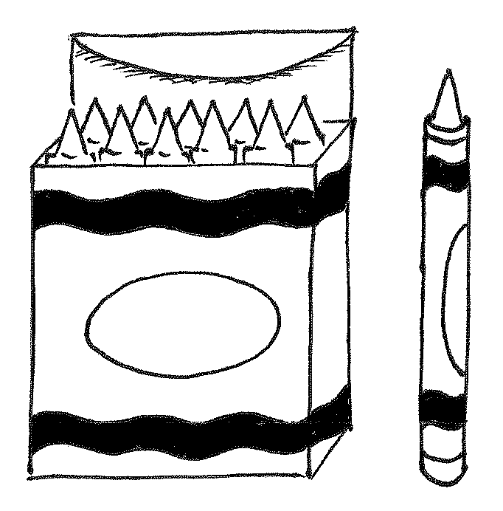  2.  20 + 4 = ____.  4 more than 20 is ____.
3.  7 + 20 = ____ | 4.  ____ + 30 = ____.
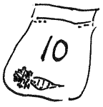  5.  carrots  20 + ____ = ____  carrots | 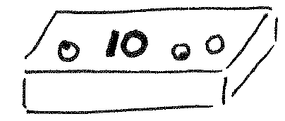  6.  ____ + ____ = ____
Match the pictures with the words.
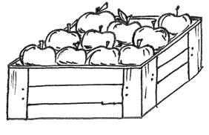
7.
1 and 30 make ______.
•
•

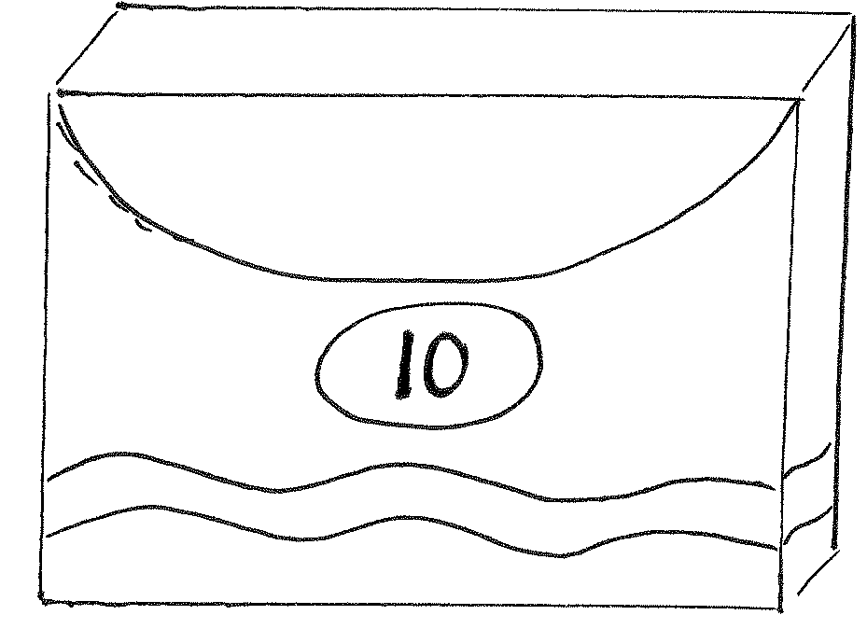
8.
8 + 30 = _____.
•

•

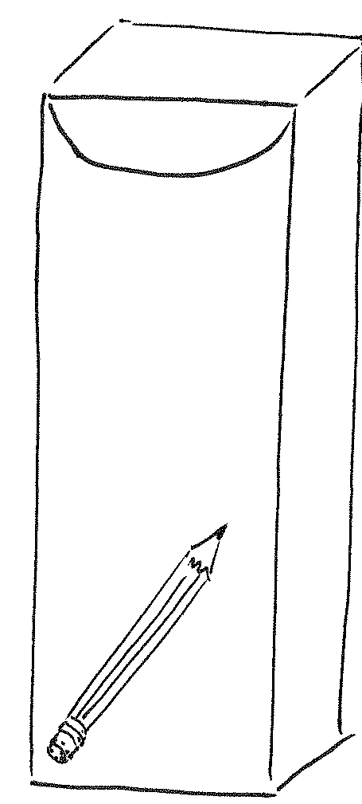
•

9.
2 more than 10 is ______.
•

20 + 4 = ______.
•
•

10.

0 | 1 | 2 | 3
4 | 5 | 6 | 7
8 | 9 | 10 | 11
12 | 13 | 14 | 15

numeral cards

