Lesson 3

Objective: Interpret two-digit numbers as either tens and some ones or as all ones.

Suggested Lesson Structure

 Application Problem (5 minutes)

 Fluency Practice (12 minutes)

 Concept Development (33 minutes)

 Student Debrief (10 minutes)

**Total Time (60 minutes)**

Application Problem (5 minutes)

Sue is writing the number 34 on a place value chart. She cannot remember if she has 4 tens and 3 ones or 3 tens and 4 ones. Use a place value chart to show how many tens and ones are in 34. Use a drawing and words to explain this to Sue.

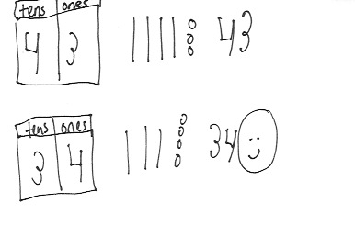

Note: This problem invites students to write or discuss their understanding of tens and ones based on what they learned in Lesson 2. For students who find it challenging to create written explanations, have them share orally with a partner and use drawings to support their thinking. During the Debrief, students will also share other interpretations of 34.

Fluency Practice (12 minutes)

* Core Addition Fluency Review **1.OA.6** (5 minutes)
* Dime Exchange **1.NBT.5** (4 minutes)
* Magic Counting Sticks  **1.NBT.2** (3 minutes)

Core Addition Fluency Review (5 minutes)

Materials: (S) Core Addition Fluency Review (Lesson 2 Core Addition Fluency Review)

Note: This activity assesses students’ progress toward mastery of the required addition fluency for first graders. Since this is the second day of this activity, encourage students to remember how many problems they answered during the last lesson and celebrate improvement.

Students complete as many problems as they can in three minutes. Choose a counting sequence for early finishers to practice on the back of their papers. When time runs out, read the answers aloud so students can correct their work and celebrate improvement.

Dime Exchange (4 minutes)

Materials: (T) 20 pennies and 2 dimes

Note: This activity provides students practice with recognizing pennies and dimes and identifying their values. This fluency activity is necessary to prepare students to utilize coins as abstract representations of tens and ones in Lesson 6.

T: (Lay out 2 dimes.) What coins do you see?

S: 2 dimes.

T: Let’s count by tens to see how much money I have. (Students count aloud.) I want to exchange   
1 dime for some pennies. What is the correct number of pennies?

S: 10 pennies.

T: (Replace a dime with 10 pennies in 5-group formation.) How much money do I have now?

S: 20 cents.

T: You’re right! I still have 20 cents. Count backward with me.

S: (Count from 20 cents to 10 cents, removing 1 penny at a time.)

Change the other dime for a penny, and students count from 10 cents to 0 cents.

Magic Counting Sticks (3 minutes)

Materials: (T) Hide Zero cards (Lesson 2 Template 1)

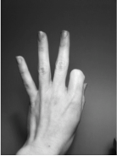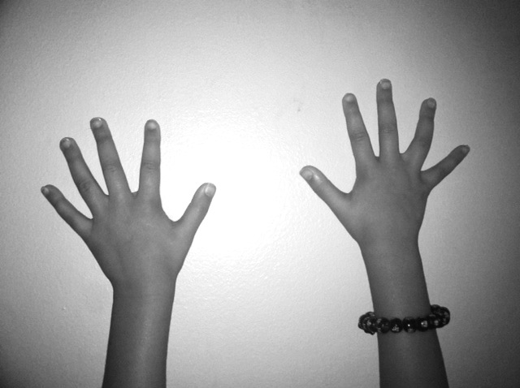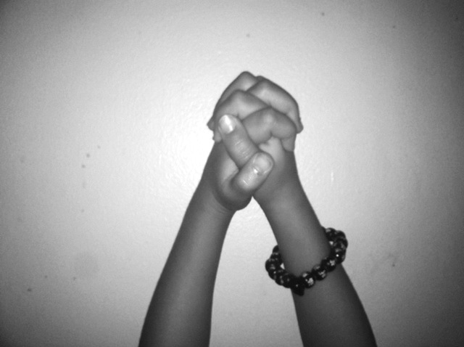

Note: This activity reviews the concept of ten as a unit and as 10 ones, which will prepare students for today’s lesson.

T: (Divide students into partners and assign Partners A and B. Show 13 with Hide Zero cards.) How many tens are in 13?

S: 1 ten.

T: (Point to the 1 in 13.) Partner A, show 1 ten with your magic counting sticks. (Partner A holds up a bundled ten.) How many ones should Partner B show?

S: 3 ones.

T: (Point to the 3.) Partner B, show 3 ones. 1 ten and 3 ones is 13. Partner A, open up your ten. How many fingers do you have?

S: 10 fingers.

T: (Take apart the Hide Zero cards to show 10 and 3.) 10 fingers + 3 fingers is…?

S: 13 fingers.

Alternate partners and repeat with other teen numbers.

Concept Development (33 minutes)

Materials: (T) Hide Zero cards (Lesson 2 Template 1), personal math toolkit of 4 ten-sticks   
(S) Personal math toolkit of 4 ten-sticks

Students gather in the meeting area in a semicircle formation.

T: Show me your magic counting sticks. Wriggle them in the air. Now, show me 1 ten.

S: (Clasp hands together.)

T: Show me 10 ones.

S: (Unclasp hands and show individual fingers.)

T: How can we show 34 using our magic counting sticks?

S: We can’t. We only have 10 magic sticks. 🡪 We need more people to show 34. 🡪 We need 4 people—3 people to show 3 tens, 1 more person to show 4 extra ones.

T: Great idea! (Call up four volunteers.) Show us 34.

S: (Three students clasp their hands together, while the last student on the right facing the class shows four fingers.)

T: How many tens and ones make up 34?

**MP.6**

S: 3 tens and 4 ones.

T: How many ones is the number 34 made of?

S: I see 3 tens and 4 ones. So, there are just 4 ones. 🡪 I see 34 ones. Each ten is made of 10 ones. So, I counted on by tens to get to 30, and I counted by ones to get to 34.

T: I heard some students say that there are 4 ones. Think again. If we *only* use ones to make 34, how many will it take? Open your hands to show your fingers, volunteers!

S: (The first three students unclasp their hands and show all fingers.)

T: How many ones make up 34?

S: 34 ones.

T: How many ones is the same as 3 tens 4 ones?

S: 34 ones.

T: Let’s count to check. How should we count?

S: We can count the fingers by ones. 🡪 Let’s count them by tens first. That will be much faster.

T: Great idea. Let’s count by grouping the 10 ones. Start with Student A. How many ones are here?

S: 10 ones.

T: Keep counting!

S: 20 ones, 30 ones, 34 ones.

T: Great. Let’s do some more. (Call up three volunteers.) Show me 27 ones.

S: (Show individual fingers.)

T: If you are able to make a ten, clasp your hands.

S: (Two students clasp hands.)

T: 27 ones is the same as how many tens and ones?

S: 2 tens and 7 ones.

T: How many ones?

S: 27 ones!

Repeat the process using the following sequence: 37, 14, 24, 34, 13, 31, 10, and 40.

|  |  |
| --- | --- |
|  | NOTES ON  MULTIPLE MEANS  OF ACTION AND EXPRESSION: |
| By introducing each number in a different way, students are held accountable for understanding place value no matter how the number is presented. Doing it this way can be a challenge for some students, so make sure that students who need information presented a specific way are still getting the information they need. | |

When students demonstrate a solid understanding with the finger work, move on to representing the numbers with Hide Zero cards.

T: (Show 24 using Hide Zero cards.) How many tens and ones make up 24?

S: 2 tens 4 ones.

T: How many ones are in 2 tens? (Pull apart 24 into 20 and 4.)

S: 20 ones.

T: How many extra ones are there?

S: 4 ones.

T: How many ones is the same as 2 tens and 4 ones?

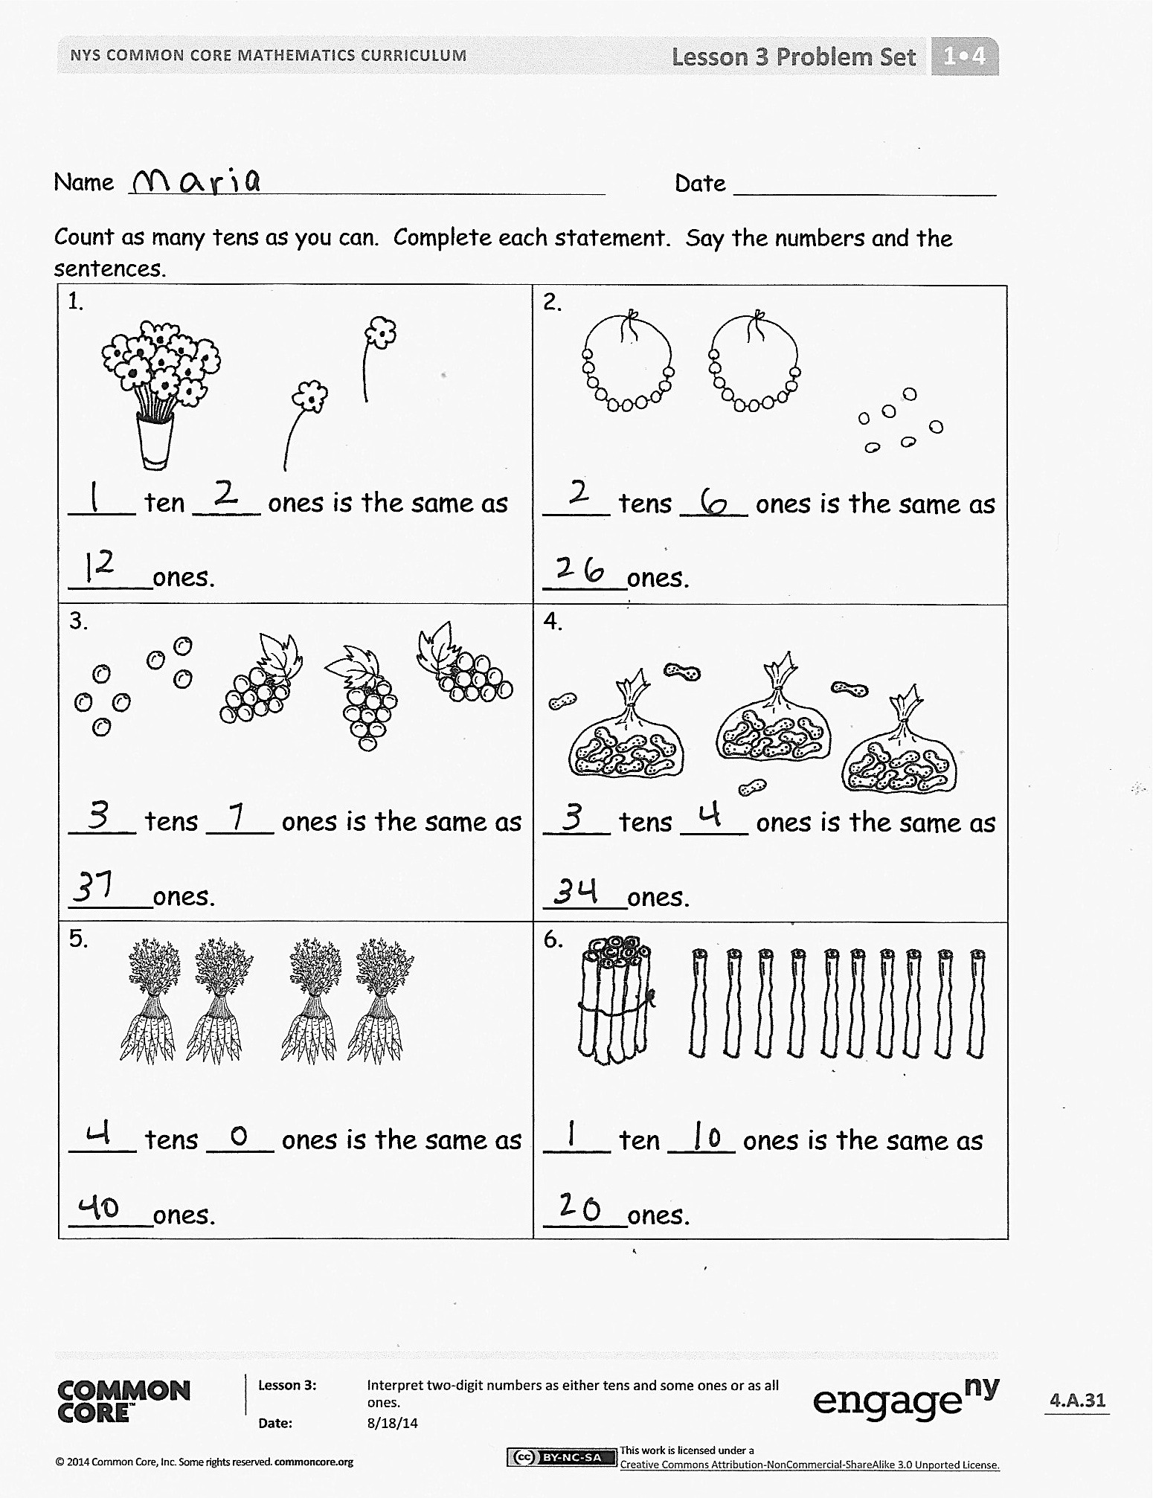S: 24 ones.

T: How many tens and ones is the same as 24 ones? (Put 24 back together.)

S: 2 tens 4 ones.

Repeat the process using the following sequence: 13, 23, 16, 26, 36, 29, 20, and 30 using Hide Zero cards. For the first two or three, have students work with a partner to represent the number with their linking cubes, first with as many tens as possible, and then decomposed into all ones. Support students in seeing that there are the same number of cubes and connecting this with the mathematical idea that, for instance, 1 ten 3 ones is the same amount as 13 ones.

Problem Set (10 minutes)

Note: For completing today’s Problem Set, have students say the number and the sentence for each problem. This will allow students to hear themselves reading numbers in different ways.

Students should do their personal best to complete the Problem Set within the allotted 10 minutes. For some classes, it may be appropriate to modify the assignment by specifying which problems they work on first.

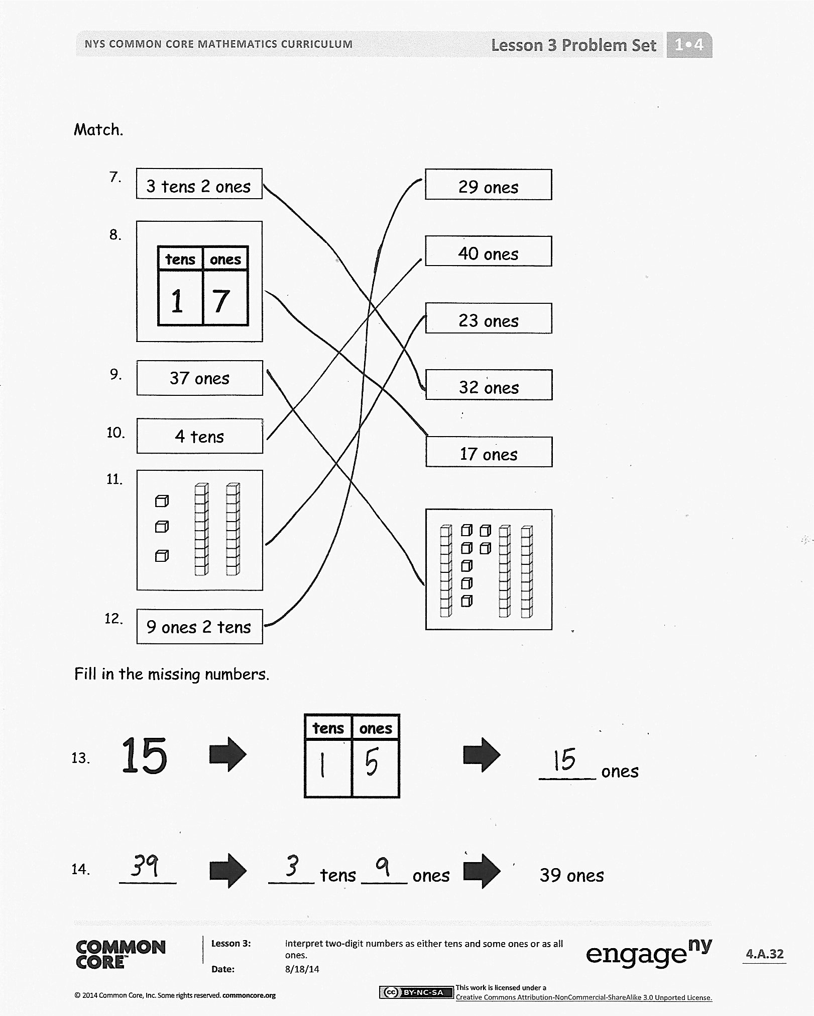Student Debrief (10 minutes)

**Lesson Objective:** Interpret two-digit numbers as either tens and some ones or as all ones.

The Student Debrief is intended to invite reflection and active processing of the total lesson experience.

Invite students to review their solutions for the Problem Set. They should check work by comparing answers with a partner before going over answers as a class. Look for misconceptions or misunderstandings that can be addressed in the Debrief. Guide students in a conversation to debrief the Problem Set and process the lesson.

Any combination of the questions below may be used to lead the discussion.

* Look at Problem 6. What is your solution? How are both of these answers correct?
* Look at Problem 10. Explain how 4 tens is the same as 40 ones. You may use linking cubes or the place value chart to support your thinking.
* Look at Problem 12. What are the different ways we can make 29?
* Student A says 2 tens and 9 ones only has 9 ones. Do you agree? Why or why not? How can you help her understand her mistake?
* Look at your Application Problem. Share your work and explain your thinking with a partner. If we counted in all ones, how many ones are in 34?

Exit Ticket (3 minutes)

After the Student Debrief, instruct students to complete the Exit Ticket. A review of their work will help with assessing students’ understanding of the concepts that were presented in today’s lesson and planning more effectively for future lessons. The questions may be read aloud to the students.

Name Date

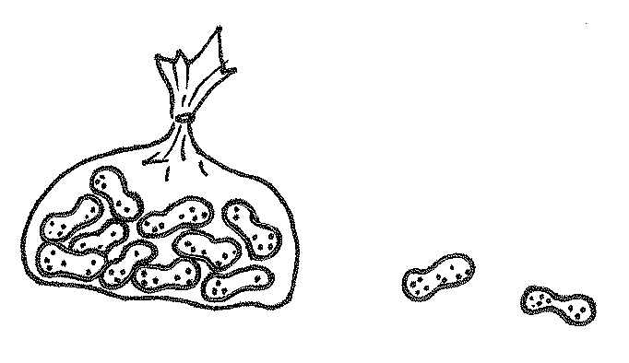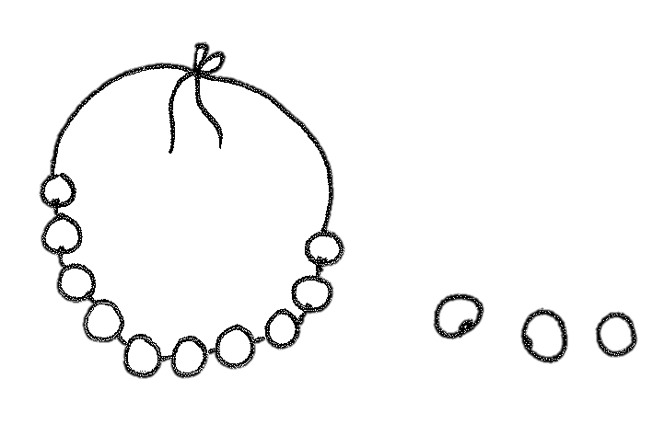Count as many tens as you can. Complete each statement. Say the numbers and the sentences.

|  |  |
| --- | --- |
| 1.    ____ ten ____ ones is the same as _____ ones. | 2.  ____ tens ____ ones is the same as _____ ones.      . |
| 3.  ____ tens ____ ones is the same as _____ ones. | 4.    ____ tens ____ ones is the same as _____ ones. |
| 5.  ____ tens ____ ones is the same as _____ ones. | 6.  ____ ten ____ ones is the same as _____ ones. |

Match.

40 ones

23 ones

32 ones

17 ones

29 ones



3 tens 2 ones

7.

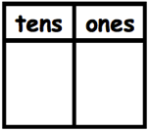

8.

37 ones

9.

4 tens

10.



11.

9 ones 2 tens

12.

1

7

12.

Fill in the missing numbers.

12.

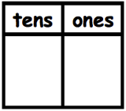

15

13.

13.

_____ ones

14.

39 ones



____ tens ____ ones

_____



Name Date

Count as many tens as you can. Complete each statement. Say the numbers and the sentences.

|  |  |
| --- | --- |
| 1.        ____ **tens** ____ **ones** is the same as _____ **ones**. | 2.  ____ **tens** ____ **ones** is the same as _____ **ones**. |

Fill in the missing numbers.

3. 27   _____ ones

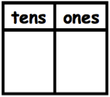

Name Date

Count as many tens as you can. Complete each statement. Say the numbers and the 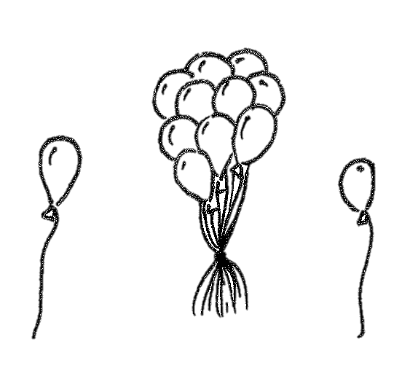sentences.

|  |  |
| --- | --- |
| 1.        ____ **tens** ____ **ones** is the same as _____**ones**. | 2.    ____ **tens** ____ **ones** is the same as _____**ones**.      . |
| 3.    ____ **tens** ____ **ones** is the same as _____**ones**. | 4.  ____ **tens** ____ **ones** is the same as _____**ones**. |

Fill in the missing numbers.

5. _____   _____ ones



21

97

6. 34  ____ **tens** ____ **ones**  _____ ones

7. _____   _____ ones



3

8

8. _____  9 **ones** 3 **tens**  _____ ones

9. _____  ____ **ones** ____ **tens**  40 ones

10. Choose at least one number less than 40. Draw the number in 3 ways:

|  |  |  |
| --- | --- | --- |
| As grapes: | In a number bond: | In the place value chart: |
|  |  |  |